Nature
Titre  Title | EAST LH Launchers ALOHA modeling
Auteur(s)  Author(s) | J.Hillairet
Catégorie  Category | report
Référence(s) | I0000990771

Version | 1.0
Auteur(s)  Author(s) | J.Hillairet | Date : 20/12/2013  Date :  Date :
Vérificateur(s)  Reviewer(s) | W.Helou, Y.Peysson | Date :  Date :  Date :
Approbateur(s)  Approver(s) |  | Date :
Approbateur(s)  Approver(s) |  | Date :

Historique des versions approuvées/Approved versions history

Indice de version  Version | Date | Auteur(s)  Author(s) | Pages ou paragraphes modifiés  Pages or paragraphs changed | Nature des modifications  Nature of the changes
1.0 | 20/12/2013 | J.Hillairet | All | First issue

Content

1 EAST launchers description 3
1.1 EAST 2.45 GHz launcher geometrical description 3
1.2 EAST 4.6 GHz launcher geometrical description 3
1.3 RF description 4
2 Plasma description 5
3 ALOHA Results 5
3.1 EAST 2.45 GHz launcher 5
3.2 EAST 4.6 GHz launcher 6

EAST launchers description

EAST 2.45 GHz launcher geometrical description
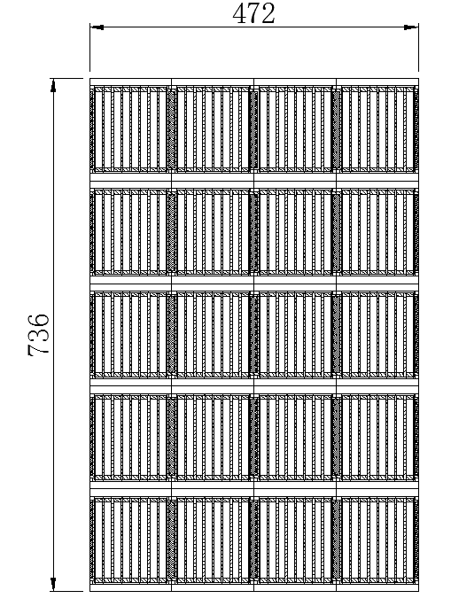
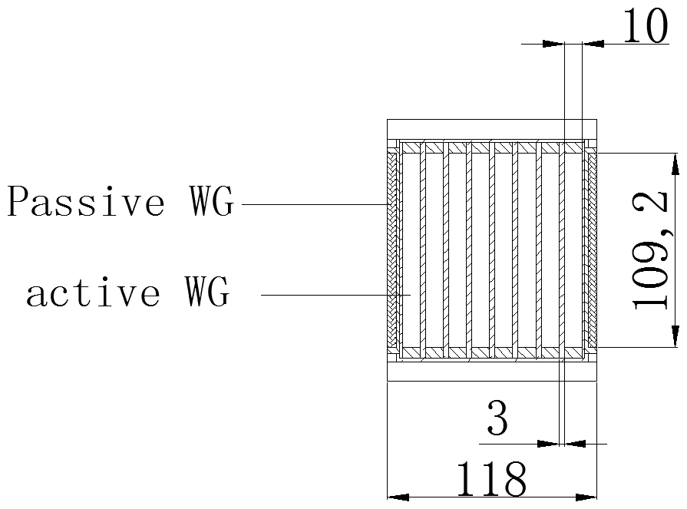
Figure 1: Geometrical description of the EAST 2.45 GHz LH launcher.
The additional dimensions not described in previous Figures have also been used:
- Septum thickness between active and passive waveguides: 3mm
- Width of passive waveguides (between two modules): 10mm
- Width of edge passive waveguides: 5 mm

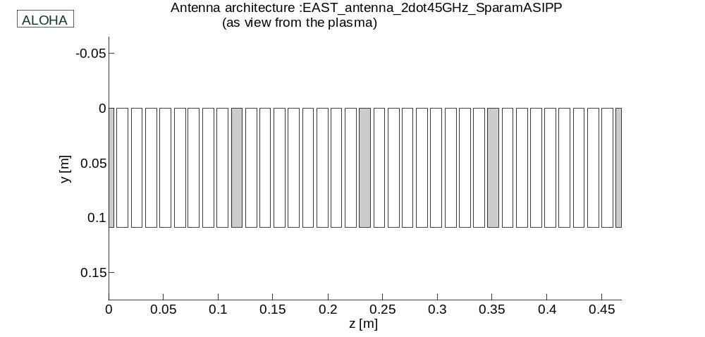
Figure 2. ALOHA geometry of the EAST 2.45 GHz LHCD launcher.

EAST 4.6 GHz LHCD Launcher Geometrical Description
The EAST 4.6GHz LHCD launcher is made of 4x6 multijunction modules. The antenna dimensions and front face waveguides are illustrated in Figure 3.
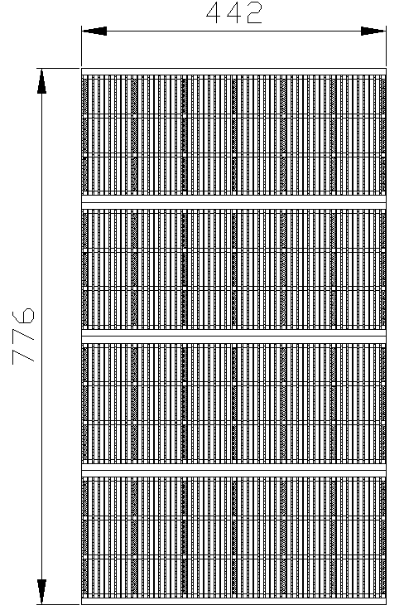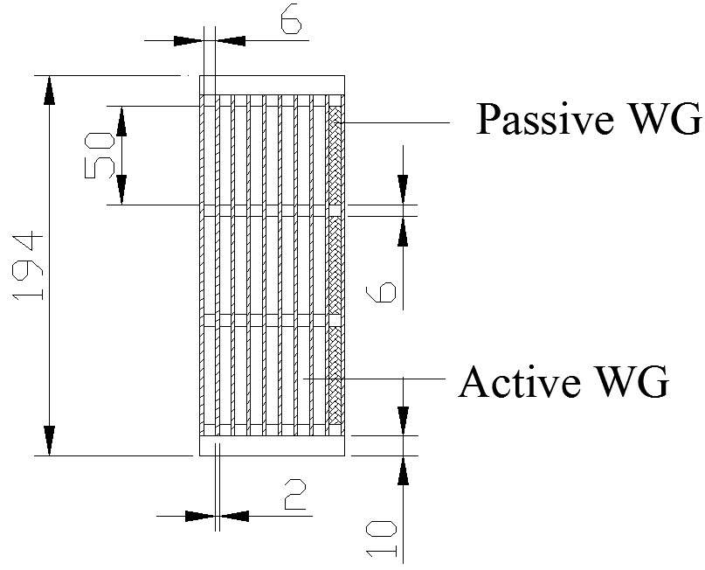
Figure 3: Geometrical description of the EAST 4.6 GHz LH launcher.

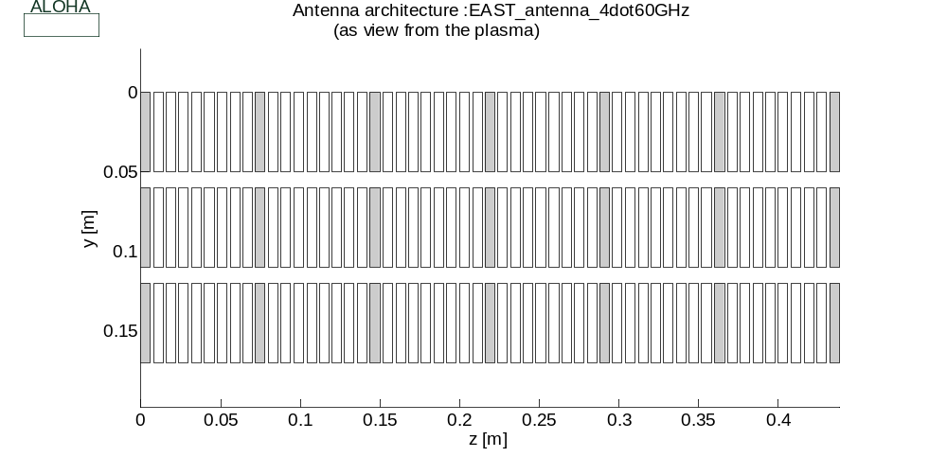
Figure 4. ALOHA geometry of the EAST 4.60 GHz LHCD launcher.

RF description
Two scattering matrixes, one for each launcher, have been calculated from the amplitude and phase data given by ASIPP. It then assumed that the scattering parameters are identical between modules (no effect of toroidal or poloidal curvature taken into account). Moreover, an HFSS modeling of the EAST 2.45 GHz Multijunction, done in June 2010 at CEA/IRFM, has also been used for benchmarking.

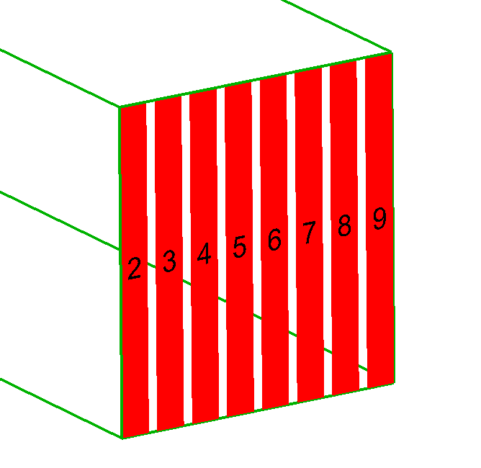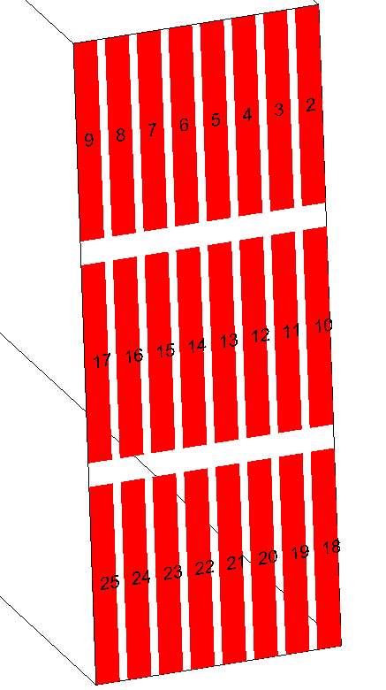
Figure 5. Port numbering of EAST LHCD multijunction modulesError: Reference source not found. Left: 2.45 GHz module. Right 4.6 GHz module.

Five RF excitation cases have been performed, consisting in five phase shift between modules: 0, 40, 90, 180 and 270 degrees, for both antennas.

Plasma description
For both antennas, a single plasma configuration has been used. The plasma is described as following:
- Edge density at the coupler mouth: n_{e0}=7e17 m⁻³
- SOL decay length: λ=0.02 m (linear gradient)
- No vacuum gap.

ALOHA Results
For both antennas, 3 modes per waveguide have been used for the coupling calculations. The ALOHA-1D plasma model has been used. The spectra for each module phase shift are illustrated in the section below.

EAST 2.45 GHz launcher
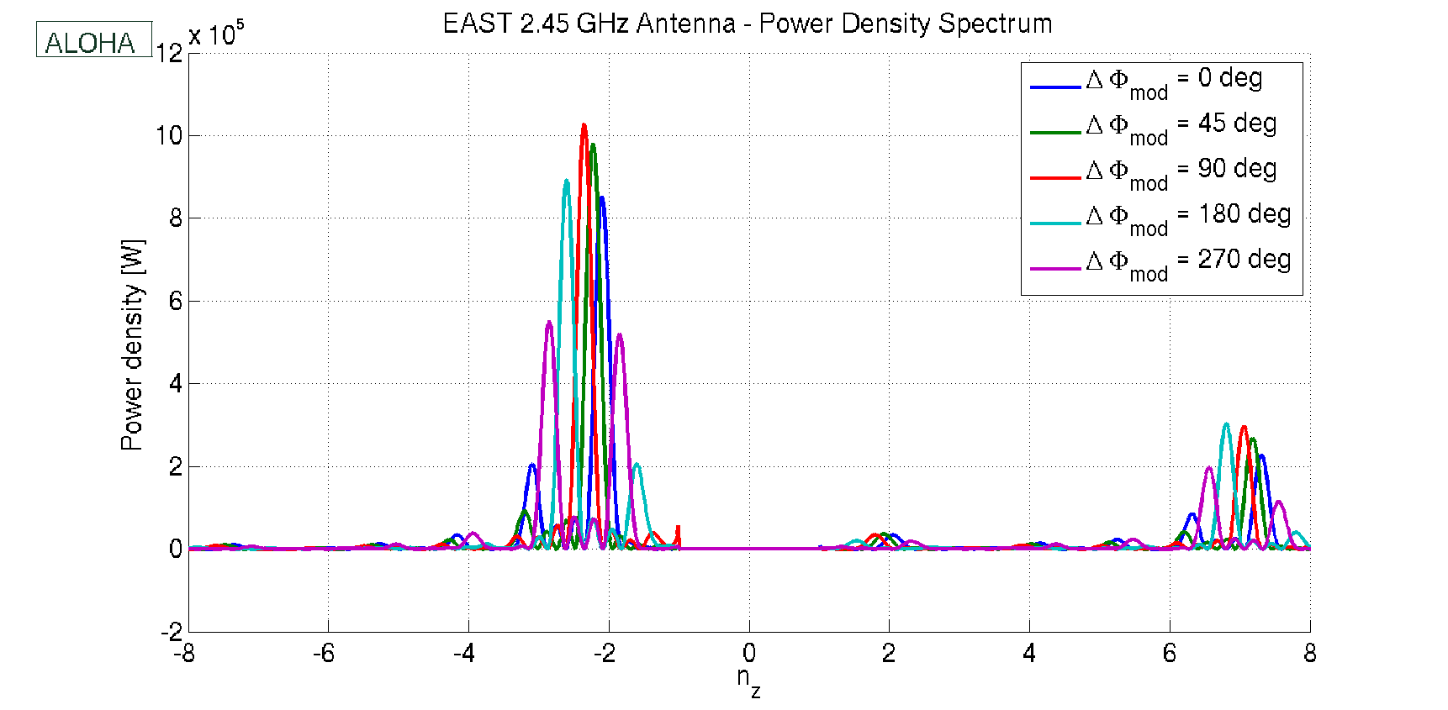
Figure 6. EAST 2.45 GHz LHCD antenna spectrum vs phase shift between modules.
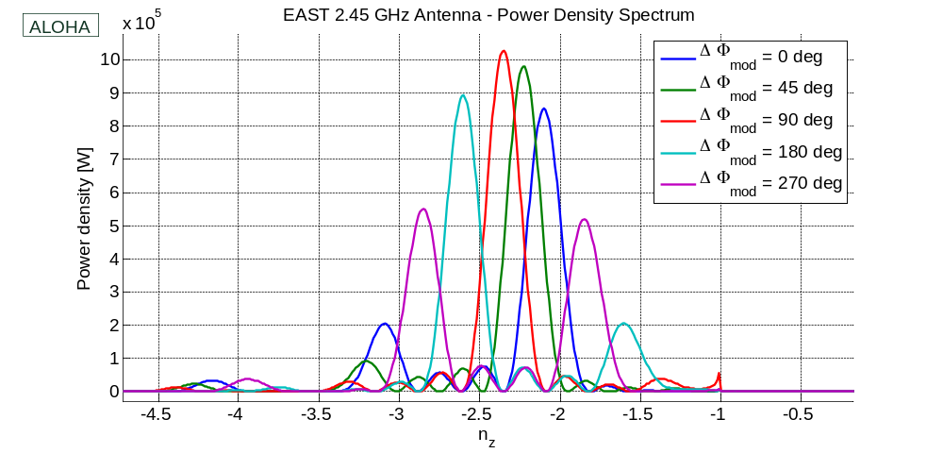
Figure 7. Zoom on previous Figure.

EAST 4.6 GHz launcher
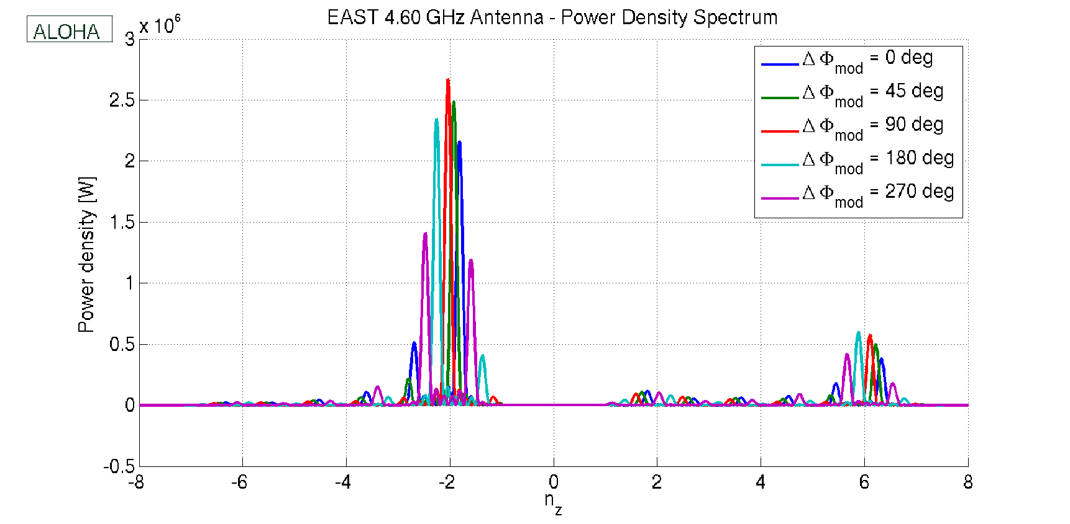
Figure 8. EAST 4.60 GHz LHCD antenna spectrum vs phase shift between modules.

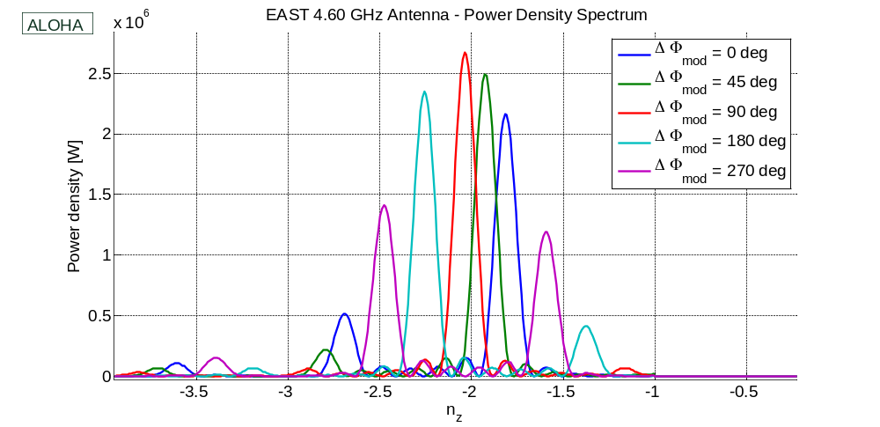
Figure 10. Zoom on previous Figure.

Emails from Miaohui Li 20/11/2013 and 09/12/2013. The data has been combined to get natural complex values.
The ports number is illustrated in the inverse order. The ALOHA calculations have been made using a reversed port numbering order with respect to the right Figure.

