**NATIONAL INSTITUTE OF TECHNOLOGY, HAMIRPUR (H.P)**

**Innovative Research Incubation Club**

**Innovative Research Project Proposal Format**

Research Project Title: **SMART PARKING SYSTEM**

Project Description:

**SMART PARKING SYSTEM**

**Introduction**

Among the challenges that we face in our day to day life one of most unavoidable challenge is parking the car wherever we go. As our need increases our travelling increases but due to drastic increase in usage of vehicles and increase in population we face the tough task of parking our car particularly during busiest hours of the day. During peak hours most of the reserved parking area gets full and this leaves the user to search for their parking among other parking area which creates more traffic and leaves them with no indication on availability of parking space.

. If a home can be “smart” why can’t a parking garage? This is the question our group has posed and it is a question we feel we have solved with a system we call “Smart Parking System”.

So an android app is developed for solving the issues related to parking problems which generally occurs in the society parking and any organization.

**Motivation**

Whenever a person enters an unknown place without any knowledge of the parking areas nearby. So he will have to enquire many people for the parking still with the chances of wrong info being conveyed or interpreted or the space being preoccupied. So we decided to make an app to reduce his effort and the time consumed and named it SMART PARKING ASSISTANCE.

The main motivation of this project is to reduce the traffic congestion caused by vehicles searching for parking. In a recent survey, researchers have found that for one year, car cruising for parking created the equivalent of 38 times trips around the world, burning 177914.8 litres of fuel and producing 730 tons of CO2. To reduce all these factors we go for the smart parking system.

**Objective**

SMART PARKING SYSTEM is developed that accurately predicts and sense spot/vehicle occupancy and guides the residents and visitors to available parking. This system uses historical parking and event data in a prediction model to provide real-time information on the availability of parking within the organization. The program enhances existing parking facilities by providing real time information using a host of information delivery methods in this case it is an android application. The primary goals of the program are to reduce search time and search time variability when finding a parking space within the organization and to make it more desirable for patrons by reducing the anxiety and uncertainties related to parking issues.

**Methodology**

The system uses a camera for the live video streaming of the traffic. The captured video is then converted into frames at a rate of 30 frames per second. Camera stabilization play important role in vision system. Camera stabilization is used to counterbalance the effect of camera shaking due to wind. The stabilized frames thus obtained are subjected to background subtraction to generate foreground mask. Background subtraction is done with the help of successive frame difference method. The result of background subtraction gives us an image with only the vehicles in it which in turn can be counted with the blob detection approach, which gives us the vehicle count for a particular frame. For each blob that is obtained, the blob parameters (height, length, width, profile, area) are determined, which can be used to classify a vehicle to the respective category. The obtained vehicle count for each category is constantly updated on a frame.

. The objective of the approach is to detect the moving objects from the difference between the existing frame and the reference frame. The frame difference method is the common method of motion detection. This method adopts pixel-based difference.

**The main features included are**:

* Accurately predict and sense spot/vehicle occupancy in real-time.
  + Guides residents and visitors to available parking.
  + Optimize Parking Space Usage
  + Simplifies the parking experience and adds value for parking stakeholders, such as drivers and merchants.
  + Enables intelligent decisions using data, including real–time status applications and history.
  + Smart Parking plays a major role in creating better urban environment by reducing the emission of CO2 and other pollutants

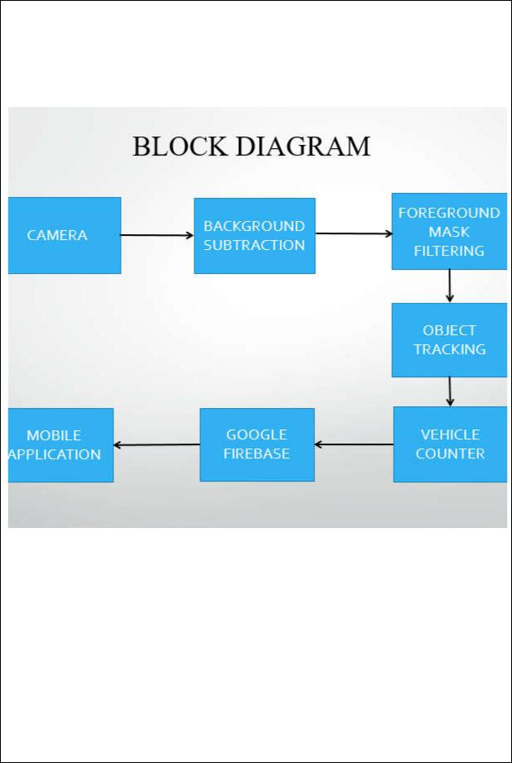

* Smart Parking enables better and real time monitoring and managing of available parking space , resulting in significant revenue generation
* Provides tools to optimize workforce management.

Fig: Block diagram of system

**FLOW CHART OF THE MOBILE APPLICATION**

Flowcharts are used in designing and documenting simple processes or programs. Like other types of diagrams, they help visualize what is going on and thereby help understand a process, and perhaps also find flaws, bottlenecks, and other less-obvious features within it.

The flow chart above shows the flow of the control of the application when it is opened.

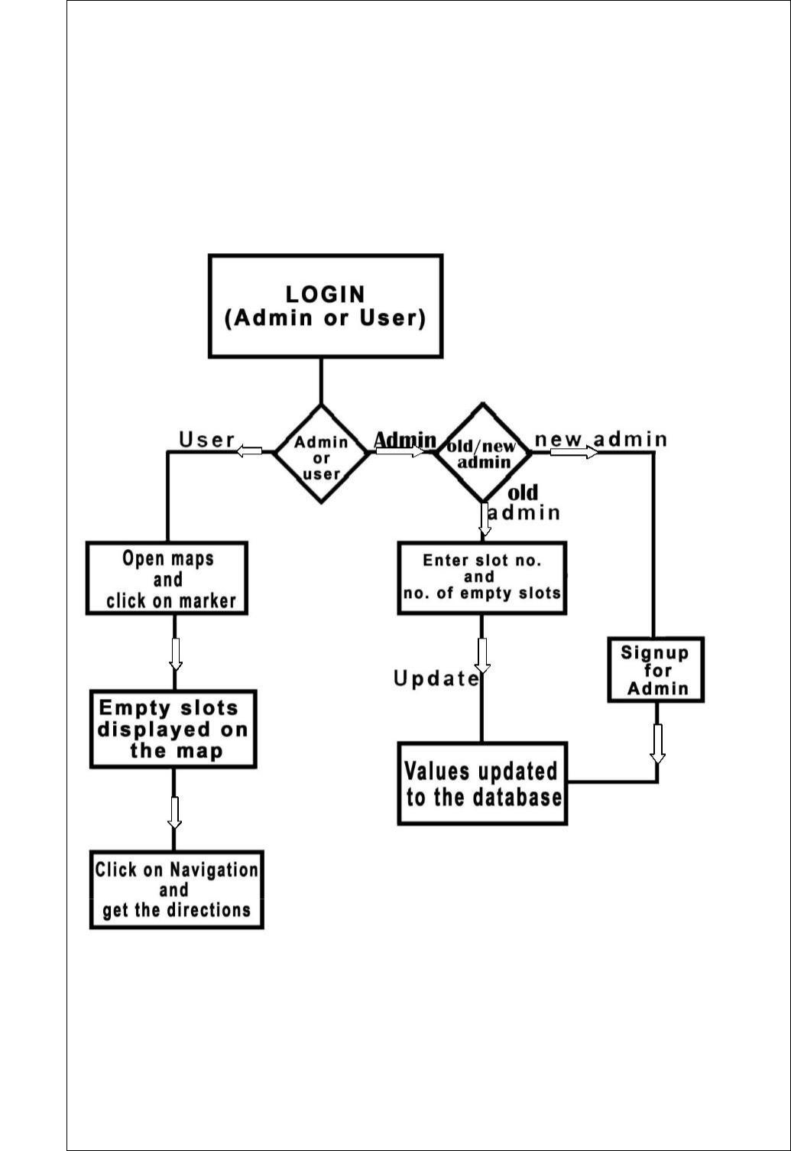

First comes the login page where the user will have to specify if he is admin or user. If user then the application will show his location and along with the nearby parking along with their respective free slots and by clicking on the spot the application will redirect the user to Google maps along with the directions to the selected slot.

If he is the admin then he can view the number of slots available in each parking zone along with this he can also update the number of available slots accordingly.

**Application Layout**

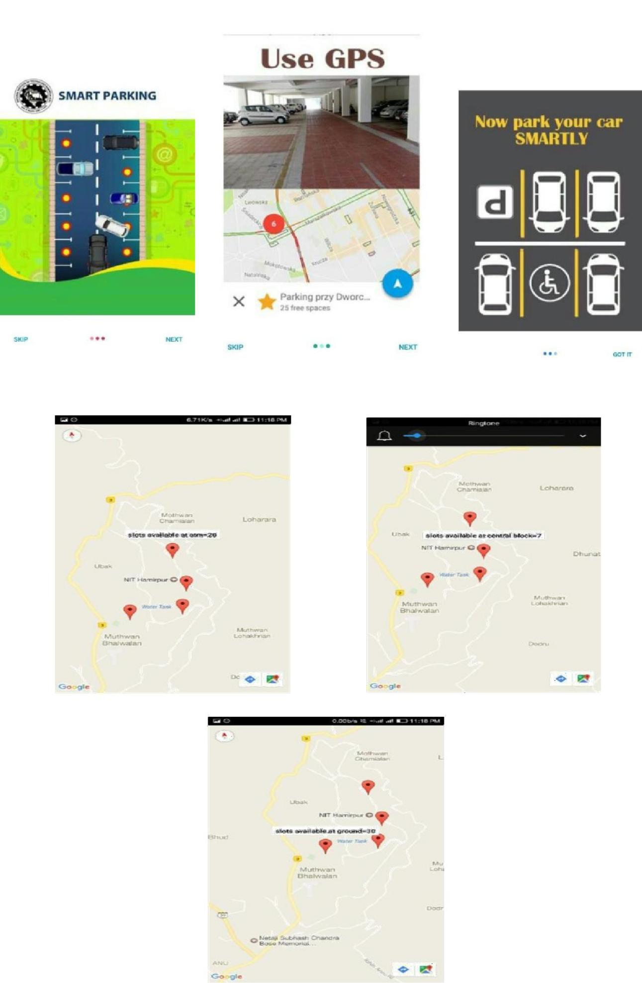

**REFERENCES**

1. Ahteshamul huq osmani, Ashwini Gawade, Minal Nikam, Swati Wavare,

“Research paper on Smart City Parking System”, Vol-2 Issue-3 2016

1. Faiz Shaikh , Nikhilkumar B.S. , Omkar Kulkarni , Pratik Jadhav ,Saideep

Bandarkar, “A Survey on “Smart Parking” System”, Vol. 4, Issue 10, October 2015

1. Hongwei Wang and WenboHe“A Reservation-based Smart Parking System”,

IEEE, 2011

1. AshwinSayeeraman, P.S.Ramesh, “ZigBee and GSM based secure vehicle parking management and reservation system.”,Journal of Theoretical and Applied

Information Technology 31st March 2012. Vol. 37 No.2

1. Renuka R. and S. Dhanalakshmi, “ANDROID BASED SMART PARKING SYSTEM USING SLOT ALLOCATION & RESERVATIONS”, Vol. 10, No. 7,April

2015

**Hardware and software requirements for the project:**

Camera of good resolution, camera tripod stand, android studio, python, OpenCv, system with minimum 4GB RAM, Android Device, Google firebase, good internet connection.

**Project Completion Time** (Tick or one option)

o Short term (up to one semester) o Mid term (up to one year)

o Long term (more than one year)

**Student Skills Required, pre-requisites** (If any):

B. Tech. students of computer science and engineering with design, Analytical and problem solving capabilities

* Strong knowledge of optimization theory
* Strong knowledge of Network programming
* Knowledge of Networking
* Good programming skills Python, Java, Android, OpenCv, Google Firebase, Image processing and Video Processing.

**Number of Students Required (UG/PG) for the Project**:Four

(Munish Kumar ,Ashima Anand , Sachdeep Singh ,Abhinav Kandoria ) CSE Final year

**Name of Faculty Member:** Dr. Lokesh Chouhan, Assistant Professor

**Department:** COMPUTER SCIENCE AND ENGINEERING

**Email ID**:lokeshchouhan@gmail.com

**Contact No:** +91 8989624399

**:**