IRIR Project Report
Project: Intelligent Research & Innovation Repository (IRIR)
Type: Spring Boot web application (server-rendered with Thymeleaf)
Date: 2026-04-07

Executive Summary
IRIR is a university-focused research project management platform that supports end-to-end submission, review, and approval workflows. It enforces role-based access control, provides similarity detection for plagiarism/duplication checks, and offers dashboards for students, supervisors, directorate, and administrators.

Project Scope
In scope: - Student project submission and lifecycle management - Role-based review workflows (Supervisor and Directorate) - Similarity detection and reporting on submission - Search/indexing of project content - Collaboration requests and recommendations - Audit logging and administrative oversight - Notifications and basic analytics dashboards - File upload, parsing, and storage - Public gallery of approved projects
Out of scope (not implemented here): - Real-time chat between users - External plagiarism APIs (uses internal Lucene-based similarity detection) - Mobile-native applications - Multi-tenant deployment across multiple institutions - Advanced ML model training and custom LLM hosting

Users and Roles
- STUDENT: submits projects, edits drafts, views feedback and similarity results
- SUPERVISOR: reviews submissions, approves/rejects, requests revisions
- DIRECTORATE: performs secondary reviews, analytics, incubation flagging
- ADMIN: user management, system oversight, logs, backups

Core Functional Requirements
- Authentication and registration for students
- Role-based dashboards
- Project submission with file uploads
- Review workflow with decisions (approve/reject/revision)
- Similarity detection and report generation on submission
- Search and discovery of indexed content
- Audit logging of key actions
- Export reporting (PDF/Excel)

Similarity Detection Specs
- Triggered only when a student submits for lecturer review
- Uses Apache Tika for text extraction and Apache Lucene for indexing
- Similarity engine uses Lucene MoreLikeThis (TF-IDF + cosine similarity)
- Verdict thresholds (from configuration):
  - >= 0.70: Potential Duplicate (project flagged)
  - 0.40 – 0.69: Similar Work Detected (warning)
  - < 0.40: Original Work
- Maximum results returned per comparison: 10

Non-Functional Requirements
- Java 17 runtime
- Maven-based build and packaging
- MySQL as default database; H2 for development
- File upload limit: 50 MB per file/request
- Server default port: 8080
- Configurable through environment variables

Tech Stack
- Backend: Spring Boot 3.2.3, Spring MVC, Spring Security
- Templating: Thymeleaf
- Persistence: Spring Data JPA + Hibernate
- DB: MySQL (default), H2 (dev)
- Search/Index: Apache Lucene
- Parsing: Apache Tika
- NLP: Stanford CoreNLP
- Reporting: Apache POI (Excel)
- Frontend assets: Bootstrap (WebJars)

Configuration Highlights
- Database configuration via env vars (MYSQLHOST, MYSQLUSER, etc.)
- Upload dir: uploads (overridable by UPLOAD_DIR)
- Lucene index dir: lucene-index (overridable by LUCENE_INDEX_DIR)
- Similarity thresholds configurable in application.properties
- Optional Gemini AI integration via GEMINI_API_KEY

Deployment
- Docker-based build and runtime
- Railway deployment supported (railway.toml)
- Health check path: /login

Project Structure (Key Paths)
- src/main/java/com/chuka/irir/config
- src/main/java/com/chuka/irir/controller
- src/main/java/com/chuka/irir/model
- src/main/java/com/chuka/irir/service
- src/main/java/com/chuka/irir/repository
- src/main/resources/templates
- src/main/resources/application.properties
- src/main/resources/application-h2.properties

Screenshot
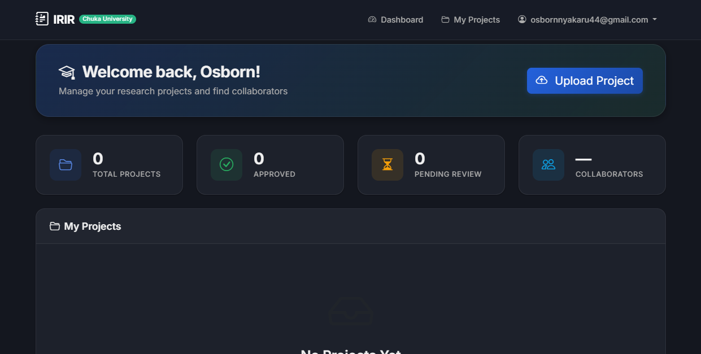
IRIR Dashboard

