**OUTPUT**

1.

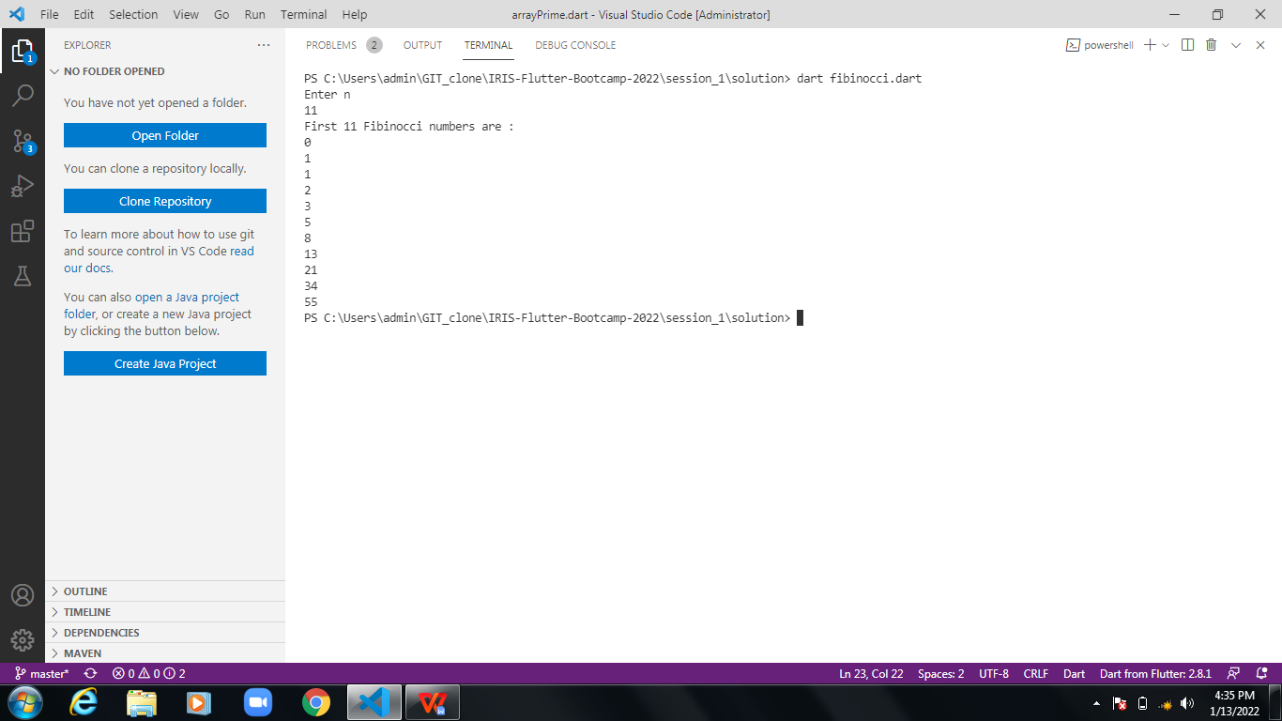

2.

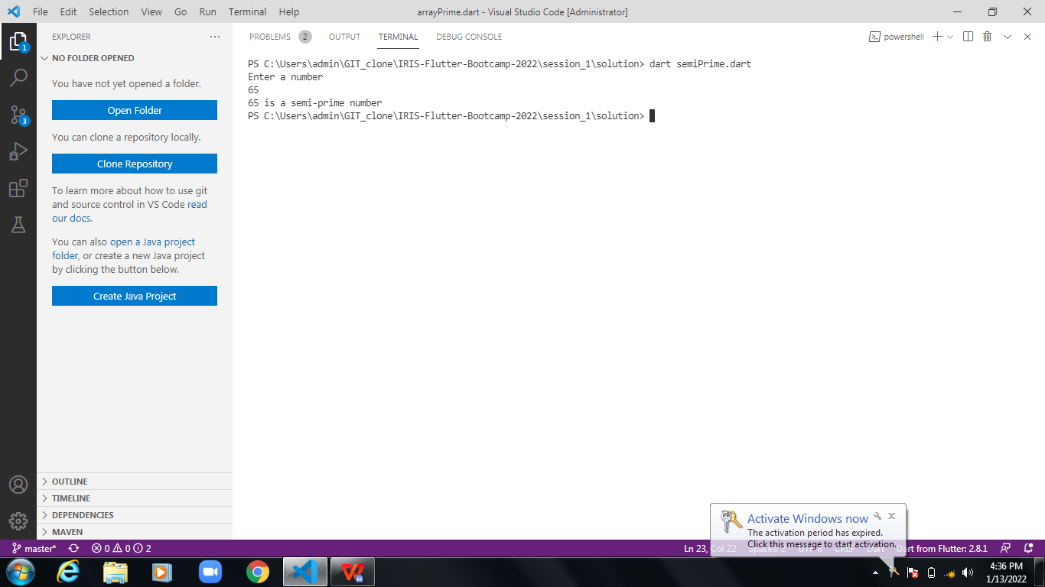

3.

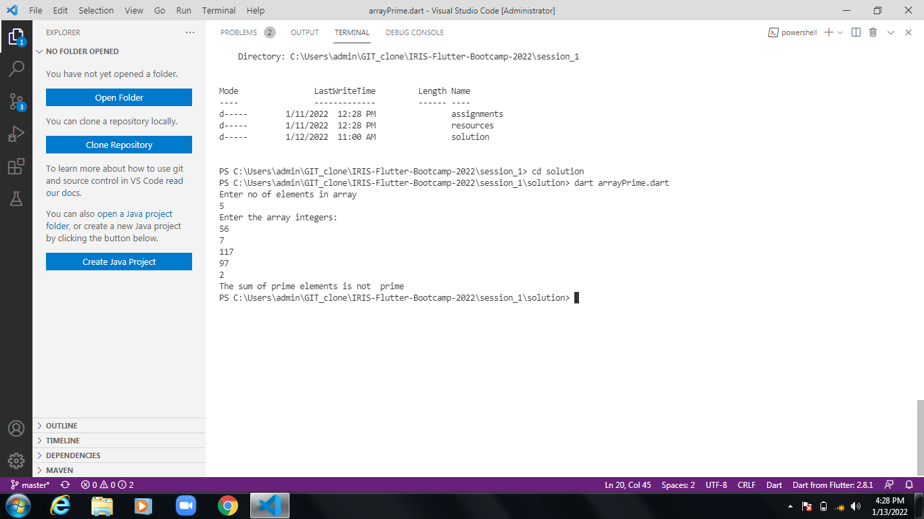

4.

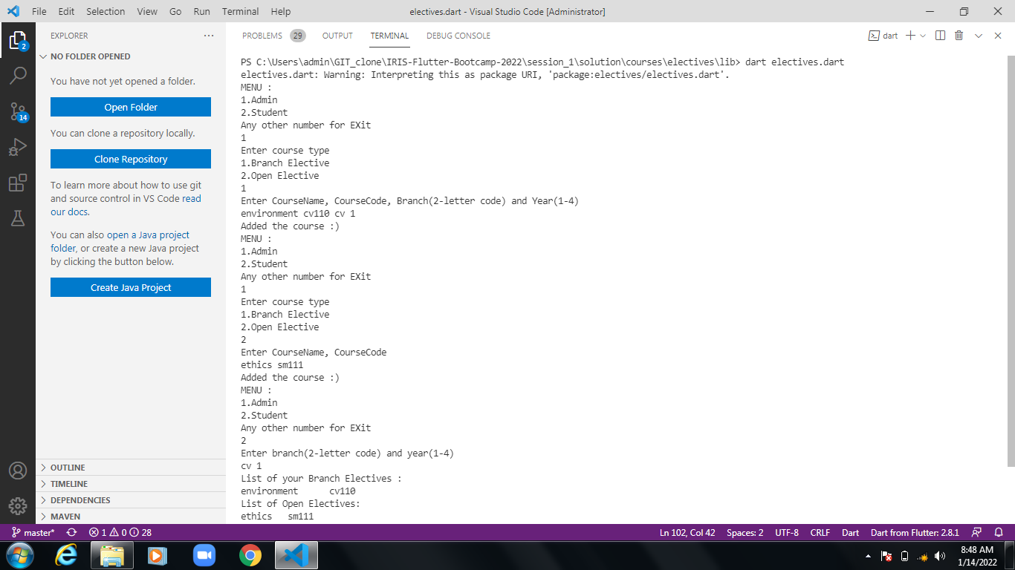

**NOTE:**

1. First 3 programs are in the solution folder
2. The last program is in **solution/courses/electives/lib** folder