1. Project Background
Online forums and developer communities often maintain a shared budget to support ecosystem-building activities such as tool development, educational content creation, onboarding resources, moderation infrastructure, and community events. In most cases, however, the allocation of such funds remains highly centralized: moderators or core teams review proposals, decide which initiatives deserve support, and manually execute payouts. While this model is operationally simple, it creates recurring governance problems. Funding decisions may be opaque, treasury control may be overly concentrated, and the historical record of proposals, votes, and payments may not be easily verifiable by the broader community.
Forum Builder Fund DAO is designed as a lightweight governance framework for a community-building treasury. Its purpose is not to decentralize every aspect of forum management, but to place the most trust-sensitive component—the allocation and execution of shared community funds—under a transparent, rule-based, and auditable process. This design direction aligns with the project guidance emphasized in class: a strong blockchain project does not need to be radically innovative in terms of industry, but it should be practical, specific, and comprehensive, while carefully considering stakeholder incentives, information structure, and logic/security risks.
The DAO operates through periodic funding rounds. Eligible contributors submit proposals, administrators conduct formal screening, whitelist members vote, proposals are ranked under a fixed budget, and the treasury contract executes approved disbursements automatically. By encoding the rules of proposal handling, voting, allocation, and payment into smart contracts, the system aims to improve procedural legitimacy and reduce reliance on discretionary post-vote administrator actions.

2. Why a Blockchain Application Is Needed
Even in a relatively small and partially trusted community, several governance risks remain in a conventional Web2 implementation:
- proposal records may be modified, hidden, or selectively surfaced;
- published vote totals may not be independently verifiable;
- allocation rules may be applied inconsistently;
- approved payouts may still depend on manual administrator discretion;
- historical funding decisions may not be easily auditable by future community members.
A blockchain-based design addresses these concerns in four ways.
First, transparency. Proposal metadata, voting outcomes, budget allocation results, and treasury transfers can all be made visible and auditable. This reflects the lecture’s emphasis that blockchain can make important information shared and verifiable across participants.
Second, immutability. Once proposal records, vote totals, and payout events are stored on-chain, they cannot be casually rewritten by moderators or committee members. This supports trust in the governance process itself, not just in the final outcome.
Third, automatic execution. Once a funding round is finalized, disbursement is performed by the treasury contract according to predefined rules. This reduces post-vote administrative discretion and prevents selective payment delays or overrides.
Fourth, reduced trust in individual operators. The project does not eliminate all trust at the membership layer, but it reduces trust in the most critical layer: treasury allocation and execution. This is particularly important for a community fund, where procedural fairness matters as much as the projects being funded.
Accordingly, the role of blockchain in this project is selective and justified: it is used where it adds the most value—shared records, transparent governance, and rule-based treasury execution—rather than as a blanket replacement for all forms of coordination.

3. Stakeholders and Incentives

3.1 Whitelist Members
Whitelist members are recognized contributors who may submit proposals and vote. Their incentive is to influence community resource allocation toward projects they believe will improve the forum ecosystem. However, they may also exhibit non-ideal behavior, such as reciprocal voting, low-effort voting, or coalition-based support for familiar participants.

3.2 Proposal Authors
Proposal authors seek funding for projects such as tool development, educational material, event organization, or contributor support initiatives. Their incentive is to obtain treasury funding, but this may encourage strategic behavior such as overstating impact, requesting excessive budgets, or submitting low-quality but well-marketed proposals.

3.3 Moderators / Committee Members
Moderators or committee members maintain the whitelist and conduct formal screening. Their incentive is to preserve forum quality and filter spam or malicious submissions. At the same time, they possess gatekeeping power and therefore introduce a potential source of centralization.

3.4 General Community Members
General community members may not directly vote in the MVP design, but they are indirect beneficiaries of better tools, better content, and a stronger forum ecosystem. Their role matters because the legitimacy of the DAO ultimately depends on whether funded projects create visible value for the broader community.

3.5 Treasury Contract
The treasury contract serves as the neutral execution layer. It does not evaluate quality, but it enforces the final allocation logic and transfers funds according to codified rules. This reduces dependence on human discretion after voting closes.

4. Whitelist Update Rules
- The whitelist is controlled by a multisig committee rather than a single administrator.
- The whitelist is updatable, but updates follow procedural constraints.
- Membership updates may only occur between funding rounds, not during an active round.
- Each round uses a voter snapshot, meaning the set of eligible voters and proposers is fixed at the start of that round.
- New applicants may be added based on transparent criteria such as sustained forum contribution, nomination by existing members, or committee approval under documented rules.
- Removal of members also requires committee action and should be recorded with reason categories such as inactivity, abuse, or malicious conduct.
This design does not eliminate centralization at the membership layer, but it contains and structures it. In effect, the system accepts limited centralization in admission control, while reducing centralization in allocation and execution, which are the more trust-sensitive parts of the treasury workflow.

5. Business Logic

5.1 Governance Objective
The DAO is designed to govern a recurring community budget used for forum-building purposes. It allows recognized contributors to collectively decide how a limited budget should be allocated, while ensuring that final treasury execution is transparent and rule-based.

5.2 Funding Round Structure
The governance process is organized into periodic funding rounds, for example one round every 30 days. Each round has four stages:
- Proposal Submission Period — 7 days
Eligible whitelist members may submit one proposal each.
- Formal Screening Period — 3 days
Moderators check completeness and compliance, but do not make substantive funding decisions.
- Voting Period — 5 days
Eligible whitelist members vote on qualified proposals.
- Execution Period — immediately after the vote closes
The system checks round validity, ranks proposals, and executes treasury payouts according to the predefined rules.
This round-based structure makes the process predictable, auditable, and easier to manage.

5.3 Proposal Rules
Each proposal must include:
- title,
- requested amount,
- recipient address,
- description of fund usage,
- project explanation,
- expected value to the community.
Each whitelist member may submit at most one proposal per round. In addition, no proposal may request more than 20% of the round’s total budget. These constraints reduce spam, discourage strategic fragmentation, and preserve budget diversity.

6. Voting Mechanism and Anti-Collusion Design
The project adopts limited approval voting. Each eligible voter may approve multiple proposals, but only up to a fixed maximum number per round—for example, at most three proposals. A proposer may not vote on their own proposal.

6.1 No Self-Voting
Proposal authors cannot vote on their own proposals. This prevents the most direct form of self-serving behavior and strengthens the integrity of each proposal’s support count. Enforced in GovernanceService.castApprovalVote, covered by test vote_selfVote_isRejected.

6.2 Delayed Reveal of Ballots
During the active voting period, individual ballots are hidden. Only aggregated results are disclosed after the voting window ends. This reduces live signaling, social pressure, and real-time coordination based on visible voting patterns.

6.3 Limited Number of Approvals
Each voter may support only a small number of proposals, such as three. This reduces “approve-everything” behavior and forces voters to make more selective judgments. It also makes approval counts more informative by raising the opportunity cost of each approval.

6.4 Fixed Voter Snapshot per Round
The list of eligible voters is fixed when a funding round begins. This prevents strategic mid-round whitelist changes that could distort the vote.

6.5 Quorum and Threshold
A round is valid only if at least 5 eligible members participate. In addition, a proposal must receive at least 3 approvals to qualify for allocation consideration. These rules serve different functions: Enforced in GovernanceService.tallyRound via the constants QUORUM_UNIQUE_VOTERS = 5 and APPROVAL_THRESHOLD = 3, covered by tally_quorumNotReached_producesNoWinners_evenIfThresholdMet.
- quorum protects the legitimacy of the round;
- threshold filters out proposals with insufficient baseline support.
Taken together, these mechanisms do not guarantee perfect resistance to collusion, but they reduce the likelihood of direct self-dealing, low-effort blanket voting, and strategic manipulation through visible live voting behavior.

7. Ranking and Allocation Logic
The treasury budget in each round is fixed. As a result, even if multiple proposals are individually acceptable, the system still needs a rule to prioritize among qualified proposals when total requested funding exceeds available budget. The allocation logic therefore works in two stages:
- Minimum support screening
A proposal must first meet the threshold requirement to be considered viable.
- Budget-priority ranking
Qualified proposals are then ranked by total approval count, from highest to lowest.
On ties the ranking falls back to submission timestamp, then submission order, then proposal id, giving a fully deterministic ordering implemented by a Comparator chain in GovernanceService.tallyRound.
After ranking, the treasury allocates funds in descending order until the round budget is exhausted.
- If a proposal’s requested amount fits within the remaining budget, it is funded.
- If it exceeds the remaining budget, it is skipped in that round. The allocator is a greedy walk rather than partial funding: a skipped proposal does not block smaller lower-ranked proposals from being funded if they still fit. Covered by tally_budgetInsufficient_skipsProposalThatDoesNotFit.

8. Oracle Boundary and Off-Chain Information
Forum Builder Fund DAO does not depend on price feeds, weather APIs, or sensor inputs. However, it still relies heavily on off-chain human judgment.
On-chain
- proposal registration,
- round timing,
- vote counting,
- quorum and threshold checks,
- ranking,
- treasury disbursement,
- auditability of decisions.
Off-chain
- quality assessment,
- contribution reputation,
- interpretation of forum value,
- evaluation of post-funding outcomes.

9. Funding Round Flow Diagram
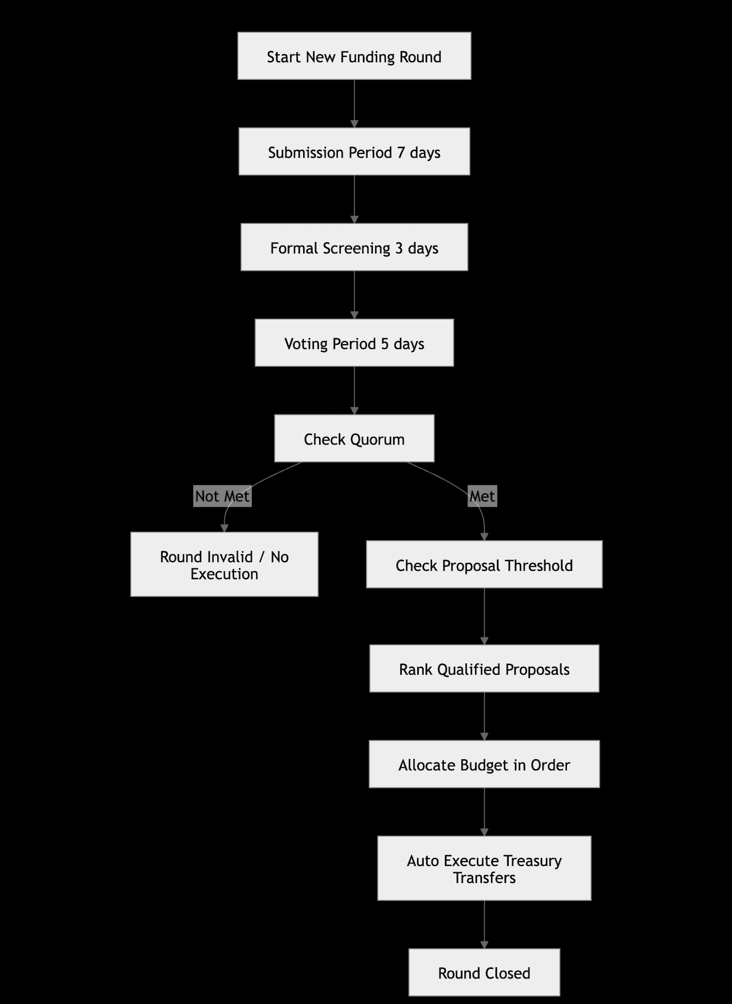

10. System Architecture Diagram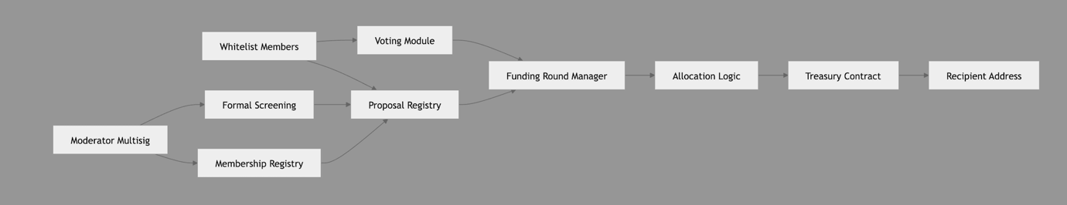
11. Technical Implementation
The governance rules in sections 5–7 are implemented across three layers: a Solidity contract for on-chain payout, a Java rules engine, and a Spring Boot web layer serving a single-page frontend.
11.1 Tech Stack
Solidity 0.8.20 on Hardhat; Java 17 with Spring Boot 3; Web3j 4.12 for the chain client; static HTML/JavaScript frontend; JUnit 5 for tests.
11.2 Components
Component | Responsibility
ForumTreasury.sol | Holds ETH and exposes executeTreasury(recipients, amounts) guarded by onlyAdmin.
GovernanceService | Off-chain rules engine: whitelist, no self-vote, no duplicate approval, quorum, threshold, deterministic ranking, greedy budget allocation.
BlockchainService | Web3j wrapper; converts USDC to Wei and executes the batch payout.
DemoService | Stateful Spring service holding the current round and member roster; exposes submit, vote, execute, reset.
DemoController / ApiExceptionHandler | REST layer at /api/*; converts governance exceptions into HTTP 400 JSON.
static/index.html | Vanilla-JS single-page frontend; renders members, proposals, tally and treasury; shows rejections as toasts.

11.3 Rule to Code Mapping
Rule | Enforcement | Test
Submitter whitelist | GovernanceService.submitProposal | submit_nonWhitelistedSubmitter_isRejected
Voter whitelist | GovernanceService.castApprovalVote | vote_nonWhitelistedVoter_isRejected
No self-vote | GovernanceService.castApprovalVote | vote_selfVote_isRejected
No duplicate approval | Proposal.addApprovalVoterAddress | vote_duplicateApproval_isRejected
Quorum ≥ 5 | GovernanceService.tallyRound | tally_quorumNotReached_producesNoWinners_evenIfThresholdMet
Threshold ≥ 3 | GovernanceService.tallyRound | tallyRound_quorumNotReached_noWinners
Ranking + tie-break | GovernanceService.tallyRound | tallyRound_sortAndBudgetCutoff
Greedy budget skip | GovernanceService.tallyRound | tally_budgetInsufficient_skipsProposalThatDoesNotFit

11.4 On-Chain vs Off-Chain Boundary
All governance evaluation runs off-chain in Java. The smart contract is invoked once per round with the pre-computed winner list, so the on-chain trusted computing base only has to enforce onlyAdmin and perform the batch transfer. Changing a governance rule does not require redeploying the contract.
12. Design Rationale
12.1 Off-chain governance, on-chain execution
All rules run off-chain in Java; the contract only executes the final payout. This mirrors the Snapshot + Gnosis Safe pattern: voting is free, rules can iterate without redeployment, and the on-chain trusted base stays minimal. Acceptable here because membership is already a whitelist concept.
12.2 Admin-gated treasury instead of per-member signatures
ForumTreasury is guarded by onlyAdmin rather than requiring every approver to sign on-chain. Members are identified off-chain by whitelist, so asking them to also sign on-chain would duplicate identity for no added integrity. In production the admin key would be a committee multisig.
12.3 In-memory state instead of a database
A funding round is a short single-writer workflow, so the current round lives in a Spring singleton. Reset is literally new GovernanceService(...). Introducing a database at MVP stage would add schema and migration work without improving governance semantics.
12.4 Exceptions as user interface
Every rule violation throws a descriptive exception; ApiExceptionHandler converts it to HTTP 400 JSON and the frontend shows the message as a toast. Rule definition, enforcement, and user-facing message all live in one place in the Java code, with no separate validation layer to drift.
12.5 Vanilla-JS frontend, no MetaMask
A single index.html with fetch() beats a React build for a three-panel demo: zero build step, readable source, direct mapping from REST to UI. We skip MetaMask because identity is whitelist-based, not wallet-based; clicking a member row is a more faithful demonstration of the business model than real wallet signing.

