**A Research on the Relationship between Gender and the Preferences of Course Selection of BNDS AP Students**

Er Mao(Emma), Yizan Fu, Zixi Zuo(Alice)

G11 AP Statistics

*Beijing National Day School, Beijing, China*

**PROPOSAL**

1. **Research question**

The group will be investigating if there is a gender related preference when BNDS AP students are selecting their courses. Some say it is a gender stereotype that boys prefer math, engineering, and computer subjects while girls prefer arts and humanities; other say gender itself will affect students' interest in different subjects, thus influencing their course choice. Whether the tendency to choose courses is related to gender or not? So, our group are going to find if there is a relationship between gender and preferences of course selection.

1. **Background research**

There are three relevant resources that help examine the relationship between gender and course selection of BNDS AP students. In the first related source, researchers examined that elative to boys, girls’ choices are far more constrained, as these choices are mediated by the constructions of gendered subjects and occupational identities, and by the larger perception of gender roles for women. The second resouse shows that gender is a significant explanatory variable of high-school course choices. Female students are less likely than male students to choose Math and especially the Physical sciences and more likely to choose Life sciences. The third related study is College Major Choice and the Gender Gap, which find out that choosing a college major is a decision that has signiÖcant social and economic consequences. Little is known about how youth choose college majors and why the observed gender gap exists.

1. **Sampling and experimental design**

Variables: Gender (m/f) and course selection preference (Science, Social Sciences, Arts, Mathematics, Language, Computers).

Type of study: This is an observational study that will examine the correlation of gender and course selection preference. This study will not contain any treatments.

Data collection: Data will be collected through a census from the AP course selection list of G11&12 students in BNDS for the 2023 AP exam.

Scope of inference: The findings of this study is intended to generalize to all high school AP students in BNDS. However, since courses open in different years differ, the result of the study might not precisely predicts the correlation of all years.

1. **Exploratory Data Analysis**

We censuses all BNDS G11&12 students who enrolled in an AP course during the 2022 - 2023 school year, in total of 1112 students (590 female, 522 male). Figure 1 below shows a two way table of our data collected.

|  |  |  |  |
| --- | --- | --- | --- |
|  | **Female** | **Male** | **Total** |
| **English** | 136 | 129 | 265 |
| **Language** | 30 | 24 | 54 |
| **Art** | 63 | 32 | 95 |
| **Social science** | 131 | 117 | 248 |
| **Science** | 52 | 62 | 114 |
| **Math** | 148 | 129 | 227 |
| **CS** | 30 | 29 | 59 |
| **Total** | 590 | 522 | 1112 |

Figure 1

From the two way table above, we can conduct a bar graph showed in Figure 2

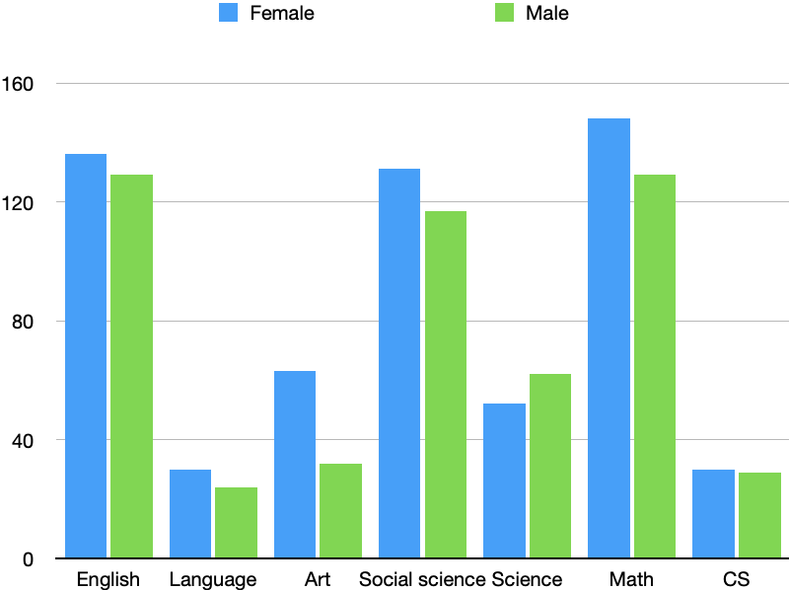

Figure 2

We will conduct a chi-square test for homogeneity. Since we are conducting a census, we do not need to check the condition for random sampling and independence. The condition we need to check is large sample size, that all expected cell counts should be equal to or greater than 5.

1. **Group Task Assignments and Timeline**

In this project, the introduction, data collection, methods, conclusion, data analysis, and future suggestions would be done together.

The proposal and data collection would be done by May 17th, the preparation(including introduction and methods) would be done by May 20th, and the main research part would be done by May 23rd. Finally, the project would be finished and re-checked before May 25th. The presentation will be in class.

1. **Data**

Figure 3 shows part of our original data derived from the AP mock exam sheet. We sort the data using variables of gender and catagory of AP courses chose by each individual.

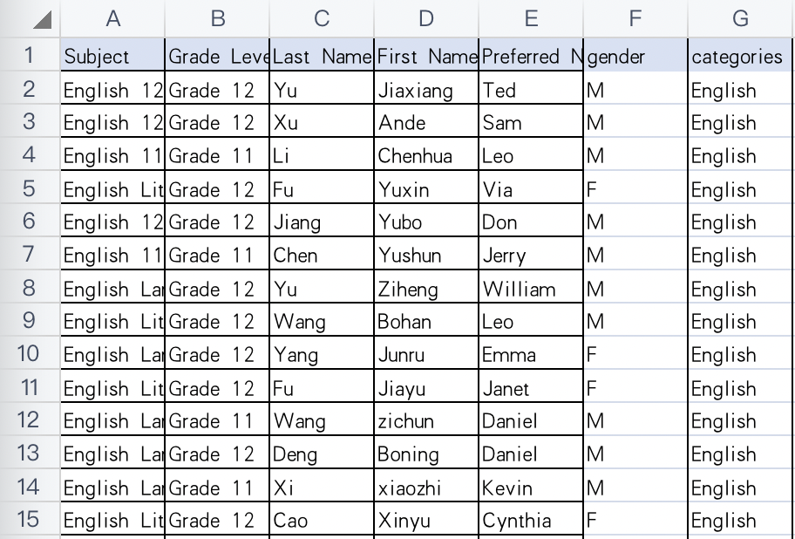

Figure 3

1. **References**

[1]Adamuti-Trache, Maria, and Robert Sweet. "Science, technology, engineering and math readiness: ethno-linguistic and gender differences in high-school course selection patterns." International Journal of Science Education 36.4 (2014): 610-634.

[2]Gautam, Meenakshi. "Gender, subject choice and higher education in India: Exploring ‘choices’ and ‘constraints’ of women students." Contemporary Education Dialogue 12.1 (2015): 31-58.

[3]Zafar, Basit. "College major choice and the gender gap." Journal of Human Resources 48.3 (2013): 545-595.