A study followed a random sample of 8474 people with normal blood pressure for about four years. All the individuals were free of heart disease at the beginning of the study. Each person took the Spielberg Trait Anger Scale test, which measures how prone a person is to sudden anger. Researchers also recorded whether each individual developed coronary heart disease (CHD). This includes people who had heart attacks and those who needed medical treatment for heart disease. Here is a two-way table that summarizes the data:

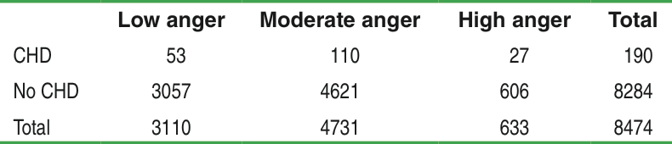 Find the conditional probability of CHD given different levels of anger.

Do the data provide convincing evidence of an **association** between anger level and heart disease in the population of interest?

* State:

Table (expected) under H0:

* Plan(check conditions + name of the test)

* Calculations:
* Conclusion:

**Practice:**

Researchers suspect that background music may affect buying behaviors. One study in a supermarket compared three randomly assigned treatments: no music, French accordion music, and Italian string music. Under each condition, the researchers recorded the numbers of bottles of French, Italian, and other wine purchased. The table below summarizes the data. Do the data provide convincing evidence of an **association** between BG music and buying behaviors in the population of interest?

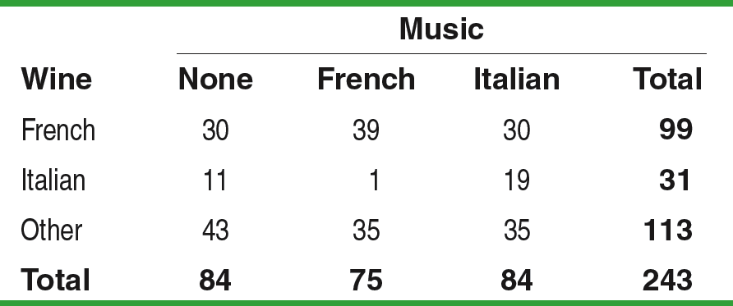s

