Researchers suspect that background music may lead to different buying behaviors. One study in a supermarket compared three randomly assigned treatments: no music, French accordion music, and Italian string music. Under each condition, the researchers recorded the numbers of bottles of French, Italian, and other wine purchased. The table below summarizes the data.

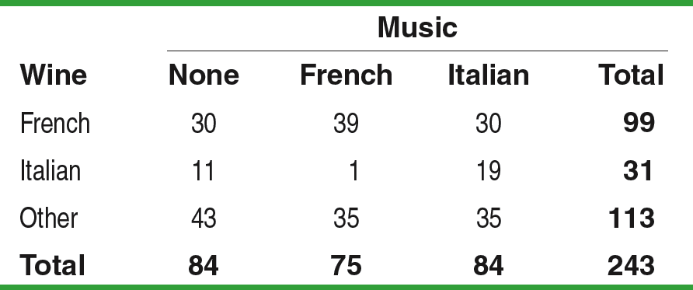 H0：

Ha：

Assume H0 is correct,



Conditions:

Calculations:

df=





Conclusion:

Practice:

Random digit dialing telephone surveys used to exclude cell phone numbers. If the opinions of people who have only cell phones differ from those of people who have landline service, the poll results may not represent the entire adult population. The Pew Research Center interviewed separate random samples of cell-only and landline telephone users who were less than 30 years old. Here’s what the Pew survey found about how these people describe their political party affiliation.

