Collaboration主要分为5个部分：

Helping TUST prepare for their first year of competition.

1. 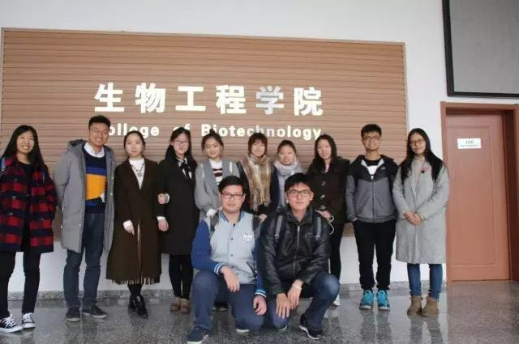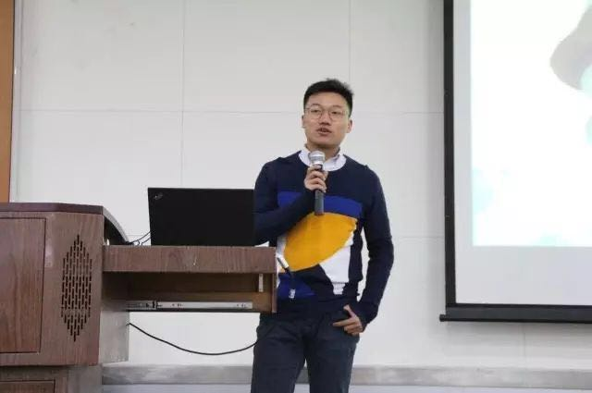To begin with, we gave them construct suggestions, communicated with their team adviser. In 24/3/2017, we were invited to TUST to carried out recruiting propaganda for them, and provided our construction guide.

1. 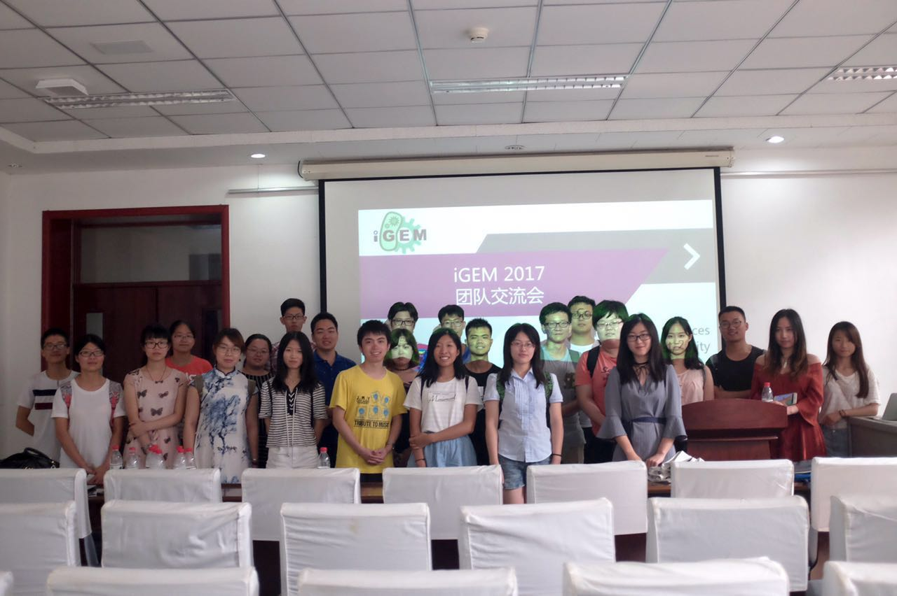In 2017.08.01, TUST and Tianjin held a meeting together, during the meeting, TUST gave an account of their recent progress, we suggested them to add some new synthetic routes and elements, and probably new strain instead of simply Xylinus for fibrin.

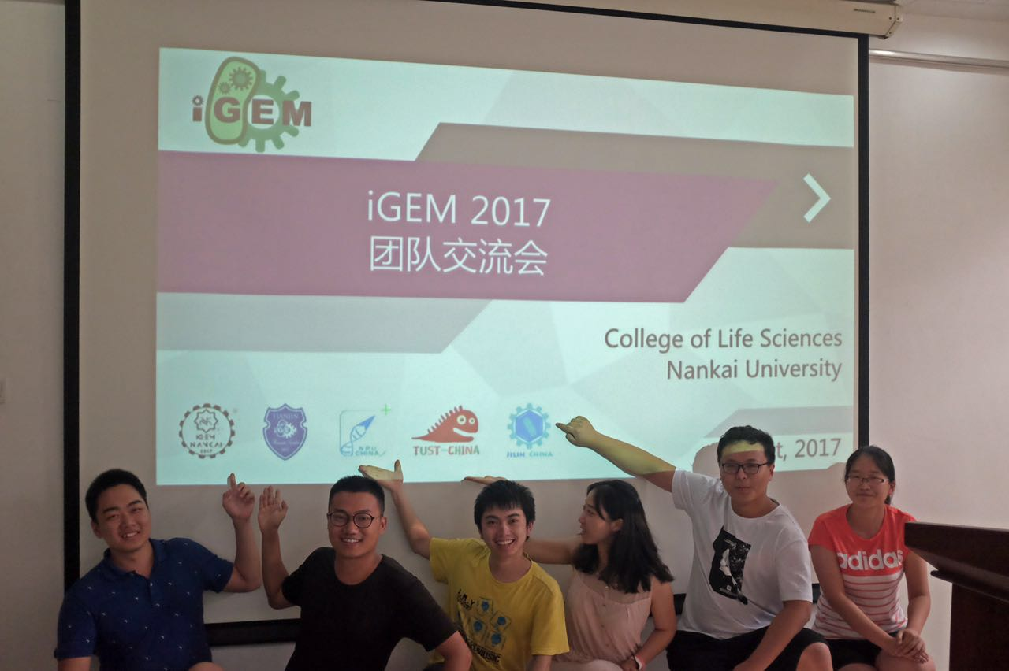

1. Later on, TUST came again with their modeling problem, we gave them suggestion that we can share the Fluorescence method and modeling method with them, design Fluorescence experience and modeling together since it’s their first year competition.

Helping NKU with their plasmid construction

1. 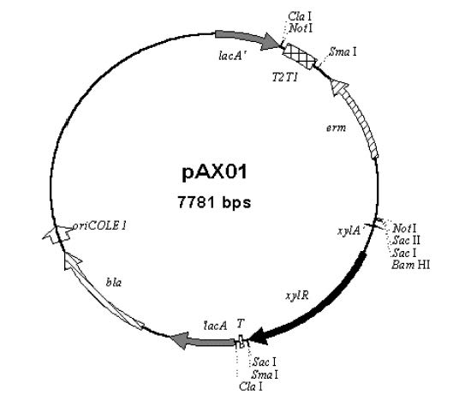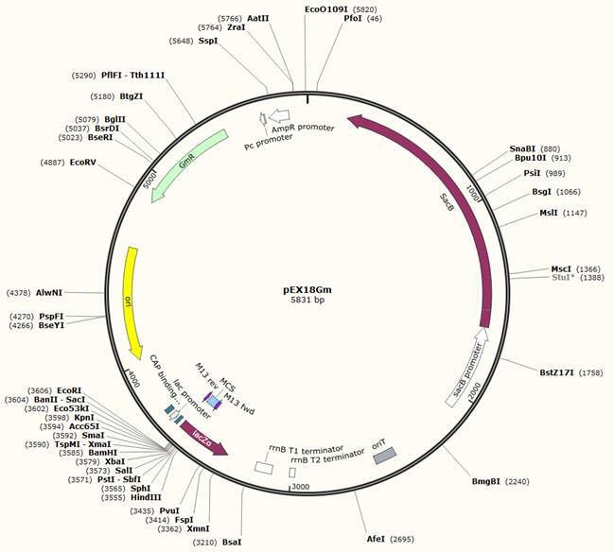NKU asked us to help them construct a plasmid. Using pEX18Gm as the supporter, we ought to added Lyase gene sequence（which they had already provided） and xyR-xyA sequence from pAX01 as well.
2. After construction, they sent us plasmid pAX01 and the plasmid which contains Lyase gene sequence, we helped them with ligasion and transformation.

Test the mini system for OUC

1. Mini system is a system composed of a mini promoter (about 100bp) and a mini terminator, and it is applicable for yeast. Because of the similarity of our biological chassis, they reached out to us and wanted us to run some control experiments for them. Using the same protocol and their mini system, we need to transform the system into our Saccharomyces cerevisiae in order to test if the plasmid will still function the same.

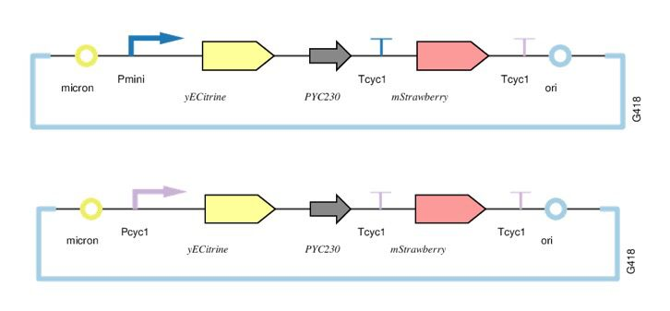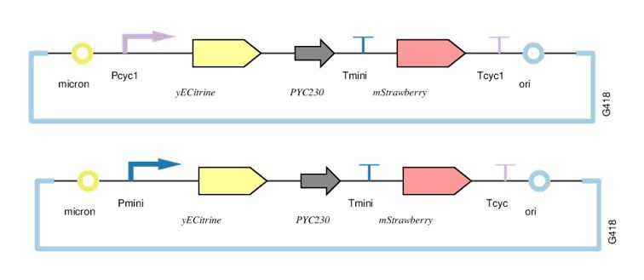

1. Protocol: initial OD600 = 0.01

Test OD600 and threshold fluorescence every other 5-6 hours

Exciting light λ=502/Emissive light λ=532

Sent a Collaboration Request and construct an alliance to build a worldwide database

1. We came up with the idea that we could gather all the iGEM team whose project is about water pollution treatment together and build an alliance to unite all our social impact, knowledge and geographical advantages.
2. In 12th of August, we had a voice conferencing with SJTU/SCUT/XMU/UCAS/JLU/FAFU, we discussed about how we want to use this alliance and came up with 2 conclusion:
3. Build a worldwide database containing contents of heavy metals in soil
4. Mutual improve our social impact
5. 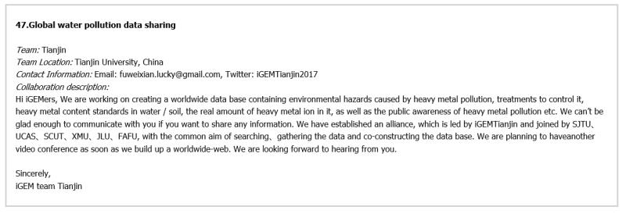In 23th of August, we sent a Collaboration Request to iGEM official website, the next day Ana Sifuentes replied our message and posted our request in the iGEM official website, and we received the response of many teams like team EXETER and team CSMU NCHU TAIWAN, with their information, we construct a database which contains the worldwide data of contents of Cu2+/Cd2+ in soil or water. And we build it based on map of the world.

Helping CQU construct their team and sign up for their first year

Filmed a biosafety video together with other 12 teams

12 teams gather together to film a biosafety video, every team took different topics, but all based on Yale biosafety manual.

Team Tianjin’s topic is Delivery of biological agents, we decided to film a video that is about

.首先是建队建议，和他们的指导老师沟通，为他们做招新宣讲，同时是提我们的队指南

2.在会议中交流各自项目，建议天科项目从单纯木醋杆菌发酵制纤维素加入新的合成线路和原件，引入新的菌种

:

3.对于建模的建议，共 同运用荧光手段和建模方法，一同设计荧光实验和建模1

1. COLLABORATION

2017.03.07 The founder of SynBioBeta came to Tianjin University to evaluate our project, introduced iGEM and interact with students both from TJU and TUST that we invited.

2017.03.07 TUST came to our school to ask for advices about how to construct a new team, we helped them build the new team and prepare for their rst year;

2017.03.24 We went to TUST to give a speech about what’s iGEM and the projects of our team;

2017.06.03 Peking University Dr. Haoqian Zhang and graduate-student leader Yihao Zhang went to our school to talk about our project and gave us some advice.

2017.08.03 We got in touch with iGEM team EXETER. we had profound understanding of each other’s project and they offered us some data in the United Kingdom in help of our construction of database.

2017.08.08 We set up an online-meeting joined by seven schools whose peoject is about heavy metal to discuss how to do our human practise work;

2017.08.09 We visited a copper factory named Zhongtiao Mountain Metal Company. We and their leaders came to an agreement that when we finaly put our project into production their tailing pond can be our touchstone and that they can do whatever they can to help us finish our project.

2017.08.23 We sent a Collaboration Request to iGEM official website named “Global water pollution data sharing”, and heard from many teams like CSMU NCHU TAIWAN who would like to help and give us some data.

2017.09.13 We received a voice call with CSMU, we mutual understand each other’s project and we wrote them a list of questions that we want them to ask for us, and they readily agree.