Demonstrate

Biosensor for Cu Ion's Detection

OVERVIEW

After communication with professors, teachers and factory leaders, our HPers summarized that It is also difficult to monitor the copper concentration of the solution in real-time. Solving this problem by biosensor seems like a good idea.

The inspiration came from promoters found in nature, which can be induced by different metal ions. Ligating this kind of promoters with reporter gene like RFP is a common idea to monitor the concentration of metals. Take Cu ions for example, we first search for promoters induced by Cu in parts, and we found both promoters in E.coli and S.cerevisiae. Actually, The resistance to Cu ions in E.coli and S.cerevisiae differs from each other. The maximum resistance to Cu in *E.coli* is 9 mM, which is less than that in S.cerevisiae. The resistance in S.cerevisiae is over 15 mM. Considering the response rage, the budding yeast is a much better host for Cu detection.

We built a biosensor based on CUP1 promoter and yEmRFP to detect Cu ion’s concentration. The response range of this biosensor were characterized with fluorescent microplate reader. To improve the sensitivity of biosensor, and enlarge the response intensity when it is induced, we used error-prone PCR to obtain a large amount of promoter mutants and characterized them.

CONSTRUCTION

The biosensor consists of two main parts. One is the Cu-induced promoter CUP1p, the other is yEmRFP, which is modified from a mCherry mRFP to adapt to the transcription environment in yeast. The promoter was synthesized without RFC sites (XbaI) and the RFP was amplified by PCR. We used overlap PCR to combine the two parts and added two restriction sites on the ends. By digestion and ligation, we constructed this biosensor on the plasmid pRS416 which contains a selective marker URA3. After that, we sequenced this part with M13F and M13R as primers. The sequencing result showed that this construction was successful, so we can take the next step – characterization.

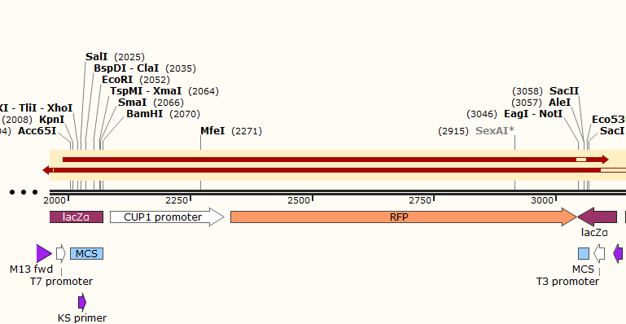

Fig. 3-1. Sequencing result of CUP1p and yEmRFP (alignment support by SnapGene®)

CHARACTERIZATION

To characterize this biosensor, strains of S.cerevisiae BY4742 containing the plasmid with an initial OD600 of 0.1 were grown for 24 hours in SC-URA medium at 30 degrees Celsius, and then were induced with copper sulfate. Samples in different copper concentration were tested with fluorescent microplate reader after 1, 6, 12, and 24 hours. This protocol was based on the experience used by Waterloo and Washington iGEM teams and amended by our team.

Fig. 3-2. The fluorescence intensity of CUP1p-yEmRFP biosensor with different Cu concentration induced

Figure 2 showed the relationship between fluorescence intensity with induction time and Cu concentration. With 0.1 mM CuSO4 induced, the fluorescence intensity is 2 times over a control with no induction at 1 hour. As time went on, the fluorescence intensity slightly reduced. Moreover, as the Cu concentration increased, the fluorescence intensity decreased, and when the concentration reached 1 mM, the intensity was close to the control group. This might be due to the higher copper ion concentration influences the transcription, expression and even growth of yeast.

This result will be useful for teams who will use the parts BBa_K2407000 & BBa_K2407012 to build an effective Cu-induced biosensor in budding yeast. We noticed that this result is a little different with works down by Waterloo team. It may be due to the differences between Cu ion’s concentration and yeast species. However, we both verified the possibility of building a biosensor based on CUP1 promoter in yeast.

This result was provided for modeling of this biosensor and try to find a proper function to accurately describe the response procedure. Click here to see more information.

PARTS IMPROVEMENT

The Cu-induced promoter CUP1p is a previous BioBrick used by iGEM16_Washington, iGEM16_Waterloo, and other iGEM teams. However, the detailed characterization like what we did this year haven’t be showed on iGEM parts page. Moreover, this part hasn’t be improved by any means or in any ways. Under this situation, we plan to work on this promoter to improve its sensitivity and response peak, reduce the leakage expression, and create new parts for future work.

1. Redesign of CUP1 promoter

First, based on the part BBa_K2165004 provided by iGEM16_Washington, we tried to ensure the core sequence for transcription. Researches about this promoter mainly published in the 1990s, and the mechanism of induction has been researched thoroughly. The promoter is activated by the complex of ACE1 and copper ions. There exist 5 ACE1 binding sites, 2 TATA boxes, and one initiation element in the promoter. The complex of ACE1 and copper ions will bind the promoter, which causes the activation of CUP1 promoter with TATA boxes’ help. ACE1 complex’s binding directly increases the possibility for TBP (TATA-Box Binding Protein) to bind the promoter, which can enhance the expression.

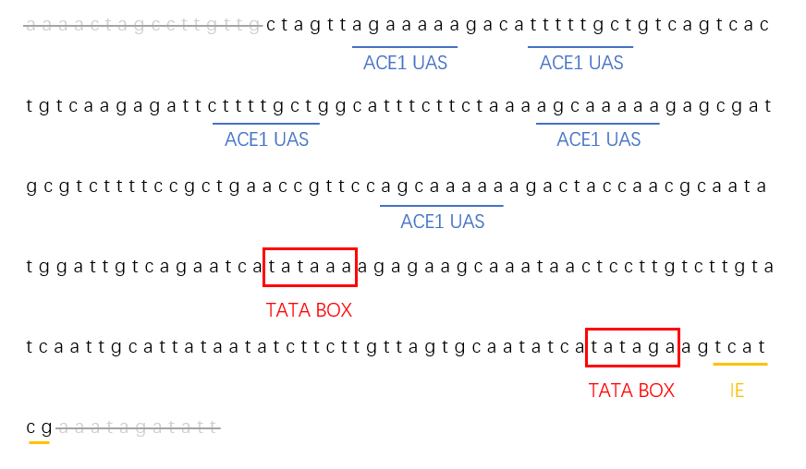

Fig. 3-3. structure of redesigned CUP1 promoter used in our project, based on BBa_K2165004

Based on this mechanism, we redesigned the part sequence provided by iGEM16_Washington. We deleted irrelevant bases on the two ends of this promoter and retained the core sequence. In this way, this promoter played its key role with less bases.

1. Error-Prone PCR

In our experiment, we noticed that CUP1 promoter still has a certain degree of leakage expression. To make a better biosensor, we planned to reduce the leakage expression and increase the sensitivity. To reach this goal, we took the fluorescence intensity at both induction or not into evaluation indexes.

The technology of Error-Prone PCR was taken into our experiment. Although there are many methods to introduce genetic diversity into a parent sequence, error-prone PCR is the most common way of creating a combinatorial library based on a single sequence. By adding some heavy metal ions into the PCR buffer and preparing dNTPs with different composition, new mutants were introduced into CUP1 promoter. The protocol is shown as the following table.

Fig. 3-4. The procedure for error-prone PCR expriment

The library of promoter mutants obtained from error-prone PCR were ligated into plasmid pRS416 with two restriction sites (BamHI and XbaI). After that, we enriched different plasmids from E.coli and established the plasmid library with 132 samples. Then, different plasmids were transferred into S.cerevisiae BY4742 to test the fluorescence intensity under different conditions.

First, we tested and selected mutants with less leakage. Compared with control group, we test the fluorescence intensity with no induction and selected two mutants with lower fluorescence intensity. Actually, we test a lot of mutants, but most of them were not positive result. We picked EP-3, EP-5, EP-9, and EP-28 whose fluorescence intensity was less or close to the control group, and sequenced them. The sequencing result can be found in the part information: BBa_K2407013 (EP-3), BBa_K2407014 (EP-5), BBa_K2407015 (EP-9), BBa_K2407016 (EP-28).

Fig. 3-5. The leakage expression of different promoters

Second, we worked on the sensitivity of biosensor. Leakage expression was not the only thing needed to be solved, and we also needed to increase the response range when it was induced. A good biosensor needs less leakage and more sensitivity.

We tested the 4 selected biosensors and control group with 0, 10, 100, 500, and 1000 μM Cu for 20 min, and the result is shown below with logarithmic coordinates.

Fig. 3-6. Different biosensors showed different sensitivities and response rages

The figure shows the response rages of biosensors with different promoters within 20 min. For most biosensors, the fluorescence intensity increases as copper ion’s concentration increases from 0 to 100 μM. However, when the concentration exceeds 100 μM, the responses of most biosensor become slow, and the fluorescence intensity decreases. A reasonable explanation is that high concentrations of copper can inhibit the biosensor's response within a short time.

Fortunately, we still found a biosensor who met the requirements of an excellent biosensor. EP-5 has a less leakage and a higher sensitivity. Its fluorescence intensity is lower than the control group by 17 units with no induction and is higher by 21 units with 100-μM-Cu induction. By aligning the sequence with CUP1 promoter, we found altered bases mainly located at the both sides of UASs and a deletion of one base even occurred between two UASs. We suspected that the change of sensitivity and leakage expression mainly due to the change of space distribution and the increase of A/T concentration, which both could influence the binding procedure of transcription factors.

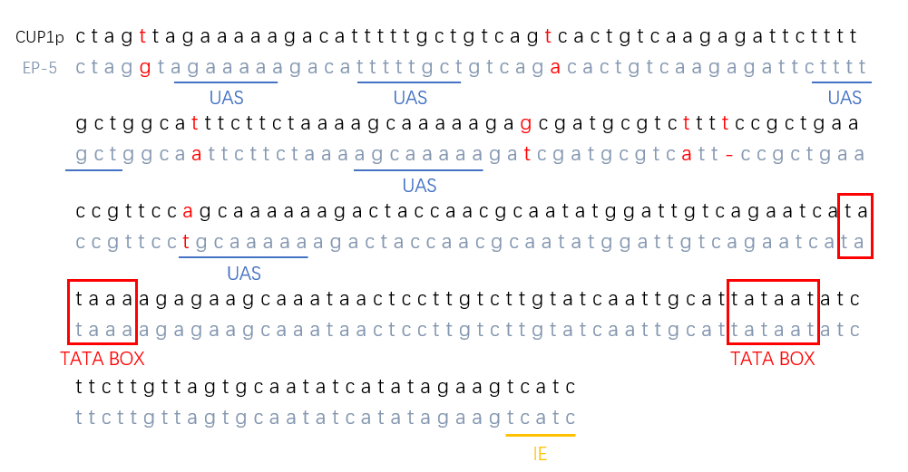

Fig. 3-7. The base changes in EP-5

Discussion and Future Work

In our characterization of both primary and improved promoters, we found the effect of induction is not as obvious as expected (Previous iGEM team’s results). After reading some references, we found the activation process is related to the acetylation of H3 and H4 located at CUP1 promoter, which showed nucleosome reposition and transcription factors binding might be the main reason for the activation. However, our biosensors were ligated on plasmid pRS416, which usually exists in the nucleus in a supercoiled state. There is only little possibility for a plasmid to binds to histones, so the transcription process shows less activation than that on a chromosome.

In the future, we plan to construct this biosensor on chromosomes to see whether the result will be more positive. Meanwhile, we will continue enlarging the response peak and rage to improve this biosensor.

Reference

Badi, L., & Barberis, A. (2002). The CUP1 upstream repeated element renders CUP1 promoter activation insensitive to mutations in the RNA polymerase II transcription complex. *Nucleic acids research*, *30*(6), 1306-1315.

Koller, A., Valesco, J., & Subramani, S. (2000). The CUP1 promoter of Saccharomyces cerevisiae is inducible by copper in Pichia pastoris. *Yeast*, *16*(7), 651-656.

Labbé, S., & Thiele, D. J. (1999). [8] Copper ion inducible and repressible promoter systems in yeast. *Methods in enzymology*, *306*, 145-153.

Leblanc, B. P., Benham, C. J., & Clark, D. J. (2000). An initiation element in the yeast CUP1 promoter is recognized by RNA polymerase II in the absence of TATA box-binding protein if the DNA is negatively supercoiled. *Proceedings of the National Academy of Sciences*, *97*(20), 10745-10750.

Shen, C. H., Leblanc, B. P., Neal, C., Akhavan, R., & Clark, D. J. (2002). Targeted histone acetylation at the yeast CUP1 promoter requires the transcriptional activator, the TATA boxes, and the putative histone acetylase encoded by SPT10. *Molecular and cellular biology*, *22*(18), 6406-6416.