OUC-iGEM COLLABORATION

What we did：

To verify whether the system built by China Ocean University is still applicable in other species of Saccharomyces cerevisiae. For this reason, we used our laboratory-specific Saccharomyces cerevisiae with synthetic chromosome 10 to observe its fluorescence values.

Protocol：

:

Yeast with plasmid was incubated overnight in YPD + G418 medium

Transfer the bacteria to the new YPD + G418 and adjust the OD to 0.1

After incubation for 20 hours, the fluorescence was measured

Excitation light 502nm

Emitting light 532nm

The OD600 values ​​were measured after fluorescence measurements

:

After comparison with the data provided by Ocean University, it is found that the experimental results are consistent, but the slight deviation of the data shows that the mini system has similar expression in different laboratories and yeast strains.

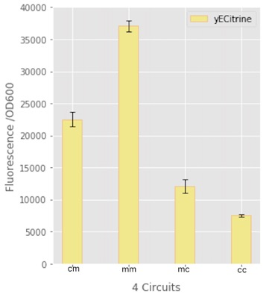

Testing results for OUC

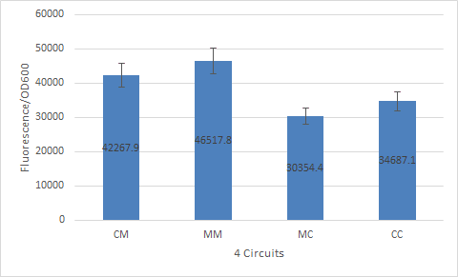

天津大学测量情况

What we ask OUC to do :

Easy - to - error PCR library development. For our use of the CUP1 promoter error-prone PCR, amplification of our existing error-prone PCR library.

Specific steps:

1.Error-prone PCR

2. digestion

3. Purification / Adsorption

4. Connect

5. Large intestine transformation

Easy-to-error PCR protocol (100μl)：

5X buffer（140mM MgCl2, 250mM KCl, 50mM Tris, and 0.1%(wt/vol) gelatin）20μl

Template (iGEM-Tianjin provided) 4μl

Primers (iGEM-Tianjin provided) 4μl\*2

10X dNTP (2mM dGTP, 2mM dATP, 10mM dCTP, and 10 mM TTP) 10μl

Taq polymerase 2μl

5mM MnCl2 10μl

ddH2O 46μl

94℃ 3min

94℃ 30s

53℃ 30s recycle for 35 times

72℃ 30s

72℃ 1min

The PCR products were recovered and digested with BamHI and XbaI, and ligated with vector pRS416.

In the case of

After intestine turn to collect bacteria and plasmids