Results

1. Obtaining the chassis.

Aiming to achieve MTS for environmental use, it is essential to make sure that when the MAT locus has DSB (double strands break) cleaved by HO, our type-a (MATa) yeast can only become type-α (MATα). Therefore, we used a Ura-tag to replace the HMR(a) domain in chromosome Ⅲ. In this way the HMR will no longer be the donor for the homologous recombination in the repairing process for MAT cleavage. Since the change of mating type may appear successively, there is a great possibility that the same type haploid mate with each other. To avoid the existence of meaningless mating, we built an vector to express MATα genes to produce a1-α2 stable corepressor so that the haploid will regard itself as a diploid and prevent mating unless the MATa locus changes to the other one. After selection, by homologous recombination, we deleted the Ura-tag for further usage. We selected the target colonies (**SynⅩ-dUra**) via 5Foa plates.

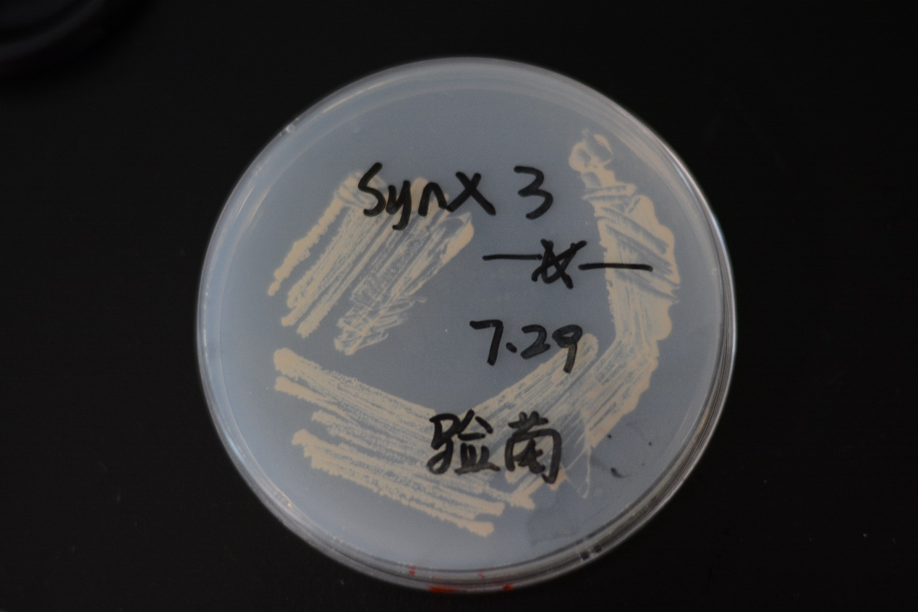

**Fig 1 We successfully acquired the target yeasts as our chassis (SynⅩ-dUra).**

1. The result for constructing the Gal systems

We designed these three parts (Gal1, HO, CYC1 ) with enzyme cutting sites on both sides. After acquiring parts. We ligated these pars and a vector (PRS416) with T4 ligase. Having got our new plasmid GHC-416, we transformed the E. coli for it, and examined the transformation result by adopting the PCR method to amplify the HO gene in the E. coli. 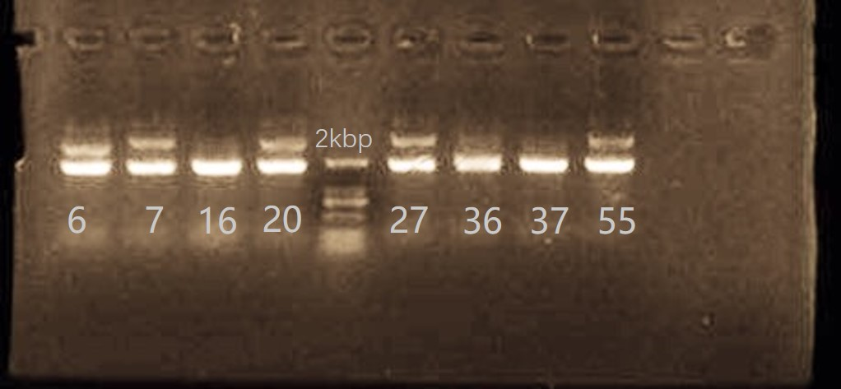

**Fig 1 The results of PCR of #6, #7, #16, #20, #27, #36, #37, #55 colonies. HO gene (length of 1770bp) . As we can see, HO gene in all 8 colonies has been amplified, which indicated that we succeeded in introducing the HO gene expression device——GHC-416 plasmid into our chassis yeast.**

1. The result of mating type switching.

After activating the Gal1 promoter, the expression of HO gene in the **SynⅩ-dUra-416** can be initiated.

Then we cultivated two groups of yeasts together. (one is **SynⅩ-dUra-416,** the other is normal BY4741 MATa) If the MTS has been accomplished (**SynⅩ-dUra-416** can become MATα), the two groups of haploids can mate with each other and become diploids.

To test whether MTS has happened, we selected some colonies in the selective plates (Sc-Ura ) and adopted PCR method. With designed the primers for both MATa locus and MATα locus, the amplification of both MATa locus and MATα locus can indicate that the yeasts has mated with each other, and turned into diploids, in other words, the MTS has been achieved.

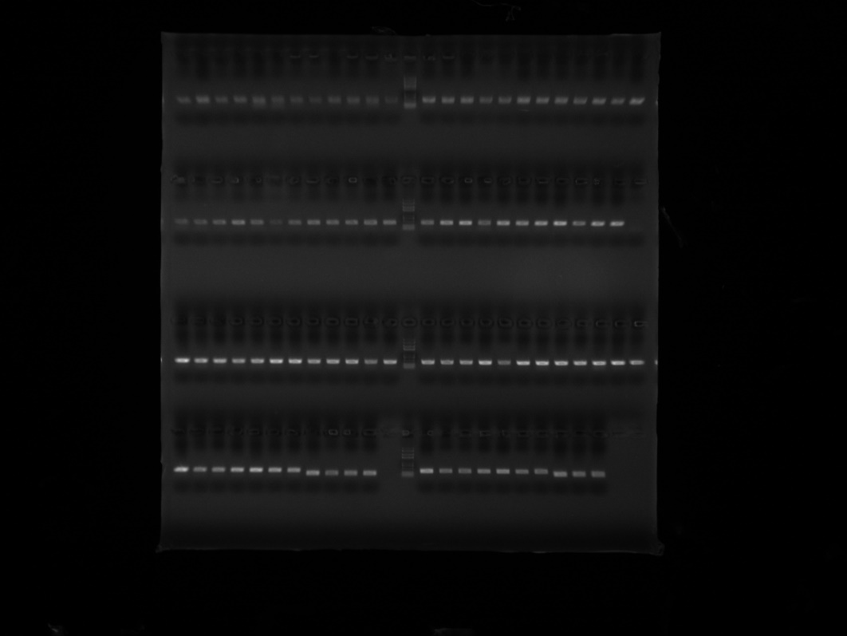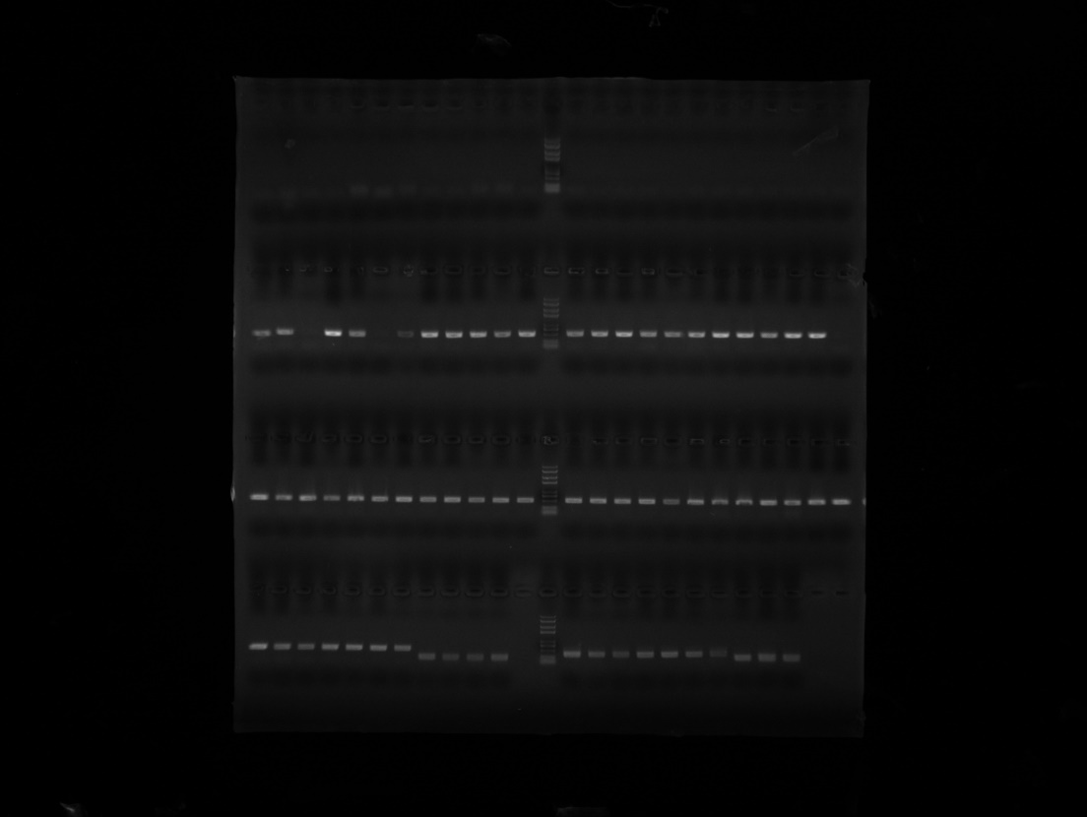

Fig 3