Design

<h4>Overview </h4>

<hr>

<p>After we found there might be revolutionary usage about the mating type switch (MTS) of yeasts in our heavy metal deposition system, In laboratory, the species of budding yeast we usually used are BY4741 and BY4742, whose HO gene are knocked out. Therefore, we intended to use two groups of MATa yeasts to realize the mating switcher. </p>

<p>One of these groups was required to achieve MTS. We decided to achieve MTS by introducing the HO gene into this group of yeasts— *Saccharomyces cerevisiae (BY4741, in our lab, whose chromosome Ⅹhas been switched by synthetic chromosome Ⅹ. And it has been renamed as* ***SynⅩ****similarly hereinafter.)* . To make the MTS controllable, it is necessary for us to adopt inducible promoters to initiate the expression of HO gene or create a pathway functioning as single gene regulator. Eventually, we landed on the Gal1 promoter first, for its convenience and efficiency. As we read in R. Scott McIsaac’s work, their the rapid, tunable, single-gene specificity control system of single gene in yeasts has given us much impression. Therefore, we decided to use this system as one of our pathway designs for the expression of HO gene. </p>

<h4>1. Getting the chassis. </h4>

<p>Aiming to achieve MTS for environmental use, it is essential to make sure that when the MAT locus has DSB(double strands break) cleaved by HO, our type-a (MATa) yeast can only become type-α (MATα). Therefore, we used a Ura-tag to replace the HMR(a) domain in chromosome Ⅲ. In this way the HMR will no longer be the donor for the homologous recombination in the repairing process for MAT cleavage. </p>

<p>Since the change of mating type may appear successively, there is a great possibility that the same type haploid mate with each other. To avoid the existence of meaningless mating , we built an vector to express MATα genes to produce a1-α2 stable corepressor so that the haploid will regard itself as a diploid and prevent mating unless the MATa locus changes to the other one. After selection, by homologous recombination, we deleted the Ura-tag for further usage. We selected the target colonies(SynⅩdUra) via 5Foa plates. **(P1)** </p>

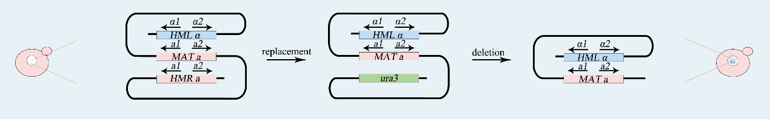

<img scr=” http://2017.igem.org/wiki/images/f/f0/Tianjin-ho-design-fig1.jpeg”>

<h4>2. Construction of systems</h4>

<hr>

<h5> (1) Gal System. </h5>

<hr>

<p>In this pathway, we chose Gal1 as our promoter for the expression of HO gene, CYC1 as the terminator, and PRS416(with Ura-tag) as our vector. As for segments ligation, we design the cutting sites for Bsa1 enzyme in each part, hoping to achieve seamless ligation of these three parts. </p>

<p>We adopted the PCR method to amplify the Gal1-part and CYC1-part from a Gal1-Vika plasmid we had used in our former lab work. We designed specific primers for this procedure. After PCR, the Gal1 has the cutting sites for SalⅠand BsaⅠon both ends, and CYC1 has that for BsaⅠand BamhⅠon both ends. Meanwhile, the HO gene was obtained by gene synthesis, flanked by specific hangtags for BsaⅠto be cohesive with Gal1 upstream and CYC1 downstream. Thus, we have built our composite part (GHC).</p>

<p>After the ligation, we transformed the E.coli for the augment of the PRS416 plasmid with GHC. (GHC-416) And eventually, we transformed our **SynⅩ-dUra** for the GHC-416 to get our target yeasts——**SynⅩ-dUra-416. </p>**

<h5> (2) Modified. Gal1 system. </h5>

<hr>

<p>In this pathway, we introduced one kind of artificial transcription factor (ATF)—Z4EV into the regulation of HO gene expression. With Z4EV working with our Modified. Gal1 promoter, we hoped to reach the on off-target dynamic control of HO gene expression.

Our designing for getting the Modified. Gal1-HO-CYC1 parts (MGHC) is quite the same as that for GHC mentioned above, only that we acquired our Modified. Gal1 part from the gene synthesis. **（P2）</p>**

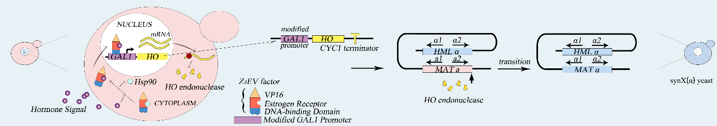

<img src=” http://2017.igem.org/wiki/images/0/0c/Tianjin-ho-result-real-fig2.jpeg”>

<p>As for the expression of Z4EV gene, we intended to induce it into the SynX chromosome in **SynⅩ-dUra** by homologous recombination. With overlap PCR strategy, we put an homologous domain CanA (originally from Can gene in chromosome X) in the upstream of the promoter of Z4EV. Thus, we got our CanA-TEF-Z4EV part. Then we planned to use Tdh2t as terminator attached with Leu-CanB (another part of Can gene). </p>

<p>Next, for double using the Leu-tag, we introduce Vika/vox system. We intended to attach the Vika operator (Tdh3p-Vikc-Tdh2t, TVT) following the Z4EV gene. We had two groups of yeasts, as mentioned above, one of them aimed to accomplish MTS and becoming MATα, the other with functional genes remained as MATa. According to our design, the former will express Vika recombinase, and the other contain functional genes whose expressions are controlled by vox-Terminator-vox structure. Thus, the function gene’s expression will be initiate during the cell fusion in yeast mating process. **(P3) </p>**

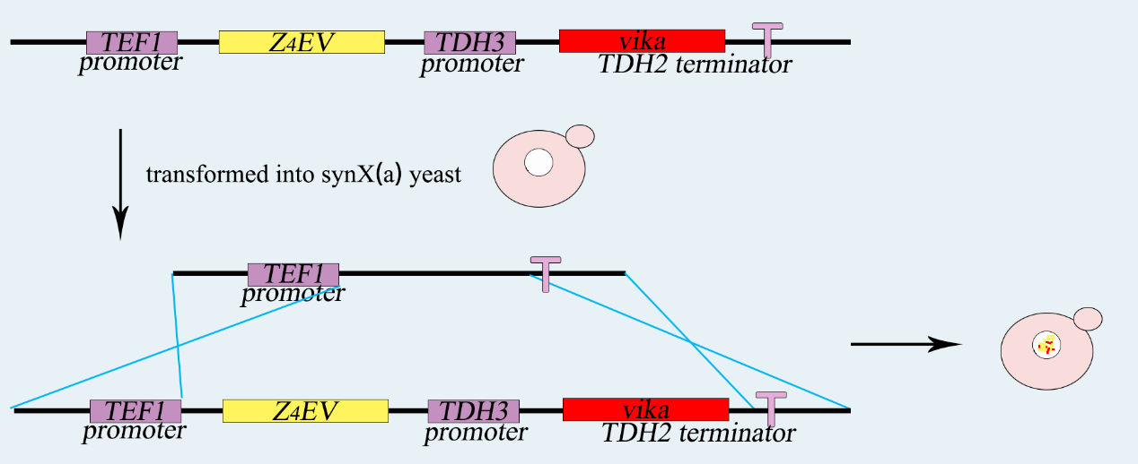

<img src=” http://2017.igem.org/wiki/images/a/a6/Tianjin-ho-design-fig3.jpeg”>

<h4>3. Test of MTS </h4>

<hr>

<p>In this section, we only got to test the Gal System due to time limits. And we figured that the results for Gal System is adequately enough to represent the feasibility of our designed strategy for MTS.</p>

<p>The whole test process can be divided into three steps. </p>

<h5>Step 1:</h5>

<p>Activate the Gal1 promoter. After that, the expression of HO gene in the **SynⅩ-dUra-416** can be initiated.</p>

<h5>Step 2:</h5>

<p> Cultivate two groups of yeasts together. (one is **SynⅩ-dUra-416,** the other is normal BY4741 MATa) If the MTS has been accomplished (**SynⅩ-dUra-416** can become MATα), the two groups of haploids can mate with each other and become diploids. </p>

<h5>Step three:</h5>

<p> Test the results of mating by PCR method. We designed the primers for both MATa locus and MATα locus. The amplification of both MATa locus and MATα locus indicates that the yeasts has turned into diploids, the MTS has been achieved in other words. </p>

<h4>Background</h4>

<hr>

<h5> Mating switch of yeasts</h5>

<p>Saccharomyces cerevisiae is a single-celled organism with three types, called a, α, and a/α. In Saccharomyces cerevisiae, three cell types differ from each other in their DNA content at the MAT locus which specifies the cell types. In nature, the two haploid cell types (a and α) of budding yeast are able to interconvert in a reversible manner by DNA-rearrangement with a DSB at the MAT locus, and this process is called mating-type switch.</p>

<p>The DSB at MAT locus is caused by HO endonuclease (a kind of site-specific endonuclease expressed by HO gene). DSBs in chromosomes can be repaired either by homologous recombination (HR) or by nonhomologous end-joining (NHEJ). In S.C haploids, the DSB caused by HO endonuclease mostly repaired by HR with HML(α) and HMR(a) as donors. If the donor is HML(α), the mating-type will become α, and vice versa. In this way, a haploid budding yeast is able to achieve mating-type switch. **(P4)</p>**



<img src =” http://2017.igem.org/wiki/images/6/6f/Tianjin-ho-design-fig4.jpeg”>

<h5>Artificial Transcription Factors——Z4EV</h5>

<p>Thanks to R. Scott McIsaac and Benjamin L. Oakes’s former work, we learned that Z4EV is a kind of fusion protein with three domains – DNA binding domain (DBD), estrogen receptor (ER) and VP16 activation domain. In the absence of β-estradiol, the ER interacts with Hsp90 chaperone complex and keep the ATF out of the nucleus. This AFT will provide a strong transcriptional activator that is dependent on the presence of β-estradiol. By using a synthetic 4-time-repeated zinc-finger DBD array from the mouse TF Zif268, residual off-target effects have been totally avoided. </p>

<p>Z4EV (the Z4EV gene has been induced into the SynX chromosome of this group of haploids) to strictly control the expression of HO gene. Unlike common β-estradiol-induced or galactose-induced promoters, this modified promoter is designed to be activated only when it is specifically bound with activated Z4EV factor. **(P5)</p>**

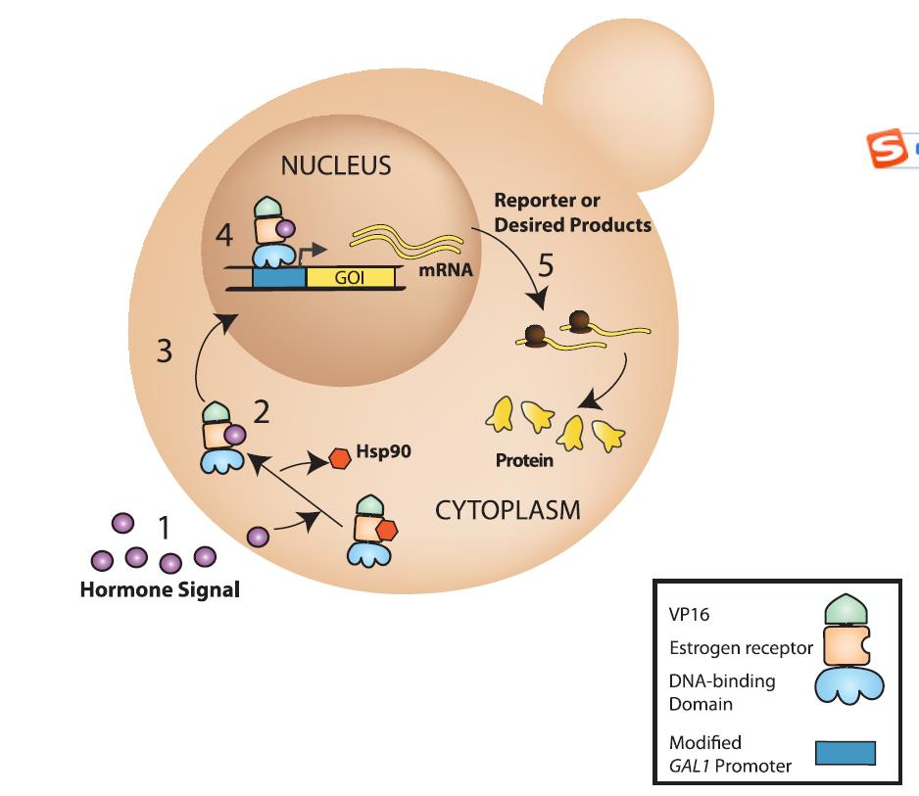

<Img src=” http://2017.igem.org/wiki/images/0/05/Tianjindajie6666.png”>