双稳态模型的构建

Construction of Bistable Model

双稳态是细胞内的常见现象，主要表现为在一定条件下细胞两种表现型共存的现象，这种现象对于许多单细胞生物适应环境的变化十分重要。生物可以根据环境的变化选取合适的表现形式，而双稳态是实现这一变化的基础。

Bistability is a common phenomenon in single-cell microbes, that two types of cell phenotype coexist. Bistability is very important for many single-cell microbes’ adapting to environmental changes. Single-cell microbes can choose the appropriate form according to changes of the environment, and bistability is the basis for achieving this change.

双稳态在生物中存在的原因比较复杂，通常认为和基因网络的正反馈调节有关。我们通过建立一个简化的基因调控模型，模拟单细胞生物内的双稳态模型。

The reason for the existence of bistability in single-cell microbes is complex, and is generally thought to be related to the positive feedback of the gene network. We simulate the bistability in single-celled microbes by establishing a simplified gene regulation model.

y代表要实现双稳态的物质的浓度，x是y的激活因子，其可以促进y基因的表达从而增加y的浓度，R是细胞内对于y的抑制物，其浓度符合Hill Function。

y represents the concentration of the bistable substance, x is the activator of y, which promotes the expression of the y gene to increase the concentration of y, and R is the intracellular inhibitor of y, whose concentration is in accordance with Hill Function.

Establish the following equation：

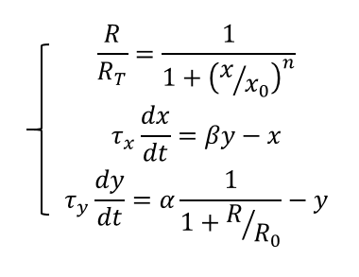（1）

这里R代表有活性的抑制因子的浓度，代表总浓度，n为Hill系数，为激活率达到一半时的浓度，y的产生由米氏函数描述，最大产生率为，、为x和y的平均存活时间.

Here R represents the concentration of the active inhibitory factor, representing the total concentration, n is the Hill coefficient, is the concentration at which the activation rate reaches the half, and the generation of y is described by the Michaelis-Menten equation, 、is the average survive time.

在正常情况下，细胞会处于稳定状态，此时方程（1）中关于时间的导数为零，我们对该方程进行处理，得到：

Under normal circumstances, the cells will be in a steady state, then the derivative of time on the equation (1) is zero, we can get:

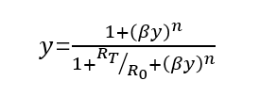(2)

Note that all of these formulations of derivation of Hill function from mass action kinetics

assume that the protein has n {\displaystyle {\mathit {n}}}nnggnsites to which ligands can bind. In practice, however, the Hill Coefficient {\displaystyle {\mathit {n}}}n rarely provides an accurate approximation of the number of ligand binding sites on a protein.[2] We assume that the Hill Coefficient is 2 according to experience.

We can get the following cubic equation form equation（2）：

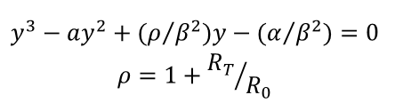(3)

对于三次方程，其存在0到3个解，由于本模型要达到双稳态，所以应该由两个解，我们假设该方程形式为：

For the cubic equation, there can be 1、2、3positive real solutions, to achieve the bistability in this model, the function should have two solutions, we assume that the equation form is:

 (4)

比较（3）和（4），我们可以得到以下参数方程：

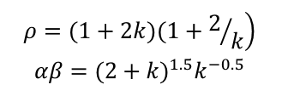（4）

描绘该参数方程，可得到双稳态下，参数的范围：

Draw the parameters equation, can be obtained under the range of parameters in bistability:

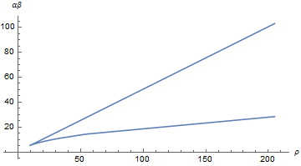

两条曲线即为我们所要求的双稳态曲线，两条曲线之间即为双稳态的范围。

The two curves are the bistable curves we want, and between the two curves the cells can achieve bistability.

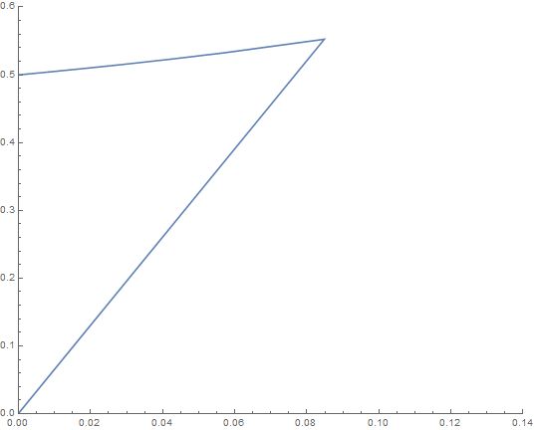

该区间是在假设细胞处于稳定状态下由方程（1）得出的，下面对方程（1）进行稳定性分析：

The above result is obtained by the equation (1) assuming that the cell is in a steady state, and the stability analysis is given below for equation (1)

令x*和y* 表示稳定态，令：

Let x * and y * represent stability：



Combine equation (1), we can get:

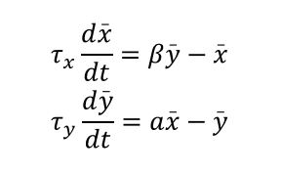(5)

In this equation:

* 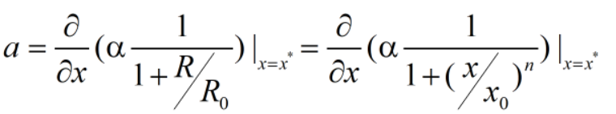

根据常微分方程的稳定态理论，平衡点是稳定的当且仅当等式（5）系数矩阵特征值均包含负实部，可以求得等式（5）特征值为：

According to the steady state theory of ordinary differential equations, the equilibrium point is stable if the eigenvalues of the coefficient matrix of equation (5) contain negative real parts, we can find the eigenvalues of equation (5)



When <1,the equations reach the steady state. Combine the equation with equation(2):



When <1, <0，thus we can judge the stability of the resulting roots of equation(2).

[2] Weiss, J. N. (1 September 1997). ["The Hill equation revisited: uses and misuses."](http://www.fasebj.org/content/11/11/835.short). *The FASEB Journal*. **11**(11): 835–841. [ISSN](https://en.wikipedia.org/wiki/International_Standard_Serial_Number) [0892-6638](https://www.worldcat.org/issn/0892-6638)