# Acknowledgment

We are very grateful because we managed successfully to complete our Distributed Systems (CNET343SL) assignment within the time given by our module leader **Mr. Rasika Alahakoon,** who has through his knowledge has been able to guide us. The assignment cannot be completed without the effort and co-operation of our group members. We thank everybody who has, directly and indirectly, helped us in this assignment to make it successful.

# Table of contents

# Table of figures

# Abstract

# Introduction

## Project Report Introduction

This the project report for the assignment of the module **CNET343SL Distributed Systems**. This document provides an overview of the developed system and further discusses the distributed architecture of the system and its component and software development technologies.

## Description of the System

Enforcing “Traffic Laws” & preventing the violation of traffic regulations and prosecution of offenders are two of the main functions of Sri Lankan traffic police. In that process, the fining for violations of traffic regulations involves a lot of paperwork. The police officer fills forms and collects the driving license. Then the driver must go to the post office, make the payment and deliver the receipt to the police station to regain the driving license. This is a long, expensive and time-consuming process.

At present, most of the people use smartphones all the time. Most of the drivers are using GPS technology from their smartphones nowadays. Therefore, we can easily address this issue through smartphones. An automated system for this scenario does not exist yet in Sri Lanka. In order to address this issue, the “**Traffic Fine Handling System**” is proposed.

This is a distributed system with three user types,

• Police Officer

• Driver (Offender)

• Admin (Staff at the police station that handles the document work)

The user interaction with the system happens via a mobile app and a web application. The police officer uses the mobile app on his smartphone to generate a fine. The driver or the offender can either use the smartphone app or the web application to view the fines under his driving license and pay the fine online. The application tracks the fining deadline and if the fine is not paid within the 14 days, the staff at the office and the police officer who generated the fine are notified.

## Scope Of The Project

The system consists of a web application and a mobile app. The system has a web server that hosts the web application. There are two database servers. One server handles the retrievals of data and the other server handles the updating and insertion of data. The mobile application and the web application use these servers to store, update, delete and retrieve data. The servers are synced properly. The database in each server is identical to each other.

## Functionalities

Functionalities of the Distributed Traffic Fine Handling System will be as follows.

From the police officer aspect,

* The police officer can log in to the mobile app or web app by using username and password.
* The police officer enters the details (that would normally be inserted to a form) into the app and files the fine.
* Thye can view paid fine details as well as not paid fine details.
* Once a made a fine that police officers can see relevant drivers’ details.
* They can view the fine details they have already made.
* The police officer can maintain his/her account.

From the driver aspect,

* The driver can log in with the mobile app or web app by using username and password
* The driver can see the relevant fine details that he/she should responsible for.
* Already paid fine details can be seen.
* Card settings can be done (payments) through the app.
* The driver can maintain his/her own account.

From the admin aspect,

* Admin can add police officers to the system or remove police officers from the system.
* Responsible for serverside handling.
* Only the admin has the authority to access the database.

# Project Background

## Objectives

### Background/Motivation

The main purpose of this project is to develop skills regarding distributed system development and to give a solution to the problem defined. This project does not have a client to fund it. But, we believe there are potential clients for this solution when this project becomes successfully completed. In the existing process, the Sri Lankan Police and Sri Lankan Postal Department works jointly. The collection of the fines happen through the postal department. Under this process, the driver who's paying the fine undergoes a lot of difficulties. Other than the amount paid as fines, they have to spend more time and money throughout the process. There are instances where the post office is closed and the police officers have to do all the tasks manually which involves a lot of paperwork. Our project aims to make this process easier and convenient through the application of modern technology.

### Project Goals

The main goals of the project are,

1. Making it easy for drivers to pay the fines without having to undergo unnecessary difficulties.
2. Removal of the manually done paperwork of the existing system.
3. Reduce the time that it takes to process the fines (receiving the fine payments).
4. Reduce the overall cost involved with the process in the existing system, enabling the departments to save money.

Apart from the above project goals, to learn about distributed systems, related technologies and improve our technical skills and knowledge was our second goal as a team.

### Project Objectives

1. Study and analyze existing processes and procedures in the world.
2. Requirements gathering.
3. Provide interoperability between the new application and the existing process.
4. Analyze relevant development technologies and deployment solutions.
5. Implement of the distributed system.
6. Introduce the application to the relevant structures. [If needed])

## Introduction to the Distributed System

Networks of computers are all over the world today. The Internet is one of those, just like the other networks which are composed and available all over the world. Mobile phone networks, Personal are networks, Local area networks, corporate networks, virtual private networks, factory networks, storage processes on a network. Hence, all components together can perform single or set of corresponding area networks, campus networks, enterprise private networks, home networks, in-car networks and all of these, contains and is responsible for very similar characteristics which makes them a discussed topic under distributed systems. A distributed system can be explained as an application which executes a collection of protocols to synchronize the actions of various tasks. Computers that are connected by a network might be physically separated by any distance. This can vary from a couple of meters to thousands of kilometers. They can also be in separate countries or even in different continents far away from each other, or even in the same country, same building and next to each other in the same room.

### What Is The Importance of Developing A Distributed System

This topic can be discussed very widely. There are many more advantages of developing a distributed system. Scalability and resource sharing are the two main features of why distributed systems are highly important. Furthermore, distributed systems can be changes to accommodate more users and resources whenever needed. In that case, a distributed system can be very large in size and very powerful when the overall capabilities of all the devices connected to the network are concerned.

# Requirement Analysis

## Functional Requirements

Functional requirements are the requirements that specify how the system should behave under different conditions.

* Services can be distributed within several API components.
* HTTP Request and HTTP Response method need to implement using NodeJS.
* The RESTful architectural pattern needs to use to make this distributed application.
* Backup of all services and API components need to implement with a backup server.
* Both web and mobile applications support JSON data types.
* Both web application and mobile application uses the MySql database.
* Supports continuous integration.

## Non-Functional Requirements

Non-functional requirements are the requirements that specify the qualitative attributes of the system.

* Scalability

The capability of a system to manage the growing amount of workload is known as scalability. Traffic Fine Handling system must be a scalable system because it serves thousands of users spread out all over the country. The system must be scalable to enhance the performance of the system and to handle a large amount of users.

* Reliability

Traffic Fine Handling system must support 24*7 for its customers. Therefore it must be a reliable system. The system is carefully designed to avoid or cover failures that can happen while running the system.

* Performance

The system must perform with short response time or low delayed time, high throughput, and low utilization.

* Availability

The system must be available when it capable of providing intended services. If the system down for a second it can be affected by millions of users. It is necessary to have efficient recovery or overprovisioning the resources and making the resources redundant. An additional web server can be deployed to host the service.

* Heterogeneity

The system must be able to interact with more than two devices that have different technologies, operating systems, programming languages, hardware platforms, and network protocols. The developed system interacts with the mobile device, Laptop, and PC that can communicate with each other in order to request a service and provide a service as a response.

* Security

Traffic Fine Handling system must be secure because it deals with police and driver details over the internet. Therefore we validate each and every form that related to the security of the whole system. We validate usernames over web service.

# System Design

## System Architecture

### Architecture Diagram

### Hardware/Software Requirements

these are the minimum requirements required for the Traffic Fine Handling system

Hardware Requirements

* **Web service**
* Intel Core i3 2.5GHz or higher processor
* Intel Xeon E52418L processor or higher (if using dedicated webserver)
* 2GB Ram
* 250MB hard disk space
* **Mobile application**
* Android-based smartphone
* Snapdragon 652 or higher processor
* 2GB system ram

Software Requirements

* **Web service**
* NetBeans IDE 8.1 or 6
* MySQL
* Glassfish server
* **Mobile application**
* Android Marshmallow or higher OS
* **Website**
* Local web hosting platform XAMP, WAMP (for private machine hosting)
* 000webhost

### UML Diagrams

#### Use Case Diagram

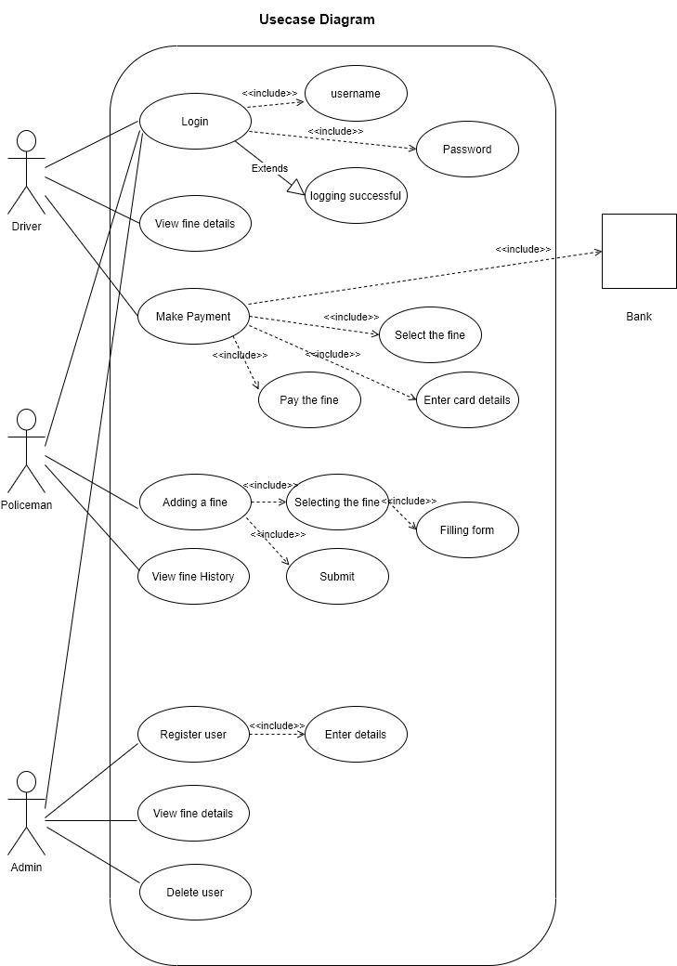

#### Class Diagram

### Database Design

#### Extended Entity Relationship Diagram

#### Relational Mapping

#### Normalized Table

#### Database Diagram

1.System Development

2. Web Application Implementation

3.Technology Description

3.Features of Web Application

1. **Admin page**

* Login

Admin can log in to the system by using his username and password. Admin must log in to the system in order to register police officers to the system.

* View registered users

Admin can view registered users' details using this feature.

1. **Driver page**

* Sing up

The driver who needs to access the system first needs to register for the system by giving the required registration details. Then the only diver can create an account. Unregistered drivers only can view the content of the web site.

* Log in

Registered drivers can log in to the system using a user name and password.

* View fines

the driver can view all fine details that he/she is responsible for using this feature.

* History

Using this feature driver can see the previous fine details that he/she already paid.

3.Web Application Work Flow

2.Mobile Application Implementation

3.Technology Description

3.Features of Web Application

3.Web Application Work Flow

2.API Implementation

3.API Development Technologies

Mobile Application and Web Application use NodeJS REST API for controlling the database and distributed application. Rest API (Representational State Transfer) APIs are web standards-based architecture and use the HTTP Protocol for exchanging data between applications or systems. In RESTFUL web service HTTP methods like GET, POST, PUT and DELETE can be used to perform CRUD operations. REST is very simple compare to other methods like SOAP, CORBA, and WSDL, etc.

3.API Development Server Details

Mainly here we have created two servers for hosting our APIs. One is the main API server and the other one is the backup API server. We are using the name as our hosting server partner.

We are using a backup server to request if the main API server is down.

Main Server Details:

Web server Name :

DB Name :

DB Usernamee :

DB Password :

Screenshot of Main Server

Backup Server Details:

Web server Name :

DB Name :

DB Usernamee :

DB Password :

Screenshot of Backup Server

3.API Service Description

3.API Documentation

1.Tools and Technologies

For Web Application :

* PHP
* CSS
* HTML
* npm
* Typescript

For Mobile Application :

* React-Native
* Redux
* Javascript
* JSX
* Node JS
* npm

Tools :

* Android Studio
* XCode
* VS Code
* Postman

2.Middleware Technology

3.Mobile Application Middleware

3.Web Application Middleware

1.system testing

1.Fault Tolerance

1.issues and approach of resolving

1.User Guide

1.conclution

2.summary

At the end of the project, the outcome of the project development was as expected. All most all the functionalities have the capability of function according to the functional specification. Overall the objective of this project was achieved which emphasizes that the proposed concept can be developed in order to distribute the functionalities of the Traffic Fine Handling system with enhancements.

2.future enhancements

1.team details

2.workload matrix

2.individual contribution

1.references