

School of Computing

PRCO303SL

Final Stage Computing Project

Smart Health Monitoring and Alerting System

Final Report

BSc (Hons) in Software Engineering

K. C. A. A. Iroshan

2019/2020

Table of Contents
Acknowledgments 4
Abstract 5
1. Introduction 6
1.1. Background 6
1.2. Business Case 6
1.3. Objectives 6
1.4. Scope 6

Table of Figures

Acknowledgments

Abstract

- Introduction

  - Background

Patients who are admitted to hospitals need to be monitored constantly in order to maintain a stable health condition or to effectively provide treatments to cure the patients as soon as possible. In most of the hospitals in Sri Lanka, medical staff go to the patient and monitor them in person. The most important vitals that are monitored are the heart rate and the body temperature. These monitoring happens periodically and is not constant because of the number of staff members being significantly less than the number of patients admitted. But, if there is a way for the staff to constantly monitor all the patients, it could help the staff to manage their treatments efficiently and precisely which would help the patients to get better quicker.

Once a patient has been cured, for the betterment of the patient, prolonged monitoring can be carried out at home. Currently, most of the hospitals in Sri Lanka does not provide any form of a remote monitoring service. For a highly effective and efficient patient management system, remote monitoring can be integrated with the patient management system of the hospital which maintains profiles for each and every patient maintaining their medical history which is readily available to the doctors which can be helpful when treating a patient or responding to an emergency situation.

  - Business Case

The existing patient monitoring mechanisms used which involves the constant attendance of medical staff can be inefficient when monitoring a large number of admitted patients and for remote monitoring which requires the presence of a nurse at the location. Medical staff does not get immediately notified of medical emergencies and does not have ready access to the medical history of the patient undergoing the medical emergency. This results in long response times.

With the Smart Health Monitoring and Alerting System, not only real time monitoring of patients can be done by the staff via a dashboard, but also the staff gets access to the medical details of the patient allowing them to plan the treatments efficiently at the right time. This system also allows a hospital to offer remote monitoring services to the patients. The system gives the ability for effective and quick responding to emergencies with the alert functionality allowing the hospital to provide better health care driving up the trust and satisfaction of the patients.

  - Objectives

- Monitor a number of patients at the same time using a dashboard.
- Monitor patients remotely.
- Maintaining profiles for patients that contains patient details and medical history.
- Enable the staff to reduce the response time in a medical emergency or a patient undergoing unstable health conditions.
- Enable the medical staff to get ready for a patient before the patient arrives at the hospital.
- Enable the medical staff to send ambulances to pick up the patients undergoing a medical emergency by letting the staff know about the emergency situation with alerts.

  - Scope

- Use Case Diagram

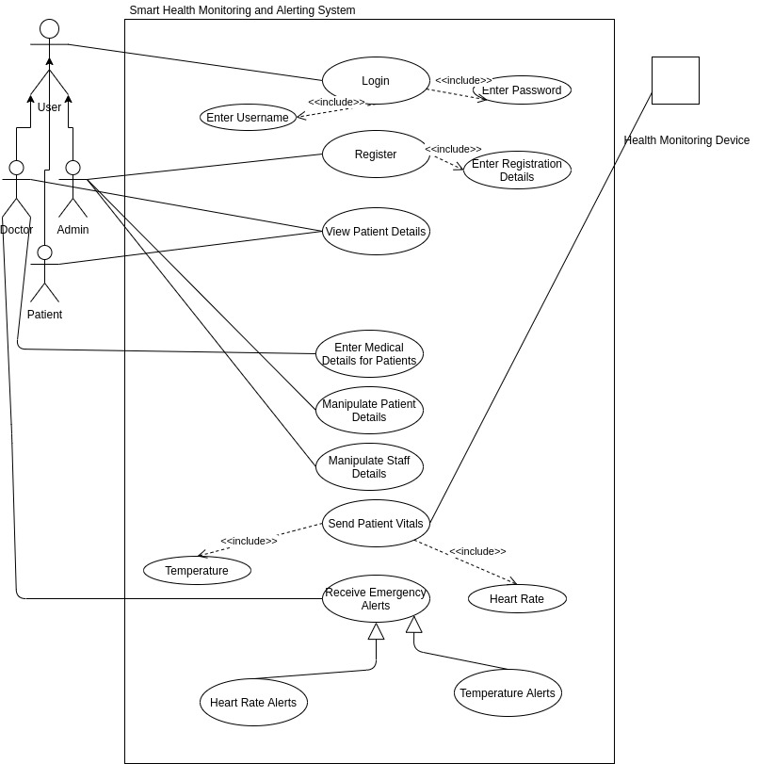

- EER Diagram

