

School of Computing

PRCO303SL

Final Stage Computing Project

Smart Health Monitoring and Alerting System

Final Report

BSc (Hons) in Software Engineering

K. C. A. A. Iroshan

10638366

2019/2020

Table of Contents
Acknowledgments 4
Report Abstract 5
1. Introduction 6
1.1. Background 6
1.2. Business Case 7
1.3. Objectives 8
1.4. Scope 8
2. The effect of computerization towards saving the lives of patients 9
2.1. Abstract 9
2.2. Literature review 10
3. System 22
3.1. Use Case Diagram 22
3.2. Architecture Diagram 24
3.3. API Structure 25
3.4. Cloud Database Dashboard Overview 26
3.5. Remote Vital Monitoring Device 28
4. Technical Review 33
4.1. Technologies Used 33
4.2. Database selection 34
4.3. API development 38
4.3.1. API Dependencies 39
4.4. Remote monitoring device 40
5. Challenges faced and their effect on the project 44
6. Links associated with the project 44
BIBLIOGRAPHY 45
APPENDIXES 46

Table of Figures
Figure 1: A brief introduction on the survey 11
Figure 2: Age groups of the participants 12
Figure 3: Participants by gender 12
Figure 4: The frequency of hospital visits 13
Figure 5: Frequency of visiting public hospitals 13
Figure 6: The frequency of coming across computerized patient management systems 14
Figure 7: Patients access to their medical details 14
Figure 8: Wait times at the hospital 15
Figure 9: Whether the hospital provides remote monitoring 15
Figure 10: Satisfaction of service 16
Figure 11: Possibiility of obtaining past medical details 16
Figure 12: Wait times 17
Figure 13: Satisfaction of service 17
Figure 14: Whether the participants have been in a remote monitoring program 18
Figure 15: Perception on whether remote monitoring saving the lives of people 18
Figure 16: Importance of having a medical profile 19
Figure 17: Remote Peritoneal Dialysis | PD - Perotneal Dialysis | RM - Remote Monitoring 23
Figure 18: Frequency of healthcare resource consumption episodes in the RM+ and RM– groups, summarized across the four assessments of each scenario 24
Figure 19: An inserted user record 26
Figure 20: Components of Computerized Patient Records 30
Figure 21: Use Case Diagram 37
Figure 22: Architecture Diagram 38
Figure 23: Node API Project Structure 39
Figure 24: Local Testing Database Dashboard overview 41
Figure 25: Remote Monitoring Device Outside View 42
Figure 26: Same device with the case 45
Figure 27: Operating 46
Figure 28: Underpinnings 47
Figure 29: Inside the device 48
Figure 30: Relational vs Non Relational 51
Figure 31: API Dependencies 55
Figure 32: Heart Rate Sensor to Finger Tip 59
Figure 33: Holding the device 62
Figure 34: Use Case Diagram 90
Figure 35: Extended Entity Relationship Diagram 91

Acknowledgments

The completion of this project would not have been possible without the help of numerous parties that have helped and guided me throughout the course of the project.

First and foremost, I would thank and express my gratitude towards my supervisor, Ms Manoja Weerasekara, for the guidance I received in accomplishing the tasks of the project. The meetings and the guidance was quite helpful in making certain decisions with regards to how I should progress with the project and what I should add and what I should remove. Her suggestions were wise and stimulation and encouraged me to achieve the best I could with every challenge that I faced and everything that was going on.

Secondly, I want to thank NSBM Green University and University of Plymouth. The final year project is the outcome of everything I have learned throughout my degree program and the knowledge and experience that I gained at the university and the skills I managed to gain and enhance played a big role in getting the final project done. I would like to thank all the lecturers at the NSBM Green University and the University of Plymouth flying faculty for teaching me the concepts in Computer Science and Software Engineering and giving me the knowledge that was essential all of my endeavors. I would also like to forward my sincere gratitude towards the instructors and the guest lecturers and professionals from the industry for spending their valuable time in providing us the industrial skills and practical technical knowledge which I have utilized in the final year project.

Last but not least, I have to thank my closest friends and the team members with whom I worked for the rest of the group assignments. Final year project is an individual coursework but that does not mean that one would be able to do it all by themselves. My closest friends provided me with suggestions and guidance when it comes to the technologies I used in this project and their pros and cons and those information helped me in making decisions with regards to what technologies I should use for the project. I want to forward special thanks for my family for providing me the opportunity of studying at the NSBM Green University without which none of these would have taken place.
Report Abstract

The report ventures in to explanations with regards to numerous aspects of the project and its course of development. The project objectives and scope has been explained in detail and the background of the project has been stated. Diagrams have been used to explain the system architecture, data flows, communication and database structure. Screenshots of parts of codes, API as well as the web application are included.

The report is consisted of a technology review that reviews the technologies that have been used in the development of the system and the reasoning behind those. It describes the path that were taken in selecting the technologies and the technologies that were tried, dropped and adopted.

The descriptive abstract of the research on the effect of computerization towards saving lives of patients and the literature review conducted is included in the report. The feedback that has been collected from many people are included in the report with the relevant graphs and diagrams.

The challenges faced throughout the project and how that affected the final outcome has been explained in detail and the cloud drive link to the project and the API documentation has been included in the report.

Finally, the document specifications of the report are as follows.

Software - Libre Office
Platform - Linux
Topic Font Style – Liberation Sans
Topic Font Size – 12
Content Font Style – Liberation Sans
Content Font Size – 12
Line Spacing – 1.5
(Microsoft Office or Ariel Font is not available on my computer)

- Introduction

  - Background

Patients who are admitted to hospitals need to be monitored constantly in order to maintain a stable health condition or to effectively provide treatments to cure the patients as soon as possible. In most of the hospitals in Sri Lanka, medical staff go to the patient and monitor them in person. The most important vitals that are monitored are the heart rate and the body temperature. These monitoring happens periodically and is not constant because of the number of staff members being significantly less than the number of patients admitted. But, if there is a way for the staff to constantly monitor all the patients, it could help the staff to manage their treatments efficiently and precisely which would help the patients to get better quicker.

Once a patient has been cured, for the betterment of the patient, prolonged monitoring can be carried out at home. Currently, most of the hospitals in Sri Lanka do not provide any form of a remote monitoring service. For a highly effective and efficient patient management system, remote monitoring can be integrated with the patient management system of the hospital which maintains profiles for each and every patient maintaining their medical history which is readily available to the doctors which can be helpful when treating a patient or responding to an emergency situation.

  - Business Case

The existing patient monitoring mechanisms used which involves the constant attendance of medical staff can be inefficient when monitoring a large number of admitted patients and for remote monitoring which requires the presence of a nurse at the location. Medical staff does not get immediately notified of medical emergencies and does not have ready access to the medical history of the patient undergoing the medical emergency. This results in long response times.

With the Smart Health Monitoring and Alerting System, not only real time monitoring of patients can be done by the staff via a dashboard, but also the staff gets access to the medical details of the patient allowing them to plan the treatments efficiently at the right time. This system also allows a hospital to offer remote monitoring services to the patients. The system gives the ability for effective and quick responding to emergencies with the alert functionality allowing the hospital to provide better health care driving up the trust and satisfaction of the patients.

The system is consisted of an electronic device that is worn by the patients on their arms, and a web application that is used by the medical staff to access the patient data. The electronic device measures the pulse rate and the temperature of the patient and sends the data to the cloud based database. The web application obtains the data from the cloud database and represents under the patient’s profile in a dash board where the medical staff can access it. The web application stores all the data of a patient including their medical history which the medical staff can access when needed. The system provides alerts when the vitals of a patients exceed the specified parameters. The device is rechargeable and communicates with the cloud using GPRS due to its longer range and low power consumption. It has a single toggle switch to turn it on and off for the simplicity of operation. The existing systems for patient management in Sri Lanka do not involve the real time monitoring of the patient vitals, which is available in our system. The feedback from the participants of the testing program has been positive on the concept with suggestions for improvements.
  - Objectives

- Monitor a number of patients at the same time using a dashboard.
- Monitor patients remotely.
- Maintaining profiles for patients that contains patient details and medical history.
- Enable the staff to reduce the response time in a medical emergency or a patient undergoing unstable health conditions.
- Enable the medical staff to get ready for a patient before the patient arrives at the hospital.
- Enable the medical staff to send ambulances to pick up the patients undergoing a medical emergency by letting the staff know about the emergency situation with alerts.

  - Scope

This project is for the development of a patient management system for medical institutions. The system will be consisted of an IOT device and a web application. The Web application will facilitate the management of patient data, their medical records and the profiles. The Web application will allow doctors to maintain their own profiles and associate patients and doctors with a certain medical record. The purpose of the IOT device would be to measure the heart rate and the temperature of the patients who are undergoing remote monitoring. The statistics of the patients who are undergoing remote monitoring would be shown to the doctors in a dashboard. The system will allow the staff in the medical institution to register or un-register doctors and patients. Doctors will have the ability to add and edit medical details of the patients.

- The effect of computerization towards saving the lives of patients

  - Abstract

Computerization in the health care industry has lead to the reduction of mortality rates globally. However, most of the systems used in Sri Lankan hospitals are incomplete and some are not computerized.

The primary objective of this study is to discover how computerization can improve the efficiency of patient management in Sri Lankan hospitals and improve the chances of survivability of patients in critical conditions. The study ventures in to explaining how the effective remote and continuous monitoring of patients and automated medication where applicable enables quicker recovery than conventional treatment methods simultaneously improving the patient safety including the newly arising aspects of patient safety due to the health information technology. Furthermore, the impact of a comprehensive medical history of a patient being available to the medical staff in the emergency setting towards the successful recovery of the patient is evaluated.

The study make use of data obtained from research articles and books for the purpose of understanding the scope of computerization that is taking place in the health care industry globally. Studies that have been conducted with regards to technologies have been analyzed for the purpose of understanding the optimal data storage mechanisms for health records and the applicable technologies in the context of a Sri Lankan hospital. A qualitative analysis of feedback gathered from two focus groups, staff of hospitals and selected group of general public obtained with the use of online forms have been conducted to discover the perceived understanding of the benefits of the system by the general public and the medical staff.

The results of this study will be beneficial at developing practical solutions for the computerization of Sri Lankan health care system and with the approach that should be taken towards the general public.
  - Survey Results

A survey was conducted using Google Forms in order to obtain feedback from the people on computerized patient management systems and remote monitoring with the intention to obtain whether they perceive that as an improvement to their personal lives and to obtain an understanding about what the people face in the health care system in Sri Lanka. The results are as follows.

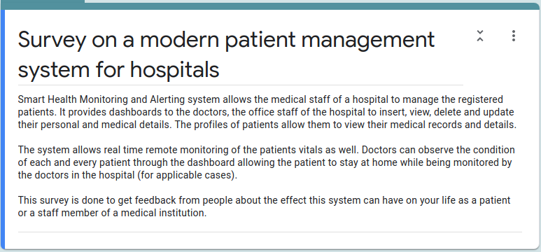Figure 1: A brief introduction on the survey

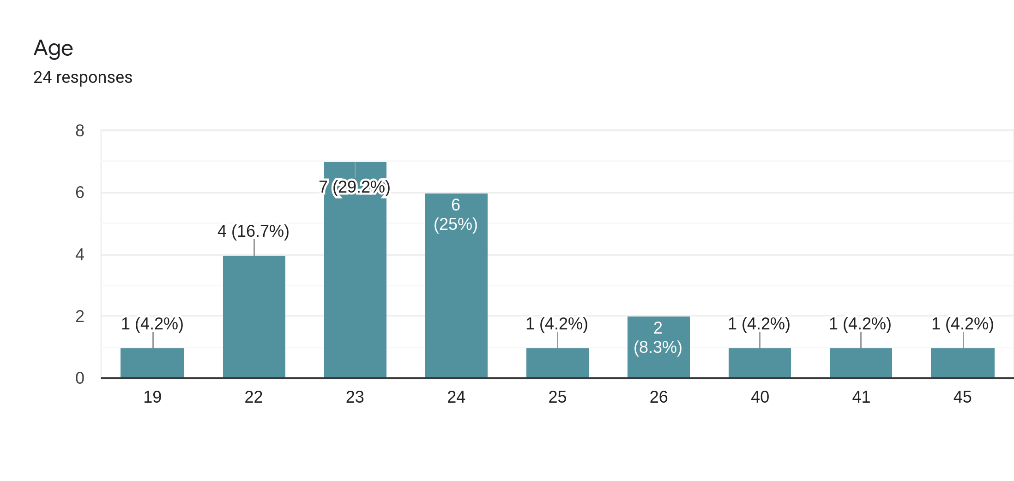Figure 2: Age groups of the participants

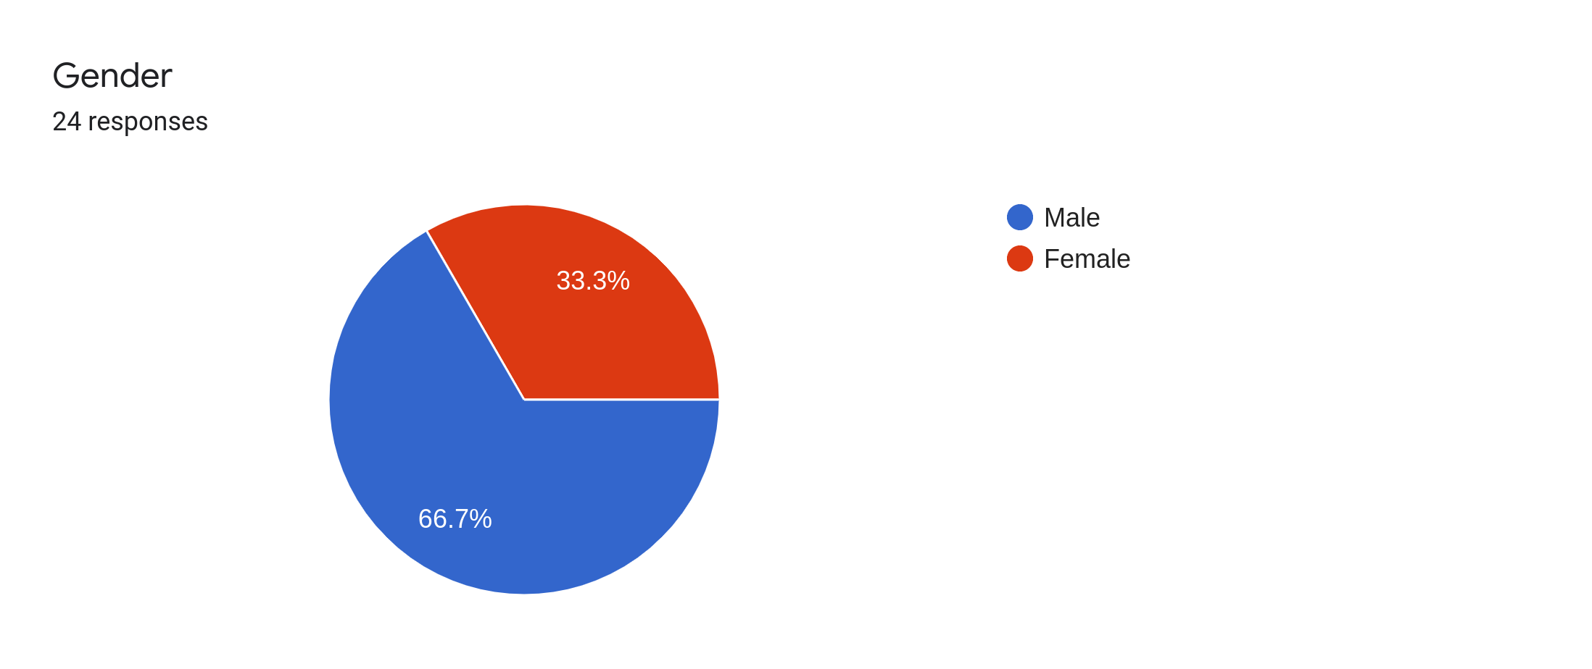Figure 3: Participants by gender

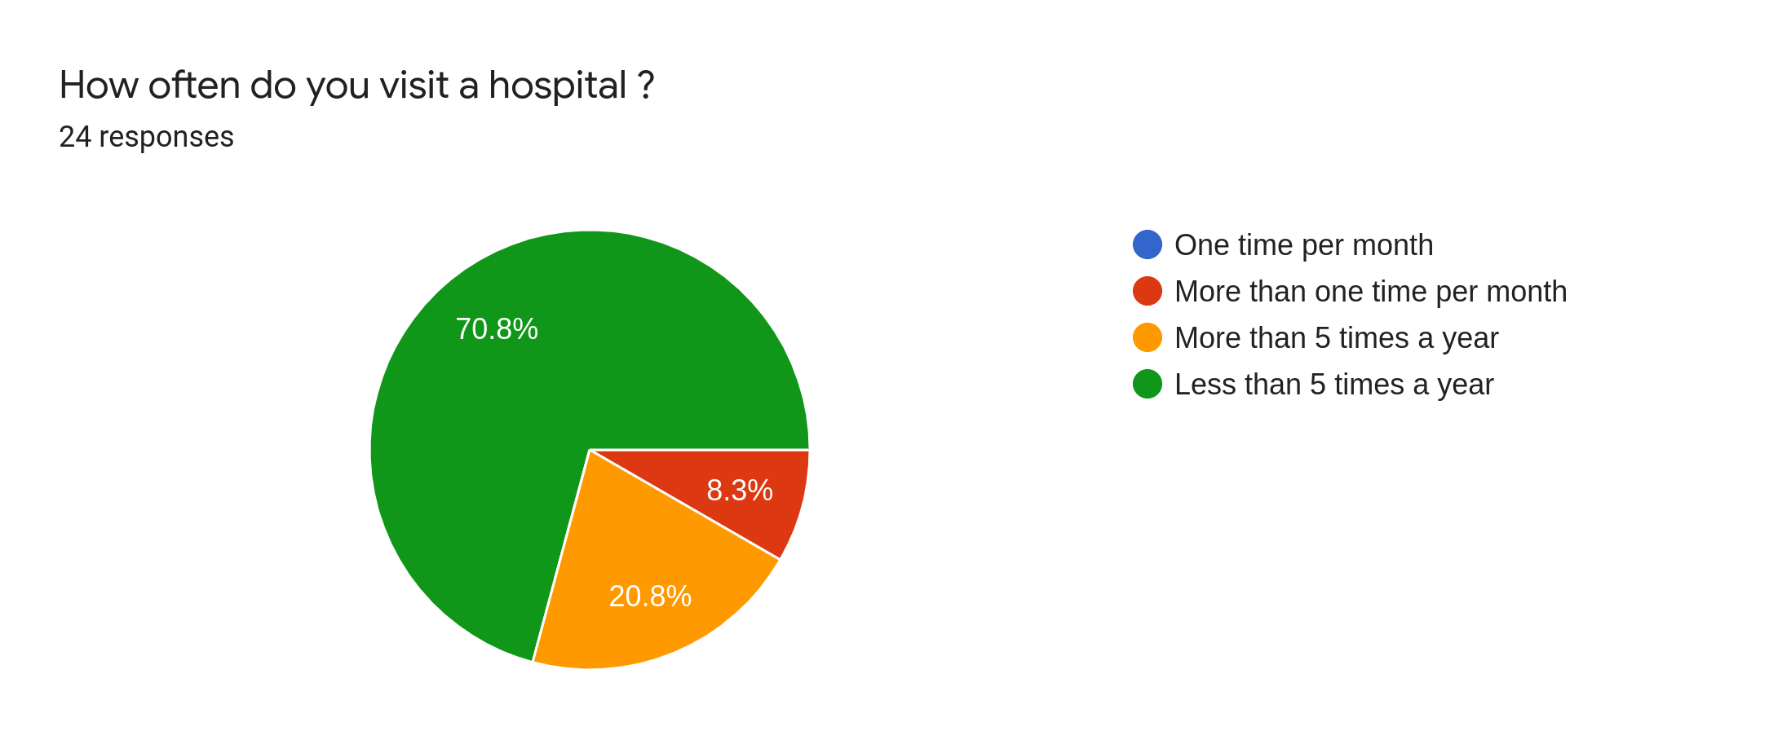Figure 4: The frequency of hospital visits

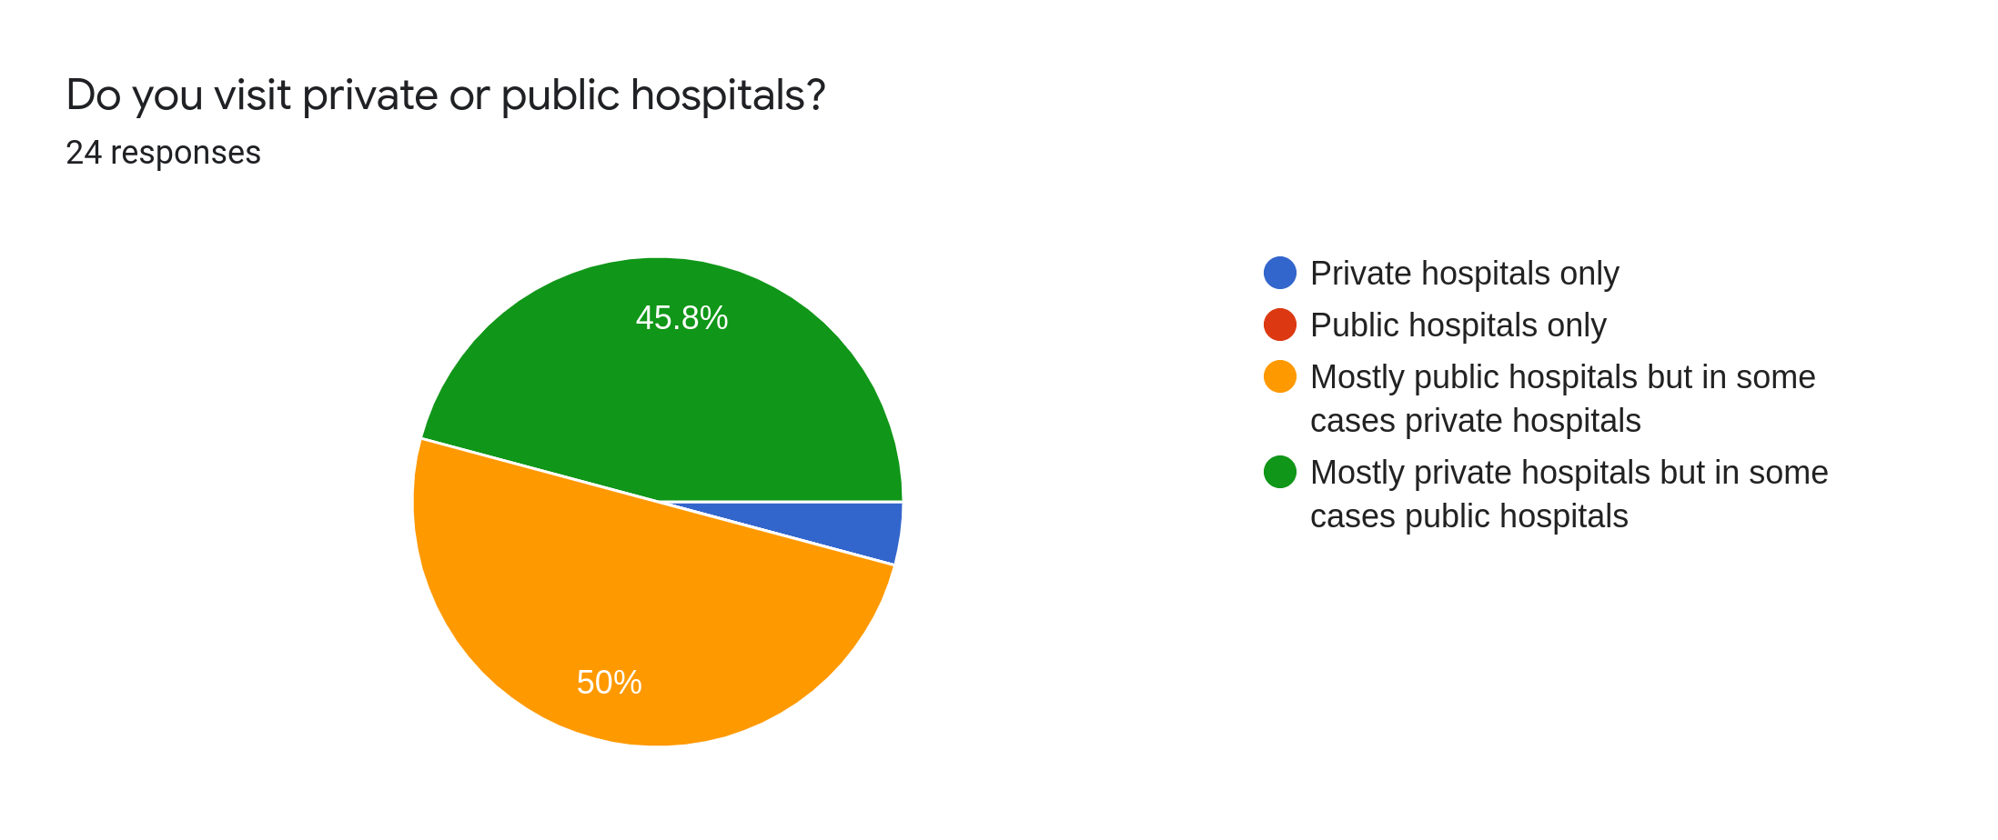Figure 5: Frequency of visiting public hospitals

Most of the people in Sri Lanka are visiting public hospitals much more than they visit private hospitals and most of the public hospitals if not all do not have computerized patient management systems or patient record systems.

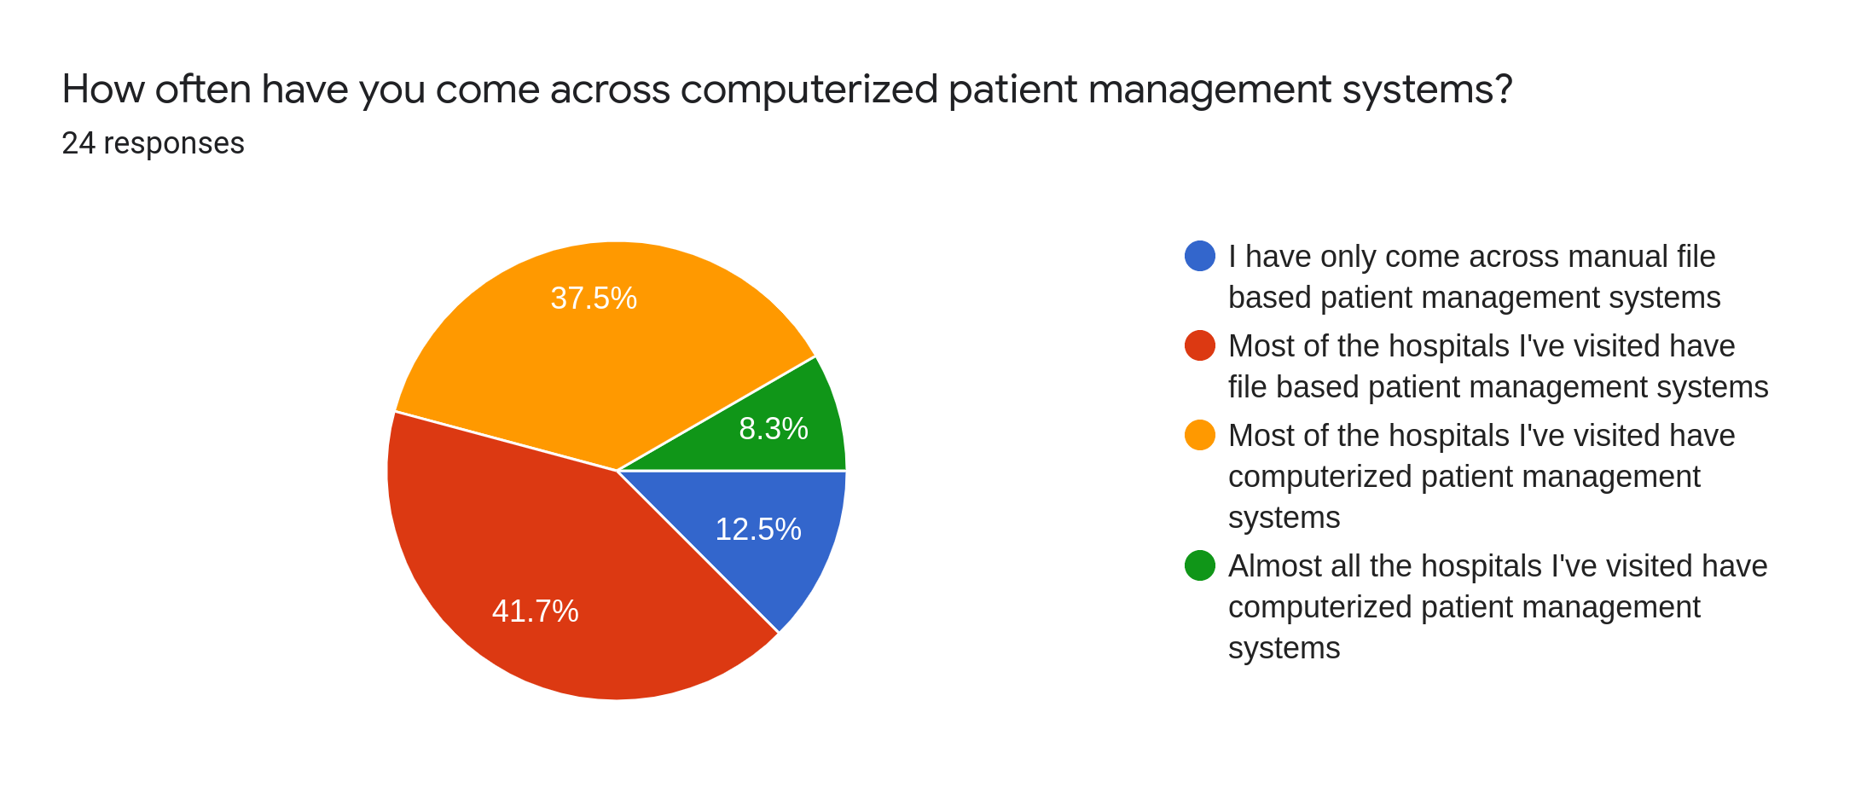Figure 6: The frequency of coming across computerized patient management systems

Most of the people do not visit hospitals with computerized health management systems.

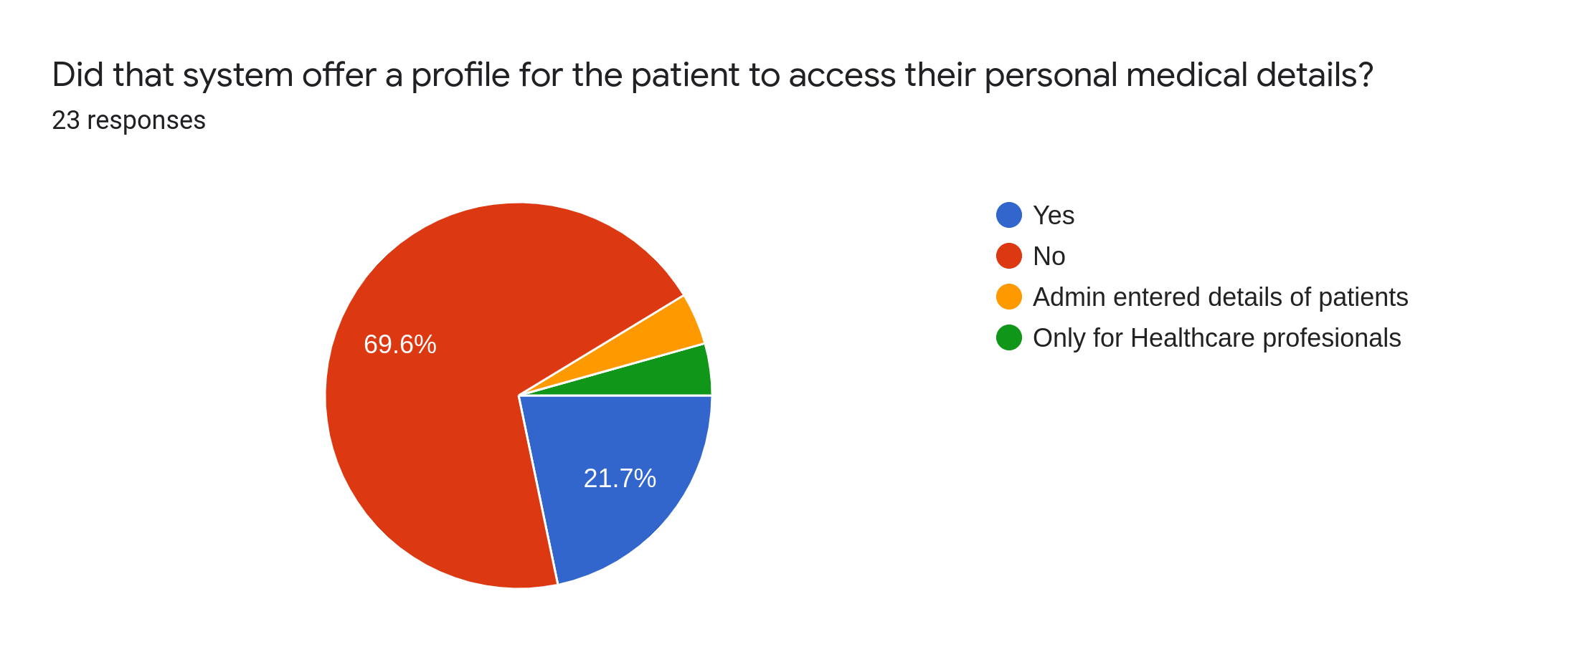Figure 7: Patients access to their medical details
69.6% of the people have replied that they were not offered profiles that would give them access to their own medical details. What this implies is that most of the computerized systems in hospitals are for management of the bills and other document work rather than patient management.
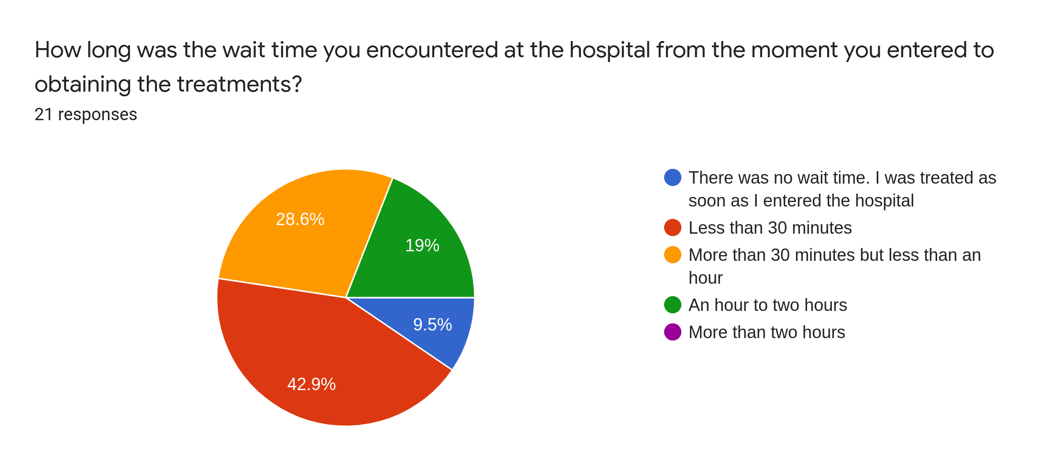Figure 8: Wait times at the hospital

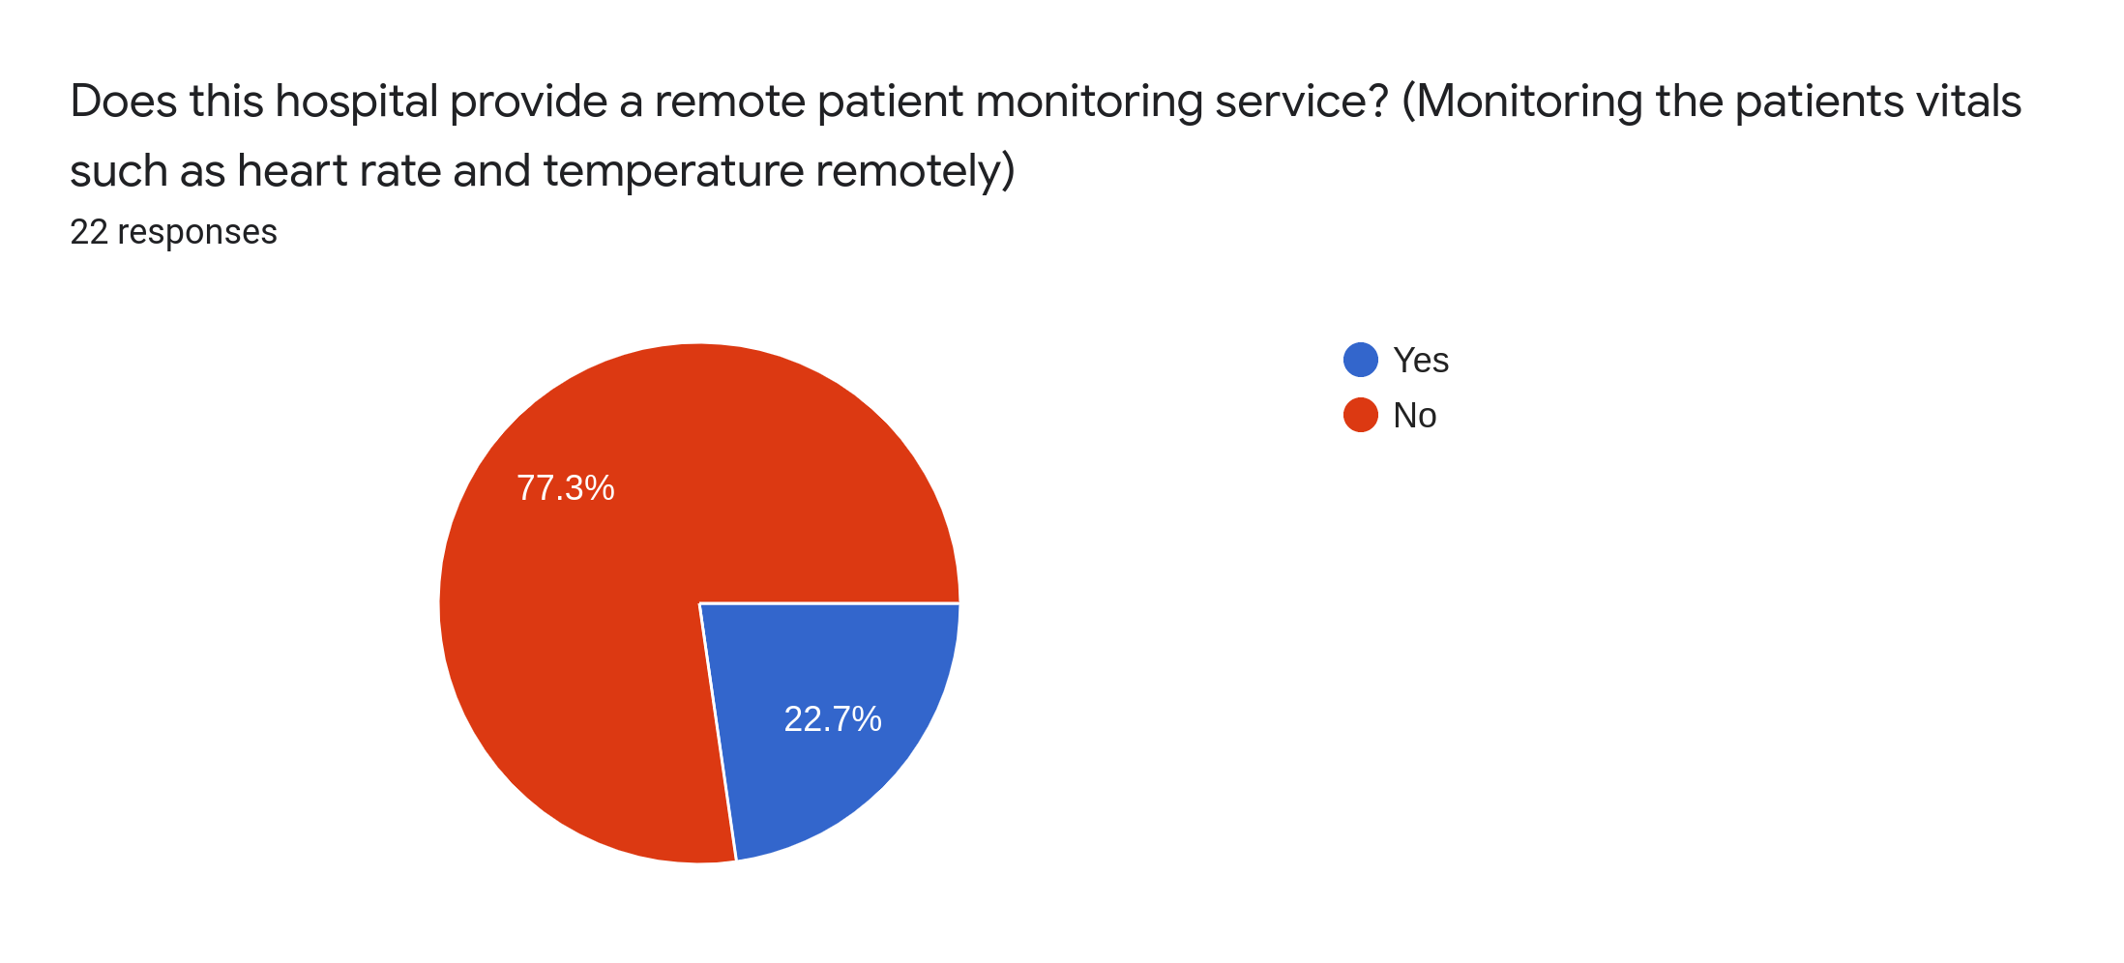Figure 9: Whether the hospital provides remote monitoring

Most of the people in Sri Lanka do not get the facility of remote monitoring and according to this chart 77.3% of the participants have said that the hospital they visit do not offer remote patient management.

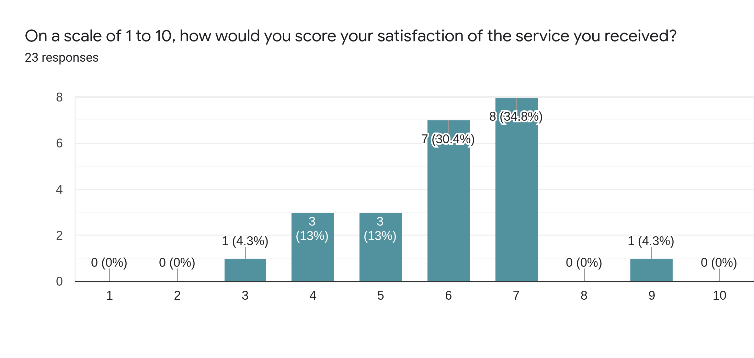Figure 10: Satisfaction of service

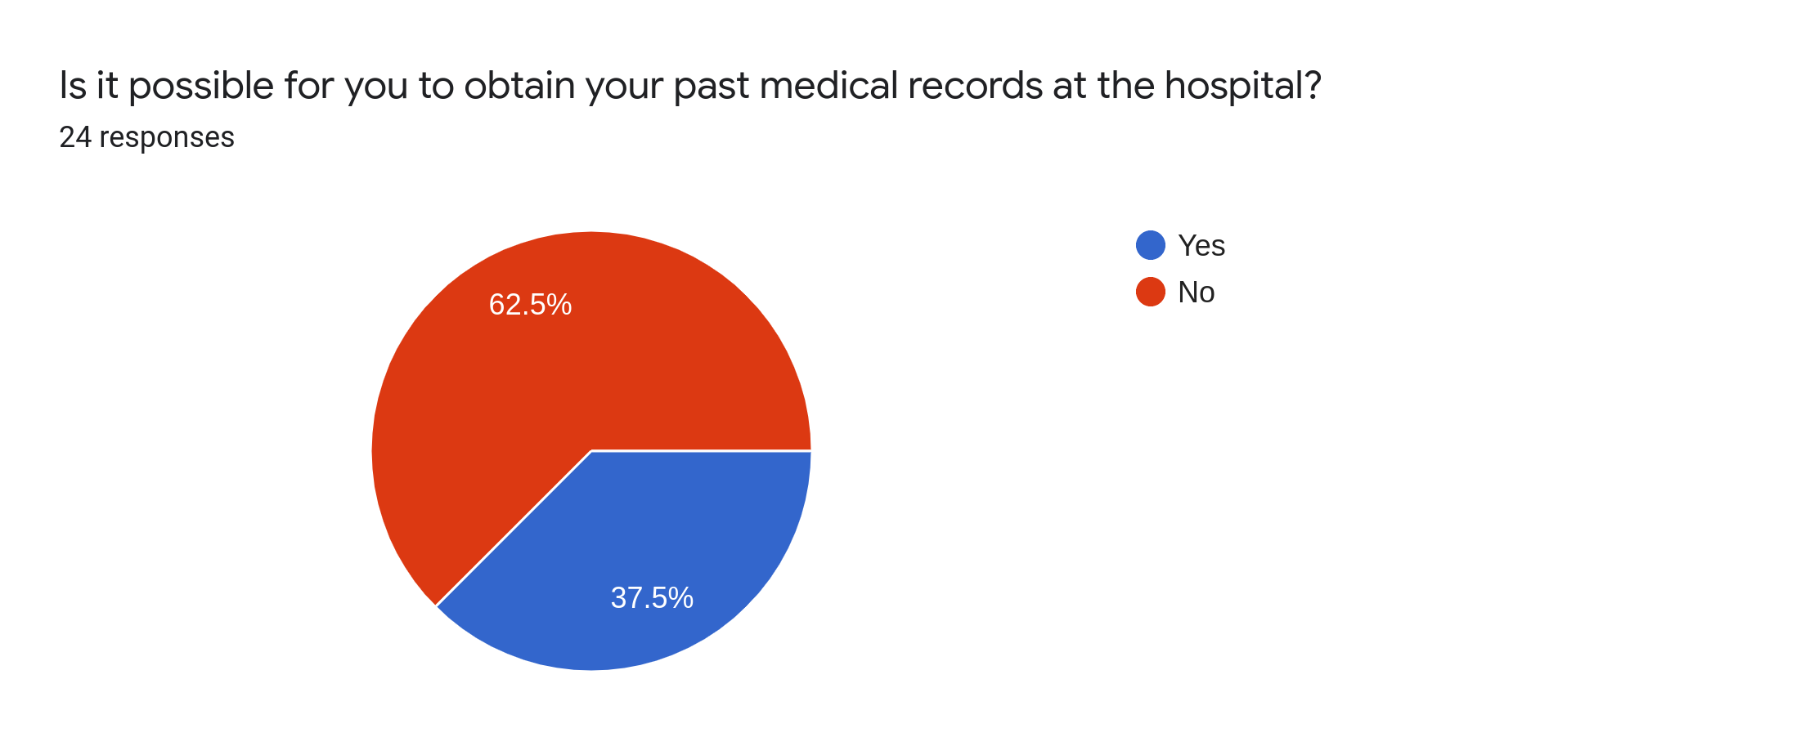Figure 11: Possibiility of obtaining past medical details

According to this chart, majority of the people do not have the ability to obtain their past medical details, either digitally or in physical file format.

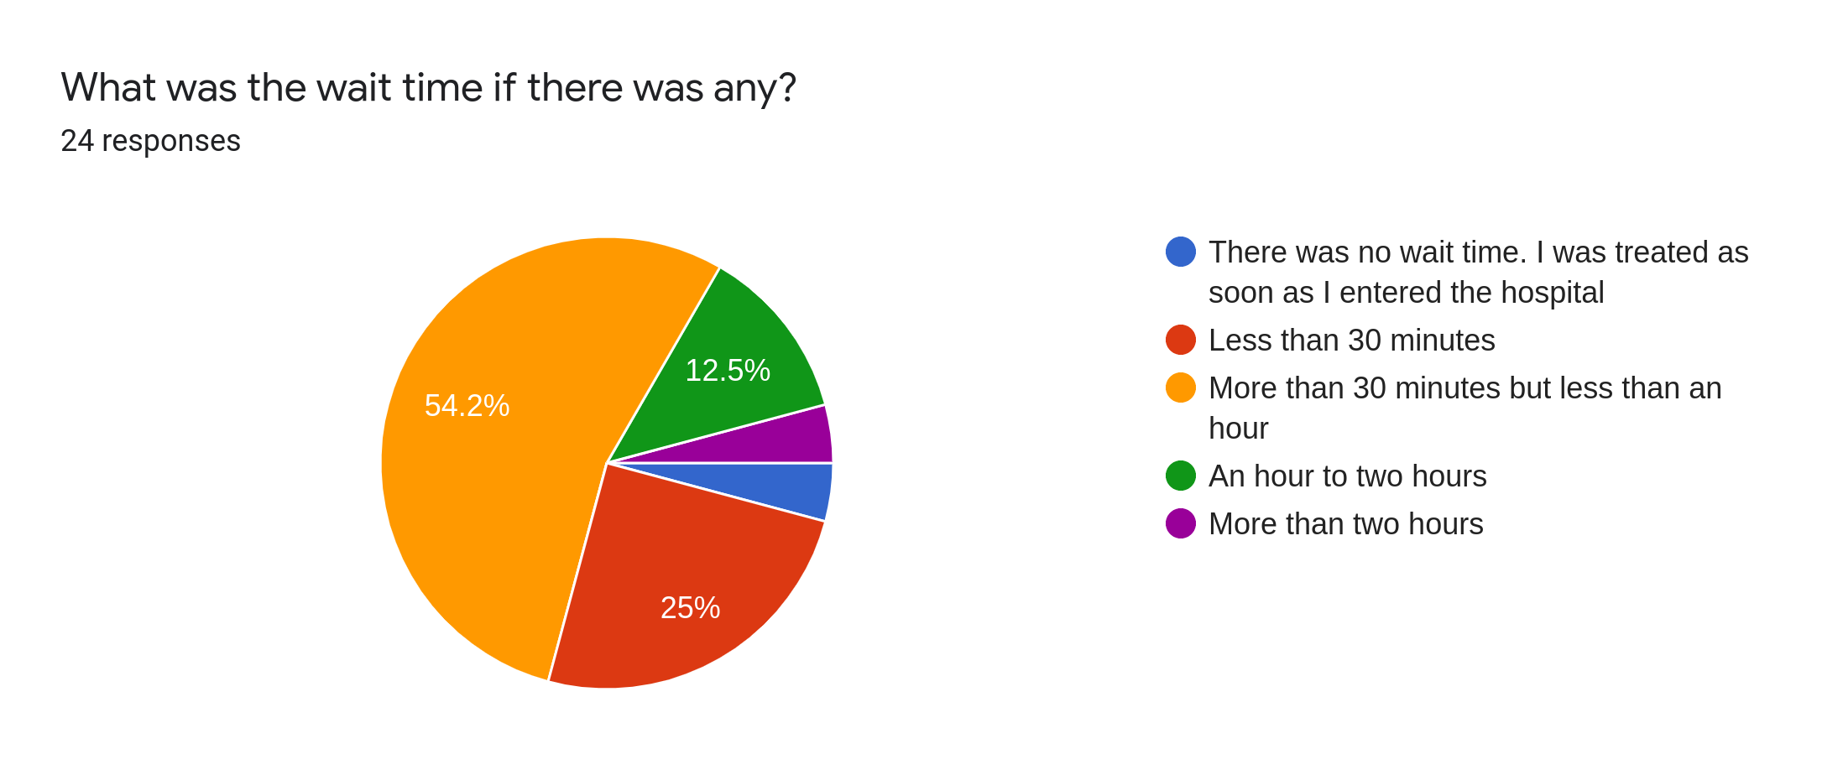Figure 12: Wait times

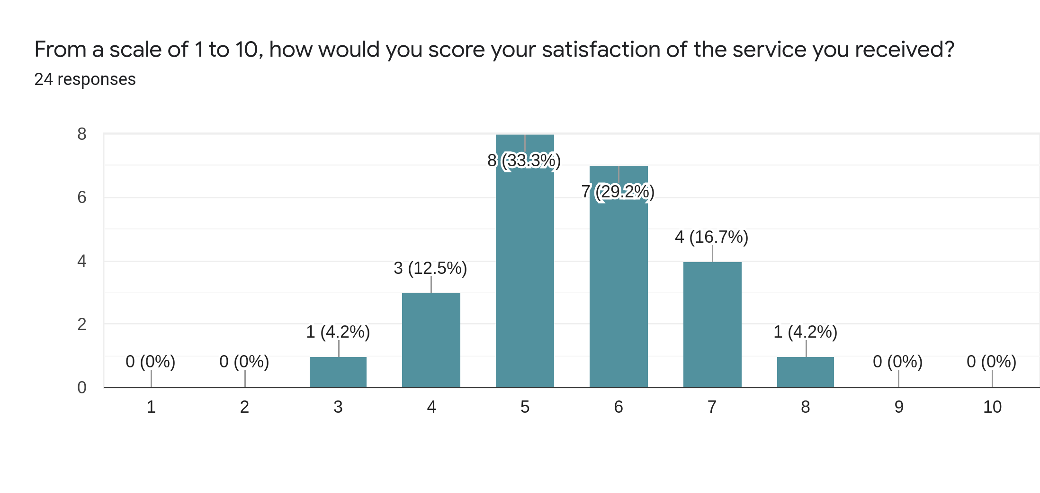Figure 13: Satisfaction of service

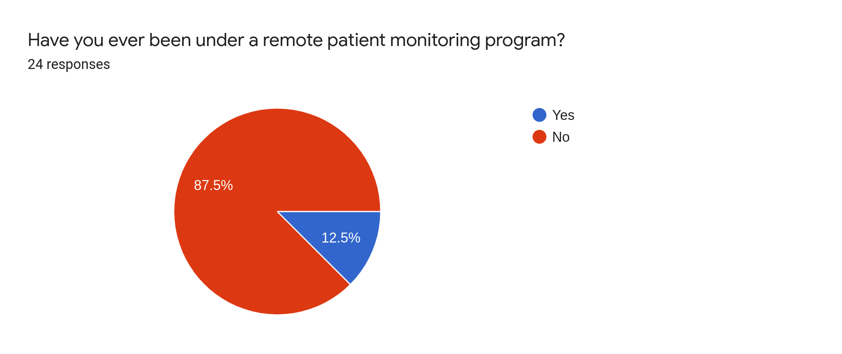Figure 14: Whether the participants have been in a remote monitoring program

87.5% of the people have not undertaken remote monitoring. This could very well be that they haven’t had the need for such a treatment. But this also could mean that most of the medical institutions lack the technology to offer a remote monitoring service.

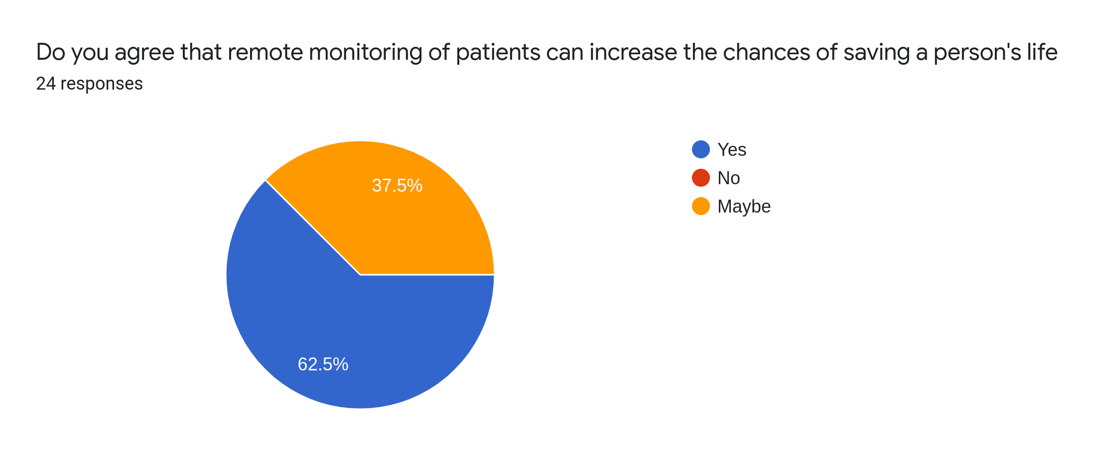Figure 15: Perception on whether remote monitoring saving the lives of people

Almost all of the people are in favor of a remote monitoring service according to this finding. 62.5% believe that it would actually help in saving peoples lives, even though the rest seem to be a bit skeptical, none has said no. This finding shows that there is an importance for a remote monitoring system in Sri Lanka at the national level.
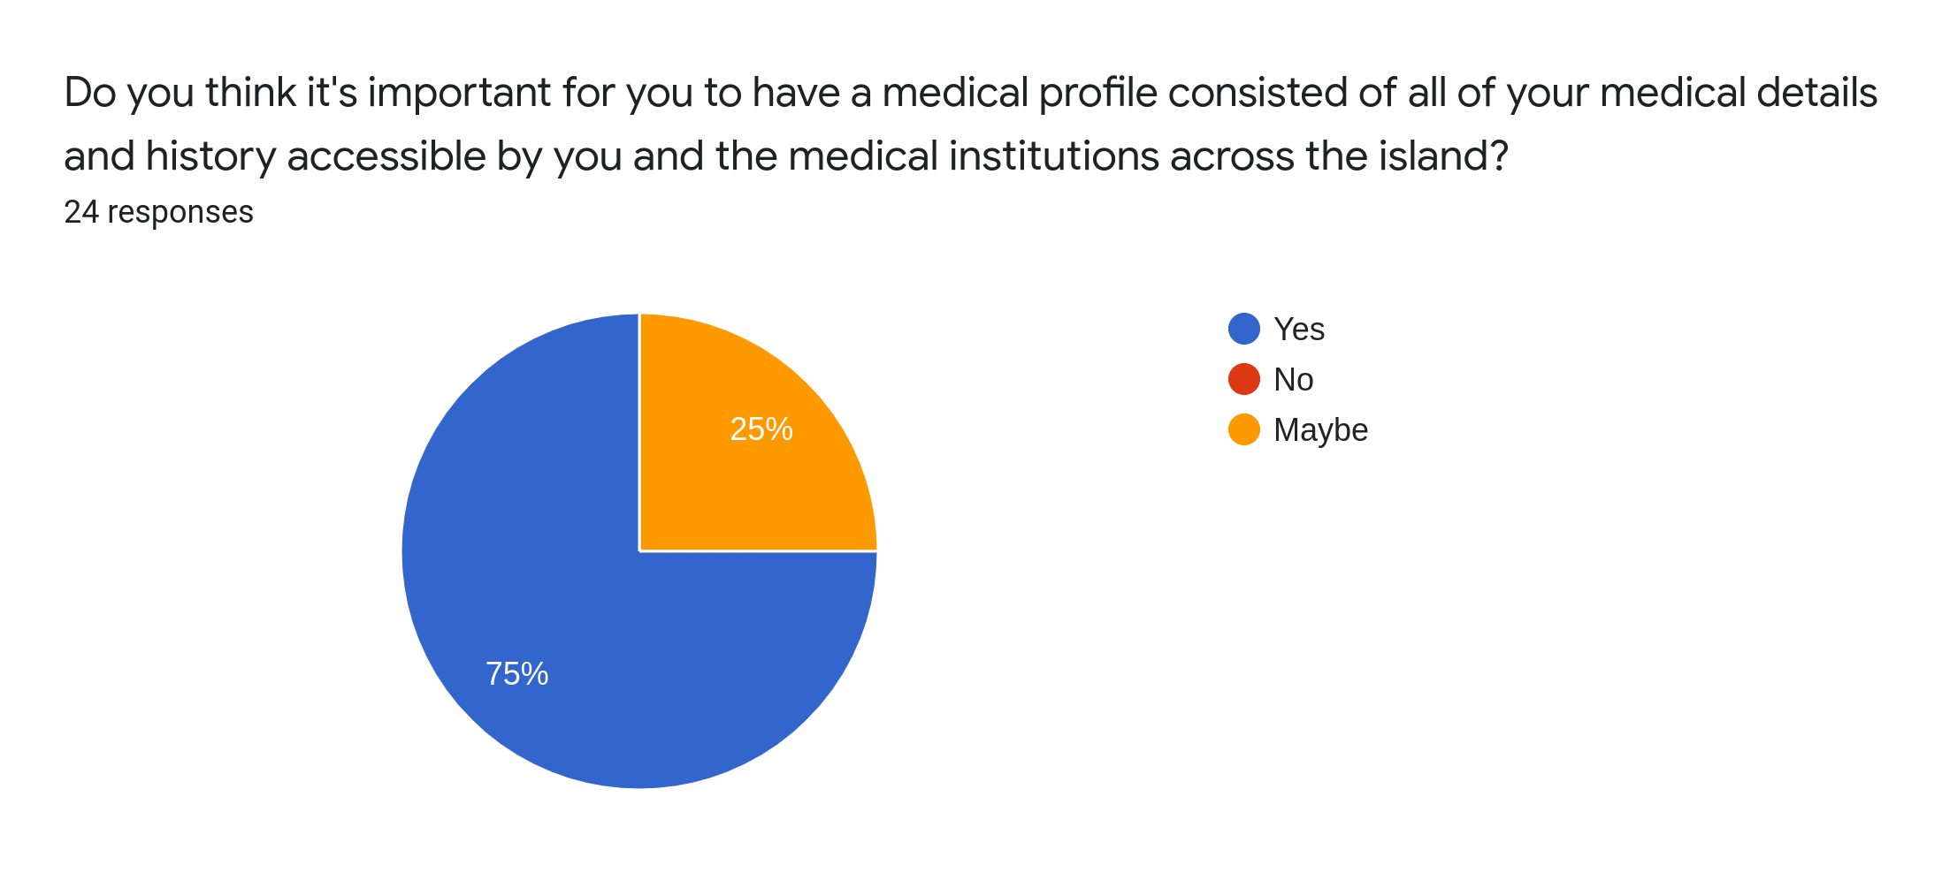Figure 16: Importance of having a medical profile

75% of the people have said yes to having access for their medical details and medical history through a health profile system. The percentage of people in Sri Lanka who are interested on having a personal health profile that include all their medical details is higher than those who would want a remote monitoring service.

According to these findings it is conclusive that a system that is consisted of both of these systems, a remote monitoring functionality and electronic patient management system with patient profiles would satisfy a large set of people in Sri Lanka.

  - Literature Review

SHMS is a product that is built by putting together a patient management system and a remote monitoring system of patients for the hospitals of Sri Lanka. The concept behind this originated with the increased utilization of information technology in the global health care industry which seem to be lacking in Sri Lanka. In the developed world almost all the hospitals are computerized with systems that are used to manage patients and their medical records. The hospitals utilize various forms of remote monitoring technologies for remotely monitoring the patients and in some cases remotely providing the medications for certain illnesses. SHMS utilizes a device developed using IOT technologies for this purpose couple with a web application that utilizes a No-SQL database system.

A number of research articles have been reviewed in this literature review that has a relevance to the research area of this project. The reviewed articles vary from theoretical studies to actual technologies developed in the focused area of research.

The international conference on Soft Computer Systems. (Suresh, 2015)⁠

Vital sign measurement of patients has been a very important task for decades. Continuous monitoring is essential in order to identify abnormal conditions. Monitoring of blood pressure, pulse rate and body temperature happens under any form of monitoring and are key measurements of vital sign observation. A health monitoring system includes continuous collection of vitals, evaluation of vital signs, transmission of data over the internet and transmission of data via cellular connections in emergency situations (Suresh, 2015)⁠. In order to facilitate continuous monitoring, this study suggests “ipath”. Retrieval of data, storing of data in the database and the control of access is handled by the base class of the software. Being a cloud based system has been helpful in cutting networking costs impactfully. Wireless networks of sensors are applied for health monitoring which places multiple sensors on the body of the patient which communicate with a cluster node(Suresh, 2015)⁠. Assessment of pulse of can reveal the status of health of the person and has been using in medicine for centuries. Development of systems that have the ability to automate this process to a certain extent is beneficial for smarten up the continuous patient monitoring. Certain monitoring systems have the capability to identify the patterns of pulse and provide QRS detection (QRS complex, no date)⁠ and arrhythmia classification(Arrhythmia Classification, no date)

An Internet of Things (IoT) Application for Standard Clinical ECG Monitoring in Real Time Application (Hadiyoso, Rizal and Alfaruq, 2019)⁠

Real-time monitoring and control devices is an advancement in various industrial sectors globally due to the ease of access, higher level of flexibility and demand. Application of IOT technologies in the health care sector has given birth to a new paradigm called IoMT which stands for Internet of Things Medical (Hadiyoso, Rizal and Alfaruq, 2019)⁠. Medical devices developed with IOT technologies (IoMT) acquires vital signals of humans and the data is simultaneously sent over to cloud and to the subsequent system for further analysis (Hadiyoso, Rizal and Alfaruq, 2019)⁠. Shape of the ECG signal is one of the most important and critical parameters that indicates the condition of the heart and long time continuous monitoring of ECG through smart ECG equipment connected with the monitoring application is required for certain patients who are undergoing critical circumstances (Hadiyoso, Rizal and Alfaruq, 2019)⁠.

Remote monitoring systems utilizes a client server architecture like most of the computer systems in the world. The concept of client-server is widely used in data collection, storage and sharing applications. The client side typically has a GUI particularly when it comes to health care industry in order to provide a simplified and non confusing interface for the staff to work with without having to require an IT literacy. Command line is used on the server side. Client-server architecture is utilized as a distributed system to facilitate large number of patients and connected IOT devices from hundreds of different locations.

One of the most important parameters of a remote monitoring system is the delay that occurs between the origination of the signal from the IoMT device and representation of the data on the client program. “Based on ITU-T forum on QoS Performance requirements for Data
(Telemetry) Realtime service, the maximum tolerance delay on real-time data applications is <250ms” (Hadiyoso, Rizal and Alfaruq, 2019)⁠ .

The impact of a remote health monitoring system of health resource consumption in patients on automated peritoneal dialysis (APD) : A simulation study (Uchiyama et al., 2018)⁠

According to a research conducted by Dr. K. Feistle and Dustri-Verlag remote monitoring has been used successfully in Japan for the management of diseases such as Chronic Obstructive Pulmonary heart disease and Congestive Heart Failure leading to reduction in hospitalization of heart patients by 29% and reduction of deaths by heart failure by 20% (Uchiyama et al., 2018)⁠. Another area where remote monitoring is widely used in Japan is in implantable cardiac devices.

The increase of the dialysis patients in Japan has resulted in rising health care expenditure in hemodialysis clinics but new ventures towards IoMT have enabled home based personalized peritoneal dialysis treatments which has resulted in reduced treatment costs (Uchiyama et al., 2018)⁠. The treatment is provided by an automated remote device that performs peritoneal dialysis while the patient is sleeping which is done for the improved quality of life of the patient however the research does not discuss about the client side software associated with the remote treatment devices. The exact client side controls used by the doctors are unclear. The following diagram explains how the remote peritoneal dialysis is done.

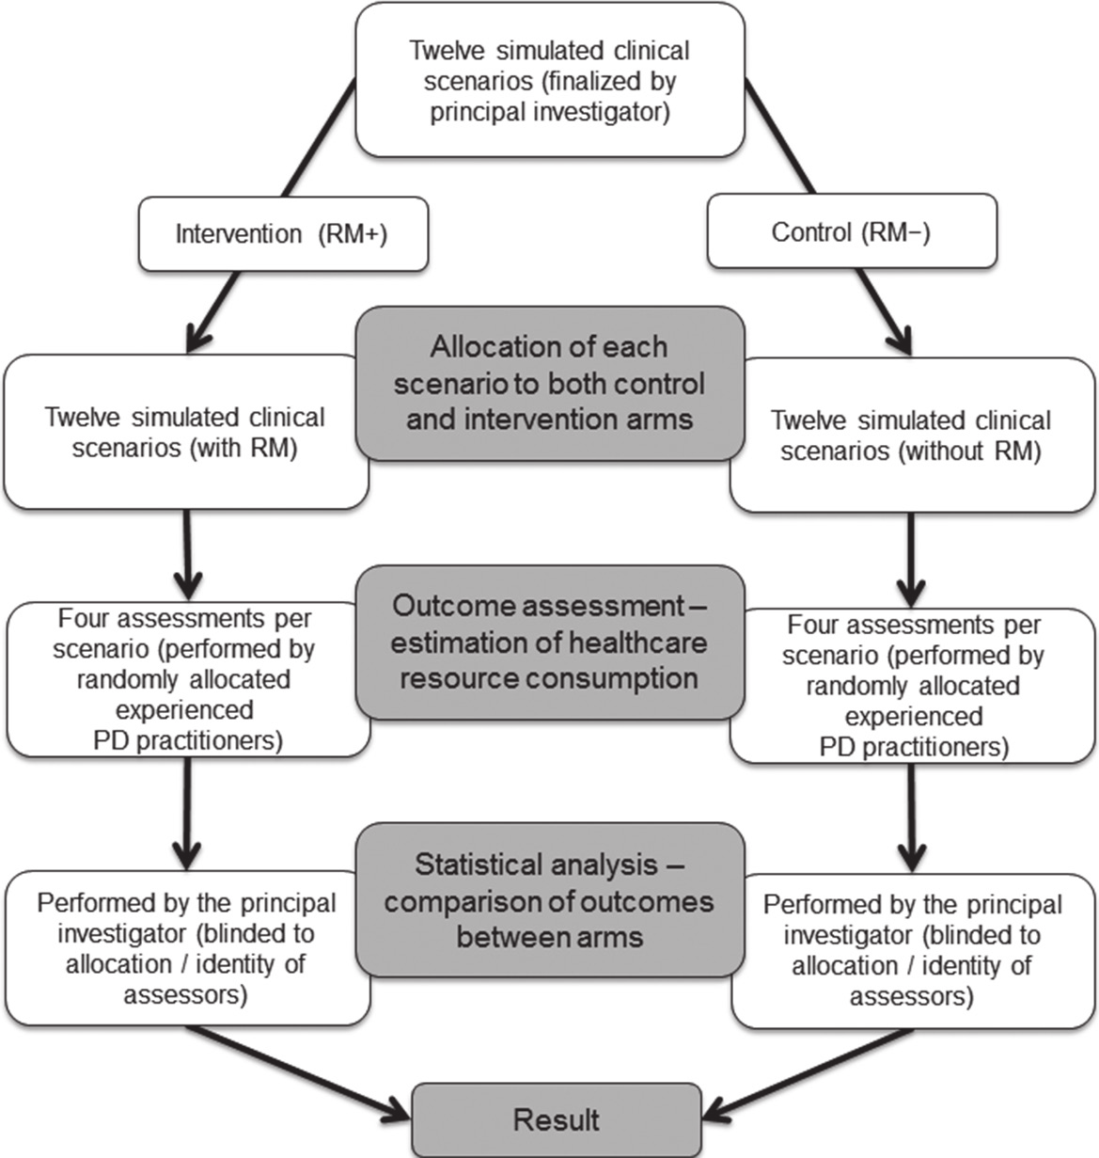Figure 17: Remote Peritoneal Dialysis | PD - Perotneal Dialysis | RM - Remote Monitoring
(Uchiyama et al., 2018)⁠

The treatment data, blood pressure and body weight of the patients are uploaded and stored in an internet based system through which prescriptions are uploaded to the APD machine by the health care professional. The outcomes of the study are as follows.

Simulated clinical scenarios were prepared with hypothetical patients in order to have a comparison between the resource consumption of a patient who is under Remote Monitoring and one who is not. The group of patients under Remote Monitoring was named RM+ and the other group was named RM-. Twelve(12) patients were simulated in the experiment. The expected outcome of the experiment was the resource consumption between the two groups for nine different categories (Uchiyama et al., 2018)⁠.
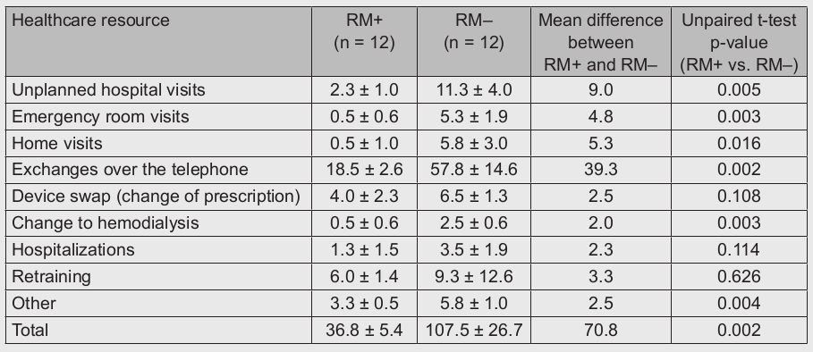Figure 18: Frequency of healthcare resource consumption episodes in the RM+ and RM– groups, summarized across the four assessments of each scenario
The experiment resulted in incredible data. The patients who belonged to RM+ group which used Remote Monitoring consumed significantly less resources than the group of patients who belonged to RM- group that did not use Remote Monitoring.

“The RM+ group showed significantly lower resource consumption in the following
categories: unplanned hospital visits (2.3 ± 1.0 vs. 11.3 ± 4.0 events, p = 0.005); emer-gency room visits (0.5 ± 0.6 vs. 5.3 ± 1.9 events, p = 0.003); home visits (0.5 ± 1.0 vs. 5.8 ± 3.0 events, p = 0.016); exchanges over the telephone (18.5 ± 2.6 vs. 57.8 ± 14.6, p= 0.002); change to hemodialysis (0.5 ± 0.6 vs. 2.5 ± 0.6, p = 0.003), and other (including medical audit, additional prescription, blood tests, domiciliary care, retraining for nurses) (3.3 ± 0.5 vs. 5.8 ± 1.0, p = 0.004)” (Uchiyama et al., 2018)⁠

The most significant change was regarding the amount of telephone call exchanges between the medical professionals and the patients. Remote monitoring seems to have almost eliminated the need for that. The results are a clear indication of the improvement of efficiency with regards to providing medical treatments that is achievable with Remote Monitoring.

Accuracy of wrist-Worn wearable device for monitoring heart rates in hospital inpatients : A prospective observational study. (Kroll, Boyd and Maslove, 2016)⁠

Other than the purpose oriented sophisticated remote monitoring and automated medication providing devices, usage of less expensive less sophisticated, cheaper and comfortable wearable devices have been under focus for many years. Currently, wearable devices have limited deployment in a professional health care setting. The limitations arises from the miniaturization of the components of the wearable in order to design it to be seamlessly integrated with the daily life of the patient. The clinical use cases for wearable at the time of this study (2016) is limited to outpatient treatments and ambulatory care (Kroll, Boyd and Maslove, 2016)⁠. Most of the focus is on the chronic diseases. Applications of this include these : “long-term ambulatory electrocardiogram (ECG) monitoring, optimizing pulmonary rehabilitation in patients with chronic obstructive pulmonary disease, and monitoring motor function in stroke patients as well as patients with Parkinson disease”(Kroll, Boyd and Maslove, 2016).
Modern wearable devices have intuitive technologies that allows monitoring of heart rate fairly accurately with tiny sensors. Photoplethysmography is a technology that is used in modern wearable devices that uses the differential reflection of light from the skin based on the “pulsatility of the superficial blood vessels”(Kroll, Boyd and Maslove, 2016)⁠. However the reliability and accuracy of Photoplethysmography sensors in an inpatient setting has not been tested firmly though they are used for outpatients. The accuracy of a typical off the shelf wearable is also uncertain and are is preferred in medical environments.

In order to measure the accuracy of Personal Fit Tracker(PFT) readings relatively to ECG reading and experiment was conducted. Fitbit Charge HR devices were used among 50 patients who were being treated in an Intensive Care Unit in Kingston General Hospital, Ontario, Canada. The PFT was a wearable that is worn on the wrist. The devices used Photoplethysmography technology. Pulse rate values were records periodically every 5 minutes. Every single patient who were subjected to the test had stable health conditions. All patients were connected to the ECG devices of the hospital to gather the pulse data generated by the ICU equipment. The difference of readings between PFTs and ECG machines were measured simultaneously. One beat per second median difference was observed between the PFTs and ECGs. Significant differences were observed between the distribution of pulse rate data obtained from PFT and ECG equipment. The accuracy of a PFT device was observed to be lower than an ECG device (Kroll, Boyd and Maslove, 2016)⁠.

The impact of health information technology on patient safety (Alotaibi and Federico, 2017)⁠

A subset of health care is patient safety. Patient safety is often associated with the safety of all the aspect of a person as a patient. This includes not only their personal physical belongings, but their digital information and privacy. The safety of the life of the patient is an obvious factor that is regarded at the highest order. With the rise of the use of Information Technology in health care, ways that IT can help at improving the patient safety are looked at. Health Information Technology allows reduction of human errors, improvements to clinical outcomes, improvement to the efficiency of practice and tracking of the medical data (Alotaibi and Federico, 2017)⁠. Studies in this area have been conducted in both community and inpatient settings with the intervention of Electronic Physicians Orders (CPOE), Clinical Decision Support (CDS), E-Prescribing, Electronic sign out, Administration of medication via bar codes (BCMA), Automated Medication Dispensing Cabinets, Electronic Medication Administration Records (EMAR), Patient Data Management Systems (PDMS), Patient Electronic Portals, Retained Surgical Item Detectors, Telemedicine, Electronic Incident Reporting with the intended primary outcomes of the safety of the patients, medical and medication errors, adverse events of all sorts and mortality rates (Alotaibi and Federico, 2017)⁠.
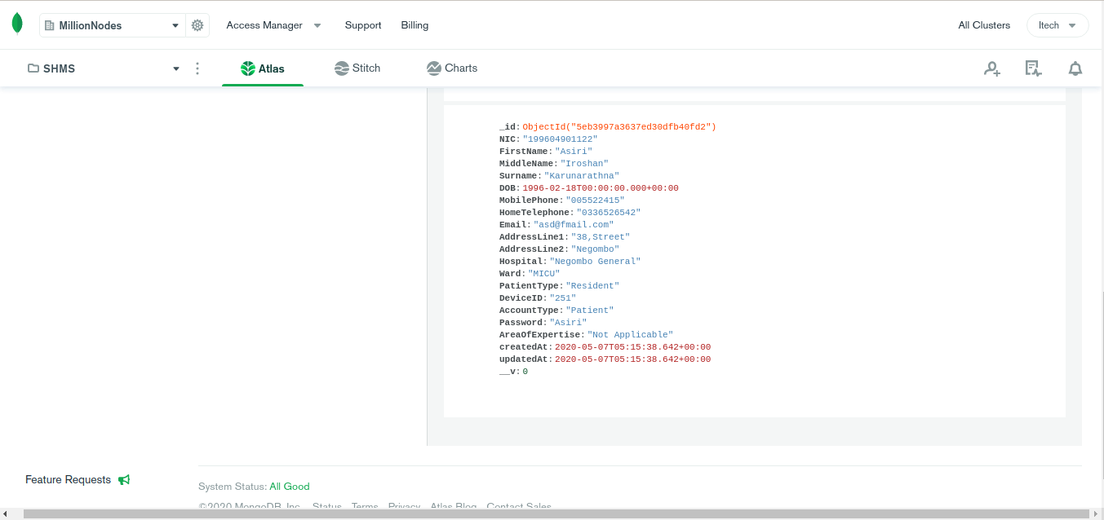Figure 19: An inserted user record

E prescribing or computerized electronic physicians orders are usually integrated with clinical decision support systems for improved accuracy and error prevention. These systems have been developed for the orderly administration of medication in order to improve the safety of the medication orders and have evolved to the point where they are capable of ordering tests, procedures and consultations(Alotaibi and Federico, 2017)⁠. Clinical decision support(CDS) systems with which the e prescribing systems are usually integrated, guide the prescription on the drug dosage, frequency of administration and the procedure. This is important as clinical decision support systems provide the health care professional patient specific information with a range of tool sets for enhancement of the clinical work flow and aid in decision making. Advanced systems are capable of prompting the prescriber about the allergies of the patient and their previous interactions with the drugs. More sophisticated systems are capable of prompting the prescriber to intervene under clinical guideline recommendations.
A meta analysis conducted with regards to the capability of Computerized Electronic Physicians Orders to reduce the medication errors have found out that the use of CPOE systems result in significant reduction of medical errors (RR:0.46; 95% CI 0.31 to 0.71)(Alotaibi and Federico, 2017)⁠. But for this result to occur, both CPOE and CDS support systems have to be integrated. CPOE acting alone would not result in advancements. It is important to mention that CPOE systems are one of the most rigorously tested and technologies in the field of health information technology. But the effectiveness of the system only goes as far as the professional who is in charge of executing the decisions. A study that evaluated 18,115 drug alerts in the Boston area, USA found out that 33% of the alerts were ignored by the physicians. In order to address this, several clinical trials and studies were conducted. It has been found out that the systems which provide simple advises are more likely to be ignored where as the systems which provide comprehensive advises and guidelines and demands the physician to justify their decision for ignoring or overriding the CDS advice are far less likely to be ignored. Providing the medical advice to both the patient and the physician has also proven to be effective towards reducing the likelihood of physicians ignoring or overriding CDS recommendations.

Electronic “sign out”, which is also called “hand over” is a process in the health information technology that is developed for ensuring the consistency and continuity of the patient care and safety when the caregivers shift from one set to another or when the care giving shifts to the family from the assigned set of caregivers. These applications are integrated with the electronic medical record systems most of the time but standalone solutions exist. According to studies conducted, it has been found out that electronic hand over systems have result in reductions of losses of patient medicare details while improving the speed of the handing over process (Alotaibi and Federico, 2017)⁠.

Bar code based medicine administration systems are also being used in modern health care industry. These systems integrate medication administration records with bar codes. Systems vary by sophistication. These systems ensures that the right patient receives the right medication at the right time(Alotaibi and Federico, 2017)⁠.

Effects of computerized patient records on patients (B N et al., 2015)⁠

This study ventures in to understanding the positive and negative effects a computerized patient management system could have on patients. It has identified four positive effects.

- Availability of medical records
- Improved diagnostics and treatments
- Cost reductions
- Improved patient safety

The study has identified patient security and privacy as a possible negative effect that could arise from computerization of medical records management.
Computerized medical records are better organized than conventional medical records and provide the ability to search for the needed records with the use of various search parameters and the output can be generated, depending on the design and the capability of the system, in many different formats which can be convenient when it comes to communication of the particular data(B N et al., 2015)⁠. Computerization offers the advantage of the ability to organize the data in clear and adaptive layouts. Properly made systems stores the data encrypted in a structured and unambiguous manner which helps the user in displaying, entering and retrieving data. Systems can be designed to present the data that the user retrieves in multiple different formats such as system generated voice recordings, emails, pagers and online medical profiles (B N et al., 2015)⁠. Systems can be made capable of communicating with remote micro controller devices that control medical devices such as automatic pill dispensers, insulin infusion pumps and connected liquid medicine dispensers. The study has mostly focused on remotely connected basic IOT devices controlled remotely by a software application which are not capable of intelligently provide the medication like the advanced medical systems described in the previous study.

Computerized patient record system is defined as a conglomeration of the functionality of Clinical Decision Making, Computerized Physician Order Entry and Health Information Exchange systems (B N et al., 2015)⁠.

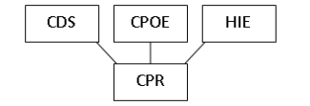Figure 20: Components of Computerized Patient Records

The newly addition in this study that was not discussed in the previous reviewed studies is Health Information Exchange systems. Health Information Exchange systems enables exchanging health information of patients between two or more health care companies or hospitals(B N et al., 2015)⁠. This enables a patient to receive consistent and accurate treatments from multiple health institutions without having to undergo the hassle of resubmitting medical records and prescription details to the next hospital or health care institution the patient attends.

The study further investigates the reduction of costs for a health care institution with the utilization of computerized patient records which could reflect in the bill to the patient. Reduction of paper based documents and reduction of staff time and effort involved with maintaining documents could result in the cost reductions. Another way the system could reduce the cost associated with medication is due to not having to conduct pre-tests which would otherwise be conducted in cases where the previous medical records do not exist (B N et al., 2015)⁠. The final cost would be considerably lower to the institution which would reflect in the bill resulting in reduced costs to the patient as well.

The study explains the added safety of computerized patient records in a different manner than in the previous reviewed studies. The safety of the patient is improved due to various forms of visual alerts such as LED indicators and LCD screens and/or audible alerts such as beeps or voice alerts through speakers. These alerts would indicate mishaps of medical prescriptions to the patients identified with the availability of the medical history of the patients under a set of pre-set conditions or rules. Taking actions against any danger towards the patient is up to the person in charge, in this case, clinicians (B N et al., 2015)⁠.

The study has identified security vulnerabilities associated with computers and software application as a possible drawback of this system and has suggested multiple solutions to mitigate them. Most of the security issues could occur due to the lack of safeguards to protect the privacy of the patients as well as maintaining proper access to the system which could result in unauthorized people meddling with patient data. Following solutions have been suggested.

- Maintaining login and session management(B N et al., 2015)⁠.
- Using bio metrics in addition to passwords for securing profiles(B N et al., 2015)⁠.
- Usage of smart card that the patient keeps in possession that are required by the system to give access to a medical personal(B N et al., 2015)⁠.
- Employing cryptography technology for digital signature standards which are used to validate and verify data sent across a network(B N et al., 2015)⁠.
- Using audit trails to track every transaction and access that is made within the system.
- Maintaining regular data backups periodically and securing the data in a trusted server infrastructure(B N et al., 2015)⁠.
- Keep the system isolated from the internet with the use of firewalls, and keep each and every component within the system isolated using firewalls to stop malicious attacks that could come from outside the system.(B N et al., 2015)⁠

A study was carried out at BSN Memorial Hospital in Bangalore on the 5th April 2015 with regards to a Computerized Patient Record System. The study has obtained information on how the systems were employed at the hospital and their future scopes(B N et al., 2015)⁠. The hospital was using the system for Computerized Radiography and as a Hospital Management Information System (B N et al., 2015)⁠.

The system works as follows. The device captures an image and it is transferred to the computer called workstation. The physicians use the client software on the workstation to manipulate the picture and study it. The image then is transferred to another computer for the doctor to view and analyze(B N et al., 2015)⁠. The physician enter details when the images comes to him with regards to his expertise and the doctor does the same when the image comes to him.

The study has concluded that due to the high cost of initiation and maintenance, at the time the research was conducted, the demand for computerized patient record system was less than anticipated.
- System

  - Use Case Diagram
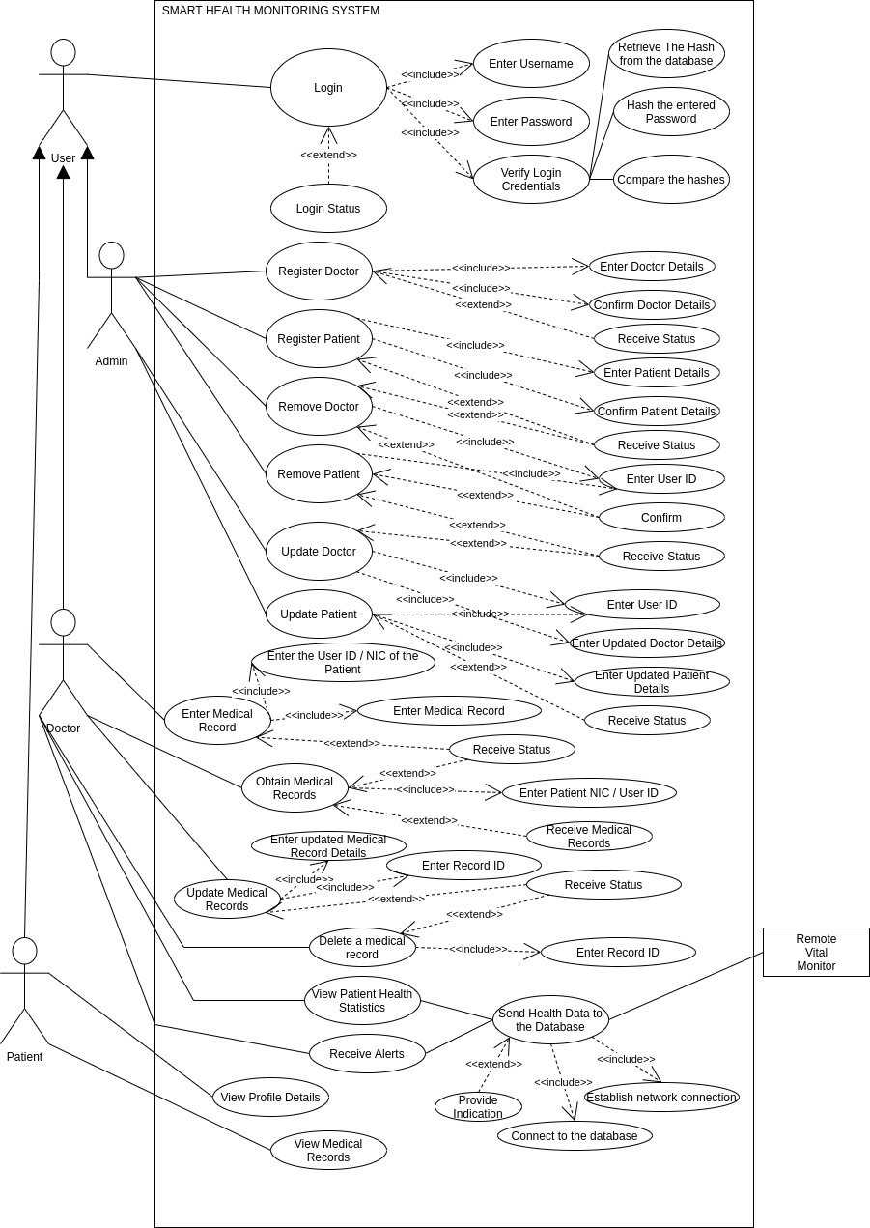Figure 21: Use Case Diagram
  - Architecture Diagram
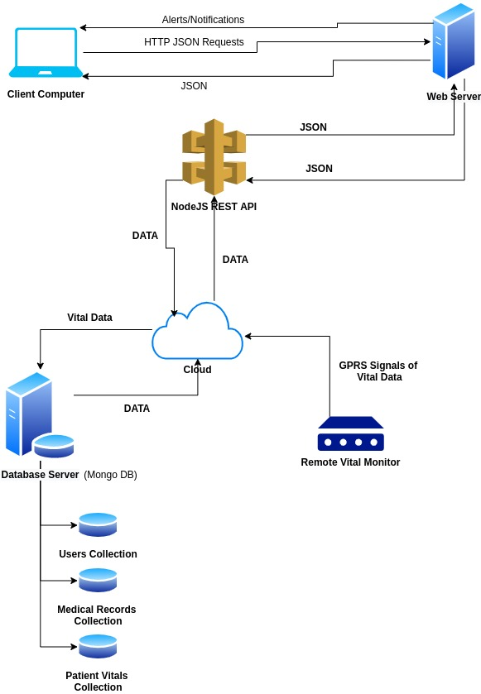Figure 22: Architecture Diagram
  - API Structure

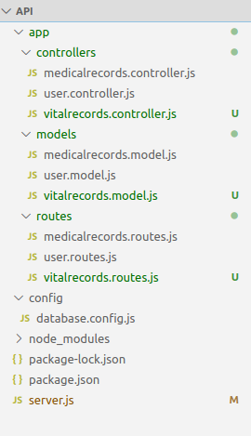Figure 23: Node API Project Structure

  - Cloud Database Dashboard Overview

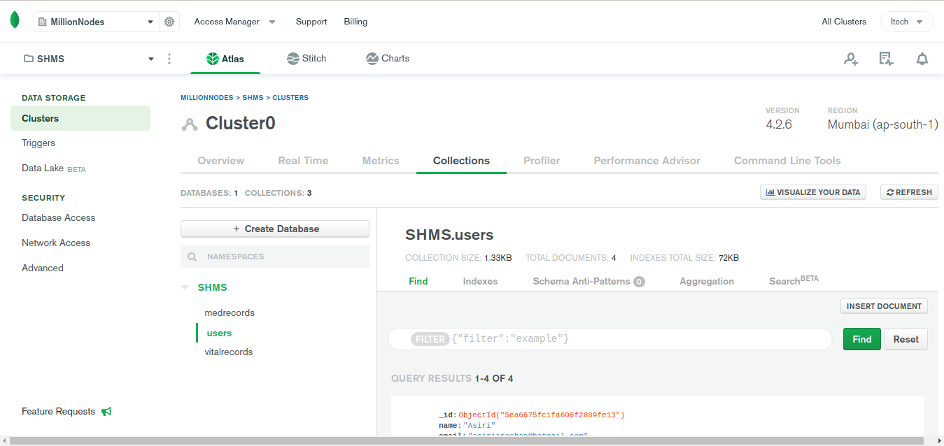

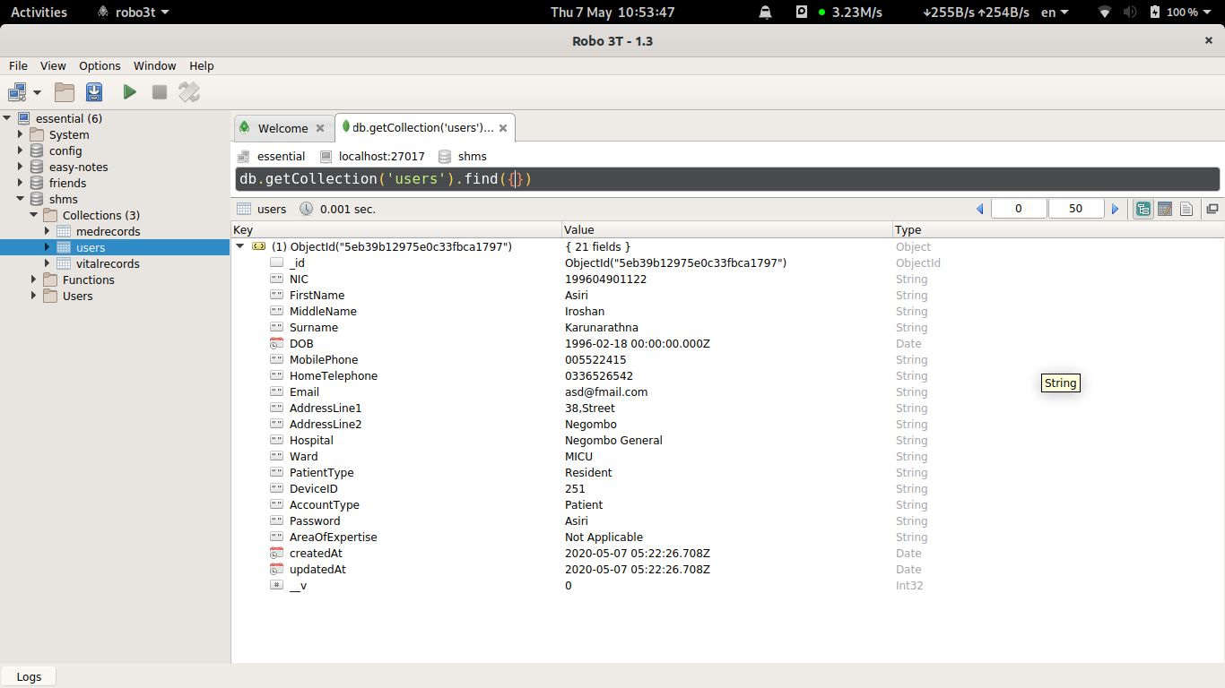Figure 24: Local Testing Database Dashboard overview

  - Remote Vital Monitoring Device

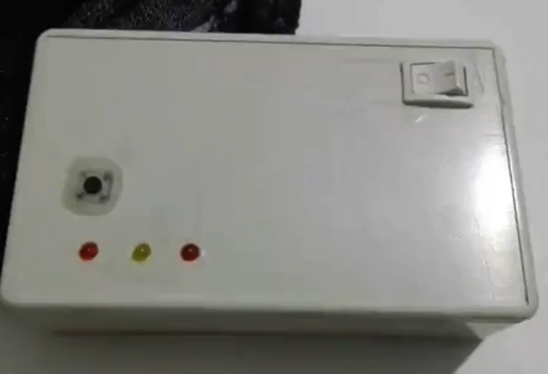Figure 25: Remote Monitoring Device Outside View

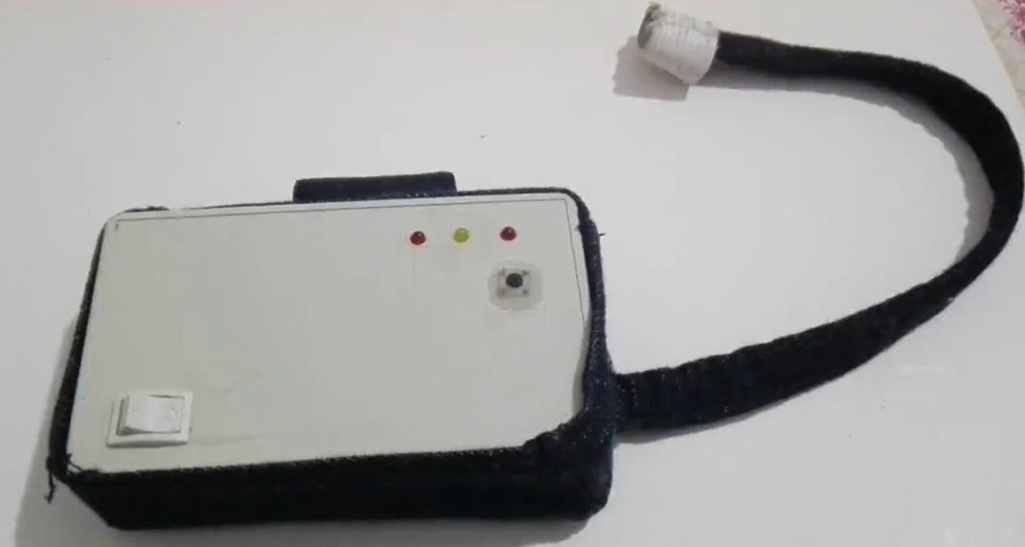Figure 26: Same device with the case
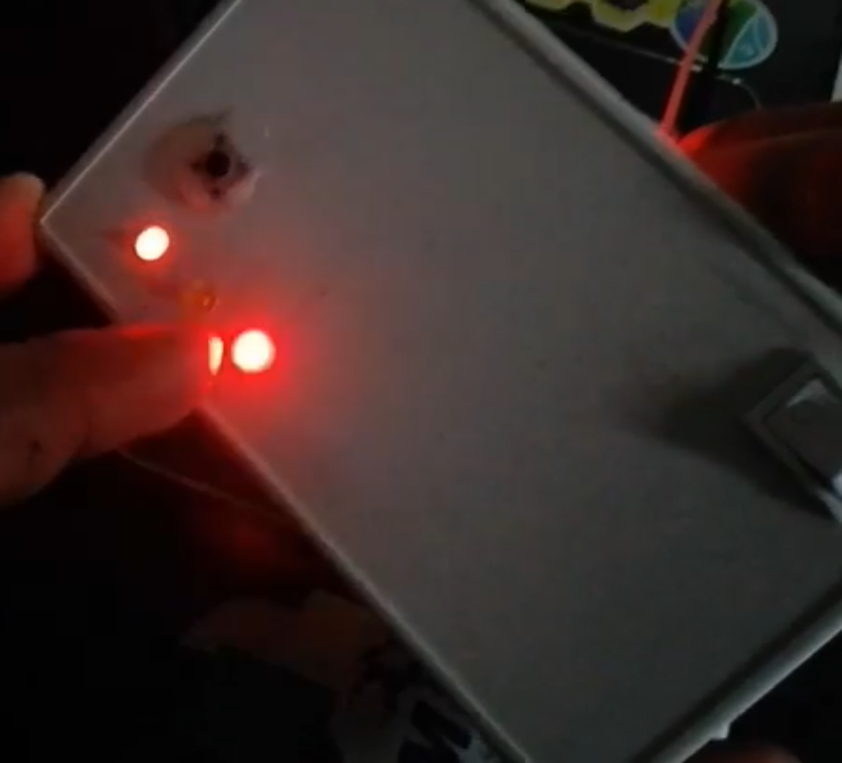Figure 27: Operating

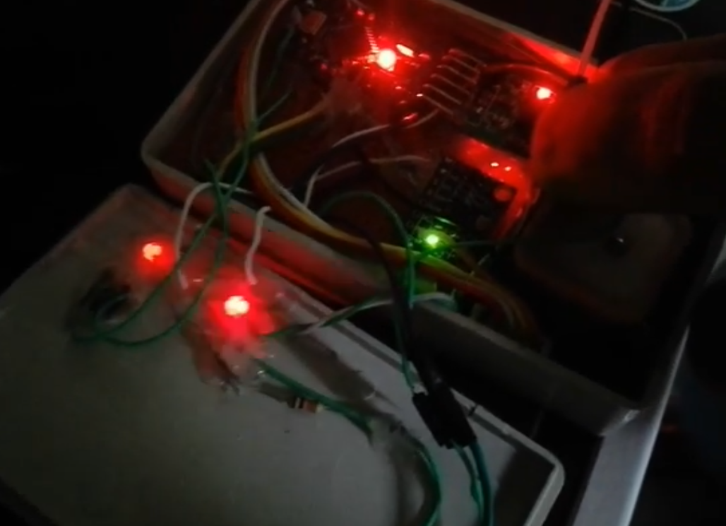Figure 28: Underpinnings

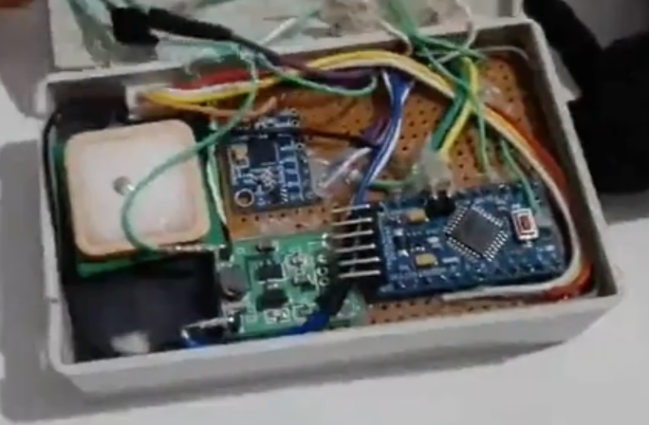Figure 29: Inside the device

- Technical Review

  - Technologies Used

- MongoDB NoSQL Databases
- Node
- HTML/CSS/JavaScript/Angular
- Remote vital monitoring device

  - Arduino Pro Mini Board
  - GY – Max30100 Heart Rate Sensor
  - MPU-6050 Accelerometer
  - GY-90614 Temperature sensor
  - SIM808 GPRS/GSM/GPS Module
  - Nokia 3.7 V Li-ion battery
  - TP4056 USB Charging module
  - A67 DC to DC Booster module
  - Jumping Wires
  - Project Box
  - Casing
  - Push Button
  - LED bulbs
  - On Off Switch

  - Database selection

No SQL database Mongo DB has been selected for storing data of the system over a SQL database which was the initial consideration. Data intensive information systems like patient management systems, electronic health record systems require a robust database solution. The size of the information systems today are increasing rapidly and scalability is one of the most important aspect that is expected from a data storing technology. This has created the need to look beyond traditional relational database systems and embrace No SQL database systems for flexibility and easier and rapid scalability than what a SQL database would allow (Ercan and Lane, 2014)⁠.

Due to the design of No-SQL database systems, which follows a philosophy of “shared nothing” architecture, a single point of failure is not possible(Ercan and Lane, 2014)⁠. Bottlenecks can be avoided due to the same design aspects of the system, horizontal scability being the most significant.

Most of the No-SQL databases are open source. This enables a higher degree of freedom of usage with flexible licenses. Even the commercial No-SQL solutions that are used by Google and Amazon tend to cost less than the Relational Database Solutions. But, today, the most popular No SQL databases have become the open source ones. Mongo DB is one of the most popular No-SQL databases used in the industry.

Today, most of the developed nations around the Earth maintains their own national Electronic Health Record systems. This is not an easy task. Maintaining a nationwide Electronic Health Record System requires well designed systems which are highly robust and need to have a significantly less likelihood of failing when compared to another government system. Poorly designed architecture could cause disruption to the health service and at the same time could cause huge financial losses (Ercan and Lane, 2014)⁠.

In order for an EHR system to be properly usable nationwide within a large number of medical institutions, it needs to be hosted in cloud, or the service has to be supplied online, it needs to be highly scalable and portable(Ercan and Lane, 2014)⁠. The ideal solution for this is a No-SQL database that is hosted in the cloud. NoSQL databases are usually distributed systems. These have the ability to scale up with the increasing sizes of the data sets they have to store without a single point of failure. Horizontal scalability of No-SQL databases allows them to increase the performance with the rising number of nodes (Ercan and Lane, 2014)⁠.

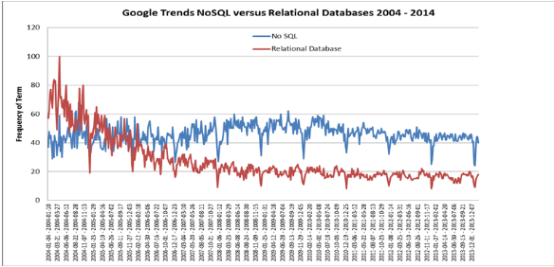Figure 30: Relational vs Non Relational

(Ercan and Lane, 2014)⁠

The above diagram shows the consistency of performance of No-Sql databases over the relational databases with the rise of data and the number of nodes.

There are multiple theories associated with database systems. They are as follows.
- Relational Database Theory
- CAP Theorem
- ACID(Atomicity, Consistency, Isolation, Durability) Properties
BASE (Basically Available Soft State, Eventually Consistent)

Relational Database Theory is the most widely adapted in the industry. This approach suggests that the data stored in data banks can be organized based on the relationships that exist among the data and redundancies and inconsistencies are eliminated through normalization (Ercan and Lane, 2014)⁠.
However in reality, in practical usage, this is not always the case. The rising amount unstructured data at large scales severly affects the performance of relational databases that expects the data to be in a properly structured manner.

CAP theorem, which stands for (Consistency Availability and Partition Tolerence) tells that there is a compromise among the three aspects. Under consistency, a server must provide the right response for each request. Under availability, each request will receive a response eventually. There will always be a response, but the consistency of the response is not guaranteed here. Under partition tolerance, services can continue the operation as usual even when some nodes lose their communication among the others(Ercan and Lane, 2014)⁠. According to this theorem, it is not possible to achieve all the three properties mentioned here perfectly at the same time. It would always be a compromise between the three.

ACID are four principles for database systems to achieve reliability at transactions. The four letters stand for Atomicity, Consistency, Isolation and Durability. Under Atomicity, a transaction either takes place perfectly or fails(Ercan and Lane, 2014)⁠. Consistency means that upon completion of every transaction, database as a whole stays consistent. Under Isolation, each transaction needs to happen completely separated from each other and one transaction will not affect another transaction(Ercan and Lane, 2014)⁠. Durability ensures that upon completion of a transaction, the database stays robust, stable and durable. The durability is guaranteed under this principle.

However, due to the very nature of NoSQL databases, they cannot adhere to any of the above described theories. No SQL databases are distributed and these do not have a master node. Compromises have been made in favor of higher levels of availability and scalability(Ercan and Lane, 2014)⁠. Because of this reason, NoSQL databases focuses on BASE theory. What this theory means basically is that even when a failure occur, the system can continue to work as usual. Consistency is not guaranteed and it’s assumed that the data will become consistent eventually with time.

As for our particular use case here, which is a Health Management System, BASE principles would suit the best. The most important to our system is availability and scalability. Hence a No-SQL database, particularly, MongoDB is used.

  - API development

Node JS has been used for the development of the REST API that is used to perform CRUD operations with the database of the project.

Node JS is a Free and Open Source Java Script framework. It is used for server side scripting. It enables running Java Scripts on server side in order to create a dynamic site on the client side. Node JS has enabled running Java Script code out side of a browser as it packs it’s own run time environment. Node JS is cross platform, or, platform independent. What is developed with it would run on any platform as long as there is a browser of a run time environment. NPM package repository which stands for Node Package Repository is considered as the largest software repository available currently. Node js is consisted of a large set of java script modules that would simplify the development process considerably.

The primary usage of Node Js is development and deployment of web servers. In comparison to PHP, one of the most popular server side scripting languages in the world, node js functions run parallel executing multiple functions at a time unlike PHP which waits for a certain function to finish it’s execution before launching the next function (Node JS, 2020)⁠. This is called asynchronous functionality. A server that is based on NodeJS would not wait for the API to return data. Node JS is built in Google Chrome’s V8 engine. This has enabled fast code execution on Node JS than on other platforms. Another reason for Node JS being fast is that it does not buffer data but output them as chunks.

These aspects played a part in selecting Node JS for the development of the REST API of this project. Other than that, the familiarity of Java Script was also another factor.

When the decision for the technologies to be used for back end development was being made, open source cross platform solutions were prioritized. While developing an ASP.NET application with Visual Studio on Windows platform would certainly have made things more convenient, it was not considered due to multiple reasons. One, as stated above, was that it is not open source and it is not cross platform. Secondly, I do not use Windows operating system. ASP.NET development, while certainly possible on Linux with the .Net core, it is not as complete as the full Microsoft .Net package and whatever the benefits I would have had with the use of Visual Studio GUI was not attainable on Linux due to Visual Studio not supporting Linux. These reasons lead towards the use of more widely adopted and cross platform solutions such as NodeJS.

    - API Dependencies

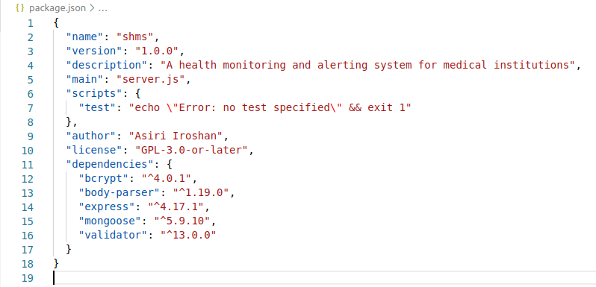Figure 31: API Dependencies

  - Remote monitoring device

The components that have been used in the remote monitoring device are mentioned above on page number 33.

The most effective and appropriate way to develop this device would be micro controller programming and developing our own circuits. It it was done this way it would’ve been possible to prototype a smaller device that is more elegant and comfortable to wear as a wearable device. But the lack of expertise at micro controller programming made it impossible.

The device at it’s current configuration as mentioned in the spec list is quite sophisticated. The device not only has the ability to transfer heart rate and temperature but it has the capability to provide the location of the user, an on demand emergency notification at the press of a button and an accelerometer to identify movement, mostly, the sudden movements. The limiting factor on board the device was the Mini Arduino board which did not have the capability to fully utilize all the sensors in the device.

The device requires a sim card with a data connection. Mere 2G data connection would suffice. However it would work on 3G sims as well. The device is coded to transmit data to Thingspeak channels. The web application would take the data from the cloud in order to be used for it’s purposes.

The operation of the device is fairly simple as shown in the following images.

Emergency Message/Alert button
Power ON/OFF

Indicate whether the device is connected to cellular network or not
Indicate whether the device is ON or OFF

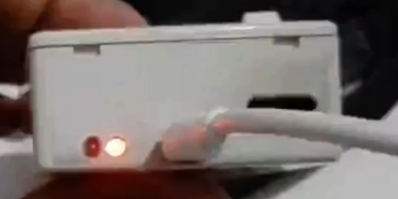

Sim Slot

Charging
Micro USB Port

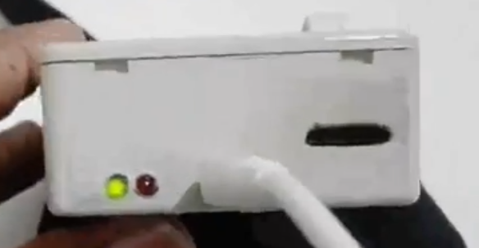

Battery Fully Charged

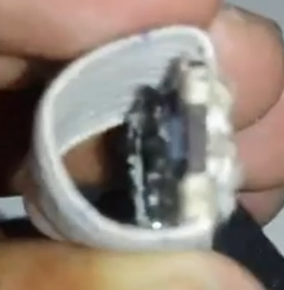Figure 32: Heart Rate Sensor to Finger Tip

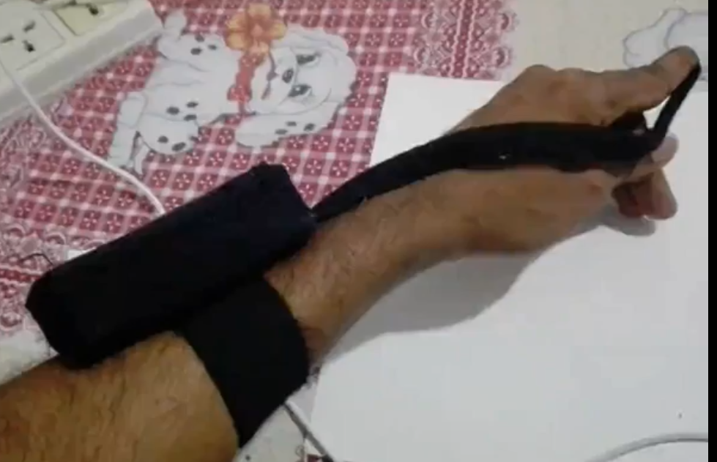Figure 33: Holding the device
- Challenges faced and their effect on the project

The sensors of the device kept faulting. Parts of the device had to be replaced multiple times including a rechargeable li-ion battery. The device as a whole with all expenses included cost more than Rs 12,000 and it is a very high expense to me. The most expensive component is the GSM/GPS/GPRS module.

The Covid-19 pandemic has had the greatest impact on the project. Due to the lock downs I was unable to fetch components of my project from the boarding house I used to stay. The complete Remote Monitoring Device is left there and I do not have any idea on the status of it. The last time it was kept uncharged for a couple of weeks it ended up having a dead battery which had to be replaced along with a set of wires that were sort of decayed for some reason.

Since I cannot get the main component of my project which is the device I am planning on developing a simulator which will run on my laptop (preferably in a VM to resemble the remoteness in a more authentic way. But the success of it is unknown as of now). I have not been able to find a good simulator online.

- Links associated with the project

GitHub : https://github.com/IROdEvO/SHMS.git
API Documentation on Postman : https://documenter.getpostman.com/view/8511782/Szme3Hqs

BIBLIOGRAPHY

Alotaibi, Y. K. and Federico, F. (2017) ‘The impact of health information technology on patient safety’, Saudi Medical Journal, 38(12), pp. 1173–1180. doi: 10.15537/smj.2017.12.20631.
Arrhythmia Classification (no date) Wikipedia. Available at: https://en.wikipedia.org/wiki/Arrhythmia (Accessed: 29 April 2020).
B N, B. U. M. et al. (2015) ‘Effects of Computerized Patient Records on Patients’, Bonfring International Journal of Man Machine Interface, 3(3), pp. 25–29. doi: 10.9756/bijmmi.8068.
Ercan, M. Z. and Lane, M. (2014) ‘Evaluation of NoSQL databases for EHR systems’, Proceedings of the 25th Australasian Conference on Information Systems, ACIS 2014, (December).
Hadiyoso, S., Rizal, A. and Alfaruq, A. (2019) ‘An Internet of Things ( IoT ) Application for Standard Clinical ECG ’ s Monitoring in Real Time Application’, International Journal of Engineering & Technology, 8(March), pp. 274–278. doi: 10.14419/ijet.v8i1.9.26668.
Kroll, R. R., Boyd, J. G. and Maslove, D. M. (2016) ‘Accuracy of a wrist-Worn wearable device for monitoring heart rates in hospital inpatients:A prospective observational study’, Journal of Medical Internet Research, 18(9). doi: 10.2196/jmir.6025.
Node JS (2020). Available at: https://en.wikipedia.org/wiki/Node.js.
QRS complex (no date) Wikipedia. Available at: https://en.wikipedia.org/wiki/QRS_complex (Accessed: 19 April 2020).
Suresh, L. P. (2015) the International Conference on Soft Computing Systems.
Uchiyama, K. et al. (2018) ‘The impact of a remote monitoring system of healthcare resource consumption in patients on automated peritoneal dialysis (APD): A simulation study’, Clinical Nephrology, 90(5), pp. 334–340. doi: 10.5414/CN109471.

APPENDIXES

PID – Project Initiation Document

School of Computing

PRCO303SL

Final Stage Computing Project

Project Initiation Document

BSc (Hons) in Software Engineering

K. C. A. A. Iroshan

Smart Health Monitoring and Alerting System
2019/2020

Table of Contents

1. Introduction............................................................................................................................................3
2. Business Case.........................................................................................................................................3
2.1. Business need.................................................................................................................................3
2.2. Business objectives.........................................................................................................................3
2.3. Background....................................................................................................................................4
3. Project Objectives..................................................................................................................................4
4. Initial scope............................................................................................................................................4
5. Method of Approach..............................................................................................................................4
6. Project Plan............................................................................................................................................5
6.1. Control Plan....................................................................................................................................5
6.2. Communication Plan......................................................................................................................5
7. Initial Risk List.......................................................................................................................................6
8. Initial Quality Plan.................................................................................................................................6

1. Introduction

When the patients are admitted to a hospital, they are treated and their health conditions are monitored.
The most important vitals that need to be monitored are the blood pressure and the body temperature as
the stability of a persons health depends on these two. Currently, on patient basis, these vitals are not
recorded and profiled, and in order to monitor a patient, the medical staff have to check on the patient
time to time. Sometimes, some patients will be needed for prolonged monitoring even after they’re
released to their homes. But other than with a dedicated medical personal, an effective remote
monitoring system is yet to be implemented. It’s also necessary to store a brief medical history of
patients to be used in case of an emergency situation for better preparation to handle the patient on the
hospital’s side.
It’s more efficient to have a centralized computer based patient monitoring system where the medical
staff of a hospital can monitor vitals of the admitted patients (who needs to be constantly monitored)
and the released patients who also may need to be monitored, using remote monitoring, all in the same
centralized system. If the medical staff gets alerted of a medical emergency of a patient with the access
to that patient’s medical history, it’d help them immensely to get ready for the patient (if the patient is
in remote monitoring, sending an ambulance to collect the patient), by arranging the hospital before the
patient arrives at the hospital. This system would also be beneficial even when monitoring the already
admitted patients, for quick attendance to the need.

2. Business Case

2.1. Business need

The existing patient monitoring mechanisms used which involves the constant attendance of medical staff can be inefficient when monitoring a large number of admitted patients and in remote monitoring. Medical staff does not get immediately notified of medical emergencies and does not have ready access to the medical history of the patient undergoing the medical emergency. This results in long response times.

2.2. Business objectives

Automating parts of the patient monitoring scenario which enables the medical staff to

● Constantly monitor a large number of patients at the same time removing the need to manually attend to the patient whenever the staff wants to know about the patient vitals.

● Effectively monitor the released patients remotely (when it’s necessary).

● Keep records of the medical history of patients under their profiles to be accessed in
a medical emergency.

● Enables the staff to reduce the response time in a medical emergency or a patient
undergoing unstable health conditions.

● Enables the staff to get ready for a patient before the patient arrives at the hospital
(in an ambulance in a medical emergency).

● Enables the medical staff to send ambulances to pick up the patient undergoing a medical emergency. (Notifying the ambulance is done by the medical staff the regular way and not through the system. The system provides the information for the medical staff that are necessary to make their decisions.

2.3. Background

This project does not have a funding client. But it’s possible to offer this system to a client once it’s completed. The client most likely would be a medical institution. This project is being done as I believe there is a need for a system like this in hospitals.

3. Project Objectives

1. Analyze the existing patient monitoring procedures.
2. Analyze the existing patient data recording procedures.
3. Analyze the existing technologies applicable to the proposed solution.
4. Implementation of the system as a prototype.
5. Documentation of the system.

4. Initial scope

1. The processes of the system are identified through observation and interviews.
2. The processes of the system are documented with UML diagrams.
3. The databases of the system are identified through observation and interviews.
4. The databases of the system are documented using EER diagrams.
5. The proposed system will allow

a) The medical staff to view the vitals (blood pressure and body temperature) of each and
every patient.
b) The medical staff to view the medical details of each and every patient.
c) The medical staff to register patients in the system.
d) The medical staff to remove patients in the system.
e) The medical staff to receive alerts regarding emergency health conditions of the patients.

5. Method of Approach

Agile software development life cycle will be used in developing the system. Possible technologies are Arduino equipment and Arduino programming language, Java native application or a web application using appropriate technologies. SQL for databases. Proper evaluation of the technologies will be done during the project in order to select the best and the most suitable technologies for implementing the system.

6. Project Plan

Stage | Deadline | Products/Deliverable/  Outcomes
1. Products/Deliverable/  Outcomes | 19 th October 2019 | Project Proposal
2. Initiation | 5 th November 2019 | Project Initiation Document
3. Investigation and  Requirements | 15 th November 2019 | Analyzing the existing system.  Identification of the suitable  technologies for the development  of the system.
4. High-Level design | 1 st December 2019 | Designing the system.  (UML, EER, Interface designs)
5. Increment 1 | 18 th December 2019 | Progress Video  Working Health Monitoring  Device
6. Increment 2 | 13 th January 2020 | Interim Report 1  Dashboard of the system with  patient registration, patient  profiles and patient health data  storing and displaying capability.
7. Increment 3 | 18 th February 2020 | Interim Report 2  Displaying real time patient  vitals (blood pressure,  temperature) under the patient  profile
8. System and User acceptance  testing | 3 rd March 2020 | Testing of the completed system.  Testing the emergency alert  functionality.
9. Assemble and Complete the  final report | 3 rd April 2020 | Final Report  Completed System

6.1. Control Plan

End stage reports and reviews, risk management, communication plan and quality plan are employed.

6.2. Communication Plan

Multiple supervisor meetings will be held regularly per week basis and feedback meetings will
be held as necessary.

7. Initial Risk List

Risk | Management Strategy
Schedule overrun | Contingency has been introduced into the project  plan.  The project will be conducted under a project plan  approved by the supervisor under the supervision  of the supervisor.
Difficulty using/learning the development  technologies | Multiple technologies will be tested by developing  simple prototypes before finalizing a main  technology to be used for the entire process.  Online tutorial usage.
Technology Failure | Regular backups of the working systems are kept  so that in case of a failure of code, there’s a  working version to resort back to. Video proof of  the working system are taken.

8. Initial Quality Plan

Quality Check | Strategy
Requirements | Requirements will be checked to make sure that  they are relevant, useful, correct and achievable.
Design Validation | Databases will be normalized.  Interface designs will be checked against HCI  guidelines.
Hardware Validation | Hardware will be tested for reliable operation.  Output will be tested against expected output and  the reliability of the output is checked.  Individual components are tested.

- Interim Report I

School of Computing

PRCO303SL

Final Stage Computing Project

Smart Health Monitoring and Alerting System

Interim Report I

BSc (Hons) in Software Engineering

K. C. A. A. Iroshan

2019/2020

Table of Contents

1. Introduction............................................................................................................................................3
2. Tasks undertaken and outcomes.............................................................................................................4
3. Products produced and product quality..................................................................................................5
3.1. Products..........................................................................................................................................5
3.2. Quality and issues...........................................................................................................................5
4. Risks that have materialized and your response....................................................................................6
5. Schedule.................................................................................................................................................7
6. Student learning undertaken and required..............................................................................................8

1. Introduction

When the patients are admitted to a hospital, they are treated and their health conditions are monitored. The most important vitals that need to be monitored are the blood pressure and the body temperature as the stability of a persons health depends on these two. Currently, on patient basis, these vitals are not recorded and profiled, and in order to monitor a patient, the medical staff have to check on the patient time to time. Sometimes, some patients will be needed for prolonged monitoring even after they’re released to their homes. But other than with a dedicated medical personal, an effective remote monitoring system is yet to be implemented. It’s also necessary to store a brief medical history of patients to be used
in case of an emergency situation for better preparation to handle the patient on the hospital’s side. It’s more efficient to have a centralized computer based patient monitoring system where the medical staff of a hospital can monitor vitals of the admitted patients (who needs to be constantly monitored) and the released patients who also may need to be monitored, using remote monitoring, all in the same centralized system. If the medical staff gets alerted of a medical emergency of a patient with the access to that patient’s medical history, it’d help them immensely to get ready for the patient (if the patient is in remote monitoring, sending an ambulance to collect the patient), by arranging the hospital before the patient arrives at the hospital. This system would also be beneficial even when monitoring the already admitted patients, for quick attendance to the need.

2. Tasks undertaken and outcomes

The IOT device that is used to obtain the vitals of the patients has been developed.

The software that is used to manage the patient details has undergone the designing phase.

The designing of the database is completed and the implementation will happen shortly.

The login and registration of the patients have been developed.

The IOT device once turned on takes inputs from the sensors and send the data to the cloud.

3. Products produced and product quality

1. Products

The system is consisted of an IOT device, a software application that displays the out puts of the IOT devices connected in a dashboard that also manages the details of the patients, and a database system that’s used to store all the data associated with the system. The development of the software is ongoing whereas the IOT device is completed as a product and is undergoing testing.

2. Quality

The parts of the device are placed under a quality housing to avoid the damage that could occur to the sensitive devices and the connections. Each and every part of the device has undergone rigorous to make sure that they function properly. Exception handling has been utilized in the parts of the software that have been developed to make sure that any error that exist is captured and taken care of and the object oriented concepts have been utilized for the program to work effectively.

4. Risks that have materialized and your response

The battery of the IOT device died and was replaced.

Some of the wires inside the device stopped supplying the power to the sensors. They were
replaced with new wires.

The heart rate sensor was burnt. New heart rate sensor was bought and will be replacing the
old one.

The device does not send both the heart rate and the temperature data to the cloud at the same
time. Only one data stream can be sent at a time. Currently working on a solution for this
matter.

The database implementation resulted in issues regarding the relationships between the tables.
The database was redesigned.

The tools that were initially planned on using needed to be changed. Selected a more familiar
set of tools to develop the software application.

5. Schedule

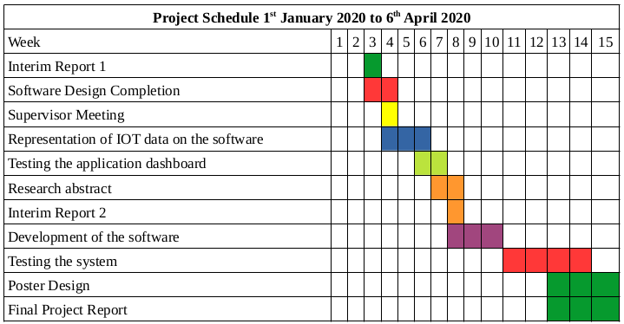

6. Student learning undertaken and required

Learning of the arduino libraries was needed.

Learning of the arduino electronics was needed.

School of Computing and Mathematics

PRCO303SL

Final Stage Computing Project

Smart Health Monitoring and Alerting System

Interim Report II

BSc (Hons) in Software Engineering

K. C. A. A. Iroshan

2019/2020
Table of Contents
1. Introduction 4
2. Tasks undertaken and outcomes 5
3. Products produced and product quality 6
3.1. Products 6
3.2. Quality and issues 6
4. Use Case Diagram 7
5. EER Diagram 8
5. Draft of the contents of the final project report 9
7. A draft of a chapter from the final project report 11
7. Schedule 12
6. Student learning undertaken and required 13

Table of Figures
Figure 1: Use Case Diagram 7
Figure 2: Extended Entity Relationship Diagram 8

- Introduction

When the patients are admitted to a hospital, they are treated and their health conditions are monitored. The most important vitals that need to be monitored are the blood pressure and the body temperature as the stability of a persons health depends on these two. Currently, on patient basis, these vitals are not recorded and profiled, and in order to monitor a patient, the medical staff have to check on the patient time to time. Sometimes, some patients will be needed for prolonged monitoring even after they’re released to their homes.

But other than with a dedicated medical personal, an effective remote monitoring system is yet to be implemented. It’s also necessary to store a brief medical history of patients to be used in case of an emergency situation for better preparation to handle the patient on the hospital’s side.

It’s more efficient to have a centralized computer based patient monitoring system where the medical staff of a hospital can monitor vitals of the admitted patients (who needs to be constantly monitored) and the released patients who also may need to be monitored, using remote monitoring, all in the same centralized system. If the medical staff gets alerted of a medical emergency of a patient with the access to that patient’s medical history, it’d help them immensely to get ready for the patient (if the patient is in remote monitoring, sending an ambulance to collect the patient), by arranging the hospital before the patient arrives at the hospital. This system would also be beneficial even when monitoring the already admitted patients, for quick attendance to the need.

- Tasks undertaken and outcomes

The IOT device that is used to obtain the vitals of the patients has been developed.

The IOT device once turned on takes inputs from the sensors and send the data to the cloud.

Development of the back end of the system is underway.

The API is being developed.

The database system has been developed.

- Products produced and product quality

  - Products

The system is consisted of an IOT device, a software application that displays the out puts of the IOT devices connected in a dashboard that also manages the details of the patients, and a database system that’s used to store all the data associated with the system.

The development of the software is ongoing whereas the IOT device is completed as a product and is undergoing testing.

The back end of the system is under development and the database system has been developed.

  - Quality

The parts of the device are placed under a quality housing to avoid the damage that could occur to the sensitive devices and the connections.

Each and every part of the device has undergone rigorous to make sure that they function properly.

Exception handling has been utilized in the parts of the software that have been developed to make sure that any error that exist is captured and taken care of and the object oriented concepts have been utilized for the program to work effectively.

- Use Case Diagram

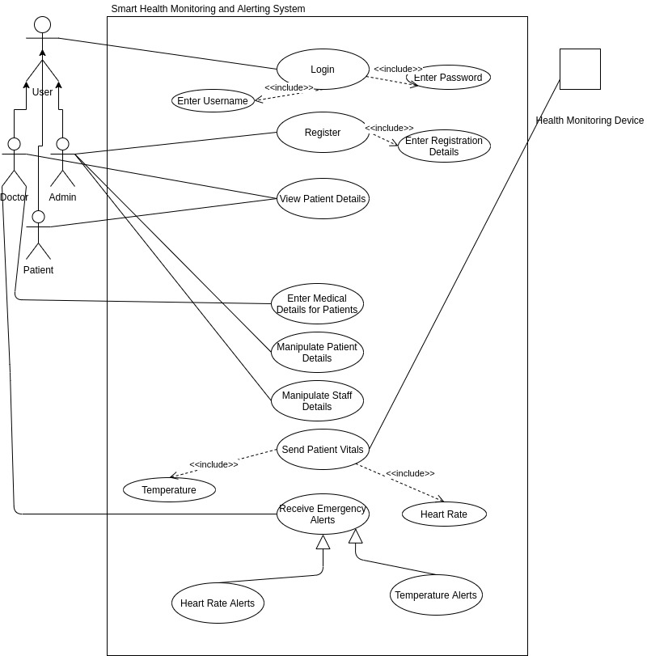Figure 34: Use Case Diagram

- EER Diagram

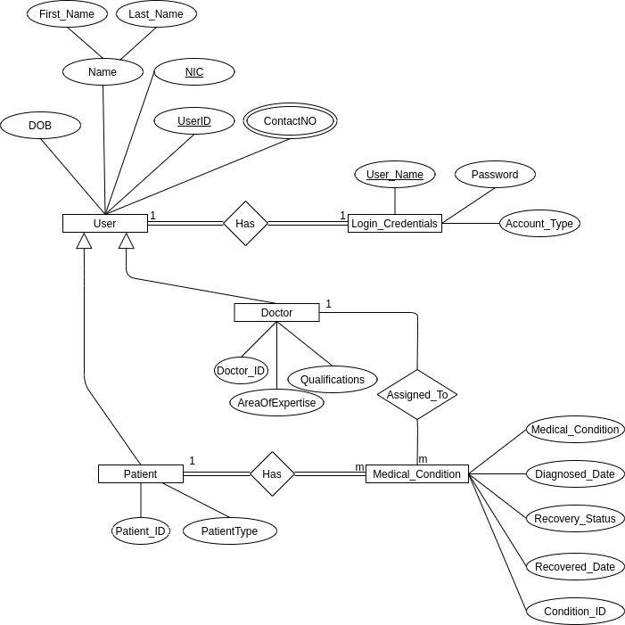Figure 35: Extended Entity Relationship Diagram

- Draft of the contents of the final project report

Acknowledgments
Abstract
- Introduction
  - Background
  - Business Case
  - Objectives
  - Scope
- Legal Social and Ethical Issues
  - Licenses
  - Data Protection
  - Privacy
  - Confidentiality
- System Analysis and Design
  - Requirement Development
    - Functional Requirements
    - Non functional requirements
  - Design
    - Architecture diagram
    - Extended Entity Relation Diagram
    - Use case diagram
    - Class diagram
    - Database Design
- Project Management
- Methods of approach
- Development technologies
  - IOT Device
  - Web application
- Learning requirements
- Testing
  - Unit testing
  - Functionality testing
  - Usability testing
- End-Project report
- Project Postmortem
  - Challenges faced
  - Future enhancements and implementations
    - Enhancements
    - Implementations
- Conclusion
- Bibliography
- Appendices
  - Technical documentation
  - User Manual
  - PID
  - Interim report 1
  - Interim report 2
  - User interface designs
  - User stories
  - Third party resources used
  - Additional studies undertaken
  - User test results

- A draft of a chapter from the final project report

- Introduction

When the patients are admitted to a hospital, they are treated and their health conditions are monitored. The most important vitals that need to be monitored are the blood pressure and the body temperature as the stability of a persons health depends on these two. Currently, on patient basis, these vitals are not recorded and profiled, and in order to monitor a patient, the medical staff have to check on the patient time to time. Sometimes, some patients will be needed for prolonged monitoring even after they’re released to their homes.

But other than with a dedicated medical personal, an effective remote monitoring system is yet to be implemented. It’s also necessary to store a brief medical history of patients to be used in case of an emergency situation for better preparation to handle the patient on the hospital’s side.

It’s more efficient to have a centralized computer based patient monitoring system where the medical staff of a hospital can monitor vitals of the admitted patients (who needs to be constantly monitored) and the released patients who also may need to be monitored, using remote monitoring, all in the same centralized system. If the medical staff gets alerted of a medical emergency of a patient with the access to that patient’s medical history, it’d help them immensely to get ready for the patient (if the patient is in remote monitoring, sending an ambulance to collect the patient), by arranging the hospital before the patient arrives at the hospital. This system would also be beneficial even when monitoring the already admitted patients, for quick attendance to the need.

- Schedule

Project Schedule 1st January 2020 to 6th April 2020
Week | 1 | 2 | 3 | 4 | 5 | 6 | 7 | 8 | 9 | 10 | 11 | 12 | 13 | 14 | 15
Interim Report 1
Software Design Completion
Supervisor Meeting
Representation of IOT data on the software
Testing the application dashboard
Research abstract
Interim Report 2
Development of the software
Testing the system
Poster Design
Final Project Report

- Student learning undertaken and required

Learning of the arduino libraries was needed.

Learning of the arduino electronics was needed.

Learning of API development was done on linked in learning and using you tube tutorials

Learning of javascript frameworks was done

