|  |  |
| --- | --- |
| User Guide & Test Cases  Test case scenarios for NUS ISS Chatbot | Abstract  This document will demonstrate how to use NUS ISS Chatbot. It also documents the pre-requisites needed to run the system locally on your machine. The test cases are also outlined in the final section of this document.  The Thrones Team Tommy Gary Ritesh Paul Ani Soorej |

Contents

1 User guide 2

1.1 Software/Tools Pre-requisites 2

1.1.1 Web Browsers 2

1.1.2 Tools/Kits 2

1.2 Deploying the application locally 3

1.2.1 Backend 3

1.3 Using the system 5

2 Test Case 6

2.1 Test Case 1 6

2.2 Test Case 2 8

# 1 User guide

## 1.1 Software/Tools Pre-requisites

### 1.1.1 Web Browsers

These browser versions will be needed to display the web application.

* Firefox 38
* IE 11
* Google Chrome 54

### 1.1.2 Tools/Kits

In order to run the application locally on any machine you will need the following tools/kits.

* Anaconda
* Python 3

Anaconda download link: <https://www.anaconda.com/download/>

You may follow the steps below to install anaconda on an ubuntu environment.

* cd /tmp
* curl -O https://repo.anaconda.com/archive/Anaconda3-2019.03-Linux-x86_64.sh

Verify anaconda is downloaded

* sha256sum Anaconda3-2019.03-Linux-x86_64.sh

The output will show a long line of numbers

* bash Anaconda3-2019.03-Linux-x86_64.sh

Keep pressing Enter and agree to the license agreement when prompted. When installation is completed, you can press enter to agree to a default installation location.

Once installation is complete just type Yes to finish.

* conda list

This command is to test the installation of anaconda, you will see a list of all the packages you have installed. This concludes the Anaconda installation phase.

To see the complete list of installation steps for anaconda, please see the website below.

<https://www.digitalocean.com/community/tutorials/how-to-install-anaconda-on-ubuntu-18-04-quickstart>

Python 3 download link: <https://www.python.org/downloads/>

A script has been created to help install all the packages into an anaconda environment. Once anaconda is successfully installed, navigate to the **cgs** project folder and enter the following command. The installation will take some time, please have a coffee.

* Bash setup.sh

Before deploying locally, please download ngrok as well.

Ngrok download link: <https://ngrok.com/download>

## 1.2 Deploying the application locally

### 1.2.1 Backend

Open up your command prompt/terminal and go into the cgs/src project folder. Please ensure section 1.1.2 has been fulfilled before proceeding or you will end with errors.

Enter the following in your command prompt/terminal:

* Source activate cgs
* Python app.py

This will run the python rest services.

Next, navigate to the folder with the ngrok file you have downloaded to retrieve the https link to your local machine. Enter the following command.

* Ngrok http 5050

You should be able to retrieve a https link.

Go to dialogflow site and login to your account.

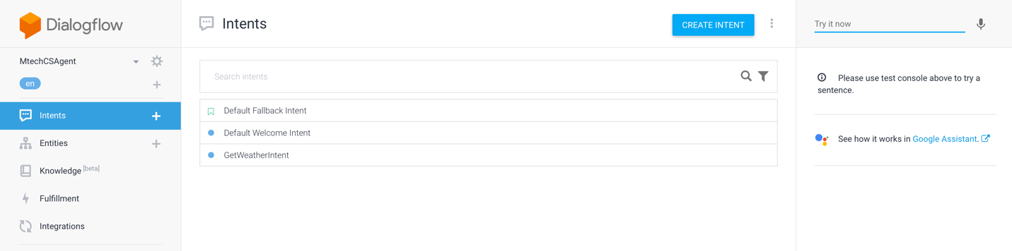

Click the settings icon on the left side on the log in page.

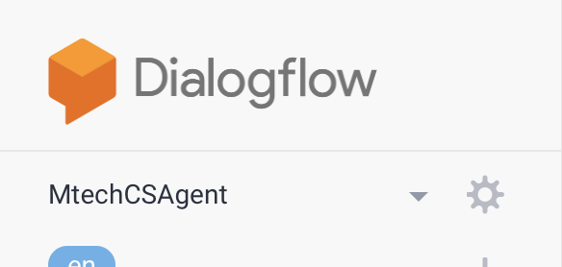

Then click the export and import link.

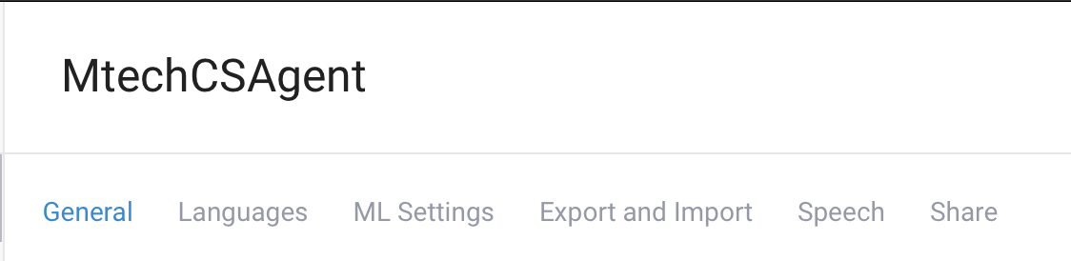

Click on import from zip and select the NUSISS Chat bot zip file from the cgs folder.

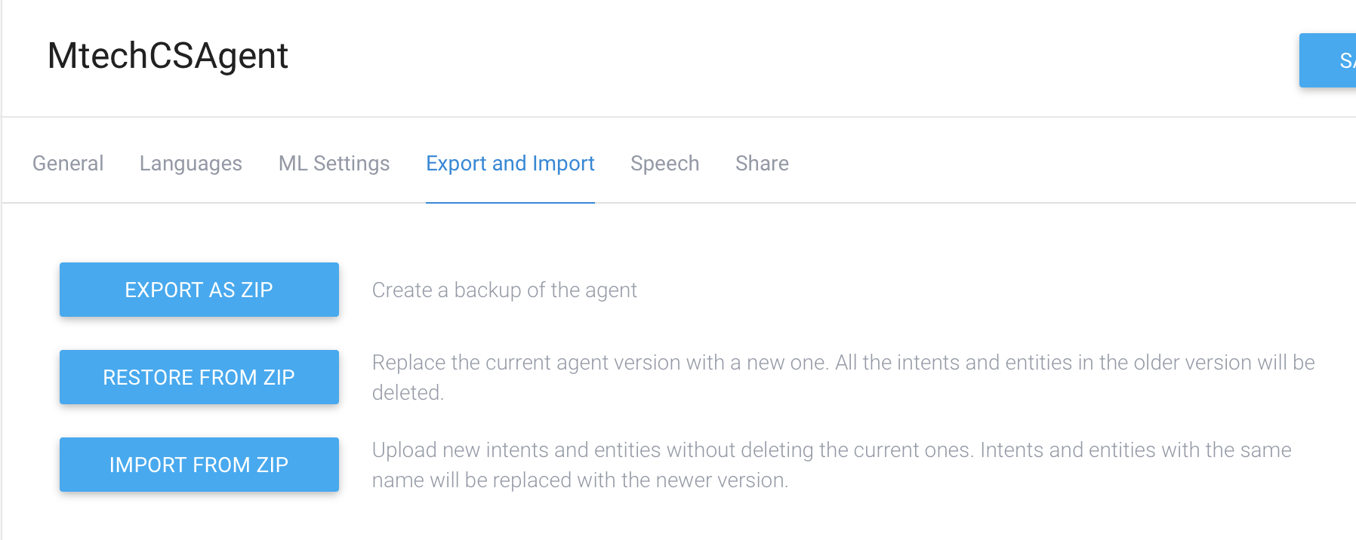

Once that is done, ensure the correct chat bot is selected. Click on the Fulfillment link at the left hand menu and insert the ngrok link you have obtained in the URL text field and click ‘SAVE’ at the bottom of the page.

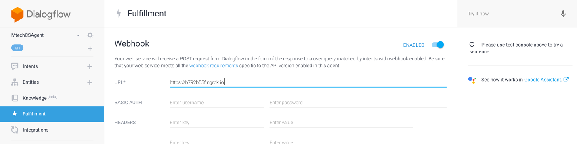

## 1.3 Using the system

On the right hand side on the screen, you can try to enter some questions to see if you are getting a response from your backend.

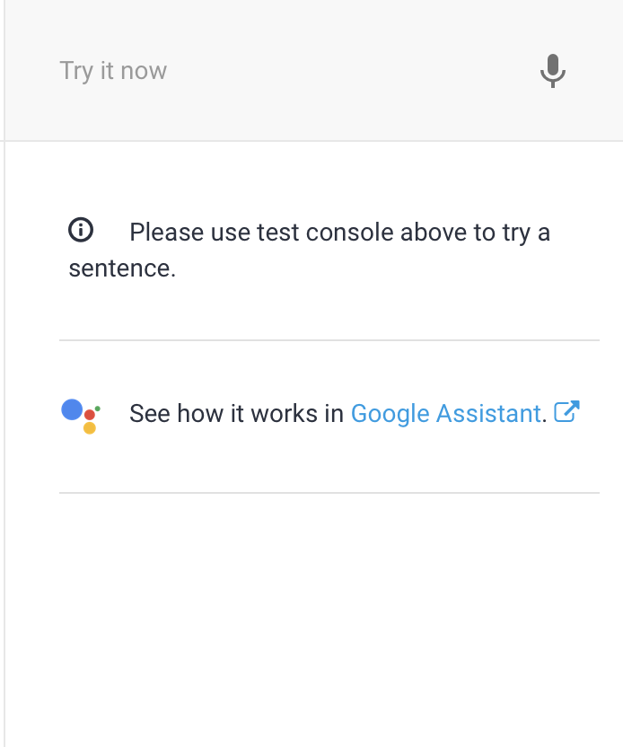

# 2 Test Case

In this section, we will take a look at some test cases of our system and an analysis of the output will be given.

## 2.1 Test Case 1

This test case follows the path of a working adult who wants to know more about the software engineering masters programme

|  |  |
| --- | --- |
| Input | what is the software engineering course about? |
| Output | Here's what I found: this programme is best suited for individuals who have a few years of experience in software engineering roles and are looking to further enhance their knowledge and skills in architecting scalable, secure and smart software systems., stack up to a master of technology in software engineering participants who wish to continue their learning journey towards the master of technology in software engineering degree will have to complete one certificate in the fundamental area, any 2 of 4 certificates in the specialist areas as well as a capstone project in smart systems & platforms., stackable certificate programme in smart systems & platforms print the nus-iss stackable certificate programme in smart systems & platforms, leading to the nus master of technology in software engineering is designed to meet the industry demand for software engineers who can help singapore organisations to realise the smart nation initiatives through building robust, reliable and scalable software systems. |
| Description | The chatbot will reply with an appropriate answer taken from data that is scrapped from the NUS ISS website. See below for screenshot of test case. |

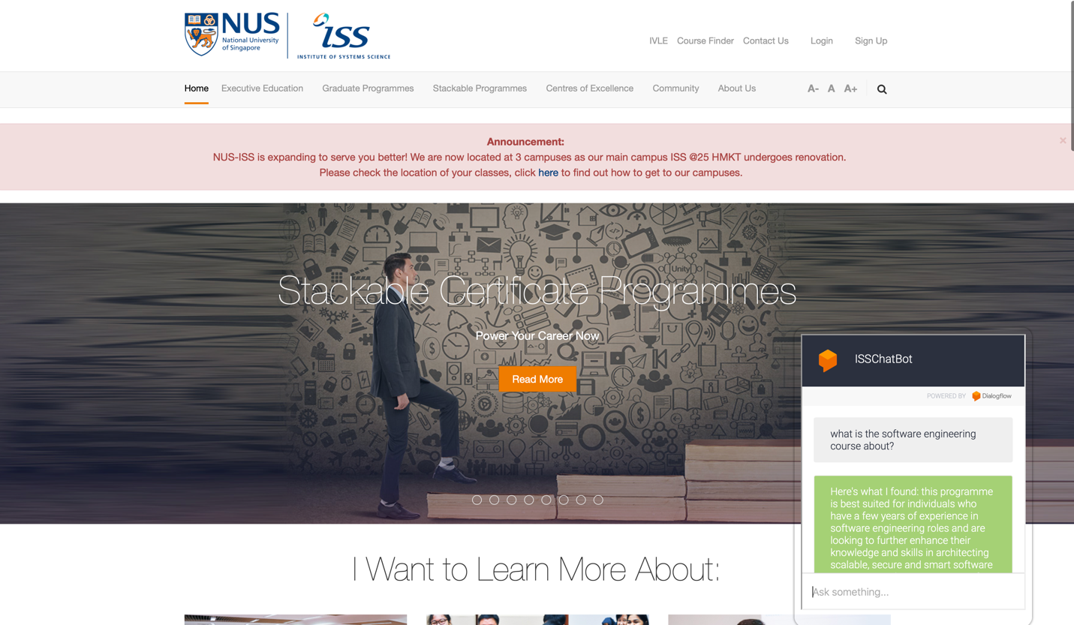

## 2.2 Test Case 2

This test case follows the path of a working adult who wants to know more about the enterprise business analytics masters programme

|  |  |
| --- | --- |
| Input | what is the enterprise business analytics course about? |
| Output | Here's what I found: stack up to a master of technology in enterprise business analytics participants who wish to continue their learning journey towards the master of technology in enterprise business analytics degree will have to complete 2 certificates in the fundamental areas, any 2 of 4 certificates in the specialist areas as well as capstone project in data analytics., it is best suited for professionals who wish to enhance their existing skill sets to progress from the entry level to specialist or expert level positions in the data science and business analytics domain., stackable certificate programme in data science print the nus-iss stackable certificate programme in data science, leading to the nus master of technology in enterprise business analytics is designed to meet the industry demand for data scientists who can help organisations achieve improved business outcomes through data insights. |
| Description | The chatbot will reply with an appropriate answer taken from data that is scrapped from the NUS ISS website. See below for screenshot of test case. |

