## horizontal line



Project Report

DoReMi online music books ordering system

**─**

Group members

Chad Ng

Jin Xin

Xu Dongbin

Sun Hang

Li Xin

# 1.0 EXECUTIVE SUMMARY

DoReMi Books Inc. is a company started in 1955 and is in business for 57 years. They specialize in the supply and sale of classical music scores and music books in the USA with subsidiaries in the major cities of each of the 50 states. As a traditional industry, some of its business processes are manual and rather traditional. With the rapid development of the information technology (IT), especially the fast popularize and spread of Internet technology, the company is now facing strong competition from its competitors (both new and old), who have embraced online and internet sales as the new way of interacting and transacting with their customers.

In response to the new challenges brought on by online sales transactions, the company decided to conduct a business process improvement exercise to revamp their music books sale transaction and order handling process as well as introduce improved stock and inventory planning and management capabilities. This will include a new order handling process, an internet sales transaction system and an advanced business intelligence module for optimal stock inventory and warehousing forecasting.

Based on machine reasoning concepts and how logical rules and knowledge can be inferred with a reasoning based system, our group of five members, brainstormed and decided to build a system with hybrid architecture (NRules Engine and Web MVC technology) and automate, as much as we can, the business or functions based on the knowledge gleaned from: (a) feedback from the management board, (b) current order handling processes and, (c) business issues encountered in current existing processes.

We began by getting a good understanding of the overall key processes of the proposed solution by mapping them out with data acquisition modelling. Next, we determined the areas of improvements that we agreed should be implemented into the new business processes. We also made sure we analysed the processes with our improvements and see how these improvements were handled with test cases to validate our assumptions.

Our primary objective is to solve the business problems which are typically encountered in many traditional businesses which naturally includes DoReMi’s books ordering business processes.

# 2.0 PROBLEM DESCRIPTION

Music is an art form and cultural activity whose medium is sound organized in time, it is one of the greatest creations of human intelligence. Human being started to create and play music from thousands of years ago. With the birth of diversified music, our human species has continued to innovate music in all kinds of culture. Nowadays, there is a huge data of the music scores and books widely available to people of all levels who appreciate and enjoy learning about music.

As a company specialized in the supply and sale of classical music scores and music books in the USA, with subsidiaries in the major cities of each of the 50 states, DoReMi Books Inc. is faced with a daily challenge of huge number of customers enquiries and sales orders, including some bulk orders, from music schools. However, in the current times, the tradition way of sales order management is no longer efficient and convenient. It has become obvious that each customer’s order entry will probably consume at least one human resource for a period of time each day.

Besides the outdated sales order and transaction systems, the company is also facing some internal business challenges. The existing logistics application system is a black box because there is no documentation as the original user project manager has left the company.

The company intends to set up a new and highly efficient order transaction, inventory and logistics application system. A number of employees reported of complex internal business work flows, and processes must always be reviewed by their supervisor before they are being approved by their managers*. (Assumption of the situation based on what is described in the case study)* This resulted in huge amount of unnecessary workload to the all teams involved. This is one of the main cause of delays in delivery and fulfillment of orders. The management finds it beneficial to track the project progress and hopes to automate the processing of invoices *(Assumption – this would be carried out in phase 2 of the project)*.

When considering bulk orders from their music schools, DoReMi intends to create a new **print-on-demand** process, but inventory control is not required for this. An automated discount promotion system is required for all orders during the festive holiday periods such as Christmas, Black Friday event and the new year. Payment handling improvements are also necessary to help their cashiers cope with the workloads during peaks hours *(Assumption – this would be carried out in phase 2 of the project)*.

In addition to the problems above, DoReMi Books Inc. is under pressure and faces external competition with their new and old competitors, this realization has convinced DoReMi’s management team to consider implementing any required changes to ensure the systems roll out is successful and thus improve the company’s profitability in the years ahead.

## 2.1 PROJECT OBJECTIVE

We aim to transform DoReMi’s business processes and create an efficient and robust sales order transaction system with good inventory control which will in turn simplify and automate as much as possible the business workflow and processes of DoReMi Books Inc. This will help DoReMi Books Inc. reduce operation costs, improve morale of the workers, and improve the accuracy of their order tracking, leading to increase timely delivery of products to their customers.

By implementing the proposed new system, we believe DoReMi Books Inc. will begin to run more efficiently over time as the full system gets implemented. *(Assumption – this project is in phase 1 of its implementation)* DoReMi is set to become much more competitive in the market in near future.

## 2.2 PROJECT SCOPE

The proposed new system will include:

(1) A sales transaction order process to support order management,

(2) a rules-based business intelligence module that will automate sales order approvals, workflow routing and improve process efficiency,

This rule-based module will also include rules that will handle the following:

* Intelligently deduce if any submitted order can be fulfilled based on the current stock level.
* Implement rules to decide if discounts are to be applied to the orders
* Automatically approve orders where the total order amount is below approval limits
* Automatically route orders to Accounts for manual approval where total order amount is equal to or above approval limits
* Automate the re-order of stock for replenishing stock inventory when stock quantity is below a formulated average quantity over three months.

(3) a best in class inventory control management using the rules described in (2) (- an auto-re-order module based on automated forecasting of stock order level requirements).

The new business intelligence module will allow management to track any sales order status anytime. At the same time, the proposed system will also include a dash board overview of products ordered in the last month and products order trends.

## 2.3 PROJECT ASSUMPTIONS

Print-on-demand orders will be captured as a system of records. But no inventory control is setup.

Sales order Invoicing and payment management is not considered in phase 1 of this project implementation. These will be handled in phase 2.

Purchase orders would be raised for stock replenishment by the automation engine for stock re-order management in demand forecasting. However, the handling of invoices to publishers would not be considered in this phase.

## 2.4 PROJECT TEAM

The project members titles and roles are listed as followings:

|  |  |  |
| --- | --- | --- |
| **Nr.** | **Name and Title** | **Role** |
| 1 | Chad Ng Choon Beng (Project Lead) | Project Management, Business process change consultant, Change Management |
| 2 | Xu DongBin (Machine Learning Analyst) | Gather system requirements |
| 3 | Li Xin (Machine Learning Analyst) | Gather system requirements |
| 4 | Sun Hang (Technical Lead) | Solution Design and Software development |
| 5 | Jin Xin (Senior Software Engineer) | Key development, principle developer |

We started with a six persons group. One member left the project team due to personal reasons.

The team has met up every week to discuss the project status and updates. Tasks were assigned and areas of responsibilities were clearly outlined for each member.

We used Zoom-US video conference call platform to host our meeting once a week and when required. The project team lead recorded meetings recaps for each meeting conference call. The daily communication between team members were done through whatsApps, and our private Slack channel “BrainWorks2019.slack.com”. Resources and sharing were done through Google Share Drive, Slack and Github.

Our team worked together on researching materials, case studies, doing the needed systems analysis and brainstorming to make sure we cover all possible areas of improvement for DoReMi’s case in phase 1 of this project. The project is successfully executed and the proposed solution is implemented on time and on target.

# 3.0 KNOWLEDGE ACQUISITION / PRESENTATION AND MODELS

The basic three elements of knowledge modeling are knowledge acquisition, knowledge extraction and knowledge presentation using models (Fig. 1).1 Knowledge modeling can be done in many ways, but the ultimate objective is to capture entities, attributes and relationships to represent these in suitable knowledge models that will provide the key foundation layers to effectively set up a good machine reasoning system.



Fig. 1 High level knowledge gathering and representation work flow

## 3.1 KNOWLEDGE DICTIONARY

In the process of knowledge identification for the new business process development for DoReMi‘s music Books Company, there are mainly three sources of information acquisition.

|  |  |  |  |
| --- | --- | --- | --- |
|  | **Source of information** | **Knowledge derived from the Information** | **Knowledge acquisition method** |
| **1** | Each major department regarding the business process change initiative  (Workshop guide) | 1. Concerns over potential loss of job (HR)  2. Technology adoption (Sales)  3. New technology challenge for older staff (Packaging and Warehouse)  4. Concerns on IT support service (IT) | Informal feedback |
| **2** | Current issues need to be considered in the system design  (Workshop guide) | 1. Existing system is a black box without documentation  2. Standardize the process for higher productivity  3. HR internal forms need to be automated  4. Print-on-demand business process for the school bulk ordering of music scores  5. Task status tracking  6. Automated publisher’s invoices process  7. Sales promotion system  8. Online payment system and process | Informal feedback |
| **3** | DoReMi Books Order Handling Process | Need to record the following data elements:   1. Customer account number 2. Sales order information   For our Implementation, we will assume the customer account number as an internal system record number automatically assigned by the system when creating a new customer record. We will use the customer email address to validate the existence of a customer account. | Documented Information |
| **4** | DoReMi Books Order Handling Process | Set up business rules for the following:   1. Auto-Approval Limit rule based on a set total dollar amount per sales order (Assumption) 2. Based on rule in (1), if rule (1) is not true, route approval to Accounts department. | Documented Information |

|  |  |  |  |
| --- | --- | --- | --- |
|  | **Source of information** | **Knowledge derived from the Information** | **Knowledge acquisition method** |
| **5** | DoReMi Books Order Handling Process | For all orders approved whether by auto-approval or by Accounts Department, a notification would be sent to packing department for processing. However, when a bulk order of music scores is approved. A notification will be sent to the printing operations team instead and then to the packing team to be packed. All packed products will be arranged for delivery by the packing team and finally a notification would be sent to the customer service upon completion of delivery arrangements.  (See High level process diagram fig 8) | Documented Information |
| **6** | DoReMi Books Order Handling Process | Manual review of non-auto approved orders will be review by Accounts department.  If Accounts approves of an order, the next processes will be as described in pt. 5 above.  If accounts disapprove an order, it will be cancelled in the system and a notification will be sent to the customer service representative. | Documented Information |

## 3.2 Scenario Analysis

Example transaction records:

|  |  |  |  |  |  |  |  |
| --- | --- | --- | --- | --- | --- | --- | --- |
| **Nr.** | **TransactionDate** | **ProductCode** | **StockActionType** | **Qty** | **Reference** | **Type** | **Customer** |
| 1 | 12-Mar-2019 08:00 | A1234 | Stock In | 300 | PO1200329 | PO |  |
| 2 | 13-Mar-2019 13:00 | A1234 | Stock Out | 100 | SO1230848 | SO | Customer_A |

Whenever, there is a “stock In”, it can be one of these cases :

1. Triggered by a standard Rule to replenish a product stock qty, [Jin Xin, please set up some standard rules to do this, eg. Stock balance must not fall below the minimum allowed qty for all active products.)
2. Triggered by a inventory the demand forecast Rules (Eg. Triggered for reordering products if product stock qty is below expected stock qty. The expected product stock qty would be 120% or the average qty ordered over the last 3 months for that product. The Minimum allowed qty is 10% of the average qty ordered over the last 3 months for that product.

**A1234 initial Qty = 200**

After **(1)** stock in, Qty = 200 + 300 = 500,

Then **(2)** Stock Out, Qty = 500 – 100 = 400, (100 was auto-approved for Cutomer_A's order)

**Scenario A**

**Current balance of product A1234 = 400.**

If Customer_B place an order on 13-Mar-2019 14:00 for 300 pcs of product A1234 with Sales. (order status: “DRAFT”)

If Customer_C place an orders on 13-Mar-2019 14:10 for 200 pcs product A1234 with Sales. (order status: “DRAFT”)

If both orders are confirmed at the about same timing, we have no issues as these actions will still be sequential handled by the Rules engine. If Customer_B's order is ran first, and it gets auto-approved, the system will deduct 300 from the current stock qty of 400. **The final product A1234 stock qty = 100.**

Then, Customer_C's order should not get approved as the current stock qty (100 pcs) of product A1234 is below the ordered qty of 200. This should show a proper message to the Sales person using the system. (Eg. Insufficient Stock Qty)

**Scenario B**

**Current balance of product A1234 = 400.**

If Customer_B place an order on 13-Mar-2019 14:00 for 400 pcs of product A1234 with Sales. (order status: “DRAFT”)

If Customer_C place an orders on 13-Mar-2019 14:10 for 500 pcs product A1234 with Sales. (order status: “DRAFT”)

However, if assuming that both orders cannot be process via the auto-approval process (ordered qty out of auto-approval limit), then both orders would be handled over to Accounts to review manually.

Assuming the Accounts team decides to approve both orders manually about the same time, we will assume that the system will process the order againts the rules engine, the result depends on which is processed first.

If Customer_B's order is processed first, the order gets processed and the final stock qty = 0. **Customer_C's order cannot be processed and the approval needs to be reversed.** Insufficient stock balance**.**

If Customer_C's order is processed first, the order will be rejected, ordered 500 > Balance 400.

But, Customer_B's order would still be processed successfully since its ordered qty is 400.

## 3.3 KNOWLEDGE SPECIFICATION

In microeconomics, supply and demand is an economic model of price determination in a market. It concludes that in a competitive market, the unit price for a particular good, will vary until it settles at a point where the quantity demanded (at the current price) will equal the quantity supplied (at the current price), resulting in an economic equilibrium for price and quantity transacted.2 One example is shown in Fig.2, Price P1 and quantity Q1 reach an equilibrium at the demand condition D1 and supply condition S1. While during high season such as black Friday and Christmas in US, typically the demand will increase as D1 will shift to D2. Giving a higher supply (S1 to S2) based on the forecasting, a reduction of price will promote the orders and reach a new equilibrium.

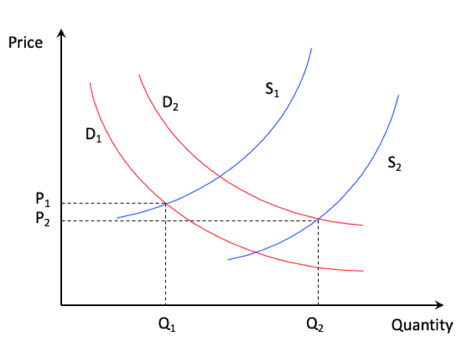

Fig. 2 Supply and demand model of price determination in microeconomics

Due to this reason, a mathematical modeling involving spend amount related discount percentage in a dynamical and intelligent way was implemented in the promotion calculation for both low season and high season.



Where n is the promote factor, it controls the promotion strength as shown in Fig.3. During high season, the promote factor can be adjusted for a higher promotion discount to further boost the volume and eventually the profit. a, b and c is the parameters can be further refined during system improvement feedback circle. The model will start from an initial state (a=-1, b=0.002, c=1, n=0.5) and refine over time to self-adjustment to adapt to different new circumstances.

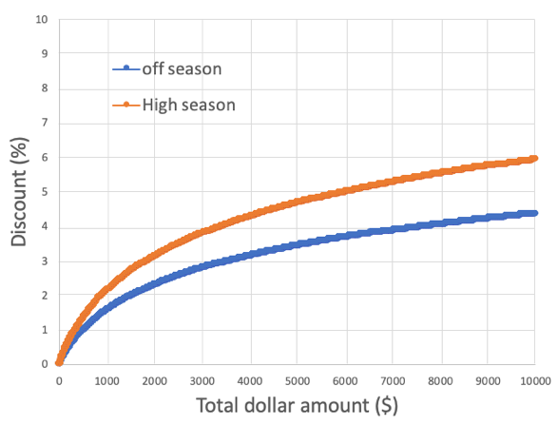

Fig. 3 Dynamical spend amount related discount percentage for both low season and high season

## 3.4 KNOWLEDGE ACQUISITION



After knowledge identification and extraction, the top goal identified is “How to implement an online order processing management system with sales transaction and inventory control”. In order to capture entities, attributes and relationships for optimization/sampling, the inference diagram was constructed in Fig. 4. Based on the knowledge acquired in section 3.1, several secondary goals were identified and shown in Fig. 4.

There are 4 goals with top inference which are directly related to the online ordering process to be developed: Order processing management, Accounts, Business intelligence module and Inventory management.

To achieve these goals, besides sub goals identified within each goal, the facts/observables were categorized and summarized in the inference diagram. Informal feedback from major department also addressed the concern about job less, technology adoption and new technology challenge for older staff regarding the business process change initiative. After team discussion, we suggest conducting more trainings for staff and let them understand this new technology will make process more efficient and believe it will make the company more competitive in the market which will benefit every people in the company.

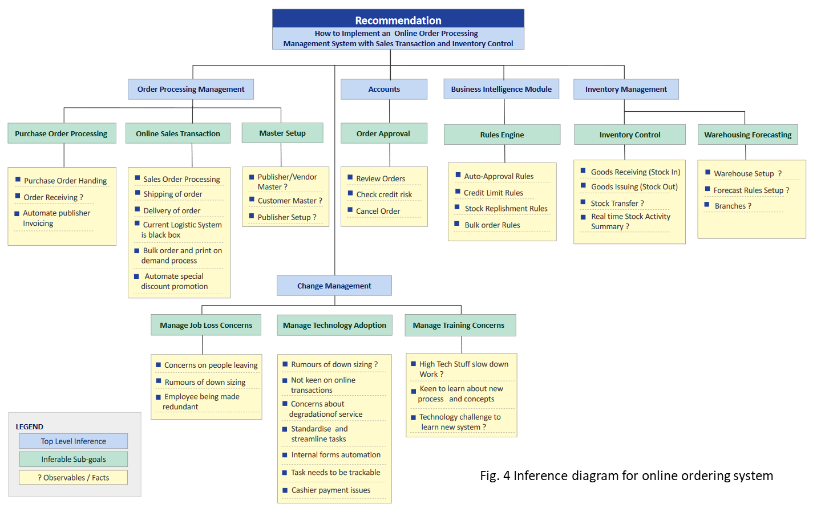

## 3.5 KNOWLEDGE REFINEMENT

Since the process will need adapt to the fast changing economic environment from time to time, and the online ordering system is still not very mature. It is essential to have a feedback loop as shown in Fig. 5 for knowledge refinement and make the system keep improving.

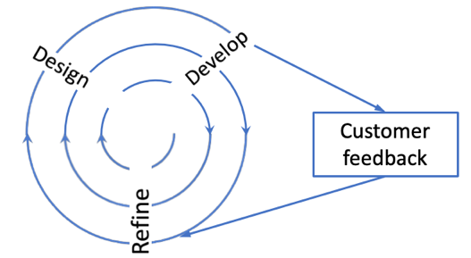

Fig. 5 Spiral feedback loop for continuing improvement

# 4.0 SOLUTION OUTLINE

The development of a knowledge model in section 3 enables the structuring of a process-base which supporting the whole processing of DoReMi Books Inc. As shown in Fig.6, DoReMi Books has a very complex process flow including order handling, purchasing, inventory, shipping and so on. Current process is manual and no on-line internet presence. The new system with Intelligent Business Module will manage all the process in on-line systems and able to conduct optimal stock inventory and warehouse forecasting.

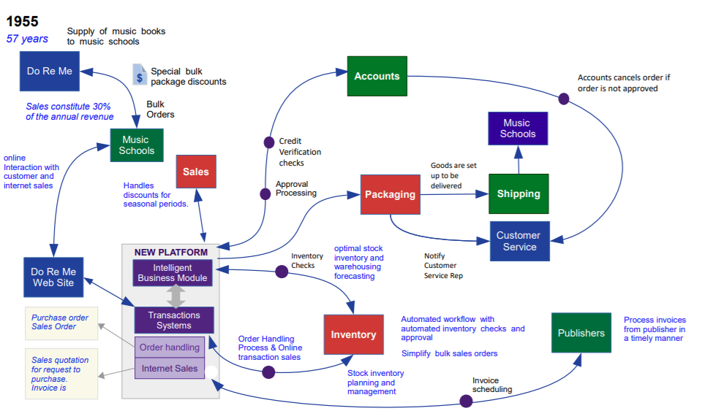

Fig. 6 DoReMi Books Company Process Flow

## 4.1 SYSTEM ARCHITECTURE



The core structure of this system is: (1) sales order transaction processing, (2) inventory control, and (3) the intelligent business rules module.

The sales order handling process starts when receiving orders from DoReMi’s customers and ending at customers receiving their orders upon completion of delivery where the final sales order status is set to closed.

These key processes are linked to discount and special promotion rules or conditions, inventory and warehouse processing, product management processes which are incorporated in the new online order management system.

Each sales order status will be recorded and tracked in the system. This provides an easy way to analyze data for intelligent management of inventory and improves stock inventory forecasting. The workflow of these processes is rule-base and the rules system is based on NRules rules engine (<https://github.cor/NRules/NRules>).

The web MVC solution is developed using Microsoft .Net visual studio 2017. The main system is an MVC web front end with MSSQL database storage. A Web API service is used for receiving confirmation of receipt of products by customers.

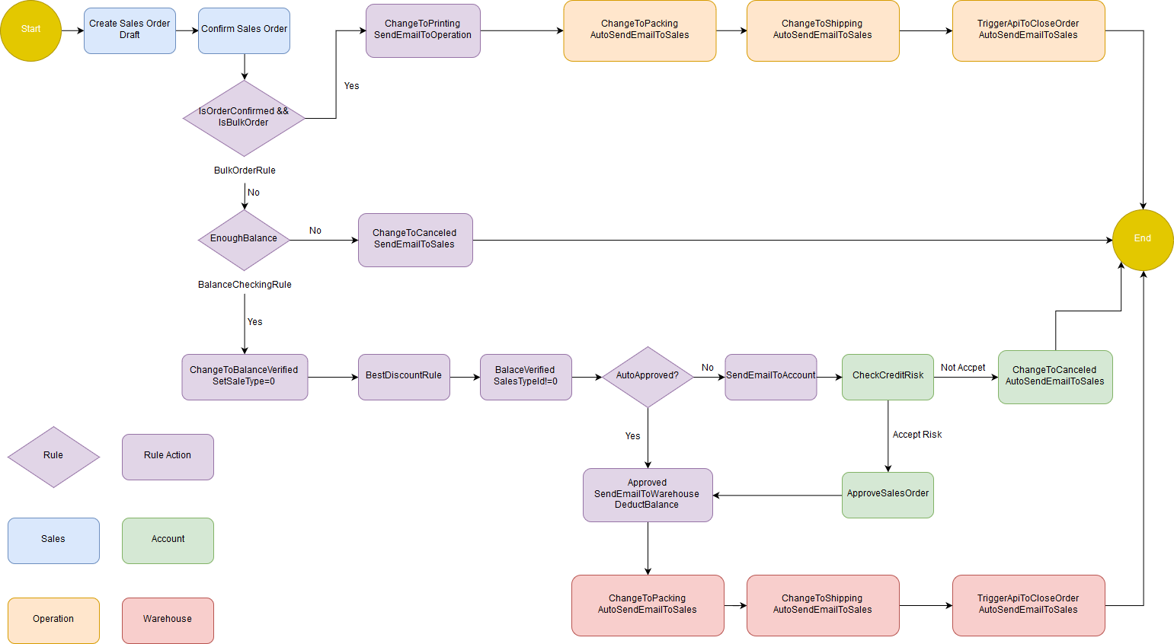

**Fig. 7 Sales Order Transaction Process Flow**

## 4.2 BUSINESS INTELLIGENCE RULES

## (DoReMi’s Online Order Management)

1. **Bulk Order Rule :**

IF ‘Order Type’ = ‘Bulk Order’

THEN ‘Send Email Notification to Operation Department for Printing’

Else

THEN ‘Check Balance’

1. **Stock Balance Check Rule :**

IF ‘Bulk Order Balance’ <= ‘Stock Balance’

THEN ‘Order Status’ = ‘Balance Verified’

Else

THEN ‘Order Status’ = ‘Cancelled’ and ‘Send Email Notification to customer’

1. **Best Discount Rule :**

IF ‘Order Status’ = ‘Balance Verified’

AND ‘Sales Type’ = null

THEN ‘Apply Best Discount’

1. **Auto Approval Checking Rule :**

IF ‘Total Amount’ < 1000

THEN ‘Order Status’ = ‘Approved’ and ‘Send Email Notification to Warehouse’ and ‘Deduct Balance’

Else

THEN ‘Send Email Notification to Account’

1. **Auto Top Up Voucher Rule :**

IF ‘Order Status’ = ‘Closed’

THEN ‘Top Up Credit Points’

## 4.2 ASSUMPTIONS

**ELIGIBILITY OF USERS**

The users of this system are within the DoReMi Book Company:

Sales: Enter Sales Type, Create Sales Order

Product: Enter Product Information

Finance: Update PO, Invoice

Inventory: Update product stock

Account: Record and update customer information

Management: Approval for application roll out to production

IT: Maintain and improve the system

## 

## 4.3 SYSTEM’S FEATURES

**Intelligent**

The system is designed with an intelligent module that handles warehouse forecasting and optimal stock inventory management.

The system records all essential sales order details including customer information, product name, ordered quantity with an order transaction time stamp. By accumulating such entry data in the long term; the system will be able to make better forecast on the optimal demand of stock inventory balance required for each fiscal year with most of products.

**Efficient**

A number of key decision making has been automated in the system. When a sales order is placed, the system will automatically review the customer information and order transaction total amount based on the rules set in the Rules Engine. The system will auto approve orders with low credit risk where their total value amount is less than the auto-approval limits. Any orders that are above the auto-approval limits will be sent to the Accounts department for further review and approval. Once Accounts review and approves an order, an email notification will be sent to the packing team in warehouse for packing and shipping. The automated process ensure improvement in the efficiency of handling the order transaction processing.

**Documented**

All the orders will be processed through the system, thus all the transaction information can be tracked and recorded. No manual documentation is required. The business data can will well protected by back up and secured properly.

## 4.4 LIMITATIONS

The first-generation system is produced and created with limitations.

On the existing system, sales order can only be manually created and processed. Manual reviews are required to confirm every order with their customers. This process is required to ensure the accuracy of sales transaction.

Only limited types of discount or special promotional discounts for certain ordered products can be applied in the existing system.

# 5.0 CONCLUSION & REFERENCES

In this project, our group deployed knowledge acquisition, knowledge extraction and knowledge model construction methodology to address all the requirements and issues from DoReMi’s customer. This served as a solid basis for getting a clear and concise outline and development plans of the proposed DoReMi online order management system. The system is developed based on Microsoft .NET Technologies and N-rules engine was used to implement the business rules in DoReMI’s business processes.

The deliverables for this system are: (1) online order management system; inventory control management system, and a rule-based business intelligent module that handles the key logic in the order transaction model of DoReMi’s books ordering business.

In development process, our group with five members had very active and fruitful discussions and we learnt a lot from each other since we’re from different professions with different skill sets. It is a good opportunity for us not only to apply the machine reasoning knowledge and solve real-life problems but also a wonderful time for every group member to experiment and learn new things.

## 5.1 IMPROVEMENTS:

The new system improved the efficiency and accuracy of DoReMi Books Inc’s business processes.

As this is Phase one implementation, it was completed in a limited time, some improvements are expected in be due in the Phase two of the project.

In Phase two, a customer would be able to place order online, and the sales order would be automatically created once the placed order is processed successfully. This will reduce the time taken for customer call in, creating sales order, reviewing and confirmation of orders with customer. The shopping experience for customer will be improved as well.

When the order is approved and ready for shipping. The warehouse system will link the shipping information, eg. tracking number with the sales order, and notify the customer of the transaction. This will provide greater convenience to DoReMi’s customer on the real-time status of their parcels in transit; and it will also help the company to document the shipping record electronically which can be reviewed to improve DoReMi’s business processes further.

Last but not least, the mode of discount and promotion can be more diversified. More promotions will serve to attract more customers and increase the enterprise sales profit.

# 

# 6.0 BIBLIOGRAPHY

1. Jay Pujara & Sameer Singh. (2018).
2. Supply and demand, Distributed Wikipedia

https://ipfs.io/ipfs/QmXoypizjW3WknFiJnKLwHCnL72vedxjQkDDP1mXWo6uco/wiki/Supply_and_demand.html

# 

# 

# 

# APPENDIX A: SAMPLE INPUT & SYSTEM OUTPUT

## SCENARIO 1

Lorem ipsum dolor sit amet, consectetuer adipiscing elit, sed diam nonummy nibh euismod tincidunt ut laoreet dolore magna aliquam erat volutpat.

## SCENARIO 2

Lorem ipsum dolor sit amet, consectetuer adipiscing elit, sed diam nonummy nibh euismod t

# APPENDIX B: USERS MANUAL

## Lorem ipsum

Lorem ipsum dolor sit amet, consectetuer adipiscing elit, sed diam nonummy nibh euismod tincidunt ut laoreet dolore magna aliquam erat volutpat.

## Dolor sit amet

Lorem ipsum dolor sit amet, consectetuer adipiscing elit, sed diam nonummy nibh euismod ti

# APPENDIX C: TECHNICAL SPECIFICATIONS

Microsoft Visual Studio 2017

ASP.Net framework 4.5

Microsoft SQL Express

NRules ( <https://github.com/NRules/NRules> )