|  |
| --- |
| Singapore Intelligent Insurance Recommender System  Functional Specification Document |

**DOCUMENT VERSION <1.0>**

**21-April-2020**

**AUTHORS**

|  |
| --- |
| **Name** |
| Veda Yogeesha |

**APPROVALS**

|  |  |  |
| --- | --- | --- |
| **Approval Date** | **Approved Version** | **Approver** |
| 02-May | 1.0 | Zhang |
|  |  |  |
|  |  |  |
|  |  |  |

**Table of Contents**

1

1. Introduction 4

1.1 Purpose of the document 4

1.2 Project Scope 5

1.3 Scope of the document 6

1.4 Terms/Acronyms and Definitions 6

1.5 Risks and Assumptions 7

2. System/ Solution Overview 7

2.1 Basics of Health Insurance in Singapore 8

2.2 Dialogflow 8

2.3 Data mining 10

2.4 Multi criteria decision making model 11

2.5 OptaPlanner 11

2.6 Intuitionistic Fuzzy sets (IFS) 12

3. Functional Specifications 13

3.1 System Design 17

3. References 20

4. Appendix 20

# 

# Introduction

To make good decisions, it is necessary to possess information in a easily understandable manner which can be easily compared to make necessary judgements based on the individual needs. However, with the growing amount of information and features, it would be also challenging to the user to be able to apply his preferences to filter the relevant applicable details. Specifically, in the area of Insurance policies that have complex terminologies and multitude of features, it is not easily comprehensible to the user.

**Business Value Created:**

1. Intelligent and yet simple user interface to determine the most suitable policy
2. Insurance Providers can also utilize the information captured to understand and evaluate the trend of user preferences and comparison of other policies to be more competitive in the market. This will assist them to drive business and operational decisions from data to maximize profitability or efficiency metrics.

## Purpose of the document

Insurance is a means of protection from financial loss. An insurance policy is a contract used to indemnify individuals for covered losses and in managing cash flow uncertainty. Insurance industry has already several well-established players and in Singapore particularly there are several new entrants as well. Competition in insurance is important in providing competitive premiums and quality service. However, a lot of competition means that insurers have to differentiate themselves via quality, innovation or price. With the overwhelming number of plans, individuals will have more options and determining the right plan can be time consuming and might not result in choosing the best plan.

Traditional recommender systems usually provide a comparison of the different policies and do not take in to account the user preferences and past preferences. This recommender system will help to look through all the current available plans, past preferences, new policies in the market and customer demographics to identify the most suitable policy.

Lot of information on the insurance policies is available to educate users on the different kinds of insurance. However, all these websites require users to read through several pages of information, hence for a common man it would be time consuming and might not be easily comprehensible to digest the information. Also going through an agent to purchase the insurance policy would also mean paying commission, paying higher premium and might bind the user with a company which is not having a good portfolio.

1. **Life Insurance Association Singapore (LIA)** is the not-for-profit trade association of life insurance product providers and life reinsurance providers based in Singapore and registered by the Monetary Authority of Singapore (MAS). It provides information on the different kinds of policies, provides tools to determine the amount an individual should get insured.
2. **compareFirst** is a joint effort by Consumers Association of Singapore, MAS, LIA and money sense to enable consumers to compare the various life insurance products. It provides general product information on policies.
3. **MoneySense** is Singapore’s national financial education programme, started in 2003. They help Singaporeans to manage their money well and make sound financial decisions on their own. It also provides resources to help on the below factors:
   1. Have the skills and knowledge to weigh their options in financial matters
   2. Know their rights and responsibilities in financial decisions
   3. Make informed decisions when it comes to personal finances
   4. Plan well for their future

Users can be coming from different backgrounds and of different generations. They might not be having the liberty or the ability to understand the different policies from different companies. Also, they might not have access to a company performance or insurance claim processing time which would also help to be a deciding factor for determination of the right policy. We have performed market research by searching several websites, meeting several customers who are unable to easily determine the best insurance policy which is recommended to the user needs.

Having considered all the above challenging issues which a user will require to go through, this application will determine the most suitable policy without going through any such hassle.

## Project Scope

Users can be coming from different backgrounds and of different generations. They might not be having the liberty or the ability to understand the different policies from different companies. Also, they might not have access to a company performance or insurance claims processing time which would also help to be a deciding factor for determination of the right policy. We have performed market research by searching several websites, meeting several customers who are unable to easily determine the best insurance policy which is recommended to the user needs.

Having considered all the above challenging issues which a user will require to go through, this application will determine the most suitable policy without going through any hassle.

We have also performed knowledge elicitation by interviewing the domain experts to obtain a deeper understanding of the policies, current pain points and current operations.

## Scope of the document

Here is the list of functionalities which will be achieved as part of the initial application development.

|  |  |
| --- | --- |
| Sl no | Functionality |
| 1 | User Demographics and Preference capture |
| 2 | Normalization of the policies |
| 3 | Determination of optimal policy by OptaPlanner |
| 4 | User feedback collection |
| 5 | Data mining based on historic transactions by Orange |
| 6 | Dialog flow |

## 1.4 Terms/Acronyms and Definitions

Stated here are some of the basic terms and the corresponding definitions relating to health insurance*.*

|  |  |
| --- | --- |
| **Term** | **Description** |
| Deductible | A deductible is what you pay annually for health services before your insurance company pays its share. For instance, if you have a deductible of $1,000, your insurance plan might not start covering its share of your bills until you’ve paid $1,000 for healthcare in a given year. However, plans often cover the cost of things like preventive care doctor’s visits even before you’ve paid your full deductible amount. |
| Premium | Your premium is what you’ll pay the insurance company for the privilege of having an active insurance plan. Most people pay theirs every month, but your payments might be due once a quarter or once a year. |
| Co-payment | The co-payment (or co-pay) is the amount you owe each time you receive certain types of medical care. Co-pays can vary depending on the kind of service you’re getting. For example, you may have to pay a $30 co-pay for each visit to your GP and $60 for each visit to a specialist. |
| Coinsurance | After you’ve met your deductible for the year you’re not off the hook when it comes to medical bills. You’ll generally face some amount of coinsurance. That’s the percentage you’ll pay of medical expenses. For example, you might meet your $2,500 deductible in May and from then on your coinsurance would be 20%. That means you would pay $20 of a $100 bill and the insurance company would pay the other $80. |
| Claim limits | There are limits to what you can claim under a policy. For example, limits may be included for all claims as well as for each illness, disability, per month, year, or for a lifetime. |
| Age limit | There is no age limit for MediShield Life. It covers you for life, and there is no age limit for entry into the scheme. Private insurance plans may have an age limit, and may not be available to you once you reach a certain age. Some health insurance policies provide cover for your whole life. |
| Policy riders | A policy rider may be added to an existing policy, which provides additional coverage. |
| Claim | a request by a plan member, or a plan member's health care provider, for the insurance company to pay for medical services. |
| Underwriting | the process by which health insurance companies determine whether to extend coverage to an applicant and/or set the policy's premium. |
| Pre-existing condition | a health problem that has been diagnosed, or for which you have been treated, before buying a health insurance plan. |

## 1.5 Risks and Assumptions

Here are the assumptions undertaken for the current design of the system.

* Currently this application search is based on the private ward policies alone
* Data mining is performed based on 500 previous transactions.
* Cognitive process of modelling and solving the decision problem involving the multiple criteria decision-making model using the Grey relational analysis
* Orange is utilized to perform data mining
* Dialogflow is implemented to support answer user queries and view the supporting FAQ from Insurance providers.

# System/ Solution Overview

This section will provide the necessary details which has supported in obtaining the necessary understanding of the different concepts required for the design of this application.

We will discuss upon the following areas:

1. Basic Health Insurance
2. Multi criteria decision making model
3. Intuitionistic Fuzzy sets
4. Dialogflow
5. OptaPlanner
6. Data Mining

## 2.1 Basics of Health Insurance in Singapore

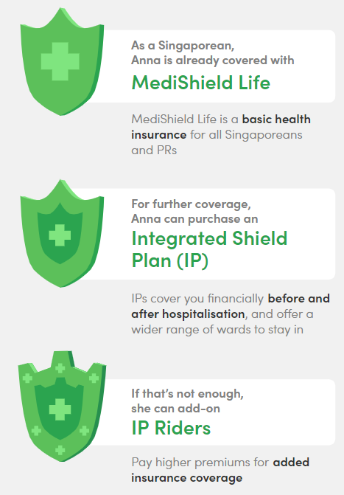

MediShield Life is the most basic sort of health insurance and covers basic healthcare in public hospitals’ lower-class wards. However, addition of Integrated Shield Plan (IP) gives you the option to get treated in better class wards and private hospitals, managed by the private insurer.

*Fig 1: Depicts the levels of coverage by the insurance plans*

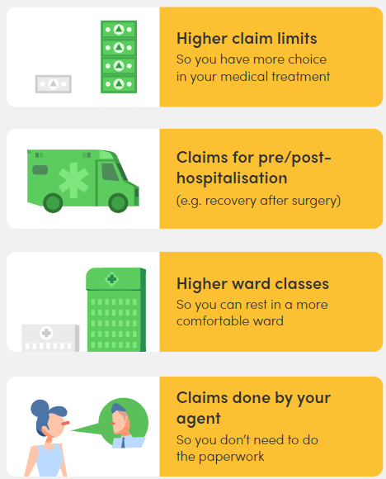

An Integrated Shield Plan (IP) provides coverage on top of your MediShield Life. Different types of IPs provide different coverage. Some cover you for a higher-type ward (A/B1) in a public hospital, while others cover admission into a private hospital.

*Fig 2: Depicts the benefits of having the Integrated Shield plan*

## 2.2 Dialogflow

Dialogflow is user-friendly, intuitive natural language processing Google service tool. It is an end-to-end development suite for building conversational interfaces for websites, mobile applications, and messaging platforms. It can be used to build chatbots, voice assistants, etc., especially relevant to those that are capable of having natural and rich interactions with the users. It is also powered by machine learning to recognize the intent and context of what a user says, allowing a conversational interface to provide highly efficient and accurate responses.

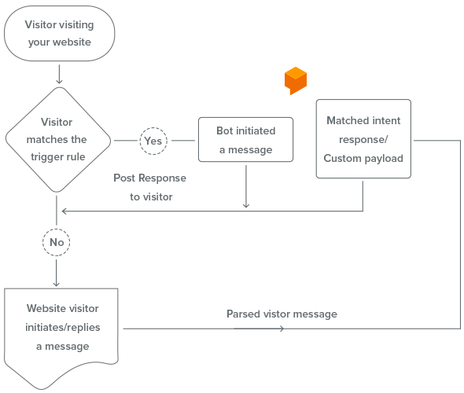

The above picture represent the flow chart for the Dialogflow execution



*Here the user may want to check upon certain frequently asked questions about the policies/ insurance providers. By associating the FAQ and policy references with Dialogflow, the bot can respond to user queries.*

**Benefits of integrating Dialogflow:**

* Easy to tailor-made bots that suit your business aspects to support the FAQ.
* It is easily configurable. Once [integrated](https://www.zoho.com/salesiq/help/developer-section/bot-dialogflow.html#integrate) with Dialogflow, the bots you have created in the platforms is all set to assist your website visitors.
* Dialogflow doesn't require any coding knowledge. The interface will guide you to build your bot as you wish without any basic coding knowledge and allows you to integrate with your application in minutes.

## 2.3 Data mining

Based on the recommendation paradigm of the supervised learning, we determine the most optimal policy based on the past transactions. In the pursuit of extracting useful and relevant information from data, process of data exploration, preprocessing, modeling, evaluation and knowledge extraction is performed. Exploratory visualization using Orange tool helped to comprehend various patterns in the data set.

Orange implements functions for construction of classification models, their evaluation and scoring. Neighbors-based classification is a type of *instance-based learning* or *non-generalizing learning*: it does not attempt to construct a general internal model, but simply stores instances of the training data. Classification is computed from a simple majority vote of the nearest neighbors of each point: a query point is assigned the data class which has the most representatives within the nearest neighbors of the point.

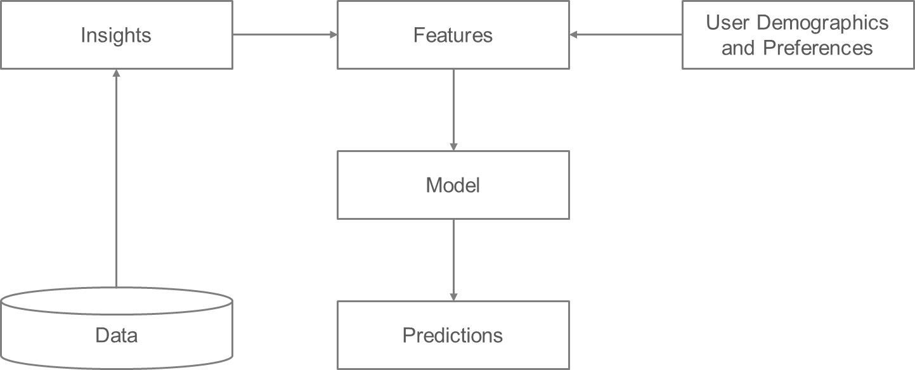

The k-neighbors classification in [KNeighborsClassifier](https://scikit-learn.org/stable/modules/generated/sklearn.neighbors.KNeighborsClassifier.html#sklearn.neighbors.KNeighborsClassifier) is the most commonly used technique. The optimal choice of the value k is highly data-dependent: in general, a larger k suppresses the effects of noise, but makes the classification boundaries less distinct. The basic nearest neighbors regression uses uniform weights: that is, each point in the local neighborhood contributes uniformly to the classification of a query point. Under some circumstances, it can be advantageous to weight points such that nearby points contribute more to the regression than faraway points. This can be accomplished through the weights keyword. The default value, weights = 'uniform', assigns equal weights to all points. weights = 'distance' assigns weights proportional to the inverse of the distance from the query point. Alternatively, a user-defined function of the distance can be supplied, which will be used to compute the weights.

< data exploration step to be added>

## 2.4 Multi criteria decision making model

It is a cognitive process of modelling and solving the decision problem involving the multiple criteria using the Grey relational analysis model. The objective of this model is to support the user in providing the best alternatives when multiple criteria is involved. The raw inputs might be in different ranges and their values in different units. While the distribution can be tamed as described above, the values might still need to be brought into comparable ranges. For this, the features might need to be transformed to some min-max range (so min is always 0 and max is always 1) or z-scored values could be used (so the mean of each feature is zero and standard deviation is 1). Such transformations then let the model do the actual job of learning the relative importance of these features instead of forcing them to also compensate for these feature differences.

Here is the explanation on the steps to be followed:

• Defining the object of decision and perform normalization:

The object of the decision is to list all the set of all candidate alternatives for which the decision has to be made.

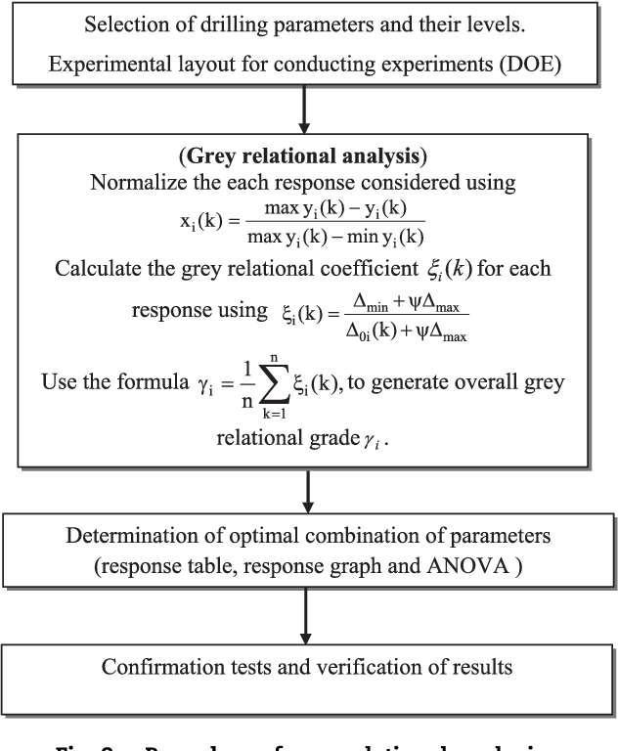

• Defining a consistent family of criteria and apply user weightage :

The performance of alternatives is determined based upon a set of user input preference captured values. Following which, the user weightage is applied to all the applicable policies which will be used to evaluate the most optimal policy. IFS logic is used to calculate the user weightage value.

## 2.5 OptaPlanner

[OptaPlanner](https://www.optaplanner.org/) is a lightweight, embeddable constraint satisfaction engine which optimizes planning problems. It is also known as *Constraint Satisfaction Programming* (which is part of the *Operations Research* discipline).

Usually, a planning problem has at least two levels of constraints:

* A hard constraint must not be broken.
* A soft constraint should not be broken if it can be avoided. For example: Teacher A does not like to teach on Friday afternoon.

These constraints define the score calculation of a planning problem. Each solution of a planning problem can be graded with a score. 

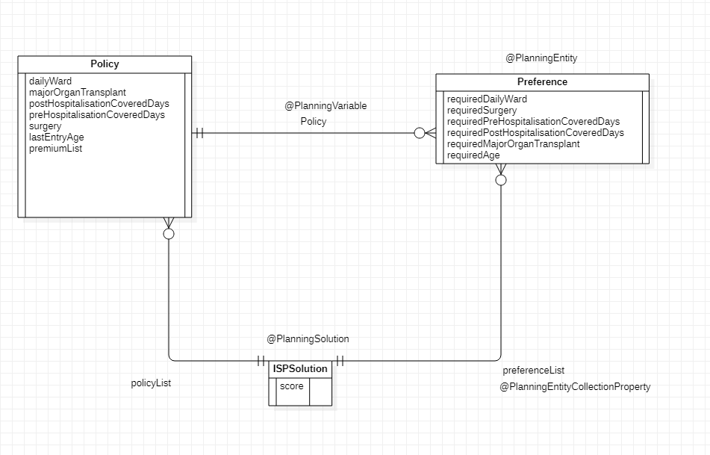

The picture above depicts the design in OptaPlanner,

* Planning entity: the class (or classes) that changes during planning [Preference].
* Planning variable: the property (or properties) of a planning entity class that changes during planning. In this examples, that's the property [Policy].
* Solution: the class that represents a data set and contains all planning entities. [ISPSolution].

## 2.6 Intuitionistic Fuzzy sets (IFS)

Is an extension of fuzzy sets. Unlike the Fuzzy set, wherein there the membership element is a single value between 0 and1. Here it incorporates 3 elements namely Membership degree, non-membership degree and Hesitancy margin.

|  |  |  |  |
| --- | --- | --- | --- |
| Linguistic Scale/ Decision Maker | Membership degree | Non-membership degree | Hesitancy degree |
| Very Important | 0.9 | 0.1 | 0.05 |
| Important | 0.75 | 0.2 | 0.05 |
| Medium | 0.5 | 0.4 | 0.1 |
| Unimportant | 0.35 | 0.6 | 0.15 |
| Very Unimportant | 0.1 | 0.8 | 0.1 |

User expresses his preferences for the policy preferences, these are transformed into a measurable values (weights) using the linguistic variables defined in the above table. Assume that decision group contains ‘n’ decision makers. The importance of the decision makers are considered as linguistic terms expressed in intuitionistic fuzzy numbers. Let Dj be an intuitionistic fuzzy number for rating of jth decision maker. Then the weight of ‘j’th decision maker can be obtained as:

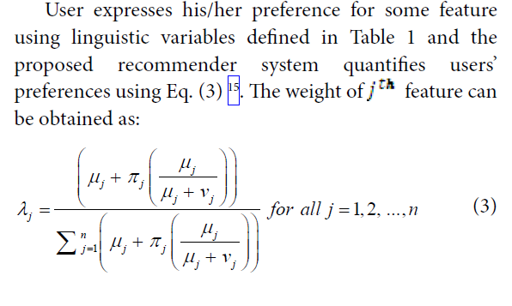

# Functional Specifications

This section will explain the overall functionality of the system in detail. We begin the section by capturing the different use cases, flow chart, activity diagram, field list, rules and followed by detailed functional explanation.

### 3.1.1 Use cases

Description of how a person who actually uses that process or system will accomplish a goal.

Here we provide the details upon the different possible use cases:

1. User only provides the demographics to determine the optimal policy
2. User provides the demographics and the preferences to determine the suitable policy
3. User to use Dialogflow
4. User would like to check upon the previous transactions history to determine the suitable policy
5. User can choose to restart the exercise by re-choosing the preferences again.

|  |  |
| --- | --- |
| **UC-1** | **Current Optimal Policy Determination** |
| **Primary Actor(s)** | User A |
| **Initiation** | User will capture the below details   1. Demographic details 2. Policy preference information |
| **Conditions** | User chooses to provide the policy preference details |
| **Post-conditions** | System will consume the user provided preference details to perform the intelligent evaluation of all the policies to determine the most optimal policy. |

|  |  |
| --- | --- |
| **UC-2** | **Historically Preferred Policy Determination** |
| **Primary Actor(s)** | User A |
| **Initiation** | User will capture the below details   1. Demographic details |
| **Conditions** | User choose to look upon the historically preferred policy based upon his basic information details. |
| **Post-conditions** | System will consume the basic user details to perform the intelligent evaluation of all the historical data to determine the most optimal policy. |

### 3.1.6 Field level specifications

**Buttons, Links and Icons:**

|  |  |  |  |  |  |  |
| --- | --- | --- | --- | --- | --- | --- |
| **Button, Link, Icon Label** | **OnClick Event** | **Visible** | **Enabled Vs Disabled** | **Navigate To** | **Validation** | **Dependencies** |
| **Start Survey** | **User will initiate the operation to fill the form details.** | **Yes, always** | **Always Enabled, after selection a new form will be displayed to capture the user details** | **User Demographic page** | **N/A** | **N/A** |
| **Next** | **User will be navigated to the next form page** | **Yes, always** | **Always Enabled, after selection a new form will be displayed** | **User Preferences Page** | **N/A** | **User should have completed capturing the mandatory information in the existing page to proceed.** |

**Form Elements:**

|  |  |  |  |  |  |  |  |
| --- | --- | --- | --- | --- | --- | --- | --- |
| **Field Label** | **UI Control** | **Mand?** | **Editable** | **Data Type** | **Value Set** | **Data Example** | **Data Source** |
| Name | Textbox | Mandatory | Yes | Alpha-numeric | none | Li Sheng | User entry |
| Age | Dropdown | Mandatory | Yes | Numeric | Numbers ranging from 20 to 75 | 25 | User selection |
| Gender | Dropdown | Mandatory | Yes | Characters | Male/ Female | Male | User selection |
| Singapore Status | Dropdown | Mandatory | Yes | Characters | Singaporean/ PR/ Foreigner | Singaporean | User selection |
| Expenditure | Selection | Optional | Yes | Numeric | Any amount | 10000 | User selection |
| Income | Selection | Optional | Yes | Numeric | Any amount | 100000 | User selection |
| Loan Amount | Selection | Optional | Yes | Numeric | Any amount | 1000000 | User selection |
| Family Size | Selection | Optional | Yes | Numeric | Number of members including self | 5 | User selection |
| Hospital Type | Selection | Mandatory | Yes | Characters | Hospital Type List | Govt and Restructured/ Private | User selection |
| Health Condition | Selection | Mandatory | Yes | Characters | Yes/ No | Yes | User selection |
| Hazard Profession Type | Selection | Mandatory | Yes | Characters | Yes/ No | Yes | User selection |
| Habit Type | Selection | Mandatory | Yes | Characters | Yes/ No | Yes | User selection |
| Other Insurance | Selection | Mandatory | Yes | Characters | Yes/ No | Yes | User selection |
| Co-Payment Percentage | Selection | Mandatory | Yes | Numeric | 5%, 10%, 20%, 25 % and above | 10% | User selection |
| Co-Insurance Payment | Selection | Mandatory | Yes | Numeric | 3000 SGD, 5000 SGD, 12000 SGD, Full Amount | 10% | User selection |
| Deductible | Selection | Mandatory | Yes | Numeric | 0 SGD,1000 SGD,2500 SGD,3500 SGD | 10% | User selection |
| Non-Panel Surcharge | Selection | Mandatory | Yes | Numeric | 3000 SGD, 5000 SGD, 12000 SGD, Full Amount | 10% | User selection |
| Preferences | Selection | Mandatory | Yes | Characters | Yes/ No | Yes | User selection |
| Ward Type | Selection | Optional | Yes | Characters | Ward Types List | Yes | User selection |
| Premium Amount Payment | Selection | Optional | Yes | Characters | Premium Amount Range List | Yes | User selection |
| Pre-Hospitalization Coverage | Selection | Optional | Yes | Numeric | Pre-Hospitalization Coverage Days Range List  3m, 4m, 6m, 1Y | Yes | User selection |
| Post- Hospitalization Coverage | Selection | Optional | Yes | Numeric | Post-Hospitalization Coverage Days Range List  3m, 4m, 6m, 1Y, 2Y | Yes | User selection |
| Annual Coverage limit | Selection | Optional | Yes | Characters | Annual Coverage limit Range List  >400 K, 400 K-800 K, 800 K to 1.2 M, >1.2 M | Yes | User selection |

**Form Business Rules and Dependencies:**

**Drools Rules:**

|  |  |
| --- | --- |
| **Rule Name** | **Validation / Business Rules** |
| Invalid Age | To ensure the age of the user is not greater than the applicable last entry age for the policy which is >75. |
| Status |  |

**Opta Rules:**

|  |  |  |
| --- | --- | --- |
| **Rule Name** | **Rule Type** | **Validation / Business Rules** |
| Hard last entry age | Hard | To ensure the age of the user is within the applicable age for the policy. |
| Post-Hospitalization Covered Days | Soft | Used to evaluate the policies |
| Pre-Hospitalization Covered Days | Soft | Used to evaluate the policies |
| Policy Year Limit | Soft | Used to evaluate the policies |
| Critical Illnesses | Soft | Used to evaluate the policies |
| Major Organ Transplant | Soft | Used to evaluate the policies |
| Community Hospital | Soft | Used to evaluate the policies |
| Premium Amount | Soft | Used to evaluate the policies |
| Surgery | Soft | Used to evaluate the policies |
| Co-Pay Capped At | Soft | Used to evaluate the policies |
| Non-Panel Surcharge | Soft | Used to evaluate the policies |
| Deductible | Soft | Used to evaluate the policies |
| Co-insurance | Soft | Used to evaluate the policies |
| Pre-Hospitalization Coverage | Soft | Used to evaluate the policies |
| Post-Hospitalization Coverage | Soft | Used to evaluate the policies |
| Claims Processing Duration | Soft | Used to evaluate the policies |
| Emergency Overseas Treatment | Soft | Used to evaluate the policies |
| Prosthesis | Soft | Used to evaluate the policies |

## 3.1 System Design

### 3.1.1 Activity Diagram

### 3.1.2 Flowchart

### 3.1.4 Mock-up

Mock up screens are captured in the Appendix section.

### 3.1.5 Functional Requirements

*<Describe the page level details that are not captured in section 3.1.5 below. These may include any requirements related to Navigation Menu, Actions, transaction status, verification and validation requirements etc.*

*Make sure each specification has a reference number and is explained in the following format.>*

|  |  |  |
| --- | --- | --- |
| **Spec ID** | **Specification Description** | **Business Rules/ Data Dependency** |
| *<Specification Identifier>* | *<Short explanation of the specification>* | *<Any validation rules or business rules>* |

*<Note: Section 3.1.4 and section 3.1.5 may be combined if there are a few functionalities on a particular page>*Integration Requirements

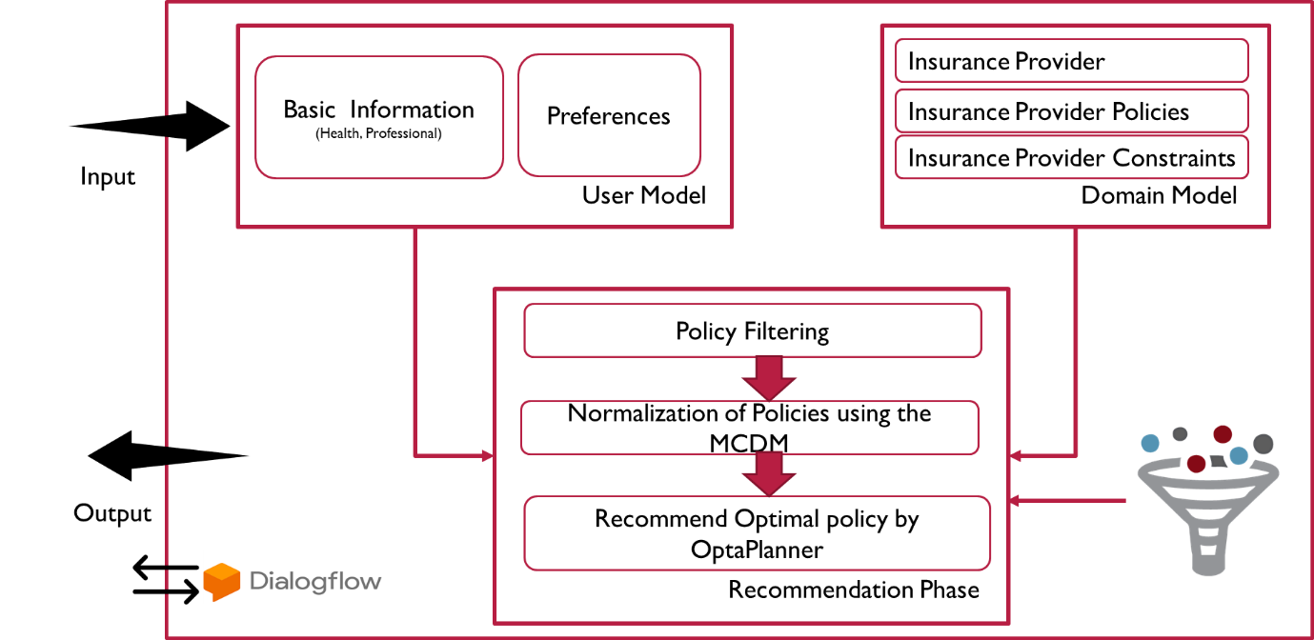

Fig 3 System Framework

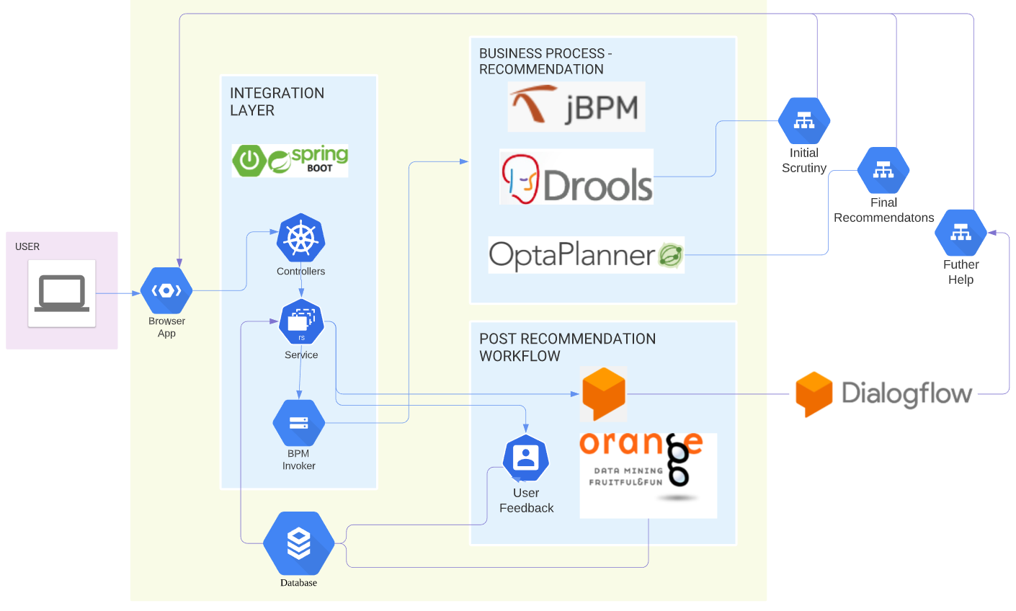

Fig 4 Architecture Diagram

# References

We have referenced the articles of the course materials and several papers on the MCDM, GRA and IFS. Her are the key papers which has helped us to build a better understanding of the various principles and methodology.

1. Roy B. Multicriteria methodology for decision aiding. Springer Science & Business Media.
2. Boran FE, Genc S, Kurt M, Akshay D. A multi-criteria intuitionistic fuzzy group decision making for supplier selection with TOPSIS method.
3. Kuo Y, Yang T, Huang GW. The use of grey relational analysis in solving multiple attribute decision-making problems. 2008

# Appendix

Future enhancements

1. Real time integration with IP
2. Feedback learning mechanism