# Installation and User Guide

Step 1: Download the DASH code from GitHub.

Step 2: Install python in your computer.

**For Window:** You can download Python 3.9 from the Microsoft Store

**For Linux:** You can install using:

sudo apt update

sudo apt -y upgrade

sudo apt install python3.9

**For Mac:** Can be downloaded from this link:

<https://www.python.org/downloads/macos/>

Step 2:

In the command line navigate to the directory you have downloaded to code into.

Run the command:

pip install -r requirements.txt

Step 3: login your Dialogflow dashboard

<https://dialogflow.cloud.google.com/>

Step 4: Click “create agent”



Step 5: Name the agent “DASH” and click create



Step 6: import SmartAgent.zip

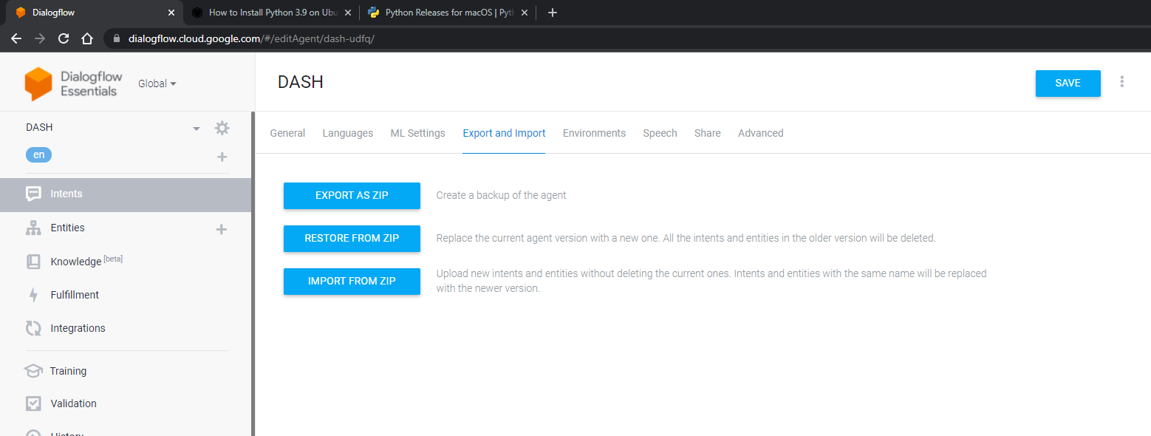



Step 7: click ngrok_start.bat

Step 8: copy to the https address into the “URL” field on the “Fulfillment” tab in Dialogflow

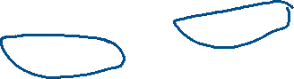

Step 9: click run_um.bat and go to the “Integrations” Tab in Dialogflow

Step 10: Scroll down to Web Demo and try out the chatbot

Note:

* Please provide your symptoms one by one to the chatbot as it asks information.

Step 11：click app_start.bat to start app and view the results of your answers

Note: Patient ID starts from 2 when using the app, at this time.