EpyScenario — Pertussis & Intervention Planner
User Acceptance Test — Evidence Document
Version 1.0 · Executed 2026-08-14 · Local (SOAR) · 19 passed / 0 failed of 19
This document provides before/after screen evidence for each acceptance test. Screenshots were captured during test execution against the running application (http://localhost:8501).

Test ID | Type | Title | Result
P-01 | Positive | Select the pertussis model activates the partial-immunity structure | Pass
P-02 | Positive | Model-parameters panel exposes all pertussis parameters | Pass
P-03 | Positive | Initial-conditions expose partial-track split and coverage profile | Pass
P-04 | Positive | Baseline scenario runs and produces trajectories | Pass
P-05 | Positive | Partial-track infectious compartment (Ip) is available | Pass
P-06 | Positive | Summary metrics are computed | Pass
P-07 | Positive | DTaP/Tdap saved campaign set loads into the scenario | Pass
P-08 | Positive | Observed-data overlay produces an Observed-vs-modeled comparison | Pass
P-09 | Positive | Contacts-by-setting age-mixing view renders | Pass
P-10 | Negative | Initial infected + background immunity over 100% is rejected | Pass
I-01 | Positive | Contact-intervention form is available | Pass
I-02 | Positive | Add a school closure (50%) to the plan | Pass
I-03 | Positive | Add an all-layers intervention | Pass
I-04 | Positive | Remove an intervention | Pass
I-05 | Positive | A scenario with an intervention runs and reflects the reduction | Pass
I-06 | Negative | End day earlier than start day is rejected | Pass
V-01 | Positive | Planner grid is pre-filled with the DTaP/Tdap schedule | Pass
V-02 | Positive | A coverage profile can be saved and persists | Pass
V-03 | Negative | Saving a coverage profile with an empty name is rejected | Pass

Pertussis Model

P-01 — Select the pertussis model activates the partial-immunity structure
Positive · Result: Pass
Steps: Open the Model dropdown.; Select 'SEIRS (Pertussis)'.
Expected: Model switches to pertussis; the pertussis-only 'Observed data & calibration' panel becomes available.
Actual: Pertussis selected; pertussis-only calibration panel present.
Before
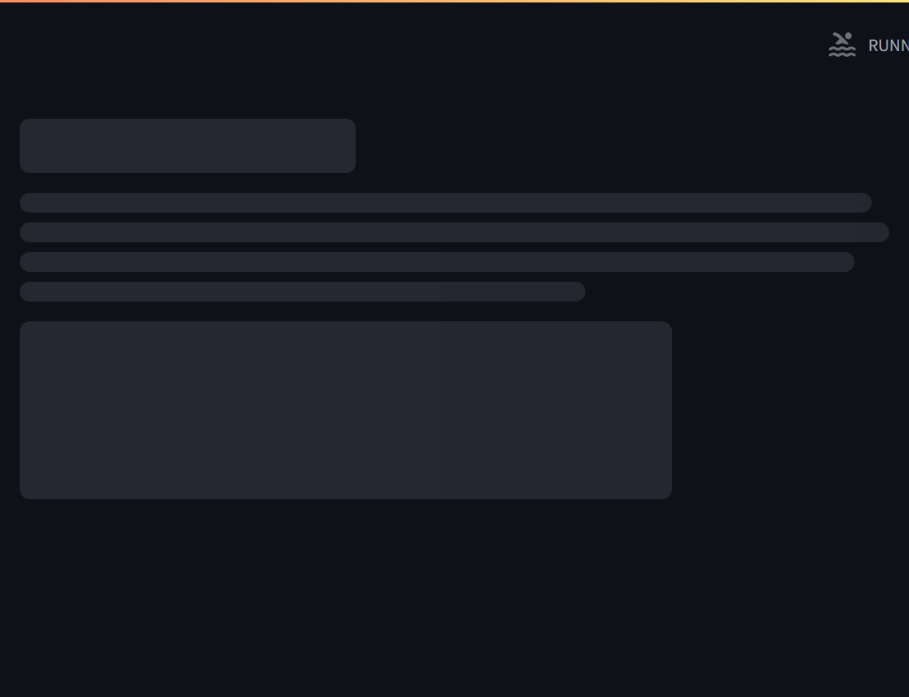
After
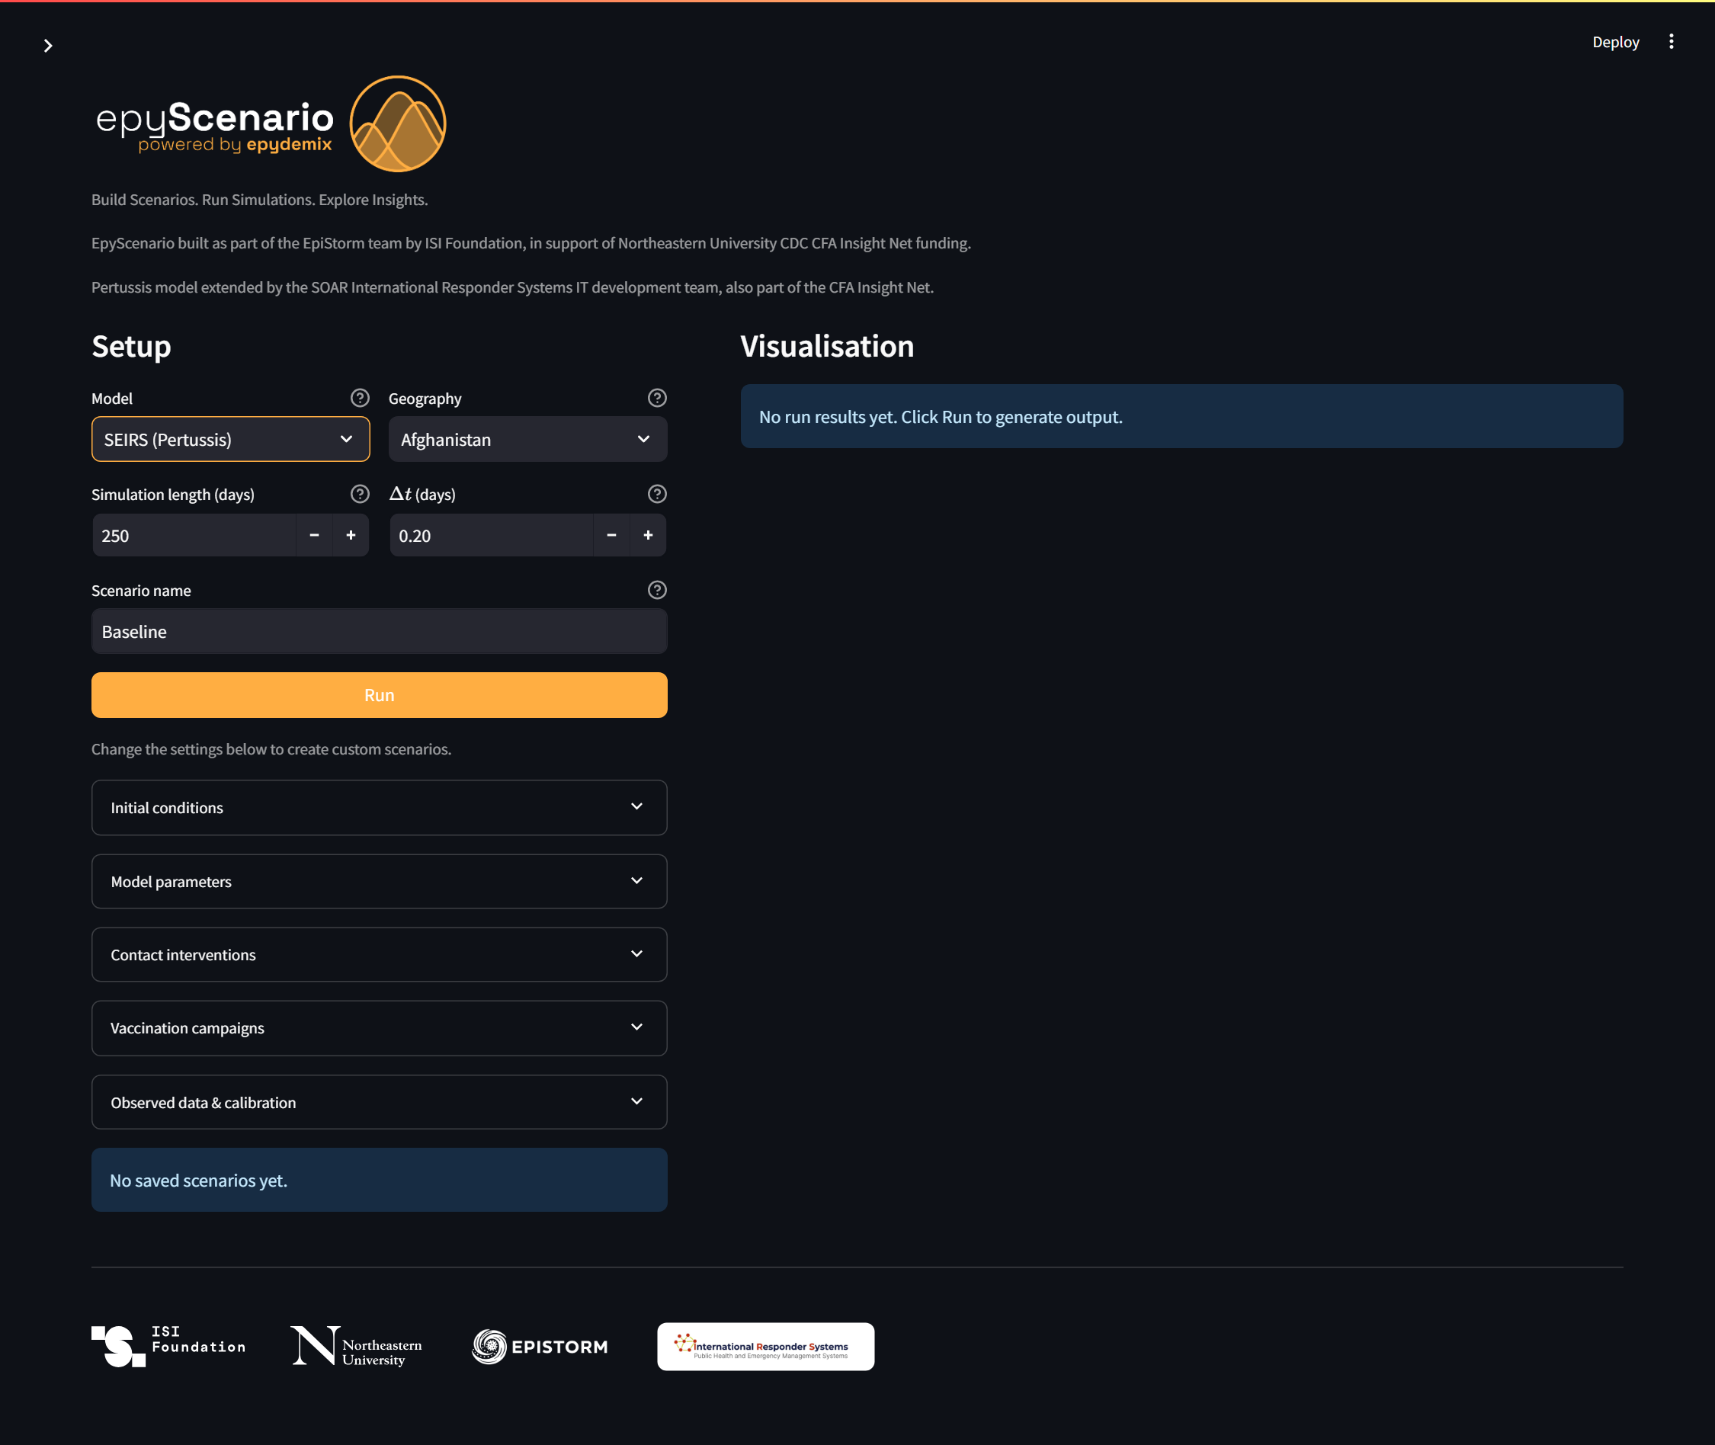

P-02 — Model-parameters panel exposes all pertussis parameters
Positive · Result: Pass
Steps: Expand 'Model parameters'.
Expected: R0, incubation, naive & partial infectious periods, sigma, delta, three waning terms (omega1/2/3) and seasonality are all shown.
Actual: All pertussis parameters present.
After
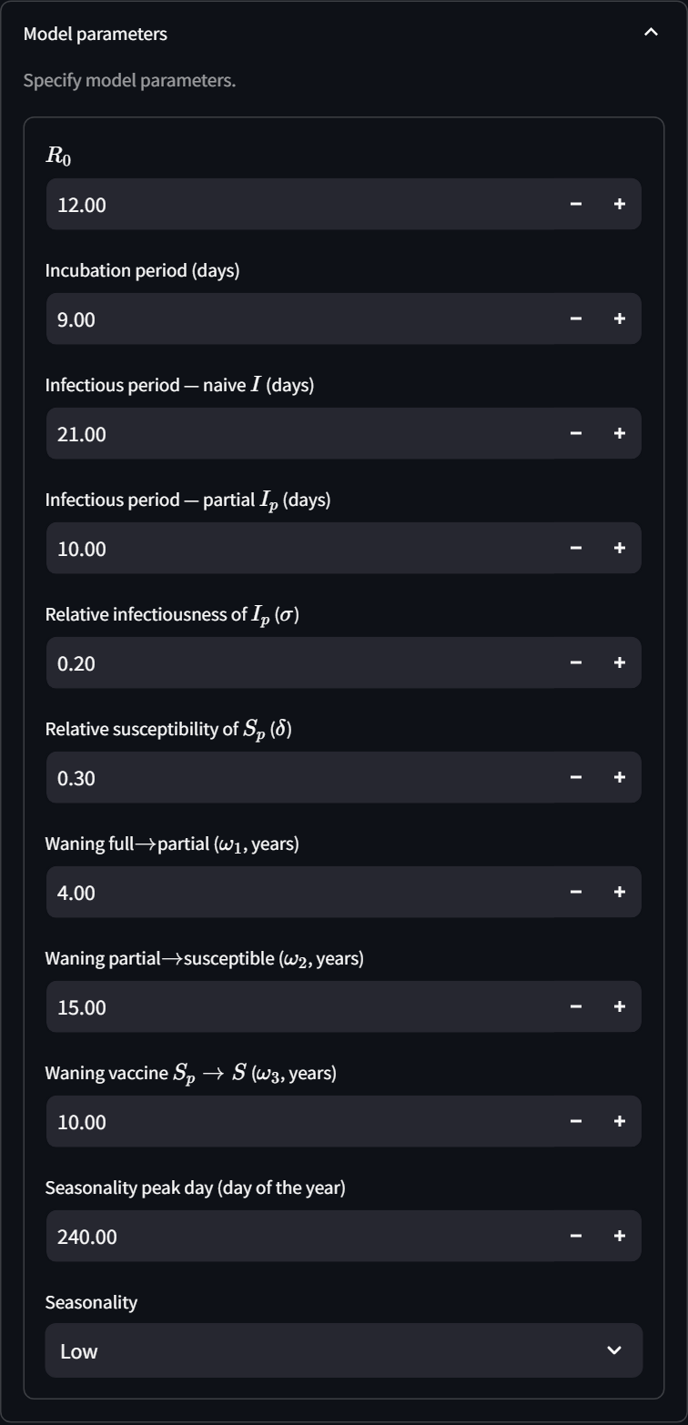

P-03 — Initial-conditions expose partial-track split and coverage profile
Positive · Result: Pass
Steps: Expand 'Initial conditions'.
Expected: Controls for infections-in-partial-track, Sp share of the immune pool, and a saved coverage-profile selector are present.
Actual: Partial-track and coverage-profile controls present.
After
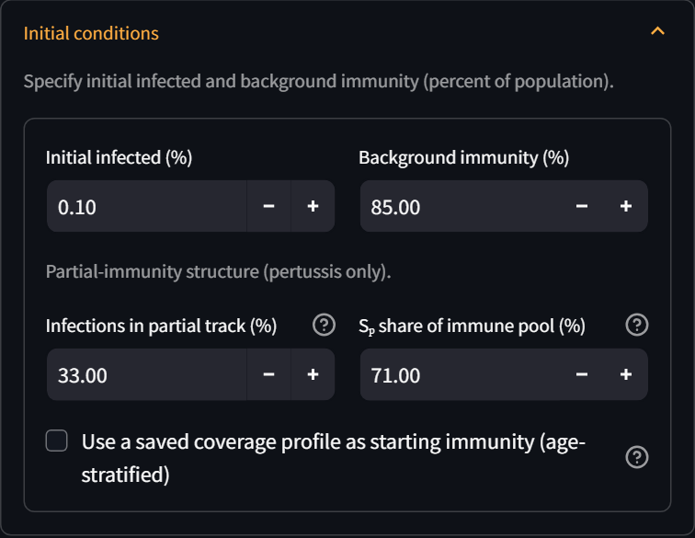

P-04 — Baseline scenario runs and produces trajectories
Positive · Result: Pass
Steps: Click Run.; Wait for results.
Expected: Result tabs appear and the Trajectories chart shows a non-zero infection curve.
Actual: Run completed; trajectories shown.
After
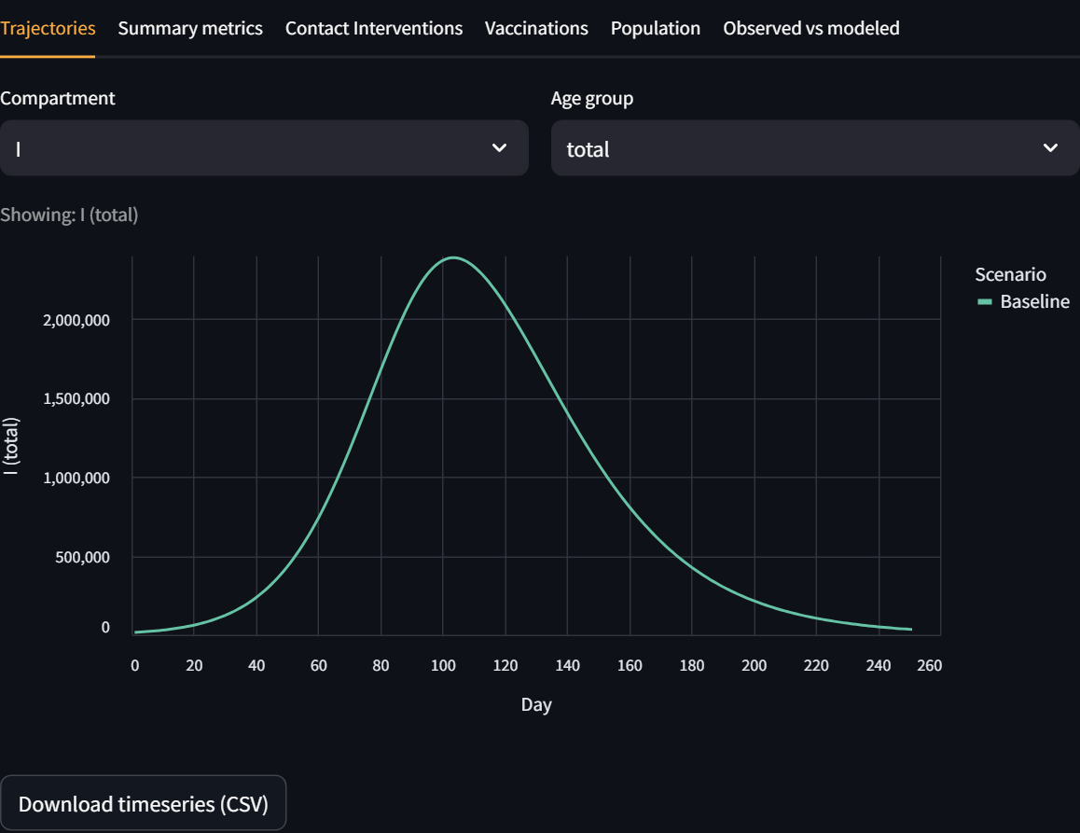

P-05 — Partial-track infectious compartment (Ip) is available
Positive · Result: Pass
Steps: On Trajectories, set Compartment to 'Ip'.
Expected: The partial-track infectious (Ip) curve is displayed.
Actual: Ip curve displayed.
After
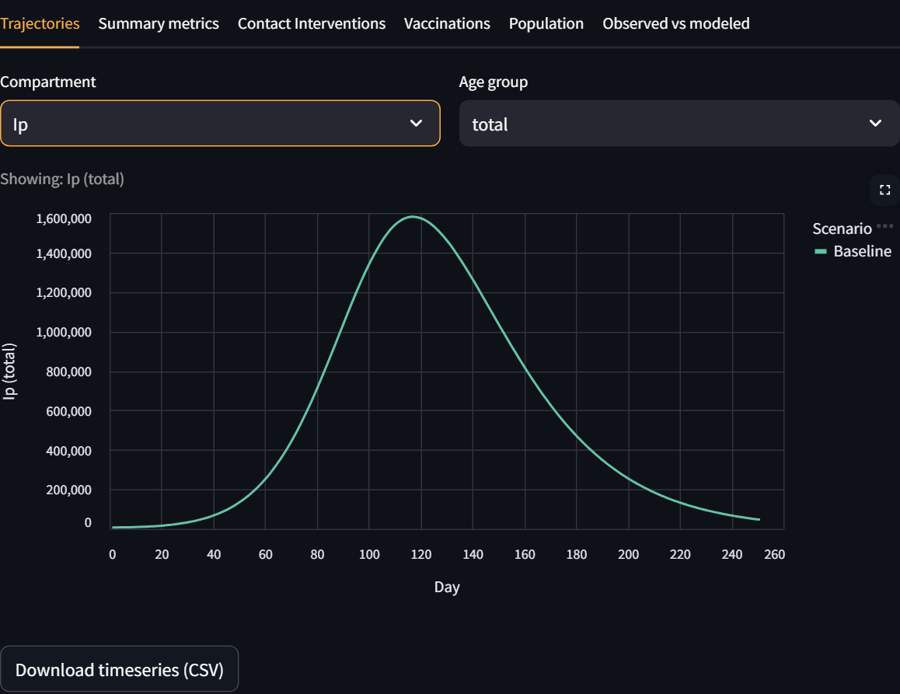

P-06 — Summary metrics are computed
Positive · Result: Pass
Steps: Open the 'Summary metrics' tab.
Expected: Attack rate, peak prevalence and related metrics are shown by age band.
Actual: Summary metrics shown.
After
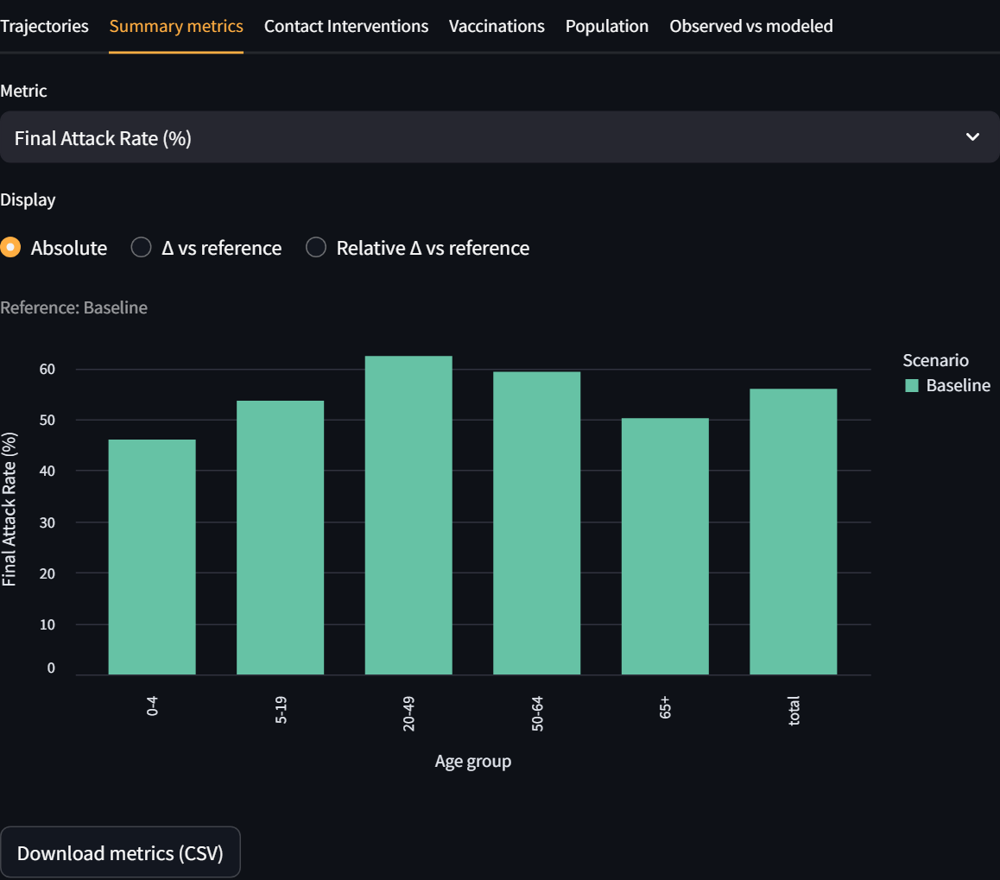

P-07 — DTaP/Tdap saved campaign set loads into the scenario
Positive · Result: Pass
Steps: Expand 'Vaccination campaigns'.; Select the 'DTaP/Tdap (CDC)' set.; Click 'Load into scenario'.
Expected: Three DTaP/Tdap campaign lines are loaded into the scenario.
Actual: DTaP/Tdap set loaded.
After
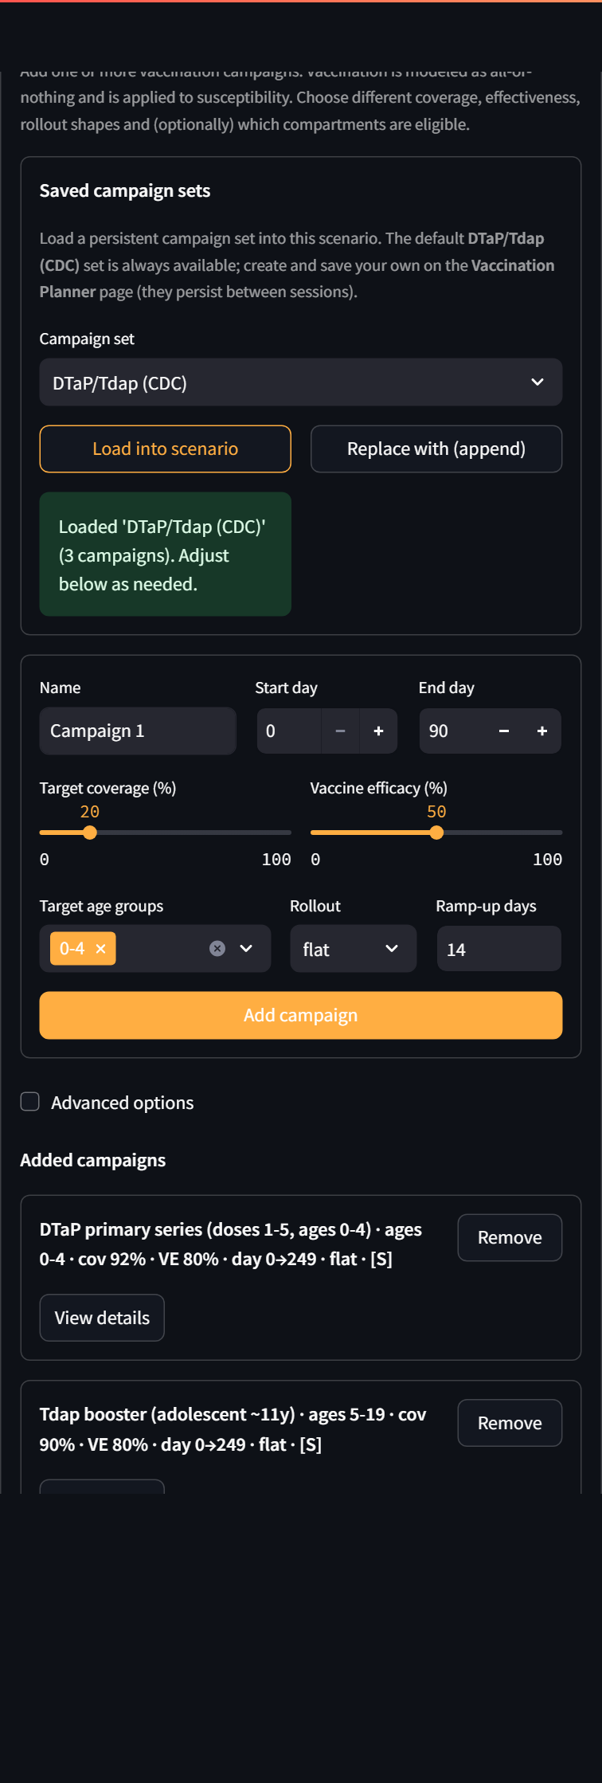

P-08 — Observed-data overlay produces an Observed-vs-modeled comparison
Positive · Result: Pass
Steps: Open the 'Observed vs modeled' tab.
Expected: Observed vs modeled vaccinated-share metrics and comparison charts are displayed.
Actual: Observed-vs-modeled comparison shown.
After
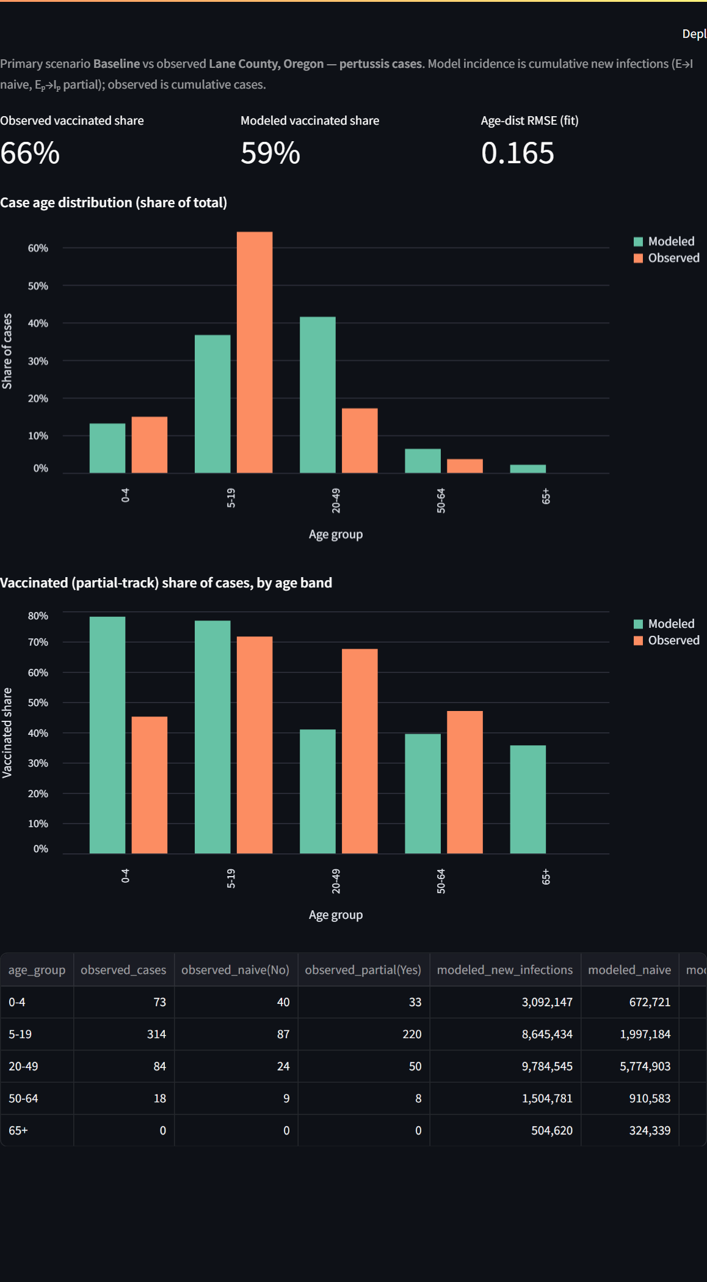

P-09 — Contacts-by-setting age-mixing view renders
Positive · Result: Pass
Steps: Open the 'Population' tab.; Choose 'Contacts by setting'.
Expected: A per-age-band breakdown of contacts across home/school/work/community is shown.
Actual: Contacts-by-setting shown.
After
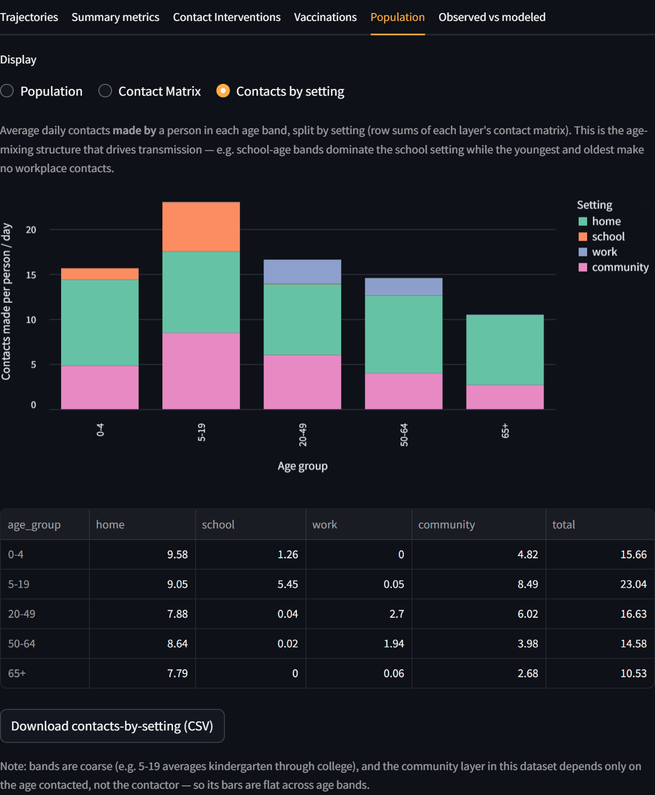

P-10 — Initial infected + background immunity over 100% is rejected
Negative · Result: Pass
Steps: Set Initial infected to 60%.; Set Background immunity to 60%.
Expected: A validation error states that initial infected + background immunity must be <= 100%.
Actual: Validation error shown for >100%.
Before
After
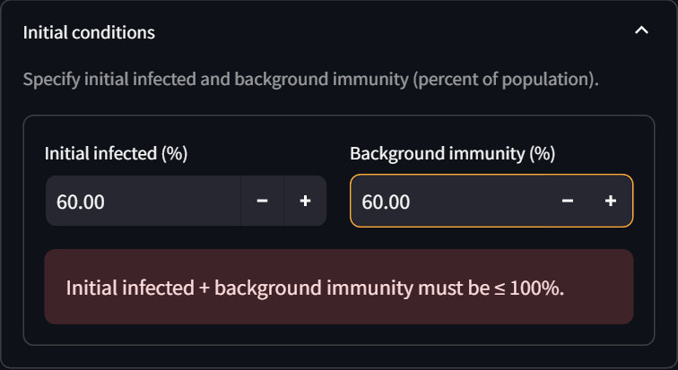

Intervention Planner

I-01 — Contact-intervention form is available
Positive · Result: Pass
Steps: Expand 'Contact interventions'.
Expected: Layer, Start day, End day, Reduction (%) controls and an Add button are present.
Actual: Intervention form present.
After
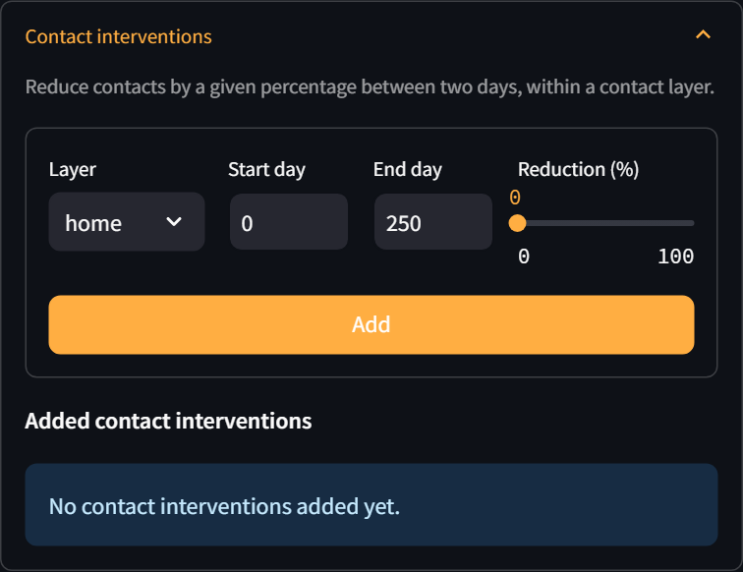

I-02 — Add a school closure (50%) to the plan
Positive · Result: Pass
Steps: Set Layer to 'school'.; Set Reduction to ~50%.; Click Add.
Expected: A 'school - 50% - day 0 -> 250' entry appears under 'Added contact interventions'.
Actual: School 50% intervention added.
Before
After
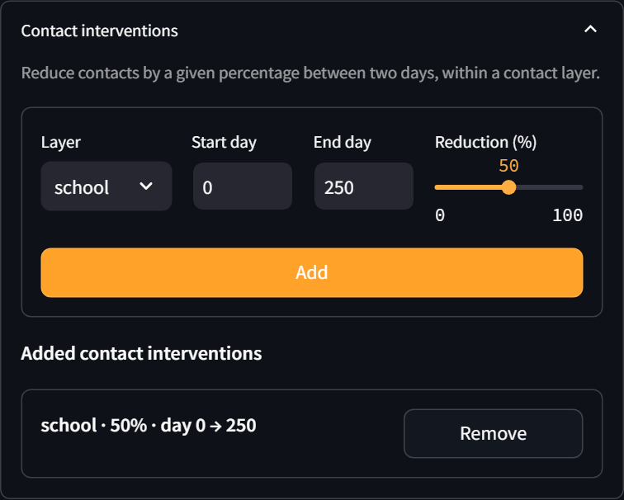

I-03 — Add an all-layers intervention
Positive · Result: Pass
Steps: Set Layer to 'all'.; Click Add.
Expected: An 'all - ... ' entry is added to the interventions list.
Actual: All-layers intervention added.
After
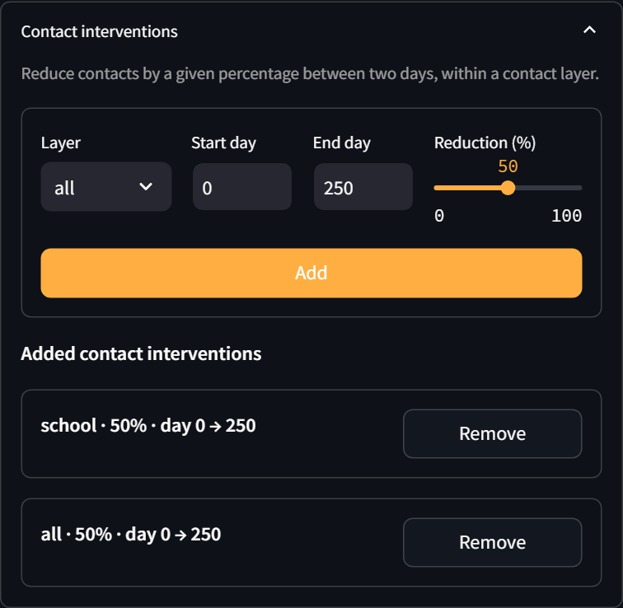

I-04 — Remove an intervention
Positive · Result: Pass
Steps: Click 'Remove' on an intervention.
Expected: The intervention is removed and the list updates.
Actual: Interventions 2 -> 1.
Before
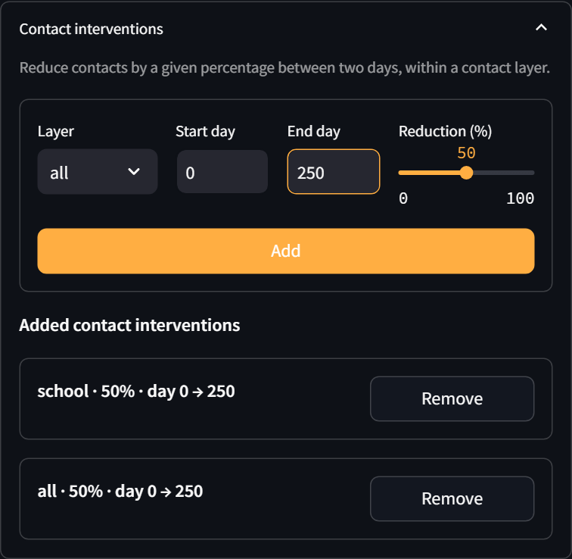
After
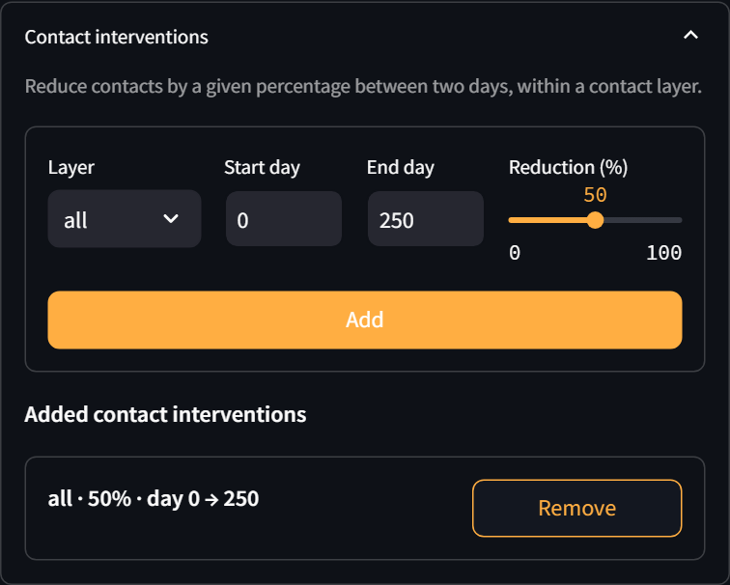

I-05 — A scenario with an intervention runs and reflects the reduction
Positive · Result: Pass
Steps: Add a school closure.; Click Run.; Open the 'Contact Interventions' tab.
Expected: The run completes and the Contact Interventions tab shows the contact reduction over time.
Actual: Intervention run completed; reduction reflected.
Before
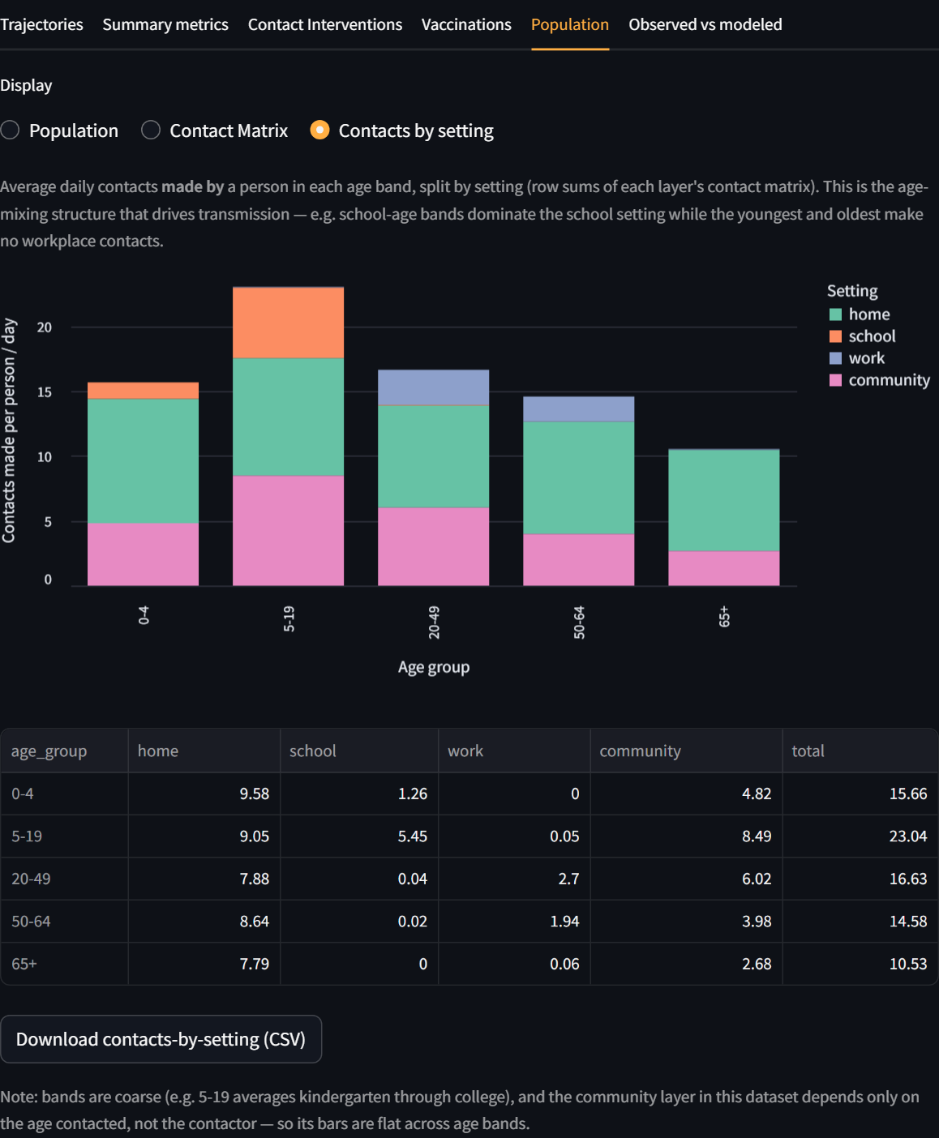
After
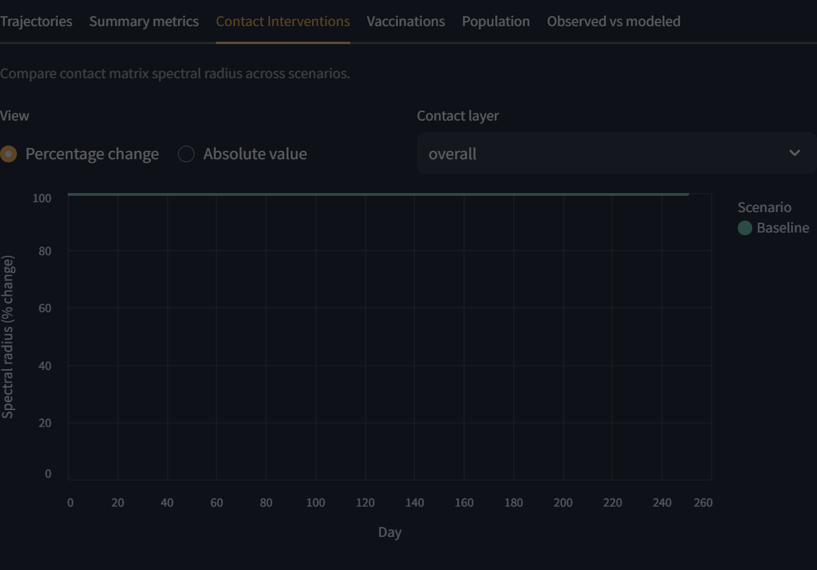

I-06 — End day earlier than start day is rejected
Negative · Result: Pass
Steps: Set Start day to 50.; Set End day to 10.; Click Add.
Expected: A warning states that End day must be greater than or equal to start day; no entry is added.
Actual: Warning shown for end<start.
Before
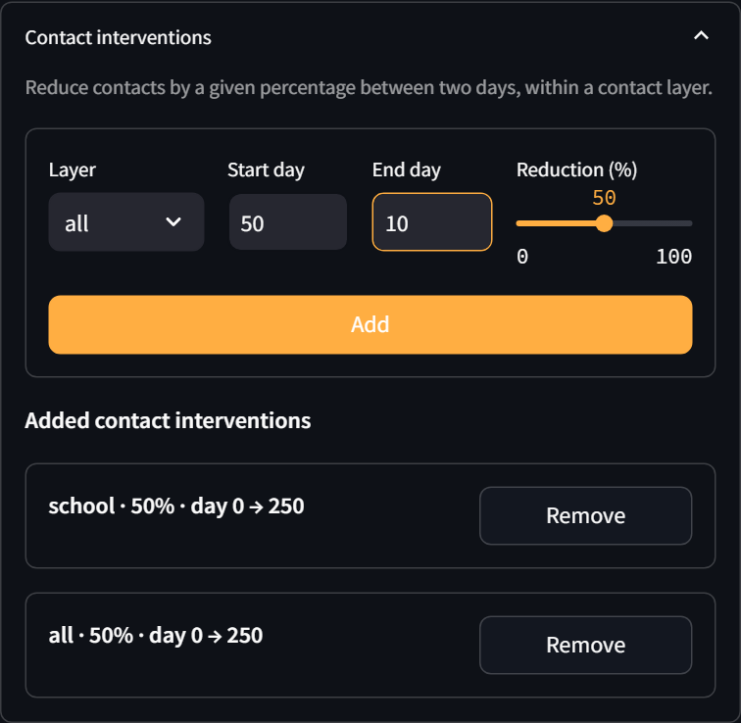
After
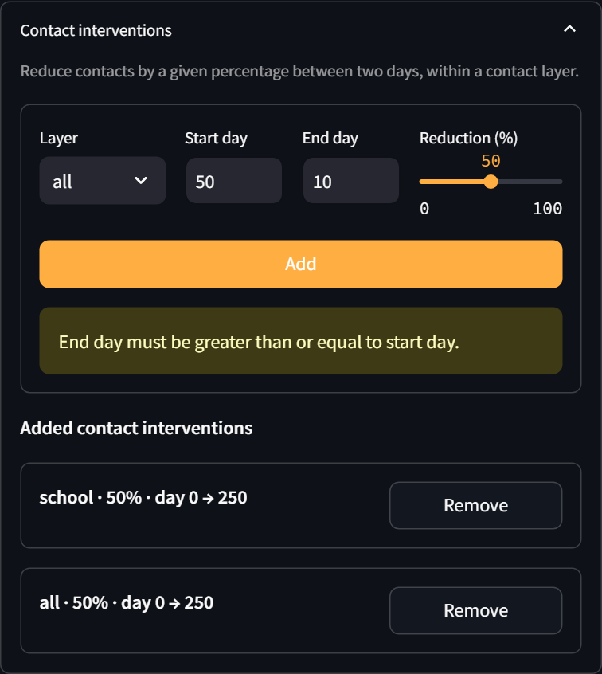

Vaccination Planner

V-01 — Planner grid is pre-filled with the DTaP/Tdap schedule
Positive · Result: Pass
Steps: Open the Vaccination Planner page.
Expected: The age-stratified grid is pre-filled with DTaP/Tdap coverage (0-4: 92%, 5-19: 90%, adults ~7%).
Actual: Planner grid pre-filled with DTaP/Tdap.
After
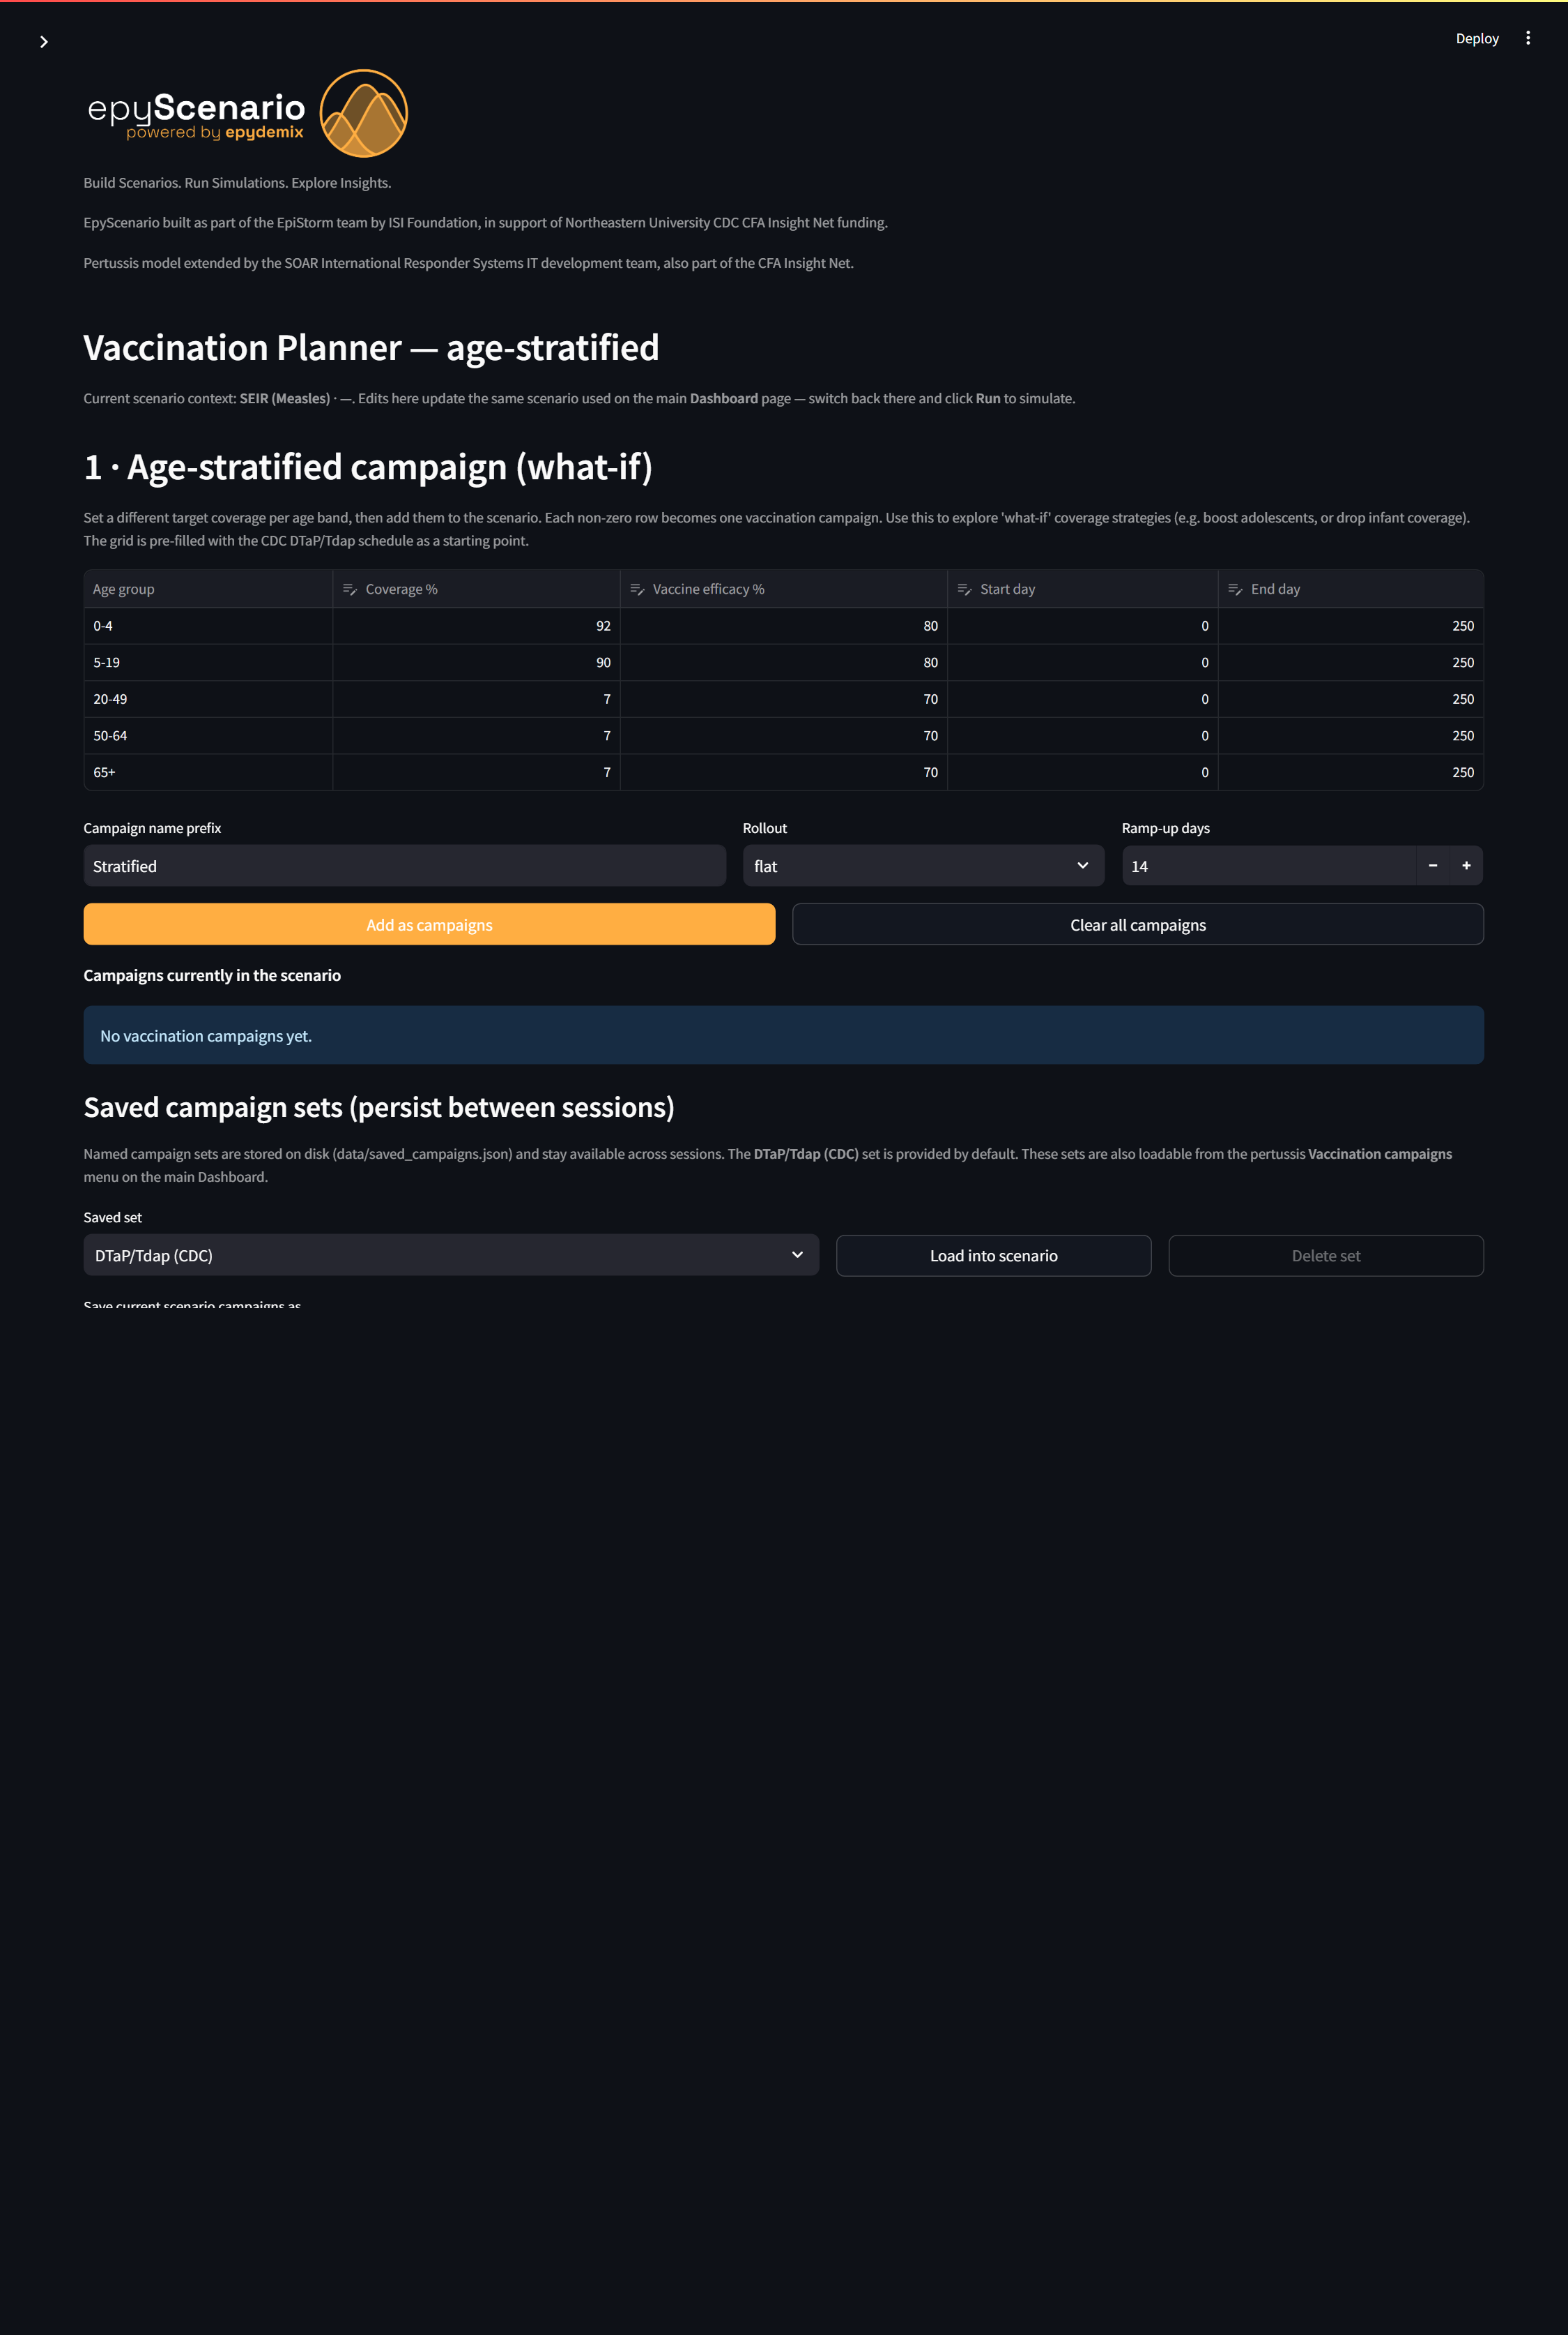

V-02 — A coverage profile can be saved and persists
Positive · Result: Pass
Steps: Enter a profile name.; Click 'Save profile'.
Expected: A confirmation states the profile was saved and will persist between sessions.
Actual: Coverage profile saved.
Before
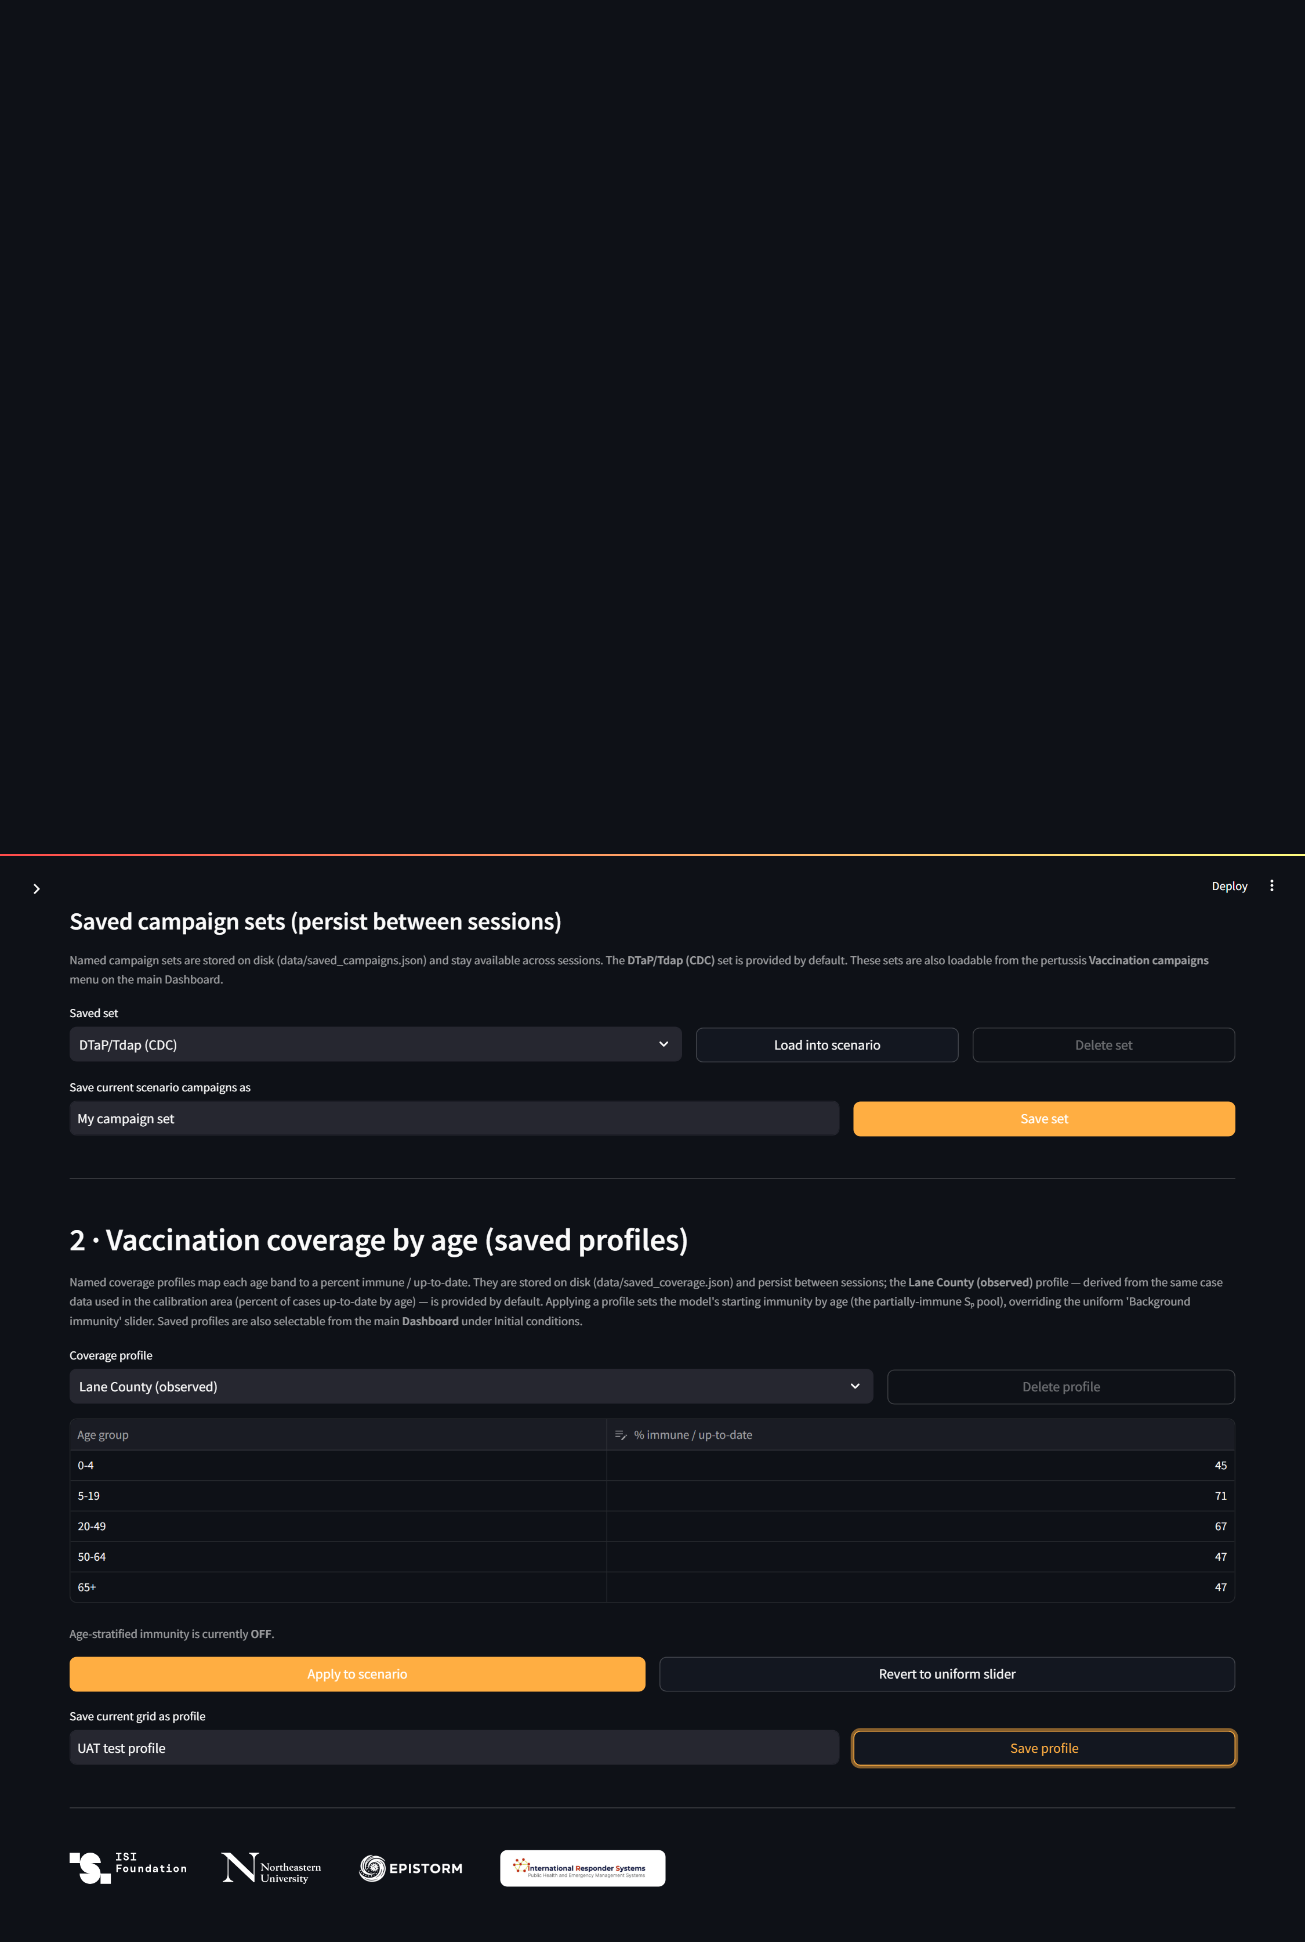
After

V-03 — Saving a coverage profile with an empty name is rejected
Negative · Result: Pass
Steps: Clear the profile name.; Click 'Save profile'.
Expected: A warning states that a profile name is required; nothing is saved.
Actual: Empty-name save rejected.
After
