EpyScenario — Pertussis User Guide
A practical guide for epidemiologists and public-health analysts
EpyScenario platform (EpiStorm / ISI Foundation) — pertussis extension by SOAR International Responder Systems
Version 1.0 · August 2026 · CDC CFA Insight Net
This guide is task-oriented and centred on the pertussis (whooping cough) model. It pairs with the companion “Pertussis Transmission Model — System Description and Validation Reference,” which gives the governing equations, parameter provenance, and validation detail. Where this guide says “see the System Description,” that document is the authoritative technical source.
Change
# | Description | Contributor | Date
1.0 | Initial version. | Mark Routson | 08/13/2026

1. Introduction and audience
EpyScenario is an interactive platform for building, running, and comparing age-structured, stochastic epidemic scenarios on real demographic and contact data. This guide covers the pertussis model, which extends the platform with an eight-compartment structure designed to reproduce the distinctive dynamics of whooping cough. It is written for epidemiologists and analysts who will parameterise the model, calibrate it to local data, and interpret its output — not for software administrators.
The running example throughout is Lane County, Oregon, which has experienced recurrent pertussis surges and provides observed case data for calibration.

2. Epidemiological primer: why pertussis needs this model
Understanding the model’s structure requires a few features of pertussis epidemiology, because each one corresponds to a control you will manipulate in the tool.
- Highly transmissible. Pertussis has one of the highest basic reproduction numbers of any vaccine-preventable disease (commonly R₀ ≈ 12–17). Susceptibility must therefore be tightly governed by immunity, or the model produces unrealistically explosive epidemics.
- A latent period. There is a 7–10 day incubation before an infected person becomes infectious, represented by an Exposed (E) compartment.
- Waning immunity — natural and vaccine. Protection from both infection and vaccination decays over years. Recovered and vaccinated individuals therefore return to susceptibility, which is why pertussis is endemic with multi-year cycles rather than eliminated.
- Partial (attenuated) reinfection. People with prior exposure or vaccination who are reinfected tend to have milder, shorter, less infectious illness. These partially-immune infections are often undiagnosed and form a “silent reservoir” — most prominently in adolescents and adults — that sustains transmission and reintroduces infection to under-vaccinated infants. This is the central reason pertussis persists despite high vaccination coverage, and the reason a simple SEIR or SEIRS model is inadequate.
- Acellular vaccine protection is non-sterilising and wanes. DTaP-derived protection declines materially within roughly 5–10 years, which underlies adolescent resurgence and the rationale for the 11-year Tdap booster.
To capture these features the model uses two parallel tracks — a naive track (fully susceptible people with classic disease) and a partial-immunity track (reduced susceptibility, milder and less infectious disease) — coupled by a shared force of infection, vaccination, and waning. The structure follows Wearing & Rohani (2009) and Lavine et al. (2011).
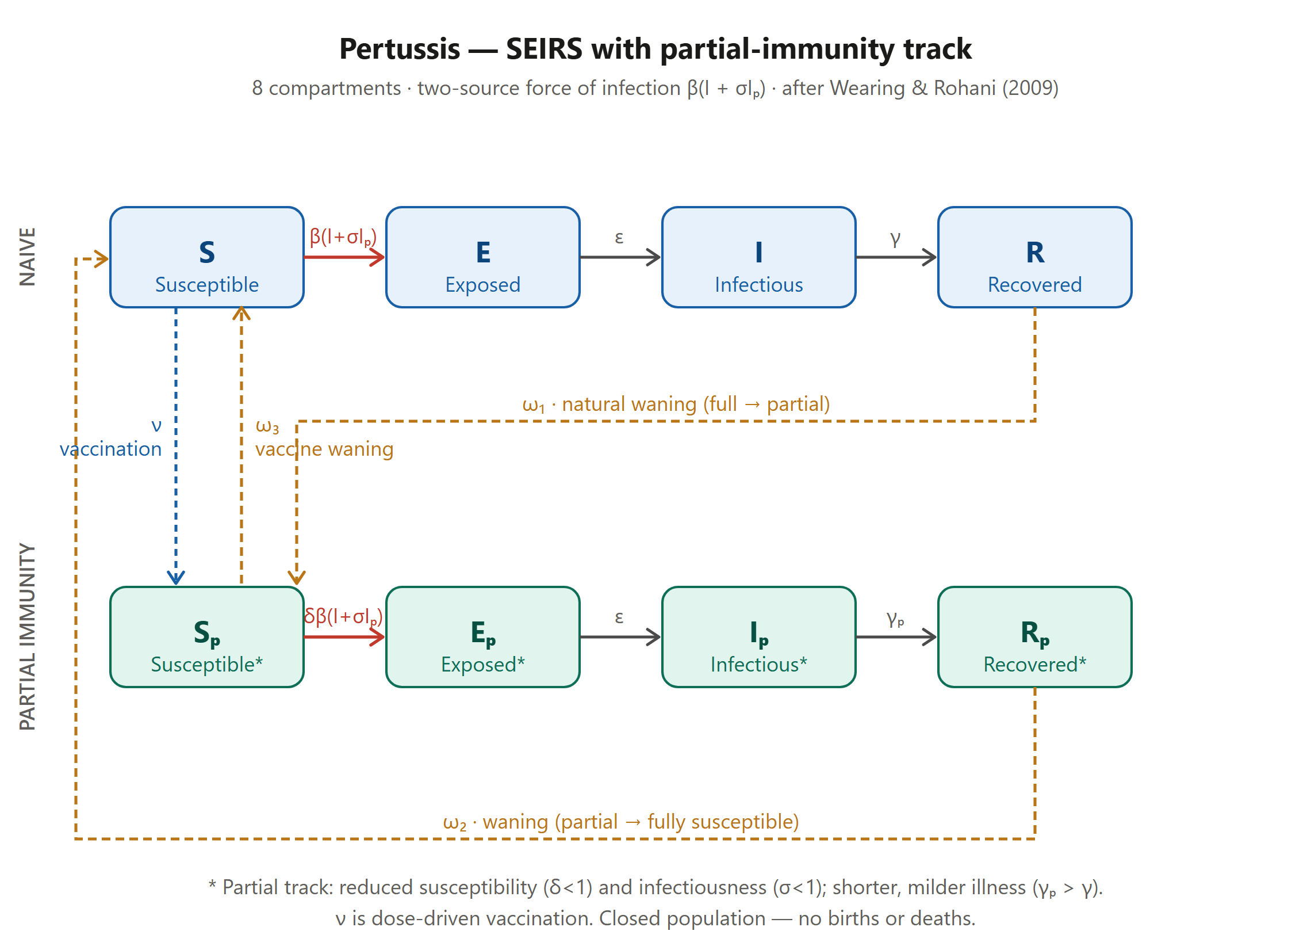
Figure 1. The pertussis compartmental model. Naive track (blue) S→E→I→R and partial-immunity track (teal) Sₚ→Eₚ→Iₚ→Rₚ. Red = two-source force of infection β(I+σIₚ); amber dashed = waning (ω₁ natural full→partial, ω₂ partial→susceptible, ω₃ vaccine→susceptible); blue dashed = dose-driven vaccination ν.
Quantities you will set, and what they mean epidemiologically:
- R₀ — transmissibility on the naive track; scales the force of infection.
- Incubation and infectious periods — set the latent duration and how long naive (I) and partial (Iₚ) cases transmit; partial cases recover faster.
- σ (relative infectiousness of Iₚ) — how much less the partial reservoir transmits (0–1).
- δ (relative susceptibility of Sₚ) — residual protection of previously-immune/vaccinated people (0–1).
- ω₁, ω₂, ω₃ (waning times) — govern the size and persistence of the susceptible and reservoir pools.
- Vaccination and coverage-by-age — move susceptibles into the partial-immunity pool.
- Contact structure — age-specific mixing (home/school/work/community) that determines who transmits to whom.

3. Orientation: the workspace
The Dashboard has two columns: Setup (left), where you define a scenario, and Visualisation (right), where results appear after a run. The collapsed sidebar (top-left arrow) contains the pages: Dashboard, Background, and Vaccination Planner. Launch is covered in the Appendix.
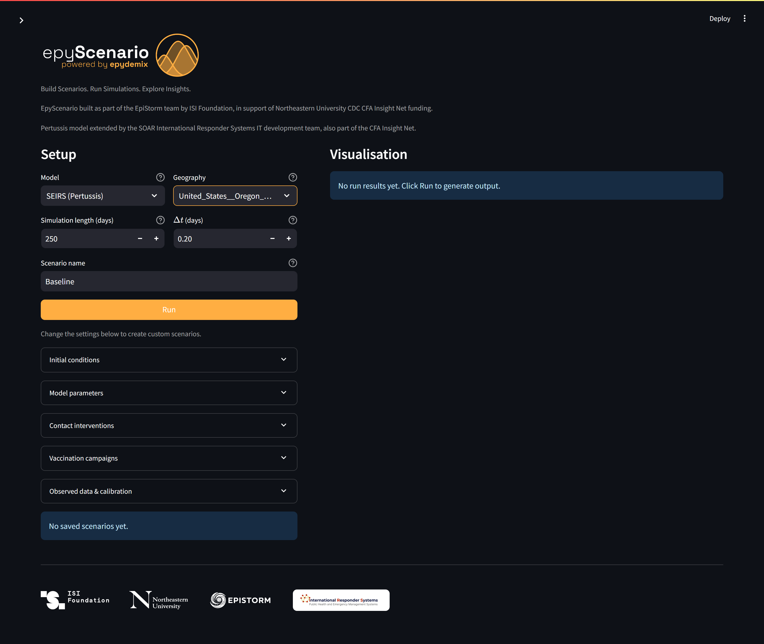
Figure 2. The Dashboard on first load with the pertussis model and Lane County selected. Setup controls are on the left; the Visualisation panel on the right prompts you to Run.

4. Selecting the pertussis model and geography
- Model — choose “SEIRS (Pertussis)”. This activates the eight-compartment structure and the pertussis-specific parameters, initial-condition splits, and calibration panel.
- Geography — type to search and select a location (e.g. United_States__Oregon__Lane_County). This loads the population age structure and the four-layer contact matrices for that area.
- Simulation length and Δt — the horizon in days and the integration time step (smaller Δt is more accurate but slower).
Once you save or run a scenario, the model and geography are locked into a “workspace” so that scenario comparisons remain valid; use “Start new session” to change them.

5. Model parameters
Open the Model parameters expander. Each control has a direct epidemiological meaning; defaults reflect the pertussis literature (see the System Description for provenance and ranges).
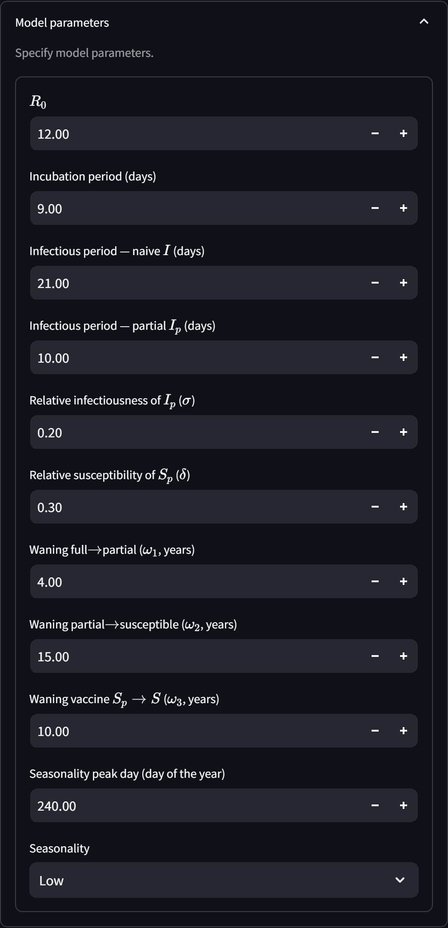
Figure 3. Model parameters for pertussis: R₀, incubation and (naive/partial) infectious periods, the relative infectiousness σ and susceptibility δ of the partial track, the three waning times, and seasonality.
- R₀ (default 12). Raise to intensify transmission; the tool re-derives the transmission rate so this R₀ is recovered on the naive track for the chosen geography.
- Incubation period (9 d). Mean latent duration before infectiousness.
- Infectious period — naive (21 d) and partial (10 d). Partial cases clear faster, reflecting milder illness; the ratio influences the relative sizes of I and Iₚ.
- σ — relative infectiousness of Iₚ (0.2). Lower values shrink the transmission contribution of the silent reservoir; a key sensitivity parameter.
- δ — relative susceptibility of Sₚ (0.3). Lower values mean stronger residual protection and a smaller partial-track attack rate.
- Waning ω₁ (4 y), ω₂ (15 y), ω₃ (10 y). Full→partial, partial→susceptible, and vaccine→susceptible decay. Together they set how quickly immunity erodes and how large the reservoir becomes.
- Seasonality (peak day, amplitude). Weak seasonal modulation of transmission, peaking in late summer/autumn.

6. Initial conditions and the immunity landscape
Open the Initial conditions expander. Because pertussis is endemic, a run should start from a realistic immune landscape rather than a naïve population.
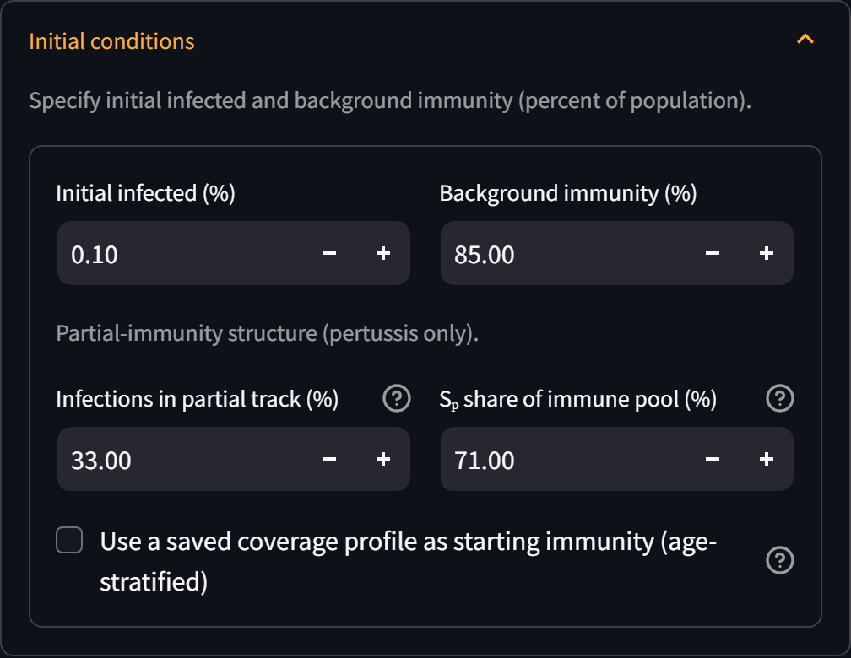
Figure 4. Initial conditions: initial infected and background immunity, the pertussis partial-immunity structure controls, and the option to apply a saved age-stratified coverage profile.
- Initial infected (%) and Background immunity (%). Seed active infection and the size of the immune pool.
- Infections in partial track (%). Splits seeded infections between the naive (E/I) and partial (Eₚ/Iₚ) tracks.
- Sₚ share of immune pool (%). How much of the immune pool is partially-susceptible (Sₚ) versus recovered (Rₚ/R). In a vaccinated population most sit in Sₚ.
- Age-stratified coverage profile. Optionally override the uniform background-immunity value with a per-age-band profile (e.g. the Lane County observed profile). This makes the starting susceptibility landscape match observation — important for calibration.

7. Vaccination: campaigns, the DTaP/Tdap schedule, and the Planner
Vaccination moves fully-susceptible individuals into the partially-immune pool (S→Sₚ): the model treats immunisation as conferring partial, non-sterilising protection that subsequently wanes (ω₃). Campaigns specify target coverage, efficacy, timing, and age band, and are converted to a dose schedule.
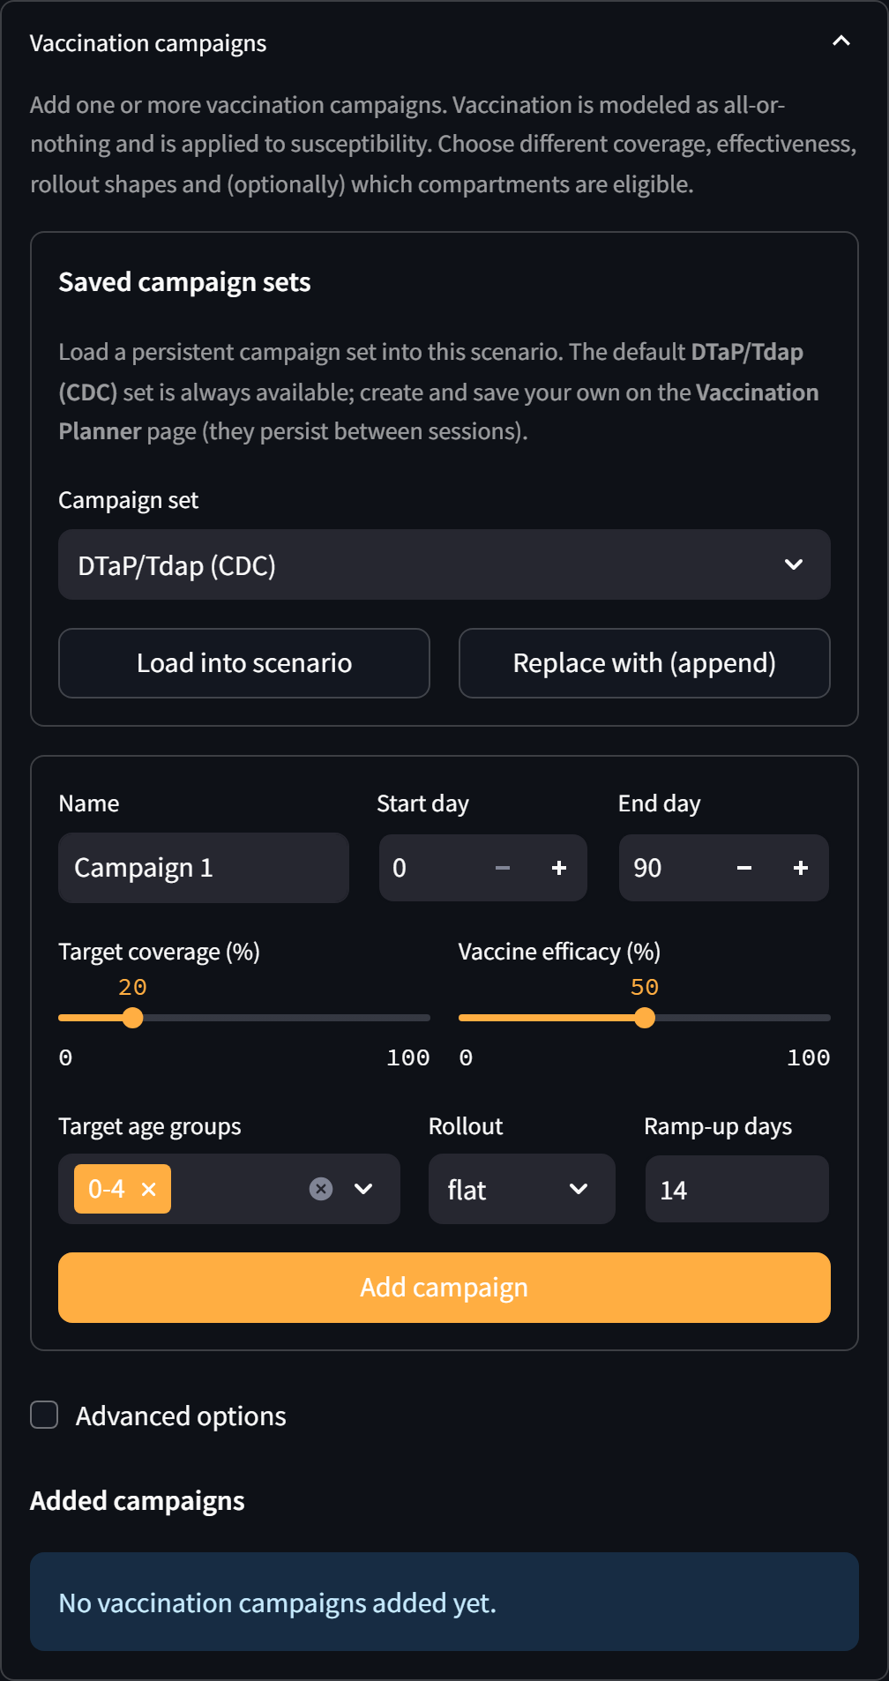
Figure 5. The Vaccination campaigns panel on the Dashboard. Load a saved campaign set (the CDC DTaP/Tdap schedule is provided) or add custom campaigns.
The Vaccination Planner page (sidebar) provides two age-stratified tools:
- Age-stratified campaign builder (what-if). A grid of per-band coverage, efficacy, and timing, pre-filled with the CDC DTaP/Tdap schedule (0–4: 92%, 5–19: 90%, adults ~7%). Edit it to test strategies such as raising adolescent coverage, then “Add as campaigns.”
- Saved campaign sets and coverage profiles. Named sets and coverage-by-age profiles persist between sessions and are selectable on the Dashboard.
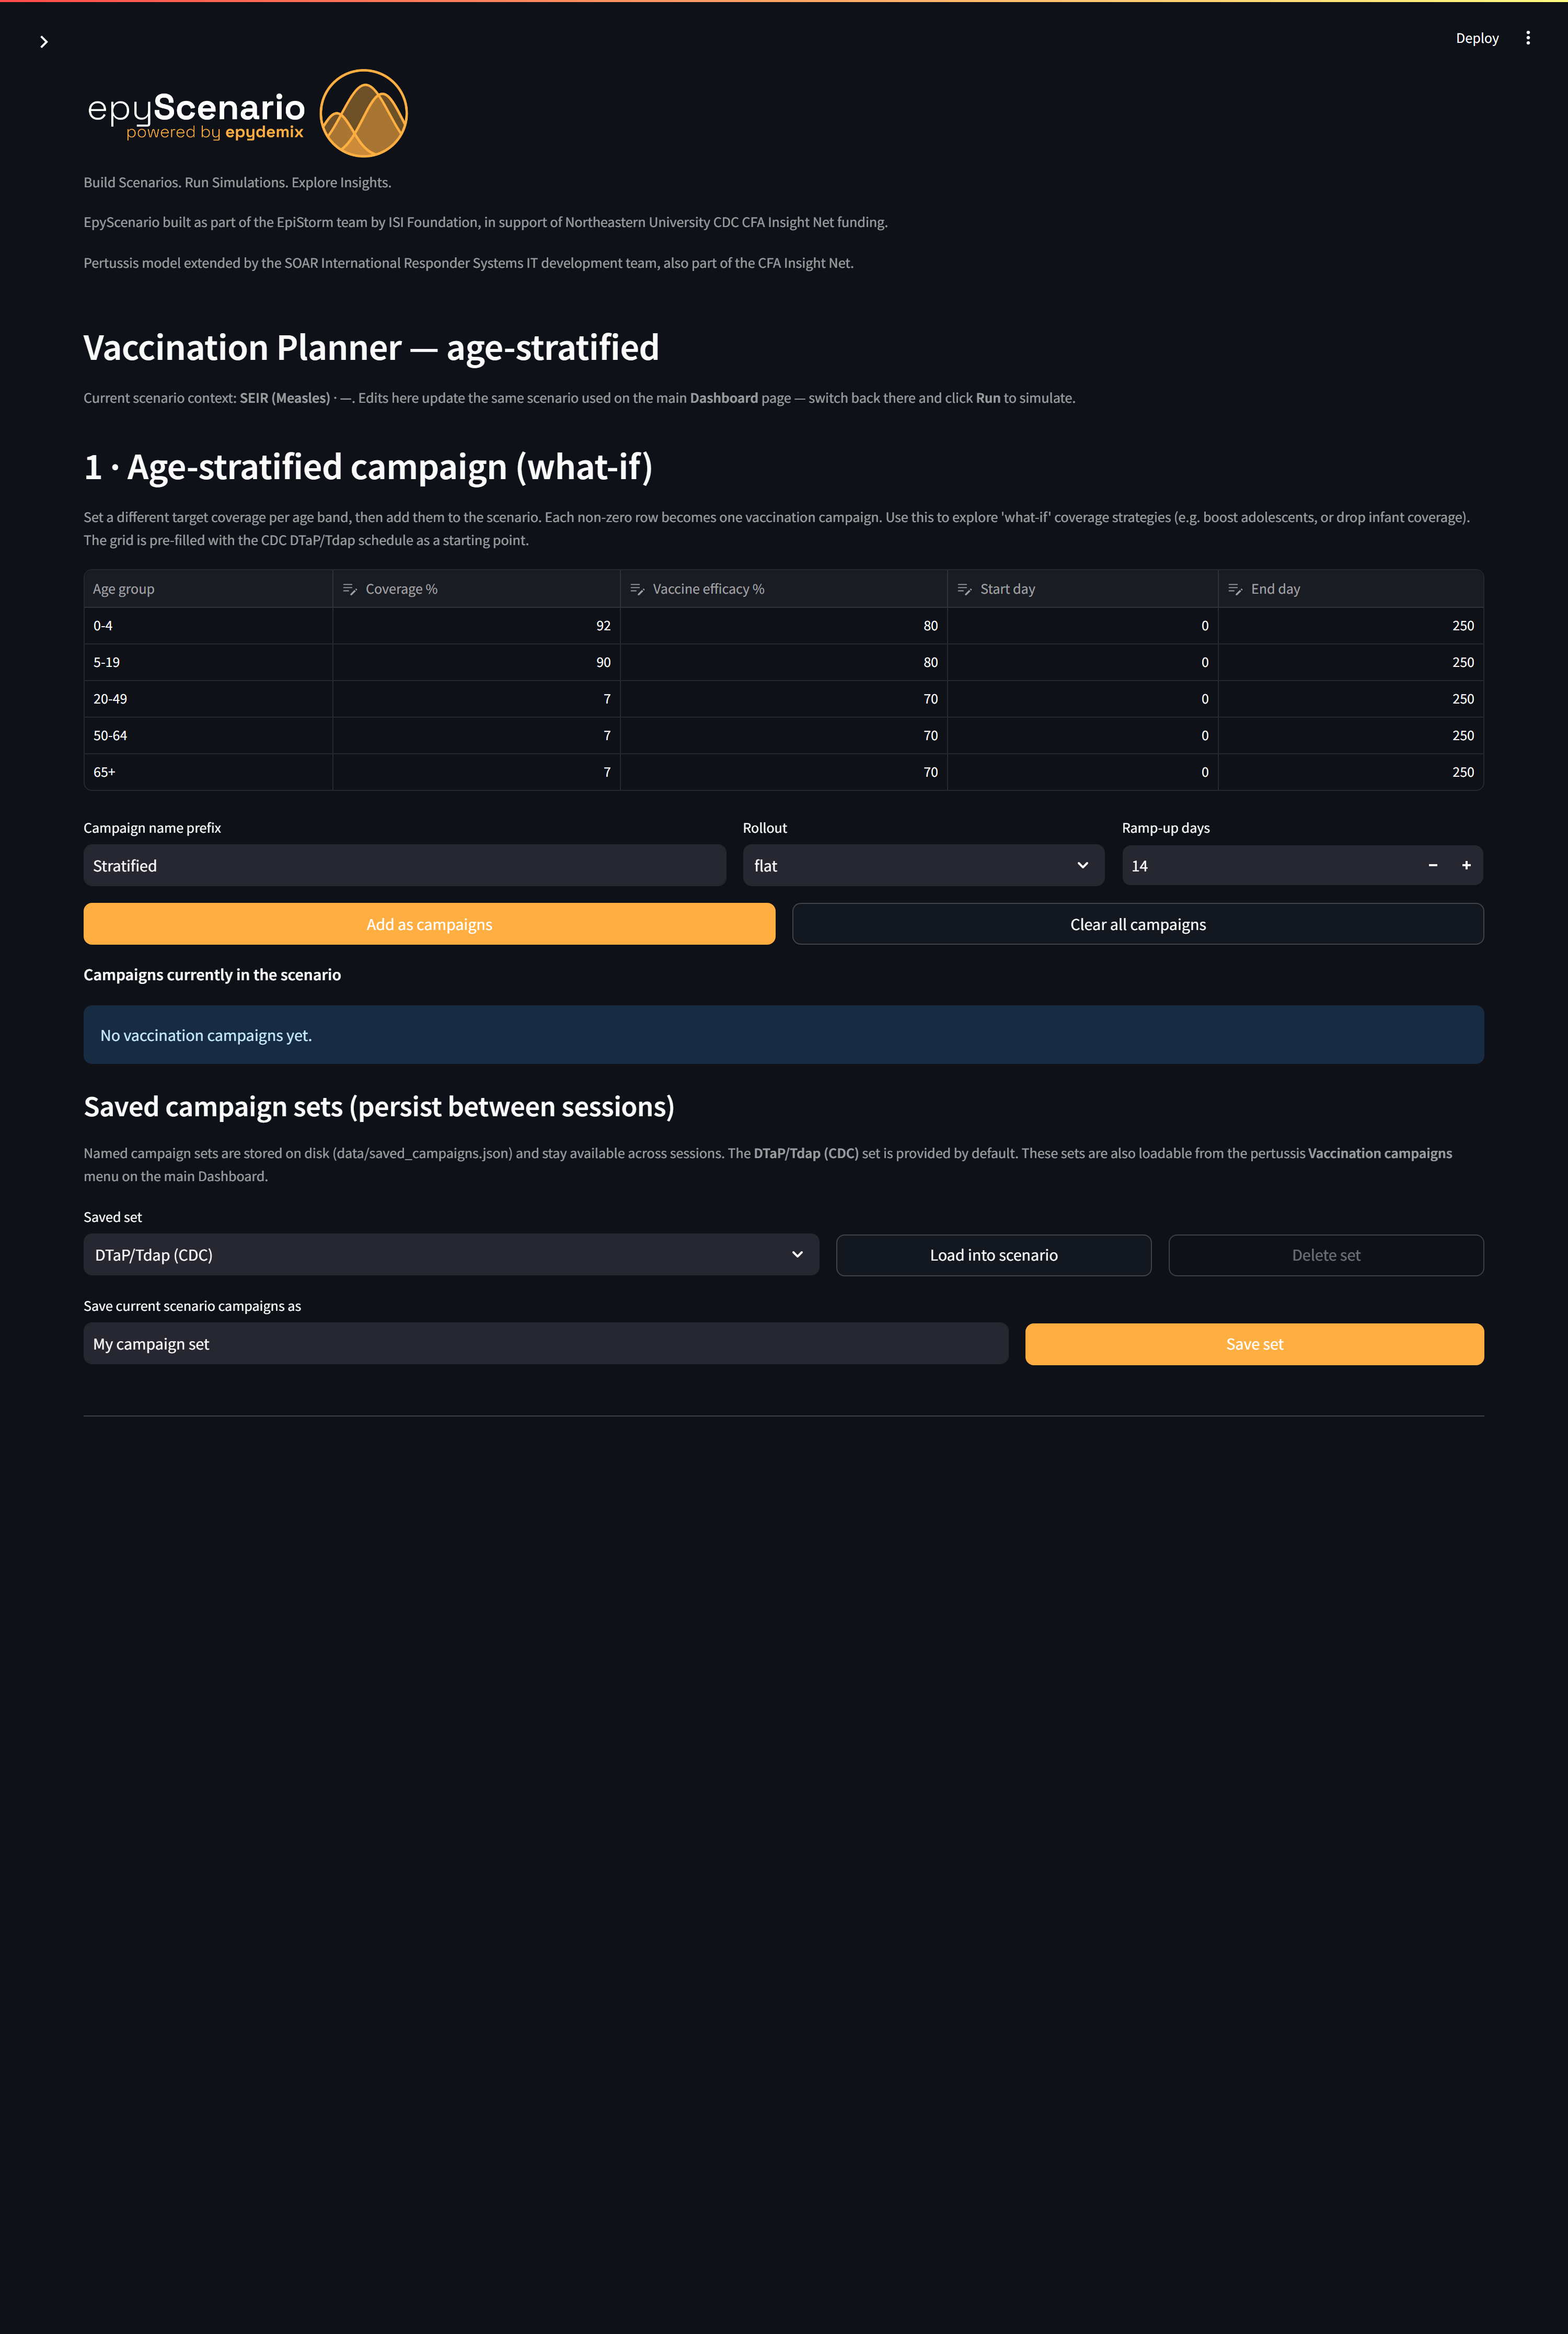
Figure 6. Vaccination Planner — the age-stratified campaign grid pre-filled with the DTaP/Tdap schedule, and persistent saved campaign sets.
Modeling note. Because the model has no birth cohorts or aging, the per-individual dose calendar (2/4/6/15–18 months, 4–6 years, 11 years, then decennial) cannot be represented as dated milestones; each element is expressed as program-level coverage of an age band over the run window.

8. Contact structure and interventions
Transmission is governed by age-specific mixing drawn from four settings — home, school, work, and community. After a run, the Population tab’s “Contacts by setting” view shows the average daily contacts each age band makes in each setting, which is the age-mixing structure that drives who transmits to whom.
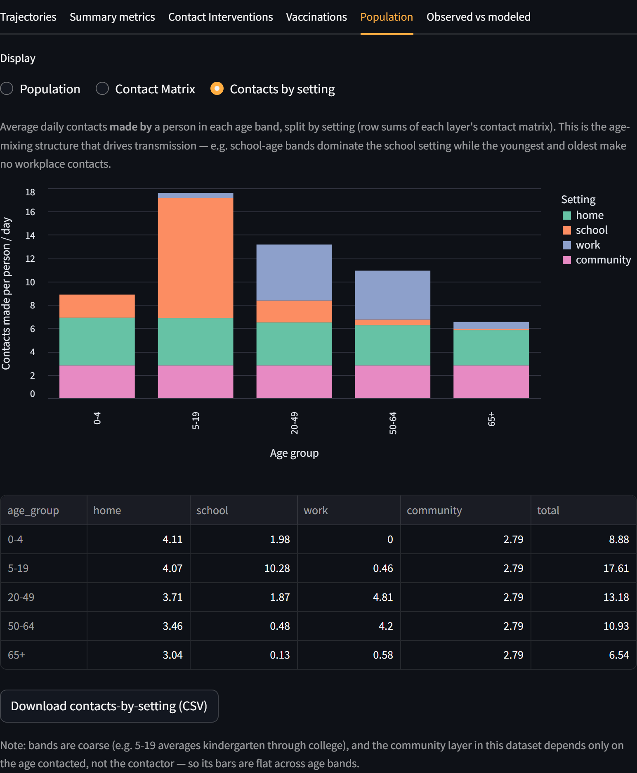
Figure 7. Contacts by setting. School-age bands (5–19) dominate school contacts and have the most total contacts; working ages carry the workplace layer; the youngest and oldest make essentially no workplace contacts.
Contact interventions (Setup expander) reduce one or more layers over a date window. Because layers are age-specific, a school closure principally lowers mixing among school-age bands, whereas workplace measures principally affect working ages.

9. Running a simulation and reading outputs
Name the scenario and click Run. Each scenario is an ensemble of stochastic replicates; reported trajectories are ensemble medians. Results appear as tabs in the Visualisation panel.
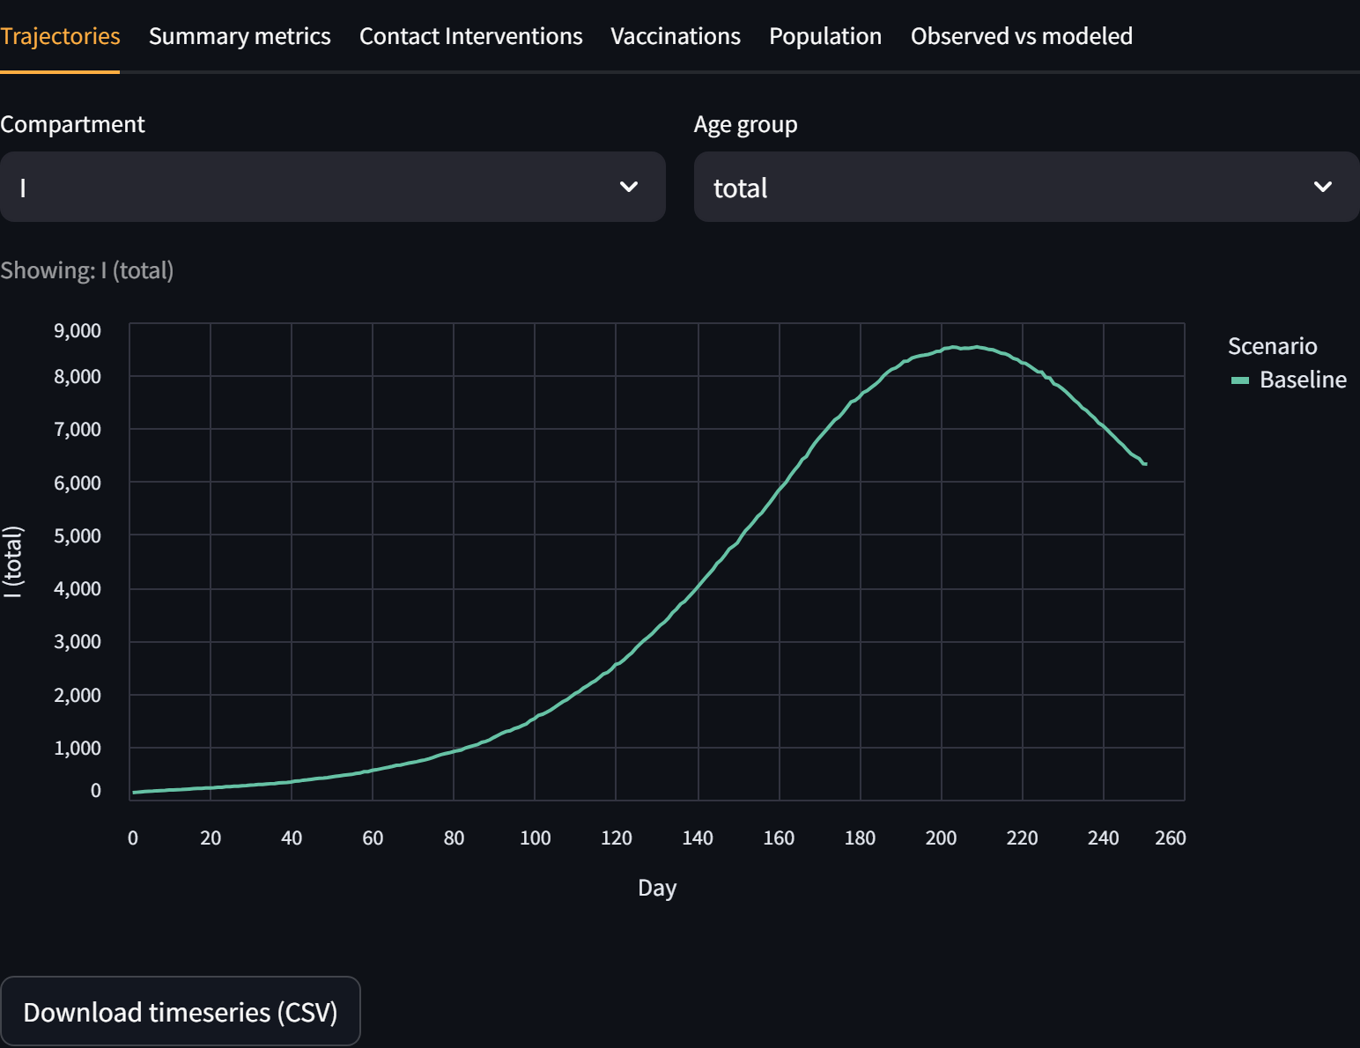
Figure 8. Trajectories tab. Select any compartment (here I, the naive infectious) and age group. For pertussis, compare I against Iₚ to see the naive epidemic versus the partially-immune reservoir.
- Trajectories. Time series of any compartment (S, E, I, R, Sₚ, Eₚ, Iₚ, Rₚ) by age or total; downloadable as CSV.
- Summary metrics. Peak prevalence and timing, final attack rate, cumulative infections, and the vaccinated (partial-track) share of cases — with the partial track included so the reservoir is not undercounted.
- Contact Interventions, Vaccinations, Population. Diagnostics for the mixing reductions, dose rollout, and demography/contacts.
- Scenario comparison. Save multiple scenarios and overlay them (e.g. baseline vs a booster campaign).
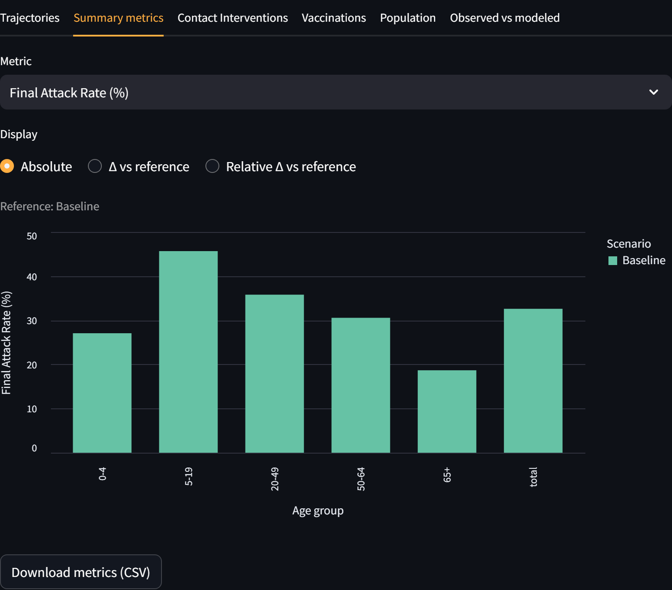
Figure 9. Summary metrics tab — per-age-band epidemic metrics with comparison to a reference scenario.

10. Calibrating to local data (Lane County)

Data provenance
The observed dataset is a case cross-tabulation by age and vaccination-up-to-date status (No / Unknown / Yes; 489 cases) for Lane County, Oregon, provided by the project team and transcribed into the tool (it is stored as LANE_COUNTY_RAW). Single-year ages and the older bands are aggregated to the five model age bands, with 65+ folded into the source’s combined “50+” category. Vaccination status maps to the two model tracks — not up-to-date → naive (I), up-to-date → partial (Iₚ) — and Unknown is allocated within each band by the known No:Yes ratio. The exact surveillance source, case definition, and collection period are attributable to the providing system.
Note: the counts are the vaccinated share of cases, not population vaccination coverage. Because many cases in a well-vaccinated population are breakthroughs, case-vaccinated share overstates population protection — use the vaccinated-share comparison as the structural check, and substitute registry coverage (e.g. Oregon ALERT IIS) as the immunity denominator where available.

How the data is used
The Observed data & calibration expander connects the model to this data. The status maps directly onto the two tracks — not up-to-date → naive (I), up-to-date → partial (Iₚ) — enabling three workflows below.
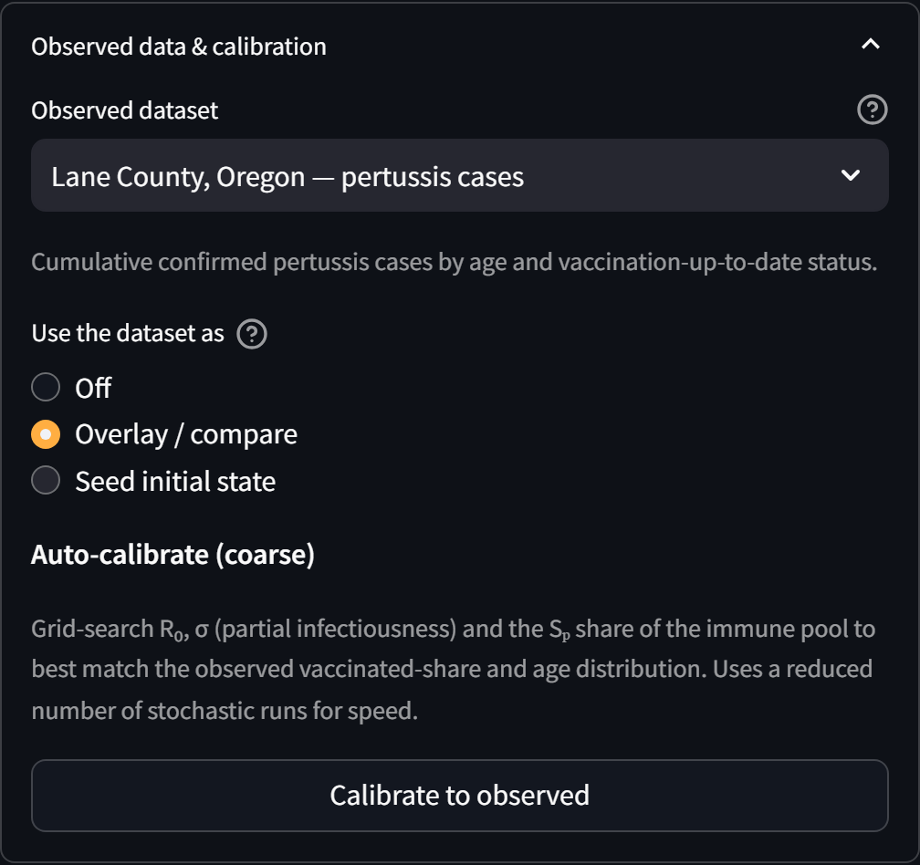
Figure 10. Observed data & calibration. Select a dataset and choose how to use it: overlay/compare, seed the outbreak from the observed counts, or auto-calibrate.
- Overlay / compare. Run the model, then the “Observed vs modeled” tab compares the case age distribution and the vaccinated share of cases, with a fit RMSE.
- Seed initial state. Start the outbreak from the observed counts (by age and track), then project forward.
- Auto-calibrate (coarse). Grid-search R₀, σ, and the Sₚ share of the immune pool to best match the observed vaccinated share and age distribution, then apply the best fit.
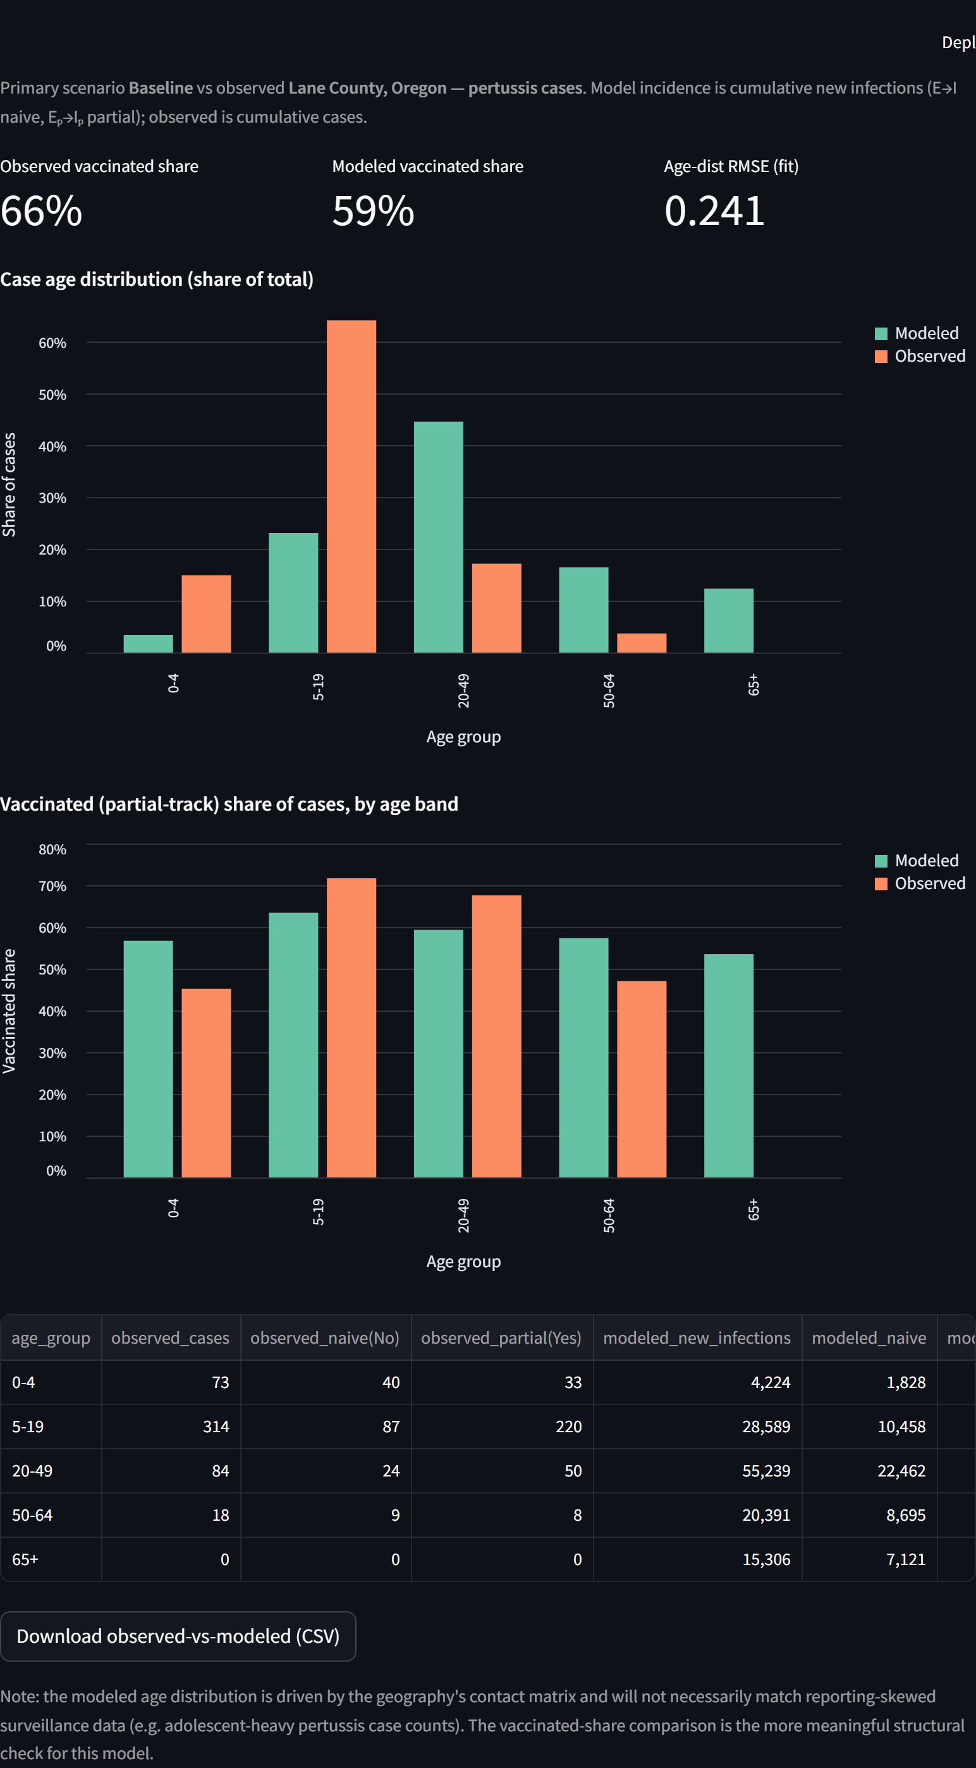
Figure 11. Observed vs modeled. The vaccinated (partial-track) share of cases — here 66% observed vs 59% modeled — is the structural target the partial-immunity model is uniquely able to reproduce.
Interpretation and caveats for an epidemiologist:
- Use the vaccinated share as the primary target. It is the model-specific signature of partial immunity and the check that this mechanism is correctly parameterised.
- Do not over-read the case age distribution. The modeled age shape is driven by the contact matrix, whereas surveillance counts are skewed by age-specific testing and reporting; treat a mismatch as expected, not as model failure.
- Case-share is not coverage. The vaccinated share of cases is not population vaccination coverage; where possible, seed immunity from registry coverage (e.g. Oregon ALERT IIS) rather than case-derived status.

11. Interpreting and validating results
Recommended checks before drawing conclusions (expanded in the System Description):
- Reproduction number. Confirm early growth is consistent with the specified R₀ at low prevalence.
- Conservation. The total population should be conserved across time (closed system).
- Endemic behaviour. Expect cycling/endemicity under waning, not a single burnout epidemic.
- Structural target. Compare modeled vs observed vaccinated share (overall and by band).
- Sensitivity. Vary σ, δ, and the three waning times, which jointly govern the reservoir.
- Ensemble spread. Ensure enough replicates that the median is stable.

12. Assumptions and limitations (summary)
- Closed population — no births or deaths; best for outbreak-to-few-year horizons.
- Coarse age bands — five bands average within-band heterogeneity.
- No aging — the dose calendar is approximated as program-level coverage.
- Synthetic contact matrices — deterministic estimates; the community layer is simplified.
- Case-share ≠ coverage — when using observed vaccination status to seed immunity.
The full treatment is in the System Description document.

13. Quick reference
- Choose the model — Setup → Model → SEIRS (Pertussis).
- Set the scene — Geography, Simulation length, Δt.
- Parameterise — Model parameters (R₀, σ, δ, waning) and Initial conditions.
- Vaccinate — Vaccination campaigns / Vaccination Planner (DTaP/Tdap, coverage profiles).
- Run — name the scenario and click Run.
- Read — Trajectories (I vs Iₚ), Summary metrics (vaccinated share), Population → Contacts by setting.
- Calibrate — Observed data & calibration → overlay / seed / auto-calibrate → Observed vs modeled tab.

Appendix. Launching and troubleshooting
- Launch (recommended). Run run_dashboard.ps1 in the project folder; it starts the app with a resilient supervisor that restarts it automatically if it exits, and opens on http://localhost:8501.
- Stale page after a restart. Hard-refresh the browser (Ctrl+Shift+R).
- Everything is local. No internet or version-control publishing is involved.

