Ultimate Guide to Data Structures and Algorithms (DSA)
This guide covers essential Data Structures and Algorithms (DSA) with explanations, coding examples, and roadmap links to help you master DSA efficiently.

1. Why Learn DSA?
DSA is crucial for:
- Cracking coding interviews at FAANG and top tech companies.
- Efficient problem-solving in software development.
- Optimizing applications for better performance.
- Competitive programming and open-source contributions.

Phase 1: Foundations
- Mathematics for DSA
  - Prime numbers, GCD, LCM, Factorization
  - Modular Arithmetic, Bit Manipulation
- Big-O Notation & Complexity Analysis
  - Time & Space Complexity
  - Best, Worst, and Average Cases

2. Roadmap to Master DSA
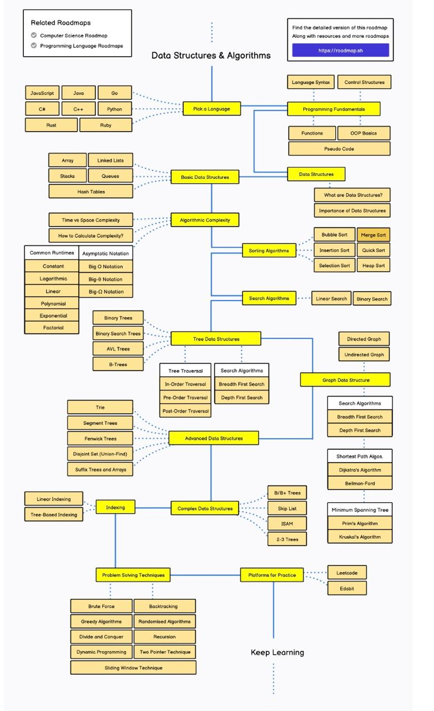
Phase 1: Foundations
- Mathematics for DSA
  - Prime numbers, GCD, LCM, Factorization
  - Modular Arithmetic, Bit Manipulation
- Big-O Notation & Complexity Analysis
  - Time & Space Complexity
  - Best, Worst, and Average Cases
Phase 2: Data Structures
Data Structure | Concepts | Important Problems
Arrays | Basics, Sliding Window, Two Pointers | Kadane’s Algorithm, Two Sum, Rotate Array
Strings | Hashing, Prefix/Suffix, Trie | Longest Palindromic Substring, Anagram Grouping
Linked List | Single/Doubly Linked List, Fast & Slow Pointers | Detect Cycle, Merge K Lists
Stacks & Queues | Stack Implementation, Monotonic Stack | Next Greater Element, LRU Cache
Hashing | HashMap, HashSet, Count Frequency | Subarray Sum Equals K
Trees | Binary Trees, BST, DFS, BFS | Lowest Common Ancestor, Serialize & Deserialize
Heaps/Priority Queue | Min-Heap, Max-Heap | Kth Largest Element, Median Finder
Graphs | BFS, DFS, Dijkstra, Floyd-Warshall | Shortest Path, Connected Components
Dynamic Programming (DP) | Memoization, Tabulation | Knapsack, Longest Increasing Subsequence

3. Algorithms to Master
Sorting Algorithms
Algorithm | Time Complexity | Space Complexity
Bubble Sort | O(n²) | O(1)
Selection Sort | O(n²) | O(1)
Insertion Sort | O(n²) | O(1)
Merge Sort | O(n log n) | O(n)
Quick Sort | O(n log n) | O(log n)
Heap Sort | O(n log n) | O(1)
Searching Algorithms
- Linear Search - O(n)
- Binary Search - O(log n)
Graph Algorithms
- BFS & DFS
- Dijkstra’s Algorithm
- Bellman-Ford Algorithm
- Kruskal’s & Prim’s (MST)
Greedy Algorithms
- Activity Selection
- Huffman Encoding
Backtracking
- N-Queens
- Sudoku Solver

4. DSA Problem-Solving Strategy
Step-by-Step Approach
- Understand the Problem – Read carefully & clarify constraints.
- Think of a Naive Approach – A brute-force solution is fine initially.
- Optimize – Use better data structures or algorithms.
- Code & Debug – Implement and debug the solution.
- Analyze Time & Space Complexity – Optimize further if necessary.

5. Best Platforms to Practice DSA
Platform | Type | Best Features
LeetCode | Interview Prep | FAANG-level questions, mock interviews
CodeChef | Competitive | Contests, beginner-friendly
HackerRank | Learning | Well-structured problems, certifications
GeeksforGeeks | Theory & Coding | Detailed explanations, coding challenges
AtCoder | Competitive | High-quality contests
Codeforces | Competitive | Timed contests & rating system

6. Best Resources for DSA
Books
- Introduction to Algorithms – Cormen (CLRS)
- Algorithms – Robert Sedgewick
- Cracking the Coding Interview – Gayle Laakmann McDowell
Online Courses
- CS50’s Introduction to Computer Science – Harvard (Free)
- Data Structures & Algorithms – Udemy by Abdul Bari
- MIT OpenCourseWare - DSA
YouTube Channels
- Striver (take U forward)
- NeetCode
- CodeWithHarry (for beginners)

7. DSA Cheat Sheets & PDFs
- Striver’s DSA Sheet
- NeetCode’s Blind 75 List
- Big-O Complexity Cheat Sheet

8. How to Prepare for Coding Interviews?
✅ Start with LeetCode Easy/Medium problems
✅ Solve company-wise problems on GeeksforGeeks
✅ Participate in mock interviews (Pramp, InterviewBit)
✅ Build projects using DSA (e.g., shortest path in a city)
✅ Time yourself while solving problems to simulate interviews

Resources with Links
🔹 1. DSA Learning Roadmap
A structured way to master DSA from beginner to advanced level.
📌 Beginner (Month 1-2)
✅ Learn Basic Programming (C++, Java, Python) → Python, C++, Java
✅ Math for DSA: Prime Numbers, Modular Arithmetic, GCD → CP Handbook - Math
✅ Big-O Complexity: Time Complexity, Recursion → Big-O Cheat Sheet
✅ Arrays & Strings: Sorting, Searching, Sliding Window → NeetCode Arrays & Strings
✅ Basic Recursion & Backtracking: Factorial, Fibonacci, Permutations → Recursion Problems
📌 Intermediate (Month 3-5)
✅ Linked Lists (Singly/Doubly/Circular) → Linked List Guide
✅ Stack & Queue: Monotonic Stack, Deque → Stack Problems
✅ Trees & Graphs: BFS, DFS, Dijkstra, MST (Prim’s/Kruskal’s) → Tree Guide
✅ Sorting & Searching: QuickSort, MergeSort, Binary Search → Sorting Tutorial
✅ Basic Dynamic Programming (DP): Knapsack, LIS, Fibonacci → DP Patterns
📌 Advanced (Month 6+)
✅ Graph Theory: Topological Sorting, Floyd-Warshall, Bellman-Ford → Graph Algorithms
✅ Advanced Dynamic Programming: Bitmasking, Matrix Exponentiation → LeetCode DP Problems
✅ Segment Trees & Fenwick Trees: Range Queries → Segment Tree Guide
✅ Trie Data Structure: String Matching, Auto-complete → Trie Problems

🔹 2. Best Websites & Resources to Learn DSA
📘 Theory & Tutorials
1️GeeksforGeeks DSA Course – Detailed explanations, coding problems
2️ CS50x (Harvard DSA Course) – One of the best free courses
3️ MIT OpenCourseWare - Algorithms – Free MIT lectures
4️ CP-Algorithms – Best resource for competitive programming
5️ Scalable System Design - DSA for Large Scale Systems
📌 Interactive DSA Learning Platforms
✅ Visualgo – Best for visualizing DSA concepts
✅ Data Structures Illustrated – Interactive learning
✅ Codecademy DSA Course

🔹 3. Problem-Solving Strategy & Practice Questions
🔥 Must-Solve DSA Questions (Striver’s SDE Sheet)
✅ Striver’s 180 DSA Sheet
🔹 Arrays
✅ NeetCode Arrays & Hashing
✅ GFG Array Problems
🔹 Linked Lists
✅ Leetcode Linked List Problems
🔹 Stack & Queue
✅ Monotonic Stack Explanation
🔹 Dynamic Programming
✅ NeetCode DP Roadmap
✅ LeetCode DP Pattern Problems

🔹 4. Competitive Programming (CP) & Interview Preparation
📌 Best Platforms for CP
1️ CodeForces – High-quality CP contests
2️ AtCoder – Best for beginners & intermediate programmers
3️ CodeChef – Long & short contests
4️HackerRank – Beginner-friendly DSA challenges
5️TopCoder – One of the oldest CP platforms
📌 How to Start Competitive Programming?
1️ Learn Basics – Arrays, Strings, STL, Sorting, Searching
2️ Practice CP on CodeForces Div 3 Contests
3️ Join Virtual Contests – Practice with real-time contest environment
4️ Solve Timed Challenges – Participate in LeetCode Weekly Contests
5️ Track Your Progress – Use LeetCode Progress Tracker

🔹 5. DSA Cheat Sheets & PDFs
✅ Striver’s SDE Cheat Sheet
✅ Big-O Complexity Cheat Sheet
✅ Common DP Problems PDF
✅ GeeksforGeeks Interview Questions

🔹 6. How to Prepare for FAANG Interviews?
📌 Steps for Interview Preparation
✅ Solve 150+ LeetCode Problems → LeetCode Problem List
✅ System Design Preparation → Grokking System Design
✅ Mock Interviews → Pramp, InterviewBit
📌 Best Resources for System Design
✅ System Design Primer
✅ Grokking the System Design Interview

