SHOULD / SHOULDN'T

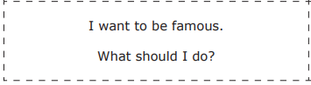

To start, you should try to become famous in some popular environment such as social networks, youtube ... But you can also become an elite athlete, actor, singer ... Finally, if it works, you should change your objective since it is very hard.

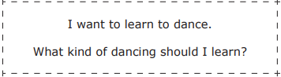

I recommend that you sign up for a dance academy specialized in the type of dance you need, if you are looking for something cheaper then I recommend you watch YouTube videos and try to practice at home.

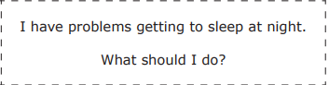

If you have trouble falling asleep, try not to drink soda or coffee at night, play sports would also be a good idea and not use your smartphone in bed because the mobile light does not help you fall asleep.

