南 京 师 范 大 学

《操作系统》
实验报告



实验题目： 线程并发
学 院： 计算机与电子信息学院/人工智能学院
专 业： 计算机科学与技术
姓 名： 袁睿
学 号： 19210230
任课教师： 段博佳
计算机与电子信息学院/人工智能学院
二O二三 年 十一 月 十五
目录
实验环境 1
实验内容 1
算法源代码 1
程序运行结果图 1
附录——程序源码 1

实验环境
OS：Linux VM-12-6-centos 3.10.0-1160.45.1.el7.x86_64 #1 SMP Wed Oct 13 17:20:51 UTC 2021 x86_64 x86_64 x86_64 GNU/Linux
语言：C
编译器版本：gcc (GCC) 8.3.1 20190311 (Red Hat 8.3.1-3)
C编译标准：C11标准
使用Makefile进行C++项目管理
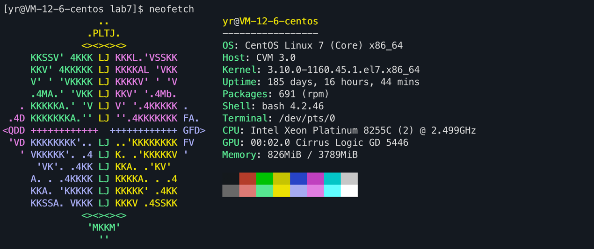

实验内容
- 观察代码运行情况
- 利用多线程统计单词个数（两种实现方法）

程序运行结果图
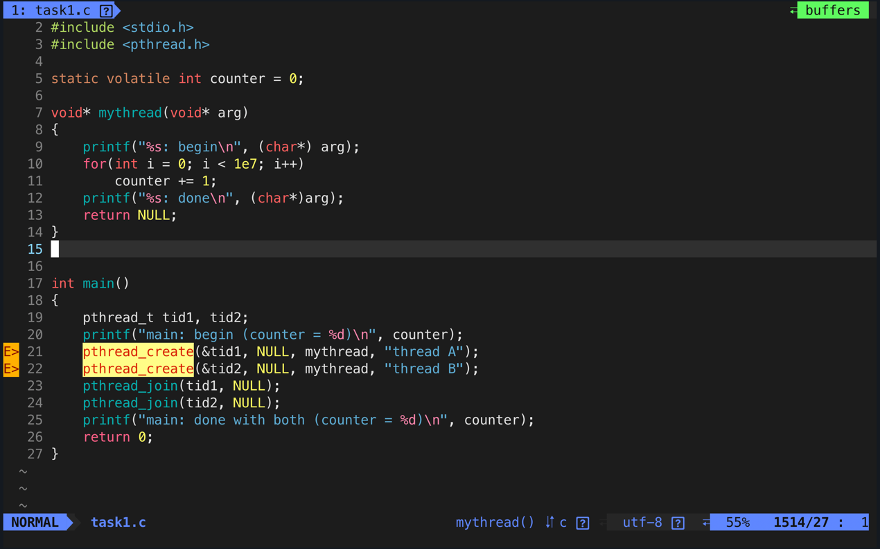
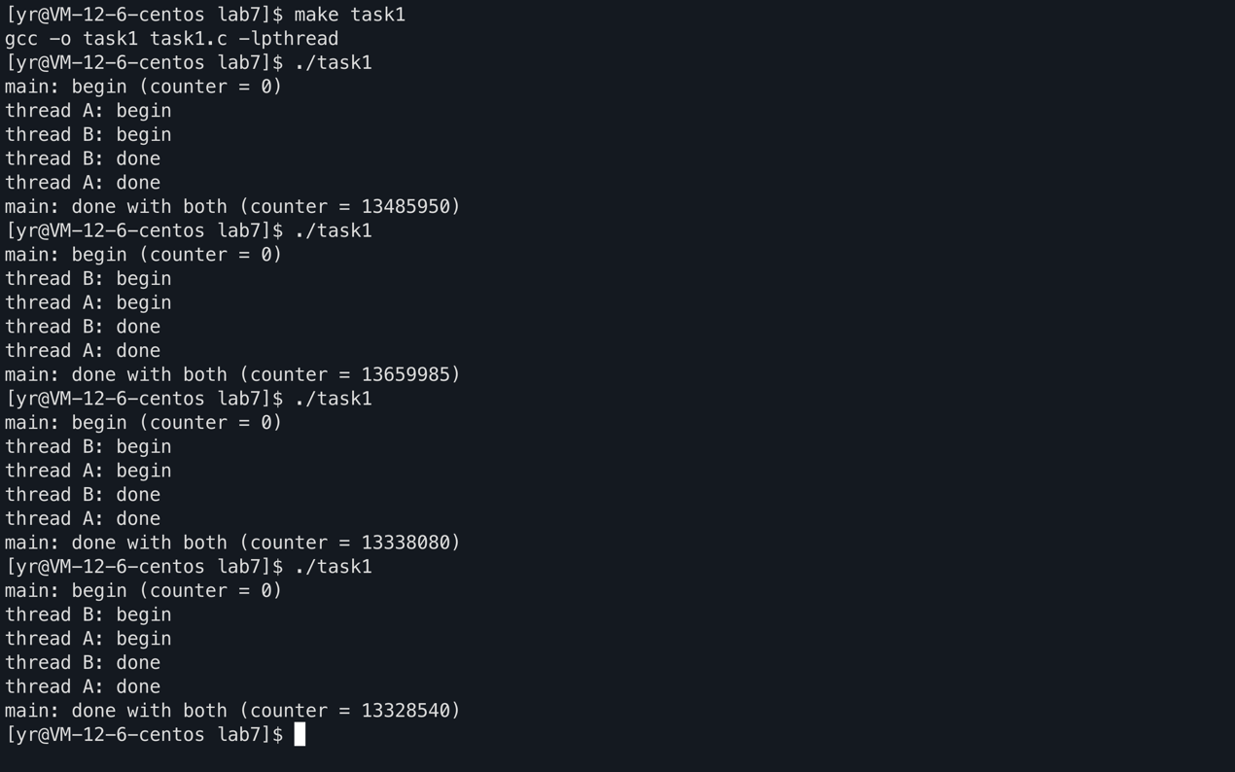
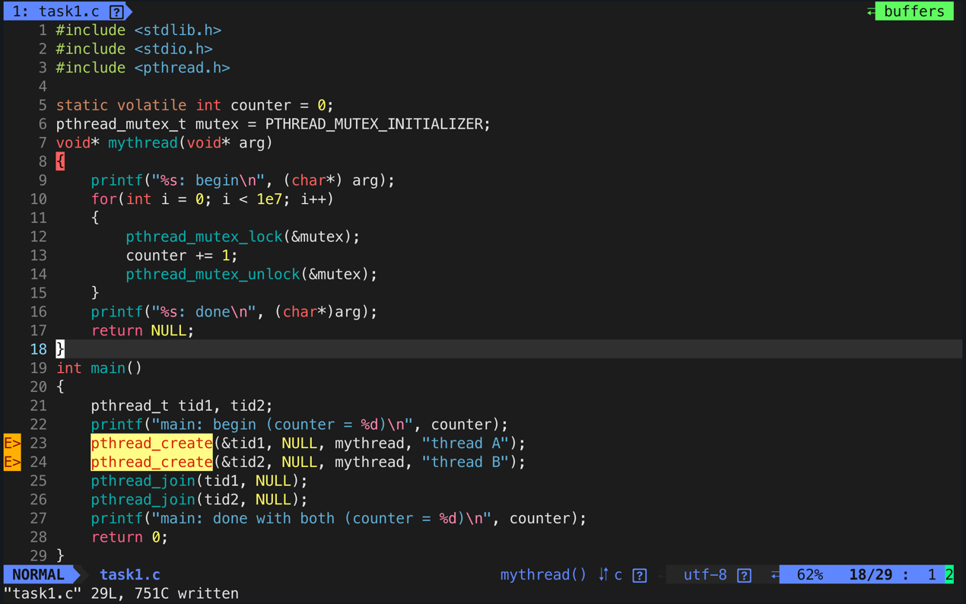
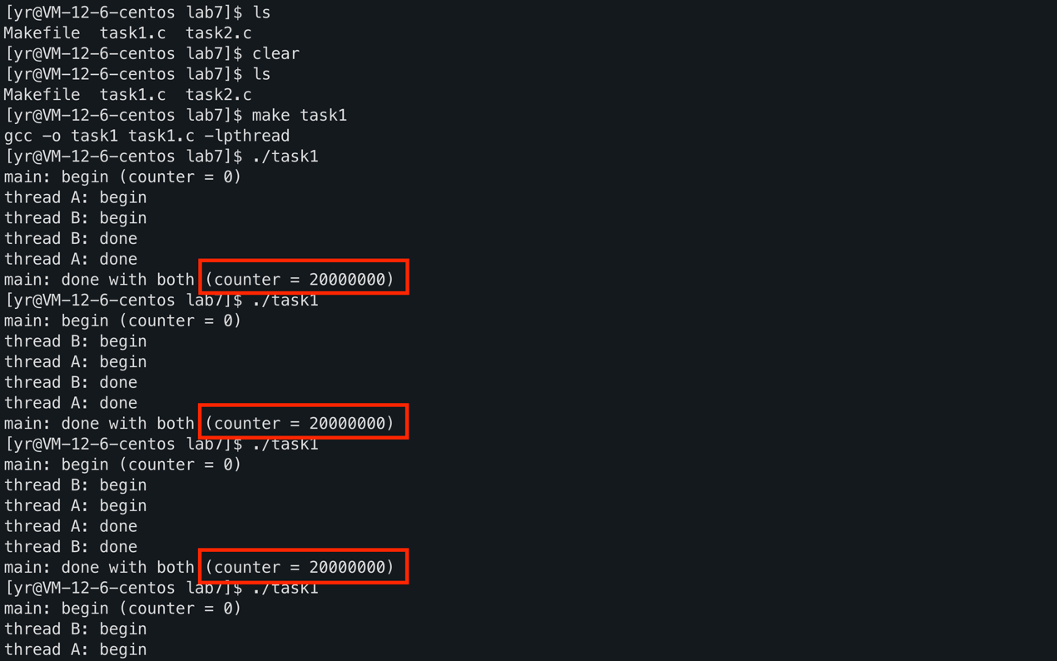
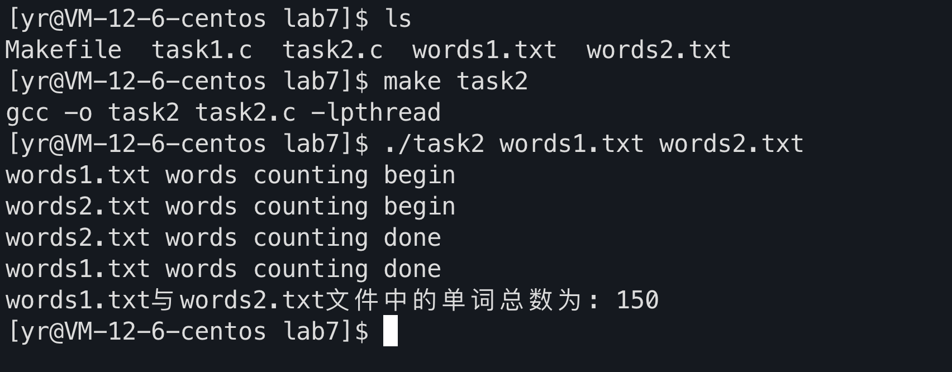
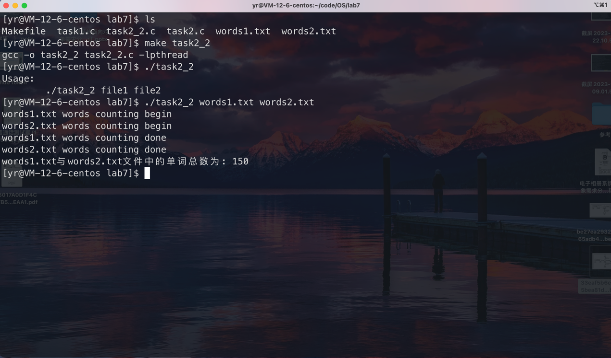

附录——程序源码
- task1.c
- #include <stdlib.h>
- #include <stdio.h>
- #include <pthread.h>

- static volatile int counter = 0;
- pthread_mutex_t mutex = PTHREAD_MUTEX_INITIALIZER;
- void* mythread(void* arg)
- {
- printf("%s: begin\n", (char*) arg);
- for(int i = 0; i < 1e7; i++)
- {
- pthread_mutex_lock(&mutex);
- counter += 1;
- pthread_mutex_unlock(&mutex);
- }
- printf("%s: done\n", (char*)arg);
- return NULL;
- }
- int main()
- {
- pthread_t tid1, tid2;
- printf("main: begin (counter = %d)\n", counter);
- pthread_create(&tid1, NULL, mythread, "thread A");
- pthread_create(&tid2, NULL, mythread, "thread B");
- pthread_join(tid1, NULL);
- pthread_join(tid2, NULL);
- printf("main: done with both (counter = %d)\n", counter);
- return 0;
- }

2 . task2.c
- #include <stdio.h>
- #include <stdlib.h>
- #include <ctype.h>
- #include <semaphore.h>
- #include <pthread.h>
- sem_t mutex;
- int total_words = 0;
- void* count_words(void* arg)
- {
- char* fileName = (char*) arg;
- printf("%s words counting begin\n", fileName);
- FILE* fp;
- int c, prevc = '\0';
- if((fp = fopen(fileName, "r")) != NULL)
- {
- while((c = getc(fp)) != EOF)
- {
- if(!isalnum(c) && isalnum(prevc))
- {
- sem_wait(&mutex);
- total_words++;
- sem_post(&mutex);
- }
- prevc = c;
- }
- fclose(fp);
- }
- else
- perror(fileName);
- printf("%s words counting done\n", fileName);
- return NULL;
- }

- int main(int argc, char* argv[])
- {
- if(3 != argc)
- {
- printf("Usage:\n\t%s file1 file2\n", argv[0]);
- exit(-1);
- }

- sem_init(&mutex, 0, 1); // 相当于互斥锁
- pthread_t fileReaderThread1, fileReaderThread2;
- pthread_create(&fileReaderThread1, NULL, count_words, argv[1]);
- pthread_create(&fileReaderThread2, NULL, count_words, argv[2]);

- pthread_join(fileReaderThread1, NULL);
- pthread_join(fileReaderThread2, NULL);

- printf("%s与%s文件中的单词总数为: %d\n", argv[1], argv[2], total_words);
- sem_destroy(&mutex);
- return 0;
- }

3 . task2_2.c
- #include <stdio.h>
- #include <stdlib.h>
- #include <ctype.h>
- #include <semaphore.h>
- #include <pthread.h>

- // 利用线程返回值获取单词统计数目

- struct buf
- {
- char *filename;
- int wc_count;
- }arg[2];

- void* count_words(void* arg)
- {
- struct buf *b = (struct buf*)arg;
- printf("%s words counting begin\n", b->filename);
- FILE* fp;
- int c, prevc = '\0';
- if((fp = fopen(b->filename, "r")) != NULL)
- {
- while((c = getc(fp)) != EOF)
- {
- if(!isalnum(c) && isalnum(prevc))
- {
- b->wc_count++;
- }
- prevc = c;
- }
- fclose(fp);
- }
- else
- perror(b->filename);
- printf("%s words counting done\n", b->filename);
- return NULL;
- }

- int main(int argc, char* argv[])
- {
- if(3 != argc)
- {
- printf("Usage:\n\t%s file1 file2\n", argv[0]);
- exit(-1);
- }

- pthread_t fileReaderThread1, fileReaderThread2;

- arg[0].filename = argv[1];
- arg[0].wc_count = 0;
- arg[1].filename = argv[2];
- arg[1].wc_count = 0;

- pthread_create(&fileReaderThread1, NULL, count_words, (void*)&arg[0]);
- pthread_create(&fileReaderThread2, NULL, count_words, (void*)&arg[1]);

- pthread_join(fileReaderThread1, NULL);
- pthread_join(fileReaderThread2, NULL);

- printf("%s与%s文件中的单词总数为: %d\n", arg[0].filename, arg[1].filename, arg[0].wc_count + arg[1].wc_count);
- return 0;
- }

