How to Submit your Project

Create a new word document that includes the following:

1. A link to your GitHub repository for a NEW project
2. Submit a word document with screen shots of the following:
3. **The project showing that you can view YOUR data tables in pycharm**

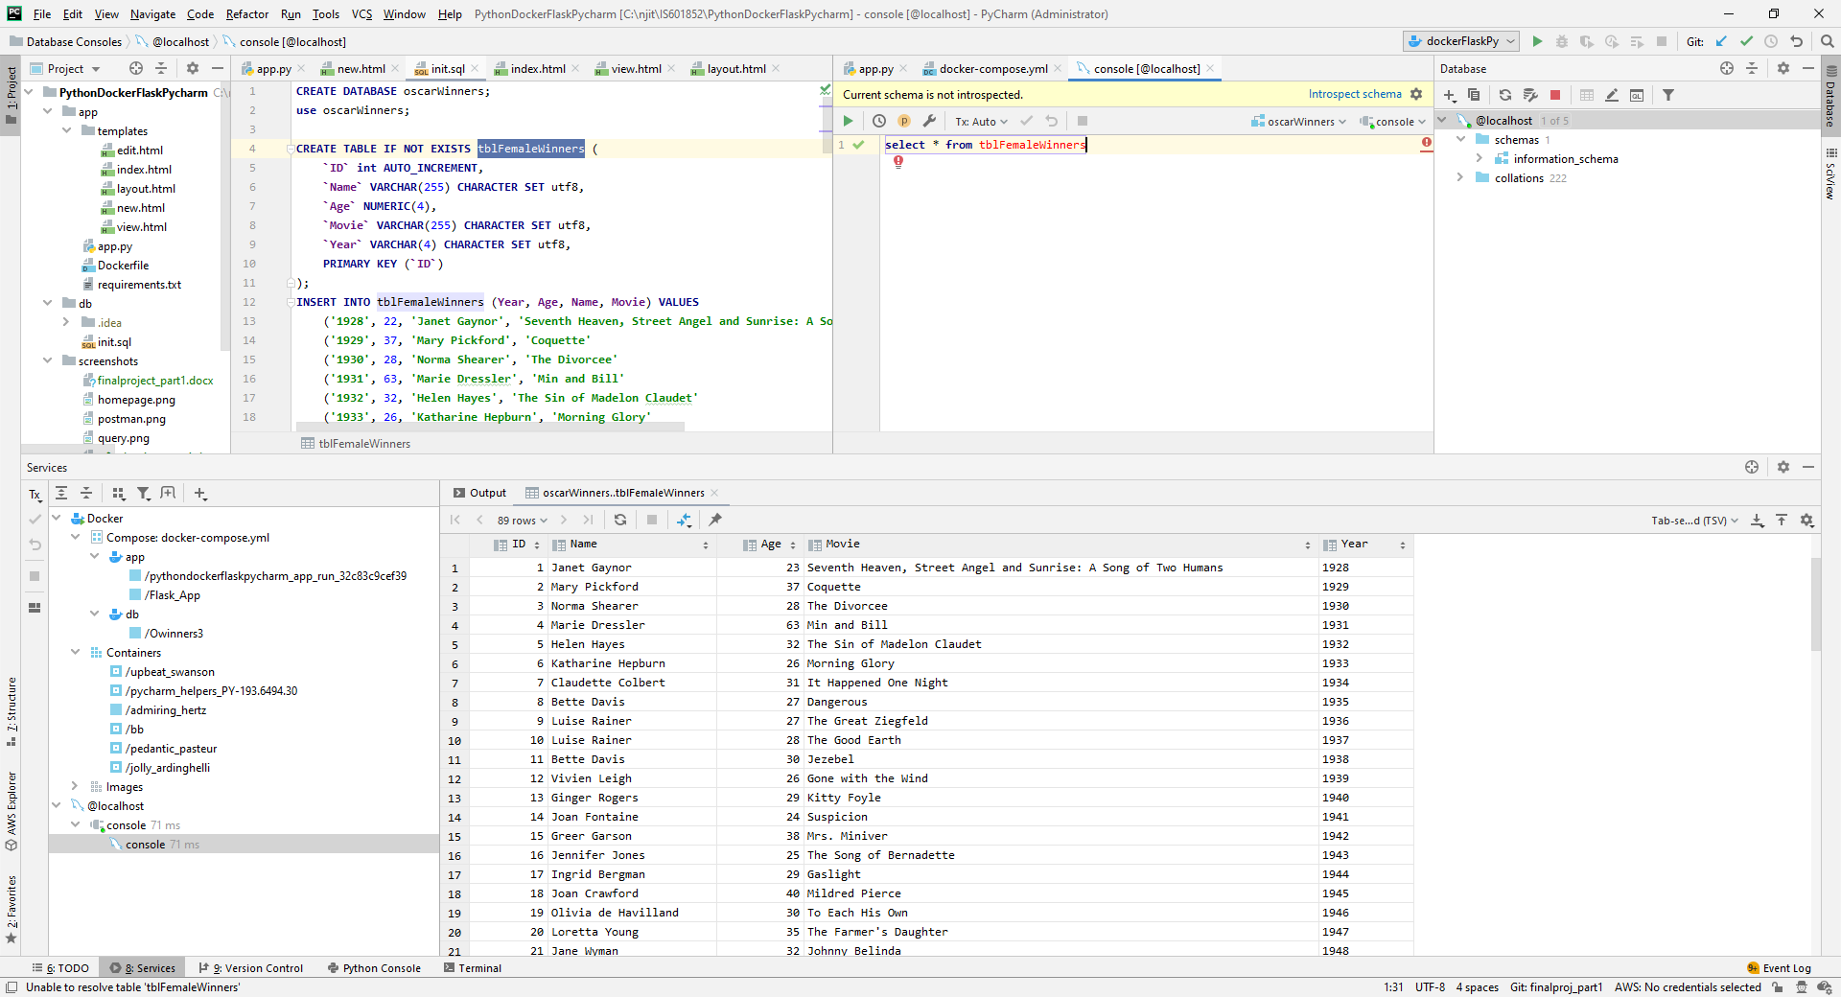

1. **YOUR project running correctly in the browser displaying your homepage with your data**

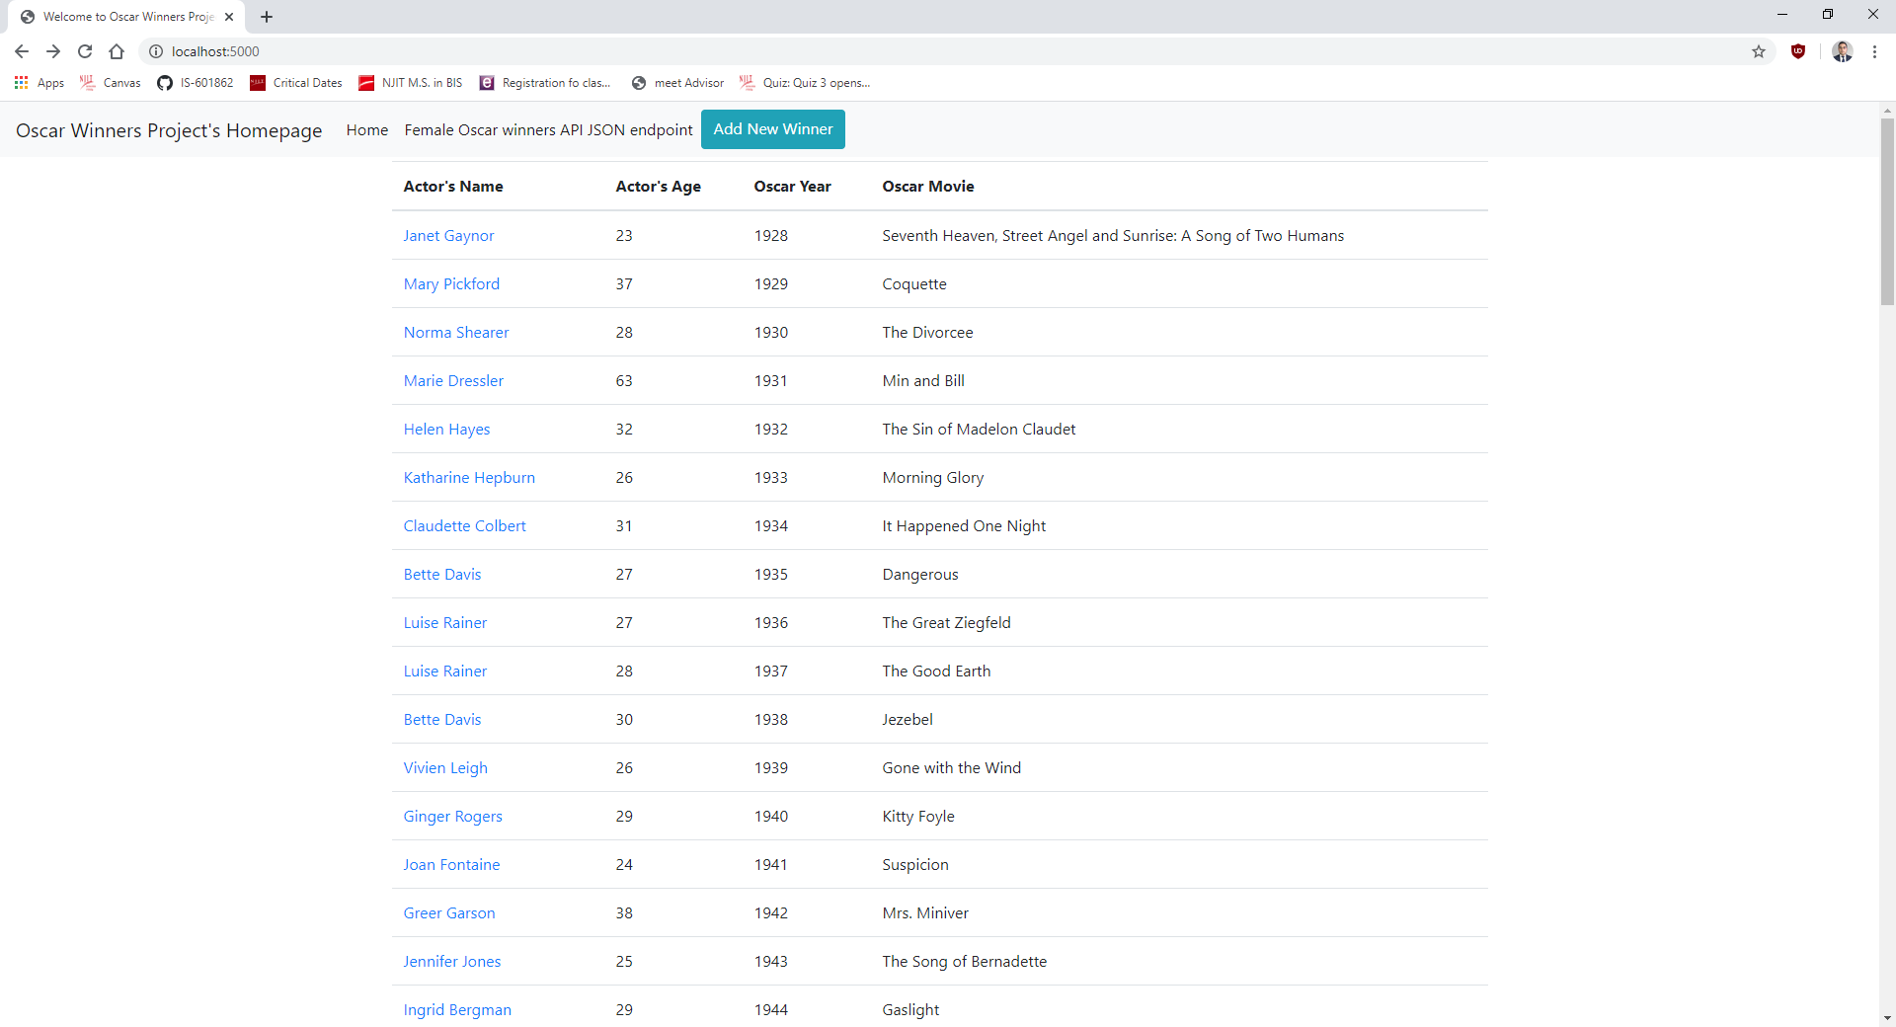

1. **YOUR project running correctly in the browser displaying your data record as a view of one record**

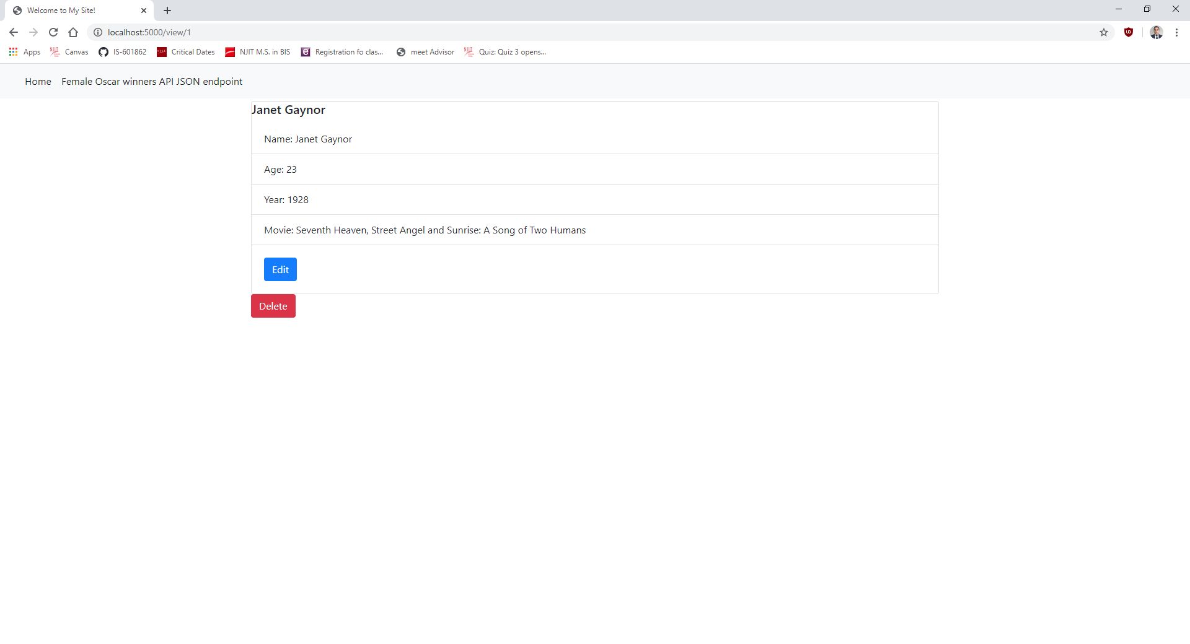

1. **YOUR project running correctly in the browser displaying a new record added to your home page**

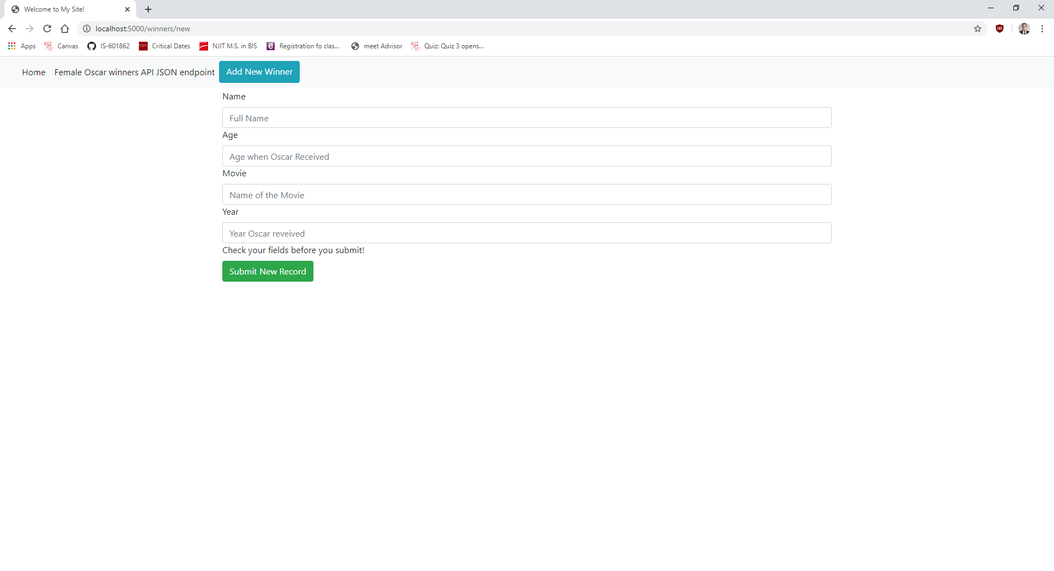

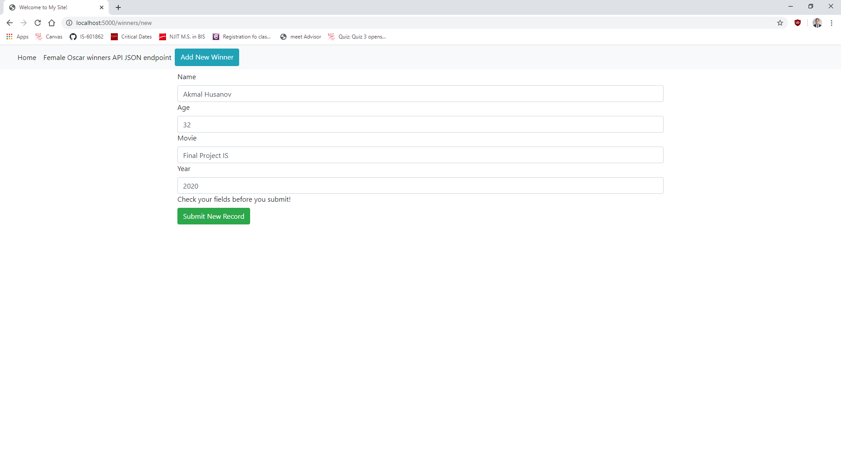

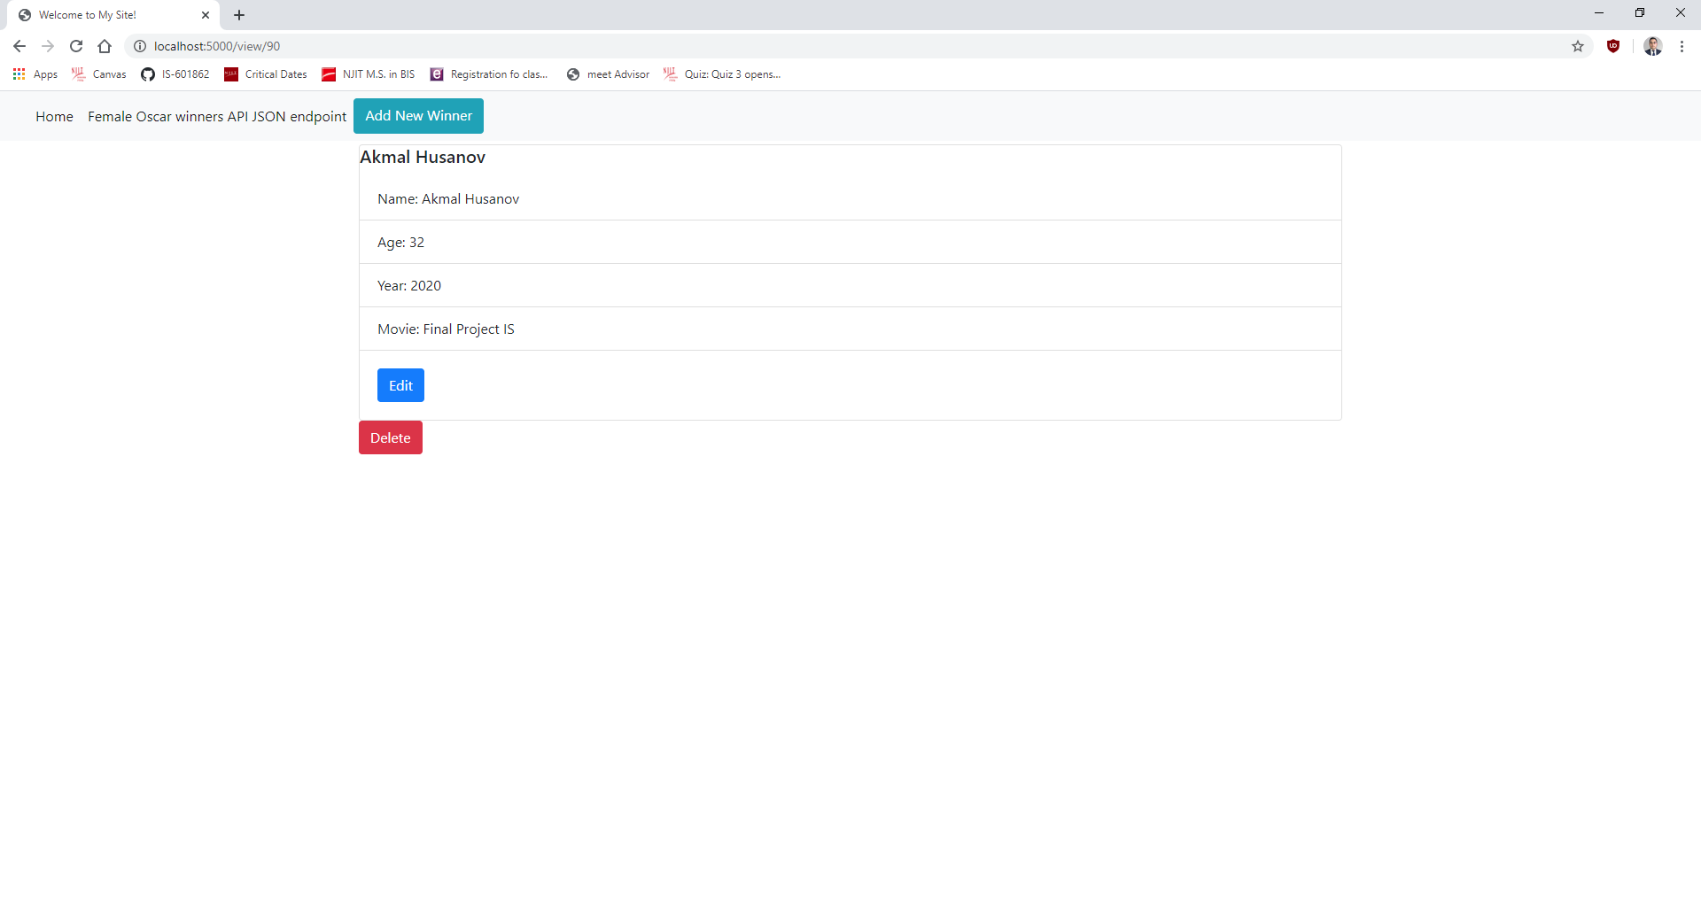

**e. YOUR project running correctly in the browser displaying an updated record added to your home**

**page**

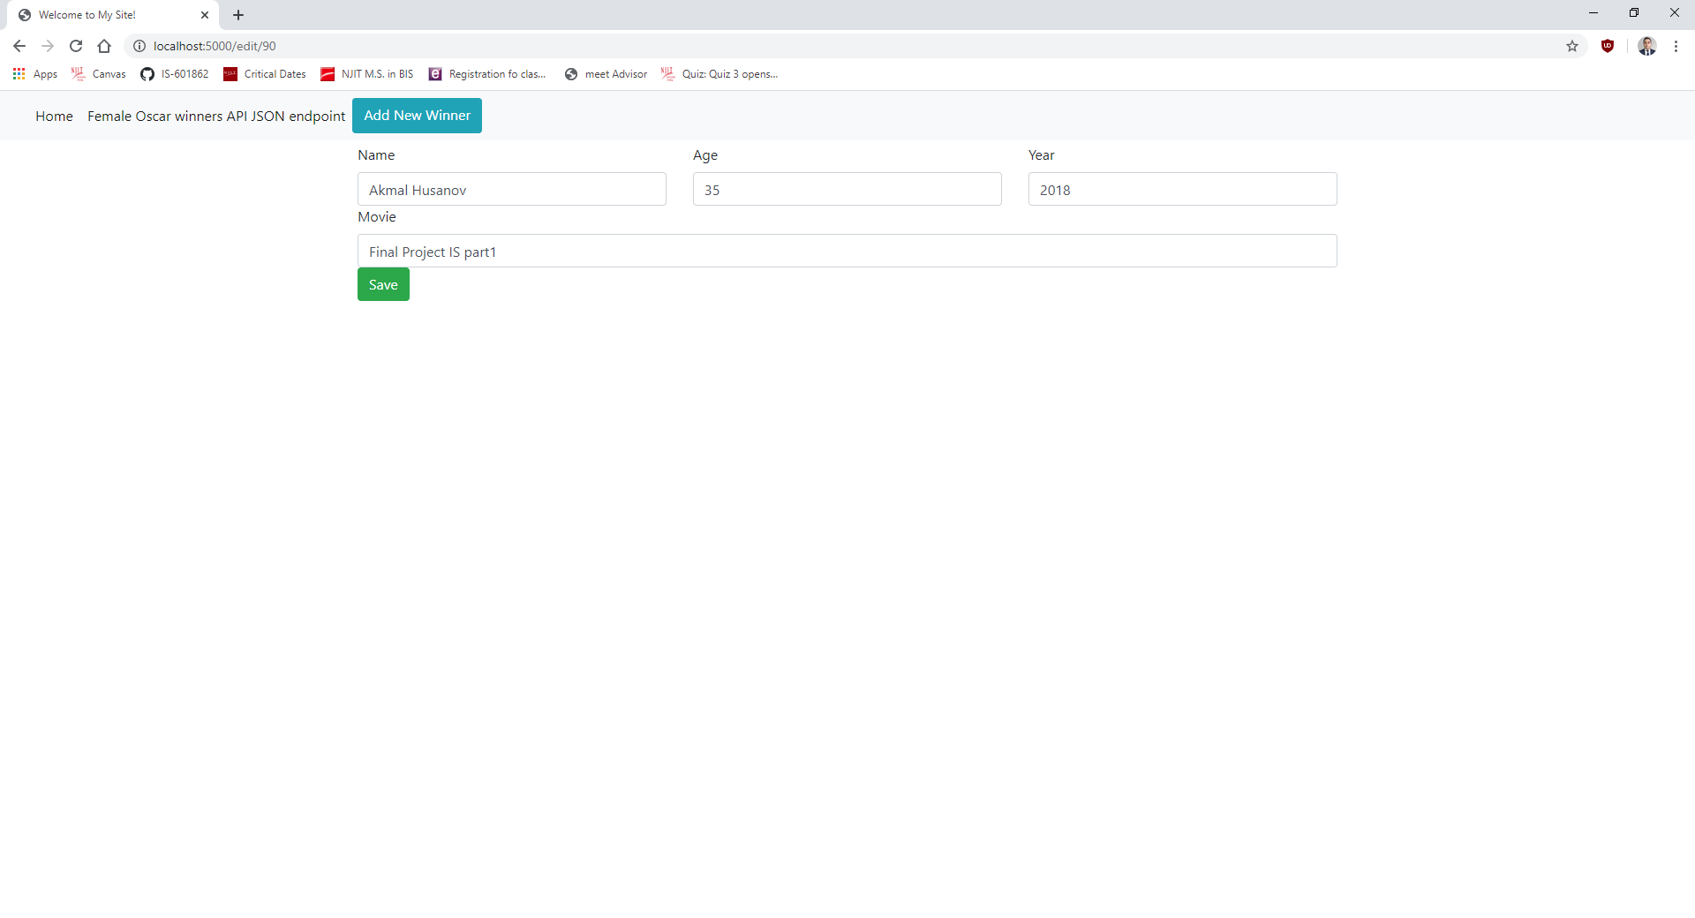

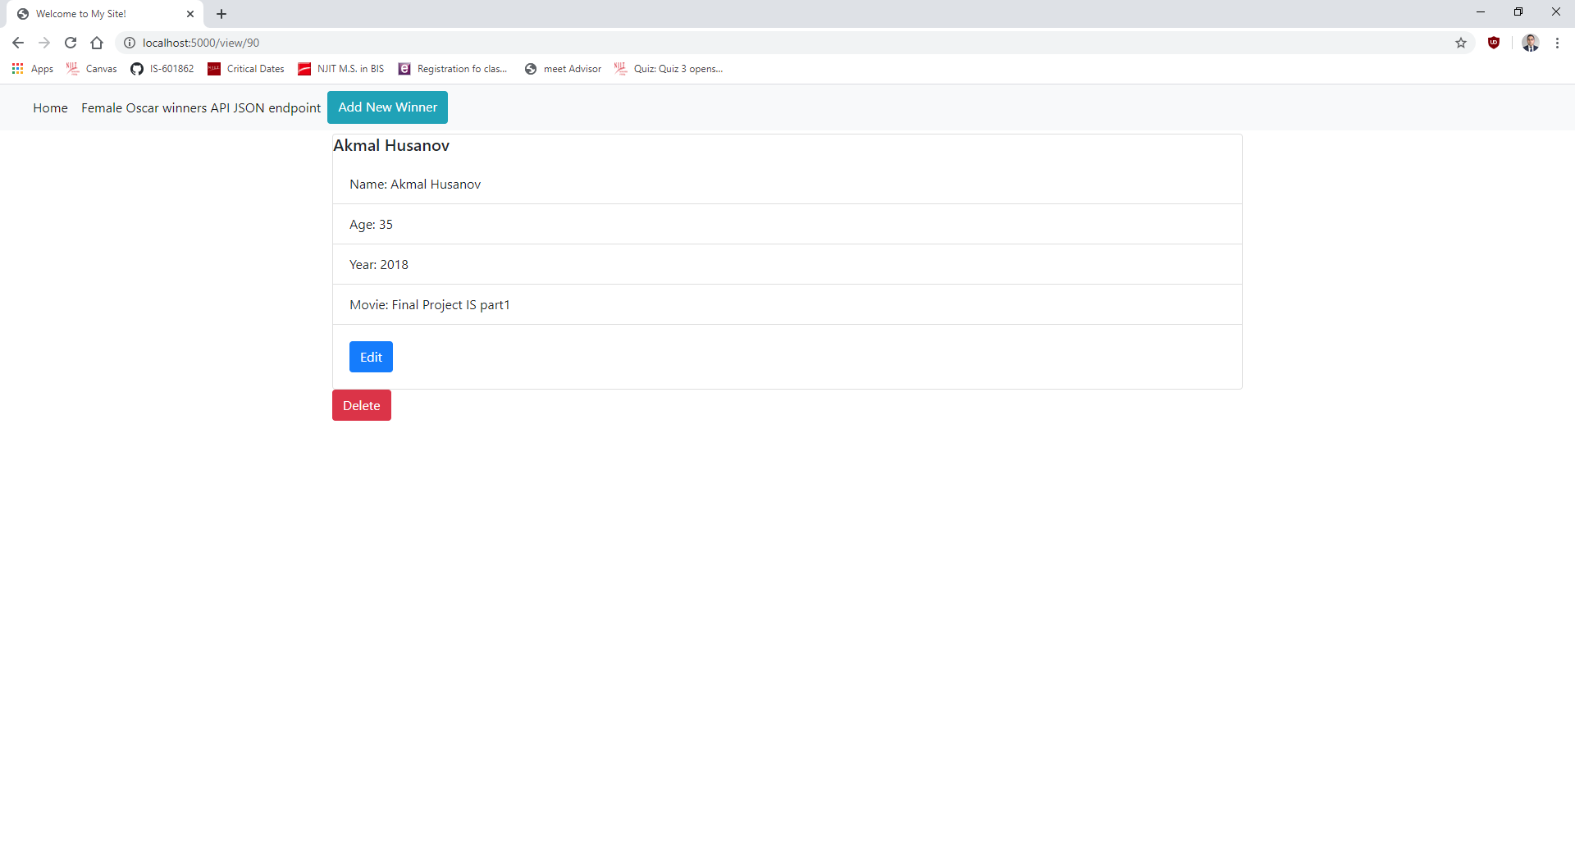

**f. YOUR project running correctly in the browser displaying a deleted record added to your home**

**page**

