## How to Submit your Project - Part2

Create a new word document that includes the following:

**1.** A link to your GitHub repository for a NEW project  
**2.** Submit a word document with screen shots of the following:

**1. YOUR project showing postman listing all records**

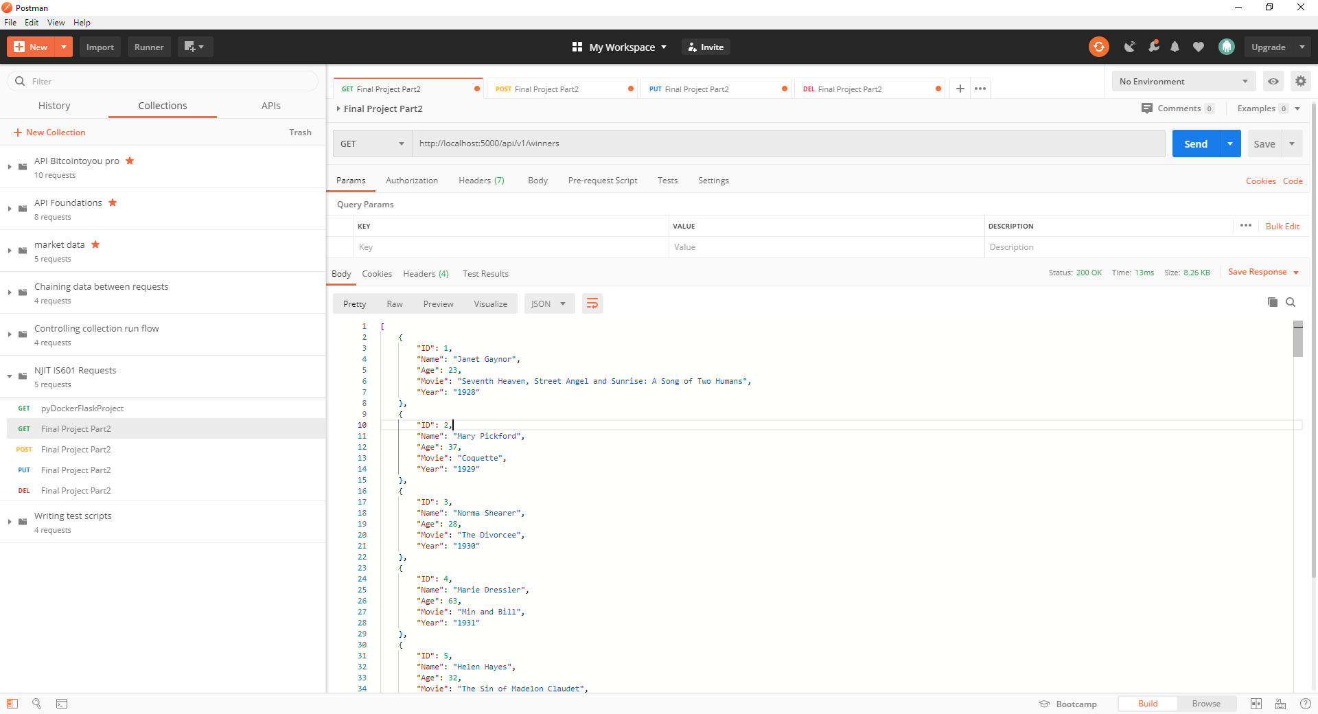

**2. YOUR project showing postman showing one record with a get request**

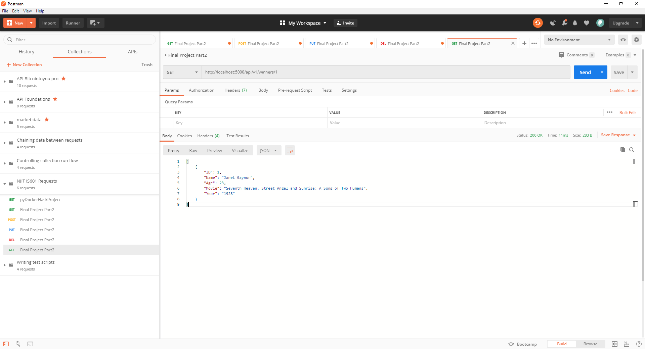

**3. YOUR project showing postman creating a record by showing the post request and the results in the record listing**

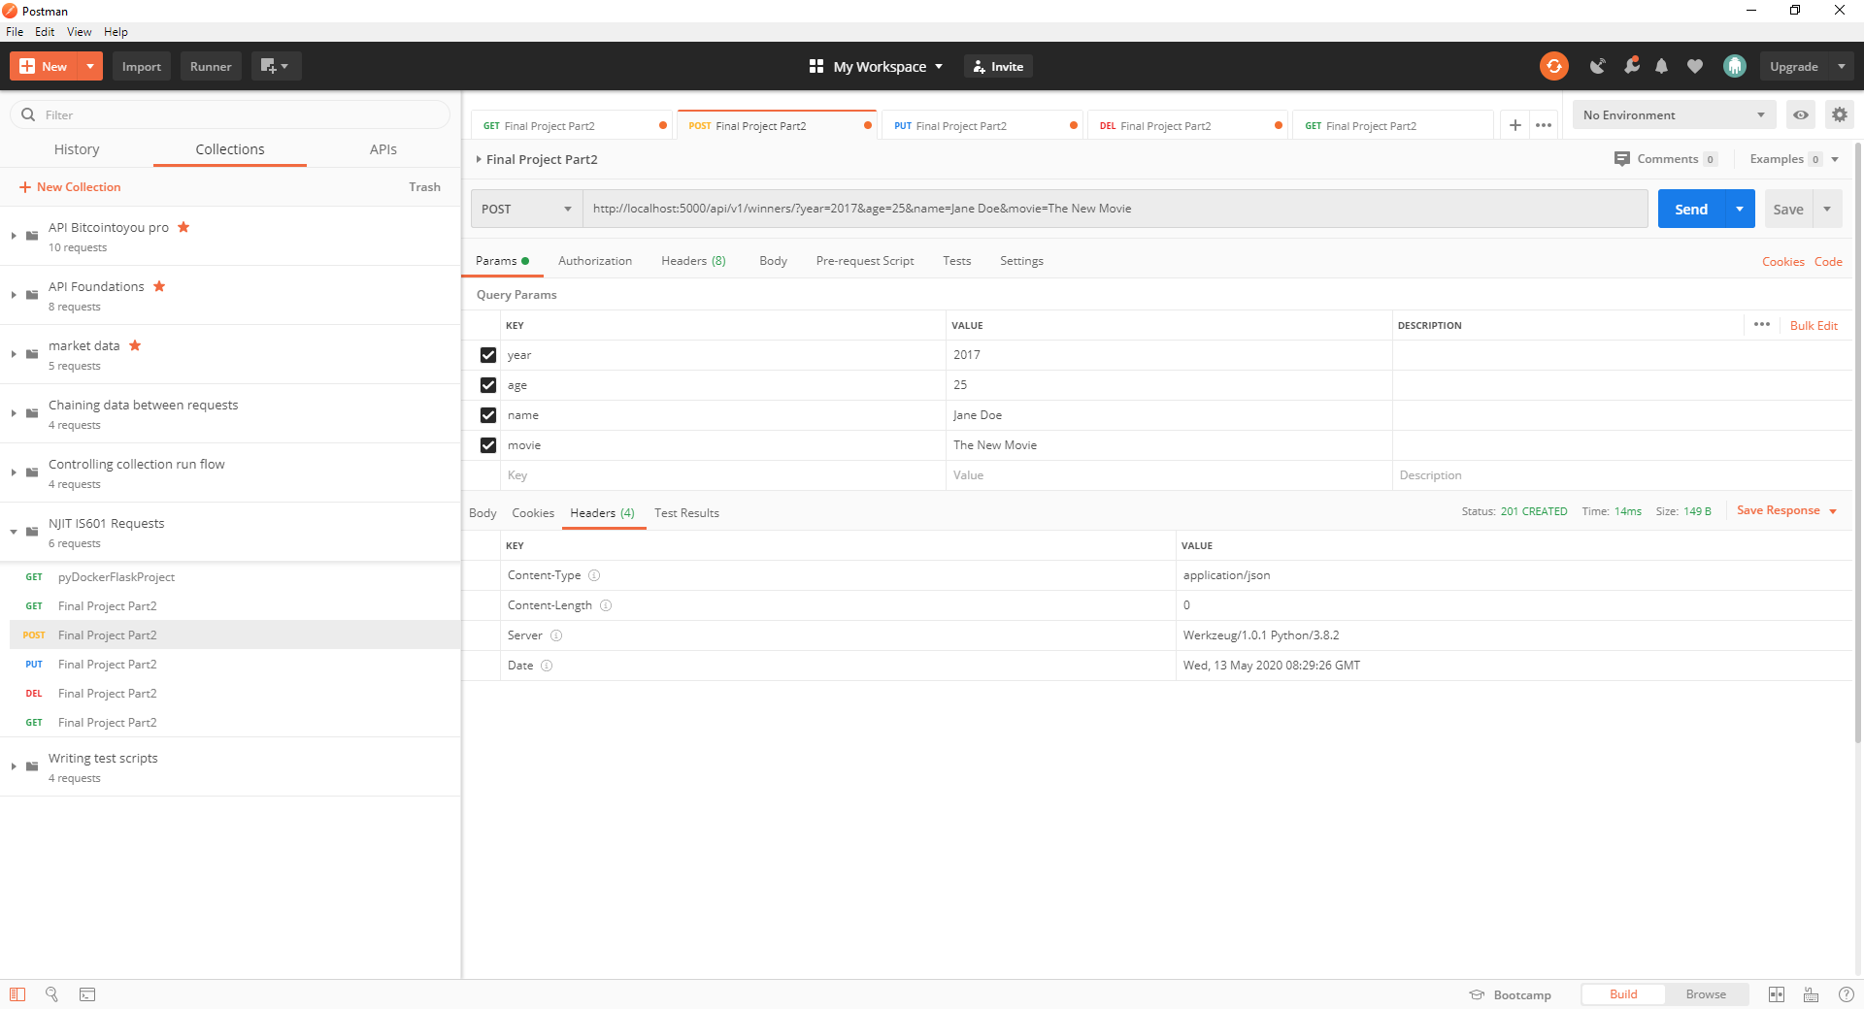

**4. YOUR project showing postman edit a record by showing the put request and the results in the record listing**

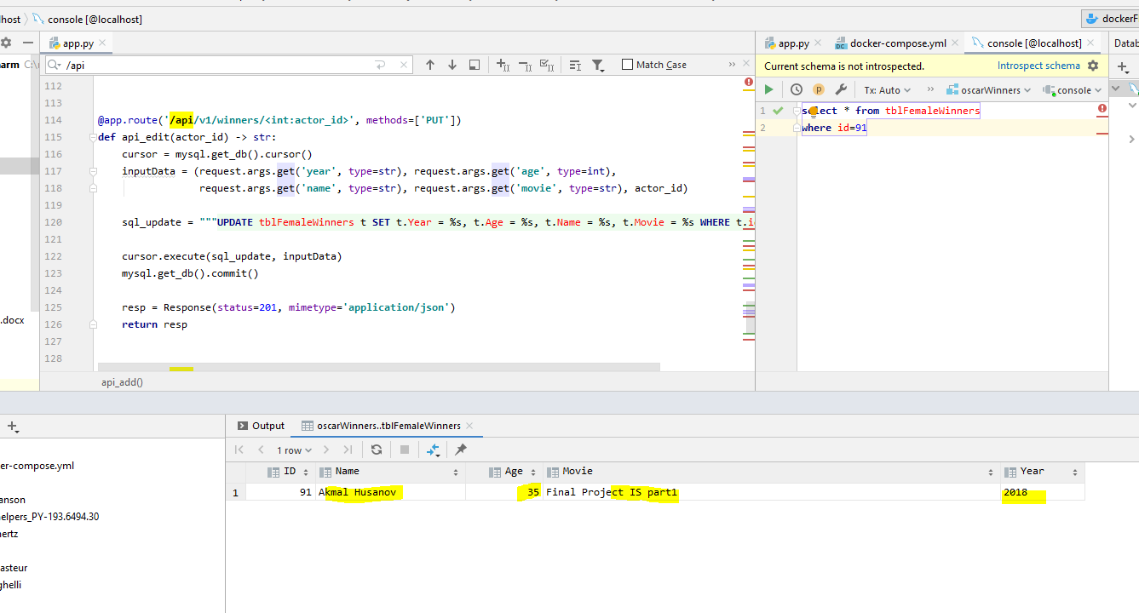

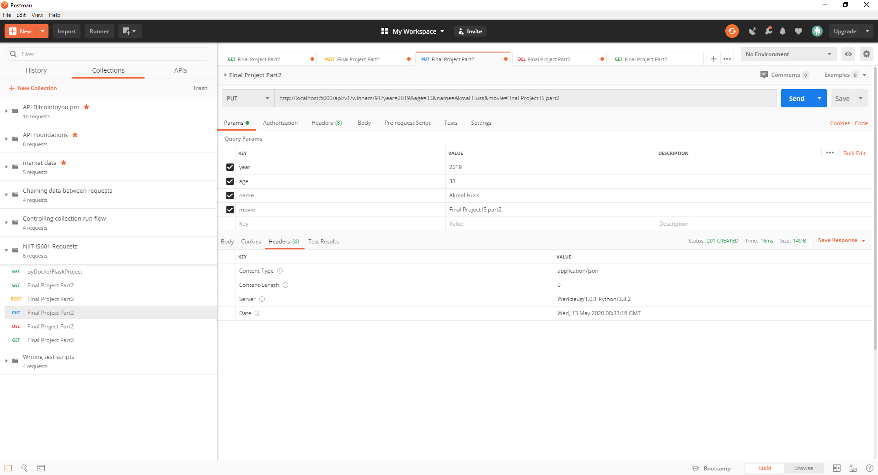

**5. YOUR project showing postman delete a record by showing the delete request and the results in the record listing**

