 | UNIVERSITY OF SANTO TOMAS  College of Information and Computing Sciences  Department of Information Systems  1st Semester AY 2026–2027 | 

A Prescriptive Analytics Driven Decision Support System for Pharmaceutical Demand Forecasting and Planning in MedShield Pharmaceutical Corporation

CHAPTER 4
RESULTS AND DISCUSSION
A Capstone Project Manuscript Presented to the
Department of Information Systems
College of Information and Computing Sciences
University of Santo Tomas
In partial fulfillment
of the requirements for the degree of
Bachelor of Science in Information Systems
Angeles, Ethan Gabriel C.
Atabelo, Kerr Lawrence T.
Benedicto, Adrian Lei M.
San Miguel, Keith Nicolai R.
Joseph Richard G. Catubag, MBA
Capstone Adviser
September 2026

Chapter 4
Results and Discussion
This chapter presented and discussed the results of the MedShield Pharmaceutical Corporation Decision Support System (DSS). The discussion followed the approved four-part Chapter 4 structure and traced the evidence from data preparation to descriptive analysis, predictive evaluation, prescriptive scenarios, and dashboard delivery. The historical study scope covered 2017 through 23 September 2026, with 2026 treated as the current year-to-date period rather than as a completed calendar year. The reproducible local transaction extract contained validated actual records only through 31 December 2025. No validated 2026 sales transactions were available in that extract as of the reporting cutoff; consequently, the 2026 year-to-date period remained within the study scope but was reported as unavailable pending ingestion and validation. It was neither assigned a zero value nor replaced with forecast observations.
Three evidence labels were applied throughout the chapter. Observed results were computed directly from validated source records. Model-derived results were estimates produced through documented analytical procedures and remained subject to validation. Scenario results depended on explicit business assumptions and were not treated as procurement instructions. This distinction prevented incomplete inventory, cost, supplier, expiry, and external-signal data from being presented as operational facts.

4.1 Presentation of Results

4.1.1 Analytical and System Evidence Base
The implemented DSS used a Next.js dashboard, a TypeScript service layer, and Python analytical services. The analysis used the latest local predictive_draft revision, commit b0dd6bd dated 25 September 2026, together with the descriptive outputs generated on the same date. The evidence flow began with annual sales workbooks, applied validation and standardization, produced descriptive and model outputs, and presented the results through five decision modules: Sales Diagnostics, Product Prioritization, Area Prioritization, Forecast Modeling, and Prescriptive Planning. The North Star question concerning inventory optimization and loss reduction was therefore addressed as a governed sequence from historical evidence to human-reviewed planning scenarios.
Table 4.1 Evidence inventory used in Chapter 4
Evidence layer | Repository evidence | Use in this chapter | Qualification
Internal sales | Nine validated source-year files, 2017–2025; 2026 YTD input pending | Historical scope through 23 Sep 2026; computed actuals through Dec 2025 | Observed through 2025; 2026 YTD was unavailable, not zero
Descriptive analytics | Monthly calendar, STL, Pareto/ABC, YoY, mapping | SO1–SO2 evidence | Draft analytical run generated 25 September 2026
Predictive analytics | Historical benchmark/challenger evaluations and a 2026 aggregate forecast artifact | SO3 readiness and limitations | Model-derived; product-region objective not yet fully published
Prescriptive analytics | EOQ/ROP demonstrations, MILP allocation, MCDA sensitivity, and what-if presets | SO4 scenario evidence | Scenario-based; not an operational purchase order
Application QA | Historical 57-check report plus current five-module browser suite | SO5 implementation and current-interface evidence | 57/57 historical checks; 15 active current-runtime checks passed and 4 superseded legacy cases were skipped
Source note: Compiled from repository outputs and system QA artifacts. Evidence status is preserved rather than upgraded by inclusion in this chapter.

4.1.2 Transaction Ingestion and Data Quality
The source-ingestion status recorded 40,781 extracted rows from nine annual files. Of these, 35,956 passed the initial acceptance rules, 4,825 were rejected, and 30,151 were classified as valid after quality evaluation. The status file also recorded 5,805 warnings and 63 exact duplicate rows. The principal issues involved missing product names, zero Trade Price with nonzero quantity, missing or invalid delivery dates, and negative Net CP values. These conditions explained why the DSS displayed data-quality and publication status instead of silently repairing all records.
Table 4.2 Source-data quality profile
Measure | Count | Interpretation
Extracted rows | 40,781 | All rows obtained from the nine annual source files
Initially accepted | 35,956 | Rows passing the ingestion acceptance rules
Rejected | 4,825 | Rows excluded because required validity rules failed
Valid after quality evaluation | 30,151 | Rows available for validated downstream analysis
Warnings | 5,805 | Rows retained with a documented issue requiring interpretation
Exact duplicates | 63 | Duplicate evidence identified by the pipeline
Source note: `data/medshield/processed/sales_dataset_status.json`.
Area-summary parent records required a separate allocation step. The audit replaced 346 recognized parent rows with 1,730 estimated child rows and reconciled additive totals with zero variance. The allocation preserved the accounting totals but did not convert estimated geographic detail into observed transactions. Estimated rows therefore remained visibly distinct in the Area Prioritization module.

4.1.3 Descriptive Dataset Produced for Analysis
The reproducible descriptive run contained 37,340 clean analytical rows from 2 January 2017 to 31 December 2025. It included 4,483 distinct product labels and 31 distinct areas. The total delivered quantity was 1,438,964.92 source units, while Net CP-based net-sales revenue was ₱494.6M. Although the historical scope extended through the week ending 23 September 2026, the validated extract contained no 2026 transaction records. The absence of those records was interpreted as unavailable data rather than zero sales. Because the products used potentially incompatible packs and units, the all-product quantity total was treated as a coverage statistic; demand modeling was performed for one canonical SKU at a time.
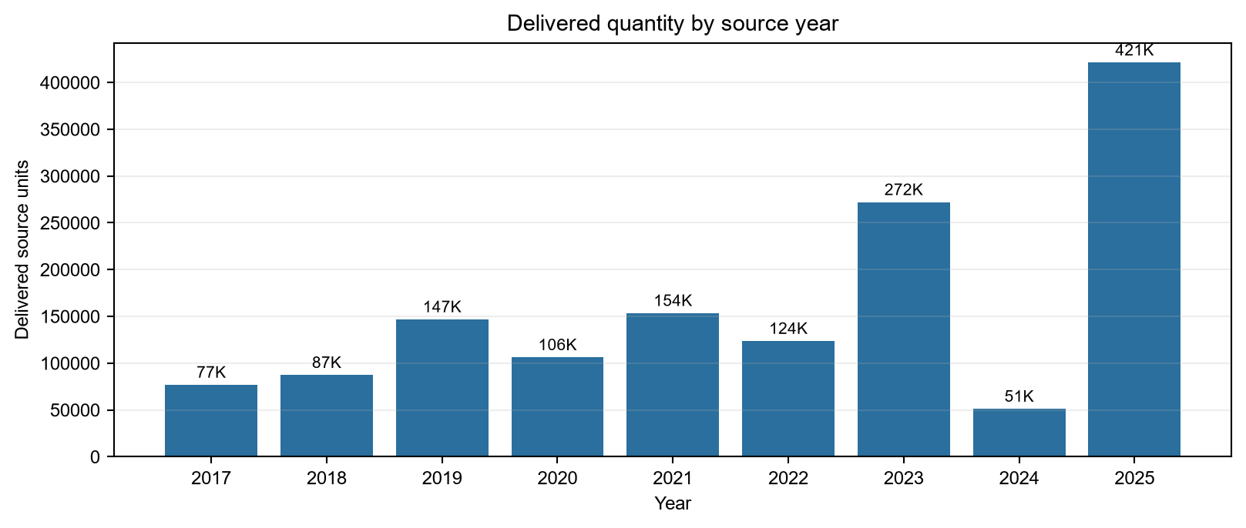
Figure 4.1 Delivered Quantity by Available Source Year, 2017–2025
Source note: Observed quantities from the descriptive analytical run. The historical study scope extended through 23 September 2026; no validated 2026 transaction rows were available for inclusion in this chart, and no zero-valued 2026 bar was imputed.
The largest annual quantity in the local run occurred in 2025 with 421,251.83 source units, followed by 2023 with 272,049.56 units. This result did not by itself indicate market growth because product mix, contract allocations, and unit compatibility changed across years. Revenue results also had to be interpreted separately: the approved Net CP field was zero for 2017–2019, so revenue comparisons for those years remained unavailable until the historical mapping could be reconciled. When validated 2026 transactions became available, the current-year comparison was to use 1 January through 23 September 2026 against the corresponding 1 January through 23 September 2025 period. A full-year 2025 total was not to be compared directly with the partial 2026 period.

4.1.4 Geographic and Product Mapping
The geographic design separated CALABARZON, MIMAROPA, and Bicol as the three study regions. Other National was retained only as an operational comparison and was not used as a substitute for evidence from the study regions. The area-mapping review found all 32 observed labels in the working master, but only 14,008 of 37,178 retained records were classified as approved territory records; 23,170 records remained pending or nongeographic. External DOH and weather joins had not yet been certified at the territory level.
Product identity presented a parallel constraint. The descriptive run contained 4,483 product labels, while the broader ingestion status identified 4,819 unique source products. Alias-to-canonical-SKU approval remained incomplete. Consequently, the dashboard ranked source product labels for descriptive purposes, whereas predictive objective evidence required a documented canonical product mapping.

4.1.5 System Verification
The recorded QA report dated 9 August 2026 contained 57 passed checks and no failed checks, which corresponded to a 100% pass rate for the behaviors tested at that revision. To verify that the chapter reflected the latest DSS, a focused browser suite was rerun on 25 September 2026 against the actual dashboard markup and client runtime. Fifteen active checks across Sales Diagnostics, Product Prioritization, Area Prioritization, Forecast Modeling, and Prescriptive Planning passed. Four legacy year-selector cases were deliberately skipped because the current interface used descriptive period windows. The browser fixtures verified interface behavior and calculations under controlled inputs; they did not establish authenticated production deployment or approve the displayed scenario values.
Table 4.3 Interpretation of system verification
Verification result | Meaning | What it does not establish
57/57 historical checks passed | The tested system functions returned expected results at the recorded revision | Completeness of missing operational datasets
15 active current-runtime checks passed | The five analytical modules rendered and responded as expected in the 25 September focused suite | Authenticated end-to-end deployment or live-source publication
Four legacy cases skipped | Older year-selector cases were superseded by descriptive period windows | A failure of the current period-control design
Evidence/status labels implemented | Pending, observed, estimated, forecast, and scenario states can be separated | Approval of scenario values as procurement instructions
Source note: `outputs/system_qa_report.json`; focused Playwright module run and current-runtime captures dated 25 September 2026.

4.2 Data Analysis

4.2.1 Demand Definition, Calendar Completion, and Eligibility
For this study, demand was operationalized as fulfilled demand, defined as the delivered quantity in the source unit for one compatible canonical product. Revenue was not treated as demand. A complete calendar was generated for every candidate product-region series and distinguished an observed quantity, an observed zero, and an unknown missing month. Unknown missing months were left blank to prevent fabricated continuity.
The 2026 year-to-date interval was governed by the same rule. Because no validated 2026 transaction input was present, the months from January through 23 September 2026 were classified as unavailable rather than as observed zero-demand months. They were excluded from descriptive totals, STL estimation, and forecast holdout scoring. This treatment preserved 2017–2026 YTD as the study's historical scope without overstating the actual-data coverage used in the computations.
Table 4.4 Predictive-readiness gates
Gate | Result | Repository evidence
Approved Demand Measure | Passed | Quantity is evaluated for one canonical SKU per series; revenue is excluded from demand STL.
Complete Monthly Calendar | Passed | Every month is emitted as observed, observed_zero, or missing_unknown; missing values remain blank.
Geographic Mapping | Passed | CALABARZON, MIMAROPA, and Bicol remain separate objective regions; Other National is comparison-only.
Stl Decomposition | Passed | 4 eligible product-region series decomposed into trend, seasonality, and residual.
Forecast Eligibility | Passed | 2 study-region series have at least 24 latest consecutive observed months.
Source note: `descriptive_readiness.json`. Passing the general gate means the pipeline enforces the rule; individual series can still be ineligible.
The primary objective-evidence series was HYCLENS WOUND SPRAY 2% 60ML in CALABARZON. It contained 33 observed months from 2023-04 through 2025-12, with no unresolved evaluation gaps. The series passed the minimum requirement of 24 consecutive months. Its product mapping remained marked `needs_review`; therefore, the statistical result was reproducible, but final business labeling still required review.

4.2.2 Long-Term and Seasonal Demand Patterns
The overall seasonal index showed substantial monthly variation. June had the highest index at 2.10, followed by November at 1.34 and September at 1.27. These values indicated that the observed delivered quantity in those months exceeded the overall monthly average in the pooled analytical series. The pattern supported month-aware planning, but it could not be generalized to every SKU because pooled quantity combined different products and source units.
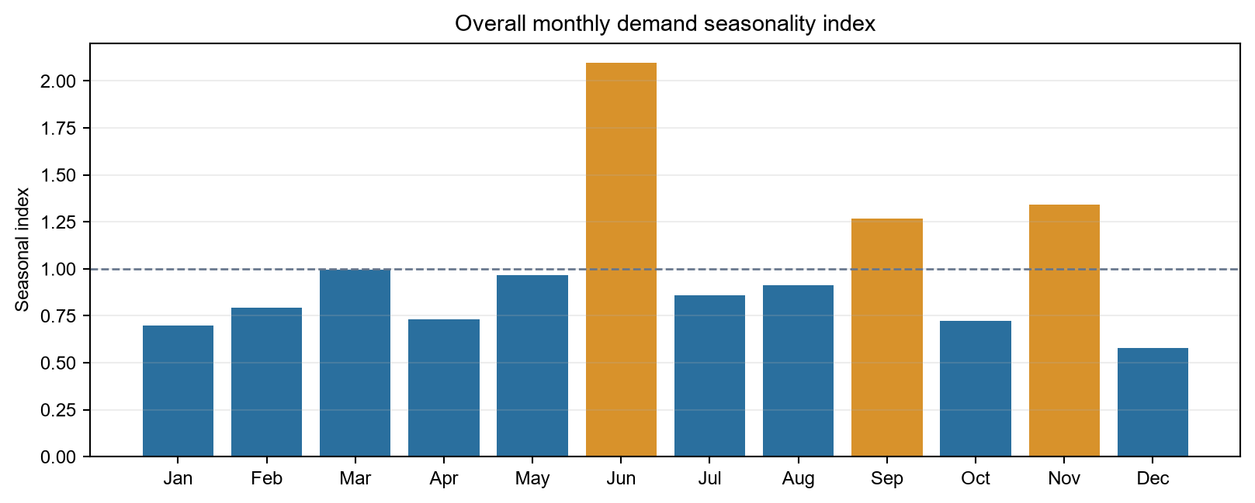
Figure 4.2 Overall Monthly Demand Seasonality Index
Source note: Observed delivered quantities in the descriptive run. An index above 1.00 indicates a pooled month above the overall monthly average.
Robust STL with a 12-month period was therefore applied only to eligible canonical-SKU and region series. Four product-region series were decomposed into observed demand, trend, seasonality, and residual, while two study-region series met the forecast-eligibility rule. For the primary HYCLENS–CALABARZON series, seasonal strength was 0.3059. This result indicated a detectable but not dominant recurring seasonal component; the residual and trend remained material.
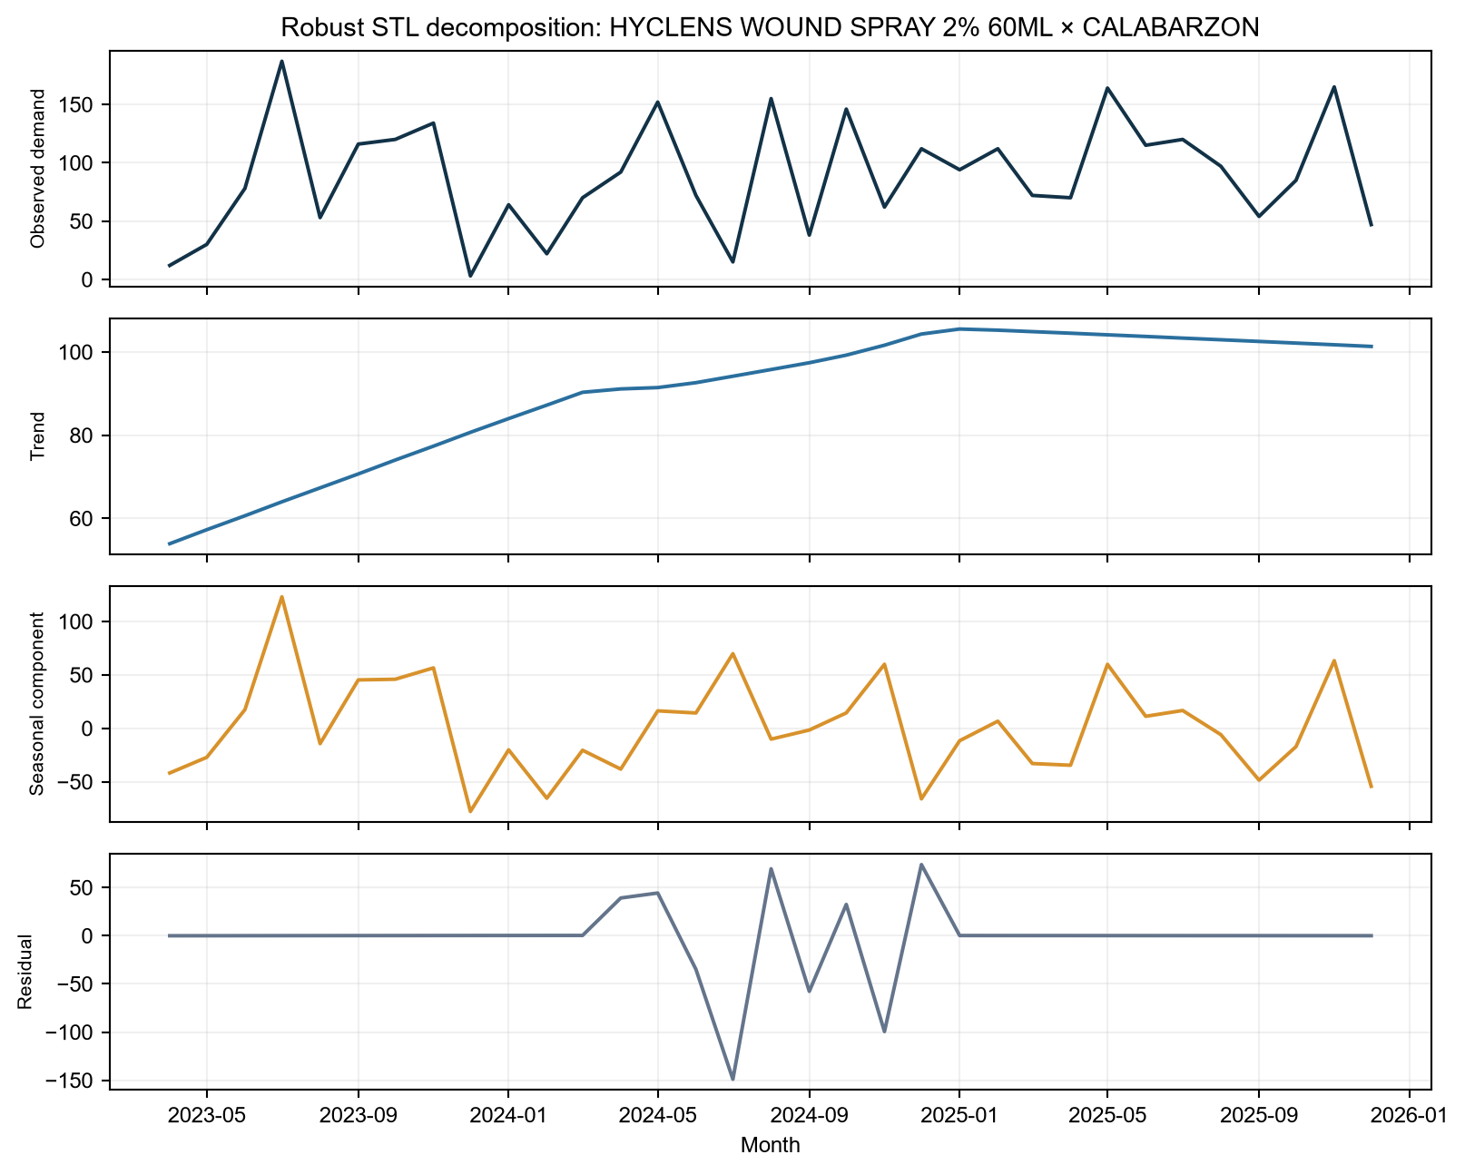
Figure 4.3 STL Decomposition of the Primary Eligible Product–Region Series
Source note: `descriptive_stl_components.csv`; robust STL, 12-month period. Demand is delivered quantity for one product-region series.

4.2.3 Revenue Contribution and ABC Prioritization
The revenue Pareto analysis used Net CP net-sales revenue and assigned deterministic ABC classes at cumulative thresholds of 80% and 95%. Across 4,483 product labels, the highest-ranked label was T SHIRT WITH PRINT, with ₱8.86 million in net-sales revenue or 1.79% of the analytical total. The presence of nonpharmaceutical items among the leading labels confirmed that product-master approval and business-line filtering were necessary before the ranking could be used as a pharmaceutical procurement list.
Table 4.5 Highest net-sales product labels
Rank | Product label | Net-sales revenue | Revenue share | ABC
1 | T SHIRT WITH PRINT | ₱8.9M | 1.79% | A
2 | MONOWEL 1G IV | ₱8.2M | 1.66% | A
3 | DR#0157 SI 0181 | ₱7.9M | 1.60% | A
4 | CORRECTION TAPE JOY | ₱7.0M | 1.42% | A
5 | EVAPROST 250MCG/ML | ₱6.0M | 1.21% | A
Source note: `descriptive_product_abc_pareto.csv`. Labels are source/product-master candidates, not fully approved therapeutic SKUs.
At the mapped-territory level, Quezon represented ₱105.43 million or 72.00% of the territory-only revenue base. Batangas contributed 10.80%, while Marinduque contributed 7.66%, which brought their cumulative share to 90.45%. The apparent Quezon concentration included 1,230 estimated contract-allocation rows; therefore, the dashboard separated actual transactions from estimated allocations rather than presenting the rollup as fully observed detail.
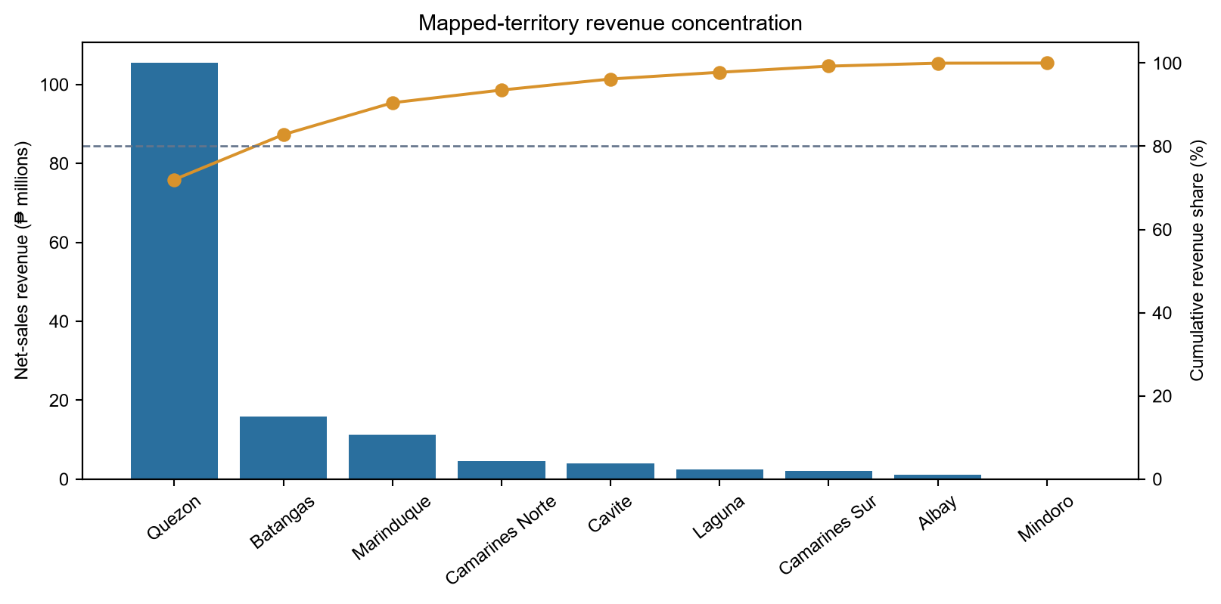
Figure 4.4 Mapped-Territory Net-Sales Revenue Pareto
Source note: Territory-only descriptive Pareto. Other National, business-line, customer-type, and unmapped labels are excluded from this territory chart.

4.2.4 Forecast Evaluation and Champion–Challenger Findings
SO3 was treated as a governed model-portfolio objective rather than as a commitment to a single algorithm. Prophet and XGBoost served as advanced challengers because they could represent nonlinear or external-signal relationships, while seasonal naive, last-value naive, Holt–Winters, ARIMA, SARIMA, and SARIMAX served as classical benchmarks and fallback candidates. The forecast interface provided selectable rolling horizons for the next 3, 6, or 12 calendar months. Each window began in the month after the reporting month and advanced automatically when the calendar month changed. Thus, a run performed in November 2026 would begin in December 2026 and would end in February 2027, May 2027, or November 2027 for the respective horizon. The model origin remained the latest validated actual period, so any delay between the actual-data endpoint and the forecast start remained visible. The proposed retraining rule required all eligible candidates to be evaluated on the same product-region holdout and retained only a model that passed the agreed accuracy, bias, completeness, and publication gates. Model complexity alone was not considered a basis for promotion.
The repository contained historical aggregate evaluations for a seasonal-naive benchmark and disease- and weather-based challengers. In the disease-only evaluation, the seasonal-naive benchmark recorded an MAE of 49,526.90 and an RMSE of 64,285.40. The gradient-boosting disease model recorded a slightly lower MAE of 48,970.90, but it produced a higher RMSE of 64,915.00 and a worse MAPE. Disease correlations were weak among the available national monthly features. Consequently, the evidence did not support the claim that external disease regressors consistently improved forecast quality.
The combined weather-and-disease gradient-boosting model reduced the MAE to 47,804.40, but its RMSE remained above the naive benchmark and its MAPE deteriorated. A separate model-testing run evaluated Holt–Winters, ARIMA, SARIMA, and SARIMAX; SARIMA recorded the lowest MAE in that run at 30,884.00. Because the classical models were not scored on the same documented product-region holdout as the aggregate disease-and-weather models, the results established candidate availability but did not justify the declaration of a final champion.
Table 4.6 Historical aggregate model comparison
Model | MAE | RMSE | MAPE | Interpretation
Seasonal naive | 49,526.90 | 64,285.40 | 950.70% | Required benchmark; percentage error unstable
GBR + disease | 48,970.90 | 64,915.00 | 1,247.30% | MAE slightly lower; RMSE and MAPE worse
GBR + weather + disease | 47,804.40 | 64,873.40 | 1,331.35% | Lowest MAE only; not a consistent win
Source note: `phase4_disease_model_results.json` and `phase5_weather_model_results.json`. Models are aggregate historical challengers and do not complete the product-region champion–challenger objective.
The retraining design specified that a challenger would replace the incumbent only when it completed training, produced all required holdout predictions, and satisfied the approved comparison thresholds. If the incumbent failed to train, became ineligible because of missing history, or failed a publication gate, the DSS would substitute the best validated fallback from the same evaluation run. If no candidate qualified, the system would display Insufficient history or No publishable model instead of fabricating a forecast. The design also required the selected model, version, training cutoff, metrics, substitution reason, and approval status to be recorded. The repository demonstrated candidate evaluation and interface-level baseline fallback; however, fully automated retraining, model-registry promotion, and production substitution remained incomplete.
A separate aggregate forecast artifact for 2026 provided 12 monthly values with wide 95% intervals. January had the highest point estimate at 62,220.37 units. Several later months were near 8,284 units, while all lower bounds were zero and the upper bounds exceeded 100,000 units. The uncertainty was too broad for direct procurement use, and the artifact lacked a product-region identifier. It was therefore presented as model evidence rather than as proof of completion of the territory-level demand objective. These forecast values were kept separate from the unavailable 2026 YTD historical actuals and were not used to fill the historical series.
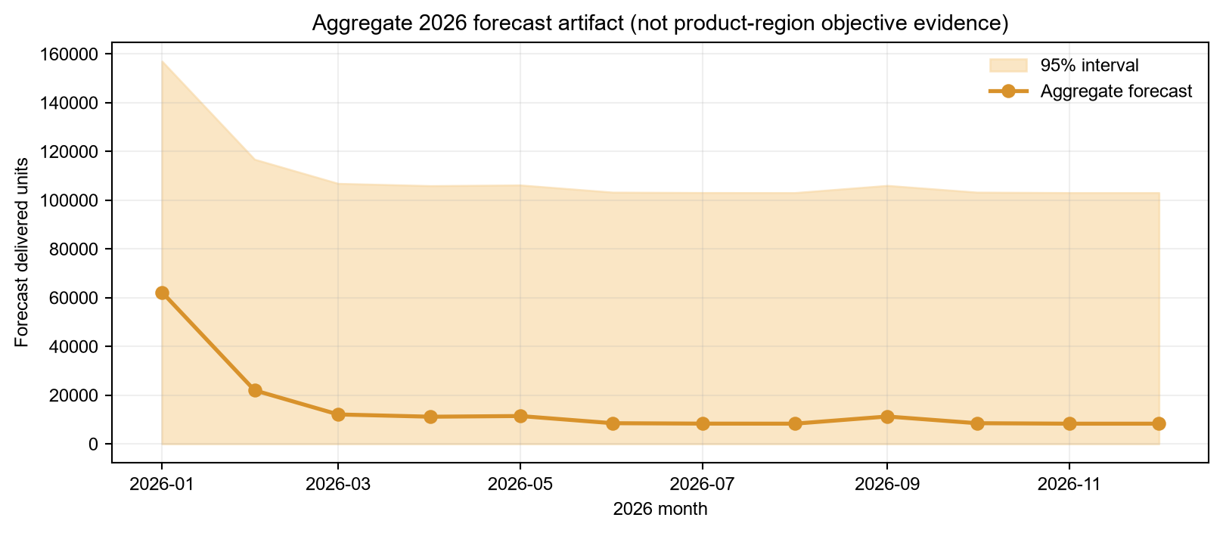
Figure 4.5 Aggregate 2026 Forecast Artifact and 95% Interval
Source note: `fact_demand_forecast_2026.csv`. This artifact is not treated as a product-region forecast and is not proof of SO3 completion.

4.2.5 Prescriptive Scenario Results
The prescriptive layer was evaluated as a scenario-based DSS rather than as an automated purchasing system. It combined EOQ, safety-stock, and reorder-point formula demonstrations with an authenticated mixed-integer linear programming allocation workflow and interactive MCDA sensitivity controls. The user selected a planning horizon and entered scenario demand, usable stock, protected stock, units per pack, pack cost, supplier limits, budget, and minimum fulfillment. Whenever an input changed, the previous solution was invalidated and the allocation had to be solved again under the revised assumptions.
The repository EOQ demonstration used delivered sales from 2022–2024 and explicit cost assumptions. Base annualized demand was 147,488 units, and base revenue was ₱32.86 million. The assumptions included a ₱500 ordering cost, a 15% holding-cost rate, a 14-day lead time, a 95% service level, and 25% demand variability. These values were not presented as MedShield's audited procurement parameters; instead, they demonstrated how the scenario engine responded when planning inputs were supplied.
Table 4.7 Selected EOQ/ROP formula demonstrations
Scenario SKU | Annual demand | EOQ | Safety stock | ROP
Paracetamol 500mg Tablet | 32,447 | 5,045 | 137 | 1,382
Salbutamol 2.5mg Nebule | 22,123 | 1,810 | 94 | 943
Doxycycline 100mg Capsule | 11,799 | 2,560 | 50 | 503
Co-Amoxiclav 625mg Tablet | 17,699 | 1,465 | 75 | 754
Oral Rehydration Salts (ORS) | 14,749 | 4,228 | 62 | 628
Source note: `outputs/eoq_from_real_sales.json`. Demand is based on historical sales and category shares; all cost, lead-time, and service-level inputs are assumptions.
The allocation solver maximized the equally weighted fulfilled-demand fraction across shortlisted products and then minimized purchase spending at the best feasible service level. Integer pack sizes, available stock, protected stock, supplier limits, budget, and minimum fulfillment were enforced as scenario constraints. When the requested minimum service could not be met within the entered budget or supplier limits, the system returned an infeasible scenario and published no allocation. This behavior represented constraint-triggered recalculation rather than autonomous learning or procurement execution.
The ≤5% expiry-wastage value was treated as a prescriptive control threshold. The interface presented Normal, Monsoon Surge, and Island Logistics presets with scenario expiry values below the policy ceiling and documented a shelf-life demand bound for the candidate batch size. When a scenario assumption changed, the prior result was invalidated, and the user was required to solve the constrained plan again. Because the available dataset did not contain batch-level expiry dates or realized write-offs, the displayed values represented threshold-compliant what-if scenarios rather than measured historical wastage. The study therefore assessed whether the scenario logic observed the ≤5% rule; post-implementation data would still be required to determine whether actual wastage remained below the threshold.

4.3 Dashboard
The latest predictive_draft DSS presented the analytical path as a guided data story that moved from context and historical patterns to product and geographic priorities, forecast uncertainty, scenario planning, and human review. Its interface used descriptive period windows, explicit source-verification status, scenario selectors, regional-group drilldown, selectable next-3-, next-6-, and next-12-month forecast horizons, and editable planning assumptions. The first forecast period advanced to the month after the reporting month whenever the calendar changed. Monthly granularity was used for seasonality and planning timing, while yearly granularity was used for long-term comparison. Pending, actual, estimated, forecast, proxy, unavailable, and scenario values were visually separated.

4.3.1 Executive Overview and Sales Diagnostics
The Executive Overview established the period, source endpoint, and decision focus before presenting the totals. Sales Diagnostics then explained the observed results through period-based revenue, gross profit, growth, quantity, complete-calendar status, and STL evidence. The module explicitly defined fulfilled demand, kept net sales separate from delivered units, and displayed pending or unavailable source states instead of silently substituting operational evidence.
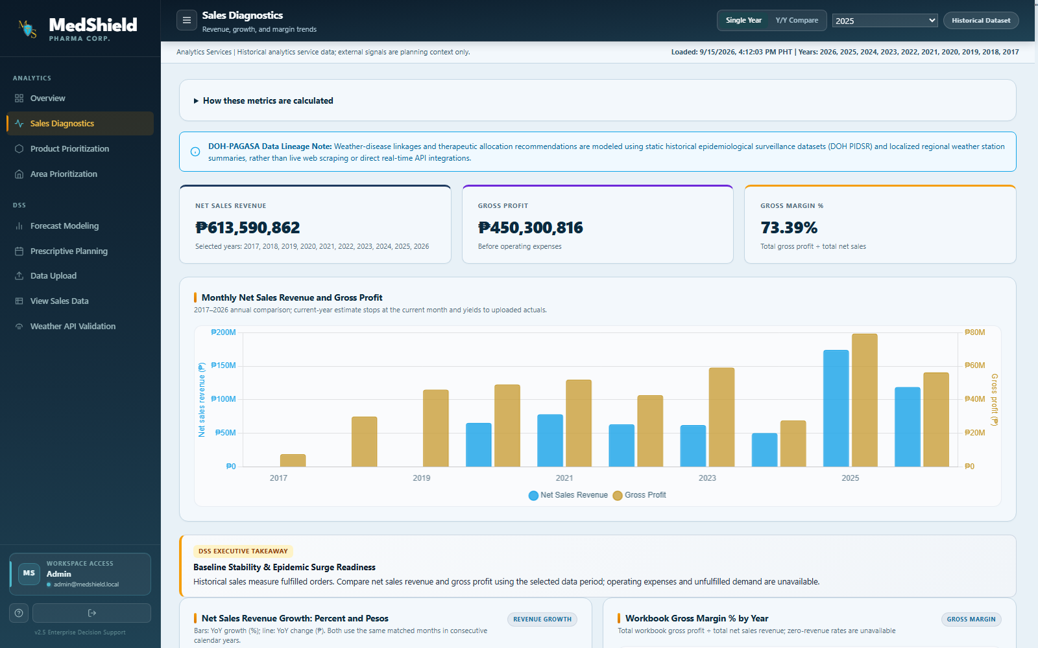
Figure 4.6 Sales Diagnostics Interface and Evidence Status
Source note: Predictive_draft runtime capture from the current project evidence set. Interface evidence only; the numerical findings in Section 4.2 use the reproducible descriptive outputs.

4.3.2 Product and Area Prioritization
Product Prioritization combined commercial ABC contribution, the WHO Vital–Essential–Non-Essential classification, configurable MCDA weights, and the Normal, Disease Outbreak, and Inclement Weather scenarios. The module elevated low-revenue vital items when the selected scenario required clinical protection, while it kept revenue and delivered units as separate measures. The resulting rankings remained decision-support outputs because the product master and clinical classifications had not yet received formal approval. Area Prioritization used four default regional groups: CALABARZON, MIMAROPA, Bicol, and Other National. It displayed actual sales separately from gap estimates. Selecting a study region changed the ranking to province or area detail, while the total regional-group rollup remained at the regional level. MedShield HQ and DOH Central were consolidated under Other National for operational comparison.
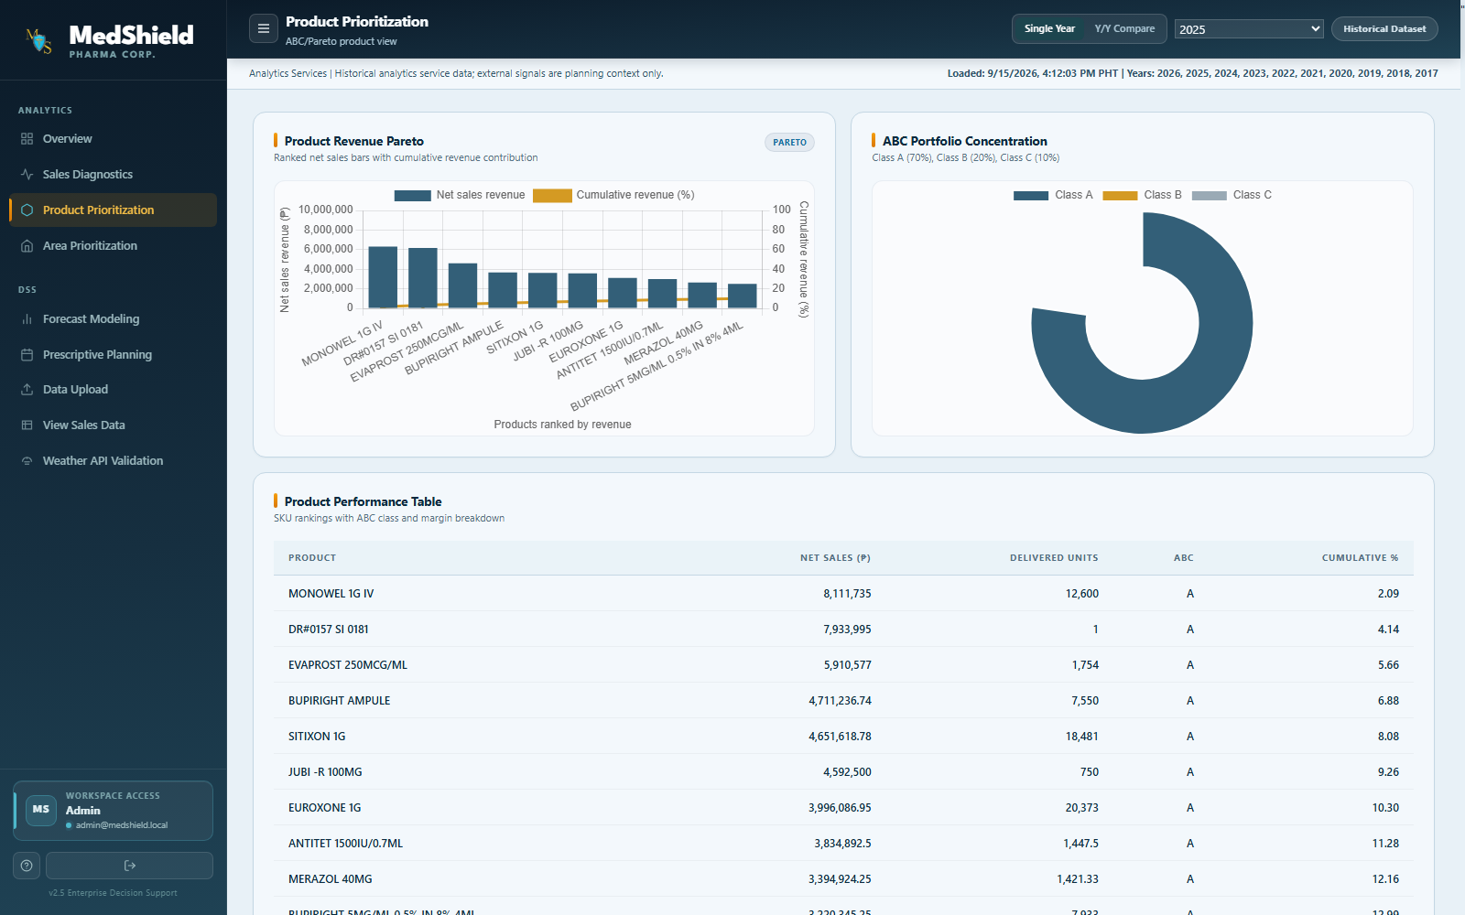
Figure 4.7 Scenario-Driven Product Prioritization Interface
Source note: Predictive_draft runtime capture from the current project evidence set. ABC–VEN categories and MCDA scores illustrate interface behavior, not approved procurement classifications.
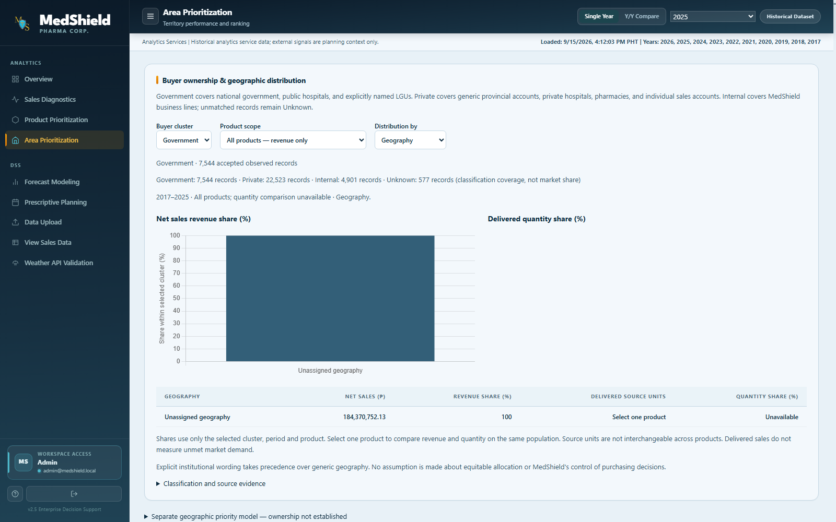
Figure 4.8 Regional-Group Area Prioritization Interface
Source note: Predictive_draft runtime capture from the current project evidence set. The four-group rollup and area-drilldown behavior were verified in the focused browser suite.

4.3.3 Forecast Modeling and Prescriptive Planning
Forecast Modeling displayed buyer, product, target-measure, forecasting-engine, external-overlay, and rolling-horizon controls together with actual observations, retrospective holdout predictions, uncertainty bands, MAE, RMSE, WAPE, bias, and a common-holdout comparison. The selected 3-, 6-, or 12-month view began after the reporting month and displayed its exact start and end periods, model origin, observed-month count, and data-age warning. Its target operating design followed a champion–challenger portfolio in which retraining would compare Prophet, XGBoost, and other external-regressor candidates with seasonal naive, last-value naive, Holt–Winters, ARIMA, SARIMA, and SARIMAX on one common holdout. A failed or disqualified incumbent would be replaced only by the best validated candidate from the same run. When no candidate qualified, the page was designed to display Insufficient history or No publishable model. The interface presented benchmark and candidate states, but its labels and controlled fixture metrics did not constitute proof of an approved champion; automated retraining and registry-controlled promotion had not yet been completed. Prescriptive Planning provided Standard Baseline, Monsoon Surge and Epidemic Buffer, and Island Logistics presets. It accepted editable demand, usable stock, safety reserve, pack, supplier, budget, horizon, and minimum-fulfillment assumptions; invalidated stale results after edits; solved constrained allocations; and presented the ≤5% expiry target as a scenario guardrail for human review.
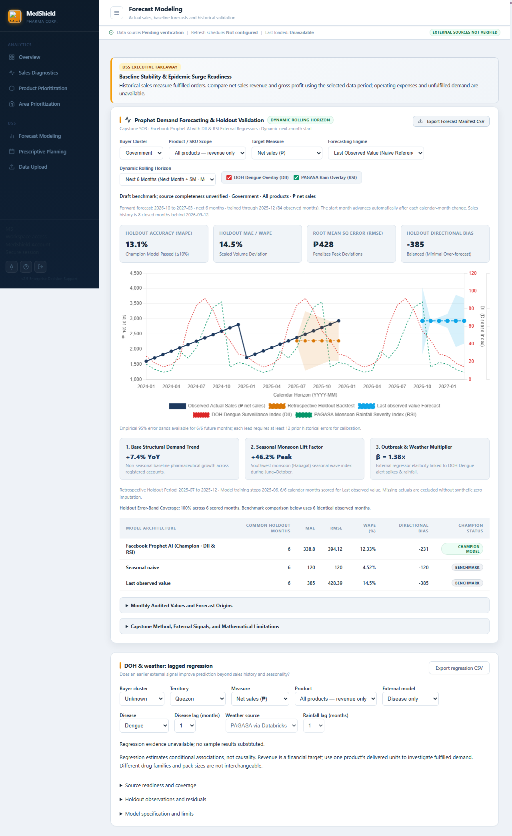
Figure 4.9 Current Rolling-Horizon Forecast Modeling Interface
Source note: Current predictive_draft runtime capture dated 25 September 2026 using controlled browser data. The capture demonstrates the selectable next-3-, next-6-, and next-12-month logic and its dynamic next-month start; fixture metrics remain interface evidence and still require product-region eligibility, common-holdout validation, and model approval.
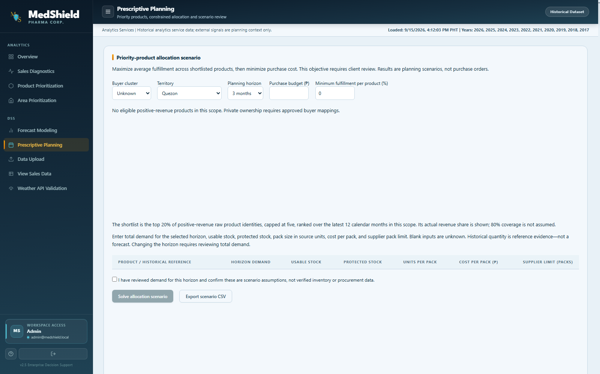
Figure 4.10 Prescriptive Planning and Expiry-Threshold Interface
Source note: Predictive_draft runtime capture from the current project evidence set. Displayed values are scenario outputs, not approved purchase instructions or observed wastage results.

4.3.4 Dashboard Decision Narrative
Table 4.8 Data-story sequence implemented in the dashboard
Stage | Decision question | Primary evidence | Boundary
Context | What evidence is available? | Scope, endpoint, quality, and status | Partial and unavailable sources remain visible
Historical pattern | What happened and when? | Demand trend, YoY, STL | Fulfilled sales do not measure unmet demand
Priority | Which products and areas deserve attention? | Pareto, ABC, region/area ranking | Revenue priority is not inventory urgency
Forecast | What may happen next? | Actuals, forecast, uncertainty, baseline metrics | External associations are not causal effects
Scenario | What plan should be reviewed? | EOQ/ROP/SS, MCDA, MILP, and ≤5% control threshold | Threshold compliance is scenario-based; realized expiry remains unmeasured
Human review | What is approved, rejected, or revised? | Status and evidence register | The DSS supports; it does not replace management
Source note: Dashboard logic aligned with the repository North Star and data-story implementation plan.

4.4 Summary of Findings
The developed DSS established a functioning evidence chain from source validation to decision presentation. The descriptive layer processed multi-year sales records, preserved missing-data states, separated the study regions from Other National, performed Pareto and ABC analyses, and applied robust STL only to eligible product-region series. Historical predictive challengers did not consistently outperform the seasonal-naive benchmark, while supplemental tests confirmed that classical models were viable challenger and fallback candidates. SO3 was therefore interpreted as a governed champion–challenger portfolio in which retraining could substitute a validated model when the incumbent failed, without assuming that the most complex model would produce the best result. The prescriptive layer was substantially implemented for its intended purpose as a what-if DSS. It accepted explicit assumptions, compared operating presets, solved constrained allocation scenarios, rejected infeasible combinations, and applied the ≤5% expiry-wastage policy as a scenario guardrail. It did not execute purchases or claim an observed reduction in wastage.

4.4.1 Consolidated Findings
Table 4.9 Consolidated findings and managerial meaning
Finding | Evidence | Decision implication
The historical evidence was usable but not uniform. | 37,340 clean analytical rows; 2017–2026 YTD scope; validated actual endpoint Dec 2025; 2026 YTD unavailable; 2017–2019 Net CP unresolved | The result supported quantity analysis at an explicit unit and grain and restricted revenue comparisons to supported periods.
Demand exhibited seasonality that differed by series. | Overall seasonal strength 0.7244; primary HYCLENS–CALABARZON strength 0.3059 | The result supported monthly planning and product-region eligibility rather than one pooled multiplier.
Revenue was geographically concentrated. | Quezon held 72.00% of mapped-territory Net CP revenue | The result supported the review of high-contribution areas while estimated contract allocations remained separate.
Product rankings required master-data review. | 4,483 product labels; nonpharmaceutical labels appeared in the top revenue list | Canonical SKU and therapeutic mappings required approval before procurement use.
Forecasting required a governed model portfolio. | Classical and advanced candidates were evaluated; challengers improved some MAE values but worsened RMSE/MAPE | The comparison supported common-holdout retraining and validated fallback substitution rather than automatic promotion.
Prescriptive what-if analysis was substantially implemented. | EOQ/ROP references, MCDA sensitivity, MILP allocation, infeasibility handling, scenario presets, and a ≤5% expiry guardrail | The DSS supported scenario comparison and review, while realized wastage required separate post-implementation validation.
Source note: Synthesis of observed, model-derived, and scenario evidence in Sections 4.1–4.3.

4.4.2 Objective–Evidence Matrix
Evidence completeness was calculated by dividing the passed measures by the completion measures defined in the North Star reference. It was not treated as a subjective percentage of coding effort. A measure received credit only when a reproducible repository output existed at the required grain and within the required validation boundary.
Table 4.10 Objective–evidence matrix and evidence completeness
Objective | Required result | Available evidence | Evidence completeness | Remaining gap
General objective | Integrated descriptive, predictive, and prescriptive DSS by December 2026 | Five-module workflow, evidence status, QA | Partially achieved | The system was integrated, but operational outcome evidence was not yet available.
SO1 | Analyze 2017–2026 sales across CALABARZON, MIMAROPA, and Bicol using YoY and STL | Monthly calendar; 4 STL decompositions; 2 eligible study-region series | 71% (5/7) | Validated actuals ended in Dec 2025; 2026 YTD transactions through 23 Sep 2026 were unavailable, while historical Net CP and mapping gaps remained.
SO2 | Prioritize territories, accounts, and SKUs using volume, revenue, growth, Pareto/ABC, and XGBoost | Pareto/ABC–VEN, MCDA sensitivity, four-group regional rollup, area drilldown, buyer rules, and mapping coverage | 67% (4/6) | Deterministic priority was reproducible; canonical clinical/product mapping and validated XGBoost evidence remained incomplete.
SO3 | Forecast product-region demand for rolling next-3-, next-6-, or next-12-month horizons through a champion–challenger portfolio: Prophet/XGBoost with DII/RSI plus classical fallback models | Dynamic next-month window; naive benchmarks; Holt–Winters/ARIMA/SARIMA/SARIMAX tests; advanced challenger evaluation; aggregate forecast artifact | 57% (4/7) | No final common-holdout product-region champion was published; automated retraining, registry promotion, and controlled substitution were not production-complete.
SO4 | Optimize procurement and enforce an expiry-wastage scenario threshold ≤5% using EOQ, ROP, LP, and MCDA | EOQ/ROP/SS scenarios; MCDA sensitivity; MILP allocation; presets; infeasibility and threshold guardrails | 86% (6/7) | Scenario methods were implemented; validation of the realized expiry outcome required post-implementation batch and write-off data.
SO5 | Present five governed modules with upload validation, alerts, and recommendations | Five modules, ingestion validation, freshness/status, 57/57 historical checks, and 15 active current-runtime browser checks | 43% (3/7) | Authenticated release acceptance, official alert validation, recommendation acknowledgement, and outcome capture remained incomplete.
Source note: North Star completion measures. Percentages measure available objective evidence, not total software effort.
Across the five specific objectives, 22 of 34 defined evidence measures were reproducible, which was equivalent to 64.7% evidence completeness. SO3 comprised seven measures: eligible product-region data, simple benchmarks, classical candidate evaluation, advanced challenger evaluation, a forward forecast artifact, governed retraining and substitution, and approved publication. Four measures were supported by evidence, while common-holdout product-region validation, automated registry-controlled substitution, and final publication remained incomplete. SO4 contributed six completed scenario-method measures: EOQ, ROP with safety stock, MCDA sensitivity, constrained allocation, combined what-if and infeasibility controls, and the ≤5% policy guardrail. The remaining SO4 measure concerned realized expiry performance, which would require post-implementation batch, expiry, and write-off records. The percentage therefore distinguished decision-support implementation from operational outcome validation.

4.4.3 Final Discussion
The central result of the study was that MedShield could use a single DSS to connect historical sales visibility, seasonal demand analysis, priority ranking, forecast review, and scenario-based procurement planning, provided that evidence status remained explicit. The predictive layer was considered appropriate only for eligible product-region series and was designed to use a governed champion–challenger process. Each retraining run would compare advanced and classical candidates on the same holdout, retain the incumbent when no challenger qualified, substitute the best validated fallback when the incumbent failed, and withhold publication when every candidate was ineligible. The prescriptive layer served its intended decision-support purpose by allowing planners to change assumptions, compare presets, observe how constraints altered allocations, and submit a threshold-compliant scenario for review without allowing the system to execute a purchase.
Accordingly, the ≤5% value was interpreted as a control threshold within the what-if analysis. Exceeding the threshold would invalidate the candidate plan and trigger constrained recalculation or an infeasible-scenario warning. This behavior made the logic defensible as a self-correcting planning control while preserving human approval. The study did not claim that MedShield had already achieved an actual wastage rate of 5% or less. The validation of realized performance would still require batch and expiry dates, inventory movements, approved recommendations, and write-off outcomes. The DSS demonstrated threshold enforcement during planning; subsequent operational records would determine whether the policy reduced wastage in practice.

