CHAPTER 4
RESULTS AND DISCUSSION
Chapter 4 reported the results of the MedShield Decision Support System and examined how far the available evidence answered the capstone questions. The clearest result was a traceable historical sales layer connected to a dashboard. A candidate population of 37,728 accepted sales facts covered 2017 to 2025. Missing months remained visible, while product, area, and forecast displays identified their evidence limits. Predictive publication, external-signal forecasting, and operational inventory optimization remained incomplete; the chapter treated evaluated features separately from measured business outcomes.
The discussion followed the project objectives and the guiding question: How could MedShield use historical sales data, validated external signals, and scenario-based planning to improve demand visibility and reduce expiry-driven inventory losses for the 2026 planning cycle? Observed sales, candidate mappings, forecast evaluations, weather proxies, and planning scenarios carried different levels of evidence. The distinctions mattered because a working screen did not establish an approved model, a verified stock position, or a reduction in expired inventory. Published studies informed the choice of methods, while MedShield receipts provided evidence for MedShield results (Nguyen et al., 2021; World Health Organization, 2024).
The MedShield sales record available for the review ended in December 2025. For elapsed 2026 months without uploaded client sales, the dashboard marked recency-weighted same-calendar values as gap estimates. The estimates supported provisional planning while 2026 actual records were pending. They remained separate from observed sales, could not serve as a 2026 validation holdout, and required reassessment after actual records became available. Future 2026 months remained unavailable rather than appearing as actual sales.

4.1 Presentation of Results
Section 4.1 presented the implemented system and the evidence behind its results before discussing the patterns. The objective audit, architecture, and data-quality profile established which claims could be defended. Historical sales referred to observed 2017 to 2025 records. A 2026 value without an uploaded actual remained a separately labeled estimate pending the client record.

4.1.1 Alignment With the Research Questions and Objectives
The proposal defined five objectives: describe sales and seasonality, prioritize products and areas, forecast demand with external signals, support inventory decisions, and present the results through five dashboard modules. The implementation advanced furthest on the first, second, and fifth objectives. Forecasting reached controlled evaluation but not release approval. The prescriptive layer solved constrained scenarios, but the study lacked the stock, expiry, lead-time, supplier, ordering-cost, and holding-cost data needed to measure an actual reduction in wastage.
Table 4.1 Objective achievement audit
Objective | Evidence expected | Observed result | Assessment
SO1 | Sales performance, year-over-year patterns, and STL seasonality | Historical summaries and a 72-month STL decomposition were available. Ten earlier months remained unobserved, and the full geography mapping still needed owner approval. | Partially achieved
SO2 | Product, territory, and account priorities using Pareto ABC and predictive scoring | Deterministic Pareto and ABC candidate views were implemented. Product labels were not approved SKUs, and no XGBoost classifier was published. | Partially achieved
SO3 | Territory forecasts using sales, DII, RSI, Prophet, and XGBoost | Sales-only baselines and offline candidates were evaluated. External joins had zero forecast-eligible rows, and no model was approved or activated. | Not achieved for operational use at review
SO4 | EOQ, ROP, and allocation decisions aimed at expiry wastage of at most 5 percent | The interface supported reviewed allocation scenarios. Real inventory and expiry outcomes were absent, so the 5 percent target was not tested. | Scenario capability only
SO5 | Five dashboard modules with upload validation and decision support | The five principal modules existed. Browser-to-warehouse CSV ingestion remained unfinished; Signal 2 alerts and collaborative filtering were not verified outputs. | Partially achieved
Source: Capstone proposal objectives and the MedShield current-state, analytics, and QA records as of 27 September 2026.
A completed interface did not by itself prove a research outcome. The forecast screen displayed a baseline without an approved model, and the planning solver operated on assumed inputs without verified stock. Each result therefore paired an implemented function with the limit of its evidence.

4.1.2 Implemented System and Runtime Architecture
MedShield was implemented as an authenticated web application. The Next.js frontend displayed analytical views and sent requests to an Express and TypeScript gateway. The gateway performed validation, authorization, and Databricks query orchestration. Databricks Unity Catalog stored the analytical source of truth through Bronze, Silver, Audit, and Gold candidate schemas. Supabase supplied identity and audit support but did not provide dashboard measures. Python services supported offline preparation, model experiments, and validation; they did not act as a browser fallback.
The runtime boundary remained strict. If Databricks or a required view was unavailable, the gateway returned an error and the dashboard showed an unavailable state. Local JSON, seeded values, and old spreadsheets did not replace the missing result. The declared runtime source made displayed analytical values traceable.
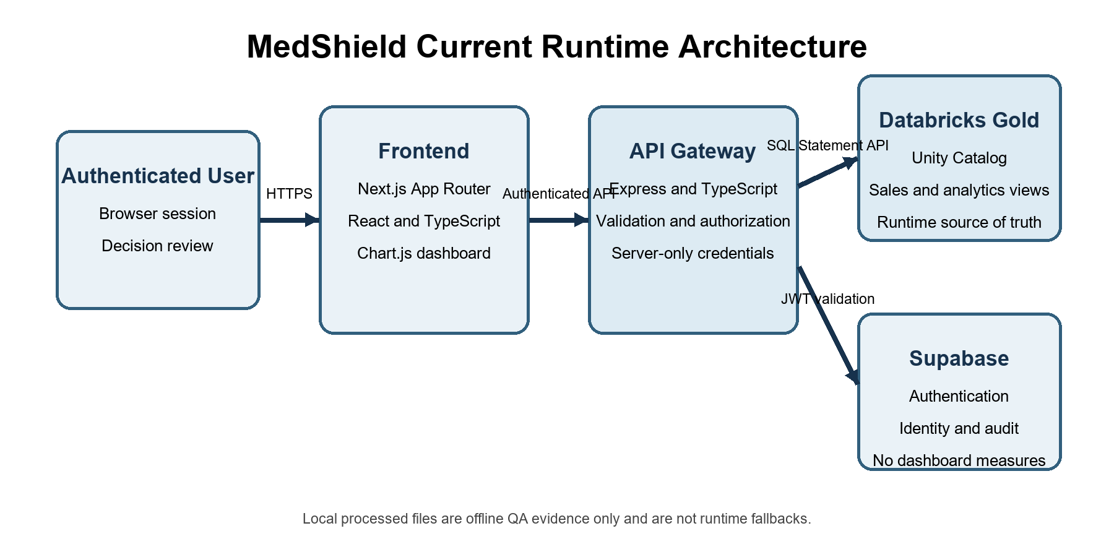
Figure 4.1 MedShield runtime architecture
Source: MedShield Architecture and Database documentation, September 2026.
Table 4.2 Implemented system layers
Layer | Implemented component | Responsibility | Boundary
Presentation | Next.js, React, TypeScript, Chart.js | Filters, charts, tables, exports, readiness labels, and scenario forms | Did not query Databricks or external providers directly
Gateway | Express and TypeScript | Authentication checks, parameter validation, query orchestration, and response contracts | Server-only credentials; explicit unavailable states
Analytical store | Databricks Unity Catalog | Bronze source evidence, Silver assessed records, Gold candidate facts and aggregates | Candidate publication awaited business approval
Identity and audit | Supabase Auth and audit persistence | Session identity, roles, and application audit events | Was not an analytical source
Offline analytics | Python jobs and tests | Reconciliation, STL, model evaluation, and scenario validation | Was not a live dashboard dependency
Source: MedShield Architecture, Database, Security, and Project documentation.

4.1.3 Data Sources Coverage and Quality
The historical sales candidate covered 2017 to 2025 and contained 37,728 accepted fact rows. The proposal emphasized 2021 to 2025 and three Philippine regions, while the warehouse retained the longer history available in the supplied records. The broader period provided context. Regional interpretation remained conditional on approval of the area mapping. Department of Health and weather sources provided historical context but were not approved sales regressors.
Table 4.3 Data sources and current analytical status
Source | Coverage | Use at review | Status and limitation at review
MedShield sales | 2017 to 2025 actuals; 2026 actuals were pending | Historical demand, revenue, product, area, and baseline forecast evaluation | 37,728 accepted facts; elapsed 2026 gaps could be estimated and remained separately labeled
DOH surveillance | 2018 to 2026 declared; 2026 partial | Historical disease context and candidate regressors | Territory join not approved; no individual health inference
PAGASA observations | 2017 to 2024 | Official historical weather context | No official 2025 observations in the project; no approved sales match
NASA POWER | 108 monthly rows for nine areas in 2025 | Separately labeled weather proxy | Provider proxy, not PAGASA; 32 candidate matches did not approve regression
Operational inventory | Not supplied | Would have supported EOQ, ROP, safety stock, allocation, and expiry analysis | Scenario inputs only
Source: MedShield Current State, System Documentation, and publication-readiness evidence.
The quality review identified a complete 108-month calendar but only 98 months with observed transactions. The ten unavailable months were May, June, July, August, and October 2017; January and February 2018; and October, November, and December 2019. The gaps indicated missing observations, not zero demand. Null periods prevented trend and validation routines from creating artificial declines.
Table 4.4 Sales candidate quality profile
Quality measure | Observed value | Interpretation
Accepted fact rows | 37,728 | Checksum-bound candidate population
Revenue-eligible rows | 36,848 | Rows were included in the net-sales measure
Margin-eligible rows | 34,105 | Rows with a valid margin denominator
Warning-bearing rows | 32,749 | Warnings remained visible and were not equivalent to rejection
Calendar coverage | 108 months total; 98 observed; 10 missing | Missing periods remained unavailable rather than zero-filled
Product identity | 4,561 source labels; 0 approved master entries | Product findings described labels, not verified canonical SKUs
Area identity | 22 derived labels | Some labels mixed geography, customer type, or business line and required approval
Returns evidence | 673 rows | Signed returns remained separate while contributing to net revenue
Source: Version-bound publication and QA evidence for the 37,728-row Databricks candidate.

4.2 Data Analysis
Section 4.2 interpreted sales, seasonality, product and area priorities, forecast evaluations, and planning scenarios against the research objectives. Recorded performance remained separate from model outputs and user assumptions. Estimates for elapsed 2026 months with pending actual records did not enter the observed 2017 to 2025 totals or serve as forecast-accuracy evidence.
In the QA review's default October 2025 to September 2026 window, observed sales were ₱61,082,570, estimated gaps were ₱88,804,257, and the combined display was ₱149,886,827, rounded to pesos. The combined amount was a mixed observed-and-estimated display value, not 2026 actual revenue or a forecast validation result. A later client upload could replace an estimate only after completion of the sales pipeline and publication controls (MedShield Capstone Group 9, 2026c).

4.2.1 Historical Sales Performance and Seasonality
Across the accepted candidate, observed net sales totaled ₱626,946,741.81. Workbook gross profit totaled ₱288,487,498.72. The weighted gross-margin rate was 60.26 percent, calculated only over the ₱478,720,670.03 margin-eligible revenue basis. The transaction-level workbook measure was not company net income. Dividing gross profit by all reported net sales would have used the wrong denominator for the stated rate.
Table 4.5 Annual sales and workbook gross profit
Year | Transactions | Net sales | Workbook gross profit | Margin eligible sales
2017 | 1,978 | ₱10,211,167.35 | ₱6,316,157.68 | ₱9,212,606.10
2018 | 6,181 | ₱51,619,691.27 | ₱28,328,721.76 | ₱44,882,495.39
2019 | 5,446 | ₱62,542,304.49 | ₱29,125,469.95 | ₱41,211,281.42
2020 | 3,980 | ₱63,593,274.63 | ₱28,013,993.68 | ₱40,259,988.09
2021 | 3,407 | ₱77,860,206.26 | ₱50,420,770.93 | ₱77,804,247.26
2022 | 3,980 | ₱63,234,990.04 | ₱40,799,049.06 | ₱60,493,221.21
2023 | 5,381 | ₱62,228,966.85 | ₱33,585,582.48 | ₱59,822,843.64
2024 | 2,831 | ₱50,259,319.88 | ₱19,563,837.42 | ₱49,956,893.05
2025 | 4,544 | ₱185,396,821.04 | ₱52,333,915.76 | ₱95,077,093.87
Source: Local descriptive calculation receipt for Delta version 15, 26 September 2026. Current-state and QA summaries reported matching overall totals for version 16; the version-16 calculation receipt was unavailable in the local checkout. Amounts were candidate values in Philippine pesos.
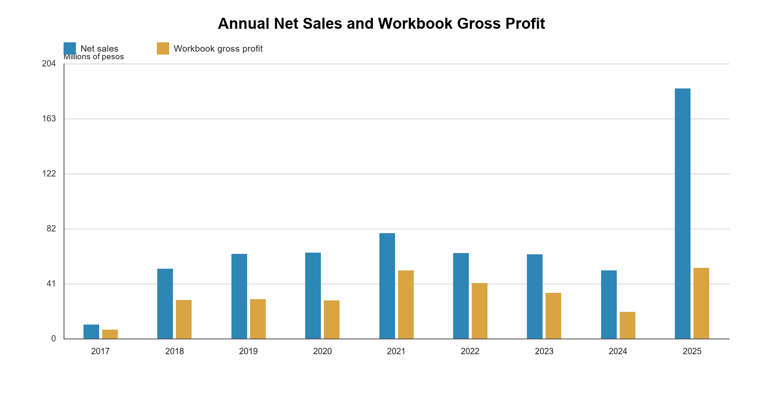
Figure 4.2 Annual net sales and workbook gross profit
Source: Generated from the version-bound descriptive calculation receipt.
The annual series recorded observed activity without proving equal completeness across years. The 2025 revenue increase was material in the candidate dataset, but source adjustments left product attribution under review. The recorded financial total could be reconciled while product-level and causal explanations remained provisional.
From 2024 to 2025, recorded net sales increased from ₱50.26 million to ₱185.40 million, or about 268.9 percent, while workbook gross profit increased from ₱19.56 million to ₱52.33 million, or about 167.5 percent. Gross profit rose substantially, although its increase was smaller in proportion to revenue. The main measurable explanation was the available calculation basis: ₱49.96 million, or 99.4 percent, of 2024 net sales had fields required for the gross-margin calculation, compared with only ₱95.08 million, or 51.3 percent, of 2025 net sales. Within the matched basis, the calculated margin rate was approximately 39.2 percent in 2024 and 55.0 percent in 2025. The chart did not establish higher costs, heavier discounts, or an unfavorable product mix as the cause. Much of 2025 revenue lacked the same margin-eligible basis, while source adjustments and product attribution remained under review. A causal explanation required finance approval and complete matched cost evidence.
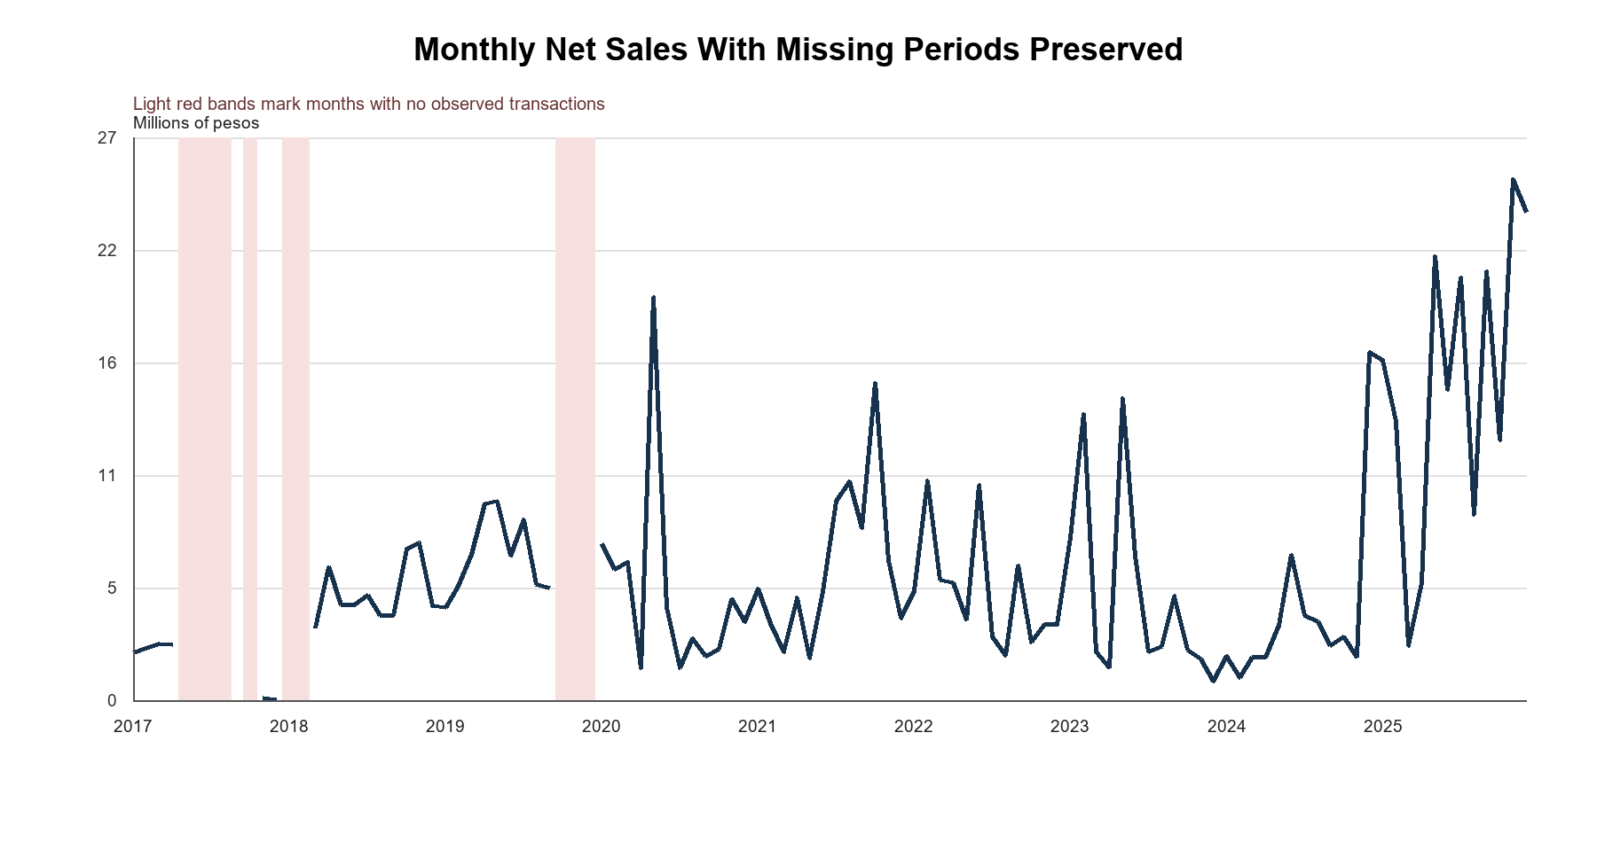
Figure 4.3 Monthly net sales and missing coverage
Source: Generated from the 108-month Databricks descriptive snapshot.
Observed calendar-month averages were highest in May at ₱9.87 million and June at ₱7.55 million. The pattern called for seasonal review but did not show a disease or weather effect. Infectious diseases could follow seasonal cycles, yet a shared calendar pattern could not establish a causal driver (Martinez, 2018). MedShield therefore presented month averages separately from its STL decomposition.
Table 4.6 Observed calendar month averages
Month | Average net sales | Observed years
Jan | ₱6,405,176.08 | 8
Feb | ₱7,098,050.31 | 8
Mar | ₱3,879,490.79 | 9
Apr | ₱4,433,381.20 | 9
May | ₱9,871,031.23 | 8
Jun | ₱7,553,552.93 | 8
Jul | ₱6,832,765.69 | 8
Aug | ₱5,074,209.17 | 8
Sep | ₱6,073,372.18 | 9
Oct | ₱6,538,044.40 | 7
Nov | ₱6,502,031.32 | 8
Dec | ₱7,126,212.47 | 8
Source: Descriptive snapshot. The method was an observed calendar-month average, not STL.
The STL routine used a 12-month period, a seasonal window of 13, robust fitting, and no imputation. Early gaps and short runs left only January 2020 through December 2025 eligible. The 72-month decomposition reconstructed the observed series to numerical precision. STL separated trend, seasonal, and remaining variation for inspection (Cleveland et al., 1990); the MedShield plot did not establish a disease or weather cause.
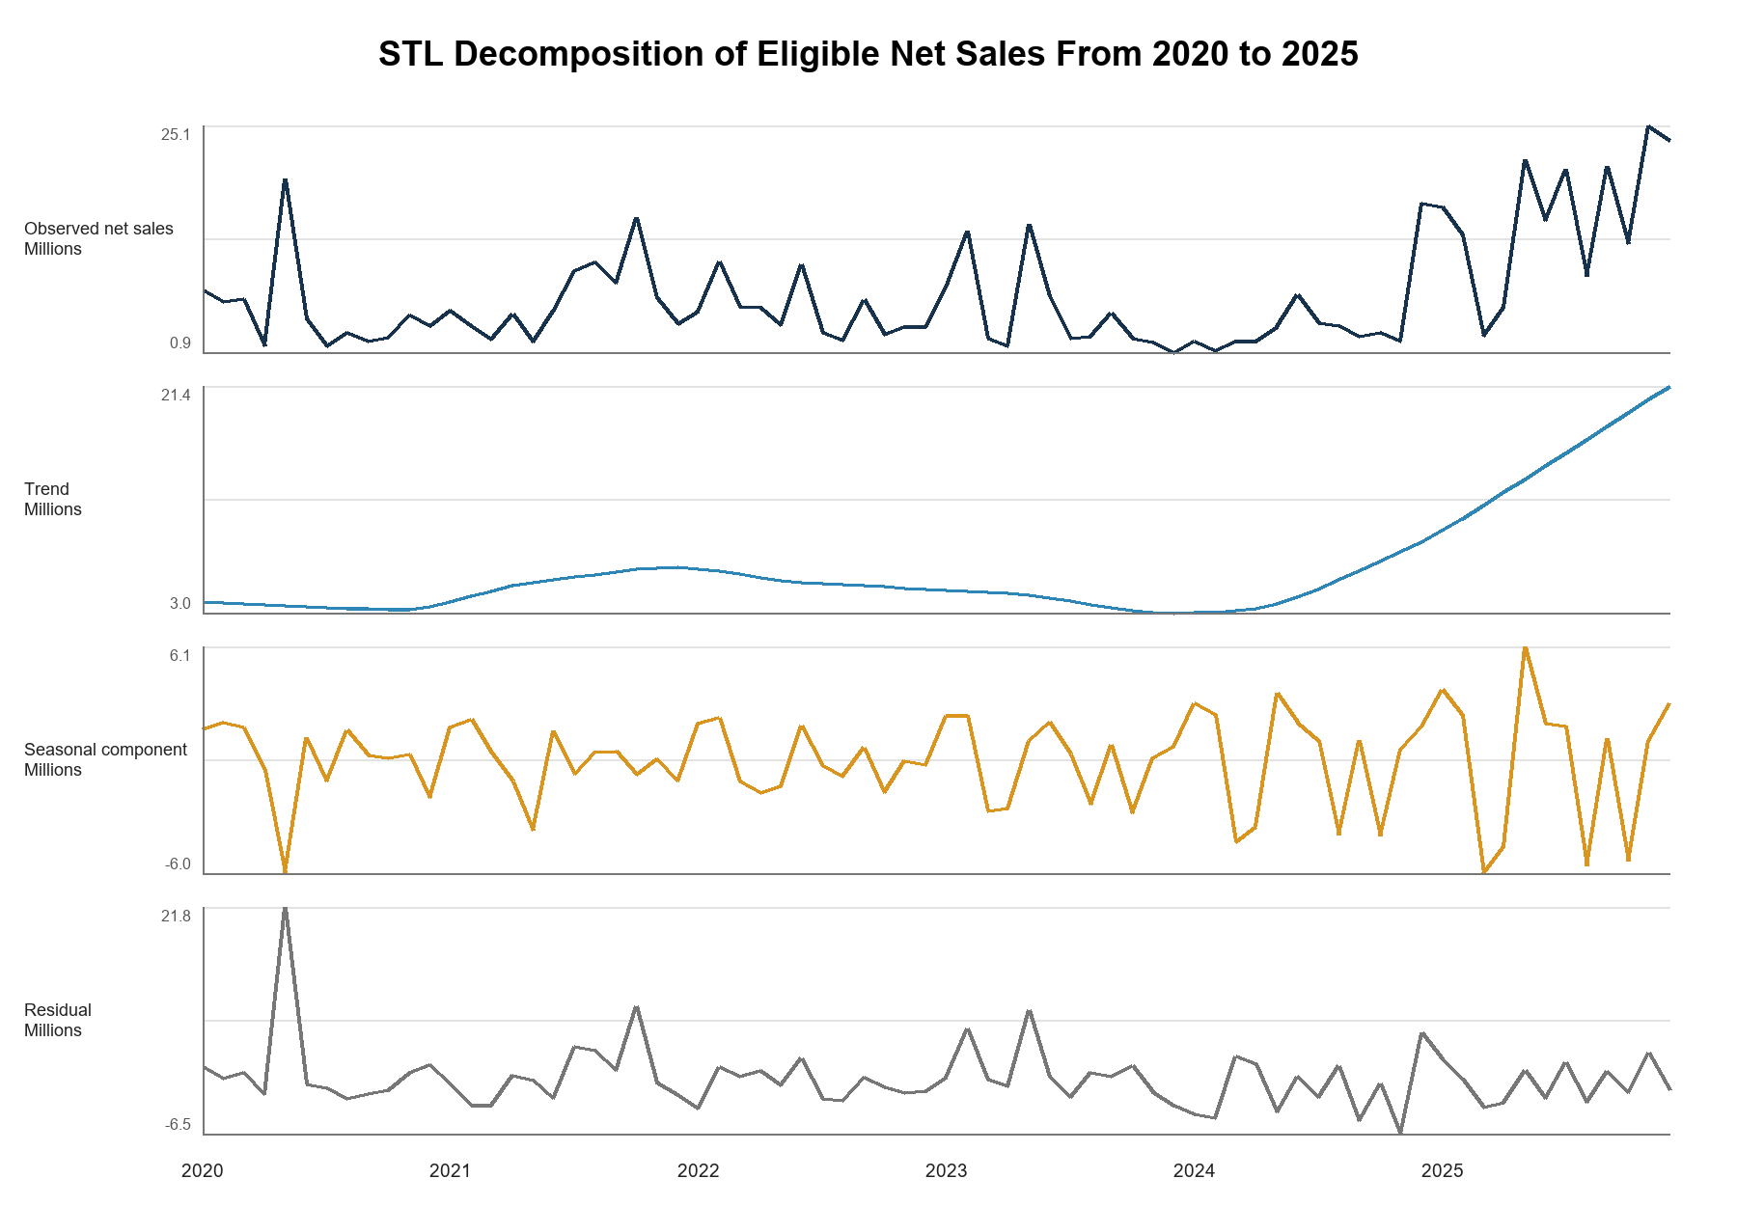
Figure 4.4 STL decomposition of eligible net sales
Source: Checksum-bound STL evidence generated with statsmodels 0.14.6.

4.2.2 Product and Area Prioritization
The second objective asked which products, territories, and accounts warranted attention. The descriptive layer answered through positive-sales contribution and deterministic Pareto or ABC grouping. No predictive XGBoost classifier had been approved. An ABC class described contribution within selected history; it did not predict future urgency or stock-out risk.
Table 4.7 Top source product labels by net sales
Rank | Source product label | Net sales | Share | ABC
1 | SPEEDA 2.5IU/0.5ML | ₱22,466,448.23 | 3.57% | A
2 | PROHAB 10MG/ML 20ML | ₱16,530,532.11 | 2.63% | A
3 | BUPIRIGHT 5MG/ML 0.5% IN 8% 4ML | ₱15,966,455.39 | 2.54% | A
4 | SITIXON 1G | ₱13,051,271.68 | 2.08% | A
5 | MONOWEL 1G IV | ₱12,313,552.50 | 1.96% | A
6 | PROFUREX 750MG | ₱11,987,494.40 | 1.91% | A
7 | EVAPROST 250MCG/ML | ₱9,753,530.12 | 1.55% | A
8 | F6 FETAL MONITOR SINGLE | ₱7,848,998.50 | 1.25% | A
9 | SPEEDA | ₱7,558,970.97 | 1.20% | A
10 | EUROXONE 1G | ₱7,311,190.91 | 1.16% | A
Source: Delta version-15 descriptive receipt and Databricks product candidate logic. The share denominator was positive eligible product sales of approximately ₱628.57 million, not overall net sales of ₱626.95 million. Labels were not approved canonical SKUs.
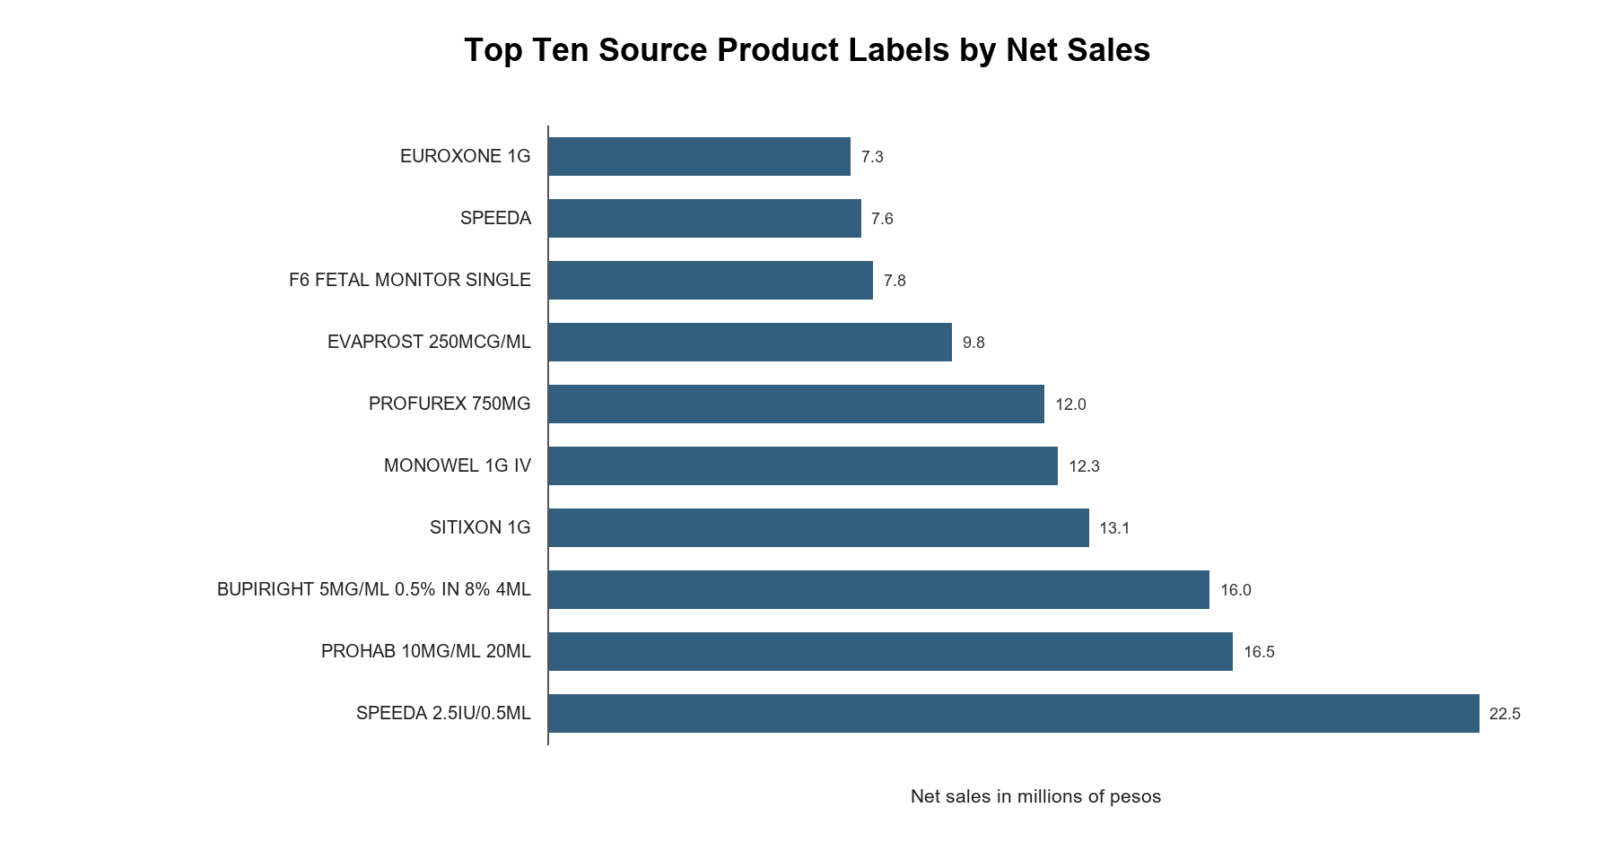
Figure 4.5 Top ten source product labels by net sales
Source: Generated from the descriptive calculation receipt.
SPEEDA 2.5IU/0.5ML ranked first with ₱22,466,448.23, or 3.57 percent of positive eligible product sales. The top five labels represented 12.78 percent and the top ten 19.85 percent on the same positive-sales basis. Overall net sales were lower because signed returns contributed to the net figure. The ranked labels showed a dispersed portfolio and required a full-population Pareto calculation. Separate SPEEDA entries also suggested possible alias fragmentation. Multiple-criteria ABC research offered a broader prioritization approach, but MedShield reported a deterministic revenue-based candidate rather than a validated multi-criteria classifier (Flores and Whybark, 1986).
Table 4.8 Top derived area labels by net sales
Rank | Derived label | Net sales | Share | Workbook gross profit
1 | GOVERNMENT | ₱310,629,101.40 | 49.55% | ₱130,353,976.35
2 | HOSPITAL | ₱165,121,239.71 | 26.34% | ₱69,103,315.46
3 | BATANGAS | ₱28,556,256.25 | 4.55% | ₱17,838,380.41
4 | QUEZON | ₱27,207,048.54 | 4.34% | ₱17,340,506.74
5 | ADMIN | ₱16,359,733.69 | 2.61% | ₱8,706,600.10
6 | EQUIPMENT | ₱14,475,259.73 | 2.31% | ₱7,679,164.32
7 | LAGUNA | ₱14,376,324.92 | 2.29% | ₱8,509,063.56
8 | MARINDUQUE | ₱13,469,314.65 | 2.15% | ₱6,984,765.63
9 | CAM NORTE | ₱11,638,151.07 | 1.86% | ₱7,508,275.57
10 | CAVITE | ₱7,799,599.04 | 1.24% | ₱5,155,855.62
Source: Databricks area candidate view. Mixed commercial labels; not a pure geography dimension.
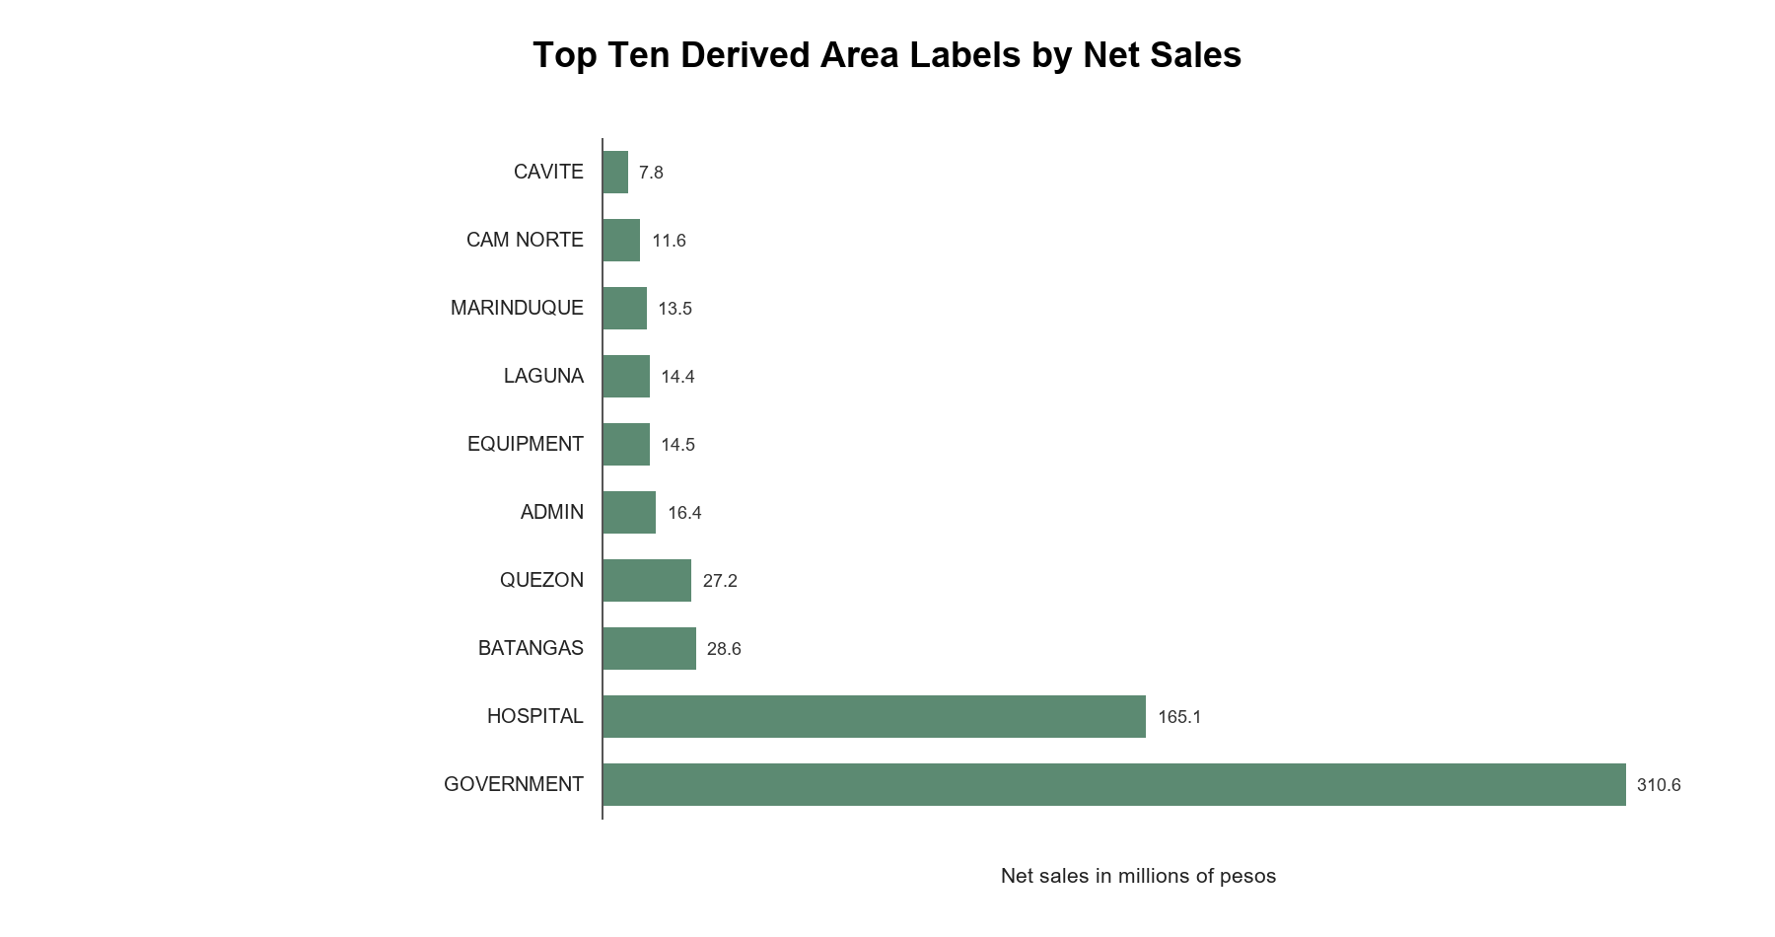
Figure 4.6 Top ten derived area labels by net sales
Source: Generated from the descriptive calculation receipt.
GOVERNMENT contributed 49.55 percent of candidate net sales and HOSPITAL contributed 26.34 percent. The labels described commercial segments, not geographic territories. Batangas, Quezon, Laguna, Marinduque, Camarines Norte, and Cavite also appeared in the legacy area field. The dashboard exposed buyer-sector and geographic mappings separately, but final owner approval remained open. Government-labeled transactions were financially important in the candidate; the label did not represent a verified territorial market share.

4.2.3 Forecast Evaluation and External Signals
The third objective was only partly realized. The system evaluated simple sales-only baselines and persisted candidate experiment evidence, but no operational forecast had been approved. In the fixed-origin Government net-sales comparison retained by the dashboard evidence, the last-observed-value method outperformed the seasonal-naive benchmark across the same nine observed holdout months. Both errors were high, and both methods underpredicted on average. The result supported transparent baseline comparison, not model promotion.
No 2026 MedShield sales actuals were present in the Gold contract reviewed for the study. The dashboard's 2026 gap estimates could not serve as a holdout result or be compared with actual 2026 performance. The estimates maintained planning continuity while actual data were pending. Forecast validation remained retrospective and used observed months within the 2017 to 2025 history.
Table 4.9 Fixed origin Government net sales benchmark
Method | Paired months | MAE | RMSE | WAPE | Bias
Seasonal naive | 9 | ₱2,695,359.26 | ₱3,459,768.58 | 85.05% | -₱2,574,060.06
Last observed value | 9 | ₱1,987,359.74 | ₱2,632,312.49 | 62.71% | -₱1,230,712.16
Source: Section 8 historical acceptance evidence. Missing actuals were excluded rather than set to zero.
A later offline experiment evaluated 15 configurations: four simple benchmarks, two ETS models, and nine Prophet configurations. Last value remained the development-selected candidate, with 83.20 percent development WAPE and 37.76 percent retrospective 2025 WAPE. No challenger met the promotion criteria, empirical uncertainty intervals were unsupported, and the model release pointer remained empty. Forecasting guidance required accuracy checks on observations withheld from model fitting (Hyndman and Athanasopoulos, 2021). MedShield's retrospective errors therefore justified withholding an operational forecast even though a candidate method was selected.
Table 4.10 Predictive readiness audit
Evidence item | Observed result | Interpretation
Candidate configurations | 15 evaluated | The experiment was completed and persisted as candidate evidence
Development selection | Last value; WAPE 83.20% | The method was selected among tested candidates but retained high error
Retrospective 2025 audit | Last value; WAPE 37.76% | Historical audit only; not a 2026 holdout
Intervals | Unsupported | Insufficient lead-specific error history for defensible bands
DOH and PAGASA forecast rows | 0 forecast eligible | External regression remained blocked
Publication | No active model release | No operational forecast could be claimed
Source: MedShield Analytics, Predictive Operations, Current State, and QA records dated 27 September 2026.
The external data audit reinforced the forecast boundary. The candidate contained 2,171 DOH and PAGASA rows, but none were join-ready or forecast-eligible. NASA POWER supplied separately labeled proxy observations and 32 candidate sales matches; the matches did not establish an approved geographic join or predictive benefit. No evidence supported a claim of improved MedShield forecasts from rainfall, disease intensity, or typhoon signals. The source-identity and publication gates in force at review superseded older exploratory validation labels.

4.2.4 Prescriptive Planning Results
The fourth objective was represented in the system as a controlled planning scenario. The interface shortlisted positive-revenue products, collected user-entered demand, usable stock, protected stock, pack size, cost, supplier limits, and budget, and solved a constrained allocation when eligible products and assumptions were supplied. Tests covered feasibility, integer packs, stock protection, and a service-first objective. The result demonstrated how a decision could be structured, but it remained conditional on user-entered values.
Table 4.11 Operational inputs required for prescriptive use
Input | Status at review | Reason for the input
On-hand and reserved stock | Not published | Determined actual availability and stock gaps
Expiry dates and batch age | Not published | Was required to measure expiry-driven wastage
Lead time and service level | Not published | Was required for ROP and safety-stock calculations
Ordering and holding cost | Not published | Was required for defensible EOQ
Pack size MOQ and supplier cap | User-entered assumption | Constrained feasible orders
Budget and approved demand | User-entered assumption | Determined the allocation objective and ceiling
Source: MedShield business definitions, analytics guidance, and planning interface.
No actual wastage rate could be calculated because no expiry or write-off outcome dataset was available. The proposal's target of expiry-driven wastage at or below 5 percent remained a goal for a future operational evaluation. A claim of achievement would have confused a design objective with a measured result.

4.3 Dashboard
Section 4.3 explained the dashboard as the visible part of the decision-support system. A reviewer could follow a summary back to its period, source records, evidence label, and model or scenario status. The 2026 display followed the same rule: observed values required published transactions, while elapsed months awaiting actual records could show separately labeled estimates based on earlier years.

4.3.1 Dashboard Structure and Navigation
The MedShield dashboard was the presentation layer of the decision-support system. An authenticated user entered through Overview and could open Sales Diagnostics, Product Prioritization, Area Prioritization, Forecast Modeling, and Prescriptive Planning. Supporting views showed transaction-level sales evidence and weather-source validation. A Data Upload page existed, but client CSV ingestion and publication remained planned. Navigation placed the historical result, source record, assumption, and limitation within one review path.
A shared top bar carried the selected period and comparison context. Single-year and year-to-year controls drew available years from the dataset. Changing the selection refreshed related cards, charts, and tables for the same population. The header showed the loaded period and dataset state, while missing periods remained gaps rather than zero demand. For an elapsed 2026 month without an uploaded actual, the dashboard could calculate a same-calendar estimate from up to three earlier years, with recency weights of 0.60, 0.30, and 0.10 where observations existed. Chart and KPI labels distinguished estimates from actual sales, and an uploaded actual took precedence. If an analytical source or required view was unavailable, the interface cleared the affected result and showed an unavailable state.

4.3.2 Dashboard Modules and Decision Flow
Each principal module addressed a planning question. Sales Diagnostics showed recorded performance. The prioritization pages directed further review. Forecast Modeling compared baselines, while Prescriptive Planning examined a user-defined scenario. The workflow supported human review rather than automatic ordering. Figures 4.7 to 4.10 illustrated the interface; the September development captures served as layout evidence and did not prove current numerical outputs.
Table 4.12 Functions of the five principal dashboard modules
Module | Question answered | Main dashboard outputs | Decision use and boundary
Sales Diagnostics | How had sales, margin, quantity, and seasonality changed? | KPI cards, annual and monthly trends, matched-period growth, heatmap, and STL evidence | Explained historical patterns; candidate definitions and missing periods remained visible
Product Prioritization | Which product labels had contributed most historical value? | Ranked contribution, focus cohort, Pareto or ABC grouping, and product table | Focused product review; did not approve SKUs or recommend purchases automatically
Area Prioritization | Which mapped areas or buyer groups had required attention? | Buyer-sector, geographic, and legacy-area shares with traceable mappings | Directed commercial review; derived mappings and mixed source labels remained provisional
Forecast Modeling | How well had transparent forecasting baselines performed? | Actual-versus-holdout plots, error metrics, future baseline, and release status | Supported model comparison; no champion, interval, or external regression was approved
Prescriptive Planning | Which allocation was feasible under entered constraints? | Priority shortlist, assumption grid, feasibility result, and scenario export | Supported scenario discussion; did not issue purchase orders or use verified inventory and expiry data
Source: MedShield Current State, Dashboard Design Logic, Analytics, and System Documentation.
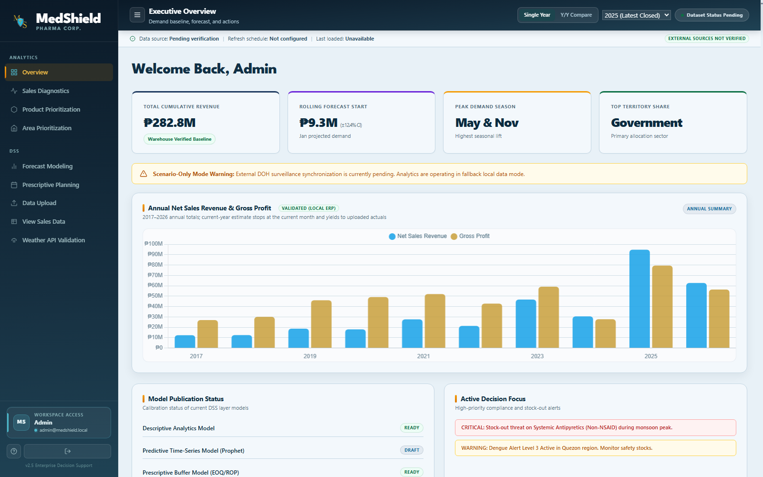
Figure 4.7 Overview dashboard development capture
Source: MedShield development interface capture dated 15 September 2026. The capture provided layout evidence only; current numerical results required a version-bound receipt.
Overview placed the selected period, sales summary, and source status at the beginning of the review. The historical source ended in December 2025. A mixed window extending into 2026 required separate observed-sales and gap-estimate labels; a combined display was not wholly historical sales.
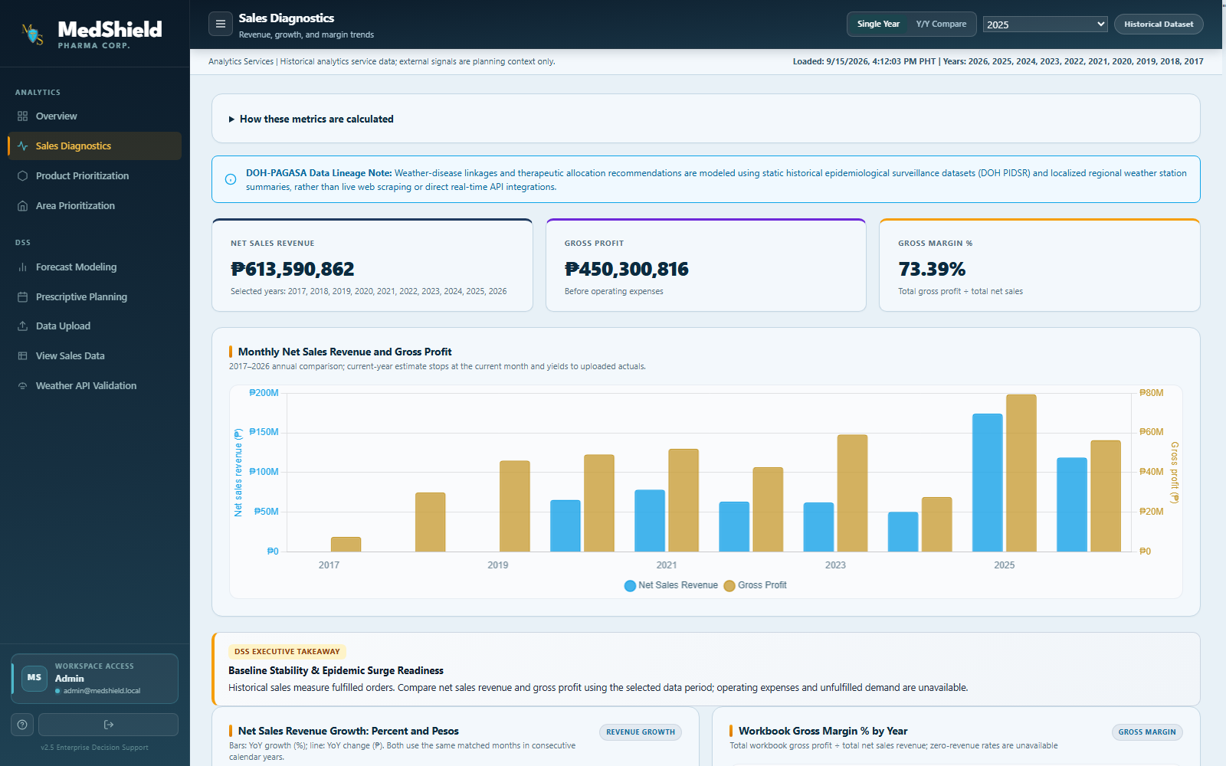
Figure 4.8 Sales diagnostics development capture
Source: MedShield development interface capture dated 15 September 2026. The capture provided layout evidence only; figures and labels required runtime verification.
Sales Diagnostics brought year comparisons and monthly patterns into the same view. Missing months remained gaps rather than zero sales. A reviewer could use the view to locate unusual periods and inspect the underlying transaction record.
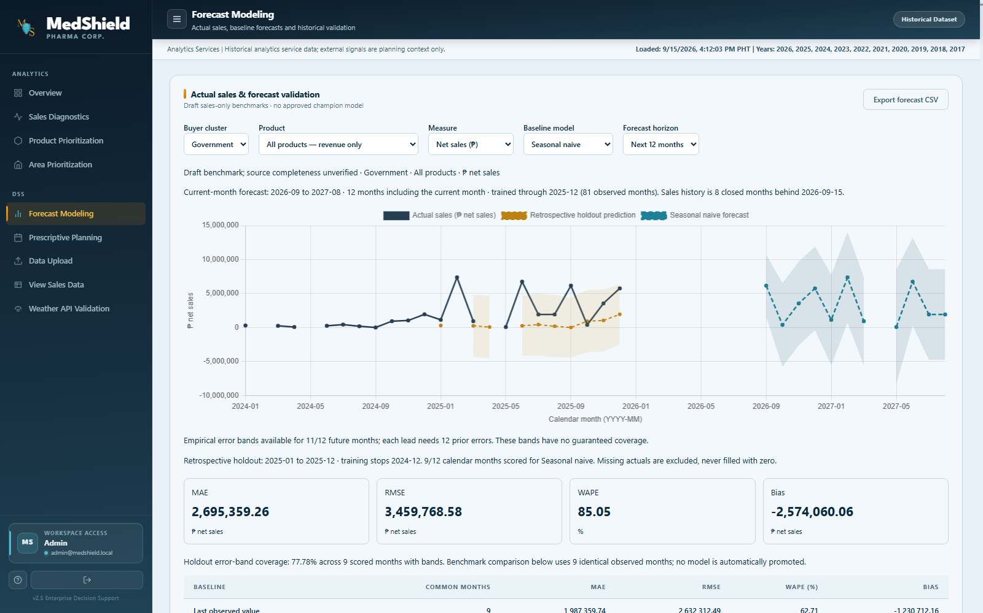
Figure 4.9 Forecast modeling development capture
Source: MedShield development interface capture dated 15 September 2026. The capture showed a historical screen layout only. A shaded forecast band appeared in the older capture, but the review record reported unsupported intervals and no approved model release.
Forecast Modeling placed the selected buyer, product, measure, baseline, and horizon above a comparison chart. Actual sales and retrospective holdout predictions appeared apart from a future baseline. MAE, RMSE, WAPE, and bias helped a reviewer judge the comparison. The older capture showed a band, but the analytical record did not support an empirical uncertainty interval. No band or future value was presented as an approved operational forecast.
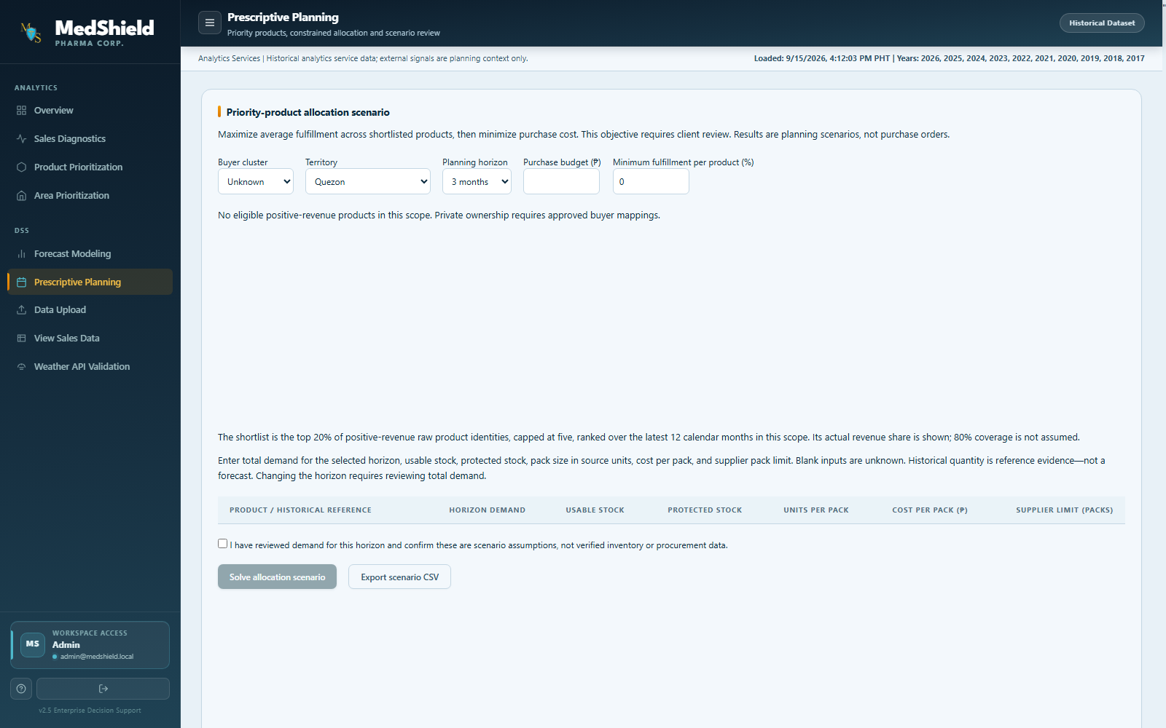
Figure 4.10 Prescriptive planning development capture
Source: MedShield development interface capture dated 15 September 2026. The displayed scope had no eligible positive-revenue products and did not show a solved allocation. Inputs represented scenario assumptions, not purchase orders.
Prescriptive Planning began with scope and budget controls and requested demand, usable stock, protected stock, pack size, cost, and supplier limits. A confirmation control identified entered values as assumptions rather than verified inventory records. The displayed empty product scope could not establish solver performance; separate feasibility tests supported the scenario capability.
View Sales Data supplied transaction details and provenance for inspecting a displayed total. Weather API Validation identified official observations separately from NASA POWER proxy data. The Data Upload screen was present, but the upload endpoint rejected submissions with a warehouse-ingestion-required response. File validation, durable ingestion status, and client-controlled publication therefore remained future work at the review date. The supporting views helped users check provenance, while the upload limitation prevented a claim of completed 2026 actual-data turnover.

4.3.3 Evidence Labels and User Controls
Evidence labels helped prevent overinterpretation. Actual identified observed sales; candidate identified data or mappings awaiting approval; estimated identified a calculated gap value; proxy identified a substitute external observation; baseline identified a forecasting comparator; blocked identified a result unavailable under the data gates; and scenario identified an output based on user assumptions. Loading, empty, infeasible, and unavailable states appeared explicitly. The browser did not train a model, call an external weather provider directly, or write a purchase transaction. The boundaries preserved the dashboard's role as decision support for an authorized reviewer.

4.3.4 Dashboard Verification
The QA review reported 70 of 70 publication checks passing for the version-16 historical candidate. The report established technical reconciliation at the review date, not client approval of product identities, area mappings, financial definitions, or a model release. The local checkout contained the earlier version-15 calculation receipt used for the detailed Chapter 4 tables; the later version-16 calculation receipt cited by QA was unavailable locally. The QA review also reported 21 backend unit tests, eight descriptive browser cases, five area and buyer-scope regressions, and six matched-period cases passing, with four retired legacy cases skipped. The sets overlapped and were not combined into one test total.
Table 4.13 Validation and acceptance evidence
Validation area | Observed result | Interpretation
Publication readiness | 70 pass 0 fail 0 unverified | Technical candidate checks passed; business approval remained open
Descriptive population | 37,728 facts 108 calendar months 98 observed months | Counts and periods reconciled; ten months remained unavailable
STL | 72 reconciled months and four components | Qualifying 2020 to 2025 segment only
Backend unit tests | 21 passed | Covered backend logic, including filter validation
Final descriptive browser run | 8 passed | Live version-bound descriptive behaviors and exports
Area and buyer regression | 5 passed | Scoped classification behavior
Matched-period and growth suite | 6 passed 4 legacy skipped | Skipped tests were retired and were not counted as passes
Predictive warehouse candidate | 1,092 rows and 15 evaluations persisted | Candidate experiment evidence persisted; the active model pointer remained empty
Source: MedShield System QA Review, Current State, Database, and Predictive Operations records dated 27 September 2026.

4.4 Summary of Findings
Section 4.4 answered the proposal's practical questions using the observed 2017 to 2025 record, tested system behavior, and documented limits. The 2026 gap estimates provided interim planning context while actual transactions were pending. They did not change the historical totals or establish a measured 2026 outcome.

4.4.1 Answers to the Practical Questions
For the question of which products performed best, SPEEDA 2.5IU/0.5ML ranked first among source product labels in the candidate. The ranking remained provisional because the approved product master was empty and aliases could divide a commercial product. Revenue-based ABC grouping directed review but did not establish clinical importance or future demand.
For next-season sales, MedShield reported retrospective baseline comparisons but could not provide an approved operational forecast. The selected last-value method retained large errors, external disease and weather joins were not forecast-eligible, and 2026 actual sales were unavailable for a genuine 2026 holdout. The dashboard's weighted 2026 gap values were estimates for elapsed periods, not validated forecasts.
For excess or insufficient stock, sales alone could not establish a stock position. On-hand units, reserved stock, lead times, and expiry dates were not supplied. For possible action, the planning module tested user-entered allocation scenarios and reported feasibility. No scenario proved a purchase quantity, avoided expiry, or the proposal's five-percent wastage target without approved operational data.

4.4.2 Historical Patterns
The technically reconciled candidate showed ₱626.95 million in observed net sales across 2017 to 2025. Recorded activity was uneven by year and by month, with ten missing months in the early history and a large 2025 value requiring careful provenance review. May and June had the highest observed calendar-month averages. STL provided a separate 2020 to 2025 trend, seasonal, and residual decomposition without imputing the earlier gaps.

4.4.3 Forecast Comparison
On the comparable fixed-origin Government holdout, last observed value performed better than seasonal naive, but its WAPE remained 62.71 percent. In the larger offline experiment, last value also remained selected, with 83.20 percent development WAPE and 37.76 percent retrospective WAPE. Large errors, unsupported uncertainty intervals, and unapproved external joins justified keeping the model unpublished.

4.4.4 Product and Area Priorities
SPEEDA 2.5IU/0.5ML was the highest-revenue source product label in the candidate, while GOVERNMENT was the highest-revenue derived area label. Both findings were useful for review, but neither represented a final canonical SKU or a geographic market-share statement. The approved product master was empty, and the legacy area field mixed different commercial meanings.

4.4.5 Planning Scenarios
The system produced constrained allocation scenarios after a user supplied operational assumptions. A result identified feasible allocations under the entered values and exposed infeasible constraints. Real EOQ, ROP, safety stock, and expiry reduction required published inventory and procurement data.

4.4.6 Decision Support Value
MedShield placed source coverage, KPI definitions, historical patterns, priority candidates, forecast errors, and planning assumptions in one review path. The arrangement supported demand review, but no before-and-after measure showed a quantified improvement in visibility. No REC-approved participant evaluation appeared in the available record. System tests established selected behaviors, not perceived usefulness or user acceptance.

4.4.7 Discussion of the North Star
The evidence supported the demand-visibility aim more directly than the expiry-loss aim. MedShield consolidated historical sales, preserved gaps, showed KPI bases, and displayed the status of models and mappings. A reviewer could move from a historical priority to an allocation scenario. The workflow made assumptions easier to inspect, although no before-and-after study measured a visibility gain.
The study did not demonstrate reduced expiry-driven losses. Measurement required a baseline of expiry or write-off losses, comparable post-implementation observations, and operational inventory inputs. The system could have supported a later evaluation by recording scenario assumptions and decisions. Without outcome data, MedShield provided information and controls for planning but did not prove the financial effect of a plan.
Simple models and explicit release gates proved useful in the forecast review. Prophet configurations did not earn promotion merely through greater complexity. Last value performed best among the tested candidates, but large errors and weak uncertainty evidence kept the model unpublished. An authorized user therefore retained the final planning decision, with the basis of any scenario available for inspection.

4.4.8 Limitations
• The Gold sales objects remained candidate publications pending named business and finance approval.
• The product master had no approved entries, so product analysis used source labels and could not standardize aliases or pack conversions.
• The legacy area field combined geographic, customer-type, and business-line labels; final mapping approval remained outstanding.
• Ten months had no observed transactions. The study preserved the gaps but could not independently determine whether missing files or absent business activity caused them.
• DOH and PAGASA rows were not approved for territory-level forecasting, while NASA POWER remained a separately labeled proxy.
• No predictive model or uncertainty interval was approved for operational publication.
• Inventory, expiry, supplier, lead-time, service-level, ordering-cost, holding-cost, and stock-position data were unavailable.
• The study contained technical and browser validation but no completed REC-approved participant evaluation or final client acceptance record.

4.4.9 Overall Synthesis
MedShield had a working historical decision-support foundation. The system reconciled 37,728 candidate sales facts, presented 2017 to 2025 performance, preserved ten missing months, decomposed a qualifying 72-month series through STL, ranked product and area labels, compared common-holdout baselines, and exposed constrained planning scenarios through an authenticated dashboard architecture. The descriptive and presentation objectives had the strongest evidence.
Important limits remained. Product identity and area mappings still needed owner approval. External signals were not forecast-eligible. The selected forecast remained unpublished because its errors were high and uncertainty support was incomplete. Prescriptive outputs remained scenarios, and the expiry-wastage target had not been measured. MedShield could therefore be defended as a historical DSS for traceable review, not as proof of an operational forecast or reduced expiry losses.
References
Cleveland, R. B., Cleveland, W. S., McRae, J. E., & Terpenning, I. (1990). STL: A seasonal-trend decomposition procedure based on Loess. Journal of Official Statistics, 6(1), 3–73.
Flores, B. E., & Whybark, D. C. (1986). Multiple criteria ABC analysis. International Journal of Operations & Production Management, 6(3), 38–46. https://doi.org/10.1108/eb054765
Hyndman, R. J., & Athanasopoulos, G. (2021). Forecasting: Principles and practice (3rd ed.). OTexts. https://otexts.com/fpp3/
Martinez, M. E. (2018). The calendar of epidemics: Seasonal cycles of infectious diseases. PLOS Pathogens, 14(11), e1007327. https://doi.org/10.1371/journal.ppat.1007327
MedShield Capstone Group 9. (2026a). Capstone project proposal objectives and conceptual framework. Unpublished manuscript.
MedShield Capstone Group 9. (2026b). Descriptive calculation and STL receipts, Delta version 15. Internal validation evidence, 26 September 2026.
MedShield Capstone Group 9. (2026c). System QA review and current-state summary. Internal verification records, 27 September 2026.
MedShield Capstone Group 9. (2026d). Analytics, architecture, and predictive operations. Internal project documentation, 27 September 2026.
Nguyen, A., Lamouri, S., Pellerin, R., Tamayo, S., & Lekens, B. (2021). Data analytics in pharmaceutical supply chains: State of the art, opportunities, and challenges. International Journal of Production Research, 60(22), 6888–6907. https://doi.org/10.1080/00207543.2021.1950937
World Health Organization. (2024). Digital transformation handbook for health supply chain architecture. https://www.who.int/publications/i/item/9789240101197

