CHAPTER 4
RESULTS AND DISCUSSION
The proponents examined how the MedShield Decision Support System answered the capstone questions using the results available at the time of review. The main result was a dashboard linked to 37,728 accepted sales records from 2017 to 2025. It showed missing months rather than treating them as zero sales and gave users ways to inspect products, areas, and forecasting results. The proponents also identified unfinished work. No forecast had been approved for operational use, external signals had not improved a published model, and inventory scenarios had not yet produced measured business outcomes.
The discussion followed the proposal's guiding question: How could MedShield use historical sales, validated external signals, and planning scenarios to improve demand visibility and reduce expiry-driven inventory losses for the 2026 planning cycle? The proponents compared each objective with a result they could verify. Sales records, proposed mappings, model tests, weather proxies, and planning scenarios did not carry the same level of certainty. A working dashboard alone did not prove a reliable forecast or fewer expired products. Published research informed the methods, while MedShield records supplied the evidence for the reported results (Nguyen et al., 2021; World Health Organization, 2024).
The latest observed MedShield sales month was December 2025. For elapsed months in 2026 without uploaded client records, the dashboard displayed estimates based on the same calendar months in earlier years. The proponents treated the estimates as temporary planning values while actual sales were pending. They did not include the estimates in historical totals or use them to judge forecast accuracy. Future 2026 months remained unavailable until the needed records or forecasts became available.

4.1 Presentation of Results
Section 4.1 presented what the proponents completed and the data used to support the results. The section first compared the five objectives with the available outputs, then described the application and the quality of the sales record. Historical results came from observed transactions dated 2017 to 2025. Any displayed 2026 value without an uploaded actual carried an estimate label.

4.1.1 Alignment With the Research Questions and Objectives
The proposal called for analysis of sales patterns, product and area priorities, demand forecasts with external signals, inventory decisions, and a five-module dashboard. The proponents made the most progress on sales analysis, prioritization, and presentation. They tested forecasting methods but did not approve one for release. The planning module solved scenarios with entered assumptions, although stock, expiry, lead-time, supplier, and cost records were unavailable for measuring a real reduction in wastage.
Table 4.1 Objective achievement audit
Objective | Evidence expected | Observed result | Assessment
SO1 | Sales performance, year-over-year patterns, and STL seasonality | Historical summaries and a 72-month STL decomposition were available. Ten earlier months remained unobserved, and the full geography mapping still needed owner approval. | Partially achieved
SO2 | Product, territory, and account priorities using Pareto ABC and predictive scoring | Deterministic Pareto and ABC candidate views were implemented. Product labels were not approved SKUs, and no XGBoost classifier was published. | Partially achieved
SO3 | Territory forecasts using sales, DII, RSI, Prophet, and XGBoost | Sales-only baselines and offline candidates were evaluated. External joins had zero forecast-eligible rows, and no model was approved or activated. | Not achieved for operational use at review
SO4 | EOQ, ROP, and allocation decisions aimed at expiry wastage of at most 5 percent | The interface supported reviewed allocation scenarios. Real inventory and expiry outcomes were absent, so the 5 percent target was not tested. | Scenario capability only
SO5 | Five dashboard modules with upload validation and decision support | The five principal modules existed. Browser-to-warehouse CSV ingestion remained unfinished; Signal 2 alerts and collaborative filtering were not verified outputs. | Partially achieved
Source: Capstone proposal objectives and the MedShield current-state, analytics, and QA records as of 27 September 2026.
The proponents distinguished a completed screen from a completed research objective. The forecast page showed a baseline, but no approved model. The planning page could solve an allocation, but its inputs were not verified stock records. The objective audit therefore reported what each feature did and what its results could not yet establish.

4.1.2 Application and Data Architecture
MedShield ran as an authenticated web application. Its Next.js dashboard requested analytical results through an Express and TypeScript gateway, which checked requests and queried Databricks. Databricks Unity Catalog held the sales data and candidate analytical views. Supabase handled identity and audit support, not dashboard sales measures. Python tools supported data preparation and model evaluation outside the browser. The arrangement let the proponents trace a dashboard figure back to its analytical source.
The dashboard did not substitute a local spreadsheet or sample value when Databricks was unavailable. The gateway returned an error, and the affected view showed an unavailable state. The proponents kept the behavior visible because a plausible-looking number without a live source would have weakened the sales analysis.
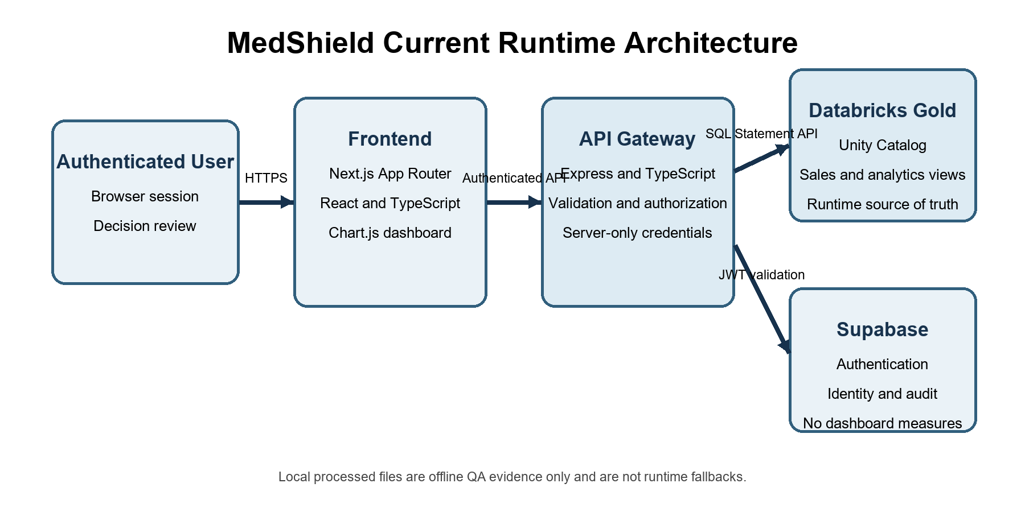
Figure 4.1 MedShield runtime architecture
Source: MedShield Architecture and Database documentation, September 2026.
Table 4.2 Implemented application layers
Layer | Implemented component | Responsibility | Boundary
Presentation | Next.js, React, TypeScript, Chart.js | Filters, charts, tables, exports, readiness labels, and scenario forms | Did not query Databricks or external providers directly
Gateway | Express and TypeScript | Authentication checks, parameter validation, query orchestration, and response contracts | Server-only credentials; explicit unavailable states
Analytical store | Databricks Unity Catalog | Bronze source evidence, Silver assessed records, Gold candidate facts and aggregates | Candidate publication awaited business approval
Identity and audit | Supabase Auth and audit persistence | Session identity, roles, and application audit events | Was not an analytical source
Offline analytics | Python jobs and tests | Reconciliation, STL, model evaluation, and scenario validation | Was not a live dashboard dependency
Source: MedShield Architecture, Database, Security, and Project documentation.

4.1.3 Data Sources Coverage and Quality
The sales data available for analysis covered 2017 to 2025 and contained 37,728 accepted records. Although the proposal focused on 2021 to 2025 and three Philippine regions, the proponents retained the earlier records to give the trends more context. Regional conclusions remained provisional because the area mapping had not been approved. Department of Health and weather data supplied background, but none had been accepted as a forecasting input for sales.
Table 4.3 Data sources and current analytical status
Source | Coverage | Use at review | Status and limitation at review
MedShield sales | 2017 to 2025 actuals; 2026 actuals were pending | Historical demand, revenue, product, area, and baseline forecast evaluation | 37,728 accepted facts; elapsed 2026 gaps could be estimated and remained separately labeled
DOH surveillance | 2018 to 2026 declared; 2026 partial | Historical disease context and candidate regressors | Territory join not approved; no individual health inference
PAGASA observations | 2017 to 2024 | Official historical weather context | No official 2025 observations in the project; no approved sales match
NASA POWER | 108 monthly rows for nine areas in 2025 | Separately labeled weather proxy | Provider proxy, not PAGASA; 32 candidate matches did not approve regression
Operational inventory | Not supplied | Would have supported EOQ, ROP, safety stock, allocation, and expiry analysis | Scenario inputs only
Source: MedShield Current State, application documentation, and publication-readiness evidence.
The calendar spanned 108 months, but transactions appeared in only 98. The missing months were May, June, July, August, and October 2017; January and February 2018; and October, November, and December 2019. The proponents kept the months blank because the available records could not show whether sales were zero or files were missing. Filling the gaps with zero would have distorted the trend and later model tests.
Table 4.4 Sales candidate quality profile
Quality measure | Observed value | Interpretation
Accepted fact rows | 37,728 | Checksum-bound candidate population
Revenue-eligible rows | 36,848 | Rows were included in the net-sales measure
Margin-eligible rows | 34,105 | Rows with a valid margin denominator
Warning-bearing rows | 32,749 | Warnings remained visible and were not equivalent to rejection
Calendar coverage | 108 months total; 98 observed; 10 missing | Missing periods remained unavailable rather than zero-filled
Product identity | 4,561 source labels; 0 approved master entries | Product findings described labels, not verified canonical SKUs
Area identity | 22 derived labels | Some labels mixed geography, customer type, or business line and required approval
Returns evidence | 673 rows | Signed returns remained separate while contributing to net revenue
Source: Version-bound publication and QA evidence for the 37,728-row Databricks candidate.

4.2 Data Analysis
Section 4.2 examined what the recorded sales revealed about annual performance, seasonality, product and area priorities, and the forecasting and planning objectives. The proponents separated observed transactions from model estimates and user-entered assumptions. Pending 2026 actuals did not enter the 2017 to 2025 totals or the forecast-accuracy calculations.
The dashboard's default October 2025 to September 2026 window illustrated the need for separate labels. It contained ₱61,082,570 in observed sales and ₱88,804,257 in estimates for missing months, for a combined display of ₱149,886,827 after rounding. The combined figure was not actual 2026 revenue. The proponents could replace an estimate with a client sales record only after ingestion and publication checks were completed (MedShield Capstone Group 9, 2026c).

4.2.1 Historical Sales Performance and Seasonality
The accepted sales data recorded ₱626,946,741.81 in net sales and ₱288,487,498.72 in workbook gross profit. The reported weighted gross-margin rate was 60.26 percent, calculated from ₱478,720,670.03 in sales with enough information for the margin calculation. The proponents did not treat workbook gross profit as company net income. Dividing gross profit by all net sales would not reproduce the reported rate because the margin-eligible sales base was smaller.
Table 4.5 Annual sales and workbook gross profit
Year | Transactions | Net sales | Workbook gross profit | Margin eligible sales
2017 | 1,978 | ₱10,211,167.35 | ₱6,316,157.68 | ₱9,212,606.10
2018 | 6,181 | ₱51,619,691.27 | ₱28,328,721.76 | ₱44,882,495.39
2019 | 5,446 | ₱62,542,304.49 | ₱29,125,469.95 | ₱41,211,281.42
2020 | 3,980 | ₱63,593,274.63 | ₱28,013,993.68 | ₱40,259,988.09
2021 | 3,407 | ₱77,860,206.26 | ₱50,420,770.93 | ₱77,804,247.26
2022 | 3,980 | ₱63,234,990.04 | ₱40,799,049.06 | ₱60,493,221.21
2023 | 5,381 | ₱62,228,966.85 | ₱33,585,582.48 | ₱59,822,843.64
2024 | 2,831 | ₱50,259,319.88 | ₱19,563,837.42 | ₱49,956,893.05
2025 | 4,544 | ₱185,396,821.04 | ₱52,333,915.76 | ₱95,077,093.87
Source: Local descriptive calculation receipt for Delta version 15, 26 September 2026. Current-state and QA summaries reported matching overall totals for version 16; the version-16 calculation receipt was unavailable in the local checkout. Amounts were candidate values in Philippine pesos.
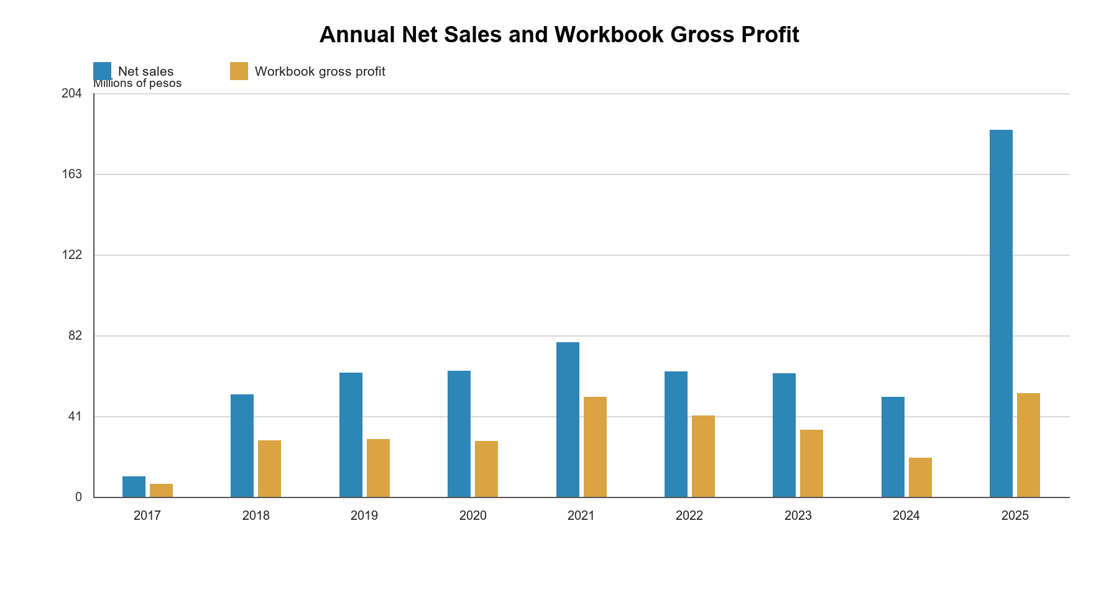
Figure 4.2 Annual net sales and workbook gross profit
Source: Generated from the version-bound descriptive calculation receipt.
Annual sales varied across the record, and the 2025 increase stood out. The proponents reported the increase as a recorded result while recognizing differences in source coverage between years. Adjustments in the underlying records also left the product-level explanation for 2025 open to review, even though the overall financial total reconciled.
Net sales rose from ₱50.26 million in 2024 to ₱185.40 million in 2025, an increase of about 268.9 percent. Workbook gross profit also rose, from ₱19.56 million to ₱52.33 million, but its proportional increase was smaller at about 167.5 percent. The difference did not, by itself, prove an increase in costs or discounts. In 2024, ₱49.96 million, or 99.4 percent of sales, had the fields needed for a gross-margin calculation. In 2025, only ₱95.08 million, or 51.3 percent, had the same fields. On the matched basis, the calculated margin rate was about 39.2 percent in 2024 and 55.0 percent in 2025. The proponents therefore attributed the gap between the revenue and gross-profit growth rates primarily to unequal calculation coverage in the available records, not to an established change in product mix or profitability. A fuller explanation required matched cost data and finance approval.
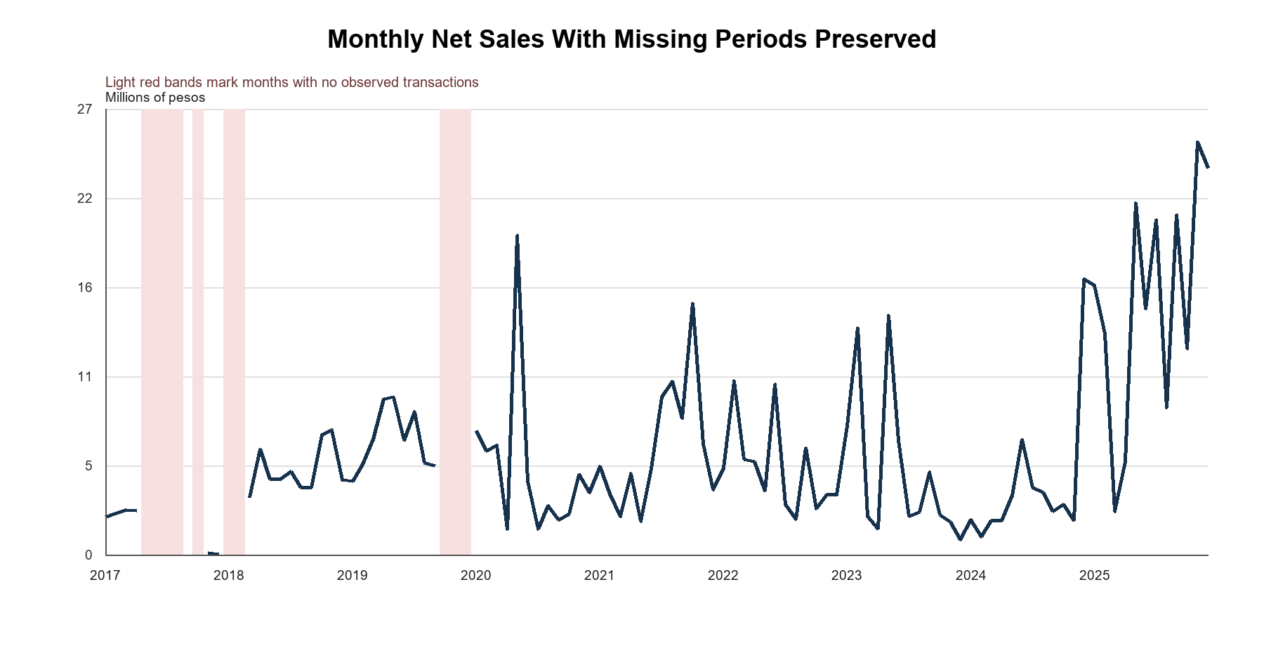
Figure 4.3 Monthly net sales and missing coverage
Source: Generated from the 108-month Databricks descriptive snapshot.
May had the highest observed calendar-month average at ₱9.87 million, followed by June at ₱7.55 million. The result gave the proponents a reason to examine seasonality, but it did not prove a link with disease outbreaks or weather. Infectious diseases could follow seasonal cycles, yet matching calendar patterns alone did not establish cause (Martinez, 2018). The proponents therefore kept simple month averages separate from the STL analysis.
Table 4.6 Observed calendar month averages
Month | Average net sales | Observed years
Jan | ₱6,405,176.08 | 8
Feb | ₱7,098,050.31 | 8
Mar | ₱3,879,490.79 | 9
Apr | ₱4,433,381.20 | 9
May | ₱9,871,031.23 | 8
Jun | ₱7,553,552.93 | 8
Jul | ₱6,832,765.69 | 8
Aug | ₱5,074,209.17 | 8
Sep | ₱6,073,372.18 | 9
Oct | ₱6,538,044.40 | 7
Nov | ₱6,502,031.32 | 8
Dec | ₱7,126,212.47 | 8
Source: Descriptive snapshot. The method was an observed calendar-month average, not STL.
The proponents used STL to examine the part of the sales record with enough uninterrupted observations. The routine used a 12-month period, a seasonal window of 13, robust fitting, and no imputation. Earlier gaps left January 2020 to December 2025 as the eligible 72-month series. The resulting plot separated trend, seasonality, and remaining variation (Cleveland et al., 1990). It helped describe the sales pattern but did not identify disease or weather as its cause.
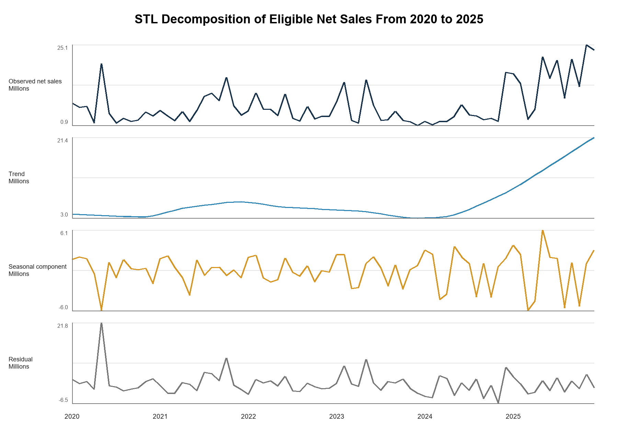
Figure 4.4 STL decomposition of eligible net sales
Source: Checksum-bound STL evidence generated with statsmodels 0.14.6.

4.2.2 Product and Area Prioritization
For the product-priority objective, the proponents ranked labels by their contribution to positive sales and grouped them through a deterministic Pareto or ABC method. The rankings showed historical value, not future demand or stock-out risk. No predictive XGBoost classifier had been approved, so the chapter did not present an ABC label as a prediction.
Table 4.7 Top source product labels by net sales
Rank | Source product label | Net sales | Share | ABC
1 | SPEEDA 2.5IU/0.5ML | ₱22,466,448.23 | 3.57% | A
2 | PROHAB 10MG/ML 20ML | ₱16,530,532.11 | 2.63% | A
3 | BUPIRIGHT 5MG/ML 0.5% IN 8% 4ML | ₱15,966,455.39 | 2.54% | A
4 | SITIXON 1G | ₱13,051,271.68 | 2.08% | A
5 | MONOWEL 1G IV | ₱12,313,552.50 | 1.96% | A
6 | PROFUREX 750MG | ₱11,987,494.40 | 1.91% | A
7 | EVAPROST 250MCG/ML | ₱9,753,530.12 | 1.55% | A
8 | F6 FETAL MONITOR SINGLE | ₱7,848,998.50 | 1.25% | A
9 | SPEEDA | ₱7,558,970.97 | 1.20% | A
10 | EUROXONE 1G | ₱7,311,190.91 | 1.16% | A
Source: Delta version-15 descriptive receipt and Databricks product candidate logic. The share denominator was positive eligible product sales of approximately ₱628.57 million, not overall net sales of ₱626.95 million. Labels were not approved canonical SKUs.
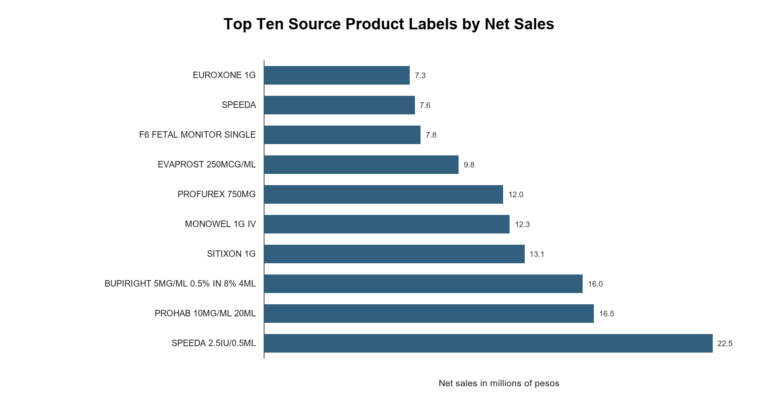
Figure 4.5 Top ten source product labels by net sales
Source: Generated from the descriptive calculation receipt.
SPEEDA 2.5IU/0.5ML led the source product labels with ₱22,466,448.23, or 3.57 percent of positive eligible product sales. The five leading labels contributed 12.78 percent, and the top ten contributed 19.85 percent on the same basis. Signed returns explained why the overall net-sales total was lower than the positive-sales base. Sales were spread across many labels, so the proponents used the full list for Pareto grouping. Separate SPEEDA entries also raised the possibility of naming differences for the same commercial product. Although research described broader multiple-criteria ABC methods, MedShield's reported grouping used revenue and had not been validated as a multi-criteria classifier (Flores and Whybark, 1986).
Table 4.8 Top derived area labels by net sales
Rank | Derived label | Net sales | Share | Workbook gross profit
1 | GOVERNMENT | ₱310,629,101.40 | 49.55% | ₱130,353,976.35
2 | HOSPITAL | ₱165,121,239.71 | 26.34% | ₱69,103,315.46
3 | BATANGAS | ₱28,556,256.25 | 4.55% | ₱17,838,380.41
4 | QUEZON | ₱27,207,048.54 | 4.34% | ₱17,340,506.74
5 | ADMIN | ₱16,359,733.69 | 2.61% | ₱8,706,600.10
6 | EQUIPMENT | ₱14,475,259.73 | 2.31% | ₱7,679,164.32
7 | LAGUNA | ₱14,376,324.92 | 2.29% | ₱8,509,063.56
8 | MARINDUQUE | ₱13,469,314.65 | 2.15% | ₱6,984,765.63
9 | CAM NORTE | ₱11,638,151.07 | 1.86% | ₱7,508,275.57
10 | CAVITE | ₱7,799,599.04 | 1.24% | ₱5,155,855.62
Source: Databricks area candidate view. Mixed commercial labels; not a pure geography dimension.
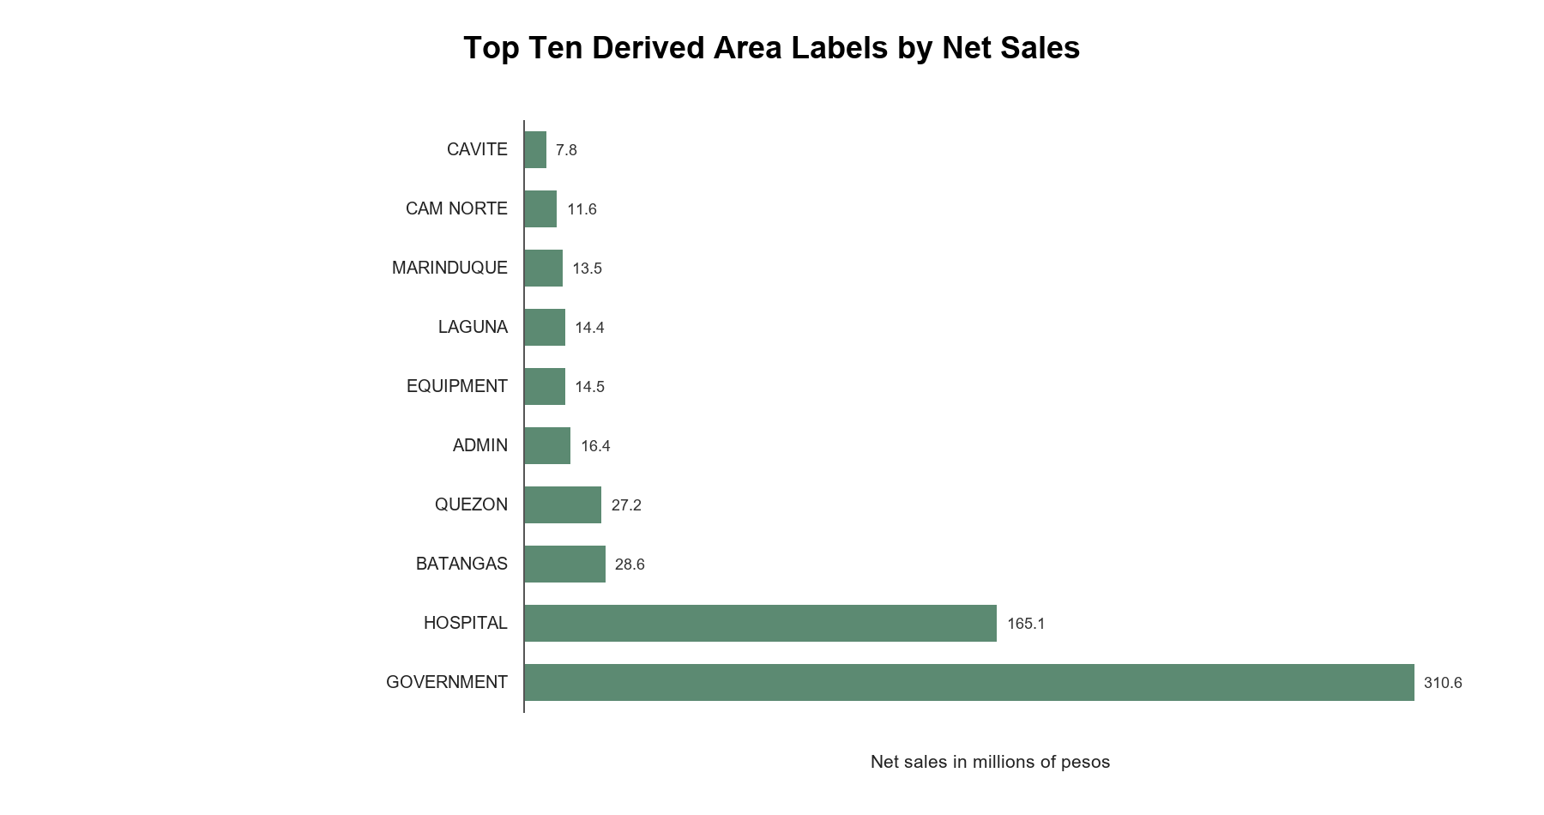
Figure 4.6 Top ten derived area labels by net sales
Source: Generated from the descriptive calculation receipt.
GOVERNMENT accounted for 49.55 percent of candidate net sales, followed by HOSPITAL at 26.34 percent. The proponents did not interpret either label as a province or territory. The legacy area field also contained Batangas, Quezon, Laguna, Marinduque, Camarines Norte, and Cavite, so it mixed buyer groups with places. MedShield showed buyer-sector and geographic mappings separately, but owner approval was still pending. The GOVERNMENT share therefore described the candidate sales grouping, not a verified geographic market share.

4.2.3 Forecast Evaluation and External Signals
The proponents completed a forecast comparison but not an operational forecast. In a fixed-origin test using Government net sales, the last-observed-value method performed better than the seasonal-naive method over the same nine observed holdout months. Both methods still had large errors and tended to underpredict. The result helped the proponents compare transparent baselines; it did not justify releasing a forecast for planning.
The reviewed Gold data contained no actual MedShield sales for 2026. As a result, the dashboard's 2026 gap estimates could not be used as actual outcomes or a 2026 forecast holdout. The proponents evaluated forecasting methods against observed months from 2017 to 2025 and kept the elapsed-2026 estimates as temporary planning context while client records were pending.
Table 4.9 Fixed origin Government net sales benchmark
Method | Paired months | MAE | RMSE | WAPE | Bias
Seasonal naive | 9 | ₱2,695,359.26 | ₱3,459,768.58 | 85.05% | -₱2,574,060.06
Last observed value | 9 | ₱1,987,359.74 | ₱2,632,312.49 | 62.71% | -₱1,230,712.16
Source: Section 8 historical acceptance evidence. Missing actuals were excluded rather than set to zero.
The proponents later compared 15 offline configurations: four simple benchmarks, two ETS models, and nine Prophet configurations. Last value had the best development selection result, with 83.20 percent development WAPE and 37.76 percent retrospective 2025 WAPE. No alternative met the release criteria, and the available results did not support empirical uncertainty intervals. The model release pointer consequently remained empty. Forecasting guidance called for evaluation on observations withheld from fitting (Hyndman and Athanasopoulos, 2021). The recorded errors gave the proponents a concrete reason to withhold an operational forecast.
Table 4.10 Predictive readiness audit
Evidence item | Observed result | Interpretation
Candidate configurations | 15 evaluated | The experiment was completed and persisted as candidate evidence
Development selection | Last value; WAPE 83.20% | The method was selected among tested candidates but retained high error
Retrospective 2025 audit | Last value; WAPE 37.76% | Historical audit only; not a 2026 holdout
Intervals | Unsupported | Insufficient lead-specific error history for defensible bands
DOH and PAGASA forecast rows | 0 forecast eligible | External regression remained blocked
Publication | No active model release | No operational forecast could be claimed
Source: MedShield Analytics, Predictive Operations, Current State, and QA records dated 27 September 2026.
External data did not resolve the forecast problem. The reviewed data contained 2,171 DOH and PAGASA rows, but none qualified for an approved sales join or forecast input. NASA POWER contributed separately labeled proxy observations and 32 possible sales matches. The matches did not verify the geographic link or show a predictive benefit. The proponents therefore made no claim of improved MedShield forecasts from rainfall, disease intensity, or typhoon indicators.

4.2.4 Prescriptive Planning Results
For inventory planning, the proponents demonstrated a scenario rather than a live ordering decision. The dashboard gathered entered demand, usable and protected stock, pack size, cost, supplier limits, and budget, then solved a constrained allocation when eligible products and assumptions were present. Feasibility, whole-pack, stock-protection, and service-first tests supported the calculation. The output showed what could be allocated under entered conditions; it did not show what the client should purchase from verified stock data.
Table 4.11 Operational inputs required for prescriptive use
Input | Status at review | Reason for the input
On-hand and reserved stock | Not published | Determined actual availability and stock gaps
Expiry dates and batch age | Not published | Was required to measure expiry-driven wastage
Lead time and service level | Not published | Was required for ROP and safety-stock calculations
Ordering and holding cost | Not published | Was required for defensible EOQ
Pack size MOQ and supplier cap | User-entered assumption | Constrained feasible orders
Budget and approved demand | User-entered assumption | Determined the allocation objective and ceiling
Source: MedShield business definitions, analytics guidance, and planning interface.
The proponents could not calculate an actual wastage rate because expiry and write-off outcomes were unavailable. The proposal's goal of keeping expiry-driven wastage at or below 5 percent remained untested. Reporting the target as an achieved result would have overstated the evidence.

4.3 Dashboard
Section 4.3 showed how the MedShield dashboard brought the analyses together for a business reviewer. A user could move from a summary to its period, source records, evidence label, and forecast or scenario status. Observed 2026 sales required published client transactions. When actual records for an elapsed month were pending, the dashboard could show a clearly labeled estimate from earlier years.

4.3.1 Dashboard Structure and Navigation
The dashboard opened with Overview and offered Sales Diagnostics, Product Prioritization, Area Prioritization, Forecast Modeling, and Prescriptive Planning. Supporting pages displayed sales transactions and weather-source checks. The proponents arranged the pages so a reviewer could inspect a result, its source, and its limitations in the same workflow. A Data Upload page was visible, but client CSV ingestion and publication had not been completed.
The top bar kept the selected period visible across the dashboard. Single-year and year-to-year controls used years found in the data and refreshed the related cards, charts, and tables together. Missing months stayed blank instead of becoming zero sales. For an elapsed 2026 month without an actual record, the dashboard calculated an estimate from up to three earlier occurrences of the same calendar month, weighted 0.60, 0.30, and 0.10 when observations existed. Labels separated estimates from actual sales, and an uploaded actual took priority. If a required data view failed, the affected display showed an unavailable state rather than an old value.

4.3.2 Dashboard Modules and Decision Flow
Each main page answered a different business question. Sales Diagnostics described recorded performance; product and area pages pointed to groups worth reviewing; Forecast Modeling compared methods; and Prescriptive Planning tested an entered allocation scenario. The dashboard did not place orders automatically. Figures 4.7 to 4.10 showed the layout captured during development in September. The captures illustrated navigation and controls but did not verify the numerical results available at the later review date.
Table 4.12 Functions of the five principal dashboard modules
Module | Question answered | Main dashboard outputs | Decision use and boundary
Sales Diagnostics | How had sales, margin, quantity, and seasonality changed? | KPI cards, annual and monthly trends, matched-period growth, heatmap, and STL evidence | Explained historical patterns; candidate definitions and missing periods remained visible
Product Prioritization | Which product labels had contributed most historical value? | Ranked contribution, focus cohort, Pareto or ABC grouping, and product table | Focused product review; did not approve SKUs or recommend purchases automatically
Area Prioritization | Which mapped areas or buyer groups had required attention? | Buyer-sector, geographic, and legacy-area shares with traceable mappings | Directed commercial review; derived mappings and mixed source labels remained provisional
Forecast Modeling | How well had transparent forecasting baselines performed? | Actual-versus-holdout plots, error metrics, future baseline, and release status | Supported model comparison; no champion, interval, or external regression was approved
Prescriptive Planning | Which allocation was feasible under entered constraints? | Priority shortlist, assumption grid, feasibility result, and scenario export | Supported scenario discussion; did not issue purchase orders or use verified inventory and expiry data
Source: MedShield Current State, Dashboard Design Logic, Analytics, and application documentation.
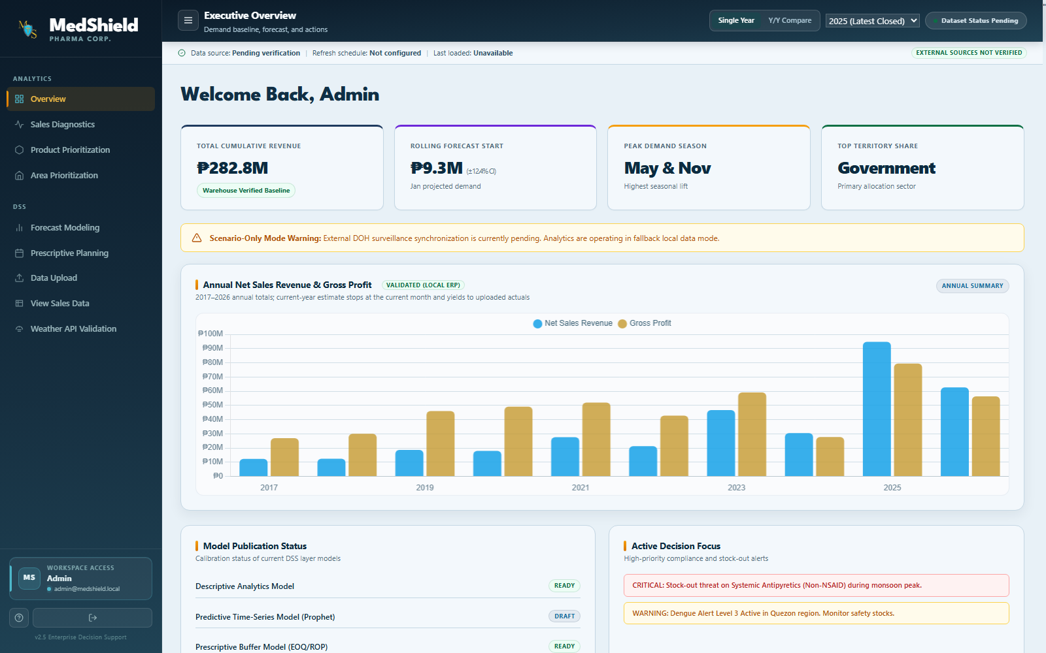
Figure 4.7 Overview dashboard development capture
Source: MedShield development interface capture dated 15 September 2026. The capture provided layout evidence only; current numerical results required a version-bound receipt.
Overview gave the reviewer a starting point: the selected period, a sales summary, and the status of the data source. The observed sales record ended in December 2025. When a selected window extended into 2026, the page needed separate labels for observed sales and estimated gaps. The combined amount could not be read as wholly actual revenue.
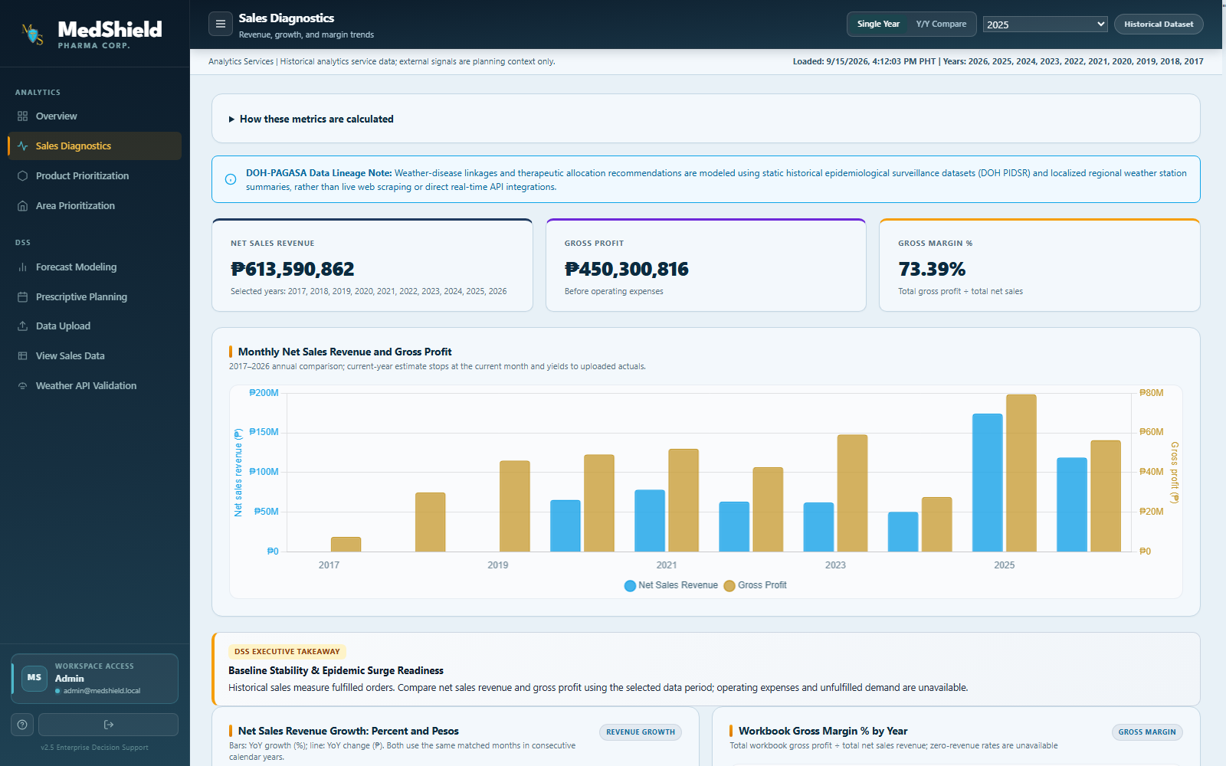
Figure 4.8 Sales diagnostics development capture
Source: MedShield development interface capture dated 15 September 2026. The capture provided layout evidence only; figures and labels required runtime verification.
Sales Diagnostics placed annual comparisons beside monthly patterns. The proponents kept missing months as gaps so a reviewer would not mistake absent transactions for zero demand. The page also offered a path from an unusual period to the underlying sales records.
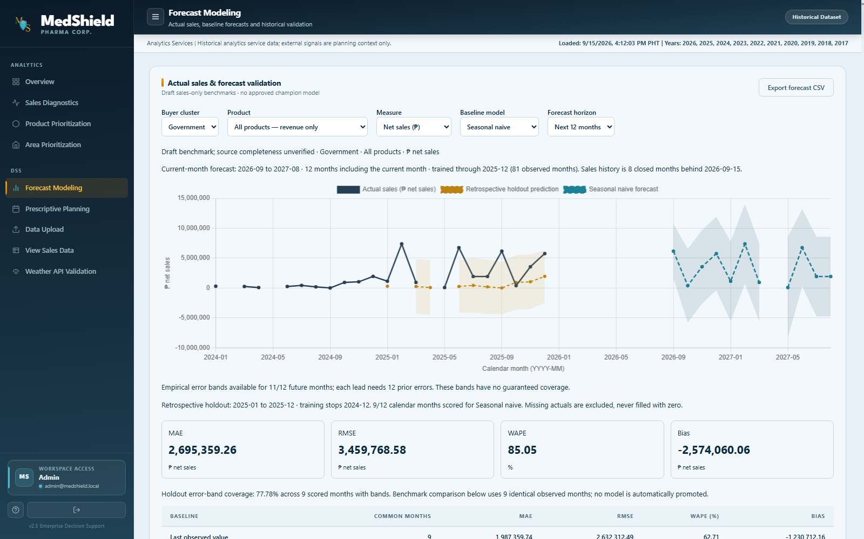
Figure 4.9 Forecast modeling development capture
Source: MedShield development interface capture dated 15 September 2026. The capture showed a historical screen layout only. A shaded forecast band appeared in the older capture, but the review record reported unsupported intervals and no approved model release.
Forecast Modeling showed the selected buyer, product, measure, method, and horizon above its comparison chart. Observed sales, retrospective predictions, and a future baseline occupied distinct parts of the view. MAE, RMSE, WAPE, and bias described how the tested method performed. An older development capture included a shaded band, but the completed analysis did not support an empirical uncertainty interval. The proponents did not present the band or the future baseline as an approved forecast.
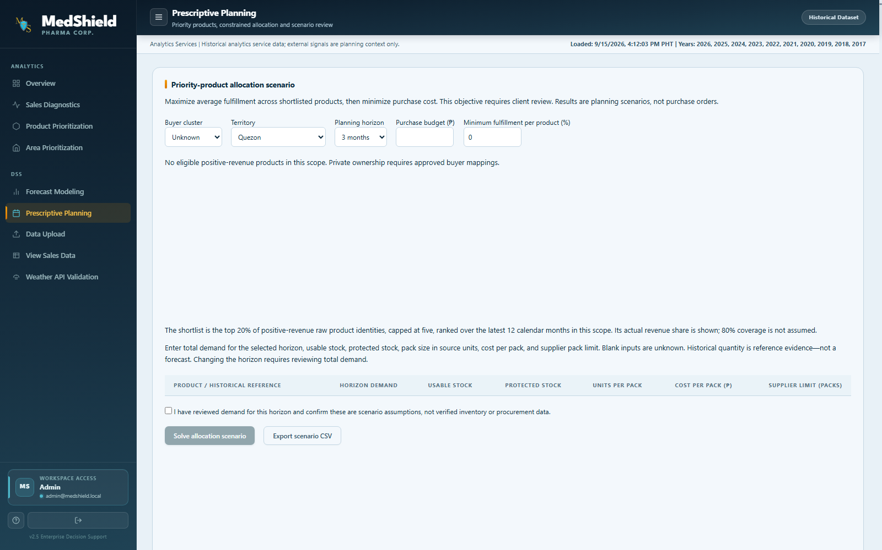
Figure 4.10 Prescriptive planning development capture
Source: MedShield development interface capture dated 15 September 2026. The displayed scope had no eligible positive-revenue products and did not show a solved allocation. Inputs represented scenario assumptions, not purchase orders.
Prescriptive Planning asked for a scope, budget, demand, usable stock, protected stock, pack size, cost, and supplier limits. A confirmation step marked the entries as assumptions instead of verified inventory. The captured screen had no eligible positive-revenue products, so it did not show a completed allocation. Separate feasibility tests, rather than the screenshot, supported the scenario calculation.
View Sales Data let a reviewer inspect the transactions behind a displayed total. Weather API Validation separated official observations from NASA POWER proxy values. Although the Data Upload page existed, its endpoint rejected submissions pending warehouse ingestion. File validation, durable ingestion status, and client-controlled publication remained unfinished. The proponents therefore did not claim completed upload of 2026 actual sales.

4.3.3 Evidence Labels and User Controls
The proponents used labels to show how much weight a reviewer could place on a result. Actual meant observed sales; candidate meant a value or mapping awaiting approval; estimated meant a calculated replacement for a missing period; proxy marked substitute external observations; baseline marked a forecast comparison; blocked marked a result withheld by data checks; and scenario marked a calculation based on entered assumptions. The dashboard also showed loading, empty, infeasible, and unavailable states. It did not train models in the browser, fetch weather directly from the browser, or create purchase transactions.

4.3.4 Dashboard Verification
The QA review recorded 70 passing publication checks for the version-16 historical sales candidate. The result confirmed technical reconciliation at the review date, not business approval of product identities, area mappings, finance definitions, or a forecasting method. The detailed tables in the chapter came from the locally available version-15 calculation receipt; the version-16 calculation receipt cited by QA was not available in the checkout. Other reported checks included 21 backend unit tests, eight descriptive browser cases, five area and buyer-scope regressions, and six matched-period cases. Four retired legacy cases were skipped. The proponents kept the sets separate because some tests overlapped.
Table 4.13 Validation and acceptance evidence
Validation area | Observed result | Interpretation
Publication readiness | 70 pass 0 fail 0 unverified | Technical candidate checks passed; business approval remained open
Descriptive population | 37,728 facts 108 calendar months 98 observed months | Counts and periods reconciled; ten months remained unavailable
STL | 72 reconciled months and four components | Qualifying 2020 to 2025 segment only
Backend unit tests | 21 passed | Covered backend logic, including filter validation
Final descriptive browser run | 8 passed | Live version-bound descriptive behaviors and exports
Area and buyer regression | 5 passed | Scoped classification behavior
Matched-period and growth suite | 6 passed 4 legacy skipped | Skipped tests were retired and were not counted as passes
Predictive warehouse candidate | 1,092 rows and 15 evaluations persisted | Candidate experiment evidence persisted; the active model pointer remained empty
Source: MedShield QA review, Current State, Database, and Predictive Operations records dated 27 September 2026.

4.4 Summary of Findings
Section 4.4 brought the main findings back to the proposal's practical questions. The proponents used observed sales from 2017 to 2025, documented dashboard behavior, and the limits of the available data. Elapsed-2026 estimates gave temporary planning context while actual transactions were pending; they did not establish a measured 2026 result.

4.4.1 Answers to the Practical Questions
SPEEDA 2.5IU/0.5ML ranked first among source product labels. The proponents treated the ranking as provisional because the approved product master was empty and different labels could refer to the same commercial product. Revenue-based ABC grouping identified products for closer review, not clinical importance or future demand.
MedShield compared retrospective forecasting baselines but did not produce an approved next-season forecast. The selected last-value method still had large errors, external disease and weather joins were not accepted for forecasting, and no 2026 actual sales were available for a genuine 2026 holdout. The weighted values shown for elapsed 2026 gaps remained estimates, not validated predictions.
Sales records alone did not show whether stock was excessive or insufficient. The proponents lacked verified on-hand units, reservations, lead times, and expiry dates. The planning page tested allocation scenarios entered by a user and reported whether the constraints could be met. It did not prove a purchase quantity, prevented expiry, or achievement of the proposal's five-percent wastage goal.

4.4.2 Historical Patterns
Observed net sales totaled ₱626.95 million across 2017 to 2025. Activity differed by year and month, ten early months lacked transactions, and the large 2025 total required careful source review. May and June had the highest observed month averages. The proponents used STL only on the uninterrupted 2020 to 2025 series, leaving the earlier missing months unfilled.

4.4.3 Forecast Comparison
On the fixed-origin Government holdout, last observed value performed better than seasonal naive, although its WAPE was still 62.71 percent. Last value also led the larger offline comparison, with 83.20 percent development WAPE and 37.76 percent retrospective WAPE. The proponents did not publish a forecasting model because the errors were substantial, uncertainty intervals lacked support, and external data joins remained unapproved.

4.4.4 Product and Area Priorities
SPEEDA 2.5IU/0.5ML led source product labels by revenue, while GOVERNMENT led the derived area labels. The proponents regarded both as useful starting points for review, not final SKU and geographic market-share findings. The product master had no approved entries, and the older area field mixed places with customer and business categories.

4.4.5 Planning Scenarios
MedShield produced constrained allocation results when a user entered the needed assumptions. The output showed feasible quantities under the entered limits or explained why a combination was infeasible. Verified inventory and procurement data were still needed for EOQ, ROP, safety stock, and an assessment of expiry reduction.

4.4.6 Decision Support Value
The dashboard brought sales coverage, KPI definitions, historical patterns, product and area rankings, forecast errors, and planning assumptions into one review path. The proponents considered the arrangement useful for examining demand, but they had no before-and-after measure of improved visibility. The available record also contained no completed REC-approved participant evaluation. Technical tests established selected dashboard behavior, not user acceptance.

4.4.7 Discussion of the North Star
The strongest result addressed demand visibility. MedShield combined historical sales, visible data gaps, clear KPI bases, and the approval status of mappings and forecasts. A reviewer could move from a sales pattern to a product or area priority and then examine an allocation scenario. The proponents could describe the improved review path, but they could not claim a measured gain in decision quality without a before-and-after study.
The expiry-loss aim required a separate measurement. No baseline of expired or written-off stock, later comparison period, or verified inventory record was available. MedShield could record assumptions and allocation decisions for a future evaluation, but the proponents could not show a reduction in expiry losses or an improvement in profit.
The forecast work also showed why a simple method deserved careful evaluation. More complex Prophet configurations did not meet the release criteria. Last value led the tested methods, yet its errors were still high and its uncertainty estimates lacked support. The proponents kept the model unpublished and left the final planning decision with an authorized user who could inspect the assumptions behind a scenario.

4.4.8 Limitations
• The Gold sales objects remained candidate publications pending named business and finance approval.
• The product master had no approved entries, so product analysis used source labels and could not standardize aliases or pack conversions.
• The legacy area field combined geographic, customer-type, and business-line labels; final mapping approval remained outstanding.
• Ten months had no observed transactions. The study preserved the gaps but could not independently determine whether missing files or absent business activity caused them.
• DOH and PAGASA rows were not approved for territory-level forecasting, while NASA POWER remained a separately labeled proxy.
• No predictive model or uncertainty interval was approved for operational publication.
• Inventory, expiry, supplier, lead-time, service-level, ordering-cost, holding-cost, and stock-position data were unavailable.
• The study contained technical and browser validation but no completed REC-approved participant evaluation or final client acceptance record.

4.4.9 Overall Synthesis
The proponents delivered a working historical business analytics solution. MedShield reconciled 37,728 accepted sales records, displayed 2017 to 2025 performance without hiding ten missing months, examined a 72-month series with STL, ranked product and area labels, compared forecasting baselines on observed holdouts, and tested constrained allocation scenarios. Sales analysis and dashboard presentation had the strongest support among the proposal objectives.
Several objectives still needed additional data or approval. Product and area labels were not final, external signals had not qualified for forecasting, and the selected model remained unpublished because its error and uncertainty evidence were insufficient. Allocation outputs depended on entered assumptions, while the expiry-wastage target had not been measured. The proponents could defend MedShield as a historical Decision Support System for business review, but not as proof of an approved operational forecast or reduced expiry losses.
References
Cleveland, R. B., Cleveland, W. S., McRae, J. E., & Terpenning, I. (1990). STL: A seasonal-trend decomposition procedure based on Loess. Journal of Official Statistics, 6(1), 3–73.
Flores, B. E., & Whybark, D. C. (1986). Multiple criteria ABC analysis. International Journal of Operations & Production Management, 6(3), 38–46. https://doi.org/10.1108/eb054765
Hyndman, R. J., & Athanasopoulos, G. (2021). Forecasting: Principles and practice (3rd ed.). OTexts. https://otexts.com/fpp3/
Martinez, M. E. (2018). The calendar of epidemics: Seasonal cycles of infectious diseases. PLOS Pathogens, 14(11), e1007327. https://doi.org/10.1371/journal.ppat.1007327
MedShield Capstone Group 9. (2026a). Capstone project proposal objectives and conceptual framework. Unpublished manuscript.
MedShield Capstone Group 9. (2026b). Descriptive calculation and STL receipts, Delta version 15. Internal validation evidence, 26 September 2026.
MedShield Capstone Group 9. (2026c). QA review and current-state summary. Internal verification records, 27 September 2026.
MedShield Capstone Group 9. (2026d). Analytics, architecture, and predictive operations. Internal project documentation, 27 September 2026.
Nguyen, A., Lamouri, S., Pellerin, R., Tamayo, S., & Lekens, B. (2021). Data analytics in pharmaceutical supply chains: State of the art, opportunities, and challenges. International Journal of Production Research, 60(22), 6888–6907. https://doi.org/10.1080/00207543.2021.1950937
World Health Organization. (2024). Digital transformation handbook for health supply chain architecture. https://www.who.int/publications/i/item/9789240101197

