CHAPTER 4
RESULTS AND DISCUSSION
This chapter presents what the MedShield Decision Support System currently demonstrates and what the available evidence does not yet support. The strongest result is a traceable descriptive layer connected to a working dashboard: 37,728 accepted sales facts from 2017 to 2025 reconcile to Databricks Gold candidate views, missing months remain visible, and the interface can compare sales, products, areas, and transparent forecast baselines. Predictive model publication, external-signal forecasting, and operational inventory optimization remain gated. We therefore discuss them as evaluated or implemented capabilities, not as proven business outcomes.
The discussion follows the project objectives and the North Star question: How can MedShield use historical sales data, validated external signals, and scenario-based planning to improve demand visibility and reduce expiry-driven inventory losses for the 2026 planning cycle? Each result is labeled according to its evidence status. Observed sales are reported as historical facts; mapped labels and ABC classes are candidates; forecast comparisons are evaluation evidence; weather data from NASA POWER is a proxy; and planning outputs are scenarios that require human review. This treatment keeps the chapter aligned with the implemented system and prevents unfinished work from being presented as a completed operational result.
The current MedShield sales record ends in December 2025. When the dashboard displays elapsed months in 2026 for which client sales have not yet been uploaded, it marks the values as gap estimates derived from recency-weighted observations for the same calendar month in earlier years. These estimates support provisional planning while the corresponding 2026 actual data are pending. They are kept separate from observed sales, do not count as a 2026 validation holdout, and must be replaced or reassessed when the actual records become available. The descriptive view also leaves future 2026 months unavailable rather than inventing actual sales.

4.1 Presentation of Results
This section presents the evidence produced by the implemented MedShield system before interpreting what the patterns mean. It first checks the research objectives against the available results, then describes the runtime architecture, data coverage, and quality controls that determine which outputs can be defended. Historical sales results refer to observed records from 2017 to 2025. Any 2026 value shown for a month without an uploaded record is treated as an estimate pending actual data and is identified separately in the dashboard.

4.1.1 Alignment With the Research Questions and Objectives
The proposal defined five objectives: describe sales and seasonality, prioritize products and areas, forecast demand with external signals, support inventory decisions, and present the results through five dashboard modules. The implementation moved furthest on the first, second, and fifth objectives. Forecasting has reached controlled evaluation but not release approval. The prescriptive layer can solve constrained scenarios, but the study does not contain the stock, expiry, lead-time, supplier, ordering-cost, or holding-cost data needed to measure an actual reduction in wastage.
Table 4.1 Objective achievement audit
Objective | Evidence expected | Observed result | Assessment
SO1 | Sales performance, year-over-year patterns, and STL seasonality | Historical summaries and a 72-month STL decomposition are available. Ten earlier months remain unobserved, and the full geography mapping still needs owner approval. | Partially achieved
SO2 | Product, territory, and account priorities using Pareto ABC and predictive scoring | Deterministic Pareto and ABC candidate views are implemented. Product labels are not approved SKUs, and no XGBoost classifier is published. | Partially achieved
SO3 | Territory forecasts using sales, DII, RSI, Prophet, and XGBoost | Sales-only baselines and offline candidates were evaluated. External joins have zero forecast-eligible rows, and no model is approved or activated. | Not achieved for operational use
SO4 | EOQ, ROP, and allocation decisions that reduce expiry wastage to at most 5 percent | The interface supports reviewed allocation scenarios. Real inventory and expiry outcomes are absent, so the 5 percent target was not tested. | Scenario capability only
SO5 | Five dashboard modules with upload validation and decision support | The five modules and gateway-backed descriptive workflow are implemented. Live Signal 2 alerts, collaborative filtering, and automated procurement are not verified outputs. | Substantially achieved with exclusions
Source: Capstone proposal objectives and the MedShield current-state, analytics, and QA records as of 27 September 2026.
This audit is important for defense because completion of software features is not the same as achievement of a research outcome. A screen can exist even when its model is not approved, and a solver can run even when its inputs are hypothetical. The remainder of the chapter reports both the implemented function and the evidence boundary that applies to it.

4.1.2 Implemented System and Runtime Architecture
MedShield was implemented as an authenticated web application. The Next.js frontend displays analytical views and sends requests to an Express and TypeScript gateway. The gateway performs validation, authorization, and Databricks query orchestration. Databricks Unity Catalog stores the analytical source of truth through Bronze, Silver, Audit, and Gold candidate schemas. Supabase supplies identity and audit support; it does not provide the dashboard measures. Python services are used for offline preparation, model experiments, and validation, but they are not a browser fallback.
The runtime boundary was deliberately kept strict. If Databricks or a required view is unavailable, the gateway returns an error and the dashboard shows an unavailable state. It does not replace the missing result with local JSON, seeded values, or an old spreadsheet. This behavior improves traceability because every displayed analytical value has one declared runtime source.
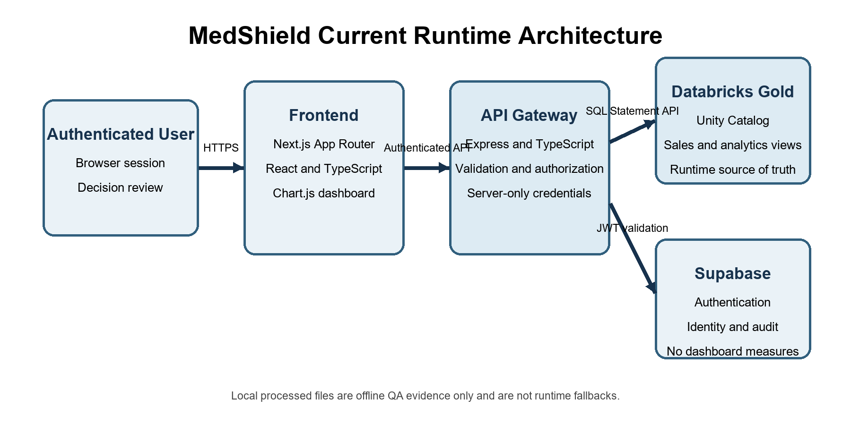
Figure 4.1 MedShield runtime architecture
Source: MedShield Architecture and Database documentation, September 2026.
Table 4.2 Implemented system layers
Layer | Implemented component | Responsibility | Boundary
Presentation | Next.js, React, TypeScript, Chart.js | Filters, charts, tables, exports, readiness labels, and scenario forms | Does not query Databricks or external providers directly
Gateway | Express and TypeScript | Authentication checks, parameter validation, query orchestration, and response contracts | Server-only credentials; explicit unavailable states
Analytical store | Databricks Unity Catalog | Bronze source evidence, Silver assessed records, Gold candidate facts and aggregates | Candidate publication pending business approval
Identity and audit | Supabase Auth and audit persistence | Session identity, roles, and application audit events | Not an analytical source
Offline analytics | Python jobs and tests | Reconciliation, STL, model evaluation, and scenario validation | Not a live dashboard dependency
Source: MedShield Architecture, Database, Security, and Project documentation.

4.1.3 Data Sources Coverage and Quality
The historical sales candidate covers 2017 to 2025 and contains 37,728 accepted fact rows. The study proposal emphasized 2021 to 2025 and three Philippine regions, but the implemented warehouse retains the longer history available in the supplied records. We used the broader period for context while keeping the proposed regional interpretation conditional on the approved area mapping. Department of Health and weather sources are retained as historical context; they are not silently joined to sales for forecast publication.
Table 4.3 Data sources and current analytical status
Source | Coverage | Current use | Status and limitation
MedShield sales | 2017 to 2025 actuals; 2026 actuals pending | Historical demand, revenue, product, area, and baseline forecast evaluation | 37,728 accepted facts; elapsed 2026 gaps may be estimated and remain separately labeled
DOH surveillance | 2018 to 2026 declared; 2026 partial | Historical disease context and candidate regressors | Territory join not approved; no individual health inference
PAGASA observations | 2017 to 2024 | Official historical weather context | No official 2025 observations in the project; no approved sales match
NASA POWER | 108 monthly rows for nine areas in 2025 | Separately labeled weather proxy | Provider proxy, not PAGASA; 32 candidate matches do not approve regression
Operational inventory | Not supplied | Would support EOQ, ROP, safety stock, allocation, and expiry analysis | Scenario inputs only
Source: MedShield Current State, System Documentation, and publication-readiness evidence.
The quality review identified a complete 108-month calendar but only 98 months with observed transactions. The ten unavailable months are May, June, July, August, and October 2017; January and February 2018; and October, November, and December 2019. These are missing observations, not zero demand. The system preserves them as null periods so that trend and validation routines do not create artificial declines.
Table 4.4 Sales candidate quality profile
Quality measure | Observed value | Interpretation
Accepted fact rows | 37,728 | Checksum-bound candidate population
Revenue-eligible rows | 36,848 | Rows included in the net-sales measure
Margin-eligible rows | 34,105 | Rows with a valid margin denominator
Warning-bearing rows | 32,749 | Warnings remain visible and are not equivalent to rejection
Calendar coverage | 108 months total; 98 observed; 10 missing | Missing periods remain unavailable rather than zero-filled
Product identity | 4,561 source labels; 0 approved master entries | Product findings describe labels, not verified canonical SKUs
Area identity | 22 derived labels | Some labels mix geography, customer type, or business line and require approval
Returns evidence | 673 rows | Signed returns remain separate while contributing to net revenue
Source: Version-bound publication and QA evidence for the 37,728-row Databricks candidate.

4.2 Data Analysis
This section interprets the historical sales, seasonal, prioritization, forecast-evaluation, and planning evidence in relation to the research objectives. The analysis distinguishes recorded performance from modeled or user-supplied values. For 2026, the available dashboard estimates describe possible sales for elapsed months whose actual records are still pending; they are not included in the observed 2017 to 2025 totals and are not used as proof of forecast accuracy.

4.2.1 Historical Sales Performance and Seasonality
Across the accepted candidate, observed net sales totaled ₱626,946,741.81. Workbook gross profit totaled ₱288,487,498.72. The weighted gross-margin rate was 60.26 percent, calculated only over the ₱478,720,670.03 margin-eligible revenue basis. This is a transaction-level workbook measure and should not be described as company net income. The separate denominators also explain why dividing gross profit by all reported net sales would give the wrong percentage.
Table 4.5 Annual sales and workbook gross profit
Year | Transactions | Net sales | Workbook gross profit | Margin eligible sales
2017 | 1,978 | ₱10,211,167.35 | ₱6,316,157.68 | ₱9,212,606.10
2018 | 6,181 | ₱51,619,691.27 | ₱28,328,721.76 | ₱44,882,495.39
2019 | 5,446 | ₱62,542,304.49 | ₱29,125,469.95 | ₱41,211,281.42
2020 | 3,980 | ₱63,593,274.63 | ₱28,013,993.68 | ₱40,259,988.09
2021 | 3,407 | ₱77,860,206.26 | ₱50,420,770.93 | ₱77,804,247.26
2022 | 3,980 | ₱63,234,990.04 | ₱40,799,049.06 | ₱60,493,221.21
2023 | 5,381 | ₱62,228,966.85 | ₱33,585,582.48 | ₱59,822,843.64
2024 | 2,831 | ₱50,259,319.88 | ₱19,563,837.42 | ₱49,956,893.05
2025 | 4,544 | ₱185,396,821.04 | ₱52,333,915.76 | ₱95,077,093.87
Source: Descriptive calculation receipt. Amounts are candidate values in Philippine pesos.
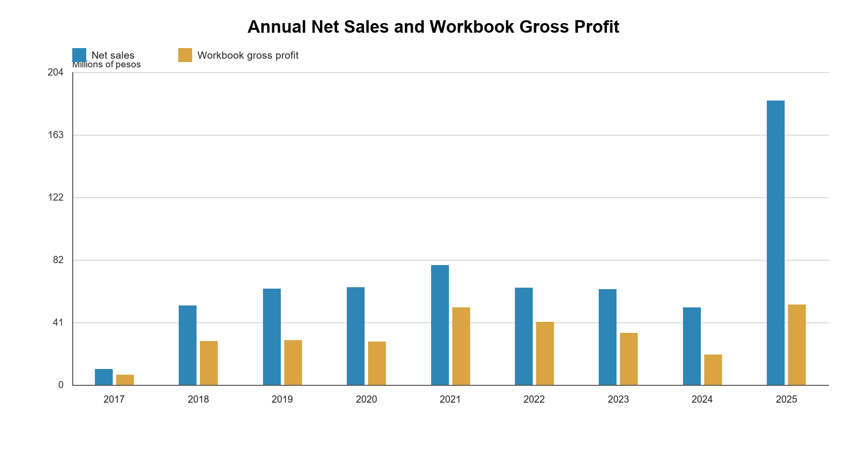
Figure 4.2 Annual net sales and workbook gross profit
Source: Generated from the version-bound descriptive calculation receipt.
The annual series should be interpreted as observed recorded activity, not as proof that every year is equally complete. The 2025 revenue increase is material in the candidate dataset, but the year also contains source adjustments whose product attribution remains under review. For this reason, we can defend the recorded financial total while keeping product-level and causal explanations provisional.
From 2024 to 2025, recorded net sales increased from ₱50.26 million to ₱185.40 million, or about 268.9 percent, while workbook gross profit increased from ₱19.56 million to ₱52.33 million, or about 167.5 percent. Gross profit therefore rose substantially, but not in the same proportion as revenue. The difference is mainly explained by the available calculation basis: ₱49.96 million, or 99.4 percent, of 2024 net sales had the matched revenue fields required for the gross-margin calculation, compared with only ₱95.08 million, or 51.3 percent, of 2025 net sales. Within that matched basis, the calculated margin rate was approximately 39.2 percent in 2024 and 55.0 percent in 2025. The chart should therefore not be used to claim that higher costs, heavier discounts, or an unfavorable product mix caused the visual gap. A large portion of 2025 revenue does not share the same margin-eligible denominator, and the year's source adjustments and product attribution are still under review. A causal explanation requires finance approval and complete matched cost evidence.
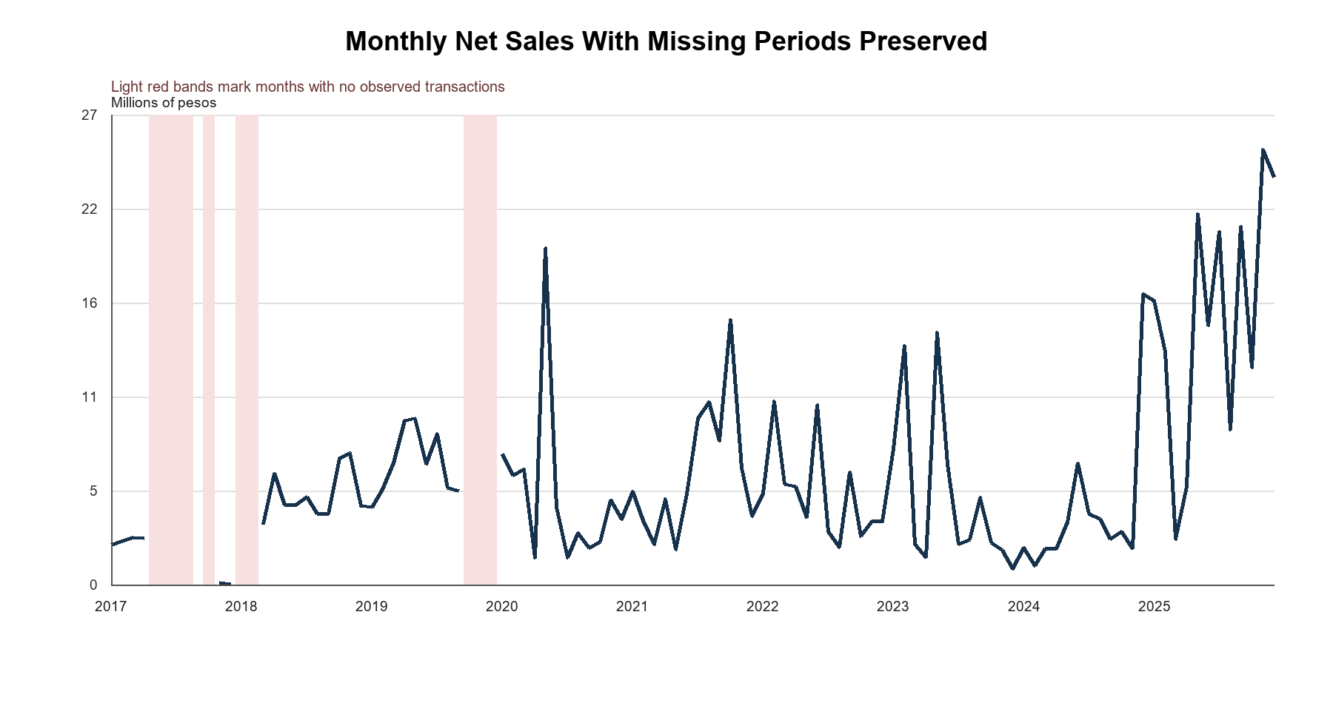
Figure 4.3 Monthly net sales and missing coverage
Source: Generated from the 108-month Databricks descriptive snapshot.
Observed calendar-month averages were highest in May at ₱9.87 million and June at ₱7.55 million. This result indicates a mid-year pattern in the recorded series, but it is not the same as a statistical seasonal component. The dashboard therefore keeps the calendar-month average separate from the STL decomposition required by the first objective.
Table 4.6 Observed calendar month averages
Month | Average net sales | Observed years
Jan | ₱6,405,176.08 | 8
Feb | ₱7,098,050.31 | 8
Mar | ₱3,879,490.79 | 9
Apr | ₱4,433,381.20 | 9
May | ₱9,871,031.23 | 8
Jun | ₱7,553,552.93 | 8
Jul | ₱6,832,765.69 | 8
Aug | ₱5,074,209.17 | 8
Sep | ₱6,073,372.18 | 9
Oct | ₱6,538,044.40 | 7
Nov | ₱6,502,031.32 | 8
Dec | ₱7,126,212.47 | 8
Source: Descriptive snapshot. Method is observed calendar-month average, not STL.
The STL routine used a 12-month period, a seasonal window of 13, robust fitting, and no imputation. Because the early history contains gaps and short segments, only the contiguous January 2020 to December 2025 series qualified for decomposition. The resulting 72 months reconstruct the observed series to numerical precision. The decomposition describes the structure of this candidate series; it does not establish that disease or weather caused the seasonal movement.
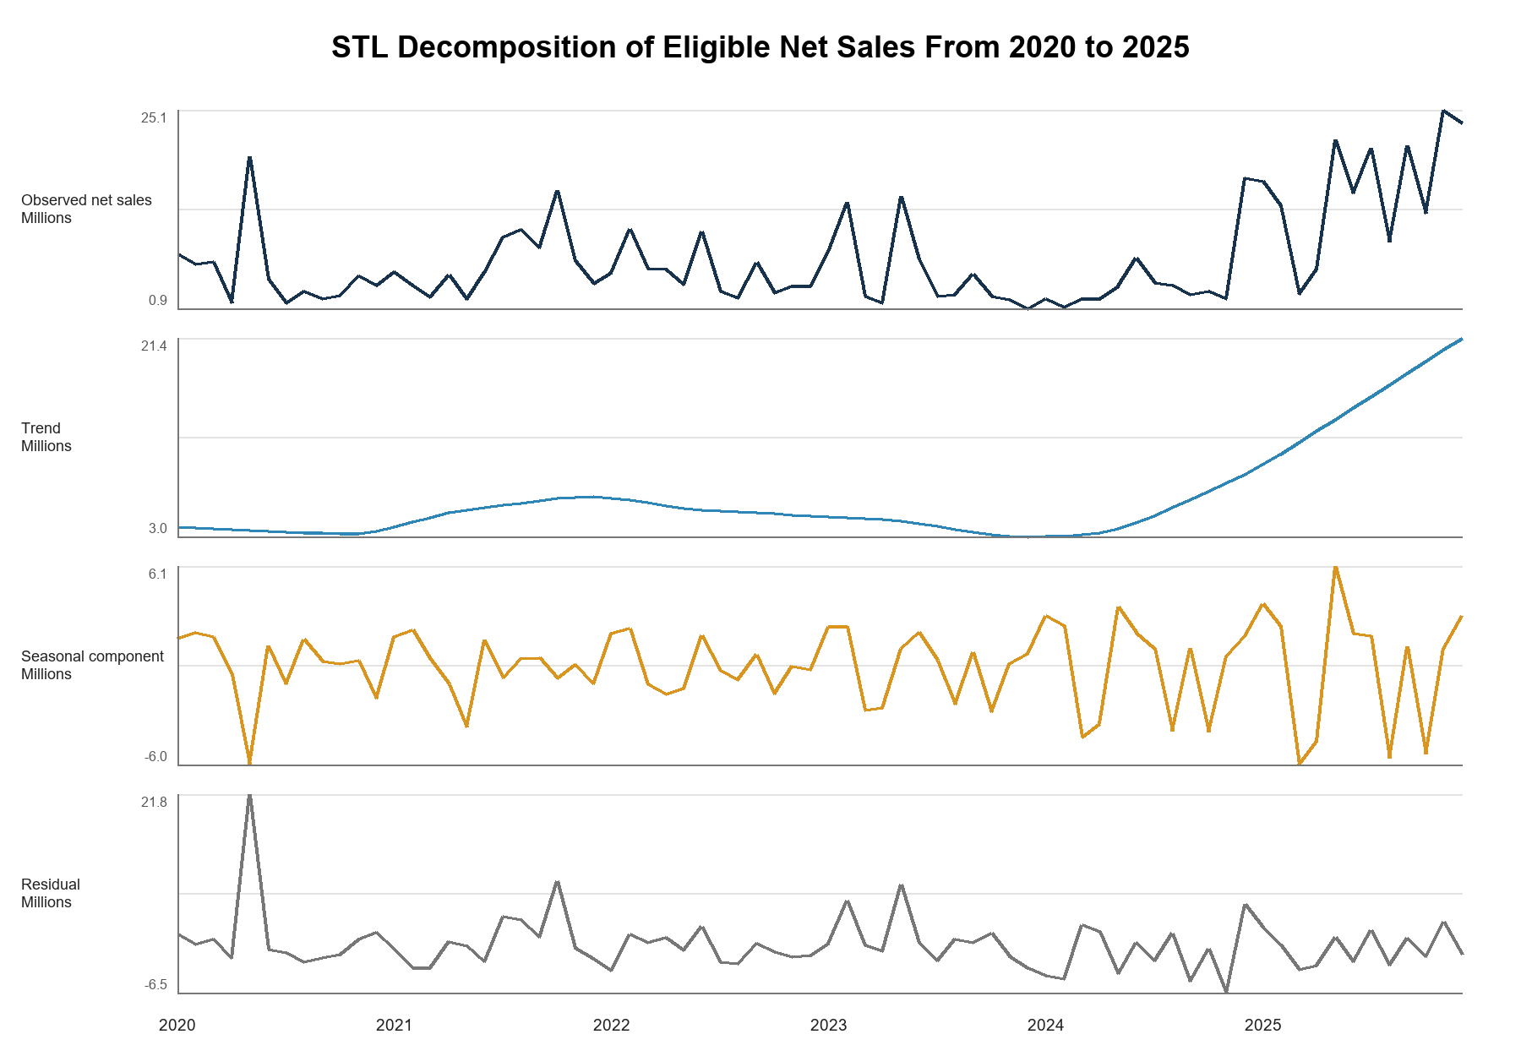
Figure 4.4 STL decomposition of eligible net sales
Source: Checksum-bound STL evidence generated with statsmodels 0.14.6.

4.2.2 Product and Area Prioritization
The second objective asks which products, territories, and accounts should receive attention. The implemented descriptive layer answers this through positive-sales contribution and deterministic Pareto or ABC grouping. It does not use an approved predictive XGBoost classifier. The distinction matters because an ABC class describes contribution within the selected history; it does not predict future urgency or stock-out risk.
Table 4.7 Top source product labels by net sales
Rank | Source product label | Net sales | Share | ABC
1 | SPEEDA 2.5IU/0.5ML | ₱22,466,448.23 | 3.57% | A
2 | PROHAB 10MG/ML 20ML | ₱16,530,532.11 | 2.63% | A
3 | BUPIRIGHT 5MG/ML 0.5% IN 8% 4ML | ₱15,966,455.39 | 2.54% | A
4 | SITIXON 1G | ₱13,051,271.68 | 2.08% | A
5 | MONOWEL 1G IV | ₱12,313,552.50 | 1.96% | A
6 | PROFUREX 750MG | ₱11,987,494.40 | 1.91% | A
7 | EVAPROST 250MCG/ML | ₱9,753,530.12 | 1.55% | A
8 | F6 FETAL MONITOR SINGLE | ₱7,848,998.50 | 1.25% | A
9 | SPEEDA | ₱7,558,970.97 | 1.20% | A
10 | EUROXONE 1G | ₱7,311,190.91 | 1.16% | A
Source: Databricks product candidate view. Labels are not approved canonical SKUs.
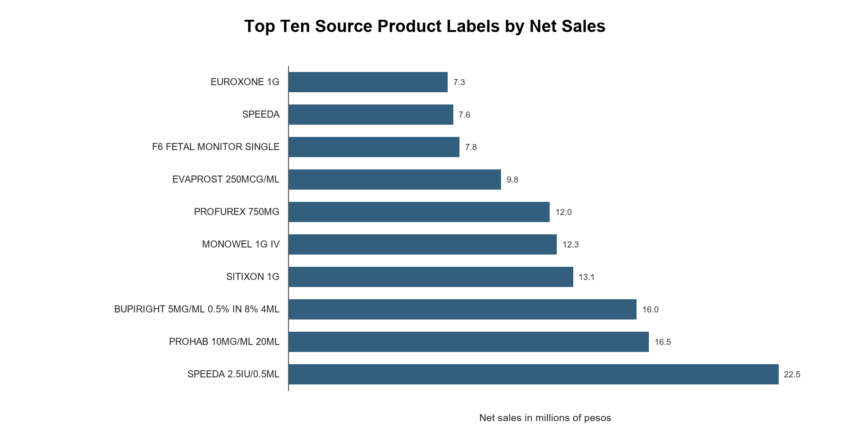
Figure 4.5 Top ten source product labels by net sales
Source: Generated from the descriptive calculation receipt.
SPEEDA 2.5IU/0.5ML ranked first with ₱22,466,448.23, or 3.57 percent of total candidate net sales. The top five labels contributed 12.78 percent, and the top ten contributed 19.85 percent. These figures do not support a claim that a handful of products dominate the entire portfolio. They instead show a long-tail distribution in which prioritization needs a full-population Pareto calculation. Alias fragmentation may also split one commercial product across several labels, as illustrated by the separate SPEEDA entries.
Table 4.8 Top derived area labels by net sales
Rank | Derived label | Net sales | Share | Workbook gross profit
1 | GOVERNMENT | ₱310,629,101.40 | 49.55% | ₱130,353,976.35
2 | HOSPITAL | ₱165,121,239.71 | 26.34% | ₱69,103,315.46
3 | BATANGAS | ₱28,556,256.25 | 4.55% | ₱17,838,380.41
4 | QUEZON | ₱27,207,048.54 | 4.34% | ₱17,340,506.74
5 | ADMIN | ₱16,359,733.69 | 2.61% | ₱8,706,600.10
6 | EQUIPMENT | ₱14,475,259.73 | 2.31% | ₱7,679,164.32
7 | LAGUNA | ₱14,376,324.92 | 2.29% | ₱8,509,063.56
8 | MARINDUQUE | ₱13,469,314.65 | 2.15% | ₱6,984,765.63
9 | CAM NORTE | ₱11,638,151.07 | 1.86% | ₱7,508,275.57
10 | CAVITE | ₱7,799,599.04 | 1.24% | ₱5,155,855.62
Source: Databricks area candidate view. Mixed commercial labels; not a pure geography dimension.
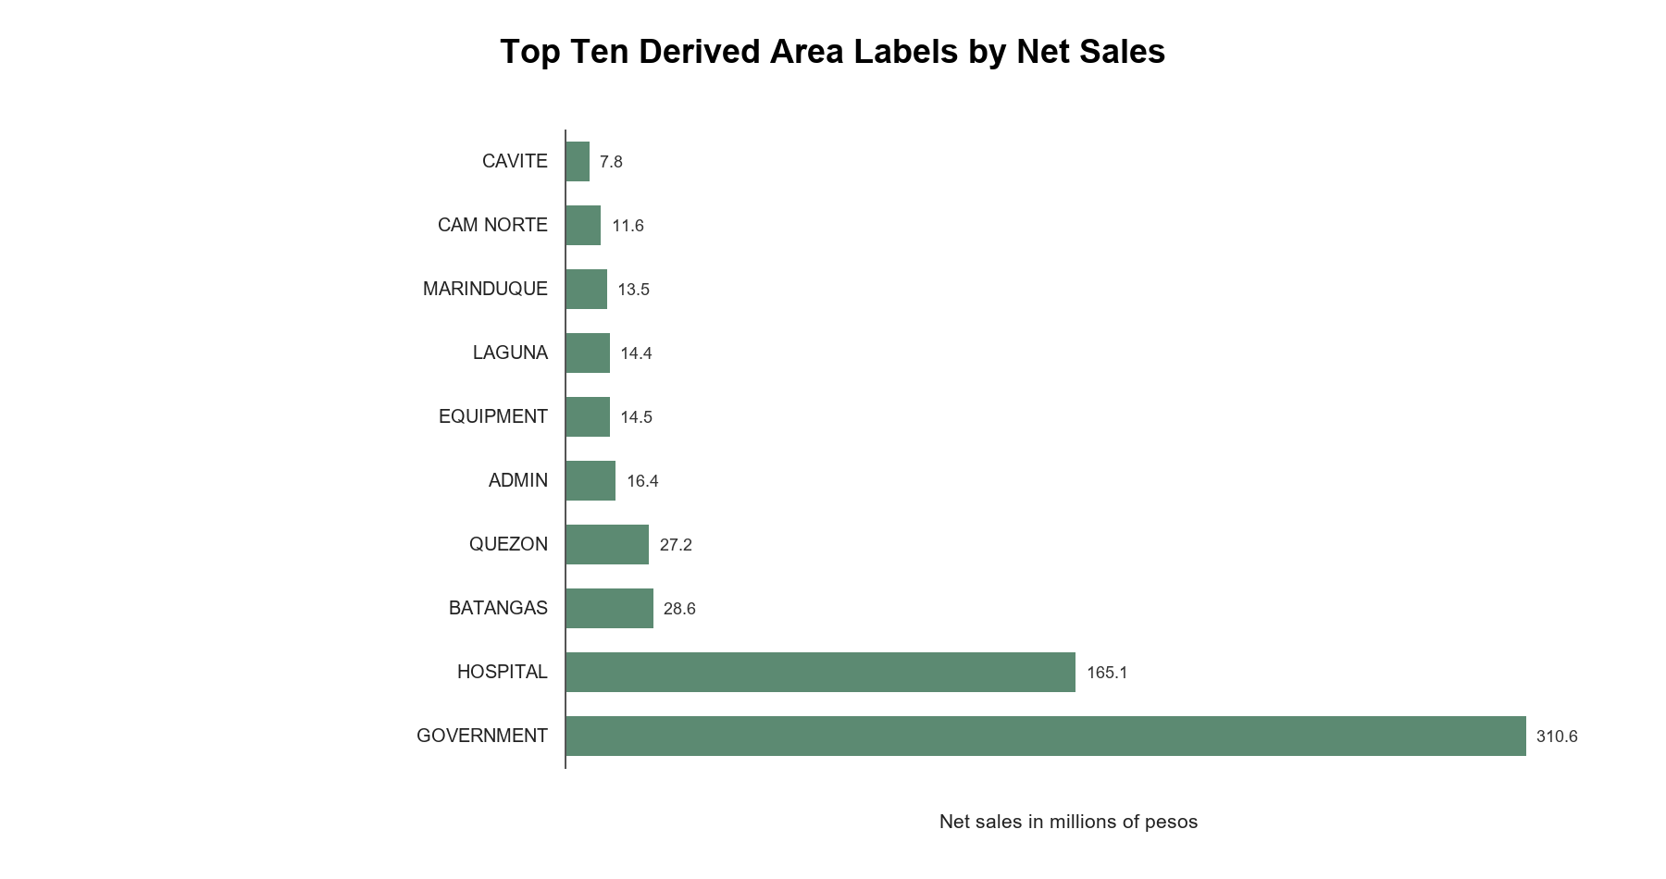
Figure 4.6 Top ten derived area labels by net sales
Source: Generated from the descriptive calculation receipt.
GOVERNMENT contributed 49.55 percent of candidate net sales and HOSPITAL contributed 26.34 percent. These labels are useful commercial segments, but they are not geographic territories. Batangas, Quezon, Laguna, Marinduque, Camarines Norte, and Cavite appear in the same legacy area field. The dashboard now exposes buyer-sector and geographic mappings separately, but final owner approval remains open. A defensible interpretation is that government-labeled transactions are financially important in the current candidate; it would be too strong to call that label a verified territorial market share.

4.2.3 Forecast Evaluation and External Signals
The third objective was only partly realized. The system can evaluate simple sales-only baselines and persist candidate experiment evidence, but it has no approved operational forecast. In the fixed-origin Government net-sales comparison retained by the dashboard evidence, the last-observed-value method outperformed the seasonal-naive benchmark across the same nine observed holdout months. Both errors were high, and both methods underpredicted on average. The result supports transparent baseline comparison, not model promotion.
No 2026 MedShield sales actuals are present in the current Gold contract. For that reason, the dashboard's 2026 gap estimates cannot be described as a holdout result or compared with actual 2026 performance. Their present role is to maintain planning continuity while actual data are pending. Forecast validation in this chapter therefore remains retrospective and uses observed months within the 2017 to 2025 history.
Table 4.9 Fixed origin Government net sales benchmark
Method | Paired months | MAE | RMSE | WAPE | Bias
Seasonal naive | 9 | ₱2,695,359.26 | ₱3,459,768.58 | 85.05% | -₱2,574,060.06
Last observed value | 9 | ₱1,987,359.74 | ₱2,632,312.49 | 62.71% | -₱1,230,712.16
Source: Section 8 historical acceptance evidence. Missing actuals were excluded rather than set to zero.
A later offline experiment evaluated 15 configurations: four simple benchmarks, two ETS models, and nine Prophet configurations. Last value remained the development-selected candidate, with 83.20 percent development WAPE and 37.76 percent retrospective 2025 WAPE. No challenger met the promotion criteria, empirical uncertainty intervals were unsupported, and the model release pointer remained empty. These results are stronger evidence than reporting a model merely because it ran. They show that the current forecast is not accurate or complete enough for an operational procurement decision.
Table 4.10 Predictive readiness audit
Evidence item | Observed result | Interpretation
Candidate configurations | 15 evaluated | Experiment completed and persisted as candidate evidence
Development selection | Last value; WAPE 83.20% | Selected among tested candidates but high error
Retrospective 2025 audit | Last value; WAPE 37.76% | Historical audit only; not a 2026 holdout
Intervals | Unsupported | Insufficient lead-specific error history for defensible bands
DOH and PAGASA forecast rows | 0 forecast eligible | External regression remains blocked
Publication | No active model release | No operational forecast may be claimed
Source: MedShield Analytics, Predictive Operations, Current State, and QA records dated 27 September 2026.
The external data audit reinforces this boundary. The current candidate contains 2,171 DOH and PAGASA rows, but none are join-ready or forecast-eligible. NASA POWER supplies separately labeled proxy observations and 32 candidate sales matches; those matches do not establish an approved geographic join or predictive benefit. We therefore cannot claim that rainfall, disease intensity, or typhoon signals improved MedShield demand forecasts. Older exploratory files that label weather or disease models as validated are superseded by the current source-identity and publication gates.

4.2.4 Prescriptive Planning Results
The fourth objective is represented in the system as a controlled planning scenario. The interface can shortlist positive-revenue products, collect user-entered demand, usable stock, protected stock, pack size, cost, supplier limits, and budget, and solve a constrained allocation. Tests cover feasibility, integer packs, stock protection, and a service-first objective. The result is useful for demonstrating how a decision can be structured, but it remains conditional on the values entered by the user.
Table 4.11 Operational inputs required for prescriptive use
Input | Current status | Why it matters
On-hand and reserved stock | Not published | Determines actual availability and stock gaps
Expiry dates and batch age | Not published | Required to measure expiry-driven wastage
Lead time and service level | Not published | Required for ROP and safety-stock calculations
Ordering and holding cost | Not published | Required for defensible EOQ
Pack size MOQ and supplier cap | User-entered assumption | Constrains feasible orders
Budget and approved demand | User-entered assumption | Determines the allocation objective and ceiling
Source: MedShield business definitions, analytics guidance, and planning interface.
No actual wastage rate can be calculated from the present study because no expiry or write-off outcome dataset is available. The proposal's target of expiry-driven wastage at or below 5 percent remains a performance target for a future operational evaluation. Claiming that the system achieved the target would confuse a design objective with a measured result.

4.3 Dashboard
This section explains how the dashboard turns the analytical results into a reviewable decision-support workflow. Its main purpose is to let users trace a summary back to the selected period, source records, evidence label, and model or scenario status. The same design governs the 2026 display: observed values appear only when actual transactions have been published, while elapsed months awaiting actual data may appear as clearly separated estimates based on prior same-calendar history.

4.3.1 Dashboard Structure and Navigation
The MedShield dashboard is the presentation layer of the decision-support system. An authenticated user enters through the Overview and then moves through Sales Diagnostics, Product Prioritization, Area Prioritization, Forecast Modeling, and Prescriptive Planning. Supporting views provide transaction-level sales evidence, controlled data upload, and weather-source validation. The sidebar keeps these pages in one workspace so that a reviewer can move from a summarized result to the records, assumptions, and limitations behind it.
A shared top bar carries the selected historical period and comparison context. Single-year and year-to-year comparison controls are populated from the available dataset rather than fixed to one reporting year. Changing the selection refreshes the related cards, charts, and tables from the same scoped population. The header also shows the loaded period and dataset state, while the pages preserve missing periods instead of displaying them as zero demand. In an elapsed 2026 month with no uploaded actual, the dashboard may calculate a recency-weighted same-calendar estimate from as many as three earlier years, using weights of 0.60, 0.30, and 0.10 when those observations are available. The chart and KPI evidence labels separate that estimate from actual sales, and an uploaded actual takes precedence. If an analytical source or required view is unavailable, the interface clears the affected result and presents an unavailable state rather than substituting a local or seeded value.

4.3.2 Dashboard Modules and Decision Flow
Each principal module answers a different planning question. Sales Diagnostics establishes what happened; the prioritization pages identify where review should begin; Forecast Modeling tests whether a baseline is dependable enough to publish; and Prescriptive Planning examines what would happen under user-entered constraints. The sequence supports a review process, not an automatic ordering decision. Figures 4.7 and 4.8 show how the predictive and prescriptive pages retain their validation and scenario boundaries inside the interface.
Table 4.12 Functions of the five principal dashboard modules
Module | Question answered | Main dashboard outputs | Decision use and boundary
Sales Diagnostics | How did sales, margin, quantity, and seasonality change? | KPI cards, annual and monthly trends, matched-period growth, heatmap, and STL evidence | Explains historical patterns; candidate definitions and missing periods remain visible
Product Prioritization | Which product labels contribute most historical value? | Ranked contribution, focus cohort, Pareto or ABC grouping, and product table | Focuses product review; it is not SKU approval or an automatic purchase recommendation
Area Prioritization | Which mapped areas or buyer groups require attention? | Buyer-sector, geographic, and legacy-area shares with traceable mappings | Directs commercial review; derived mappings and mixed source labels remain provisional
Forecast Modeling | How well do transparent forecasting baselines perform? | Actual-versus-holdout plots, error metrics, future baseline, and release status | Supports model comparison; there is no approved champion, interval, or external regression
Prescriptive Planning | What allocation is feasible under entered constraints? | Priority shortlist, assumption grid, feasibility result, and scenario export | Supports scenario discussion; it does not issue purchase orders or use verified inventory and expiry data
Source: MedShield Current State, Dashboard Design Logic, Analytics, and System Documentation.
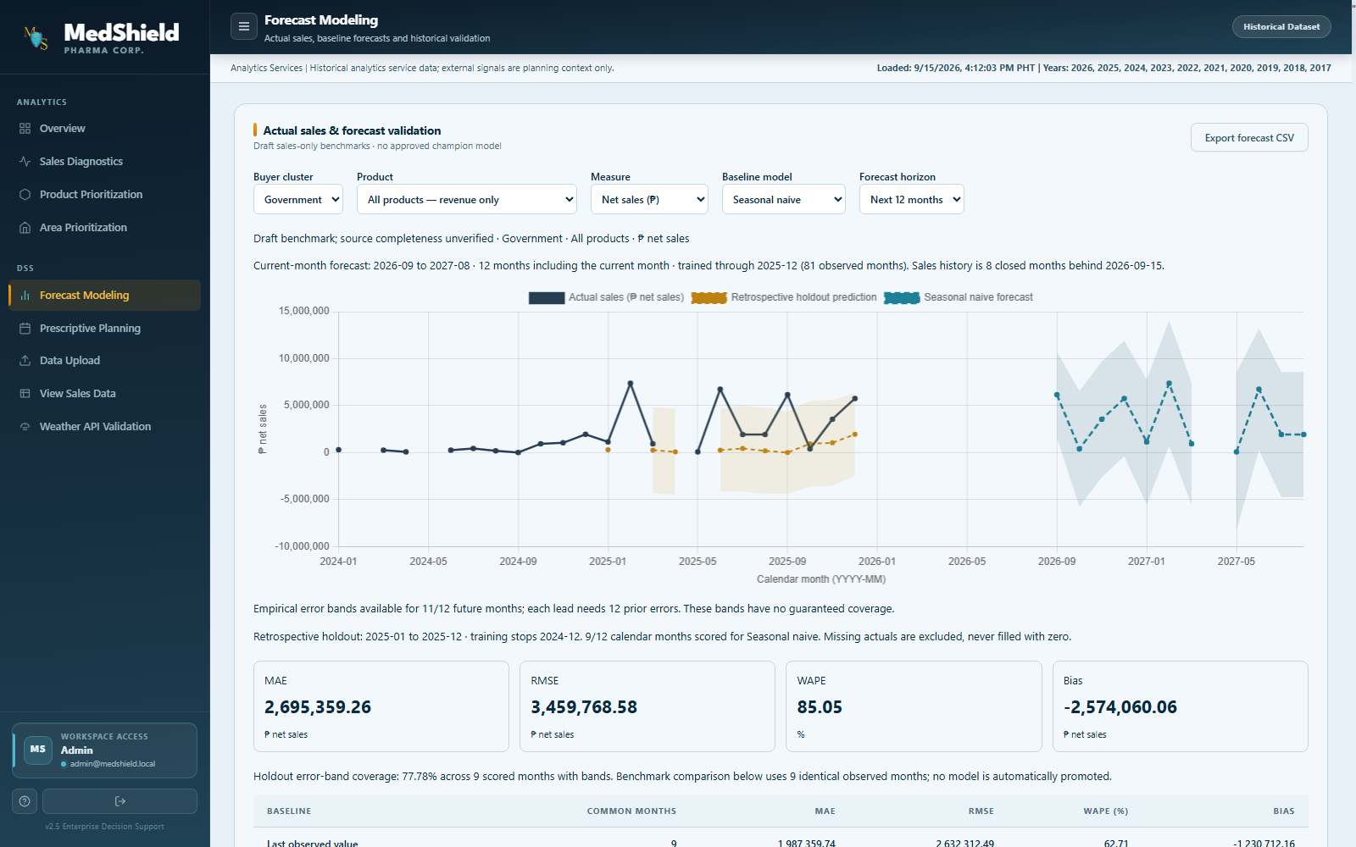
Figure 4.7 Forecast validation dashboard
Source: MedShield development interface capture dated 15 September 2026. The screen illustrates the dashboard workflow; the displayed baseline is evaluation evidence and not an approved model release.
The Forecast Modeling page places the selected buyer, product, measure, baseline, and horizon above one comparison chart. Actual sales, retrospective holdout predictions, and the future baseline are visually separated, while MAE, RMSE, WAPE, and bias remain visible below the chart. This arrangement lets the reviewer see both the forecast and the evidence used to question it before any model is considered for release.
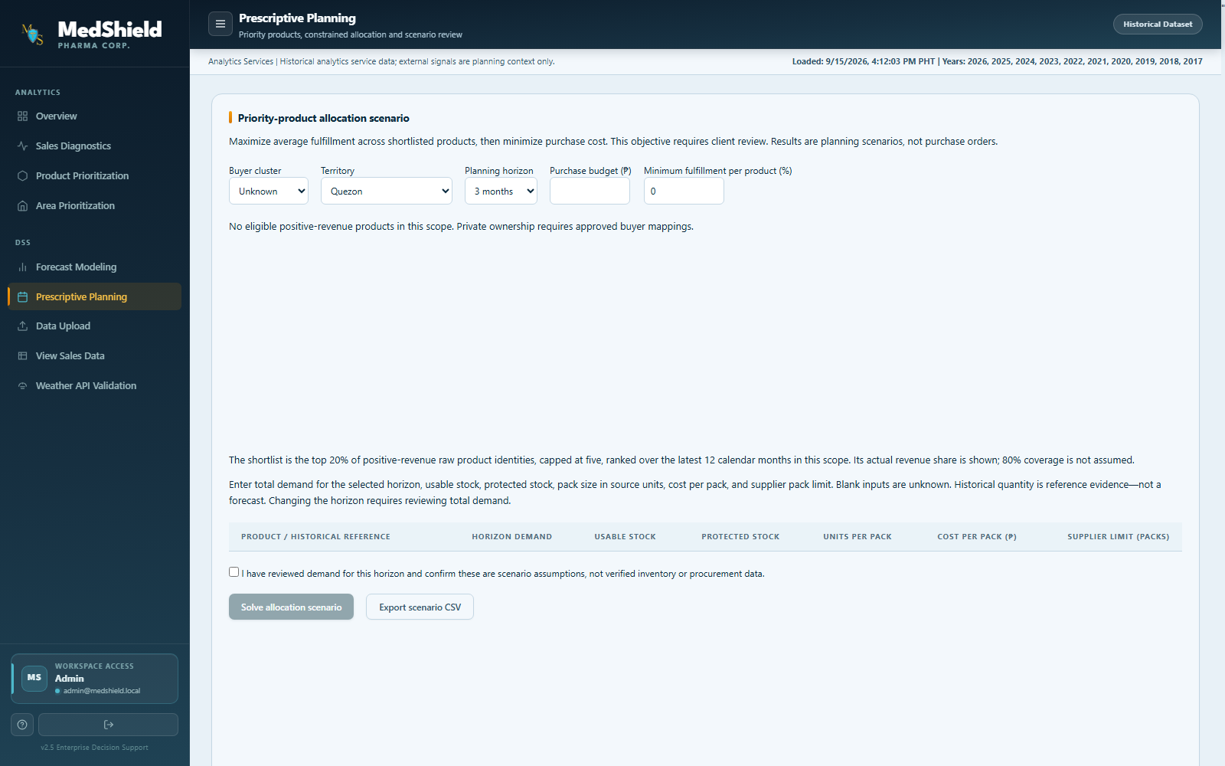
Figure 4.8 Prescriptive planning dashboard
Source: MedShield development interface capture dated 15 September 2026. Inputs and outputs are scenario assumptions, not purchase orders.
The Prescriptive Planning page begins with scope and budget controls, then asks the user to enter demand, usable stock, protected stock, pack size, cost, and supplier limits. The confirmation control makes the user acknowledge that these are assumptions rather than verified inventory or procurement data. The page therefore presents the solver as a reviewable what-if tool and not as an automated purchasing screen.
The Overview summarizes the current historical evidence and publication status before the user enters a detailed module. View Sales Data provides the transaction ledger and provenance fields needed to inspect a displayed total. Data Upload accepts controlled source files, validates the submitted structure, and records ingestion status for review. Weather API Validation keeps official observations and NASA POWER proxy data separately identified. These supporting pages are part of the DSS because they let the user check where a number came from before relying on it in a planning discussion.

4.3.3 Evidence Labels and User Controls
The dashboard uses evidence labels as a control against overinterpretation. Actual identifies observed sales; candidate identifies data or mappings awaiting approval; estimated identifies a calculated gap value; proxy identifies a substitute external observation; baseline identifies a forecasting comparator; blocked identifies a result that cannot be produced under the current data gates; and scenario identifies an output based on user assumptions. Loading, empty, infeasible, and unavailable states are shown explicitly. The browser does not train a model, call an external weather provider directly, or write a purchase transaction. Those boundaries keep the dashboard in its intended role as decision support for an authorized reviewer.

4.3.4 Dashboard Verification
The latest descriptive verification reported 70 of 70 publication checks passing for the version-16 candidate. This means the technical pipeline reconciled at the time of the review. It does not mean that the client approved the product master, area mappings, financial definitions, or model release. The QA record also reports 21 backend unit tests passing, a final eight-case descriptive browser run, five area and buyer-scope regressions, and six matched-period and growth cases with four explicitly retired legacy tests skipped. These sets are reported separately because they overlap in scope and should not be added into one inflated test count.
Table 4.13 Validation and acceptance evidence
Validation area | Observed result | Interpretation
Publication readiness | 70 pass 0 fail 0 unverified | Technical candidate checks passed; business approval still open
Descriptive population | 37,728 facts 108 calendar months 98 observed months | Counts and periods reconcile; ten months remain unavailable
STL | 72 reconciled months and four components | Qualifying 2020 to 2025 segment only
Backend unit tests | 21 passed | Covers current backend logic including filter validation
Final descriptive browser run | 8 passed | Live version-bound descriptive behaviors and exports
Area and buyer regression | 5 passed | Scoped classification behavior
Matched-period and growth suite | 6 passed 4 legacy skipped | Skipped tests are retired and are not counted as passes
Predictive warehouse candidate | 1,092 rows and 15 evaluations persisted | Candidate experiment evidence; active model pointer remains empty
Source: MedShield System QA Review, Current State, Database, and Predictive Operations records dated 27 September 2026.

4.4 Summary of Findings
This section brings together the results that answer the research questions and identifies the claims that remain provisional. The summary gives priority to observed 2017 to 2025 sales, tested system behavior, and documented limitations. The 2026 gap estimates are retained only as interim planning values while actual records are pending; they do not change the historical totals or establish a measured 2026 outcome.

4.4.1 Historical Patterns
The authorized candidate shows ₱626.95 million in observed net sales across 2017 to 2025. Recorded activity is uneven by year and by month, with ten missing months in the early history and a large 2025 value that requires careful provenance interpretation. May and June have the highest observed calendar-month averages. STL provides a separate 2020 to 2025 trend, seasonal, and residual decomposition without imputing the earlier gaps.

4.4.2 Forecast Comparison
On the comparable fixed-origin Government holdout, last observed value performed better than seasonal naive, but its WAPE remained 62.71 percent. In the larger offline experiment, last value also remained selected, with 83.20 percent development WAPE and 37.76 percent retrospective WAPE. These errors, the lack of uncertainty support, and the absence of approved external joins justify the decision to keep the model unpublished.

4.4.3 Product and Area Priorities
SPEEDA 2.5IU/0.5ML is the highest-revenue source product label in the current candidate, while GOVERNMENT is the highest-revenue derived area label. Both findings are useful for review, but neither should be treated as a final canonical SKU or a geographic market-share statement. The approved product master is empty, and the legacy area field mixes different commercial meanings.

4.4.4 Planning Scenarios
The system can produce constrained allocation scenarios after a user supplies operational assumptions. The resulting plan identifies feasible allocations under those assumptions and exposes infeasible constraints. It cannot determine real EOQ, ROP, safety stock, or expiry reduction until the client publishes the required inventory and procurement data.

4.4.5 Decision Support Value
MedShield improves demand visibility by placing source coverage, KPI definitions, historical patterns, priority candidates, forecast errors, and planning assumptions in one review path. Its current contribution is transparency and structured comparison. The study does not establish usability through participant ratings because no REC-approved user evaluation evidence is included in the available record. System tests demonstrate behavior; they do not substitute for user acceptance or perceived usefulness data.

4.4.6 Discussion of the North Star
The evidence supports the first half of the North Star more strongly than the second. MedShield improves demand visibility because it consolidates historical sales, preserves data gaps, shows the basis of each KPI, and makes the status of models and mappings visible. It also creates a path from historical priority to a reviewed allocation scenario. These are practical decision-support gains because they reduce the amount of hidden judgment in a planning discussion.
The study does not yet demonstrate reduced expiry-driven losses. That outcome requires a baseline of expiry or write-off losses, comparable post-implementation observations, and operational inventory inputs. The current system can help prepare such an evaluation by recording the assumptions and decisions used in each scenario. Until outcome data exist, the defensible conclusion is that MedShield provides the information and controls needed to support planning; it has not proven the financial effect of those plans.
The findings also show why simple models and explicit release gates are valuable. A more complex forecasting method did not earn promotion merely by using Prophet or external regressors. The system retained last value because it performed best among the tested candidates, then withheld publication because the errors and uncertainty evidence were still weak. This is consistent with the role of a decision-support system: it should make the basis of a recommendation inspectable and leave the final action to an authorized user.

4.4.7 Limitations
• The Gold sales objects remain candidate publications pending named business and finance approval.
• The product master has no approved entries, so product analysis uses source labels and cannot standardize aliases or pack conversions.
• The legacy area field combines geographic, customer-type, and business-line labels; final mapping approval is still required.
• Ten months have no observed transactions. The study preserves these gaps, but it cannot independently prove whether they represent missing files or no business activity.
• DOH and PAGASA rows are not approved for territory-level forecasting, while NASA POWER remains a separately labeled proxy.
• No predictive model or uncertainty interval is approved for operational publication.
• Inventory, expiry, supplier, lead-time, service-level, ordering-cost, holding-cost, and stock-position data are unavailable.
• The study contains technical and browser validation but no completed REC-approved participant evaluation or final client acceptance record.

4.4.8 Overall Synthesis
MedShield now has a working and testable historical decision-support foundation. The system reconciles 37,728 candidate sales facts, presents 2017 to 2025 performance, preserves ten missing months, decomposes a qualifying 72-month series through STL, ranks product and area labels, compares common-holdout baselines, and exposes constrained planning scenarios through an authenticated dashboard architecture. These results satisfy the descriptive and presentation objectives most directly.
The chapter also records where the project has not yet reached its intended outcome. Product identity and area mappings still need owner approval. External signals are not forecast-eligible. The selected forecast remains unpublished because its errors are high and uncertainty support is incomplete. Prescriptive outputs remain scenarios, and the expiry-wastage target has not been measured. Presented this way, the system is defendable as a historical DSS that improves visibility and review discipline while keeping operational claims within the evidence.
References
Carvajal, T. M., Viacrusis, K. M., Hernandez, L. F. T., Ho, H. T., Amalin, D. M., and Watanabe, K. (2018). Machine learning methods reveal the temporal pattern of dengue incidence using meteorological factors in metropolitan Manila, Philippines. BMC Infectious Diseases, 18, 183.
Hyndman, R. J., and Koehler, A. B. (2006). Another look at measures of forecast accuracy. International Journal of Forecasting, 22(4), 679–688.
MedShield Capstone Group 9. (2026). Capstone project proposal objectives and conceptual framework. Unpublished manuscript.
MedShield Capstone Group 9. (2026). Analytics. Internal project documentation, reviewed 27 September 2026.
MedShield Capstone Group 9. (2026). Architecture. Internal project documentation, reviewed 27 September 2026.
MedShield Capstone Group 9. (2026). Current State. Internal project documentation, reviewed 27 September 2026.
MedShield Capstone Group 9. (2026). Descriptive calculation and STL receipts. Internal validation evidence.
MedShield Capstone Group 9. (2026). Predictive Operations. Internal model-evaluation documentation, reviewed 27 September 2026.
MedShield Capstone Group 9. (2026). System QA Review. Internal verification record, reviewed 27 September 2026.
MedShield Capstone Group 9. (2026). System Documentation. Internal technical and operational overview.

