PROJECT SUBMISSION REPORT
- Student Details
Full Name: Muchina, Marlyn Wairimu
GitHub Username: marlynmuchina
Email: marlyn.muchina@strathmore.edu

- Deployed Project Link
GitHub Link: https://is-project-2026.github.io/laplog-169319/

- Reflection
- Best Commit
URL: https://github.com/IS-PROJECT-2026/laplog-169319/commit/ef0bab7
Why this one? This commit does not add any features, rather than truncating a decimal field to a whole number it adds proper form validation and clear footer linking it to the issue it closes. This commit also was the first commit that went smoothly when merging.
- A Mistake
Link: https://github.com/IS-PROJECT-2026/laplog-169319/pull/11
What happened and how did I recover? My feat/3-log-form branch had a commit that was rejected but after resolving that I realized the file changes had not been committed at all, so I ran git status. I fixed by verifying the file contents before recommitting and started checking git log –oneline after every commit after wards.
- A Pull Request I am Proud Of
PR URL: https://github.com/IS-PROJECT-2026/laplog-169319/pull/14
What did I check before merging? I checked through the files changed tab to check the updates were done where they should, specifically the new feature computePersonalBests logic only flags set that genuinely exceeds the prior best and CSS addition did not affect any other component’s layout then manually tested the updated feature.
- One Thing I Would Do Differently
What would I change? I would build the project incrementally through the issues from the start, rather than committing most of the working project in a single initial commit, in my case I bundled everything into issue #1.
URL: https://github.com/IS-PROJECT-2026/laplog-169319/commit/7c232b1

- Screenshots of Key GitHub Features
- Milestones and Issues
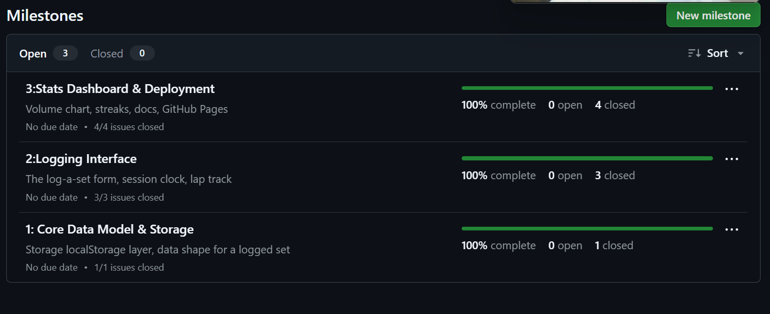
- Project Board
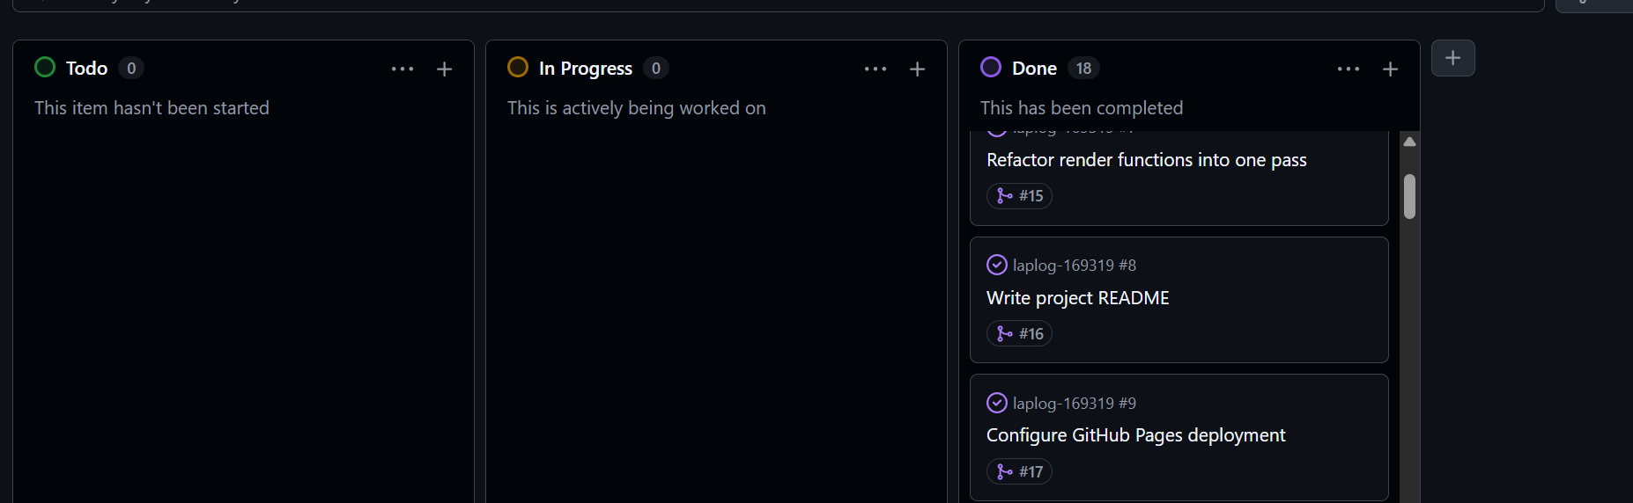
- Branching Architecture
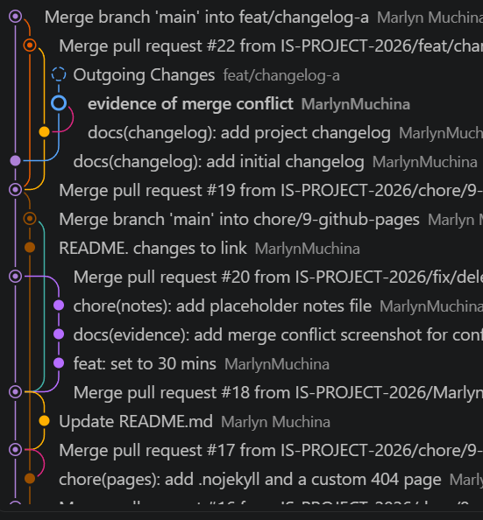
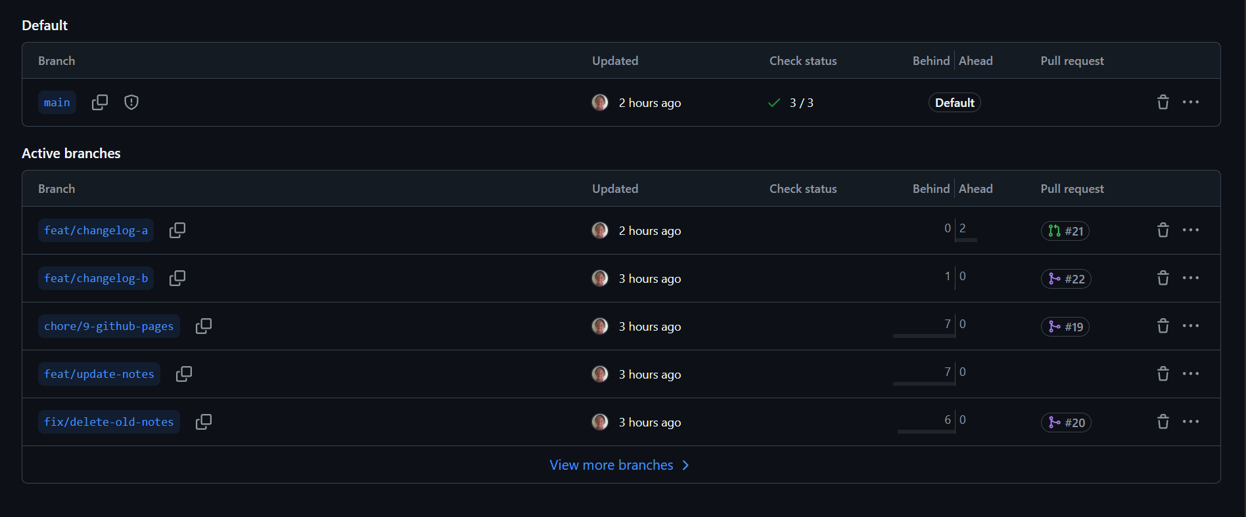

- Pull Request and Traceability
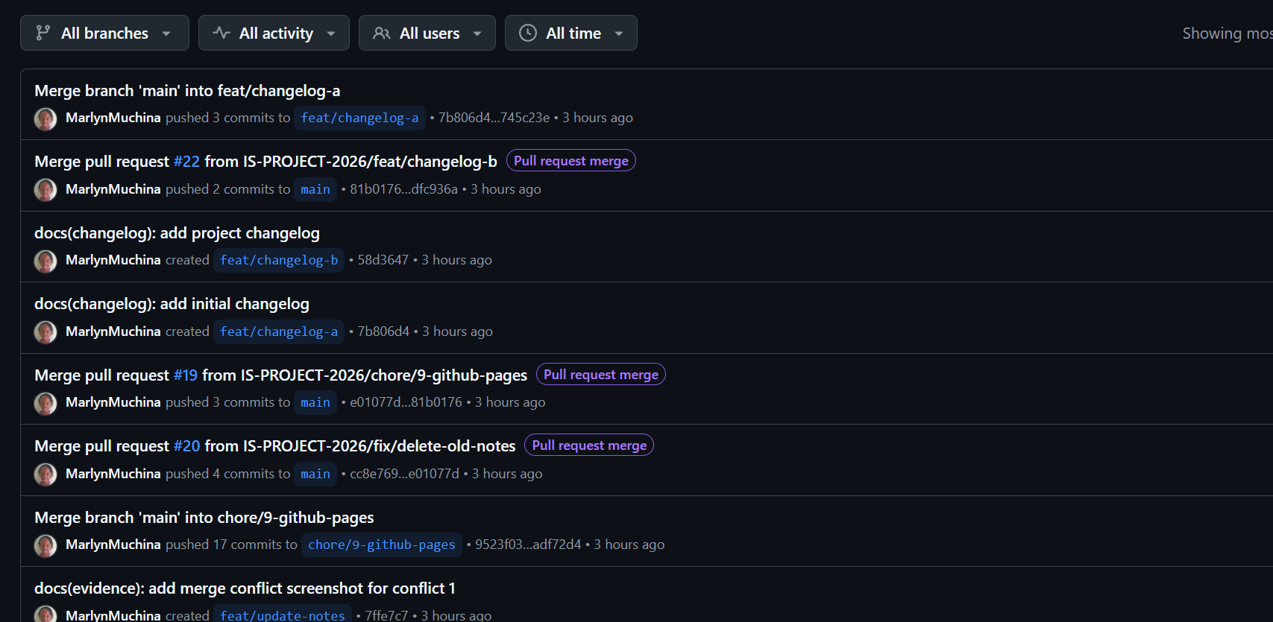

- Merge Conflict Evidence
Conflict 1
Editing the same line, two branches modified the same line.
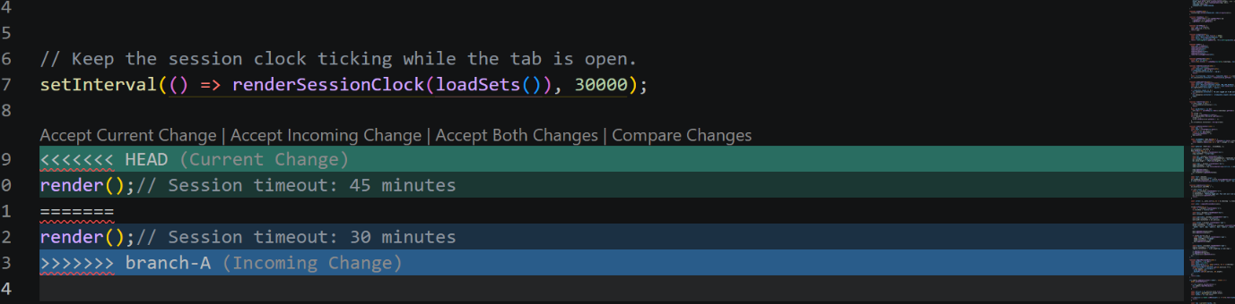

Conflict 2 – Delete/modify conflict
One branch deleted a file while another independent branch edited the contents in the deleted file.
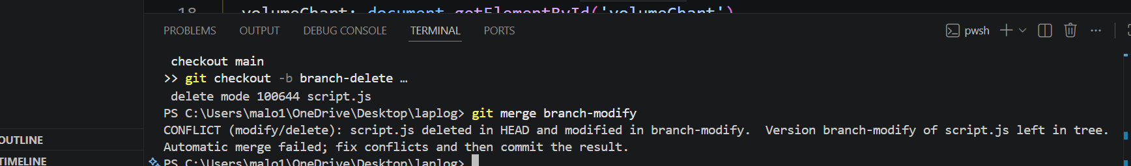

Conflict 3 – add/add conflict
Occurred when two branches create a new file with the same name but different content and since there is no shared history for the file, Git can not tell which version should win.

