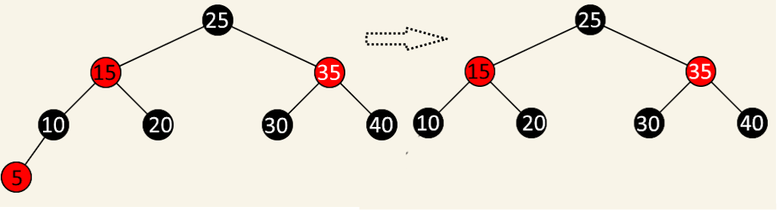
Case |/Node | Description | Required Actions | | FixDoubleBlack?
1/5 | Alone Red node | Remove this node | No

Case |/Node | Description | Required Actions | | FixDoubleBlack?
1/10 | Black node with one red child | Replace x with its child; recolor child to black | No

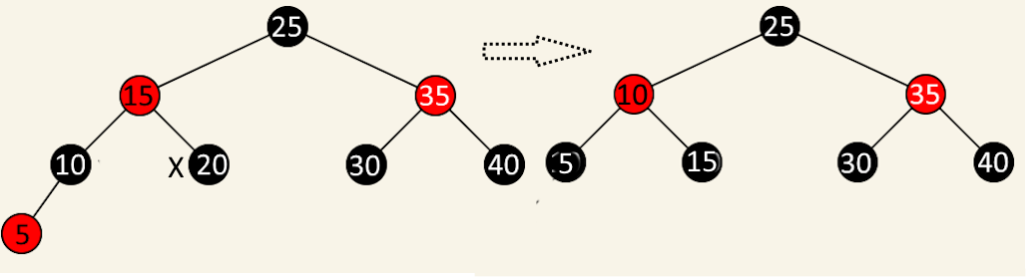

Case |/ Node | Description | Required Actions | | FixDoubleBlack?
2 / 20 | Black child with without childs | Replace x with its parent; recolor it to black | No

