11/22/2013 6th lecture “multi-species flow”#####################################
* Introduction
At first, to start this section, you have to get version 0.2 of share code. Please contact me when you start this section.
This program can calculate reactive flow. To obtain the data related to reactions, this program uses 'CHEMKIN' format. You can see what it is in 'tmp_yamanaka/share_code/Chemkin-II.pdf'. If you want 'CHEMKIN-II' immediately, I give you it, but after this CFD lecture I plan to begin another lecture about the chemical reaction reduction, so you can get it at the time. In this lecture, the chemkin file you use is at 'tmp_yamanaka/share_code/chem.inp' (this file includes thermodynamical data about species and reactions), and so you can use it without understanding what it says.

* how to checkout
You can get the code for multi-species flow if you select 'Cold Flow by chemical kinetics D.B.' at 'thermal model'. When you use it, you have to set the number of species to 'The number of gas types' window. When you use 2 species, type 2 to the window. And you have to set the number of elements and reactions. The windows for these parameters appear when you select the thermal model. Please type 2 and 1 to 'Number of Elements' and 'Number of Reactions' each other.

* control_chem.inp
When you checkout the code, you can get 'control_chem.raw.inp'. This input file is used to define fuel and oxidizer properties.

#Control parameters for chemistry
NumToCalcAtFlameSheet : -1
Oxidizer Pressure(Pa) : 1.e5
Oxidizer Temperature(K) : 300.
Oxidizer Composition(mass ratio):
O2 1
N2 1
end
Fuel Pressure(Pa) : 1.e5
Fuel Temperature(K) : 300.
Fuel Composition(mass ratio):
O2 1
end

NumToCalcAtFlameSheet is used when you calculate the initial condition before ignition. When there is no heat, the flow does not react. So if you put the number of species of reactants in this raw and list the species at the top of species list at chem.inp, the program calculate about only the species when calculating the thermodynamical values such as temperature and molecular weight. When it is set to -1, all of the species will be used to the calculation of the thermodynamical values. In this section, you do not have to use it.
The compositions of reactants are set by mass ratio. You have to put species name first, one space and the ratio in this order. The ratio is normalized automatically, so the sum of the ratio do not have to be one. After the inputs of all the species, you have to make one line saying 'end'.
By this operation, you can get variables below in the module 'chem_var'. The last letters of each variables 'f' and 'o' mean 'fuel' and 'oxidizer' each other. 'ns' means the number of species.
- pf, po … pressure (Pa)
- rhof, rhoo … density (kg/m^3)
- Tf, To … temperature (K)
- Ef, Eo … internal energy (J/kg)
- vrhof, vrhoo … densities of each species (kg/m^3). The sums are rhof and rhoo each other.
- vwf, vwo … mass fractions of each species. The sums are 1 each other.
- vhif, vhio … internal energies of each species (kg/m^3).
- MWf, MWo … molecular weight (g/mol)
- kappaf, kappao … specific heat ratio
- muf, muo … viscosity coefficient (Pa*s)
You can use these values at condition.f90. The file I used to solve the problem next is at 'tmp_yamanaka/share_code/condition_chem.f90'. You can see what to do in this file.

Execise 6.1 boundary layer with multi-species
Solve boundary layer of multi-species flow. The inflow velocity is 0.1 m/s, the pressure is 1 bar, the temperature is 300K. Set the initial condition filled with O2 and set the inflow gas to CO2, then you can see O2 is being replaced by CO2.
In the calculation of this problem, you can use pre-conditioner, but because this problem has discontinuity, Newton-Raphson method, which is one part of the pre-conditioner scheme you used last time, can not be used.
Then you can use another one. The newer version of my program has pre-conditioned one deformated by LU-SGS scheme. The name is 'Pre-conditioner with LU-SGS'. You can solve the problem quickly with this scheme. Try it.
To see the mass fraction of each species, the vtk files has 'phi001' and 'phi002'. They are the mass fractions of CO2 and O2 each other this time, so you can see the replacement of O2 by this value as the image below.
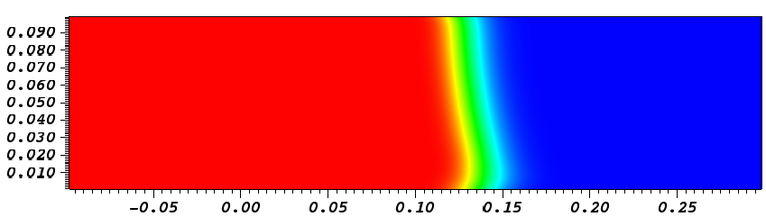

11/15/2013 5th lecture “Newton-Raphson, preconditioner and dual time step”##########
* Governing Equations
For Governing Equations, see “tmp_yamanaka/share_code/Dual Time Step_2.pdf”. This text was written by Dr. Motoe. Although the title of this text is “dual time step”, this governing equations is Newton-Raphson method. If you multiply preconditioner matrix to the differential of t, the equation becomes pre-conditioner.
- Newton-Raphson method
This method is used when one needs both high time accuracy and large time step. This method is 2nd order, but 1st order time accuracy scheme can be used at internal step.
- Pre-conditioner
This method is used when one needs only the converged solution and to solve low-Mach number phenomenon.
Normally, the eigenvalues of jacobian of F by Q is local speed and local speed plus/minus acoustic speed. So when the absolute value of local speed is far smaller than the one of acoustic speed, this matrix becomes stiff and unrealistic time step is necessary to obtain the converged solution. But by multiplying some matrix to the time differential, one can change this eigenvalues so that the absolute values of them becomes near. This matrix is the pre-conditioner.
For more close description, see “tmp_yamanaka/share_code/AIAA-12946-604.pdf”.
- Dual time step
When using pre-conditioner, we cannot see unsteady phenomena because we changed the governing equation. But if we modify only the tau differential, each internal converged solution become the ordinal governing equation because at each internal loop the tau differential has to vanish. So in this way we can obtain unsteady time accuracy also with pre-conditioner when we use this scheme.
However, the current version you have may have some bugs, and I have few succeeded experiences in this scheme. I guess the bugs may be:
- Mistakes at governing equation when making LU-SGS scheme.
- Using conservative quantities at pre-conditioner ( easier to oscillate than primitive ones)
In my research, because the chemical time step is smaller than the flow one, I cannot use this scheme, so I do not attack this bugs now. For governing equations, see my text @ 'tmp_yamanaka/share_code/DualTimeStep.pdf'. The latter part is about this scheme.

* control.inp
In the program, there are many parameters which control the schemes above. You can see them as follows at control.raw.inp if you select the time schemes above.

#For Internal Loop Control
InternalLoop CFL tau : 1.e-2
InternalLoop Omega Max : 1.e-1
InternalLoop Omega Min : 1.e-3
InternalLoop Dqrate Max : 1.e-2
InternalLoop ResRateWarn: 1.e-5
InternalLoop ResRateErr : 1.e-3
InternalLoop OutOmega : true
InternalLoop Max Number : 60

At internal step of this scheme, Delta q is added with relaxation factor. This factor is set as to the change of densities of each species do not exceed some percentage of the densities itself each. This amount is 'InternalLoop Dqrate Max'. So if it is 1.e-2 as the example, the percentage is 1%.
The other parameter which controls the relaxation factor is 'InternalLoop Omega Max'. This parameter determines the maximum value of relaxation factor. So if it is 1.e-1, the relaxation factor is 0.1 or less. (if it is less than 0.1, the value is determined from 'InternalLoop Dqrate Max'.)

In some calculation, the time scheme above does not suite and the calculation diverges. This divergence can be catch by 'InternalLoop Omega Min', 'InternalLoop ResRateWarn' and 'InternalLoop ResRateErr'.
'InternalLoop Omega Min' shows the lower limit of relaxation factor. If the relation factor calculated by 'InternalLoop Dqrate Max' is very small, we had better to use small time steps. So if the relaxation factor is smaller than 'InternalLoop Omega Min', the program stops.
Even the relaxation factor is large, if the internal loop does not converge, the concept of this scheme collapses. This can be catch by 'InternalLoop ResRateWarn' and 'InternalLoop ResRateErr'. These factors watch the energy residuals rate of (last internal step)/(first internal step) and warn if the rate exceeds 'InternalLoop ResRateWarn', stops the program if the rate exceeds 'InternalLoop ResRateErr'.

'InternalLoop CFL tau' is cfl number to tau at dual time step scheme. 'InternalLoop Max Number' is the number of internal loop.

* how to adjust the parameters
To adjust the parameters, if you set 'InternalLoop OutOmega' to true, you can get 'internal_res.dat'. (For fast calculation, please set it false.) This file records internal step number at 1st column, the relaxation factor calculated by Dqrate (not modified by Omega Max) at 2nd column, and the residuals rate of (current internal step)/(first internal step) at 3rd column. I will show some criteria to change the parameters from this record.
- Increase 'InternalLoop Max Number', when the residual rate decrease exponentially but does not reach the 'InternalLoop ResRateErr' because of the shortage of the number of internal loop.
- Decrease 'InternalLoop Max Number', when the residual rate reaches the limit at the step number far less than the 'InternalLoop Max Number'.
- Increase 'InternalLoop Omega Max', when the convergence of internal loop is very slow compared with the standard below, and the relaxation factor is controlled mainly by this factor.
- Decrease 'InternalLoop Omega Max', when the omega does not increase exponentially and the relaxation factor is determined by Omega Max at first internal step. This situation occurs when the Delta q of internal step is too large and becomes poor estimation and is not controlled by Dqrate, so at first step the updated q becomes too poor to be modified by other internal steps.
- Increase 'InternalLoop Dqrate Max', when the convergence of internal loop is very slow and the relaxation factor is controlled mainly by this factor.
- Decrease 'InternalLoop Dqrate Max', when the omega does not increase exponentially and the relaxation factor is determined by Dqrate Max at first step.
These do not have theoretical reasons. They depend on my experiences. So they may be wrong. Please try various parameters.

* standards of parameters
- 0.1 @ Omega Max...If it works well, 0.8 or 0.9 is also OK, I have used 0.01 also in dual time step scheme.
- 0.001 @ Omega Min... Any calculations below this limit have never yielded proper answers. I think this limit should be fixed.
- 0.01 @ Dqrate Max... To be honest, this parameter works only when multi species are used. I have used 0.001 in this value in dual time step scheme. In my experiences, 0.1 was too big.
- 1.e-5 @ ResRateWarn and 1.e-3 @ ResRateErr … I think you should decrease ResRate at least three order of magnitude. So I propose that 1.e-3 @ ResRateErr is fixed. Because ResRateWarn yields only warnings, you can select a value you want for this parameter.
- 60 @ Max Number … This number is used when multi species problems are calculated. In my experiences, 20 is sufficient at ideal gas problems. I have used 100 when I calculated multi species problems with Dual Time Step schemes.

Exercise 5.1 Boundary layer at low Mach speeds
When other schemes, such as Euler scheme, 2nd order Runge-Kutta scheme or LU-SGS scheme, are used to boundary layer problem at low Mach speeds, many time steps are necessary to obtain the converged solution. However, when you use pre-conditioner, you can obtain it immediately. Please try LU-SGS scheme and pre-conditioner scheme, and feel the differences.
The same grid to Exercise 4.1 can be used. Please use real coefficient of kinematic viscosity --- it is about 1.6e-5 when air at normal temperature is used. To obtain same boundary layer geometry to Exercise 4.1, the inflow velocity will be about 0.1 m/s. If you get converged solution, compare it with the blasius solution.

11/8/2013 4th lecture “MUSCL and viscosity”###################################
* MUSCL
You can use MUSCL easily by selecting 'MUSCL' at tabular 'high order scheme' at GUI.py. If you select 'MUSCL', you can get 'control.raw.inp' as follows.

#FOR GENERAL PARAMETERS
Max Step Number : 1.e7
convergent RMS : 1.e-14
CFL Number : 0.3
File Output Period : 5000

#FOR MUSCL
MUSCL ON(1)/OFF(0) : 1
MUSCL Precision Order : 3

Now you know how to modify the upper part, but you do not know about the lower part.
For 'MUSCL ON(1)/OFF(0)' you can decide to use or not to use MUSCL by set it 1 or 0. No other number is allowed.
For 'MUSCL Precision Order', you can decide the order. You can select 2 or 3. If you select 2, kappa is -1, and if you select 3, kappa is 1/3. Only Van Albada limiter can be used now.

* viscosity
You can use viscous term easily by selecting 'viscous flow' at tabular 'viscosity' at GUI.py.
No specific parameter at 'control.inp' is necessary.

* time scale
To obtain the converged solution, you can use 'local time step'. For closer explanation please see the Shimada text.

* time scheme
You can use Euler and 2nd Order Runge-Kutta scheme, LU-SGS scheme now. To obtain converged solution, you can use LU-SGS and set cfl number to 1 or more because LU-SGS is implicit scheme.

* boundary condition
From now, you can calculate various phenomena. But you have to know about general boundary conditions to do so.
- Slip condition
On slip condition, velocity vector have to be parallel to the wall. So if the boundary of j=1/2 is slip wall, from the figure below,
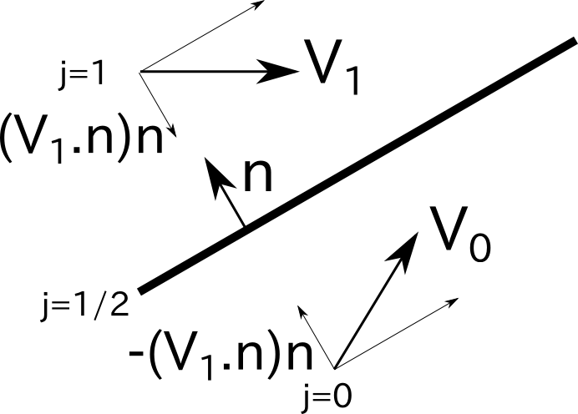

V0=V1-2*(V1.n)n
where n is normal vector to the wall.
At the program, n is stored as vni and vnj. vni(:,i,j) is normal vector of (i+1/2,j) wall and vnj(:,i,j) is normal vector of (i,j+1/2) wall.
- Non-slip condition
On non-slip condition, V0=-V1 because V must be 0 at wall.
- Subsonic inflow
All of the parameters except pressure have to be assigned. Only pressure has to be extrapolated.
- Subsonic outflow
All of the parameters except pressure have to be extrapolated. Only pressure has to be assigned.

* for memory allocation
The program belows use large memory. So you have to run the command before run the main program.

ulimit -s unlimited

Or segmentation fault will occur.

Exercise 4.1 Boundary Layer
Now you can use MUSCL and viscous flow, you can calculate boundary layer. At the share disk 'disk', at 'tmp_yamanaka/share_code/' you can get ideal_bl.x. At this grid, set the boundary conditions as follows.

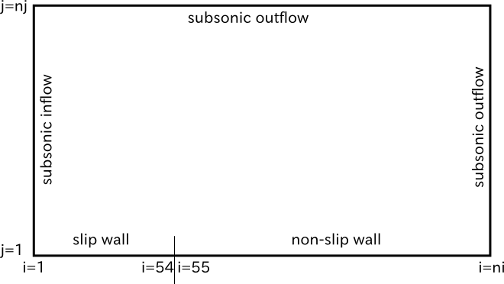

To obtain the converged solution, low-Mach speed is bad. However, if the velocity is high, the boundary layer becomes thin and turbulent flow easily. So if you want to check the code, you can change the viscosity coefficient. The solution below is obtained at inflow velocity is 100 m/s and obtained 2 cm boundary layer at 10 cm from the front edge of boundary layer (i=55). You can calculate the viscosity from the boundary layer theory. The viscosity coefficient can be changed at GUI.py.
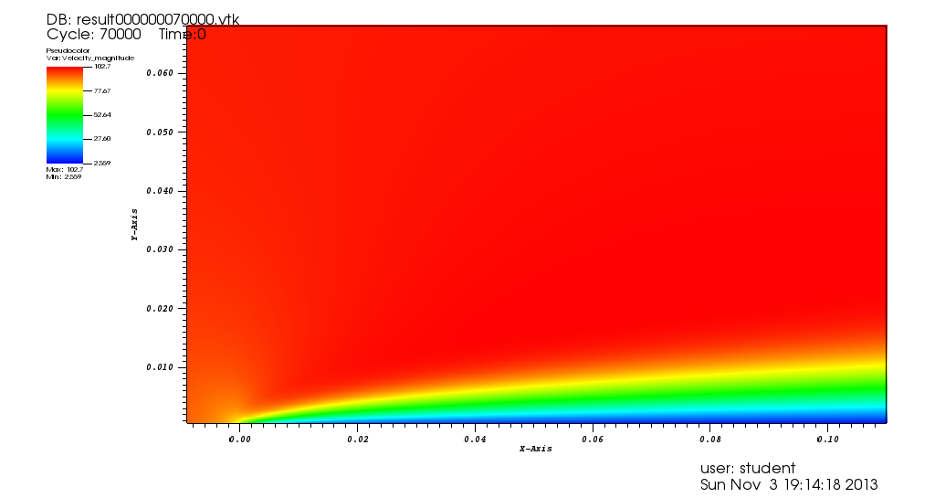

If you get the solution, you can compare the solution with the blasius solution. The figure below is my one. To obtain the distribution of velocity, you have to rewrite the postprocess.f90. You can get it from main.f90 directly, but as the practice for future, please get it by rewriting postprocess.f90. You can get blasius analytical solutions below at 'tmp_yamanaka/share_code/blasius.plt'
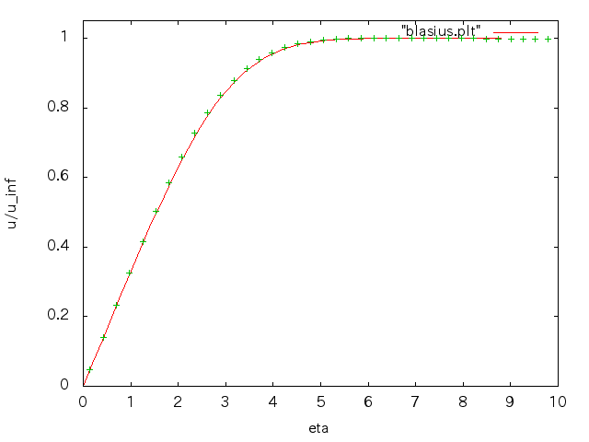

Exercise 4.2 naca0012
NACA0012 wing is symmetrical wing. You can obtain experimental data of pressure distributions of this wing at 'tmp_yamanaka/share_code/NACA0012_CP_Data.pdf'. Though this data is obtained at the turbulent flow, if you calculate the pressure distribution at non-viscous flow condition, the calculated one agrees well with the experimental one as follows.
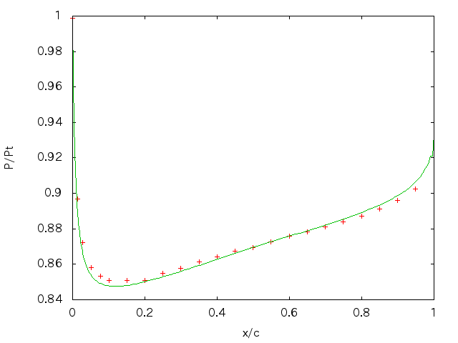

The line is calculated one, and the points are experimental one. You can get the grid at 'tmp_yamanaka/share_code/naca0012.x'.
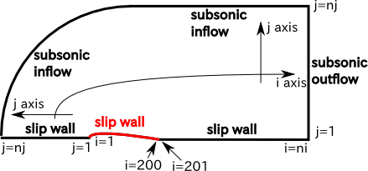

Red line is wing. So only half of the wing is calculated because at this problem attack angle is zero and symmetric wing is used. The pressure contours are as follows.
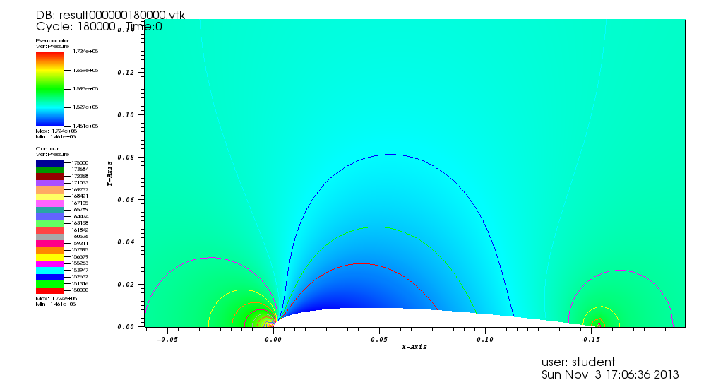

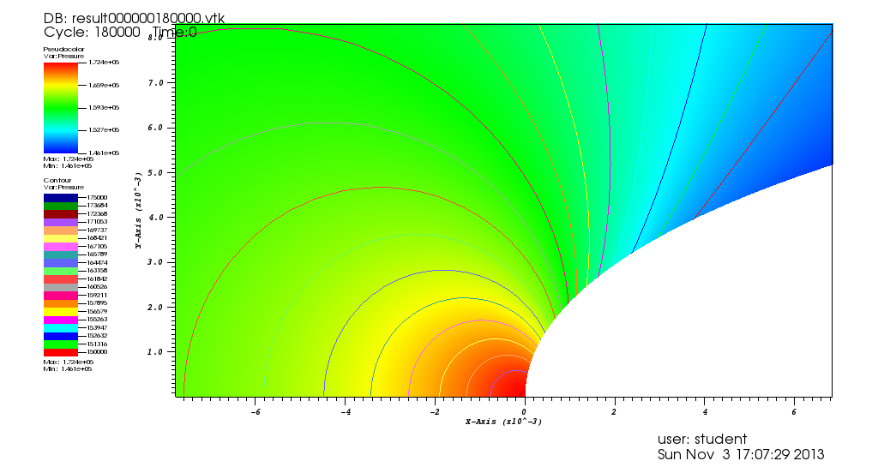

You can get the pressure data file I used from 'tmp_yamanaka/share_code/naca0012.dat'. To calculate the other conditions, you can see 'NACA0012_CP_Data.pdf'.

11/1/2013 3rd lecture “condition.f90”##########################################
* Introduction
In the previous lecture, all of the file except one file are generated by your instruction. The file you have never edit is 'condition.f90'. In this file, you can control the initial conditions and boundary conditions.
Before talking about this file, I will explain some modules condition.f90 uses. They are:
- n_grid.f90
module contains major parameters such as the dimension of q.
- variable.f90
The module contains major variables.
- mod_mpi_dummy.f90
The module for MPI dummy functions. MPI functions are used in super computer.

* Legends … the values not mentioned below are explained at the lectures later.
- n_grid.f90
- ni … the number of cell of i-direction
- nj … the number of cell of j-direction
- nY … the number of species
- dimq … the dimension of q
- dimw … the dimension of w
- indxg … the index of specific heat ratio at w
- indxht … the index of total enthalpy (J/kg) at w
- indxR … the index of gas constant (J/kg/K) at w
- indxMu … the index of viscosity (Pa*s) at w
- variable.f90
- q … the conservative values
  - index=1 … nY : the density of each species
  - index=nY+1 : the momentum of x-direction
  - index=nY+2 : the momentum of y-direction
  - index=nY+3 : the total energy (J/m^3)
  - qp … q of previous time step.
  - qpp … qp of previous time step.
  - w … primitive values
- index=1 : the total density
- index=2 : the velocity of x-direction
- index=3 : the velocity of y-direction
- index=4 : pressure
- index=5 … nY+4 : the mass fractions of each species
- index=nY+5 : specific heat ratio
- index=nY+6 : total enthalpy (J/kg)
- index=nY+7 : gas constant (J/kg/K)
- index=nY+8 : viscosity (Pa*s)
- vhi … the internal enthalpy of each species (J/kg)
These values contain the enthalpy of production.
- wHli,wHri, wHlj, wHrj … w estimated by high order schemes ( ex. MUSCL)
- 'l' is 'left', 'r' is 'right', 'i' is i-direction (+1/2) location, 'j' is j-direction (+1/2) location.
- ex) wHli(:,2,3) represents the left side values of w_{2+1/2,3}
- TGi, TGj … TG values of i-direction and j-direction each other. For TG value, see Section 9 of Shimada Text. These values are also at (+1/2) locations and the indices are the same as the wH values.
- TGvi, TGvj … the viscous fluxes.
- Vol … Volume of each cell at axi-symmetric problems and Area at two-dimensional plane
- dsi, dsj … Delta s of i-direction and j-direction.
- vni, vnj … normal vectors.
- xh, rh … the coordinates of cross points of mesh. The same (+1/2) rules are used.
- x, r … the coordinates of cell centers
- dt_mat … Delta t of each cell at local time step.
- dt_grbl … Delta t of grobal time step.
- mod_mpi_dummy.f90
- nxs, nxe … start and end indexes of i-direction.
- nys, nye … start and end indexes of j-direction.
- When used at super computer, these values represent which regions of the plane the processor is responsible for.

* condition.f90
At condition.f90, you must set the initial conditions and the boundary conditions.
- set_IC
At this subroutine, you must set the initial condition to the variables below.
- all of the q values.
- w(4,:,:) … pressure
- w(indxg,:,:) … specific heat ratio
- w(indxR,:,:) … gas constant
Now you are using ideal gas model, so if you include module 'gas', you can use 'kappa_gas' ( specific heat ratio), 'R_gas' (gas constant), 'nu_gas' ( coefficient of kinematic viscosity).
- set_BC
At this subroutine, you must set the boundary conditions to the variables below.
- all of the w values.
- all of the vhi values.
You must set two cells next to calculated regions. You can see this if you see the indexes of do-loop.
Execise 3.1
Change IC and BC of 'condition.f90'.

10/25/2013 2nd lecture “input file”#############################################
* Introduction
In previous lecture, four input file were prepared. They are:
- debug0.x … for grid.
- checkout.inp … for the generation of source files.
- control.inp … for the modification of input parameters
- condition.f90 … for initial conditions and boundary conditions
In these files, 'debug0.x' is generated from shareware. You can use this program on Share PC, but if you get Super Computer account, you can install it on your personal one in the lab. So in this lecture, if you continue to join this lecture until the beginning of use of Super Computer, I will tell you how to generate debug0.x. But if you want to generate, feel free to ask.
When editing 'condition.f90', some knowledge is necessary and a lot of bugs can easily be generated. So we will use full time of next lecture on this theme.
Therefore, this lecture is dedicated to editing 'checkout.inp' and 'control.inp'

* checkout.inp and checkout.py
By editing checkout.inp and then executing checkout.py, you can get order-made code.
checkout.inp is input file which can select grid file – in this time, 'debug0.x' -, architecture, time scale – global or local -, time scheme, existence of viscosity, high order scheme and thermal model by changing the number responding to each item.
The file you used in the previous lecture is extracted by 'run.sh' you executed and is in the directory 'sample/no00.shock_tube' as 'checkout.inp'. If you copy it to the directory where checkout.py is and run checkout.py, you can get pre-processed source file in the directory 'checkout'.

*GUI.py
GUI.py is GUI program which generate checkout.inp and execute checkout.py. You can do the same operation at CUI manually, but GUI is easier to use.
If you want to use it, you have to install python module. You can do that by running the command below
sudo apt-get install python-wxgtk2.8
and when you want to use it, run the command below.
./GUI.py
then you can get the window like below.
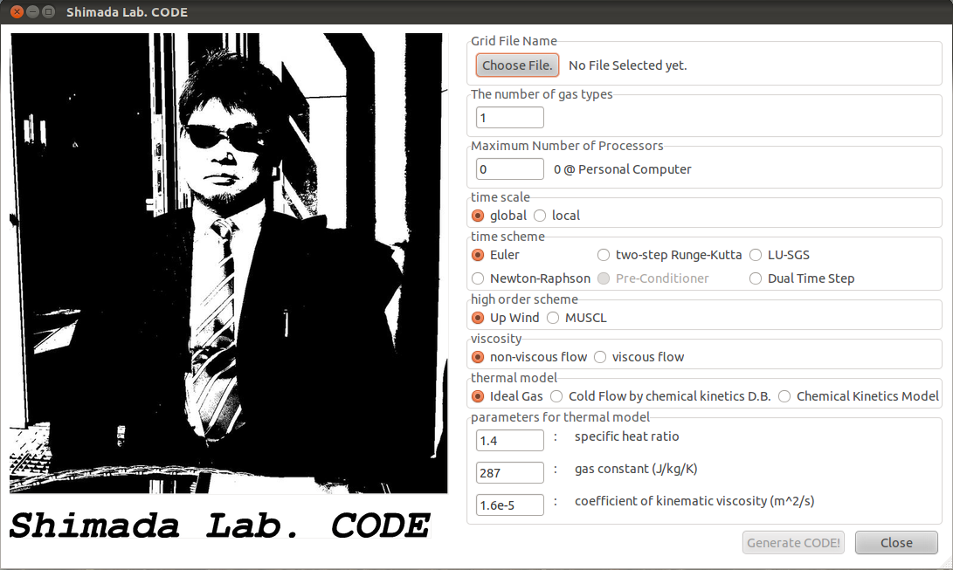
By selecting options and finally push the “Generate CODE”, you can get pre-processed code like you get it by checkout.inp and checkout.py.

Exercise 2.1: Try to make checkout.inp and pre-processed code. checkout.inp must be the same to the one at 'sample/no00.shock_tube' by using GUI.py.

*control.inp
checkout.py can make 'pre-processed' code. In this word, I meant that this code cannot be run as it. We must modify this code. The modifications are about 'input parameters' @ control.inp and 'initial and boundary condition' @ condition.f90.
If your selections of options are the same to the previous lecture, your control.raw.inp @ checkout will be like this:
#FOR GENERAL PARAMETERS

Max Step Number : 1.e7

convergent RMS : 1.e-14

CFL Number : 0.3

File Output Period : 5000

You can change these parameters if you want. If you cannot understand what these values mean, ask it to me. After you finished editing this file, you have to rename it as 'control.inp'.
For compile, you have to edit condition.f90 also @ checkout, but this time, I don't mention how to edit this file. So please remove 'condition.raw.inp' and copy 'condition.f90' from 'sample/no00.shock_tube'.
Then you can compile the program. Run the command below@ directory 'checkout'
make
then you can get program 'main'. You can run the program by the command below.
./main
Then you can get vtk files in 'checkout/result'.

Exercise 2.2: Edit 'control.inp' along to sample/no00.shock_tube/control.inp and copy condition.f90 from the same directory. Then make and run the program.

In the previous lecture, you did the same procedure by running 'run.sh'. By opening 'run.sh', you can see the same commands.

* Post Processing
The program for postprocess is at the directory 'postprocess'. You can compile by 'make' command.
This program also has 'control.inp'. Default file is like this.
#Input File for PostProcessing
File Read Freq. : 100
From Where : -1
Database Place : ../checkout/
OverWrite? Yes(1)/No(0) : 0
i-direction start index : 1
i-direction end index : -1
j-direction start index : 1
j-direction end index : -1
At this time, 'File Read Freq.' is the only parameter to modify. You have to modify it when 'File Output Period' @ checkout/control.inp is changed. (Same value is OK, but multiples of it also.)

Exercise 2.3: change 'control.inp' @ both checkout and postprocess to change 'file output period' to 10. Then visualize that by VisIt or paraview.

10/17/2013 1st lecture “just run”#############################################

*Preparation
OS
Ubuntu only.
Need to install
- VisIt ( visualization software)
- Paraview ( visualization software)
- Intel Fortran ( Free only on Linux System)
All of the softs are free. Either VisIt or Paraview is enough. ( both is better.) VisIt cannot be used on 32Bit version Ubuntu.

*Procedure
- Download and save “share_code.tar.gz” from face book page
- move to directory where the file was saved.
- Run the command below.
tar xzvf share_code.tar.gz
then you can get directory 'share_code'.
- Move to 'share_code'
- Run the command below
cp sample/no00.shock_tube/run.sh .
then you can get run.sh at share_code/
- Run the command below
./run.sh
then the first program “shock tube” will be running and final output will be 'normal end'.
- Move to directory 'postprocess' and Run the two commands below.
make
./postprocess
then you can get vtk files in your 'postprocess/result' directory.
- Open the vtk files via 'VisIt' or 'paraview'

