# Consent

## POST

### 400 Bad Request

#### Case 1: Incorrect Patient ID/Doesn’t exist in MPI

{

    "patient_id": "P0247838",

    "action": "OPTIN",

    "agent": "handoko"

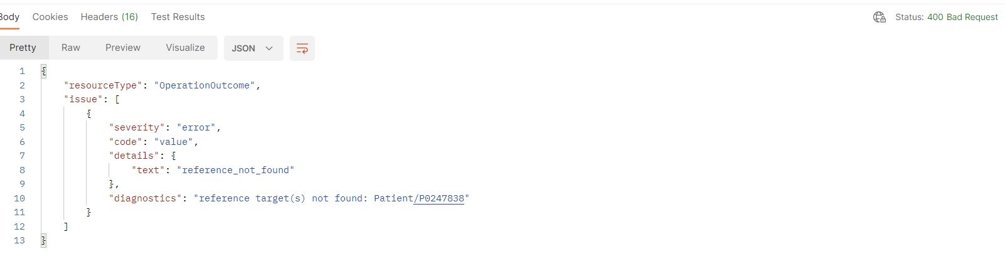

}

### 200 OK

#### Case 1: Duplicate

{

    "patient_id": "P02478375538",

    "action": "OPTIN",

    "agent": "handoko"

}

Same payload, but response is different consent IDs with 200 OK (Treat POST like PUT). The payload action can be updated to OPTOUT.

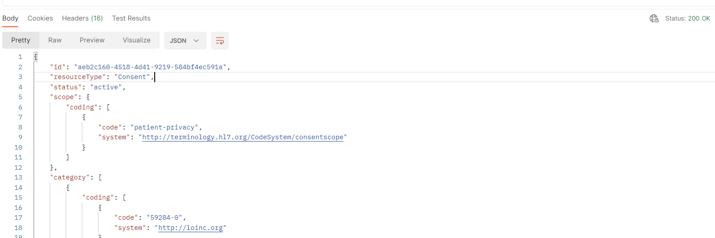

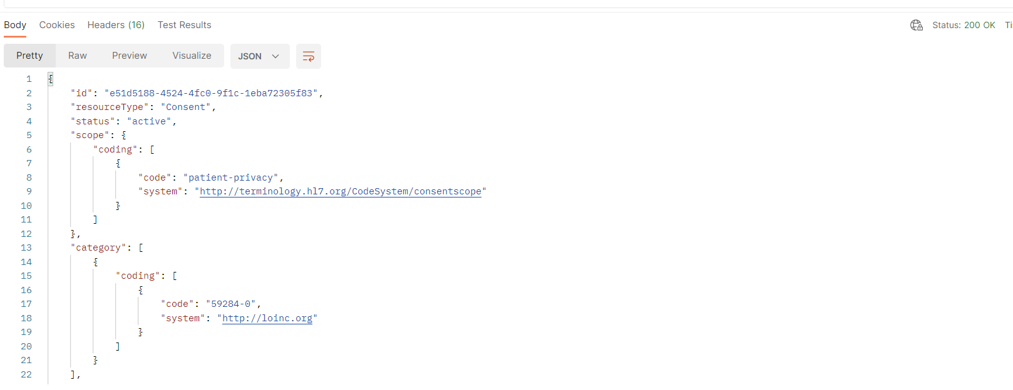

**Note that consent by default is posted with reference to own organization id as shown below

## GET

### 404 Not Found

#### Case 1: No consent posted

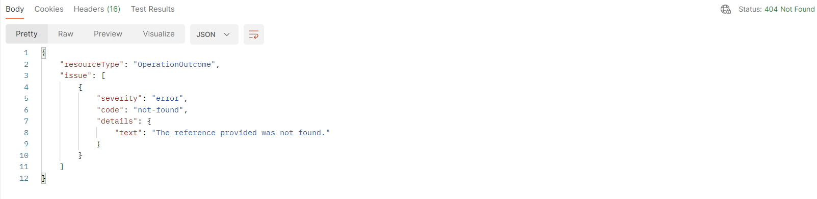

Performing a GET request with the patient’s id will return 200 OK. It will only the most recent consent (most recent consent ID).

# Encounter

Notes:

* When using Location ID that is not under our organization, POST and PUT still works.
* Encounter POST can be done with patient reference for both patients with/without consent.
  + For a successful 201 created
* Encounter with references to other organizations are masked.

## POST

### 400 Bad Request

#### Case 1: Duplicate

Creating an Encounter instance that already exists in the database (same payload)

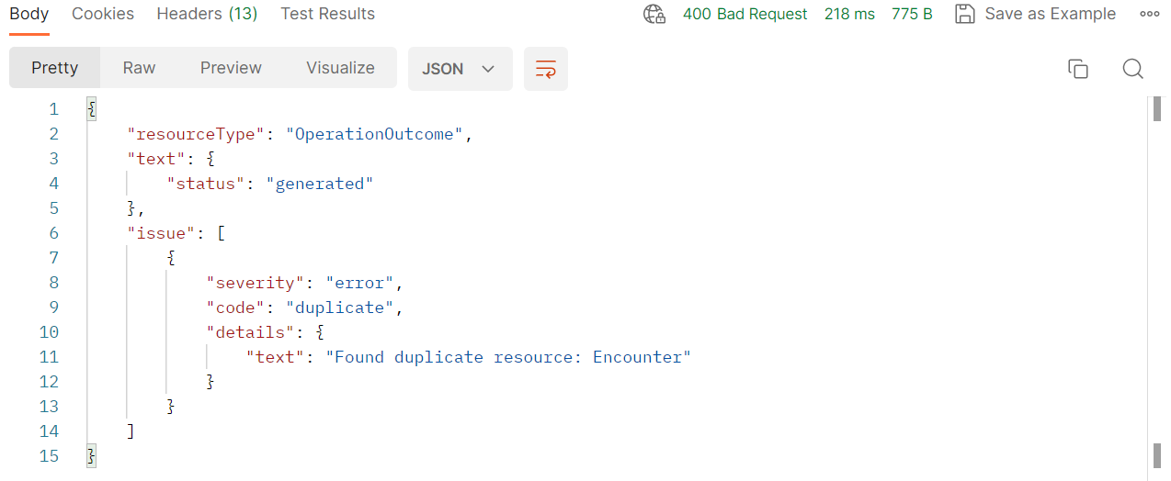

#### Case 2: No Patient in MPI

"subject": {

        "reference": "Patient/P00020000",

        "display": "patient x"

    },

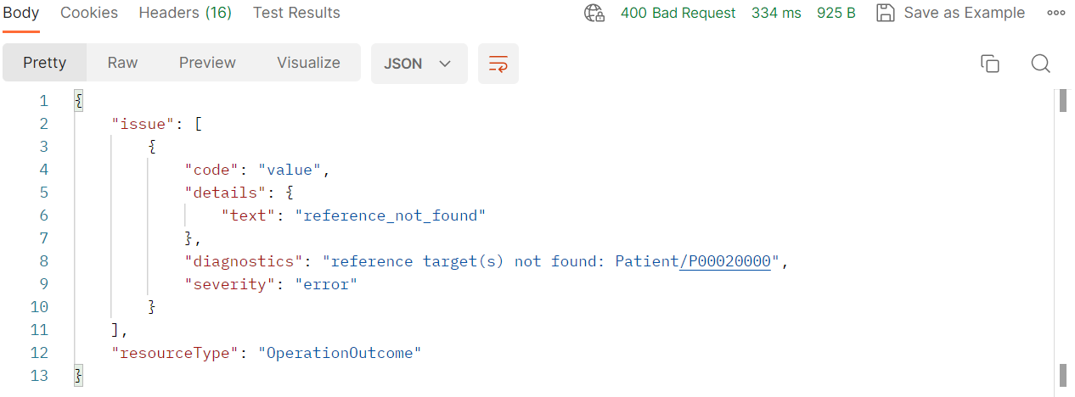

#### Case 3: No Practitioner in MNI

"individual": {

                "reference": "Practitioner/N99",

                "display": "Dokter Bronsig"

            }

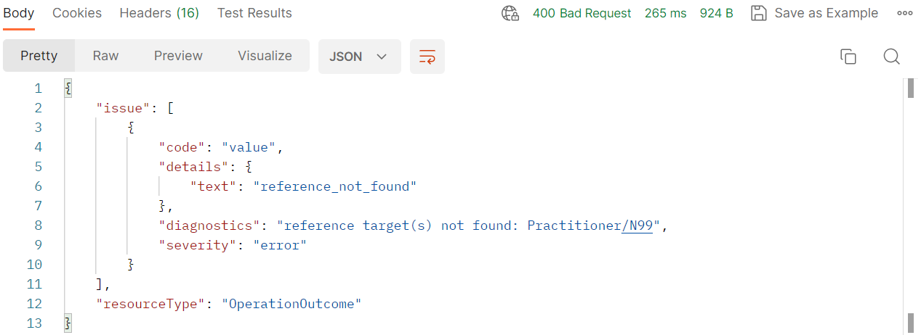

#### Case 4: Invalid Location

"location": [

        {

            "location": {

                "reference": "Location/9999",

                "display": "Ruang 1A, Poliklinik Bedah Rawat Jalan Terpadu, Lantai 2, Gedung G"

            }

        }

    ],

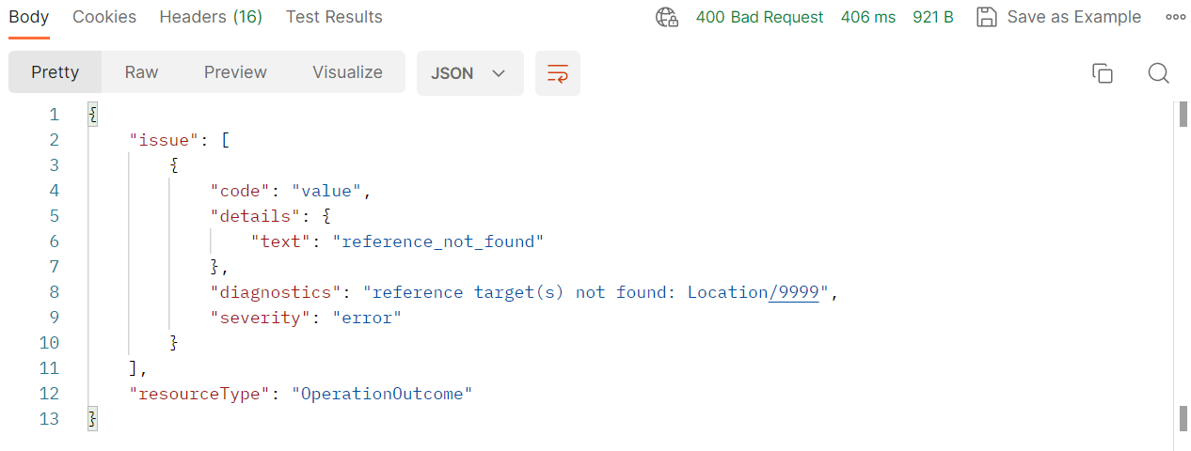

#### Case 5: Incorrect Encounter.class

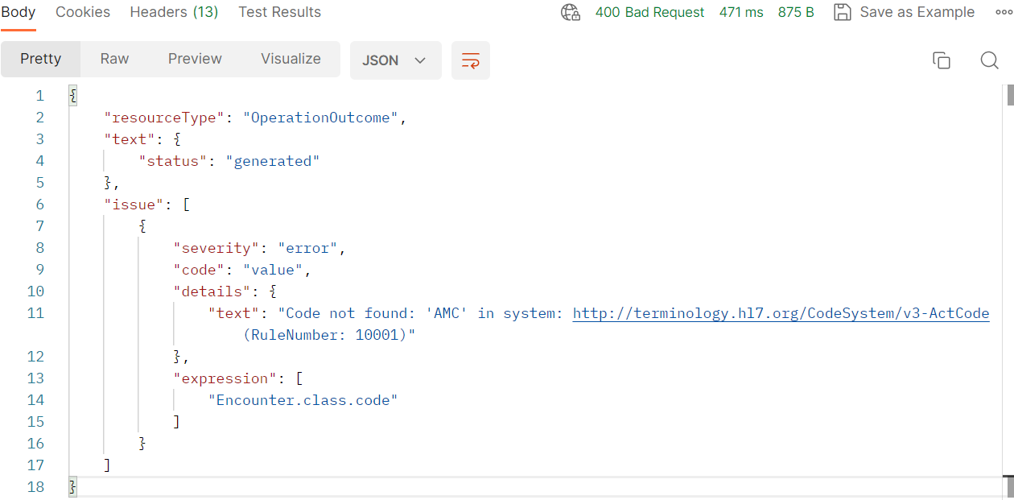

#### Case 6: Incorrect Encounter.status

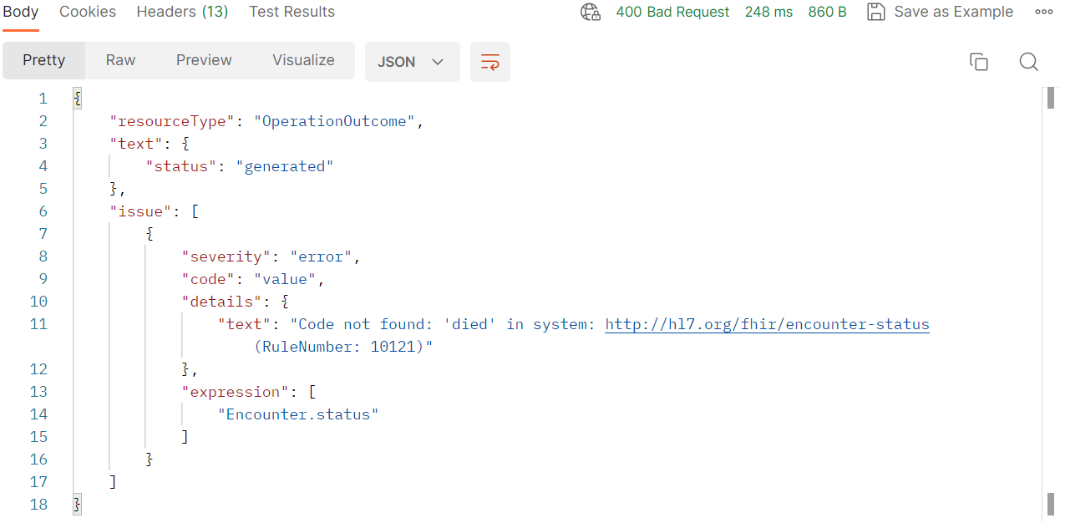

#### Case 7: Incorrect Encounter.participant.type

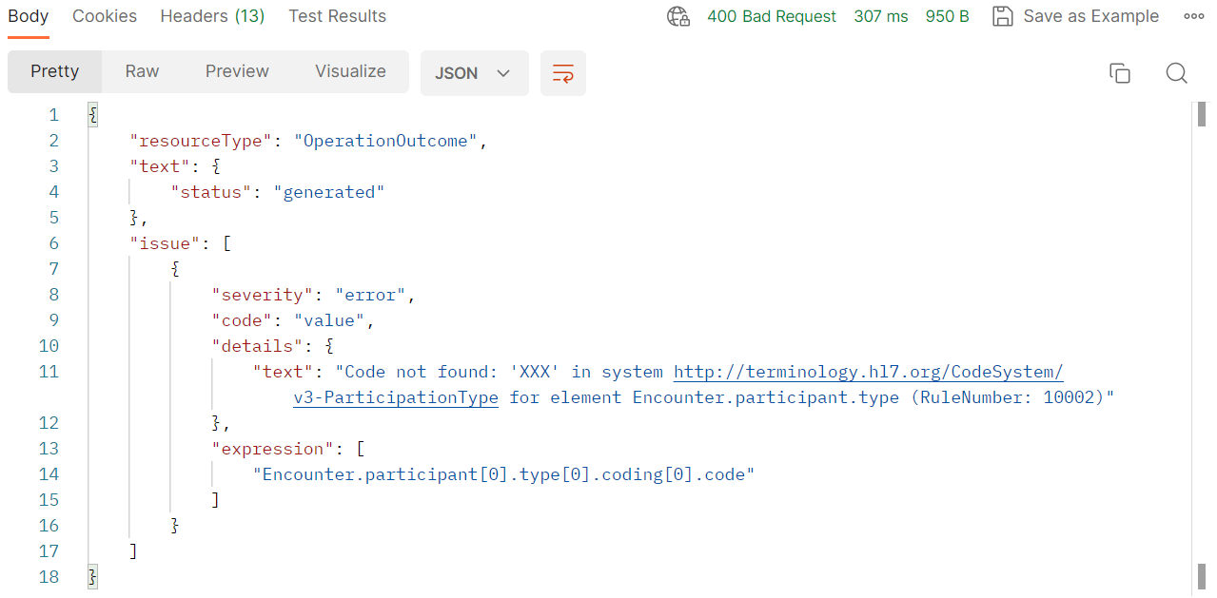

### 403 Forbidden

#### Case 1: Incorrect Organization ID / serviceProvider.reference

"serviceProvider": {

        "reference": "Organization/9999"

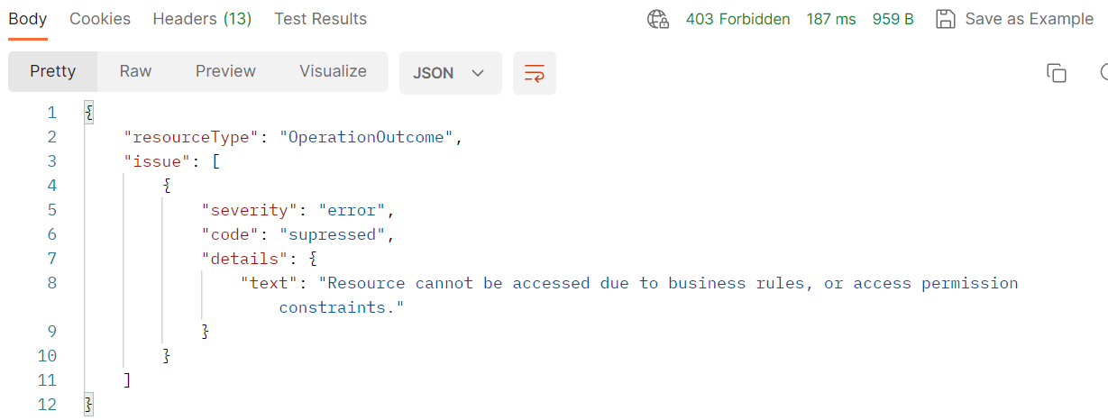

### 201 Created

#### Case 1: Incorrect identifier.system

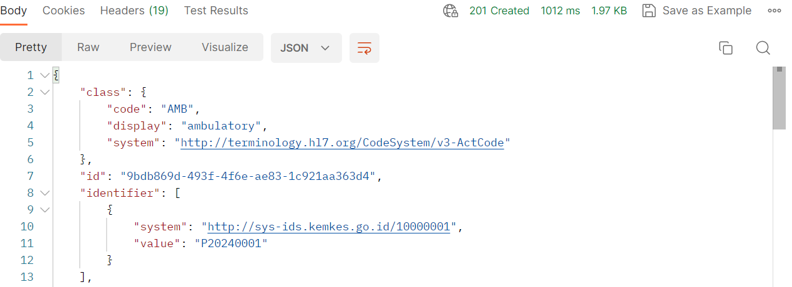

## PUT

### 400 Bad Request

#### Case 1: Invalid resource ID

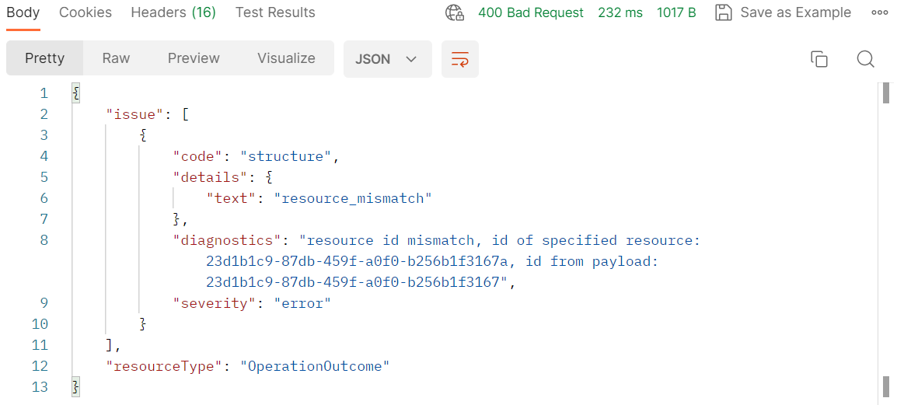

#### Case 2: No Patient in MPI

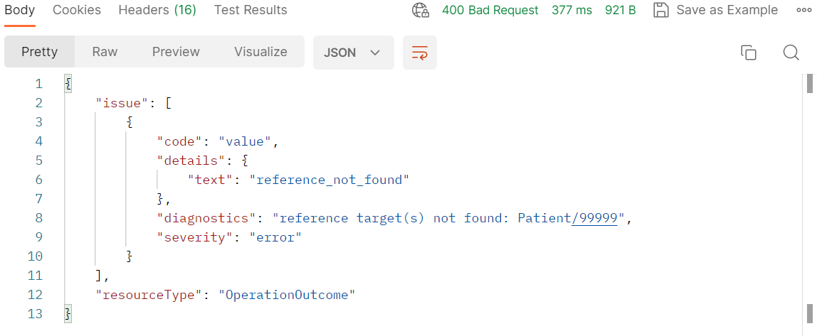

#### Case 3: No Practitioner in MNI

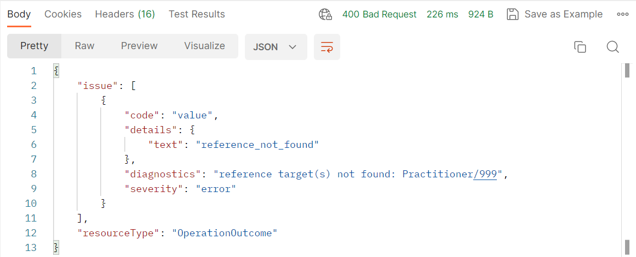

#### Case 4: Invalid Location

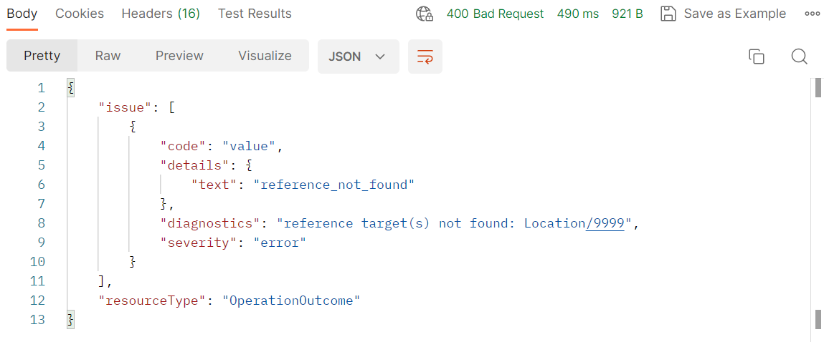

#### Case 5: Incorrect Encounter.class

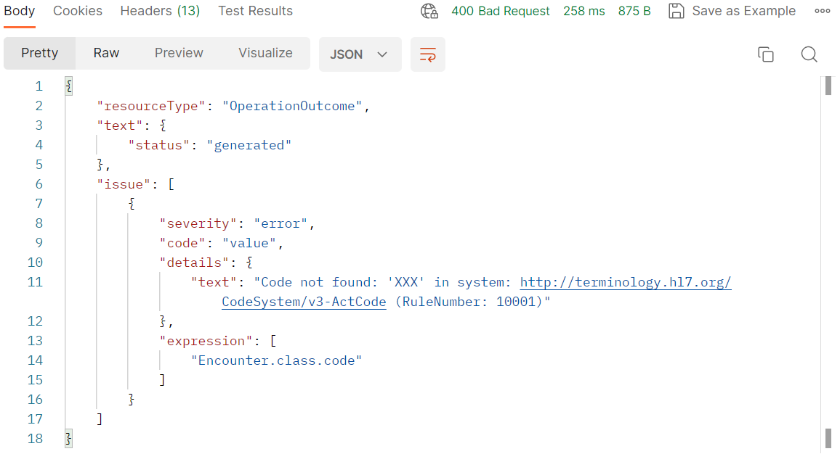

#### Case 6: Incorrect Encounter.status

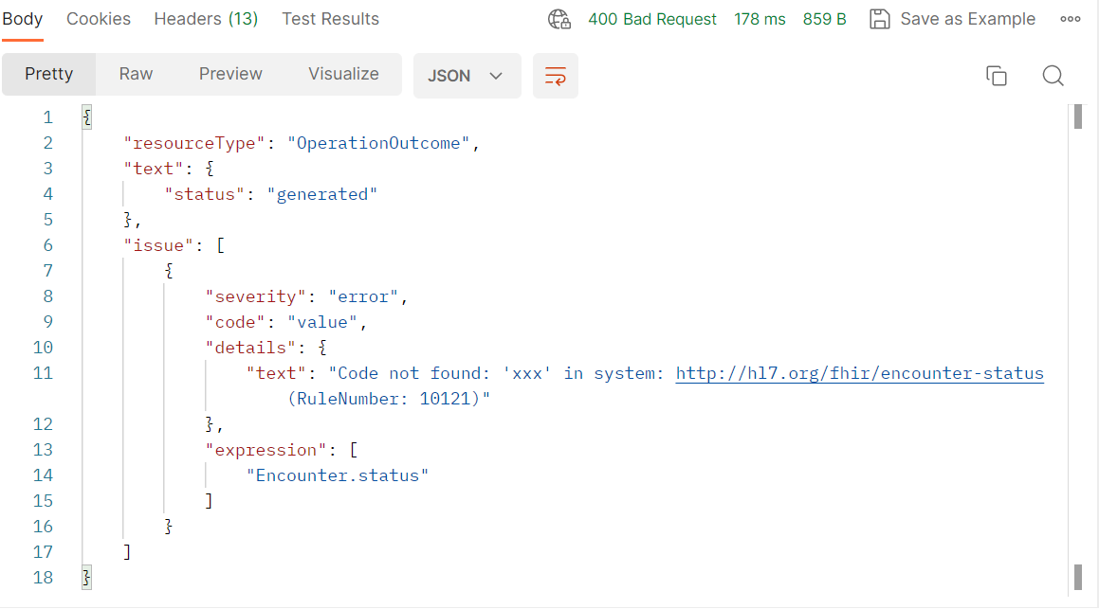

#### Case 7: Incorrect Encounter.participant.type

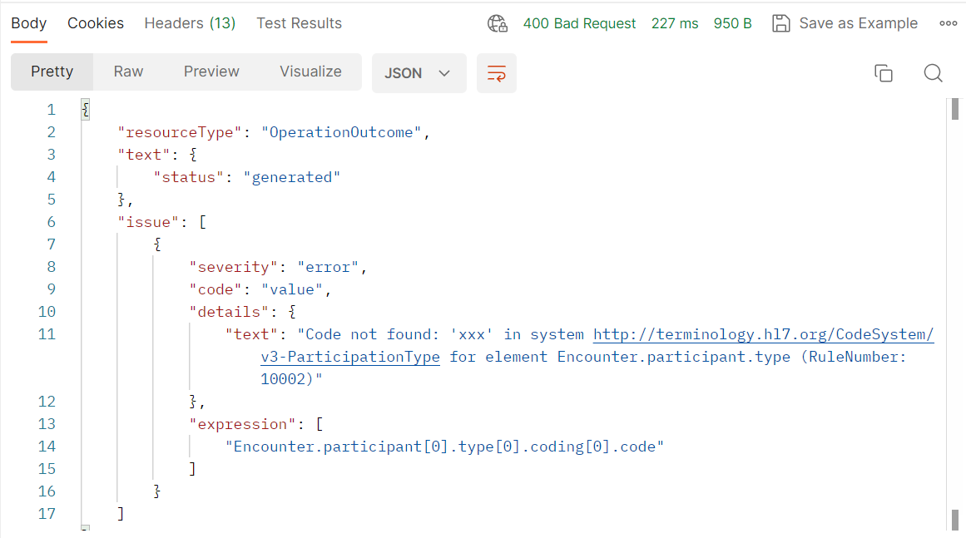

#### Case 8: Incorrect Encounter.hospitalization

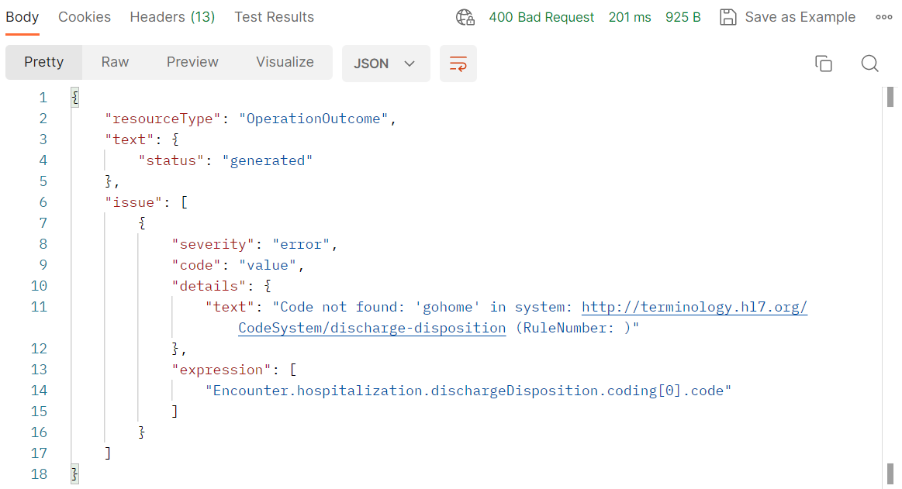

### 403 Forbidden

#### Case 1: Incorrect Organization ID / serviceProvider.reference

"serviceProvider": {

    "reference":"Organization/9999"

  }

}

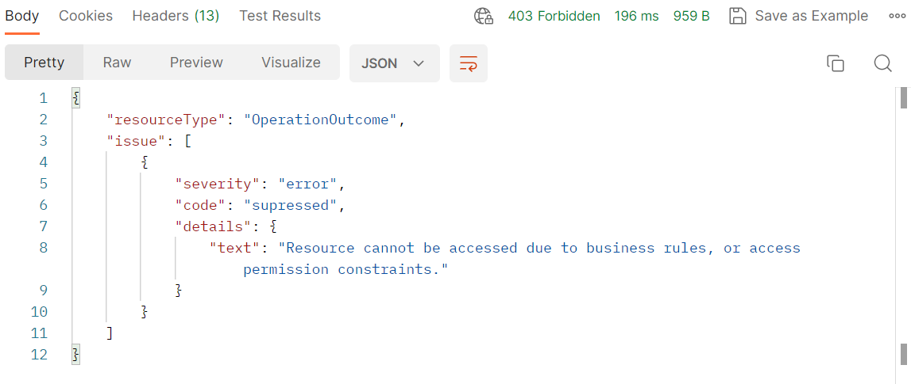

### 200 OK

#### Case 1: Incorrect identifier.system

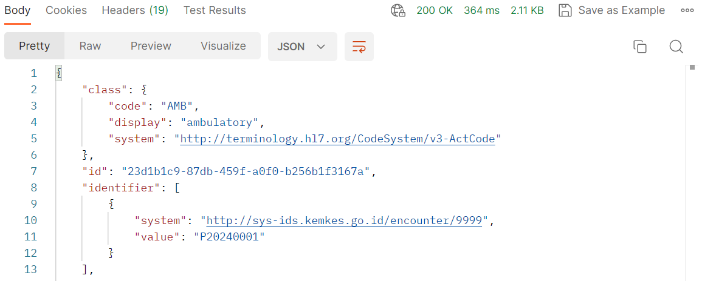

## GET

### 404 Not Found

#### Case 1: Get by invalid ID

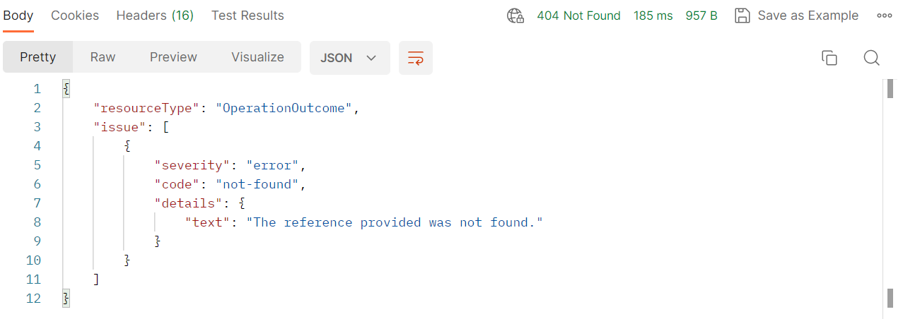

### 200 OK

#### Case 1: Get by subject ID (No Consent)

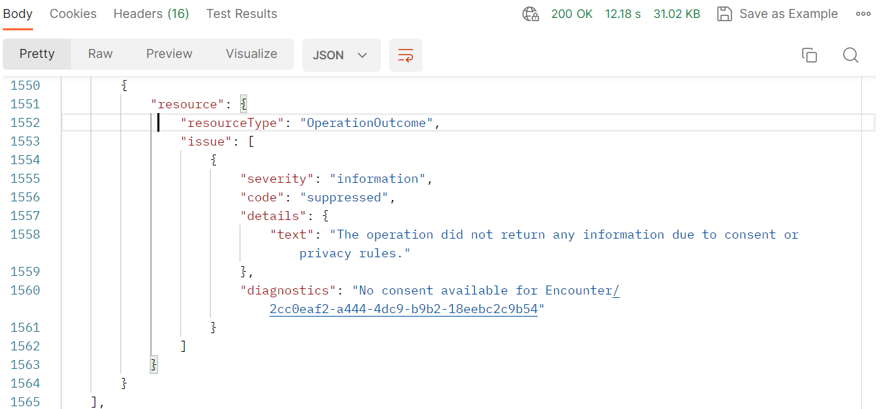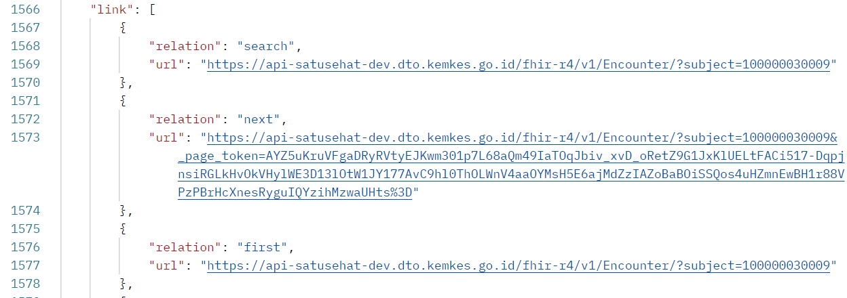

# Condition

## POST

### 400 Bad Request

#### Case 1: Duplicate

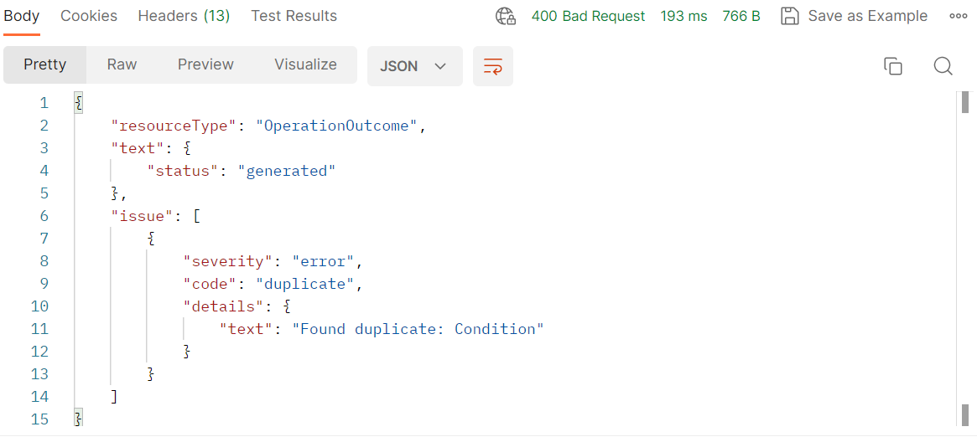

#### Case 2: Invalid Encounter ID

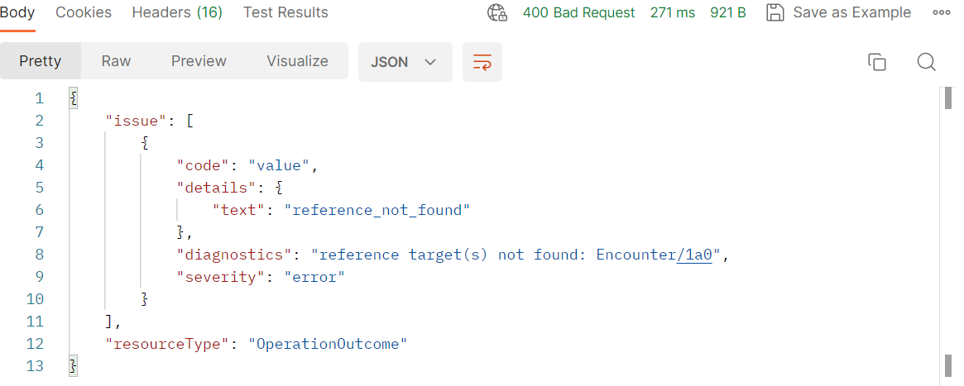

#### Case 3: Invalid Patient ID

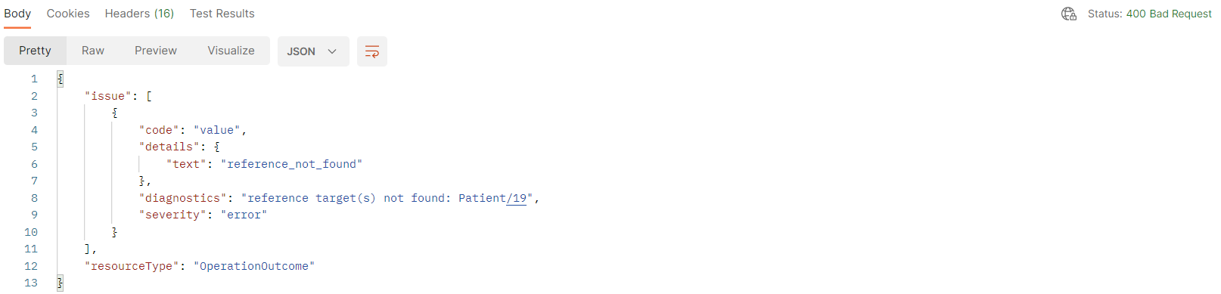

## PUT

#### Case 1: Incorrect Resource ID

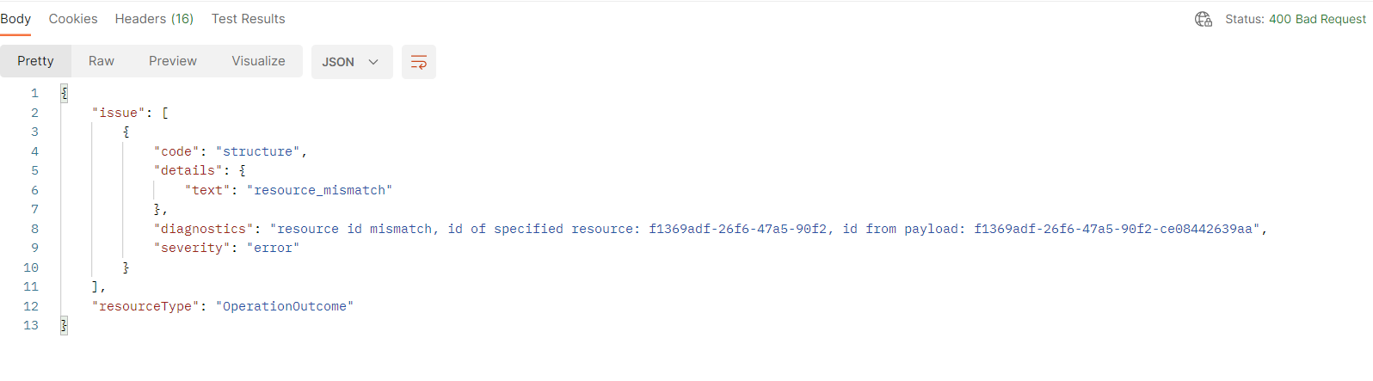

## GET

### 404 Not Found

#### Case 1: Incorrect resource ID

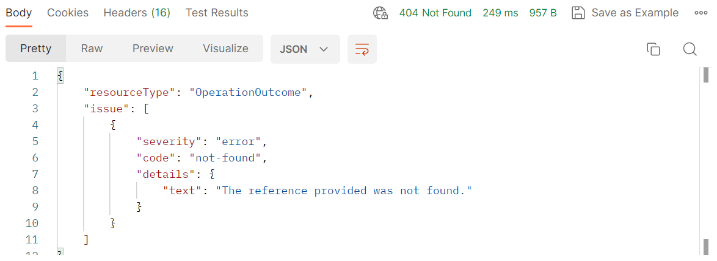

#### Incorrect Patient and Encounter ID also yields same error

### 200 OK

#### Case 1: Zero Output

