|  |  |
| --- | --- |
| **Division of Applied Science and Technology**  **Community College of City University** | |
| **AST10106 Introduction to Programming**  *(2015/16 Semester A)*  ***Group Project (Café Point Of Sale System)*** | |
| ***User Manual*** | |
|  | |
| **Group** | 45 |
| **Tutorial:** | LC3 |
| **Programme** | AScISD |
|  | |
|  | |
|  | |

Introduction:



This program is generated to be a POS system of a Café provided with a user-friendly interface for the staff to control this system. As a POS system is playing a significant role in a Café, we provide functions like choosing table, assuming the number of customers in a table, ordering food for a table, checking the order list of a table, and doing the payment and discount part.

The Coverage: Showing all tables for staff to choose which is going to have action, there are 20 tables for the staff to use, also with a logo of table using and not using indicating how the state of the table.

The Table Page: Showing the details of the table chosen, for example the items ordered by the customers of the table, the table number, the number of customers in the table. And in table page, staff can order food, do payment and give discount to the table.

The Order Page: Showing all the list of food, drink that can offer to the table, staff can add items to the table chosen, there is also a table in the left margin showing what the staff has chosen for this table, the staff should enter the amount of items which he/she is going to add. The button “Back” can let the staff go back to the table page, but this button also confirm the order list to be released to the kitchen, after clicking “Back” the items in order list will be confirmed to the order list of the table page.

Input amount / number: The staff should enter an integer for both customers number, amount of food, and the discount(in %). If the staff entered English words or punctuation mark, the system will show the window of “Invalid Input”. But if the staff entered a number out of range, the system will show the window of “Please enter it again”.

User Manual

Coverage:

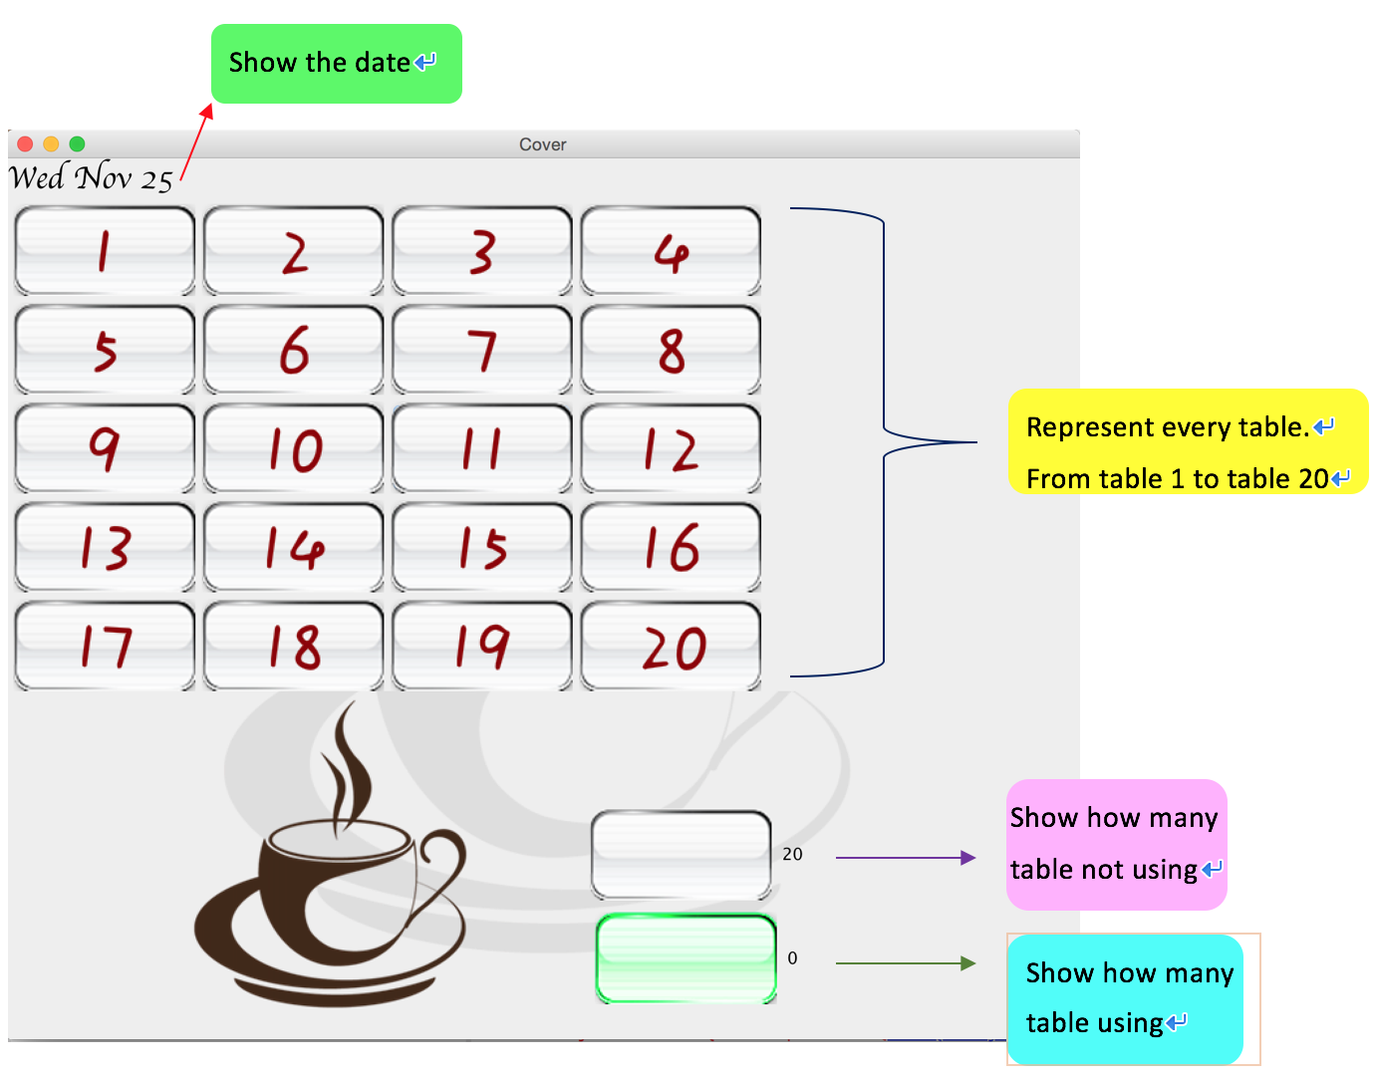

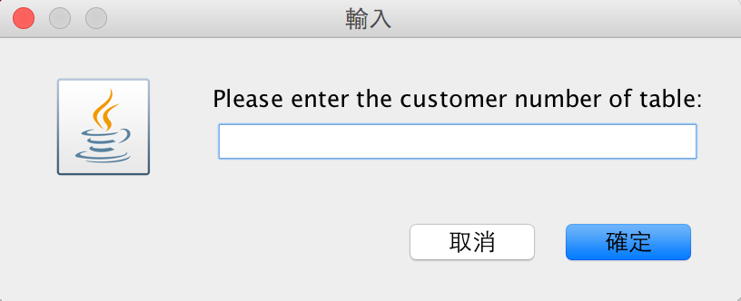when clicking on the table, a window will appear for entering the numbers of customers going in:

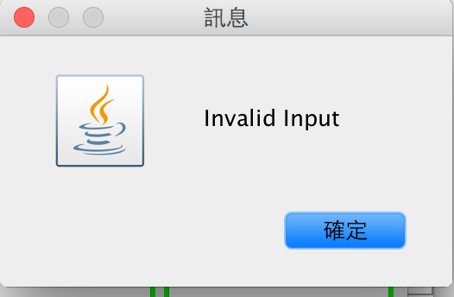The staff can input the number of customers such as 10, 5. If the input is not a digit, the system will show “Invalid Input”. But if the input is not an integer or positive number, the system will show” Please enter the customer number of table again:”.

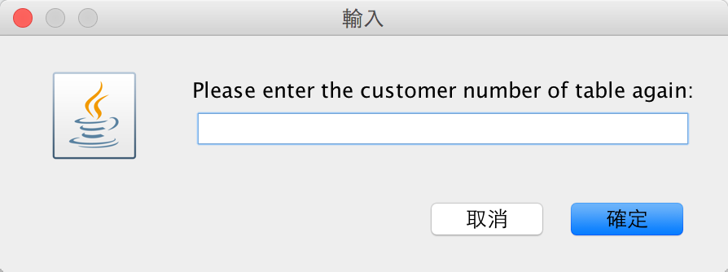

After entering the table, the page would be :

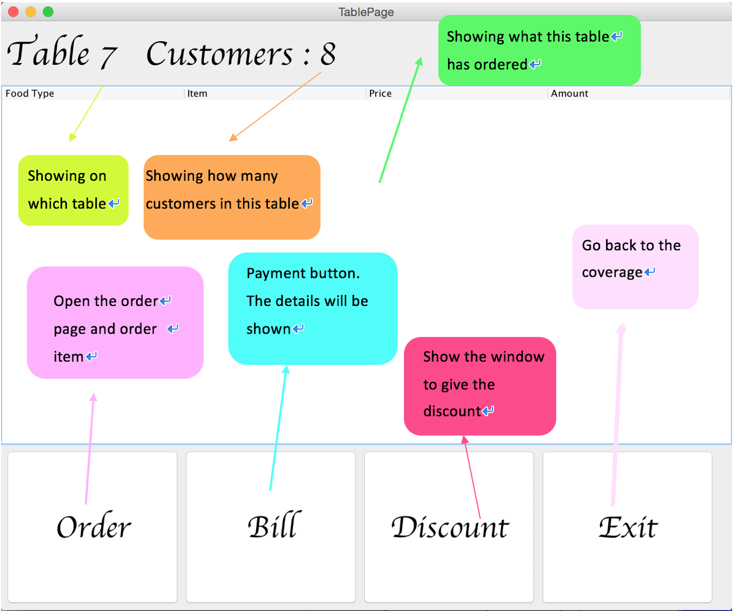

Show the details of the table choosing, there are several functions in this page, order food, payment, giving discount and going back to the coverage. This page also shows which table the staff are using, the customers number in this table and also the order list of this table. After ordering food, the details will be shown in the middle part.

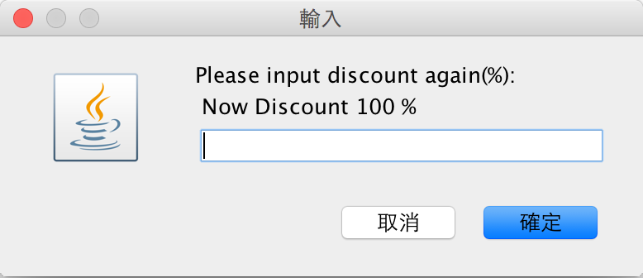Payment window: Discount window:

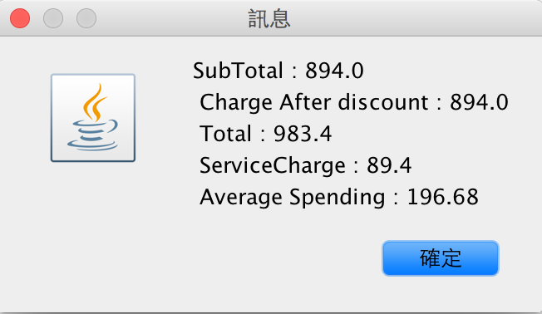

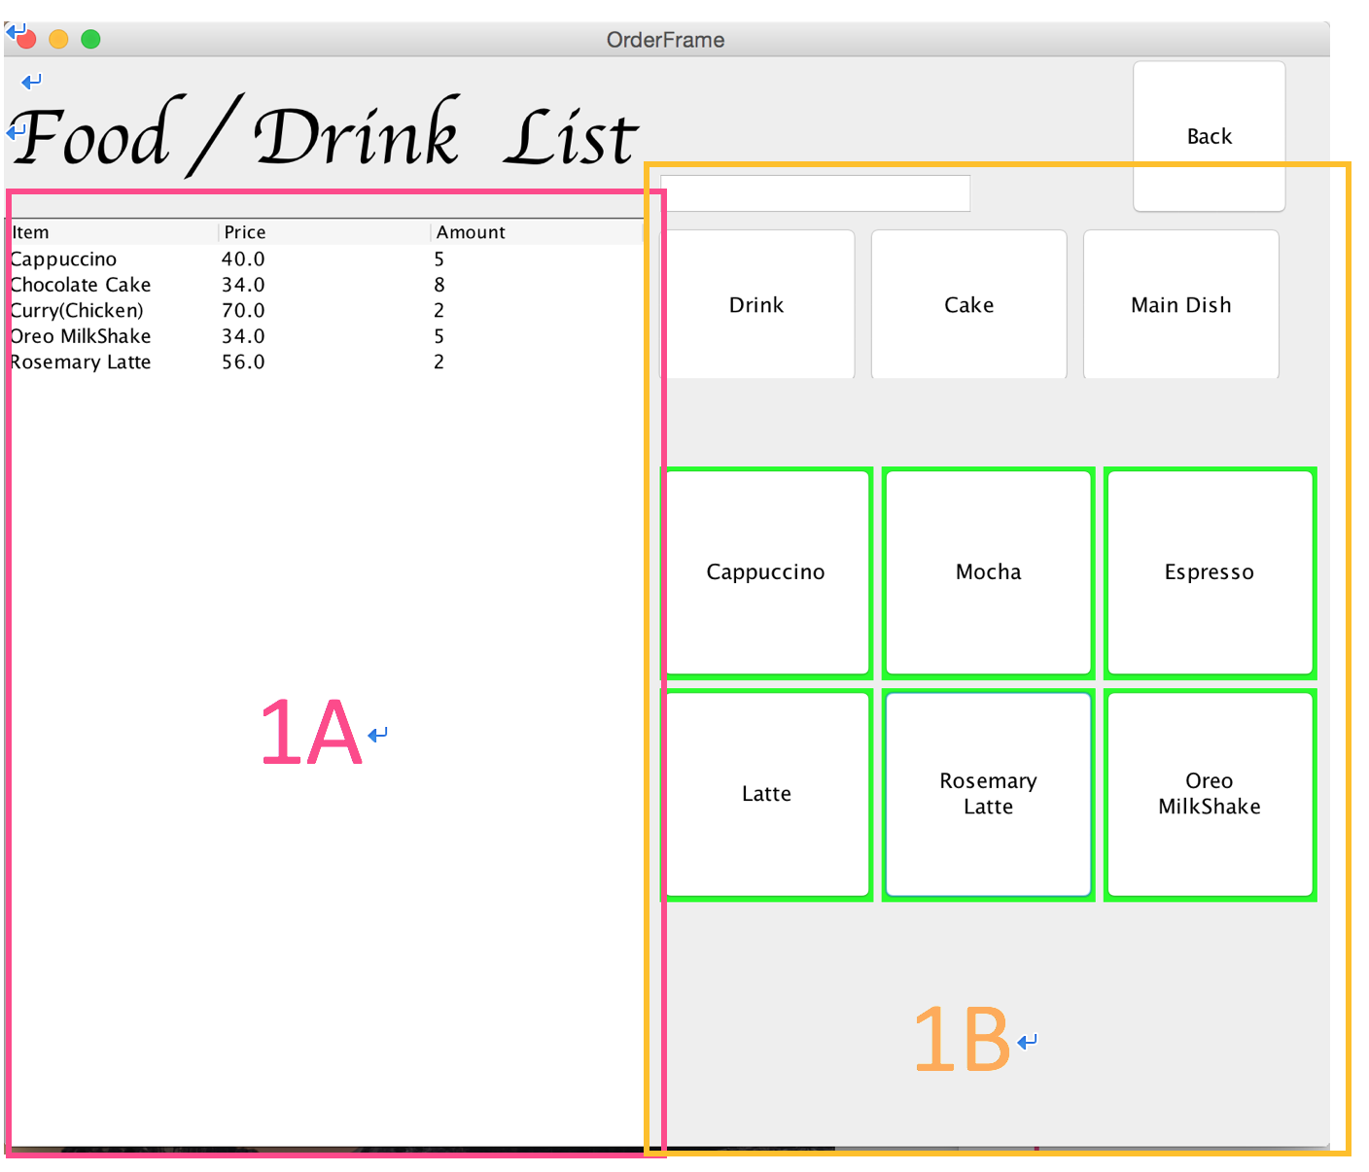

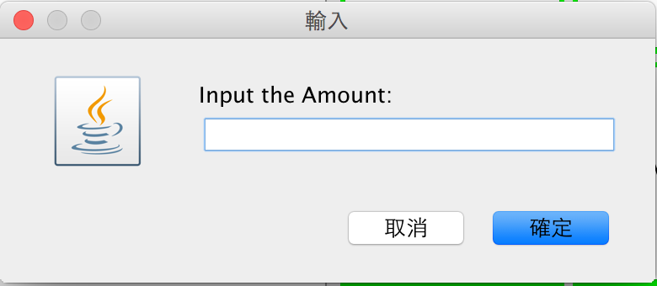This page is showing the food and drink list for ordering items. The left margin(1A) shows the order list. The right margin(1B) shows the list of food and drink for the staff to choose. After clicking the button of food and drink, a window will be shown for the staff to input the amount of this item:

When clicking the “Back” button,

those ordering items will be confirmed to

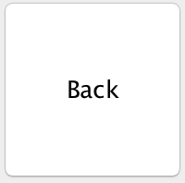the table which

the staff is using.

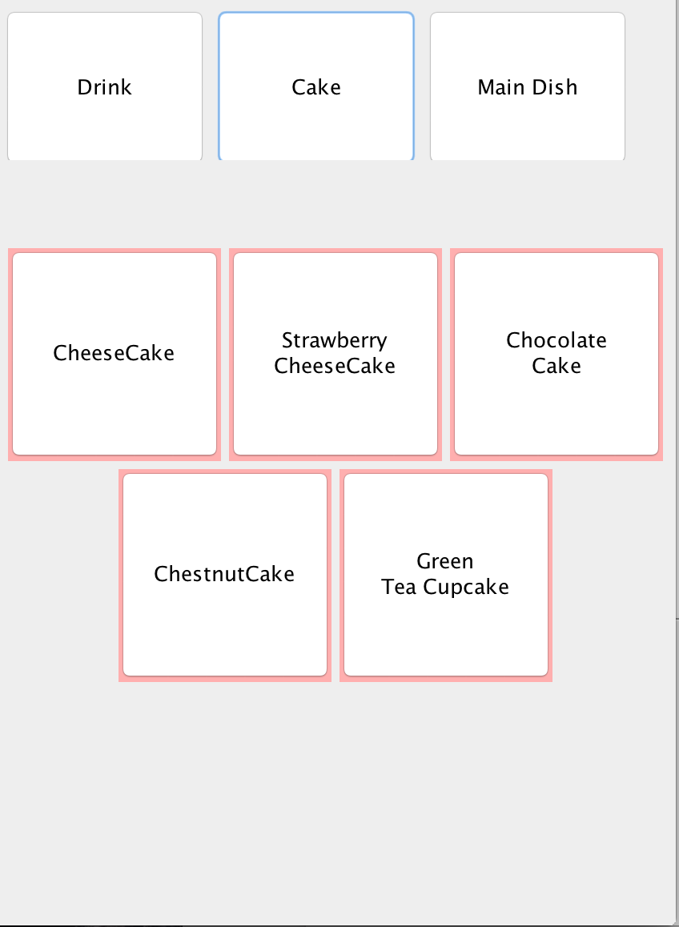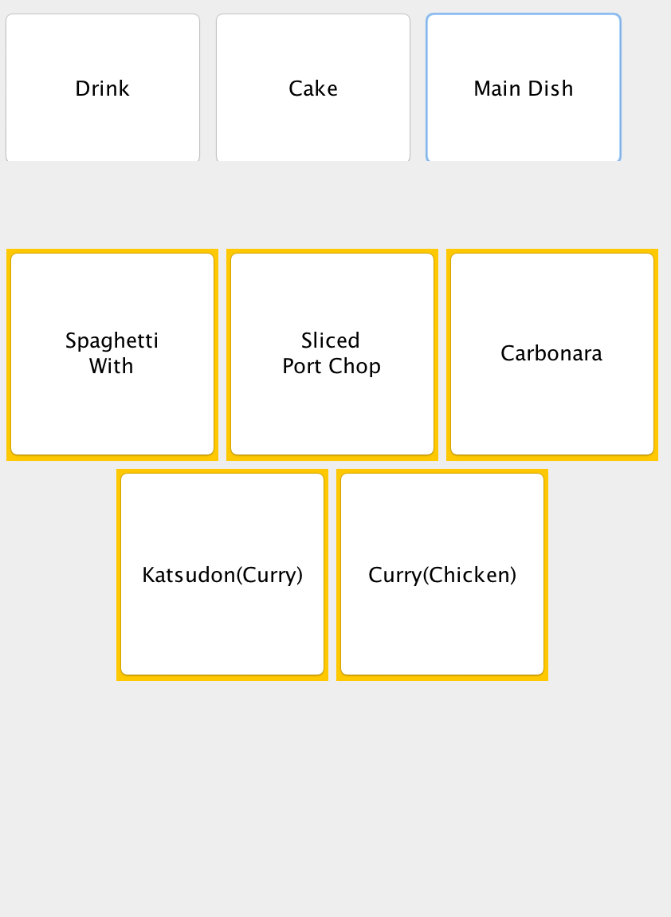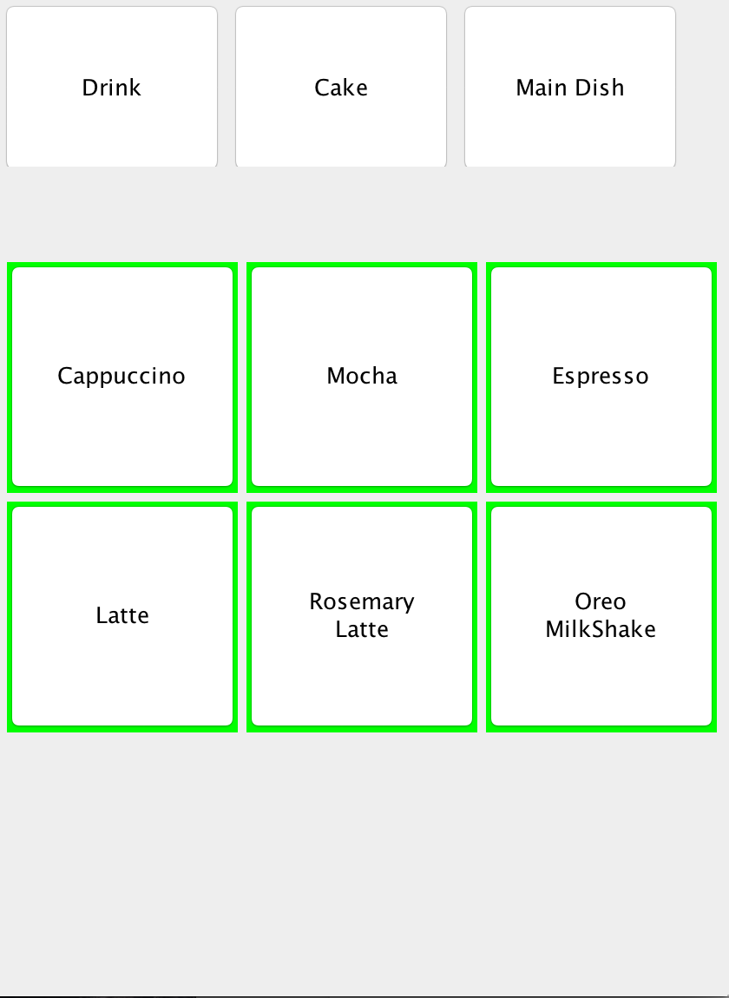

List of Main Dish

Cake List

Drink List

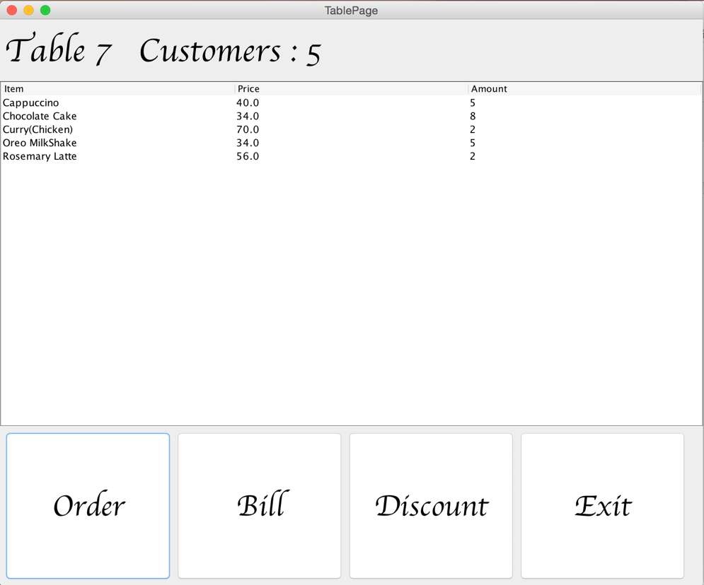Table page with items being ordering.

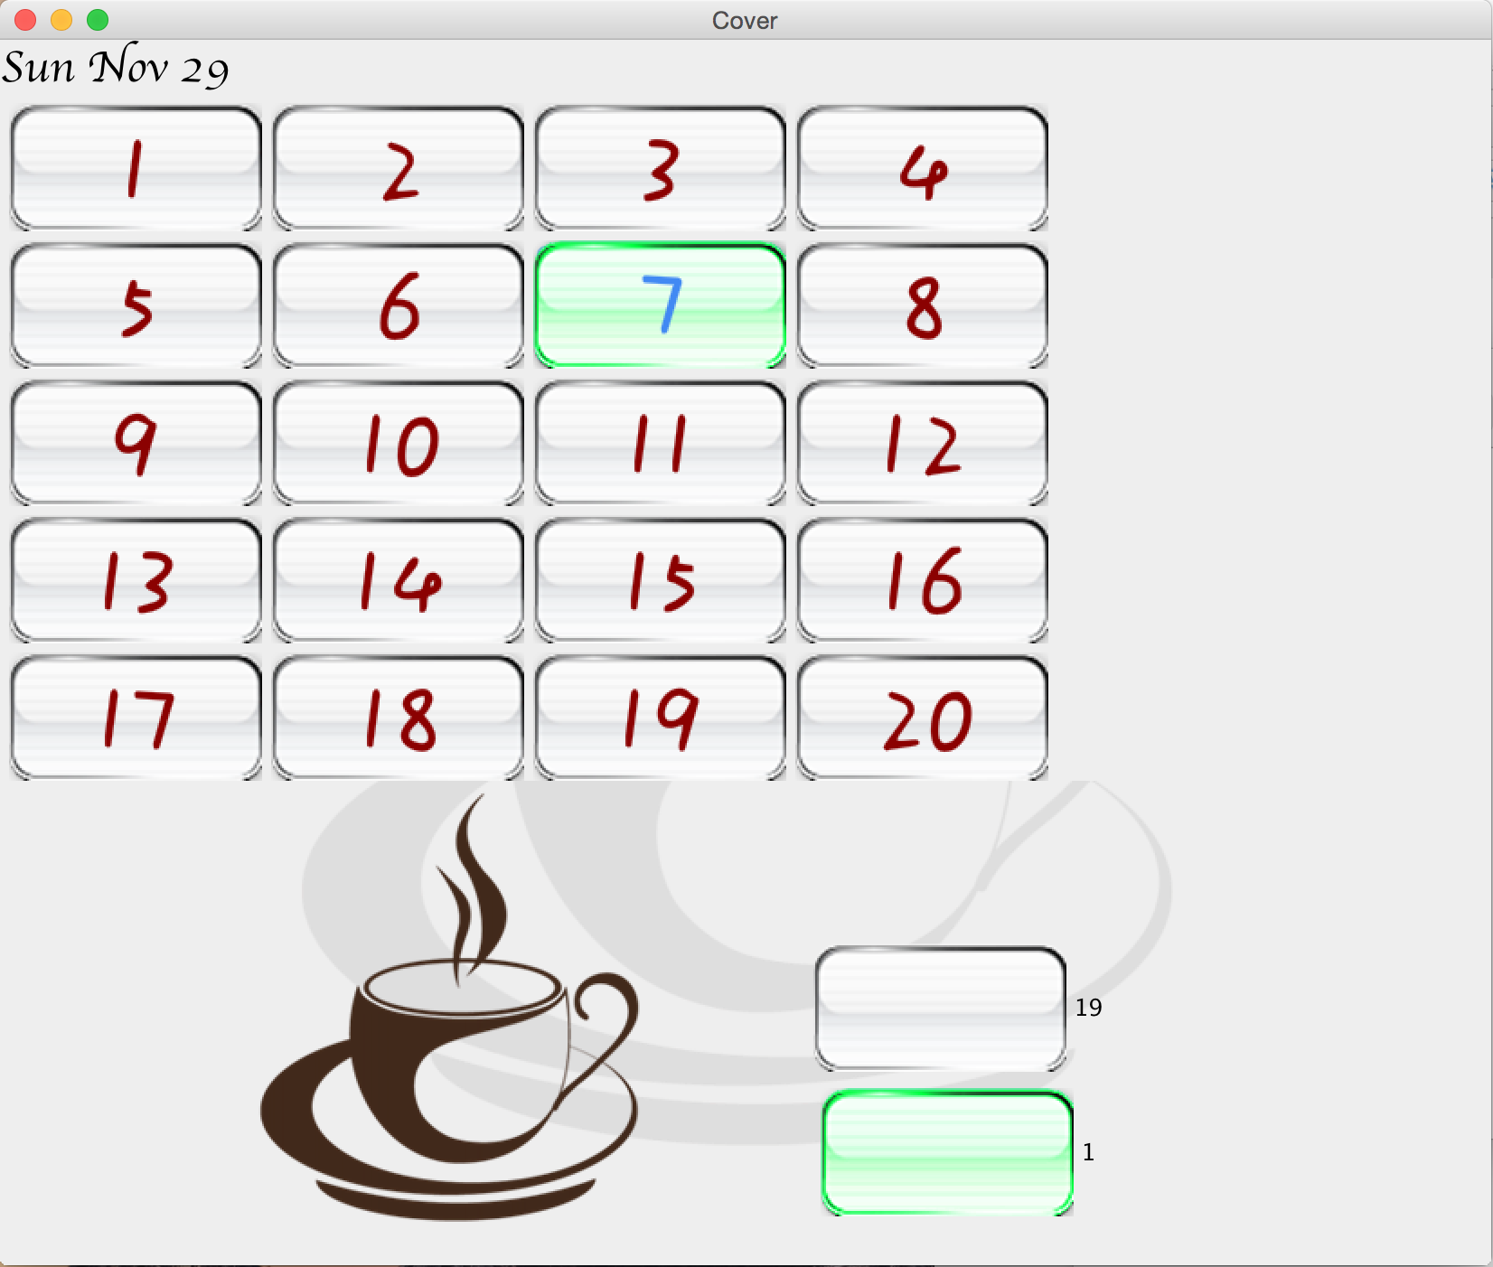

After opening a table, the table icon will be changed. Showing that the table is using.

And the number of table using and not using will be also changed.