Division of Applied Science and Technology
Community College of City University

AST10106 Introduction to Programming
(2015/16 Semester A)
Group Project (Café Point Of Sale System)

Technical Report

Group | 45
Tutorial: | LC3
Programme | AScISD

Contents

- Design
- Data Processing
- SystemFlow
- SystemStructure
- DataStructure
- Java User Interface
- Swing
- IO Operation
- Printed Document
- PDF Printing
I. Design( A . Data Processing )
- SystemFlow

The system flow chart of the café POS system

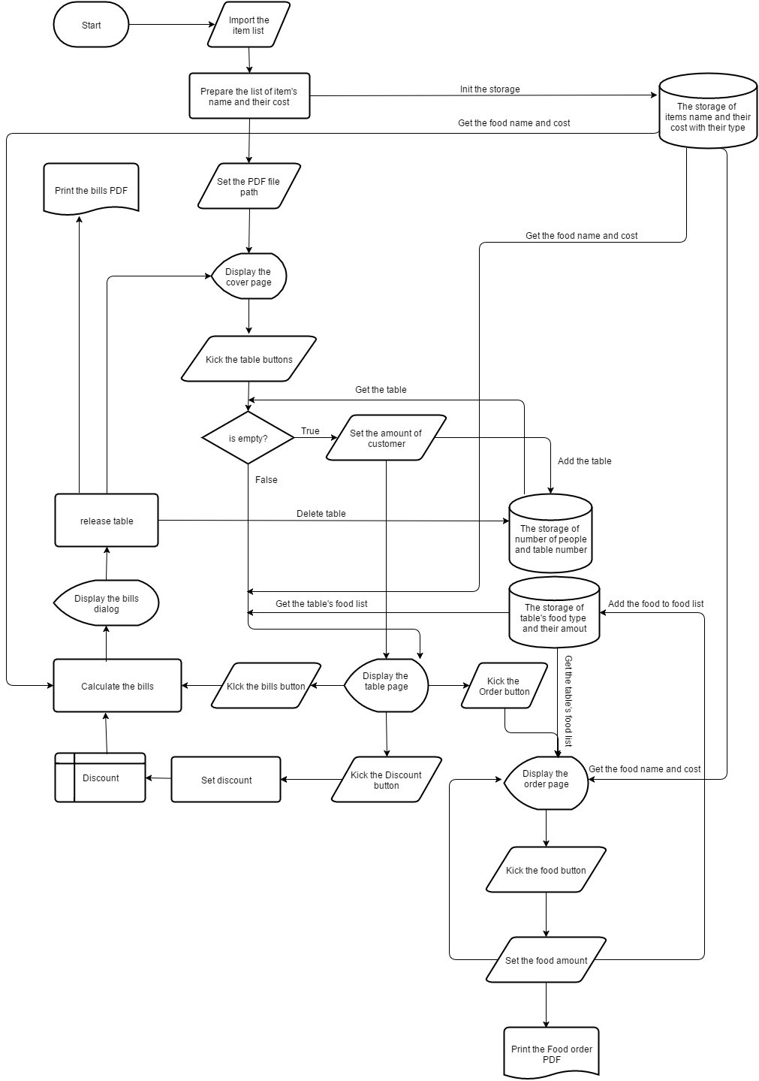

- System Structure
- System classes
The class name with their associated function are listed below.
Package | Class name | Function
Cafepossystem.io | FileChooser.java | A class instance of JFileChooser
 | PictureLoader.java | A static class to load the resource eg. Picture of the program
 | PrintPDF.java | A class instance of printing the PDF (itext)
 | ReadFile.java | A class instance of reading the itemlist
Cafepossystem.main | Main.java | To start the program
Cafepossystem.userinterface | BaseFrame.java | A class instance which inherit JFrame ,  Set up the styles that are common to all Pages
 | CoverPageFrame.java | A class instance which inherit BaseFrame ,  The cover main page of the program
 | OrderButton.java | A class instance which inherit JButton ,  Set up the methods and styles that are common the order button
 | TableButton.java | A class instance which inherit JButton ,  Set up the methods and styles that are common the table button
 | TablePageFrame.java | A class instance which inherit BaseFrame ,  The table page of the program
 | UserTableModel.java | The reference model that used by the JTable
 | OrderPageFrame.java | A class instance which inherit BaseFrame ,  The order page of the program
Cafepossystem.util | AdvanceSearchFunction.java | A static class for doing the advance search
 | Caculation.java | A static class for caculate the bills of the table
 | Food.java | A class instance for food
 | ItemList.java | A class instance to storing the table’s food which inherit LinkedHashMap
 | Singleton.java | A static class for storing all the static items ,  Eg tableList and init the items list
 | Table.java | A class instance for table
 | TableInUsingList.java | A class instance to storing the occupying table which inherit LinkedHashMap
- External libarary
In this project , we use (itextpdf-5.5.7) as the reference libarary . Most of the case , the methods and the instance class from the reference libarary are used in the PrintPDF.java class
The function of the itextpdf-5.5.7 is to print the PDF with format way .

C ) Data Structure
To store the data in a effective way , in this program , we simple build the data structure as the following format

Firstly , for the food , they are store in the Table class , (List)foodList<Food> .To order a new food for a table , we need to access the method addFood() in Table class .Then , a instance of food will be created and store in the foodList<Food> in Table class

The struture of the instance of food
Food.java
Variable type | Variable name | Variable function
int | foodType | The type of the order food
int | foodQuantity | The quantity of the order food
Secondly , for the table , they are store in the Singleton class , (tableInUsingList) tableInUsingList .To add a new table , we need to access the method addTable which is the method of tableInUsingList .Then , a instance of table will be created and store in the tableInUsingList in Singleton class
The data structure can be access through this direction

The struture of the instance of table
Table.java
Variable type | Variable name | Variable function
int | numberOfPeople | The number of people at that table
int | timeStamp | The time when the table start to be occupy
List<Food> | foodList<Food> | To store the food
Thirdly , tableInUsingList which is the custom class instance extends HashMap<Integer, Table> declare in the Singleton class, it use Key to store the table number and use the value to store the table object.

Finally , the whole data structure will be inited by the Singleton class which is the static class , all the action such as add table , release table , can be acted through the Singleton class

The struture of the Singleton class
Singleton.java
Variable type | Variable name | Variable function
tableInUsingList | tableInUsingList | To store the table
itemList | itemList | To the item that imported from the item list txt
printpdf | printpdf | The instance for doing the print pdf action
I . Design (B . Java User Interface)

For implement the java user interface effectively , we use swing .
The interface flow are shown below.

To import the itemlist (FileChooser.java) The order page (OrderPage.java)
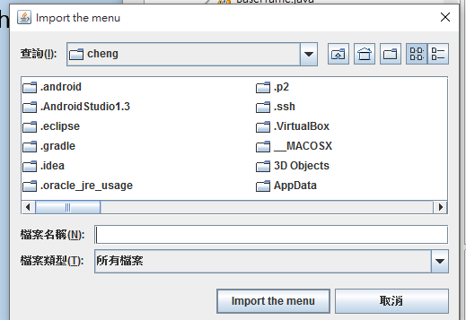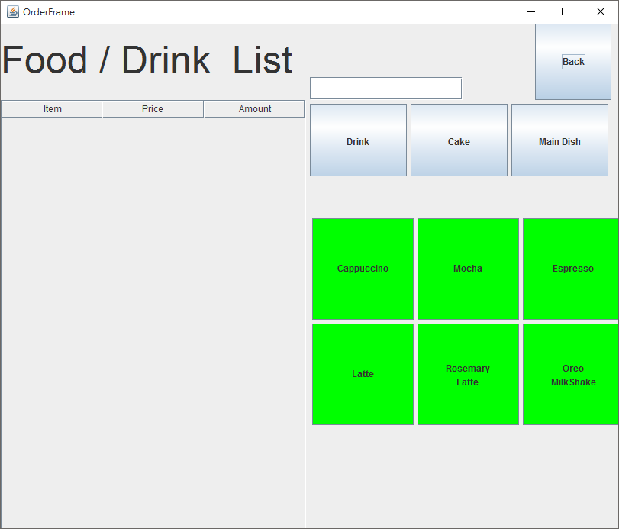

To import the itemlist (FileChooser.java) The table page (TablePage.java)
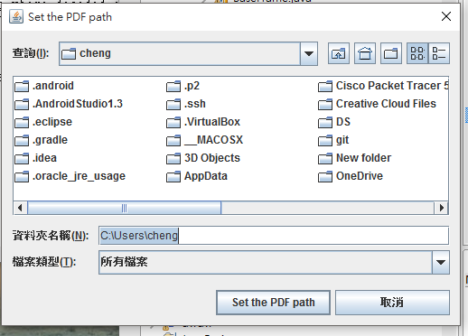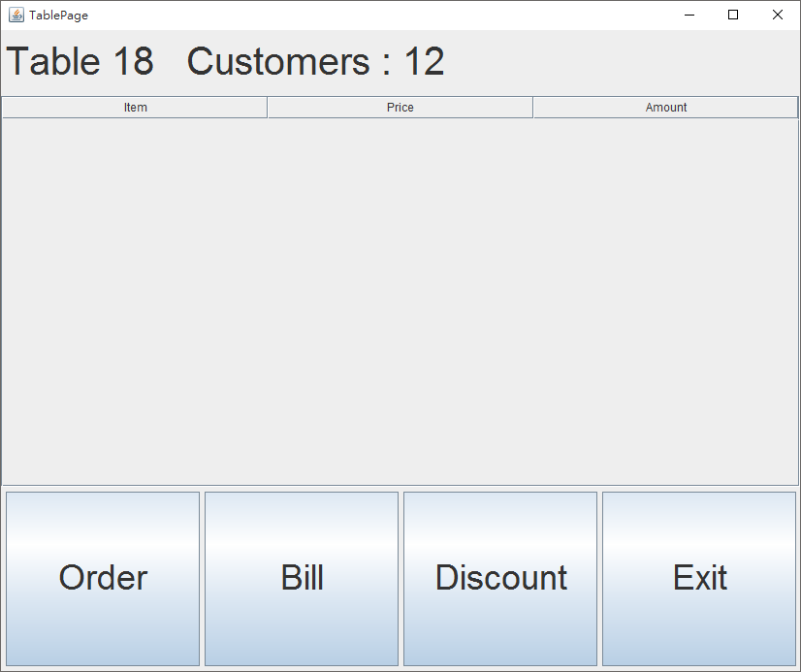

The cover page (CoverPage.java)
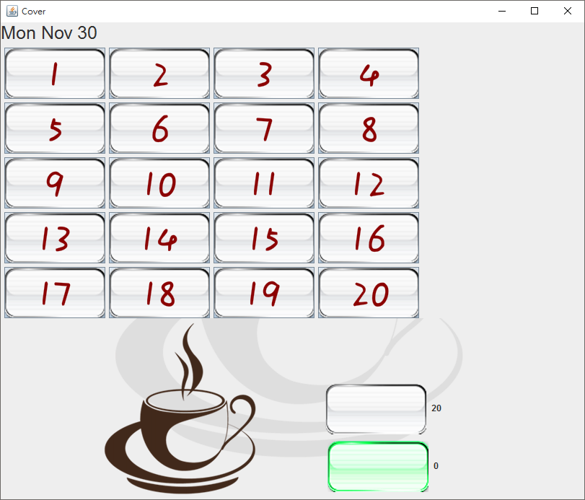

I . Design (C . IO Operation)

- Read the item list
To read the item list from outside , some process and format need to be followed

Allow item list format :
.txt

The format inside the txt
For exmaple ,menu.txt ,
Water
12
Coke
45
FoodName
FoodPrice
All the format should be follow as above , the food name follow by the price
- The number of food should equal to 16 , other wise some of the food may not be read by the system

- All the configuration of readFile is inside the readFile.java

- Print out the PDF
There are only two condition that the PDF is creaded , 1. After ordering the food in the order page and go back to tablepage , 2. When kick the bills button on the tablePage.

Print out format :
.pdf

- All the configuration of PDF is inside the PrintPDF.java
- The name of the PDF will be TableNumber+Date+Time+.pdf

To

