# Hands-on Experiment # 4: Worksheet

Section______1______ Date______1/9/2020___________

Student ID _________6338110221__________ Name________Nonthapat Kaewamporn_________

## Part A: Creating and using objects

“StudentGPAX.java” is a java class representing student’s GPAX (the accumulated (overall) grade point average) with the class diagram as follows:

* There are two static variables: *MIN_CREDIT (3)* & *MIN_GPAX (2)*.
* To create a student object, you need to enter *studentID*.
* In the method “*addCourseGrade*”, there are three inputs: (1) *courseID*, (2) *credit*, (3) *grade*. This method will update the value of *totalCredit and totalGradePoint*.
  + Grade point is a multiplication between credit and grade.
  + Enter 4 for grade “A”, 3.5 for grade “B+”, 3 for grade “B”, …, and 0 for grade “F”
* The method “*computeGPAX*” aims to compute and update student’GPAX using their total credit and total grade point.

Put “StudentGPAX.java” in your folder and write a java program “SimpleTranscript.java” to create objects of two students as follows:

* Student “s1” with ID “6031707921”
  + Create an object of this student
  + Add course "2190101" (3 credits) with grade “A”
  + Add course "2190151" (1 credits) with grade “C”
  + Add course "2301107" (3 credits) with grade “A”
  + Compute GPAX
* Student “s2” with ID “6031754321”
  + Create an object of this student
  + Add course "2304153" (3 credits) with grade “D”
  + Add course "2304192" (1 credits) with grade “C”
  + Compute GPAX

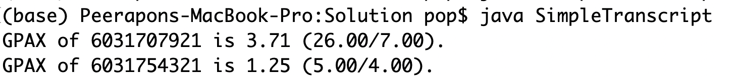

* Copy your code and paste here. You must use the class “StudentGPAX” along with its fields and methods.

public class SimpleTranscript{

public static void main(String[] args)

{

StudentGPAX s1 = new StudentGPAX("6031707921");

s1.addCourseGrade("2190101",3,4);

s1.addCourseGrade("2190151",1,2);

s1.addCourseGrade("2301107",3,4);

s1.computeGPAX();

StudentGPAX s2 = new StudentGPAX("6031754321");

s2.addCourseGrade("2304153",3,1);

s2.addCourseGrade("2304192",1,2);

s2.computeGPAX();

System.out.format("GPAX of %s is %.2f (%.2f/%.2f)\n",s1.studentID,s1.gpax,s1.totalGradePoint,s1.totalCredit);

System.out.format("GPAX of %s is %.2f (%.2f/%.2f)\n",s2.studentID,s2.gpax,s2.totalGradePoint,s2.totalCredit);

}

}

## Part B: Using objects with Scanner

Use the class “StudentGPAX” and write a java program “TranscriptForThreeCourses.java” that aims to compute student’s GPAX from three courses, which are entered from keyboard (Scanner). The output is GPAX along with total grade points and total credits. Also, you must check whether a student can finish the program (true/false) based on the minimum credit (*MIN_CREDIT*) and minimum GPAX (*MIN_GPAX*); passing when both criteria are satisfied (greater than or equal).

* The program should have results as follows.
* **The program must use object from the StudentGPAX class; otherwise, it won’t be scored!**

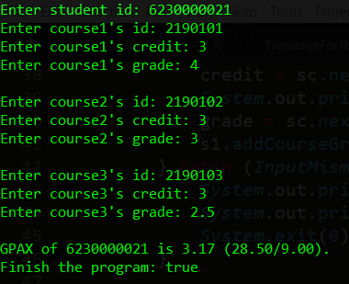

1. Case1: Please try to enter your inputs as follows with your OWN student’s ID and then capture your output in the space provided:



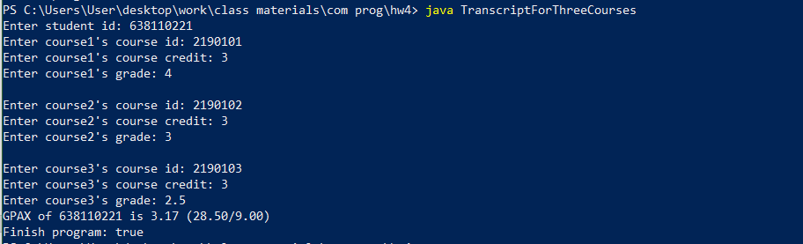

1. Case2: Please try to enter your inputs as follows with your OWN student’s ID and then capture your output in the space provided:

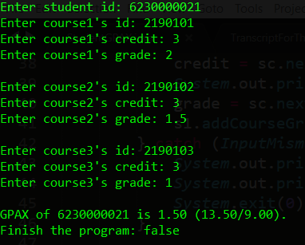

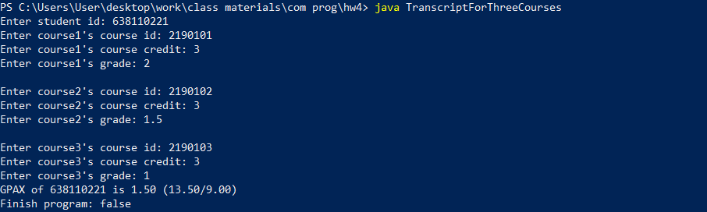

1. List your source code in the space provided:

import java.util.Scanner;

public class TranscriptForThreeCourses

{

static Scanner sc = new Scanner(System.in);

public static void main(String[] args)

{

String course;

Int credit,grade;

System.out.print("Enter student id: ");

StudentGPAX student = new StudentGPAX(sc.nextLine());

System.out.print("Enter course1's course id: ");

course = sc.nextLine();

System.out.print("Enter course1's credit: ");

credit = sc.nextInt();

System.out.print("Enter course1's grade: ");

grade = sc.nextInt();

sc.nextLine();

student.addCourseGrade(course,credit,grade);

System.out.print("\nEnter course2's course id: ");

course = sc.nextLine();

System.out.print("Enter course2's credit: ");

credit = sc.nextInt();

System.out.print("Enter course2's grade: ");

grade = sc.nextInt();

sc.nextLine();

student.addCourseGrade(course,credit,grade);

System.out.print("\nEnter course3's course id: ");

course = sc.nextLine();

System.out.print("Enter course3's credit: ");

credit = sc.nextInt();

System.out.print("Enter course3's grade: ");

grade = sc.nextInt();

sc.nextLine();

student.addCourseGrade(course,credit,grade);

student.computeGPAX();

System.out.format("GPAX of %s is %.2f (%.2f/%.2f)\n",student.studentID,student.gpax,student.totalGradePoint,student.totalCredit);

System.out.println("Finish program: " + (student.totalCredit >= StudentGPAX.MIN_CREDIT && student.gpax >= StudentGPAX.MIN_GPAX));

}

}

1. What should happen when you enter non-numeric to credit or grade? What is the name of exception? Capture your output:

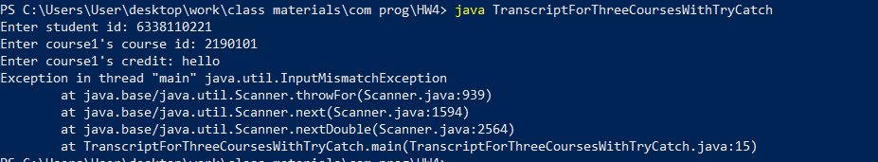

Name: InputMismatchException

1. What should happen when your total credit is 0? What is the name of exception? Capture your output:

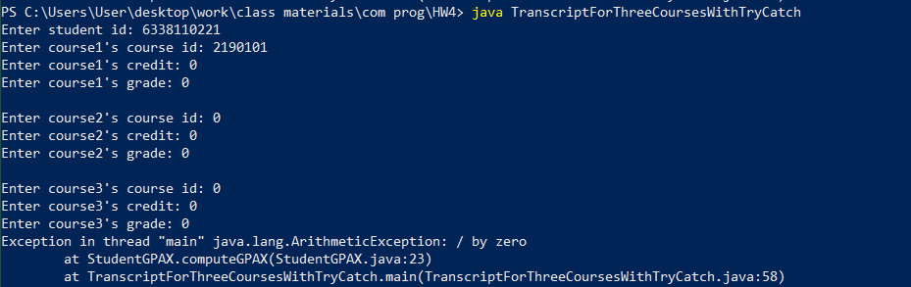

Name: ArithmeticException

## Part C: Trying out Exception Handling

Write another class called “TranscriptForThreeCoursesWithTryCatch.java”. Copy all the code from “TranscriptForThreeCourses.java”. Modify the code such that:

* When either credit or grade is non-numeric, your program must print the warning as in the figure below and the program must stop running (System.exit(0)).

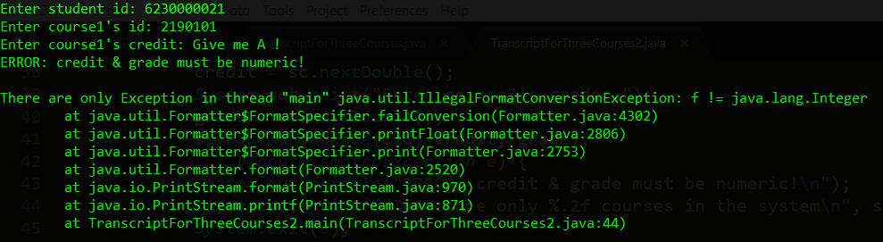

* When the total credit is 0, your program must print the warning as in the figure below and the program must stop running (System.exit(0)).

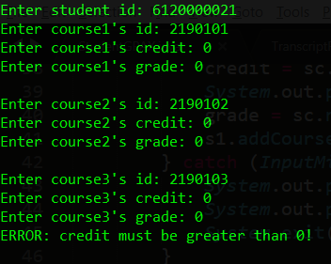

1. Show part of your code that handles the above request.

try

{

student.computeGPAX();

}

catch (ArithmeticException e)

{

System.out.println("Error: credit must be greater than 0!");

System.exit(0);

}

1. Run your program. Try to give invalid value for either course credit or grade. Capture your screenshot and show it below:

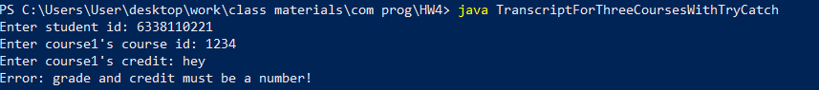

1. Run your program. Try to give your total credit to be 0. Capture your screenshot and show it below:

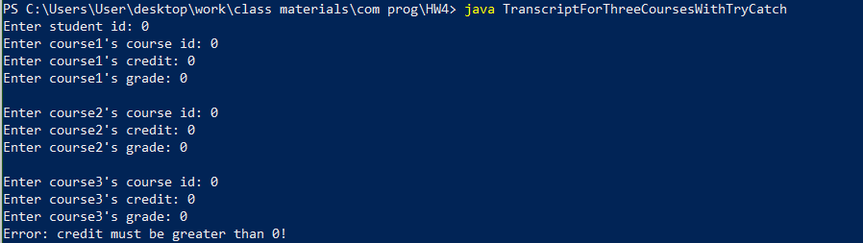

Submit this worksheet (by only one member of the group) via <http://www.myCourseVille.com> (Assignments > Lab05) by the deadline specified in Courseville.