# Hands-on Experiment # 5: Worksheet

## (Do not submit this document file)

To submit this homework, zip all your .java files into 1 zip file and submit as attachment on MyCourseville assignment page. Make sure you have completely uploaded your file!

## Part A: Practice the use of decision in Java (10 marks)

Write your own class ***MyMath.java***, implementing the working of function f that satisfies an equation below (use int as input parameter type) using if statements. The value of x is received from the keyboard. The result (as double) is then calculated and printed on screen.

$$f\left(x\right)= \left\{\begin{aligned}x+2 x≤0 \\ 13 x==1 \\ x^{2}-2x+3 1<x≤10 \\ x^{3}-3x^{2} otherwise \end{aligned}\right.$$

An example run is shown below:

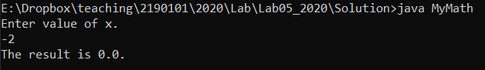

The table below shows sample answers:

|  |  |
| --- | --- |
| Value of x | Value of result |
| -5 | -3.0 |
| 1 | 13.0 |
| 3 | 6.0 |
| 9 | 66.0 |
| 11 | 968.0 |

## Part B: Implementing Switch statement (10 marks)

You are to write a character encoder, which reads a character and prints an output character according to the following table:

|  |  |
| --- | --- |
| input character | output |
| a | B |
| A | B |
| b | C |
| B | C |
| c | D |
| C | D |
| other character | Z |

Example: if a user inputs ‘a’, your program will print out ‘B’.

if a user inputs ‘E’, your program will print out ‘Z’.

Assume that the user always types in 1 character when a scanner is used, create and write your program in ***Encoder.java***.

**YOU MUST USE THE SWITCH STATEMENT, OTHERWISE THE SCORE IS 0!**

* **HINT:** you can use s.chatAt(i) to return the ith character inside the string s. The first character is at position 0th.

Example runs are shown below:

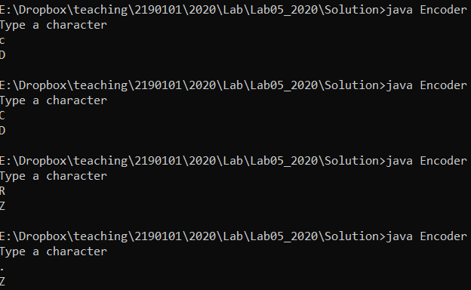

## Part C: Rock, paper, scissors (10 marks)

You are to write a program that simulate a game of rock-paper-scissors. Your program should

* 1. ask for your move (to be typed in from keyboard).
  2. the legal moves are only “R”, “P”, and “S”(“r”, “p”, and “s” also work). If illegal move is read, print message "Illegal move, please re-run the program" and exit the program.
  3. ask for the opponent’s move (to be typed in from keyboard).
  4. If illegal move is read, print message "Illegal move, please re-run the program" and exit the program.
  5. Then the program evaluates the moves and print “You win”, “You lose”, or “Draw” according to this rule:
     1. same moves will result in a draw
     2. “R” beats “S”
     3. “P” beats “R”
     4. “S” beats “P”

Here is a sample screenshot when an illegal move is read:

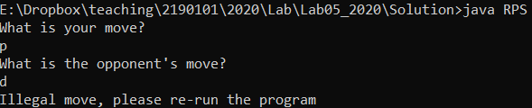

Here is a sample screenshot when moves are legal:

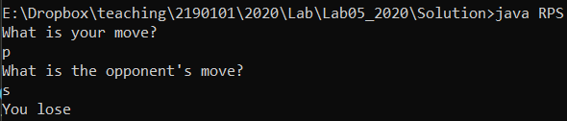

Write your program as ***RPS.java*** It must give correct result for all possible combinations of inputs.

## Part C: Comparing Card in Magic: The Gathering (8 marks)

A Magic: The Gathering! Sorcery card has the following properties (the card details used in this question are simplified from the real game):

* name: a string displaying the card name.
* cost: a string displaying casting cost.
* text: a string describing what the card does.

name

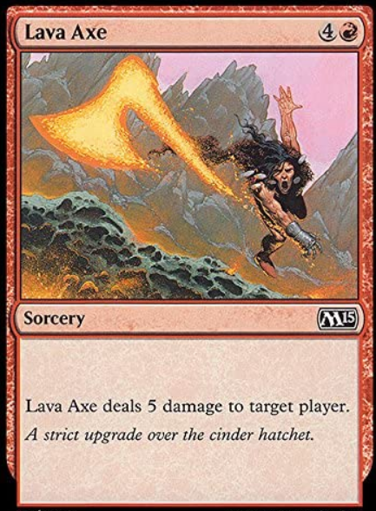

Cost: “4R” means 4 of anything and 1 of red color.

Sorcery card may have color, represented by; W, R, B, U , G

text

toughness

power

Two cards are considered equal **if all their properties are the same**.

A class MTGCard is given. A program that tests a few cards for their equality (TestMTG.java) is also given.

TestMTG can run now, but its use of “equality testing” may not be what we want.

* Write code in method **equals** of class MTGCard and use the method to do comparison.
* Modify TestMTG.java so that it gives correct result for each comparison (according to our definition of equal).

You must include both ***MTGCard.java*** and ***TestMTG.java*** in your submission.