# Hands-on Experiment # 6 : Worksheet (Iteration)

Section_______1_______ Date_________15/9/2020_________________________

Student ID ________6338110221_______________ Name_______Nonthapat Kaewamporn__________________

## Part A: Loop Writing Practice

Convert the given do-while into while and for loop.

int k = 0;

int n = 800;

do {

System.out.println(k);

k++;

n /= 2;

} while (n > 0);

List your while loop here.

int k = 0;

int n = 800;

while (n > 0)

{

System.out.println(k);

k++;

n /= 2;

}

List your for loop here.

for (int n = 800, k = 0; n > 0; n /= 2, k++)

{

System.out.println(k);

}

Program ParityCheck.java reads data from a text file given from command line and finds the parity of each number in the file. The output of the program is given below. Complete the methods: countOnes() and parity() using “loops” in ParityCheck.java to make the ParityCheck runs correctly.

An integer number has EVEN parity if sum of all binary representation bit is even number, and ODD parity otherwise. For example, a number 14 is ‘1110’ in binary. Summation of all bits is 3. Therefore, 14 has ODD parity. A number 33 is ‘10001’ in binary. Summation of all bits is 2. Therefore, 33 has EVEN parity.

**Note:** Integer.toBinaryString() convert an integer number to a binary String.

Fill out the result with input from “data.txt”

|  |  |  |
| --- | --- | --- |
| Number read from file | Binary representation | How many 1’s |
| 123 | 1111011 | 6 |
| 2,346 | 100100101010 | 5 |
| 1,285,434 | 100111001110100111010 | 12 |
| 25,993,669 | 1100011001010000111000101 | 11 |
| 458,299,015 | 11011010100010001011010000111 | 14 |

List your method countOnes() here

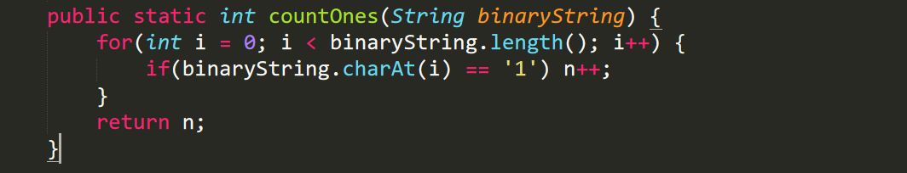

List your method parity() here

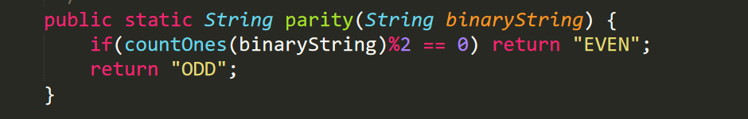

Run your program and capture the output screen here. The output should similar the following example but show that actual data read from ‘data.txt’

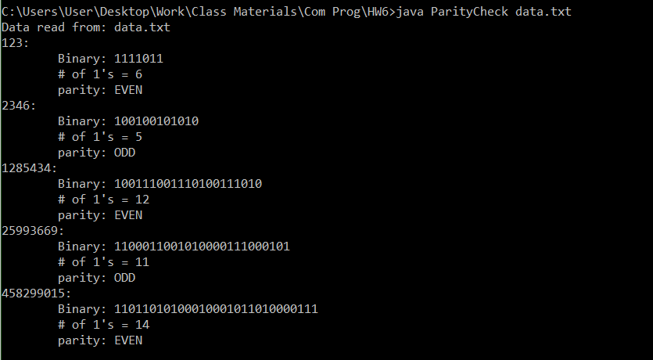

## Part B: Square Root Estimation

We can use bisection method to estimate the value of $\sqrt{a}$ as following:

1. Let *lower = 0, upper = a*
2. Begin with the estimated value, *x*, is the middle of [*lower, upper*]
3. Repeat the following steps until *x2* is closed enough to *a* (“closed enough” when )
   1. if x2>a then change the range to [lower, x]
   2. if x2<a then change the range to [x, upper]
   3. x is the middle value
4. x is the estimated value of $\sqrt{a}$

Complete the method bisection() in Bisection.java to estimate the square root of values reading from “bisection.in”. The output of the program should be similar to the picture below.

Run your program and capture the output screen

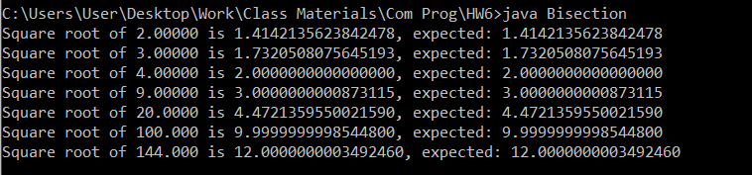

List your method bisection() here

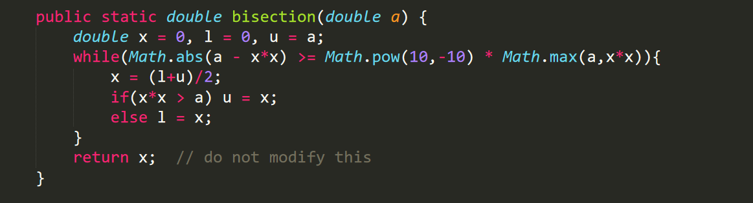

## Part C: Text File Processing

“sheet1.in” is a text file contains multiple choice answers of students. The first line is the correct answers. The remaining lines are students name, follow by at least one space and their answers as show below.

**ABCDEABCDEEDCBAEDCBA**

**Bank ABCDDDDCDEEDCBAEDCBA**

**Lin ABBDEBBCDEBDCBBEDBBA**

**Pat AACCEEBBDDEECCAADDBB**

**Grace BBDDAACCEEDDBBEECCAA**

Complete the program MultipleChoiseApp.java to read input data file as command line argument. There are two data files given, sheet1.in and sheet2.in. The expected output is also given for you in sheet1.out and sheet2.out to check that your program executes correctly. Your program should produce the output similar to the given picture below. The first line shows total number of questions follow by all correct answer. Each of the remaining lines shows student’s name, his/her score and their marked answers. (The question that is correct, show as original. The question that is wrong, show as ‘-‘.)

Run your program with “sheet1.in” and capture the output screen here.

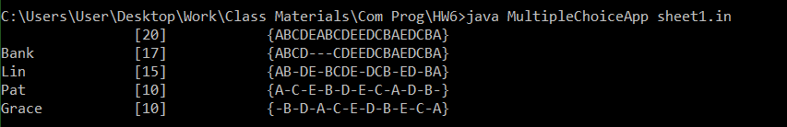

Run your program with “sheet2.in” and capture the output screen here.

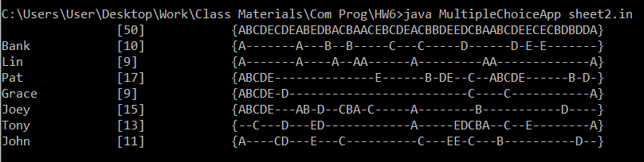

## *** Submission instructions ***

Combine the following files into ONE .zip file, “assignment-6.zip”.

1. This worksheet file saved as “Lab06-2020.pdf”.
2. ParityCheck.java
3. Bisection.java
4. MultipleChoiceApp

Submit the zip file to <http://www.myCourseVille.com> (Assignments > Assignment 6) before midnight of three days after your lecture.