11/12/2014 CDC

Name:

# CDC

Complete the crossword below

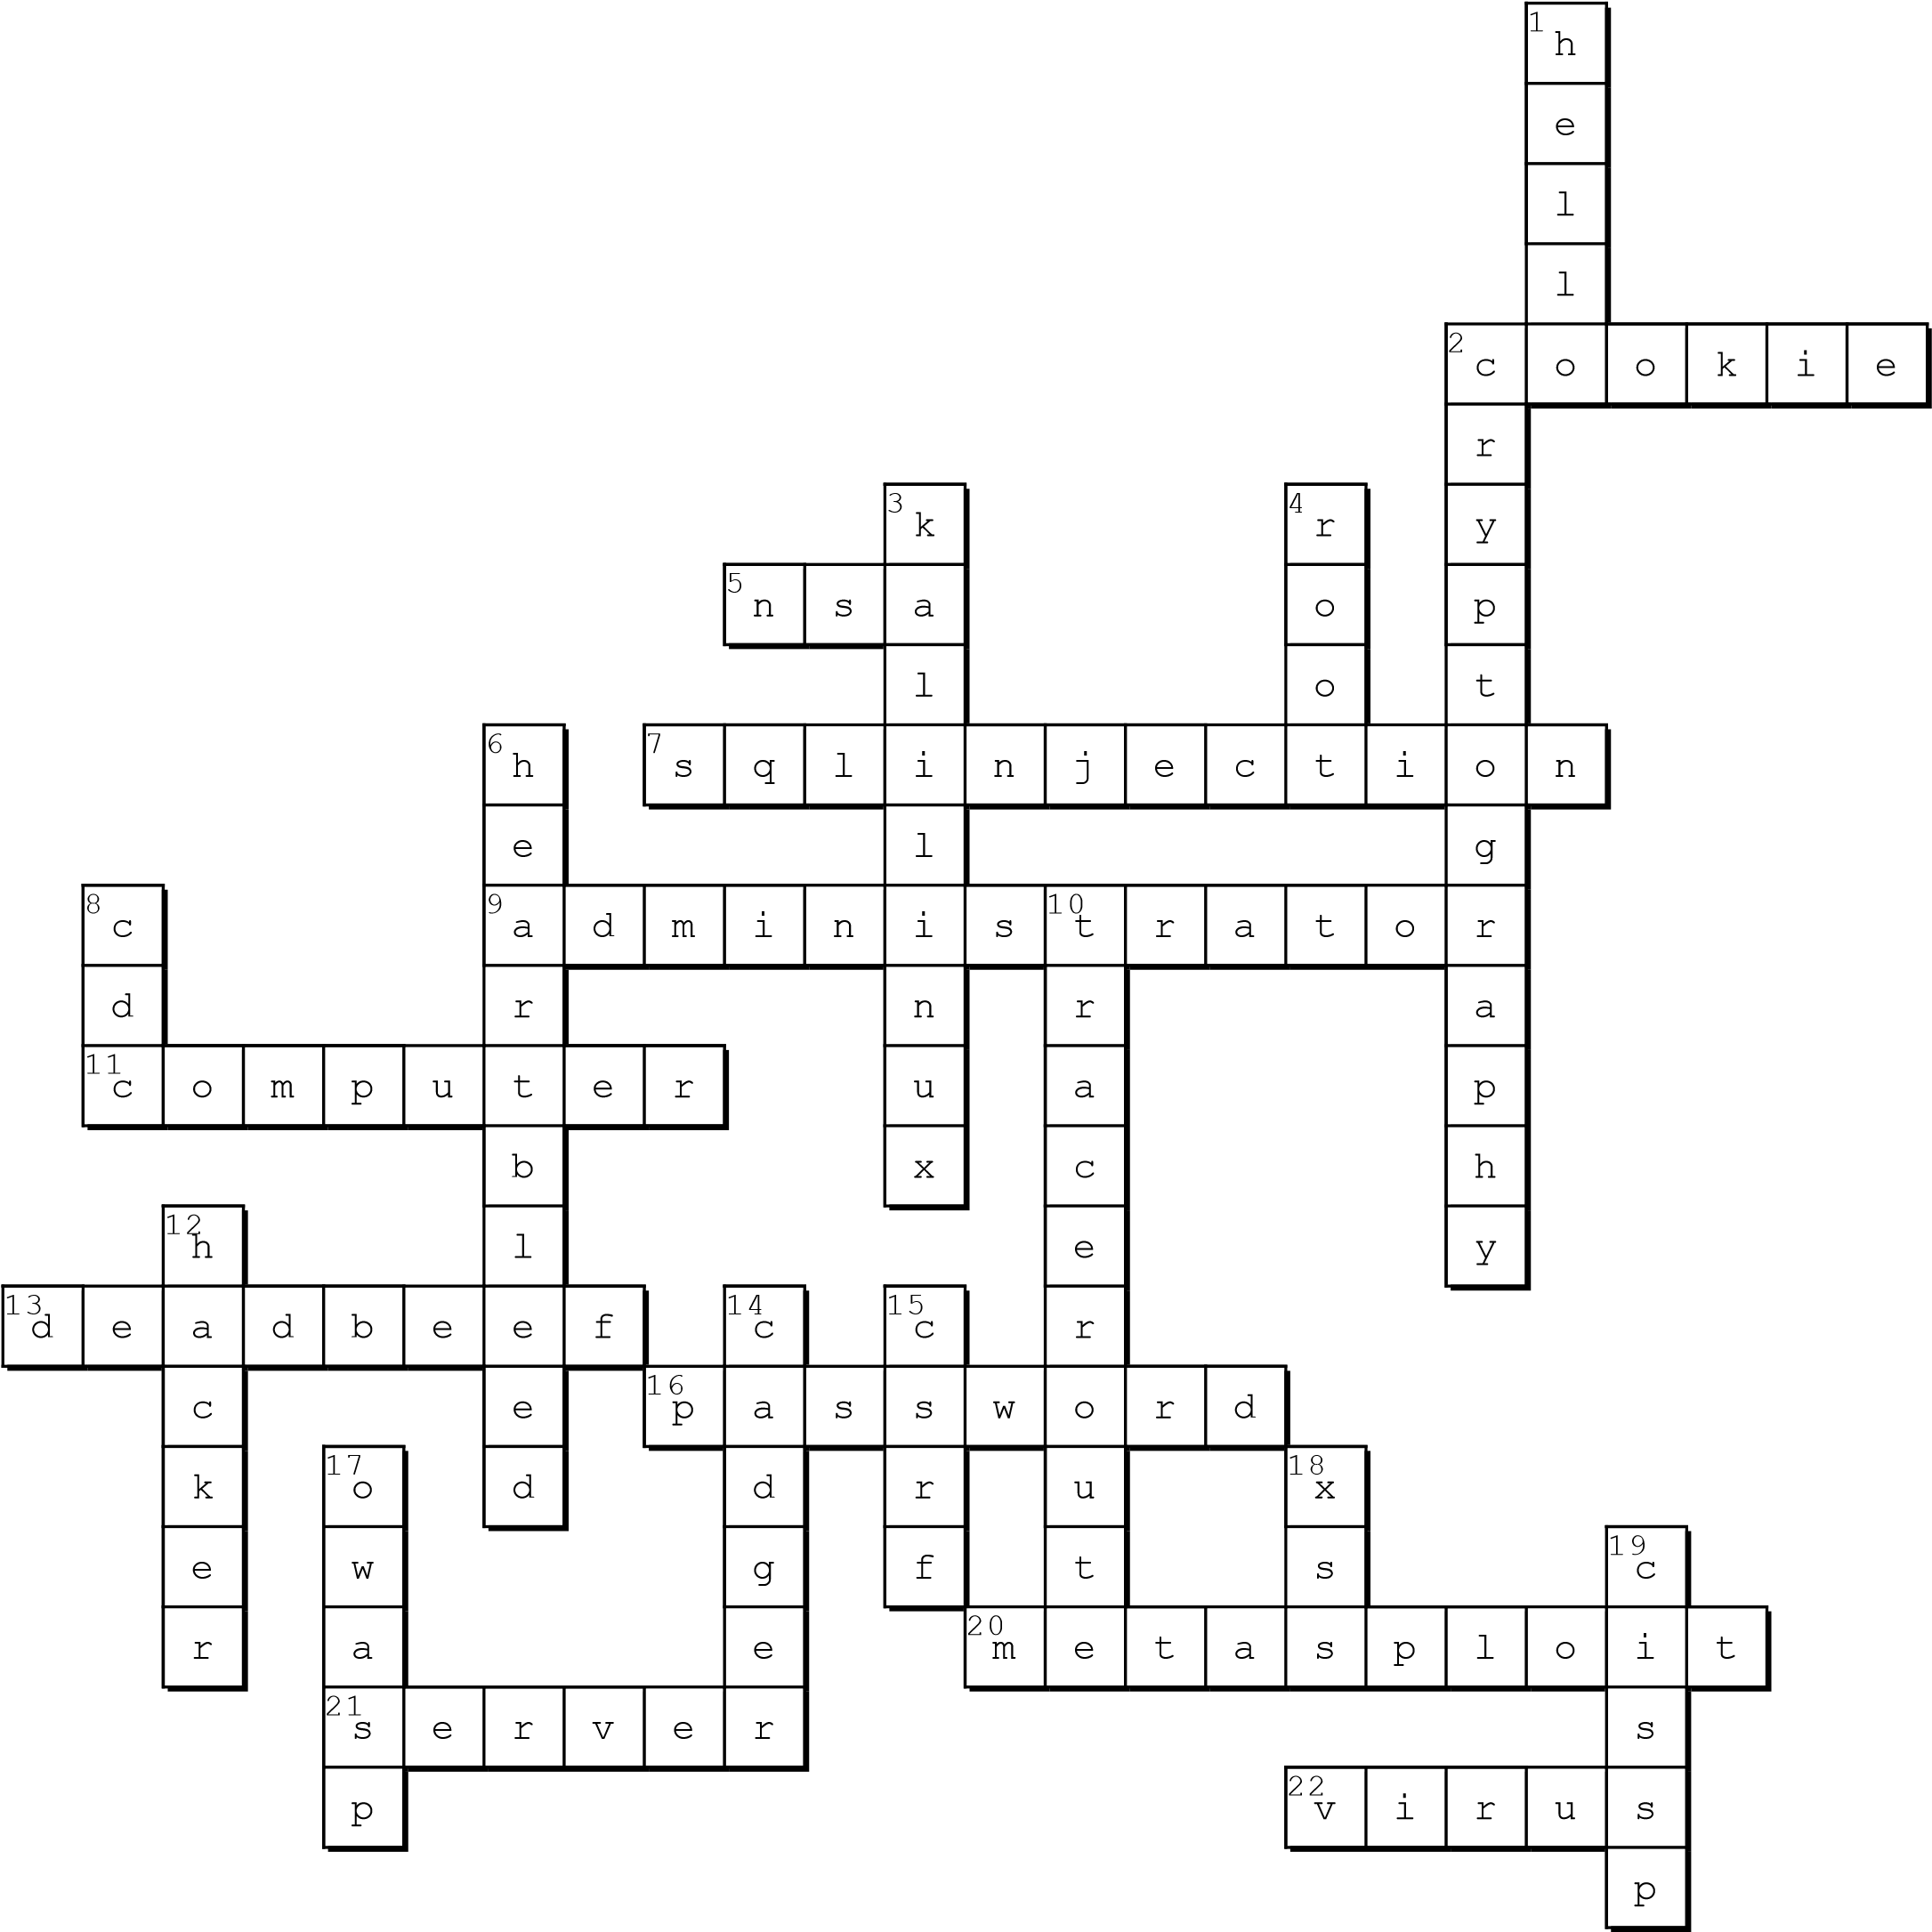

Created on TheTeachersCorner.net Crossword Maker

http://worksheets.theteacherscorner.net/make-your-own/crossword/crossword.php 1/2 11/12/2014 CDC

Horizontal

2. a small piece of data sent from a website and stored in a user's web browser while the user is browsing that website (cookie) 5. a U.S. intelligence agency responsible for global monitoring, collection, decoding, translation and analysis of information and data for foreign intelligence and counterintelligence purposes (nsa)

7. is a code injection technique, used to attack data-driven applications, in which malicious SQL statements are inserted into an entry field for execution (e.g. to dump the database contents to the atta (sqlinjection)

9. a person responsible for running technically advanced information systems

(administrator)

11. a general purpose device that can be programmed to carry out a set of arithmetic or logical operations automatically (computer)

13. the word for :64 65 61 64 62 65 65 66

(deadbeef)

16. default credentials are username and

_______ (password)

1. a computer security project that provides information about security vulnerabilities and aids in penetration testing and IDS signature development (metasploit)
2. a running instance of an application (software) capable of accepting requests from the client and giving responses accordingly

(server)

1. Often mistaken as having a cold (virus)

Vertical

1.

011010000110010101101100011011000110111

1 (hello)

1. is the practice and study of techniques for secure communication in the presence of third parties (cryptography)
2. a Debian-derived Linux distribution designed for digital forensics and penetration testing

(kalilinux)

1. super user (root)

6. A security bug disclosed in April 2014 in the OpenSSL cryptography library, which is a widely used implementation of the Transport Layer Security (TLS) protocol (heartbleed)

8. Short for Cyber Defense Competition (cdc) 10. is a computer network diagnostic tool for displaying the route (path) and measuring transit delays of packets across an network (or can (traceroute)

12. someone who seeks and exploits weaknesses in a computer system or computer networ (hacker)

1. to ask, expect, or encourage another person to pay for or provide one's drinks, meals, etc (cadger)
2. Cross Site Request Forgery (csrf)
3. The Open Web Application Security Project

(owasp)

1. Cross Site Scipting (xss)
2. Certified Information Systems Security

Professional (cissp)

http://worksheets.theteacherscorner.net/make-your-own/crossword/crossword.php 2/2