**FUNDAMENTAL CONCEPTS**

Spatial Resolution - M rows x N columns

Plano = Matrix

Depth Resolution -> n bits/pixel

Image levels -> L = 2^n

Energy:

-Sum of all pixel

-The square of the value of each pixel is the instant/spatial power of the pixel

Power:

-Power is the average energy per pixel

Average Intensity:

-The average intensity is the mean value of all the pixels in the image

Brightness (sometimes average intensity):

-Low brightness->The histogram is on the left-hand-side

-Excessive brightness->The histogram is on the right-hand-side

Contrast:

-high contrast = spread histogram

-low contrast = concentrated histogram

--c1 = mx – mi

--c2 = (mx + 1) / (mi + 1)

--c3 = 20 log10 ((mx + 1) / (mi + 1) )

Entropy:

-Low entropy –> highly predictable image

-High entropy –> less predictable image

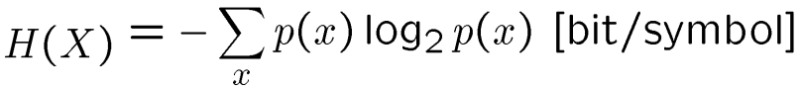

**BASIC OPERATIONS**

Overflow Problem:

Histogram equalization:

**Spatial filtering:**

Non-linear- in which the window / kernel / mask is defined by horizontal and vertical dimensions and a function.

Linear- in which the window/kernel/mask is defined by a set of numbers.

Smoothing -> sum = 1

Sharpening -> sum = 0

Derivatives:

First ->

Second->

Laplacian masks:

Gradient Concept:

-The gradient is a generalization of the derivative concept for multi-variate functions

-A derivative is defined as a function of a single variable

-For functions with more than one variable the gradient is applied

-The gradient is a vector-valued function

-The derivative is scalar-valued

-The gradient points in the direction of the greatest rate of increase of the function

-Its magnitude is the slope of the graph in that direction

Roberts cross:

Magnitude and angle:

Sobel:

Magnitude and angle:

Prewitt:

Magnitude and angle:

