Energy:

-Sum of all pixels

-The square of the value of each pixel is the instant/spatial power of the pixel

Power:

-Power is the average energy per pixel

Average Intensity:

-The average intensity is the mean value of all the pixels in the image

---------------------------------------------------------------

Pseudo-color - intensity slicing

Histograma equalization HSI is better than RGB because its less computer consuming.

ICC advantage over RGB its easier to make changes over colour without changing the luminosity.

h-> colour

s->saturação

i->intensidade

Color balancing - change s IN HIS model

tone balancing - change I IN HIS model

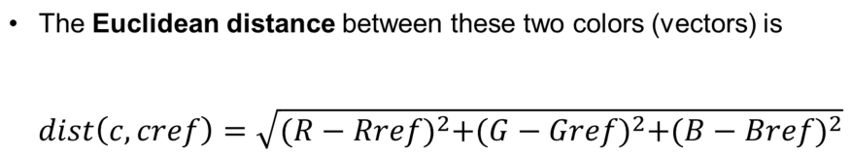

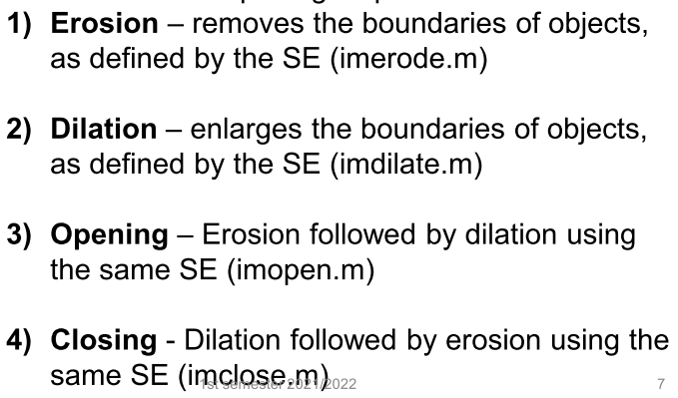

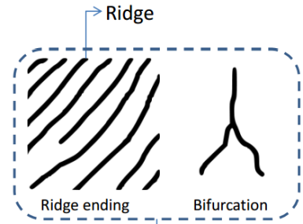

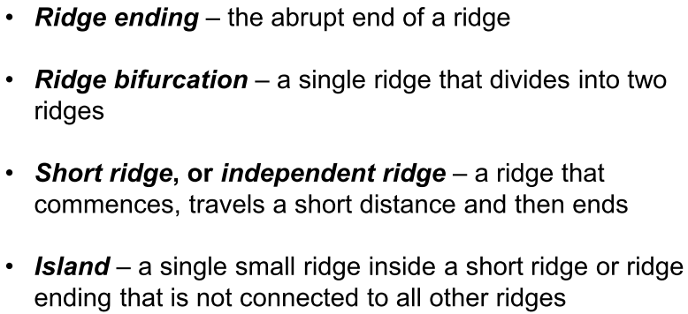

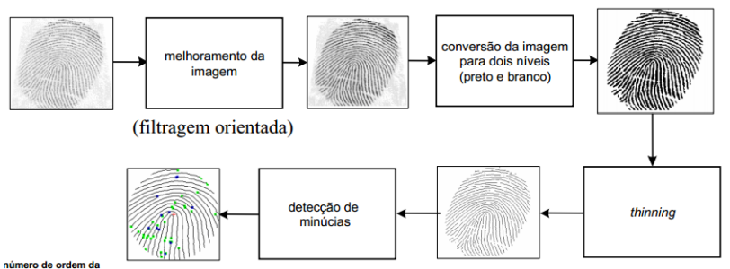

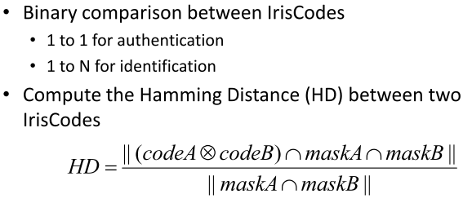

Universalidade - significa que todas as pessoas devem possuir a característica;

Singularidade - indica que esta característica não pode ser igual em pessoas diferentes;

Permanência - significa que a característica não deve variar com o tempo;

Mensurabilidade - indica que a característica pode ser medida quantitativamente.

DFT

IDFT

