Empirical Exercise

Group 8

(a)

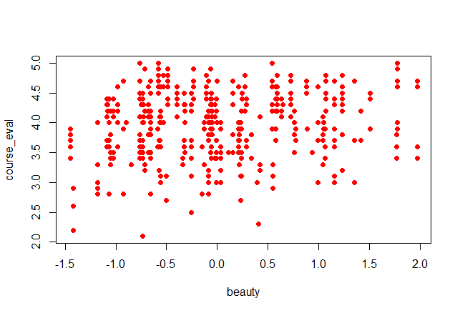

(b)

> plot(TeachingRatings$beauty, TeachingRatings$course_eval,

+ main = "TeachingRatings",

+ xlab = "beauty",

+ ylab = "course_eval",

+ pch = 19, col = "red")

> lm.reg=lm(course_eval~beauty,data=TeachingRatings)

> summary(lm.reg)

Call:

lm(formula = course_eval ~ beauty, data = TeachingRatings)

Residuals:

Min 1Q Median 3Q Max

-1.80015 -0.36304 0.07254 0.40207 1.10373

Coefficients:

Estimate Std. Error t value Pr(>|t|)

(Intercept) 3.99827 0.02535 157.727 < 2e-16 ***

beauty 0.13300 0.03218 4.133 4.25e-05 ***

---

Signif. codes: 0 ‘***’ 0.001 ‘**’ 0.01 ‘*’ 0.05 ‘.’ 0.1 ‘ ’ 1

Residual standard error: 0.5455 on 461 degrees of freedom

Multiple R-squared: 0.03574, Adjusted R-squared: 0.03364

F-statistic: 17.08 on 1 and 461 DF, p-value: 4.247e-05

>

Estimated intercept 3.99827

Estimated slope 0.13300

*Course_eval=4.00+0.133*beauty*

Estimated intercept=course_eval-0.133*beauty

The mean of beauty is 0,so estimated intercept=course_eval.

(c)

The standard deviation of beauty is 0.789.

Professor Watson’s predicted course evaluations = 4.00 + 0.133*0*0.789 = 4.00

Professor Stock’s predicted course evaluations = 4.00 + 0.133*1*0.789 = 4.105

(d)

The standard deviation of course evaluations is 0.55. A one standard deviation increase in beauty is expected to increase course evaluation by 0.133* 0.789 = 0.105. 0.55>0.105,The effect is small.

(e)

= 0.036

Beauty explains 3.6% of the variance in course evaluations.