Homework2
Group12
成员：金梦茹 张子竹 张岳曦
2017年4月4日

a.
> data<-
+ read.table("clipboard",header=T)
>plot(data[,1:2],main="Scatterplot of average course evaluations on the professor's beauty",ylab="Course_Eval",xlab="Beauty",xlim=c(-2,2),ylim=c(0,5))
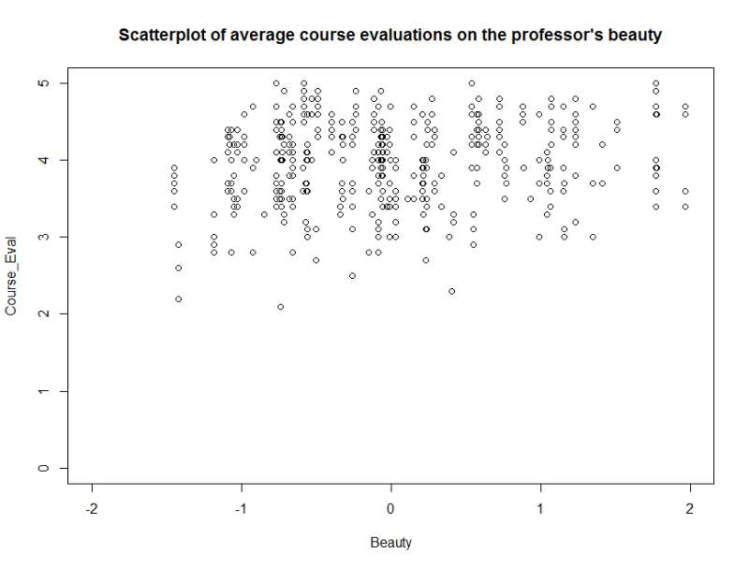
According to the scatterplot, it seems no relationship between the variable.

b.
> df <- data[,1:2]
> lm(course_eval~beauty,data=df)

Call:
lm(formula = course_eval ~ beauty, data = df)

Coefficients:
(Intercept) beauty
3.998 0.133

> mod1<-lm(course_eval~beauty,data=df)
> summary(mod1)

Call:
lm(formula = course_eval ~ beauty, data = df)

Residuals:
Min 1Q Median 3Q Max
-1.80015 -0.36304 0.07254 0.40207 1.10373

Coefficients:
Estimate Std. Error t value Pr(>|t|)
(Intercept) 3.99827 0.02535 157.727 < 2e-16 ***
beauty 0.13300 0.03218 4.133 4.25e-05 ***
---
Signif. codes: 0 ‘***’ 0.001 ‘**’ 0.01 ‘*’ 0.05 ‘.’ 0.1 ‘ ’ 1

Residual standard error: 0.5455 on 461 degrees of freedom
Multiple R-squared: 0.03574, Adjusted R-squared: 0.03364
F-statistic: 17.08 on 1 and 461 DF, p-value: 4.247e-05

> plot(df$course_eval,df$beauty,col="blue",ylab="Course_Eval",xlab="Beauty",xlim=c(-2,2),ylim=c(0,5))
> intercept <- coef(mod1)[1]
> slope <- coef(mod1)[2]
> abline(intercept, slope, col="red")

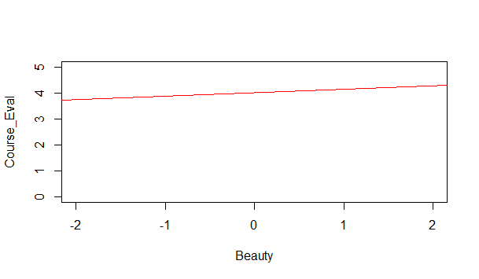
Estimated intercept=3.99827
Estimated slop=0.133
Sample mean of beauty=0.0000000626
Sample mean of Course_Eval=3.998+0.133*sample mean of beauty=3.998+0.133*0=3.998=Estimated intercept

c.
Waston: Course_Eval=3.998+0.133*0=3.998
Stock: SD=0.55
Course_Eval=3.998+0.133*(0+0.55)=4.07115

d.
Small. Because the scatterplot is uniformly distributed and the line is flat, so the estimated effect of beauty on course_eval is small. Small means the change of beauty doesn’t effect the course.

e.
No. Most of points are not on the line, so it may be other variables effect the course.

