Incorporating Zemax lens descriptions into ISET simulations

ISET enables modeling the image formation of specific lenses. We provide a Zemax macro (ISET_RT_ZEMAX.ZPL) that you can use with a lens description file to model image formation. The image formation model is a ray trace from the scene to the sensor surface.
In this application note we describe how to
1. Use the Zemax macro ISET_RT_ZEMAX.ZPL to create Zemax data files,
2. Convert these data files into an ISET optics structure, and
3. Import the ISET optics data structure and run the simulation.
(1) Using Zemax to create ISET data

You should have the file called ISET_RT_ZEMAX.ZPL in ISET-3.0\modules\raytrace\
If you cannot find it, send a message to imageval@imageval.com
Save ISET_RT_ZEMAX.ZPL file in C:\ZEMAX\Macros directory.
Create a folder for the distorted image height, relative illumination, optical parameters, and PSF data.
Start ZEMAX (hardware key must be installed)
Open lens in ZEMAX using File pull-down menu
File ➔ Open

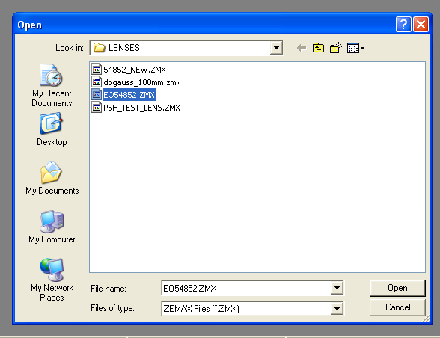
Open a PSF window using Analysis pull-down menu
Analysis ➔ PSF ➔ FFT PSF
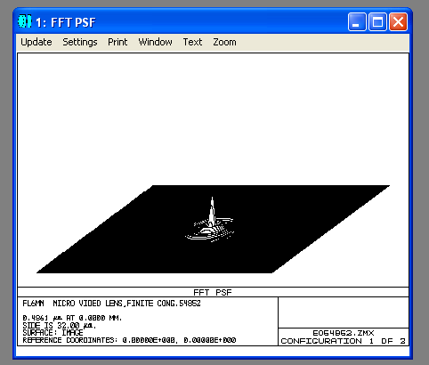
Use Settings pull-down menu to change Sampling, Wavelength, Field, Image Delta (in microns) to achieve a computable PSF. You MUST match the sampling in ZEMAX to what you set in the ZPL macro (ISET_RT_ZEMAX.ZPL). We suggest 0.00025mm.
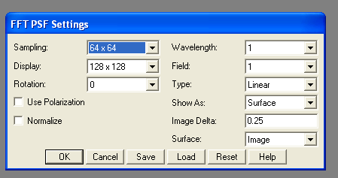

When a suitable PSF can be computed, click on Settings to open FFT PSF Settings dialog box. Make sure Wavelength selection is 1, Field selection is 1, and click on Save.
Save lens using File pull-down menu
File ➔ Save
Edit ISET_RT_ZEMAX.ZPL file using notepad or another text editor to include the desired path and filenames, PSF_SIZE (which should be equal to Display selection in FFT PSF Settings dialog box), wavelength and field information, etc.,. Save ISET_RT_ZEMAX.ZPL file in C:\ZEMAX\Macros directory.
Run ISET_RT_ZEMAX macro using the Macros pull-down menu
Macros ➔ ISET_RT_ZEMAX
The optical system parameters will be stored in ISETPARMS.txt in the folder designated in the ISET_RT_ZEMAX.ZPL file. Below is an example of an ISETPARMS.txt file.
% C:\ZEMAX\LENSES\EO54852.ZMX
lensFile='EO54852.ZMX'
psfSize=128 % PSF ROW AND COL SIZE
psfSpacing=0.0002500 % PSF GRID SPACING IN MM
wave=400:50:700 % WAVELENGTH SAMPLES (NM)
imgHeight=0.000:1.000:3.000 % PARAXIAL IMAGE HEIGHTS (MM)
objDist=250.000 % OBJECT DISTANCE (MM)
mag=-0.023954 % OPTICAL SYSTEM MAGNIFICATION
baseLensFileName='C:\ZEMAX\OPTICAL_DATA_E054852\EO54852'
refWave=587.562 % REFERENCE WAVELENGTH (NM)
fov=26.200876 % MAXIMUM DIAGONAL HALF FOV (DEGREE)

The distorted Image Height matrix will be stored in BASENAME$_DI_.dat in folder designated in ISET_RT_ZEMAX.ZPL file.
The relative Illumination matrix will be stored in BASENAME$_RI_.dat in folder designated in ISET_RT_ZEMAX.ZPL file.
The PSF Data will be stored in BASENAME$_PSF_1_1.txt, BASENAME$_PSF_1_2.dat, … , BASENAME$_PSF_wavelength#_field#.dat in folder designated in ISET_RT_ZEMAX.ZPL file.

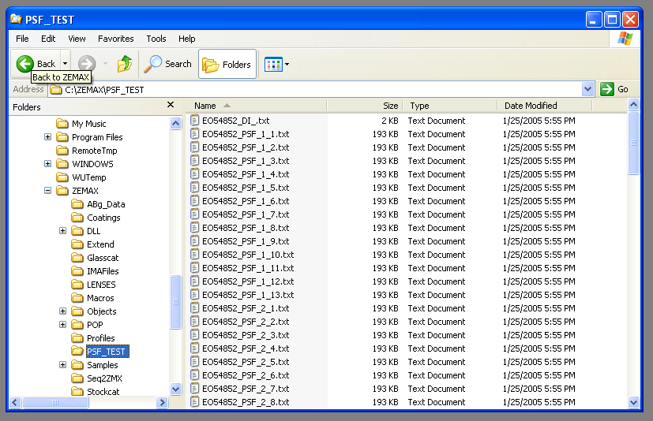
The PSF data files will have heading information that must be handled when loading or reading the data into Matlab.

(2) Converting Zemax data into an ISET optics structure
Place the ZEMAX data files into a separate directory (referred to here as C:\DIRECTORY)
The ZEMAX macro will create many data files, including a text data file the lists the optical system parameters (referred to here as ISETPARMS.txt ).
Edit ISETPARMS.txt file so that baseLensFileName = ‘C:\DIRECTORY\FileName’ where DIRECTORY is the name of the directory where the Zemax data files are stored and Filename is the name of the lens you are modeling.
Open the main ISET window by typing ISET in the Matlab command window.
Select “Optics” from the main ISET window.
Select “Convert Zemax” from the Optics menu, as shown below.
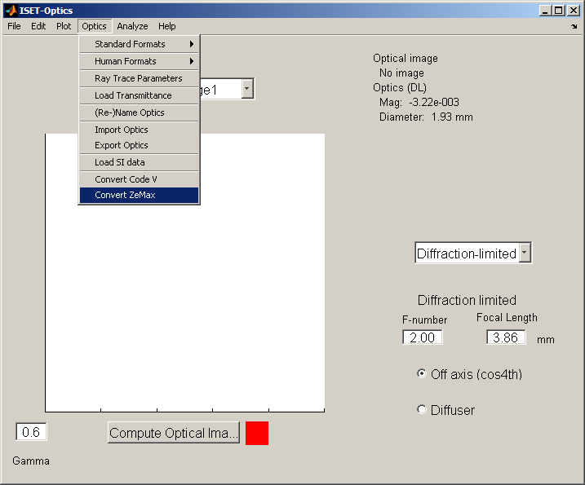
A window will open to allow you to change to the appropriate directory and select the ISETPARMS.txt file.
When the data have been converted, a window will appear asking you to save the converted optics. Select the directory you wish to store the ISET optics structure in and give it a name (in this example, we will refer to the ISET optics structure as ISETOPTICS.mat.
(3) Importing the ISET optics structure to run a simulation
The computational time to run the Ray trace depends on the size of the scene image and the number of wavelength bands in the scene image data. We recommend that you first test the simulations using a relatively small scene image with a few wavelength bands. In the example below, we select the Slanted Bar pattern from the Scene menu. Then, we will reduce the size of the scene and the number of wavelength samples.
Scene
Select the “Scene” option from the main ISET window.
Select Scene>Patterns>Slanted Bar (ISO 12233) from the Scene window menu, as shown below.

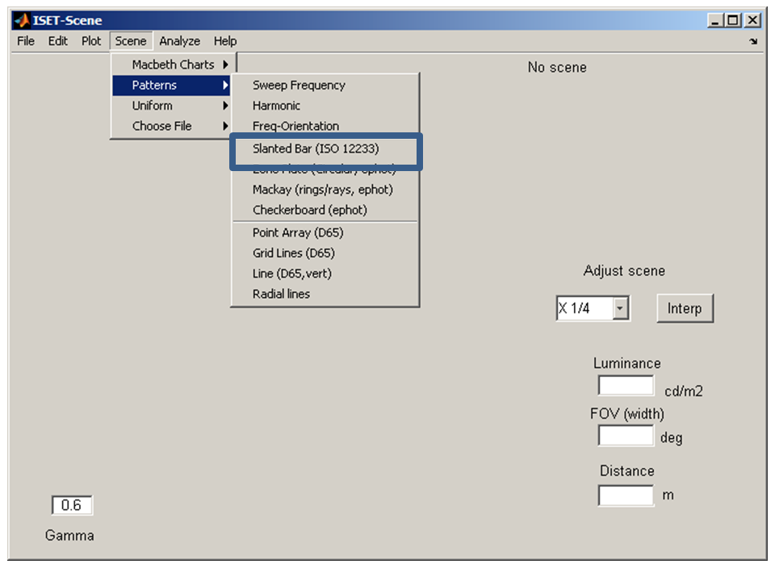

Reduce the size of the scene image data by selecting the “X ¼” in the Adjust scene box
Reduce the number of wavelength bands by selecting
Edit>Adjust SPD > Resample Wavelength
A window will appear. Change Spacing (nm) to 150, as illustrated below
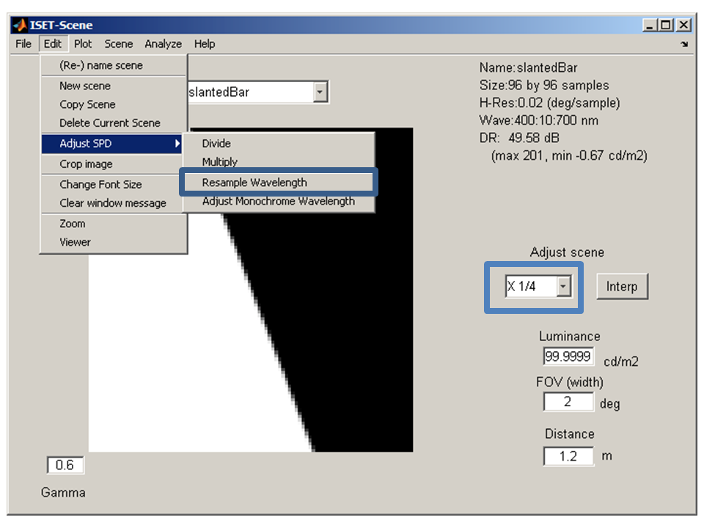 | 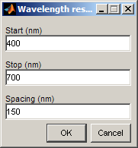
Notice that the information in the upper right hand corner has Size:96X96 samples and Wave:: 400:150:700

Optics
Select “Optics” from the main ISET window.
Select “Import Optics” from the Optics menu. A window will appear allowing you to select the ISET Optics structure file (referred to in this example as ISETOPTICS.mat).
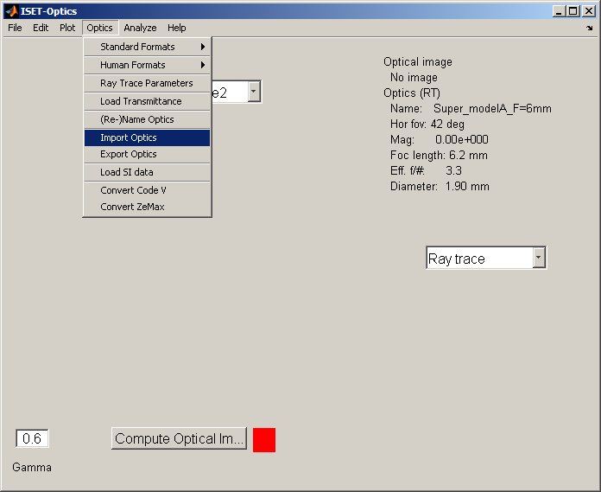

Select “ Compute Optical Image”
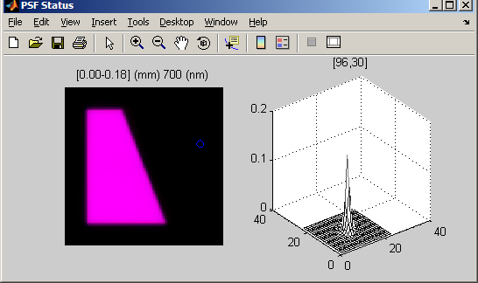

A window (titled ‘PSF Status’) will appear that will show the progress in computing the point spread functions at different locations in the optical image

