3. Setup Cloudberry and Earthquake application:

Step 3.1: Install Oracle Database 10g+ on your machine and remember your server information and account information.

Step 3.2: Start Oracle Database on your machine and create EARTHQUAKEDATA table and insert example data.

3.2.1 Start Oracle Database

Execute the following command on your machine and a “SQL>” prompt will be appear.

sqlplus "/as sysdba"

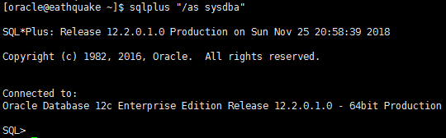

Then, execute command “startup” to startup Oracle Database and quit the SQL PLUS environment with “quit” command.

3.2.2 Start Oracle listener

lsnrctl start

3.2.3 Create EARTHQUAKEDATA table and insert example data.

Start SQL PLUS with the flowing command using your own password instead of YOURPASSWORD

sqlplus system/YOURPASSWORD

copy and past the script in file “createsql.txt” to here

wait the command to finished and quit SQL PLUS with “quit” command.

C:\Users\XIAOMI~1\AppData\Local\Temp\1543208514(1).png

Step 3.3: Configure Cloudberry server.

C:\Users\XIAOMI~1\AppData\Local\Temp\1543208622(1).png

Comment the statement “asterixdb.lang = SQLPP”, and add the following statements:

**oracledb.url = "jdbc:oracle:thin:system/PASSWORD@//SERVERIP:1521/INSTANCENAME"**

**asterixdb.lang = oracle**

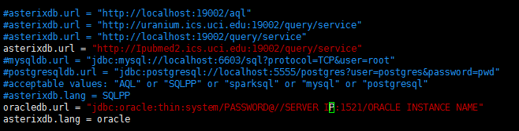

Step 3.4: Compile and run the Cloudberry server.

~/cloudberry> cd cloudberry

~/cloudberry> sbt compile

~/cloudberry> sbt "project neo" "run"

Wait until the shell prints the messages shown as following:

$ sbt "project neo" "run"

[info] Loading global plugins from /Users/white/.sbt/0.13/plugins

[info] Loading project definition from /Users/white/cloudberry/cloudberry/project

[info] Set current project to cloudberry (in build file:/Users/white/cloudberry/cloudberry/)

[info] Set current project to neo (in build file:/Users/white/cloudberry/cloudberry/)

--- (Running the application, auto-reloading is enabled) ---

[info] p.c.s.NettyServer - Listening for HTTP on /0:0:0:0:0:0:0:0:9000

3.5 Open the browser to access cloudeberry/example/EarthquakeWeb/TestCloudberry.html to see the EathquakeWeb frontend.

If you want to view this web application in other computer, you can copy the forder “EarthquakeWeb” to your computer and use notepad edit the file “TestCloudberry.html”. To make sure “COLUDBERRYURL” variable to point to your own cloudberry server.

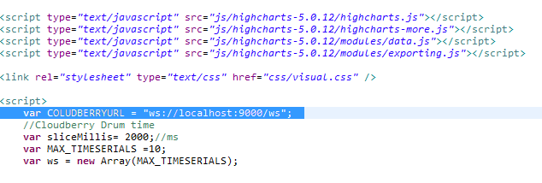

3.6 You can change the search conditions and click button “Search” to view the result.