Mini Project Report

Big Data Analysis

Smart Energy Stream Analytics: Memory-Efficient Pattern Detection and Distinct State Estimation Using Bloom Filter and Flajolet-Martin Algorithm

By

Ishaan Singh PRN: __________
Student Name 2 PRN: __________
Student Name 3 PRN: __________


Department of Computer Engineering
SIES Graduate School of Technology Nerul, Navi Mumbai - 400 706
(AY 2026-27)

Contents
Abstract...................................................................3
Chapter 1: Introduction....................................................4
1.1 Introduction...........................................................4
1.2 Motivation.............................................................4
1.3 Problem Statement & Objectives.........................................5
1.4 Mini Project Contribution..............................................6
Chapter 2: Proposed System and Methodology.................................7
2.1 Proposed System........................................................7
2.2 Architecture / Framework / Block Diagram...............................7
2.3 Dataset Description....................................................8
2.4 Algorithm and Process Design...........................................9
2.5 Hardware & Software....................................................11
2.6 Methodology............................................................11
2.7 Evaluation Metrics.....................................................12
Chapter 3: Results and Discussions.........................................13
3.1 Results................................................................13
3.2 Code...................................................................14
3.3 Discussion.............................................................17
Chapter 4: Conclusion and Future Scope.....................................18
References.................................................................19

Abstract
The rapid growth of smart-metering systems produces continuous streams of electricity measurements that are difficult to process using only exact, memory-intensive techniques. This mini project presents a memory-efficient Big Data Analytics approach for analysing a real household electricity-consumption stream using two probabilistic stream-mining algorithms: Bloom Filter and Flajolet-Martin. The project uses the UCI Individual Household Electric Power Consumption dataset, which contains 2,075,259 one-minute electricity measurements collected over almost four years. The data is imported into Google Colab, cleaned, ordered chronologically, and converted into discrete energy states using active power and voltage.
The Bloom Filter is used to determine whether a particular energy state has probably appeared earlier in the stream. Its performance is studied using false-positive rate and varying filter sizes. The Flajolet-Martin algorithm is used to estimate the number of distinct energy states without storing every unique state. Its output is compared with exact distinct counting to calculate estimation error. To make the project more useful as a BDA mini project, additional experiments compare exact and approximate methods in terms of memory usage, execution time, and accuracy. Stream-window analysis and basic energy-consumption analysis are also included to show how data behaviour changes over time.
The project directly implements concepts from the Mining Data Streams module of Big Data Analysis: stream data models, Bloom filters, and count-distinct estimation using the Flajolet-Martin algorithm. The main contribution is an easy-to-run Google Colab pipeline that demonstrates how probabilistic techniques can trade a small amount of accuracy for substantial memory savings when analysing large or continuously growing data streams.
Keywords: Big Data Analytics, Data Streams, Bloom Filter, Flajolet-Martin, Smart Meter, Approximate Counting, Memory Efficiency, Google Colab.

Chapter 1: Introduction

1.1 Introduction
Smart meters record electricity-related measurements at short time intervals. When such measurements are collected continuously for months or years, the result is a large chronological stream rather than a small static dataset. Traditional exact methods can answer questions such as “Has this state appeared before?” or “How many unique states are present?”, but they often require storing every distinct element. In a continuously growing stream, the amount of memory required by exact structures can also continue to grow.
Big Data Analytics includes methods for processing high-volume and high-velocity data efficiently. Stream-mining algorithms are especially useful when only one pass over the incoming data is preferred and storage is limited. This project focuses on two such techniques. A Bloom Filter provides memory-efficient approximate membership testing, while the Flajolet-Martin algorithm estimates the number of distinct elements in a stream using compact probabilistic state.

1.2 Motivation
Many student BDA projects concentrate on database queries or dashboard visualisation. This project was selected to demonstrate an important algorithmic aspect of the BDA syllabus: mining a large data stream using probabilistic techniques. Smart-meter data is a suitable domain because measurements naturally arrive in time order and can be considered a continuous stream of operating states.
• Use a real-world dataset rather than synthetically generated records.
• Implement algorithms explicitly listed under Mining Data Streams in the BDA syllabus.
• Demonstrate the memory–accuracy trade-off that motivates approximate Big Data algorithms.
• Keep the implementation lightweight and reproducible using Python in Google Colab.
• Provide meaningful energy-consumption insights in addition to algorithm evaluation.

1.3 Problem Statement & Objectives

Problem Statement
Large smart-meter streams may contain millions of repeated and unique energy states. Exact membership and exact distinct counting can become increasingly memory intensive as the number of unique states grows. The problem is to analyse such a stream using compact probabilistic techniques while measuring the loss of accuracy introduced by approximation.

Objectives
1. Import and preprocess a real household electricity-consumption dataset containing more than two million observations.
2. Convert continuous electricity measurements into discrete energy states suitable for stream-mining algorithms.
3. Implement a Bloom Filter for memory-efficient membership testing and analyse its false-positive behaviour.
4. Implement the Flajolet-Martin algorithm for approximate counting of distinct energy states.
5. Compare exact and approximate approaches using accuracy, memory usage and execution time.
6. Analyse high-consumption behaviour and stream windows to provide interpretable energy insights.
7. Create a complete and reproducible Google Colab workflow suitable for demonstration and viva.

Scope
The project is an academic prototype. It models the imported chronological records as a stream inside Google Colab. It does not claim to be a live IoT deployment. The Bloom Filter and Flajolet-Martin components are the main BDA contribution; exploratory energy analysis is included only to provide context and interpretation.

1.4 Mini Project Contribution
The project contributes a compact end-to-end stream analytics pipeline with the following components:
• Real UCI smart-meter dataset with 2,075,259 minute-level readings.
• Data cleaning, timestamp construction and chronological ordering.
• Energy-state construction by discretising active power and voltage.
• Bloom Filter implementation from first principles using multiple SHA-256 based hash positions.
• Flajolet-Martin implementation using trailing-zero statistics and multiple estimators for stability.
• Exact-versus-approximate comparison for accuracy verification.
• Memory and execution-time measurement for performance discussion.
• Stream-window and high-consumption analysis for additional BDA interpretation.
The most important contribution is not the size of the dataset alone. The project demonstrates how streaming algorithms maintain a compact summary of the data instead of retaining every distinct state for the required query. This idea is central to large-scale stream processing.

Chapter 2: Proposed System and Methodology

2.1 Proposed System
The proposed system imports the UCI household electricity dataset into Google Colab and processes it in chronological order. After cleaning missing values, two continuous measurements—Global Active Power and Voltage—are rounded and combined into a discrete Energy_State identifier. These identifiers form the logical stream processed by both approximate algorithms.
Bloom Filter answers an approximate membership query: whether a given energy state has probably occurred earlier. Flajolet-Martin answers an approximate count-distinct query: how many different energy states have occurred in the processed stream. Exact Python set operations are used only as ground truth for evaluation.

2.2 Architecture / Framework / Block Diagram
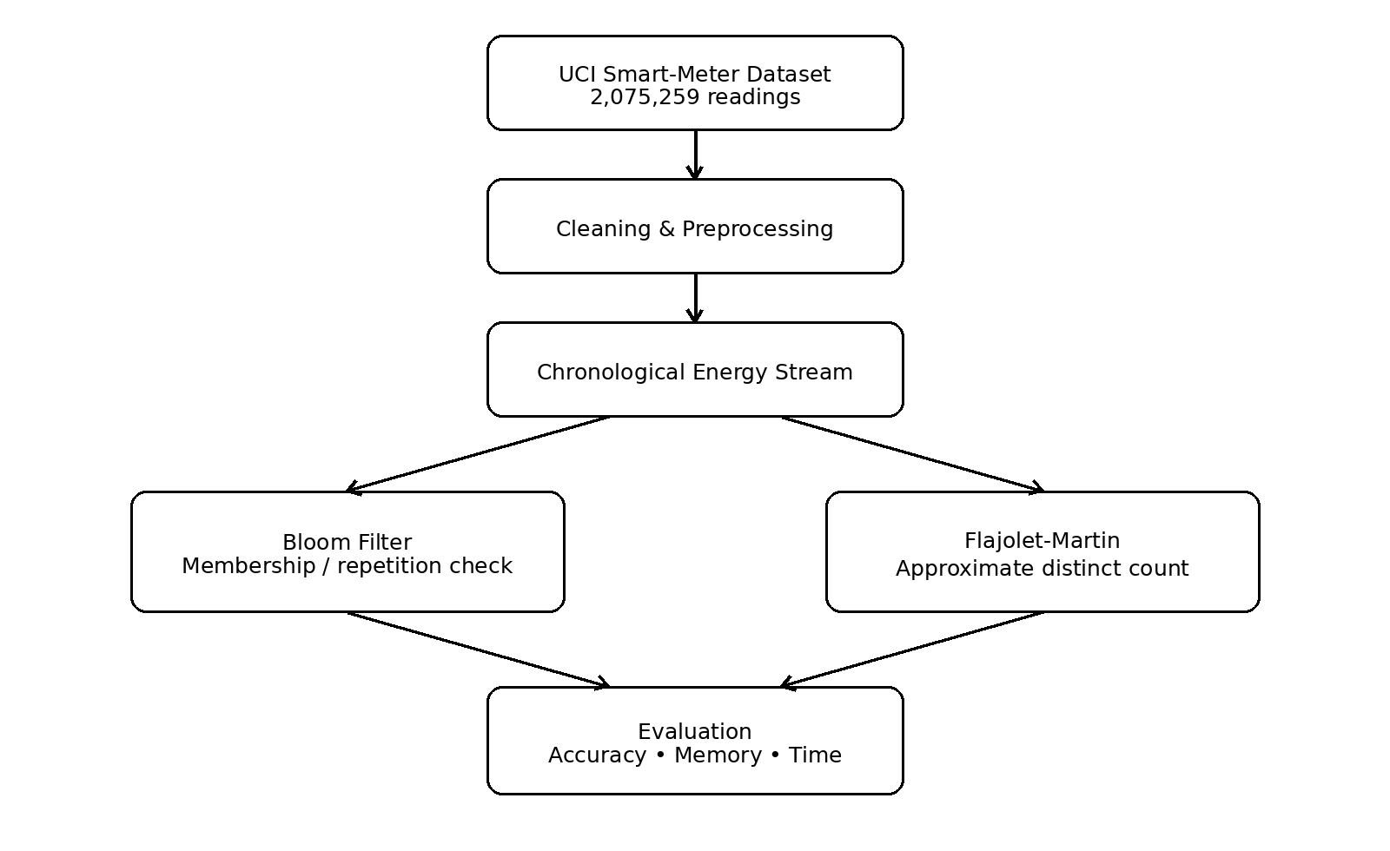
Figure 2.1 Overall architecture of the proposed smart energy stream analytics system

2.3 Dataset Description
The project uses the UCI Machine Learning Repository dataset “Individual Household Electric Power Consumption”. It contains 2,075,259 measurements recorded at one-minute intervals from December 2006 to November 2010 for a single household. Missing measurements are represented using the “?” symbol in the raw text file. During preprocessing these values are treated as missing and incomplete rows are removed for a clean demonstration stream.
Attribute | Description | Unit / Format
Date | Date of observation | dd/mm/yyyy
Time | Time of observation | hh:mm:ss
Global_active_power | Minute-averaged active power | kW
Global_reactive_power | Minute-averaged reactive power | kW
Voltage | Minute-averaged voltage | Volt
Global_intensity | Minute-averaged current intensity | Ampere
Sub_metering_1 | Kitchen energy sub-metering | Wh
Sub_metering_2 | Laundry-room sub-metering | Wh
Sub_metering_3 | Water-heater / air-conditioner sub-metering | Wh

Energy-State Construction
The raw numeric stream contains many floating-point values. For membership and distinct counting, readings are converted into discrete operating states. Active power is rounded to one decimal place and voltage to the nearest integer. The two values are concatenated, for example: 4.216 kW and 234.84 V become the state “4.2_235”. This preserves useful consumption information while creating repeatable stream elements.

2.4 Algorithm and Process Design

2.4.1 Bloom Filter
A Bloom Filter is a probabilistic data structure used for membership testing. It uses a fixed-size bit array and multiple hash functions. To insert an energy state, each hash function maps the state to a bit position and those bits are set to 1. To query an energy state, the same positions are checked. If any bit is 0, the item is definitely not present. If all bits are 1, the item is probably present. A standard Bloom Filter can generate false positives but not false negatives.
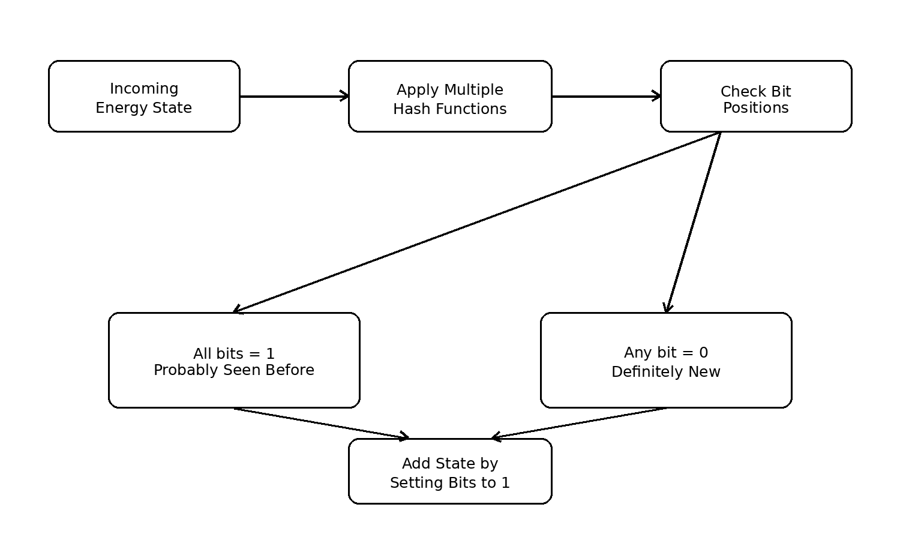
Figure 2.2 Bloom Filter processing flow

2.4.2 Flajolet-Martin Algorithm
The Flajolet-Martin algorithm estimates the number of distinct elements in a data stream. Each energy state is hashed into a pseudo-random binary value. The algorithm observes the maximum number of trailing zeros seen among the hashes. Long runs of trailing zeros are rare, so observing a larger run suggests that more distinct elements have been processed. A basic estimate is proportional to 2^R, where R is the maximum trailing-zero count. Multiple estimators are used and combined to reduce instability.
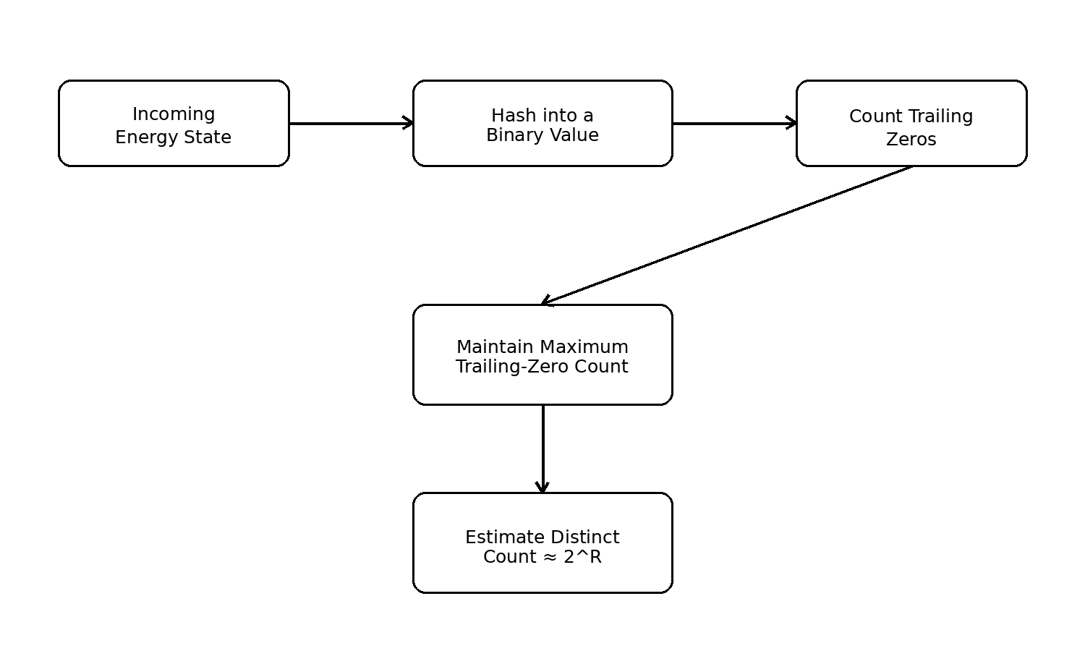
Figure 2.3 Simplified Flajolet-Martin processing flow

2.5 Details of Hardware & Software
Category | Requirement
Platform | Google Colab
Programming Language | Python 3
Libraries | Pandas, NumPy, Matplotlib, hashlib, time, sys
Dataset Source | UCI Machine Learning Repository
Browser | Any modern browser with Google account access
Hardware | Standard laptop/desktop; Colab runtime handles execution
Internet | Required mainly for dataset download and Colab access

2.6 Methodology
1. Download and import the real UCI dataset in Google Colab.
2. Replace “?” with missing values, convert numeric columns and remove incomplete rows.
3. Combine Date and Time into a Timestamp column and sort chronologically.
4. Create discrete energy states from rounded active power and voltage.
5. Run basic energy analytics such as hourly average power and high-consumption event counts.
6. Process the energy-state stream through a Bloom Filter and compare its output with an exact set.
7. Calculate Bloom Filter false-positive rate for multiple filter sizes.
8. Process the same stream with the Flajolet-Martin algorithm and compare the estimated distinct count with exact counting.
9. Measure execution time and memory requirement of exact and approximate methods.
10. Divide the chronological data into windows to study how distinct states and energy behaviour change over time.
11. Plot the experimental results and interpret the observed trade-offs.

High-Consumption Analysis
To add interpretable domain analysis, the 90th percentile of Global Active Power is used as a data-driven threshold. Readings at or above this threshold are treated as high-consumption events. Their frequency can then be analysed by hour of day. This step does not change the main BDA algorithmic contribution; it simply gives practical meaning to the smart-meter stream.

2.7 Evaluation Metrics
Metric | Purpose | Formula / Interpretation
False Positive Rate | Evaluates Bloom Filter membership errors | False positives / genuinely new items × 100
FM Estimation Error | Measures difference between estimated and exact distinct count | |Estimate − Exact| / Exact × 100
Memory Usage | Compares storage required by exact and approximate structures | Measured in bytes
Execution Time | Compares processing cost in the Colab implementation | Measured in seconds
Stream-size Behaviour | Checks scalability as more events are processed | Repeat experiment for increasing stream sizes
Window Statistics | Observes changes across successive stream segments | Distinct states, average power, high-usage events

The purpose of the evaluation is not to prove that every Python implementation of a probabilistic algorithm is faster than Python’s highly optimised built-in set. The main expected advantage is bounded or substantially smaller memory state, with a controlled loss of accuracy. All final numeric values should be taken directly from the executed Colab notebook.

Chapter 3: Results and Discussions

3.1 Results
The notebook produces four groups of results: dataset and preprocessing statistics, energy-consumption insights, Bloom Filter evaluation, and Flajolet-Martin evaluation. The UCI source contains 2,075,259 raw observations. After cleaning, the exact number of retained rows is printed by the notebook so that the report reflects the final execution rather than a manually assumed value.

3.1.1 Energy Analytics Outputs
• Average Global Active Power by hour of day.
• 90th-percentile high-consumption threshold.
• Number of high-consumption readings for each hour.
• Window-wise average power and number of distinct energy states.

3.1.2 Bloom Filter Outputs
• Number of stream elements processed.
• Number of genuinely new energy states.
• Number of Bloom Filter false positives.
• False-positive rate for each Bloom Filter size.
• Memory used by the Bloom Filter compared with the exact set.

3.1.3 Flajolet-Martin Outputs
• Exact distinct energy-state count for each stream size.
• Flajolet-Martin estimated distinct count.
• Percentage estimation error.
• Execution time and compact estimator state.
Experiment | Recommended Plot / Table | Expected Interpretation
Bloom Filter size test | Filter size vs false-positive rate | Larger filters generally reduce false positives
FM stream-size test | Exact vs estimated distinct count | Estimate should follow the trend of exact count
FM error test | Stream size vs estimation error | Error may fluctuate because the method is probabilistic
Memory comparison | Exact set vs approximate structure | Approximate structures require much smaller persistent state
Energy analysis | Hourly average power / high-use event plot | Shows real smart-meter behaviour

Note: The final submission should replace any placeholder result table with values copied from the final Colab execution. This report intentionally does not invent numeric performance results that have not been produced by the notebook.

3.2 Code
The following code represents the core Colab implementation. The complete notebook can be organised into matching cells.

3.2.1 Import and Load Dataset
import pandas as pd
import numpy as np
import matplotlib.pyplot as plt
import hashlib, time, sys

!wget -q https://archive.ics.uci.edu/static/public/235/individual+household+electric+power+consumption.zip
!unzip -o -q individual+household+electric+power+consumption.zip

df = pd.read_csv(
'household_power_consumption.txt',
sep=';', low_memory=False, na_values='?'
)
print('Raw shape:', df.shape)

3.2.2 Preprocessing and Stream Construction
numeric_columns = [
'Global_active_power','Global_reactive_power','Voltage',
'Global_intensity','Sub_metering_1','Sub_metering_2','Sub_metering_3'
]
for col in numeric_columns:
df[col] = pd.to_numeric(df[col], errors='coerce')

df = df.dropna().reset_index(drop=True)
df['Timestamp'] = pd.to_datetime(
df['Date'] + ' ' + df['Time'], dayfirst=True
)
df = df.sort_values('Timestamp')

df['Power_State'] = df['Global_active_power'].round(1)
df['Voltage_State'] = df['Voltage'].round(0)
df['Energy_State'] = (
df['Power_State'].astype(str) + '_' +
df['Voltage_State'].astype(str)
)
stream = df['Energy_State'].tolist()

3.2.3 Bloom Filter Implementation
class BloomFilter:
def __init__(self, size=500000, hash_count=5):
self.size = size
self.hash_count = hash_count
self.bit_array = bytearray(size)

def _hashes(self, item):
indexes = []
for seed in range(self.hash_count):
value = f'{seed}-{item}'
digest = hashlib.sha256(value.encode()).hexdigest()
indexes.append(int(digest, 16) % self.size)
return indexes

def add(self, item):
for index in self._hashes(item):
self.bit_array[index] = 1

def contains(self, item):
return all(self.bit_array[i] == 1 for i in self._hashes(item))

sample = stream[:500000]
bloom = BloomFilter(size=500000, hash_count=5)
exact_seen = set()
false_positives = 0
new_elements = 0

for item in sample:
bloom_seen = bloom.contains(item)
actual_seen = item in exact_seen
if not actual_seen:
new_elements += 1
if bloom_seen:
false_positives += 1
bloom.add(item)
exact_seen.add(item)

fp_rate = false_positives / new_elements * 100
print('False Positive Rate:', fp_rate)

3.2.4 Flajolet-Martin Implementation
def trailing_zeros(number):
if number == 0:
return 256
count = 0
while (number & 1) == 0:
count += 1
number >>= 1
return count

def flajolet_martin(stream, num_hashes=16):
estimates = []
for seed in range(num_hashes):
max_zero = 0
for item in stream:
value = f'{seed}-{item}'
digest = hashlib.sha256(value.encode()).digest()
hashed = int.from_bytes(digest, byteorder='big')
max_zero = max(max_zero, trailing_zeros(hashed))
estimates.append(2 ** max_zero)
return np.median(estimates)

fm_stream = stream[:100000]
actual = len(set(fm_stream))
estimated = flajolet_martin(fm_stream)
error = abs(estimated - actual) / actual * 100
print('Actual:', actual)
print('Estimated:', int(estimated))
print('Error %:', error)

3.2.5 Memory and Time Comparison
# Bloom Filter versus exact set memory
exact_memory = sys.getsizeof(exact_seen)
bloom_memory = sys.getsizeof(bloom.bit_array)
print('Exact set memory:', exact_memory, 'bytes')
print('Bloom Filter memory:', bloom_memory, 'bytes')

# Example timing pattern
start = time.time()
_ = len(set(stream[:100000]))
exact_time = time.time() - start

start = time.time()
_ = flajolet_martin(stream[:100000], num_hashes=16)
fm_time = time.time() - start

print('Exact count time:', exact_time)
print('FM time:', fm_time)

3.2.6 High-Consumption and Window Analysis
df['Hour'] = df['Timestamp'].dt.hour
threshold = df['Global_active_power'].quantile(0.90)
high_usage = df[df['Global_active_power'] >= threshold]

hourly_power = df.groupby('Hour')['Global_active_power'].mean()
high_by_hour = high_usage.groupby('Hour').size()

WINDOW = 50000
window_results = []
for start_i in range(0, min(len(df), 500000), WINDOW):
part = df.iloc[start_i:start_i + WINDOW]
window_results.append({
'window': start_i // WINDOW + 1,
'avg_power': part['Global_active_power'].mean(),
'distinct_states': part['Energy_State'].nunique(),
'high_usage_events': (part['Global_active_power'] >= threshold).sum()
})
window_df = pd.DataFrame(window_results)

3.3 Discussion
The project demonstrates the central trade-off in stream analytics: exact methods provide perfect answers but their memory requirement grows with the number of unique elements, whereas approximate methods maintain compact summaries and accept limited probabilistic error. The Bloom Filter is especially suitable for repeated membership queries because its memory can be fixed in advance. Increasing the filter size generally lowers the probability that unrelated items collide on the same set of bits.
Flajolet-Martin addresses a different problem. It does not identify individual unique states; instead, it estimates how many distinct states have appeared. The estimate can fluctuate because it is probabilistic, which is why multiple hash estimators are combined. Comparison with exact counting makes the approximation transparent rather than treating the estimate as unquestioned truth.
The energy-domain analysis makes the streaming experiment easier to interpret. Hourly averages and high-consumption events show that the source is a real chronological measurement stream rather than an arbitrary list of identifiers. Window-wise analysis further illustrates how statistics can be maintained over successive stream segments.

BDA Achieved
• Volume: more than two million real observations are imported and processed.
• Velocity model: records are ordered chronologically and processed as a logical stream.
• Stream mining: Bloom Filter and Flajolet-Martin are applied to one-pass style analysis.
• Approximation: the project explicitly studies false positives and distinct-count estimation error.
• Resource awareness: memory and execution-time measurements are compared with exact methods.
• Value: the stream is also interpreted using hourly, high-consumption and window-based energy analytics.
Therefore, the BDA achievement is not merely loading a large CSV file. The project demonstrates how compact probabilistic summaries can answer useful questions on large or continuously growing data streams while controlling resource usage.

Chapter 4: Conclusion and Future Scope

4.1 Conclusion
This mini project presents a practical implementation of Big Data stream-mining concepts using a real smart-meter dataset. The chronological electricity measurements are transformed into discrete energy states and analysed using Bloom Filter and Flajolet-Martin algorithms. Bloom Filter provides memory-efficient approximate membership testing, while Flajolet-Martin estimates the number of distinct states without retaining all unique states. Exact calculations are used as reference values so that false positives and estimation error can be measured objectively.
The project directly maps to the BDA syllabus topics of Stream Data Model, Filtering Streams using Bloom Filter, and Counting Distinct Elements using the Flajolet-Martin algorithm. The additional memory, execution-time, window and high-consumption experiments make the notebook a complete mini-project rather than only a code demonstration. The implementation is intentionally kept in Google Colab so that it remains easy to reproduce, explain and demonstrate.

4.2 Future Scope
• Replace the simulated stream traversal with a live smart-meter, MQTT or Kafka event source.
• Use scalable distributed stream-processing frameworks when permitted, such as Apache Spark Structured Streaming or Apache Flink.
• Compare Bloom Filter with Counting Bloom Filter or Cuckoo Filter for deletion-aware membership tracking.
• Compare Flajolet-Martin with HyperLogLog for improved distinct-count accuracy.
• Use DGIM for approximate counting over sliding windows, directly extending another topic from the syllabus.
• Add real-time anomaly detection for unusually high power-consumption patterns.
• Build an interactive dashboard for live false-positive, distinct-count and energy statistics.

REFERENCES
[1] G. Hebrail and A. Berard, “Individual Household Electric Power Consumption,” UCI Machine Learning Repository, Dataset ID 235. DOI: 10.24432/C58K54.
[2] B. H. Bloom, “Space/Time Trade-offs in Hash Coding with Allowable Errors,” Communications of the ACM, vol. 13, no. 7, pp. 422–426, 1970.
[3] P. Flajolet and G. N. Martin, “Probabilistic Counting Algorithms for Data Base Applications,” Journal of Computer and System Sciences, vol. 31, no. 2, pp. 182–209, 1985.
[4] J. Leskovec, A. Rajaraman and J. D. Ullman, Mining of Massive Datasets, Cambridge University Press.
[5] Python Software Foundation, “Python 3 Documentation.”
[6] pandas Development Team, “pandas Documentation.”
[7] Matplotlib Development Team, “Matplotlib Documentation.”

Submission Notes
• Replace the Student Name 2 / Student Name 3 placeholders and all PRN placeholders on the cover page.
• Run the final Colab notebook once and copy the actual result values/plots into Section 3.1 before final submission.
• Keep the project title and algorithm names consistent across report, notebook and presentation.

