**bitmovin GmbH**

Lakeside Science and Technology Park

Building B01

9020 Klagenfurt

Österreich

Tel.: 0043 463 27008747

eMail: office@bitmovin.net

www.bitmovin.net | www.bitcodin.com

**Streaming & Cloud Services**

**Multimedia Application Development**

**Multimedia Consulting**

**Multimedia Research**

xmpeg-logo

**Member of:**



Table of Contents

1 libdash 3

1.1 Architecture 3

2 bitdash 4

2.1 Key Facts 4

2.2 Target Platforms 4

2.3 Architecture 5

2.4 Licensing 5

**List of Figures**

Figure 1. libdash Architecture 3

Figure 2. bitdash Architecture 5

# libdash

libdash is a C++ library that encapsulates the XML parsing process of the MPD and thereof it provides an object oriented interface to the MPD, which enables convenient access to the individual media segments. This means that it also handles the download process of the media segments. The library is cross platform buildable including Windows, Linux and Mac. It implements the full *ISO/IEC MPEG-DASH standard according to ISO/IEC 23009-1, Information Technology Dynamic Adaptive Streaming over HTTP (DASH) Part 1: Media Presentation Description and Segment Formats* and handles the download and XML parsing of the MPD, which provides an interface for application developers based on that information. Internally the library uses libcurl for the download of the individual segments and therefore basically all protocols that libcurl supports, e.g., HTTP, FTP, etc. are supported by libdash.

However, it also provides a configurable download interface (*IConnection*), which enables the use of external connections that can be implemented by the user of the library for the download of media segments. For example, if a set top box does not support libcurl, it can be easily disabled and through the external connection interface another implementation or library of the platform can be used. The same applies for libxml, which can be replaced in the same way as libcurl by another xml parser through an interface (*IDOMParser*).

## Architecture

The general architecture of DASH is depicted in Figure 1 where the orange parts are standardized. libdash is depicted in blue and encapsulates the MPD parsing and HTTP Manager component on the client side. Therefore the library provides interfaces for a Media Player to access MPDs and downloadable media segments. The download order of such media segments is not handled by the library. This is left to the Media Player. In a typical deployment, a DASH server provides segments in several bitrates and resolutions.

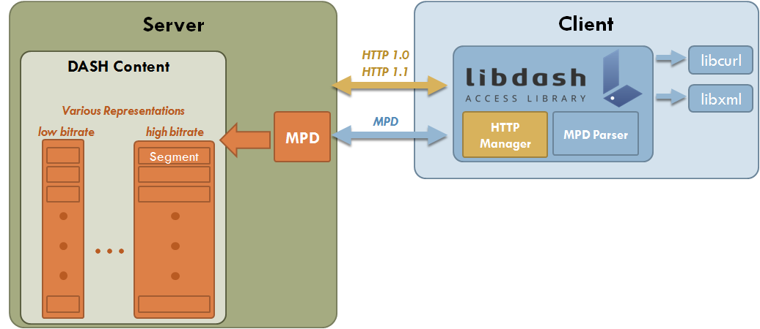

Figure 1. libdash Architecture

The client initially receives the MPD through libdash, which provides a convenient object oriented interface to the MPD. Based on that information the client can download individual media segments through libdash at any point in time. The download order of the segments and the decision which quality of a given segment should be downloaded is not part of libdash this will be left to the application which is using libdash or any other layer, like e.g., our bitdash framework.

# bitdash

bitdash is a comprehensive suite of metrics, adaptation logics and helpers. The helpers include DRM key management, streaming control, network statistics, HTTP management and simplified access to specialized DASH mechanisms for live and on-demand streaming, such as SegmentTemplate, SegmentTimeline, etc. This enables simplified usage of DASH, which results in a tremendous streaming performance.

## Key Facts

* Platform independent solutions based on C/C++ for Windows, Linux, Mac on 32 and 64 bit systems as well as mobile platforms like Android, etc.
* Up to 100 % higher effective media throughput, as shown by our R&D department = Higher Quality for the User!
* Effective DASH adaptation logic, enabling smooth media streaming, even in toughest environments
* Support of the full MPEG-DASH Standard according to ISO/IEC 23009-1
* Cutting Edge HTML5 + JavaScript and Adobe Flash Client Implementations
* DRM key management and fully compatible to third party DRM system
* Advanced network statistics
* Advanced HTTP management (HTTP Header Management, HTTP Setting, etc.)
* Simplified access to advanced DASH concepts for live and on-demand streaming
* Support for different IDEs like Visual Studio and Eclipse to speed up your development
* Comprehensive test suite and content, to reduce your time-to-market and for testing your DASH systems

## Target Platforms

* Set-Top Boxes
* TV-Sets
* Smartphone Platforms and Apps (Android, iOS, Windows Phone)
* Web-platforms, VoD Providers, Streaming Services
* Custom Streaming System, Entertainment Systems, etc.

## Architecture

The architecture of bitdash integrated into a sample client platform is depicted in Figure 2. libdash enables the access to the MPD and bitdash provides the streaming interface for the media player. Internally bitdash uses a modified version of libdash, to enable detailed network statistics and advanced HTTP management. Additionally, bitdash provides simplified methods to handle DRM key management through DASH. In a typical deployment the media player would start the streaming process and handover the URL to a specific MPD to bitdash. bitdash downloads the MPD and provides through libdash’s simplified interfaces and bitdash’s adaptation logics enable high quality streaming performance. In case of DRM encrypted segments the DRM key for a given segment can be extracted through bitdash from the MPD so that the media player can decode the segment with the given key. Further details on the interfaces and the detailed design of bitdash are shown in the *bitdash documentation*.

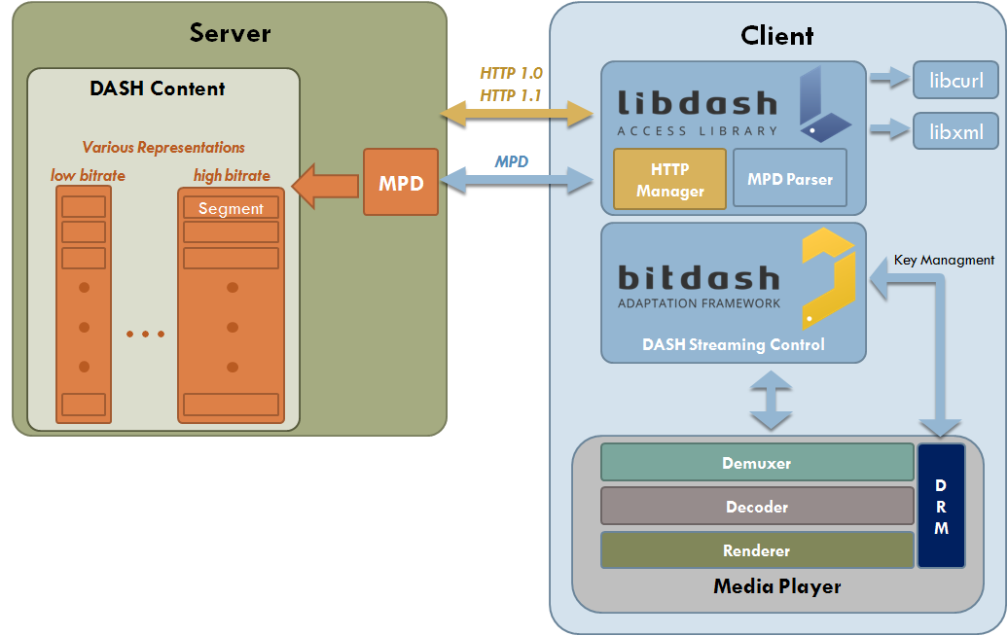

Figure 2. bitdash Architecture

## Licensing

bitdash can be licensed by our customers. For an evaluation of bitdash we offer a limited evaluation license. Depending on the needs of our customers we also provide relicensing of the Open-Source code of libdash (as it’s LGPL, changes have to be published otherwise), as well as integration support, modifications of the library, adjustment of our adaptation logics for the desired network and customer needs, porting to specific customer platforms such as certain Set-Top-Boxes, mobile devices, etc. The innovations and advanced streaming algorithms within bitdash are protected by several US Patents.

Feel free to contact [sales@bitmovin.net](mailto:sales@bitmovin.net) so we can start to discuss your particular requirements and create you an individual offer.